Deminder
Software Architecture Document

Version <1.0>

[To customize automatic fields in Microsoft Word (which display a gray background when selected), select File>Properties and replace the Title, Subject and Company fields with the appropriate information for this document. After closing the dialog, automatic fields may be updated throughout the document by selecting Edit>Select All (or Ctrl-A) and pressing F9, or simply click on the field and press F9. This must be done separately for Headers and Footers. Alt-F9 will toggle between displaying the field names and the field contents. See Word help for more information on working with fields.]

Revision History
Date | Version | Description | Author
29/11/2018 | 1.0 | Fill | Team Deminder

Table of Contents
1. Introduction 2
1.1 Purpose 2
1.2 Scope 2
1.3 Definitions, Acronyms, and Abbreviations 2
1.4 References 2
1.5 Overview 2
2. Architectural Representation 2
3. Architectural Goals and Constraints 2
4. Use-Case View 2
4.1 Use-Case Realizations 2
5. Logical View 2
5.1 Overview 2
5.2 Architecturally Significant Design Packages 2
6. Process View 2
7. Deployment View 2
8. Implementation View 2
8.1 Overview 2
8.2 Layers 2
9. Data View (optional) 2
10. Size and Performance 2
11. Quality 2

Software Architecture Document

Introduction

Purpose
This document provides a comprehensive architectural overview of the system, using a number of different architectural views to depict different aspects of the system. It is intended to capture and convey the significant architectural decisions which have been made on the system.

Scope
This document describes the architecture of the Deminder project.

Definitions, Acronyms, and Abbreviations
Abbrevation | Description
N.A. | Not Applicable
MVC | Model View Controller
UC | Use case

References
Title | Date | Publishing organization
UC Add deadline | 22/10/2018 | Deminder Team
UC Manage deadline | 01/11/2018 | Deminder Team
UC Add subtask | 01/11/2018 | Deminder Team
UC Manage subtask | 01/11/2018 | Deminder Team
UC Show deadline list | 01/11/2018 | Deminder Team
icalendar | 29/11/2018 | Wikipedia

Overview
This document contains an overview of the architecture of the software Deminder.

Architectural Representation
We develop an Android App which uses MVC pattern.
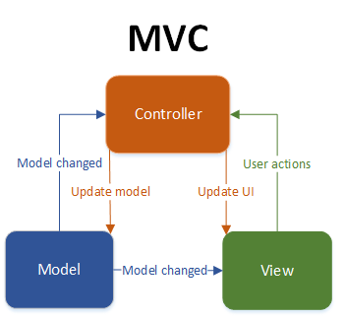

Architectural Goals and Constraints
There is no server used in our app (yet), so there’s only a client side which uses MVC. Our View displays deadlines which can be managed by the User. It is written in Java and uses the icalendar format for storing the deadlines.

MVC

The main goal of the MVC architecture is to separate the view from the logic. The controller takes care of handling actions by the user and telling View or Model, that there were actions performed that concern them. Models contain the data that is displayed in the views.

Data Storage

There is no database use. Instead of that, the data is stored in the icalendar format on the phone drive. The icalendar format (.ics) is the current standard for saving appointments and tasks. The files may be reused in different calendar or todo apps.

Use-Case View
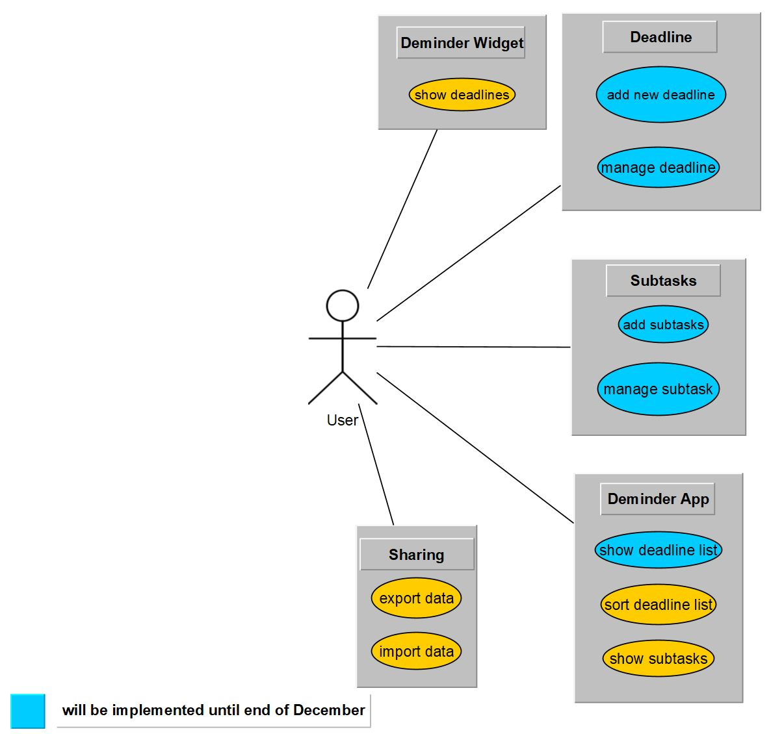

Use-Case Realizations
N.A.

Logical View

Overview
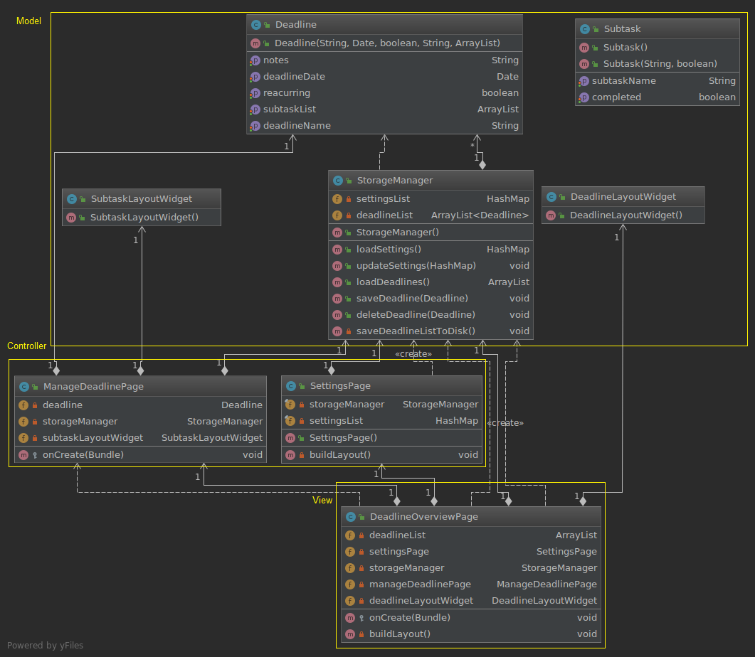

Architecturally Significant Design Packages
N.A.

Process View
N.A.

Deployment View
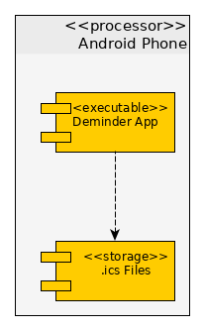

Implementation View
N.A.

Overview
N.A.

Layers
N.A.

Data View (optional)
Data is stored on the android phone in .ics format. These files are accessed by the app directly. There is no database used.

Size and Performance
N.A.

Quality
N.A.

