From screenshot we can notice that application become unstable after 4:23 s of execution (first error has appeared and server didn’t manage to process upcoming transactions)  
  
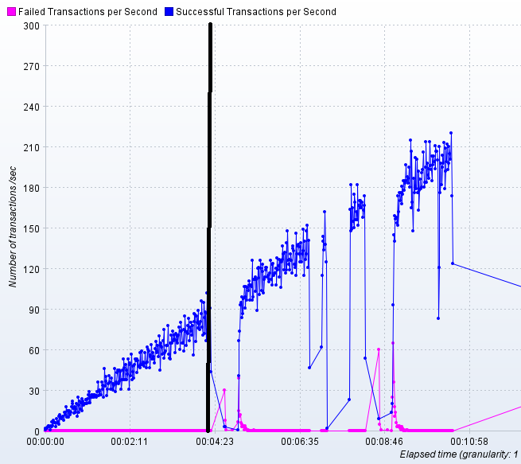  
At 4:24 time of execution were there around 28 active users what can be assumed as capacity of the system under test (see screenshot below).  
