ANSIBLE

Sources:

https://github.com/rahulwagh/ansible-examples.git
https://github.com/iam-veeramalla/ansible-zero-to-hero.git

Ansible is an open-source automation tool used for configuration management, application deployment, orchestration, and provisioning of IT infrastructure.
It works by connecting to systems over SSH (or WinRM for Windows) and executes tasks using simple YAML-based playbooks, without requiring any agent installation on target machines.

YAML file that defines automation tasks for managed hosts.

- Agentless → No need to install software on remote nodes
- Push-based → Control node pushes configurations to managed nodes
- Uses YAML (Playbooks) → Easy to read and write
- Supports idempotency → Running the same playbook multiple times won’t cause changes if state is already achieved
- Works over SSH → Secure and simple

CORE COMPONENTS:

- Control Node → Machine where Ansible is installed
- Managed Nodes → Target servers
- Inventory → List of hosts
- Playbooks → YAML files defining tasks
- Modules → Units of work (e.g., install package, create user)

Widows - wsl - install
Ubuntu – sudo apt-get install ansible
CentOs – sudo yum install ansible

Installing Ansible on Ubuntu: Ansible can be installed on Ubuntu using the apt package manager.
First, you'll need to add the Ansible PPA to your system by running the following command:
- sudo apt-add-repository ppa:ansible/ansible
Next, update the package list and install Ansible using apt-get:
- sudo apt-get update
- sudo apt-get install ansible
Installing Ansible on CentOS: Ansible can be installed on CentOS using the yum package manager.
First, you will need to add the Ansible repository to your system by running the following command:
- sudo yum install epel-release
Next, install Ansible using yum:
- sudo yum install ansible

Passwordless Authentication:

ssh-copy-id -f "-o IdentityFile <PATH TO PEM FILE>" ubuntu@<INSTANCE-PUBLIC-IP>

Using Password
- Go to the file /etc/ssh/sshd_config.d/60-cloudimg-settings.conf or /etc/ssh/ssh_config
- Update PasswordAuthentication yes
- Restart SSH -> sudo systemctl restart ssh
- Create a password if your using pen or ppk file using
  - sudo passwd ubuntu

- ssh-copy-id -f ubuntu@<INSTANCE-PUBLIC-IP>

Ansible Adhoc Command:

Ansible Ad-hoc commands are quick, one-liner commands you run from the terminal to perform tasks on remote machines without writing a full playbook. They’re great for simple operations like checking connectivity, copying files, restarting services, etc.
Syntax:
ansible <host-pattern> -m <module> -a "<arguments>"

ansible all -m ping
ansible webservers -m command -a "uptime"
ansible webservers -m shell -a "df -h | grep /dev"
ansible all -m copy -a "src=/home/user/file.txt dest=/tmp/file.txt"
ansible all -m apt -a "name=nginx state=present"
ansible all -m yum -a "name=httpd state=present"
ansible all -m user -a "name=devops password=123456"
ansible all -m apt -a "name=git state=present" --become

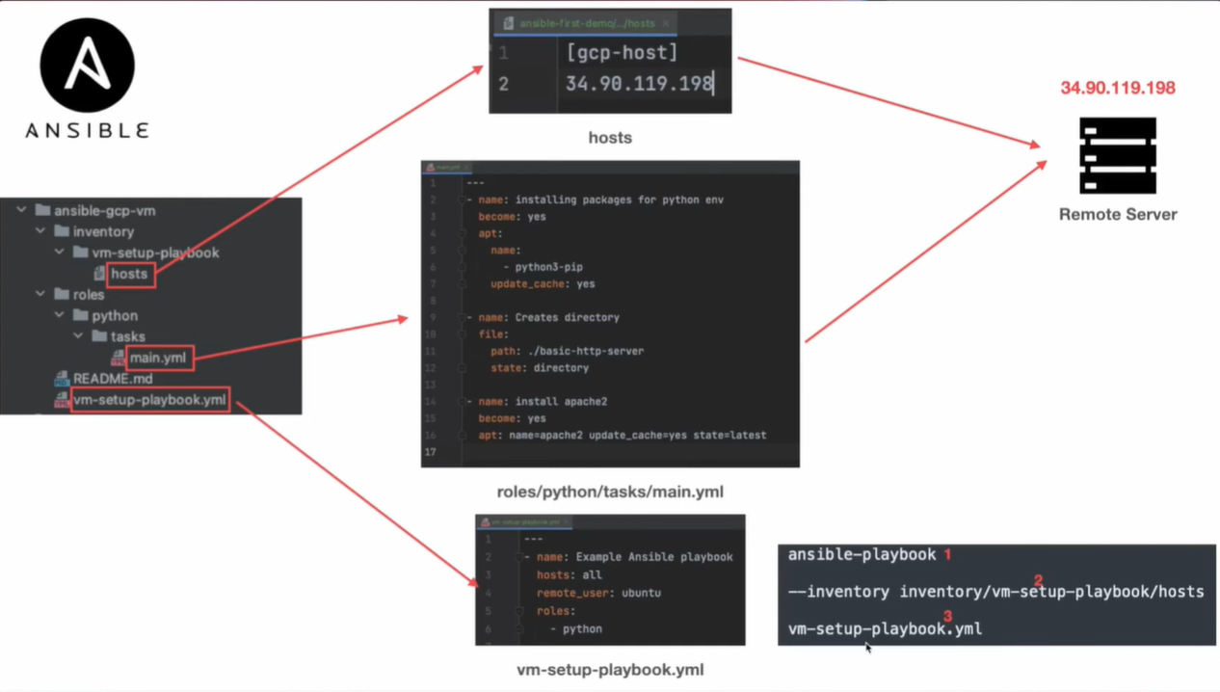

Your setup follows this flow:
Playbook → Inventory → Roles → Tasks → Remote Server
ansible-gcp-vm/
│
├── inventory/
│ └── vm-setup-playbook/
│ └── hosts
│
├── roles/
│ └── python/
│ └── tasks/
│ └── main.yml
│
├── vm-setup-playbook.yml
└── README.md
- Inventory File:
- Define Target servers.
- Runs tasks on this IP Server.

- Playbook (vm-setup-playbook.yml)
- Main entry point
- Define:
  - Which hosts to target
  - User to connect
  - What to run – roles

- Roles
- Roles help organize code in a modular way.
- name: installing packages for python env
become: yes
apt:
name: python3-pip
update_cache: yes

- name: Creates directory
file:
path: /basic-http-server
state: directory

- name: install apache2
become: yes
apt:
name: apache2
state: latest
- Reusable automation blocks
- Keeps playbook clean and scalable

- Tasks
Each task uses a module
- apt – install packages
- file – manage directories
Task do things like
- Install Packages
- Create directories
- Setup services
- Execution Command
End to End Flow

- You run the playbook command
- Ansible reads inventory → finds server
- Executes playbook
- Call’s role (python)
- Runs tasks (main.yml)
- Applies changes on remote server

ansible-playbook \
--inventory inventory/vm-setup-playbook/hosts \
vm-setup-playbook.yml

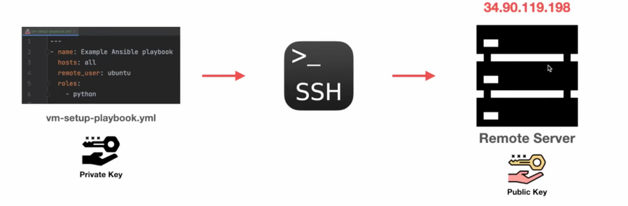
generate a ssh-key using
- ssh-keygen
- public key is copied to the remote server.

YAML (YAML Ain’t Markup Language)
---
- name: Creates a directory
file:
path: ./basic-http-server
state: directory

Ansible Handler:

An Ansible Handler is a special type of task that runs only when notified by another task—typically used to perform actions like restarting services after a change.
---
- name: Example Ansible for Ansible HANDLERS
hosts: all
become: yes
remote_user: nithin_kallem
roles:
- handlers

handlers:
- name: Restart Nginx
service:
name: nginx
state: restarted

---
- name: Update the apt cache and install Nginx
apt:
name: nginx
state: latest
update_cache: yes

- name: index.html copy
template: src=index.html dest=/usr/share/nginx/html/index.html

#Update the content on server.
- name: Updated html Copy
template: src=Updated.html dest=/usr/share/nginx/html/index.html
notify:
- Restart Nginx

ANSIBLE VARIABLE:

C:\Users\user\OneDrive\Learnings\Notes\Ansible\ansible_variables\ansible-variable-playbook.yaml

C:\Users\user\OneDrive\Learnings\Notes\Ansible\ansible_variables\my-vars.yaml

ANSIBLE EVIRONMENT VARIABLE:

C:\Users\user\OneDrive\Learnings\Notes\Ansible\ansible_environment_variable.yaml

ANSIBLE ROLE and TASKS:

A role is a way to organize tasks, variables, files, and handlers into a reusable and structured format.

A task in Ansible is a single unit of work that performs a specific action on a managed node.

C:\Users\user\OneDrive\Learnings\Notes\Ansible\ansible_import_roles

ANSIBLE JINJA2:

Jinja2 is a templating engine used in Ansible to create dynamic configurations by inserting variables, logic, and expressions into files.
It allows you to generate configs dynamically instead of writing static files.
Syntax:
{{ variable_name }}

Most Asked Questions on ANSIBLE:

- Web server setup
  - Install package
  - Start and enable the service
  - Deploy the custom HTML

- name: Setup web server
hosts: web
become: yes
tasks:
- name: Install nginx
apt:
name: nginx
state: present

- name: Start nginx
service:
name: nginx
state: started
enabled: yes

- name: Deploy index file
copy:
content: "Welcome to Ansible"
dest: /var/www/html/index.html

- Deploy Sources and restart service
---
- name: Deploy the sources and restart
hosts: app
become: yes
tasks:
- name: Copy files
copy:
src: myapp.jar
dest: /opt/var/myapp.jar
notify: restart app
handlers:
- name: restart app
service:
name: nginx
state: restarted

- User Creation
---
- name: User Creation
hosts: all
become: yes
tasks:
- name: Create User
user:
name: demo.user
state: present

- Package Install across servers
---
- name: Package Install
hosts: all
become: yes
tasks:
- name: Install https
yum:
name: httpd
state: present
when: ansible_os_family == "RedHat"

- name: Start https
service:
name: https
state: started
enabled: yes

5.Database Set-up
---
- name: My SQL server setup
hosts: DB
become: yes
tasks:
- name: Install my-sql
apt:
name: sql-server
state: present

- What is Idempotency?
Idempotency in Ansible ensures that tasks only make changes when required and do nothing if the system is already in the desired state.

- What are Handlers?
Handlers are special tasks that run only when triggered (notified) by other tasks, typically used for actions like restarting or reloading services.

ignore_errors: true is used when you don’t want Ansible to stop the playbook even if a task fails.
---
- name: Disk Cleanup
hosts: all
become: yes
tasks:
- name: cleaning files
file:
path: /var/log/app.log
state: absent
ignore_error: true

any_errors_fatal: true is used to stop the entire playbook execution on ALL hosts if even ONE host fails.
---
- name: Deploy the sources and restart
hosts: app
become: yes
tasks:
- name: Copy files
copy:
src: myapp.jar
dest: /opt/var/myapp.jar
any_errors_fatal: true
notify: restart app
handlers:
- name: restart app
service:
name: nginx
state: restarted

Ansible Galaxy:

Ansible Galaxy is the official hub (by Red Hat) where you can find, share, and reuse Ansible roles and collections.

1. Roles
Reusable automation units (tasks, handlers, vars, templates)
2. Collections
A bundle of:
- roles
- modules
- plugins

Below command helps in creating own role but with proper files/directory strcture.
ansible-galaxy init my_role

my_role/
├── tasks/
├── handlers/
├── templates/
├── files/
├── vars/
├── defaults/
└── meta/

