**Project Name: Magic Millets Website**

Table of Contents

**1.** **OVERVIEW** 4

2. **BACKGROUND** 5

**3.** **SCOPE OF THE PROJECT** 6

**In Scope** 6

**Out of Scope** 6

**4.** **TOOLS REQUIRED** 7

**5.** **PROCESS FLOW** 9

**User Register Process Flow** 9

**User Login Process Flow** 10

**Process flow for Order Millets** 10

**6.** **USE CASES** 12

**Register Use Case** 12

**Login Use Case** 13

**View Products Use Case** 14

**Buy Products Use Case** 14

**7.** **FUNCTIONAL AREAS** 16

**8.** **DATABASE** 17

**9.** **SCREENS** 21

**GLOSSARY** 24

Table of Figures

Figure 1: User Register Process Flow 11

Figure 2 : User Login Process Flow 12

Figure 3: Process Flow for Order Millets 12

Figure 4: Use Case Diagram 14

Figure 5: Database Relationship Diagram 22

Figure 6: Home Page with Search Bar 23

Figure 7: Login 23

Figure 8: Sign Up 23

Figure 9: Andu Korralu 24

Figure 10: Shopping Cart 24

# **OVERVIEW**

Online food sales are a growing e-commerce sector which is fast gaining ground as an accepted and used business paradigm. The magic millet website is a millet purpose **e-commerce store** where any millet product (such as millets, millet cookies and products made from millets) can be bought from the comfort of home through the Internet.

The objective of this online shopping project is to develop a responsive, cross-browser and device friendly website to sell our millets and products made from millets, and to display our products, product details, cart, recipes, blogs, etc. The customers of today are attracted to online shopping not only because it is very convenient, but also because they have broader selections, highly competitive prices, better information about the product (including people’s reviews) and extremely simplified navigation for searching regarding the product.

An online store is a virtual store on the Internet where customers can browse the catalog and select products of interest. The magic millets website allows visitors to our on-line shopping site which displays our **millet products categorically**, product details separately for each category, recipes of products made from millets, our blog which also helps the visitor to know the health benefit of various kinds of millets. The user can also **search** for different types of millets in the search bar.

The user may **register** their accounts to subscribe to the newsletter of the website and to ensure the authentication of the customer, they can **log in** whenever they use the site. The customer can shop their required items under different categories and can collect items in a **virtual shopping cart** which is very versatile.

They may view the contents of their shopping cart at any time and may add or delete items at will. The program automatically calculates the subtotal, shipping charges and grand total. When a visitor decides to check-out, they must enter their contact details to place the order. The customer is not directed to the payment gateway and must pay after the delivery of products. The order information from the database including the buyer's name, address and billing instruction is e-mailed to the administrator.

# **BACKGROUND**

Online shopping is a form of electronic commerce which allows consumers to directly buy goods or services from a seller over the Internet using a web browser. Magic millets is aiming to develop a responsive web site to display gallery of our products categorically and provide features to view product details and order the products from frontend by the end-users/customers. This millet purpose e-commerce store simplifies the way millets are sold online. The web site displays many various kinds of millets, diverse products made from millets, recipes of various dishes using millets and the blog regarding the health benefits of numerous millets.

Today, many customers are lured to online shopping because they are highly convenient being available for 24 hours a day, detailed information of the products and reviews are trustworthy, the prices are affordable and worth the products, and the selection of products can be done swiftly.

The customers can **register** using their e-mail so that they can **login** to their accounts while using the site; by registering, the customer will also get updates of the products in the website. Customers can search for their wished products, recipes, etc. Customers can **shop** their required products of millets by adding them to the virtual shopping cart where the quantity of each product can be increased or decreased. The customer can also **search** for the product they wish in the search bar.

The shopping cart shows the product name, price of each product, quantity and the total amount. When the customer wants to check-out, to place the order the contact details are to be filled. An **e-mail** is sent to the **administrator** regarding the order information from the database.

Backend functionality is provided to **administrator** user where various products can be added or updated. The rows in the database tables can be added or removed or modified only by the administrator. The privilege of changing the **status** of the orders of the customers in the database from ‘**pending’** to ‘**completed’** or ‘**cancelled’** lies in the hands of the admin to ensure security.

# **SCOPE OF THE PROJECT**

## **In Scope**

Scope of our project is not limited to below items:

1. Magic Millets should be **device friendly** i.e. web pages can be viewed using many different devices: desktops, tablets, and phones.
2. Website should have Search Engine Optimization to enhance user reachability. And hence focusing on responsive web designing that gives the website a Higher ranking (SEO) and more over it generates profits and more sales. It brings a great experience for the user. Responsive web design saves your time, money and energy and helps a user to track his visitors faster.
3. Website should have optimized search functionality. The search engine embedded in the website should be quick to find the user’s requirement.
4. Should contain **multiple product categories** and navigation to the products/recipes/blogs/etc., should be compatible with different devices.
5. The responsive images, the responsive videos and the responsive tables present in the website may resize, hide, shrink, enlarge, or move the content to make it look good on any screen. All this brings a great experience for the user. Responsive web design saves developer’s time, money and energy and helps a user to track his visitors faster. Bootstrap approaches with pre-styled components for alerts, dropdowns, navigation bars, etc.., being a feature-rich, Bootstrap provides numerous advantages of using it.

## **Out of Scope**

* Payment gateway option is not in scope.

# **TOOLS REQUIRED**

1. **Language:** Hypertext Markup Language (HTML)

**Description**: Hypertext Markup Language (HTML) is the standard markup language for documents designed to be displayed in a web browser. It can be assisted by technologies such as Cascading Style Sheets (CSS) and scripting languages such as JavaScript. Web browsers receive HTML documents from a web server or from local storage and render the documents into multimedia web pages. HTML describes the structure of a web page semantically and originally included cues for the appearance of the document.

1. **Language:** JavaScript (JS frameworks like angular JS/jQuery/etc.)

**Description**: JavaScript often abbreviated as JS, is a high-level, interpreted programming language that conforms to the ECMAScript specification. JavaScript has curly-bracket syntax, dynamic typing, prototype-based object-orientation, and first-class functions. Alongside HTML and CSS, JavaScript is one of the core technologies of the WWW. JavaScript enables interactive web pages and is an essential part of web applications.

1. **Language:** Configurable CSS

**Description**: Cascading Style Sheets (CSS) is a style sheet language used for describing the presentation of a document written in a markup language like HTML. CSS is a cornerstone technology of the WWW, alongside HTML and JavaScript. CSS is designed to enable the separation of presentation and content, including layout, colors, and fonts. This separation can improve content accessibility, provide more flexibility and control in the specification of presentation characteristics, enable multiple web pages to share formatting.

1. **Tool Name:** Bootstrap 4

**Description**: Bootstrap is an open source toolkit for developing with HTML, CSS, and JS. It is a free and open-source CSS framework directed at responsive, mobile-first front-end web development. It contains CSS and JavaScript-based design templates for typography, forms, buttons, navigation and other interface components. It is the world’s most popular framework for building responsive, mobile-first sites.

1. **Database:** MySQL database using XAMPP

**Description**: MySQL is an open-source relational database management system (RDBMS). XAMPP is a free and open-source cross-platform web server solution stack package developed by Apache Friends, consisting mainly of the Apache HTTP Server, MariaDB database, and interpreters for scripts written in the PHP and Perl programming languages. MySQL database can be implemented using XAMPP server.

1. **Language:** PHP version 7

**Description**: PHP- Hypertext Pre-processor is a general-purpose programming language originally designed for web development. PHP code may be executed with a command line interface (CLI), embedded into HTML code.

# **PROCESS FLOW**

The online millet selling website has many facilities. The user can **buy various kinds of Millets**, Millet Cookies and other products which are made from the millets. The customer can **view the product** and **add it to cart**, the shopping cart details such as product, prize, quantity, total, remove are visible where they can increase the quantity of the product or remove it, then, if the customer wishes to continue shopping they can continue else they can **check out**. The **contact details** are asked here, and the user can **proceed to buy**.

The cart items and amount are visible on the right side of the contact details page so that the customer can check the items and add items if they wish. After proceeding, the customer’s order has been placed successfully and they can see their order details. The user can **register** and **login** to their accounts to subscribe to the **newsletter** of the website.

The recipes to many millet products are available on the site so that the user can use the millets to the fullest. The user can also know the benefits of different kinds of millets by reading the section where various health benefits of many major millets are listed.

## **User Register Process Flow**

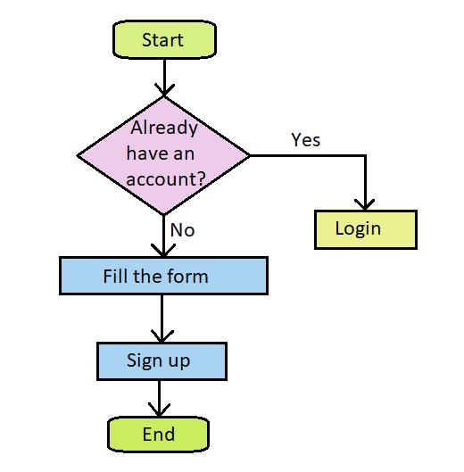

Figure 1: User Register Process Flow

If the user wishes to register an account in the site, then the user must fill the form to create an account. The user must enter their details such as first name, last name, e-mail, password and click on the “Sign Up” button. If the user already has an account, he can click on the “login here” button which redirects the user to the Login page.

## **User Login Process Flow**

If the user wishes to log in to their accounts, then they must already register in the site. The user must enter details such as e-mail, password and click on the “Log In” button to login to their accounts. If the user enters the details wrongly, then a message saying “Email or password is incorrect” is displayed, then the user can correct the details to login correctly.

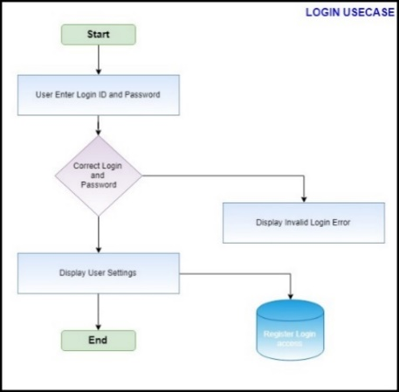

Figure 2 : User Login Process Flow

## **Process flow for Order Millets**

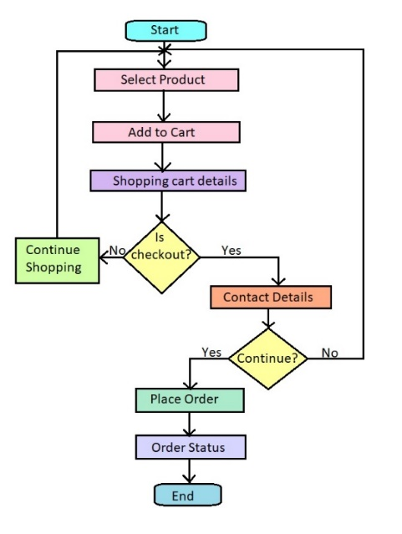

Figure 3: Process Flow for Order Millets

When the customer wants to purchase the products, they view the details of the products and add them to the cart. The shopping cart is displayed whenever an item is added to the cart. The cart displays the details of the products such as product name, price of the product, quantity of each product which can be increased or decreased, total amount of each product and total amount of all the products in the cart are displayed. The customer may continue shopping or checkout at their will. If the customer wishes to check-out, then, a check out page is displayed where the contact details of the customer must be entered. After entering all the contact details, the customer can place the order. Finally, an order status page is displayed with the order information which signifies the successful placement of the order and the admin receives an e-mail regarding the order.

# **USE CASES**

* Register and Login to the user’s account
* Buy Millets

**Use-Case Diagram:**

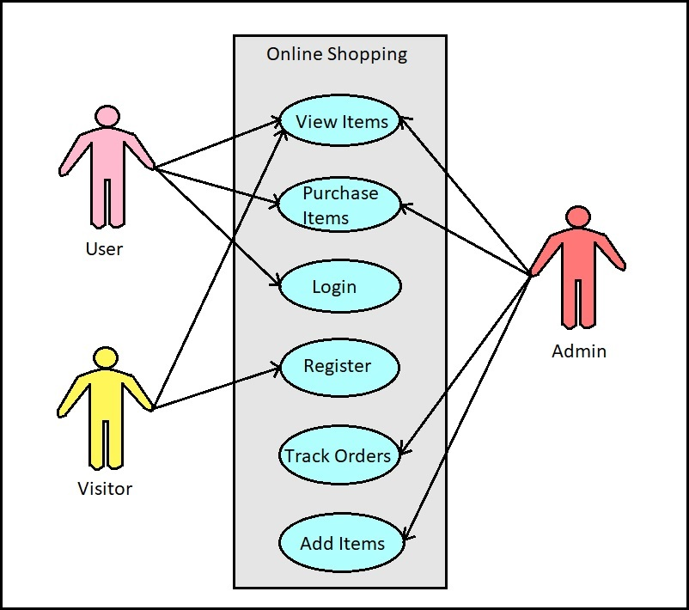

Figure 4: Use Case Diagram

**Use-Case Description:**

## **Register Use Case**

|  |  |
| --- | --- |
| **Module Name** | Visitor Module |
| **Use Case Name** | Register |
| **Use Case Description** | Here using this use case, the customer can register to the site. |
| **Primary Actor** | Customer |
| **Use Case Diagram** |  |
| **Precondition** | Customer wants to subscribe to the newsletter and wants to shop in the site. |
| **Postcondition** | Not applicable. |
| **Basic Flow** | 1. Open the site. 2. Sign Up for new registration. 3. Fill the form. a) Enter first name b) Enter last name c) Enter e-mail id d) Enter password 4. Click “Sign Up” button. |
| **Input** | 1. First Name 2. Last Name 3. E-mail id 4. Password |
| **Output** | Registration is confirmed and redirected to the home page. |
| **Alternate Flows** | The user is already registered.   1. Click “Login here”. 2. User is redirected to log in page. |
| **Special Instructions** | Password must contain ‘6’ to ‘10’ characters or numbers. |

## **Login Use Case**

|  |  |
| --- | --- |
| **Module Name** | Visitor, User Module |
| **Use Case Name** | Login |
| **Use Case Description** | Here using this use case, the customer can login to the site. |
| **Primary Actor** | Customer |
| **Use Case Diagram** |  |
| **Precondition** | To login, the customer must register with the complete details. |
| **Postcondition** | Not applicable. |
| **Basic Flow** | 1. Open the site. 2. Open Login page. 3. Enter user e-mail id. 4. Enter password. 5. Click “Log In” button. |
| **Input** | 1. E-mail id 2. Password |
| **Output** | Opens the home page on the site. |
| **Alternate Flows** | The user enters the details wrongly.   1. A message saying “Email or password is incorrect” is displayed. 2. User corrects the details. 3. Clicks on the “Log In” button again. |
| **Special Instructions** | Enter correct E-mail and password. |

## **View Products Use Case**

|  |  |
| --- | --- |
| **Module Name** | Visitor, User, Admin Module |
| **Use Case Name** | View the Products |
| **Use Case Description** | Here using this use case, the customer will view the products to buy. |
| **Primary Actor** | Customer |
| **Use Case Diagram** |  |
| **Precondition** | Product details must exist in the system. |
| **Postcondition** | Not applicable. |
| **Basic Flow** | 1. Open the site 2. View the list of products by products category |
| **Input** | Not applicable. |
| **Output** | The list of products under products category are displayed. |
| **Alternate Flows** | Not applicable. |
| **Special Instructions** | Not applicable. |

## **Buy Products Use Case**

|  |  |
| --- | --- |
| **Module Name** | Visitor, User, Admin Module |
| **Use Case Name** | Places Order |
| **Use Case Description** | Here using this use case, the customer will add the products to the cart and places the order. |
| **Primary Actor** | Customer |
| **Use Case Diagram** |  |
| **Precondition** | 1. Product details must exist in the system. 2. Customer must know the details in the shopping cart. |
| **Postcondition** | Order must be placed successfully. |
| **Basic Flow** | 1. Open the site. 2. View the products. 3. Places order a) Add items to the cart b) Remove items from the cart c) Review the contents of the cart 4. Click “Check Out” button. 5. Fill the form of contact details a) Enter First name a) Enter Last name a) Enter e-mail id a) Enter phone number a) Enter detailed address 6. Click “Place Order” button. |
| **Input** | 1. View the products 2. Add the items to the cart 3. Enter the contact details |
| **Output** | An order status page is shown which contains the order information. Order status |
| **Alternate Flows** | Not applicable. |
| **Special Instructions** | Not applicable. |

# **FUNCTIONAL AREAS**

The functional areas of the website are accessible for the users of the website, based on their roles, are customers (users) and the administrator (owner).

1. **Admin:** The administrator is the owner of this online shopping application. One must have a basic understanding of computers and the internet as well as prior knowledge for operating the Xampp server and Sublime Text, HTML language, JavaScript language, Cascading Style Sheets language, database languages. The administrator is responsible for maintaining all the training documents required for the system. The administrator can perform the following functions:

* **Add** or **delete** or **alter** any rows or columns of the **tables** present in the database.
* **Assign** or **change** the price of the products, update the products in the list, and delete the **products** in the database.
* View the **register details** of the customers who have registered.
* View the **history** of the customers who purchased the items.
* **Tracking** **the order** of the customers and the privilege of changing the **status** of the orders of the customers in the database from ‘**pending’** to ‘**completed’** or ‘**cancelled’.**

1. **Users**: The users of this online shopping application are all customers who would shop to **buy millets** and **products made from millets**. They must have basic understandings about computers and the internet. The users should be able to perform the following functions using this system:

* View, browse, and **select any millets** category on the home page.
* **Search** for any product the user wishes.
* **View**, **add**, and **update** items in the **cart**.
* **Delete** items from the **cart**.
* **Check out** the items from the cart or continue shopping.
* **Register** once by filling the sign-up page and **login** using an e-mail and password.
* **Place the order** by completing the contact details check out form.

# **DATABASE**

This section describes database design and table definitions.

* **Table Name**: Register

**Description:** It contains the details of the user such as first name, last name, email and password so that the user can register once and then login to their accounts.

|  |  |  |  |  |
| --- | --- | --- | --- | --- |
| **S. No** | **Column Name** | **Default Value** | **Datatype** | **Column Description** |
| 1 | First_Name |  | varchar (50) | First name of the user |
| 2 | Last_Name |  | varchar (50) | Last name of the user |
| 3 | Email |  | varchar (100) | E-mail id of the user |
| 4 | Password |  | varchar (30) | Password set by the user |

* **Table Name**: Customers

**Primary Keys:** id

**Description:** It contains the details of the customer’s address such as id, first name, last name, email, phone number, address, created, modified and status.

|  |  |  |  |  |
| --- | --- | --- | --- | --- |
| **S. No** | **Column Name** | **Default Value** | **Datatype** | **Column Description** |
| 1 | id |  | Int (11) | User id |
| 2 | First_Name |  | Varchar (25) | First name of the user |
| 3 | Last_Name |  | Varchar (25) | Last name of the user |
| 4 | Email |  | Varchar (50) | E-mail id of the user |
| 5 | Phone |  | Varchar (15) | Phone number of the user |
| 6 | Address |  | text | Detailed address of the user |
| 7 | Created |  | datetime | Date and time of creation |
| 8 | Modified |  | datetime | Date and time of updation |
| 9 | Status | 1 | enum | Active (1) or inactive (0) status of the customer |

* **Table Name**: Orders

**Primary Keys:** id

**Foreign Keys:** customer_id (from Customers table)

**Description**: It contains the details about the order made by the customer such as id, customer id, grand total, created and status.

|  |  |  |  |  |
| --- | --- | --- | --- | --- |
| **S. No** | **Column Name** | **Default Value** | **Datatype** | **Column Description** |
| 1 | id |  | Int (11) | Id of order |
| 2 | Customer_id |  | Int (11) | Id from customer table |
| 3 | Grand_total |  | Float (10,2) | Total amount of order |
| 4 | Created |  | datetime | Date and time of order |
| 5 | Status | Pending | Enum (‘Pending’, ’Completed’, ’Cancelled’) | Status of the order whether pending or completed or cancelled |

* **Table Name**: Products

**Primary Keys:** id

**Description:** It contains all the details of products such as id, name, description, price, created, modified and status.

|  |  |  |  |  |
| --- | --- | --- | --- | --- |
| **S. No** | **Column Name** | **Default Value** | **datatype** | **Column Description** |
| 1 | id |  | Int (11) | Id of product |
| 2 | Name |  | Varchar (200) | Name of the product |
| 5 | Description |  | text | Description of the product |
| 6 | Price |  | Float (10,2) | Price of the product |
| 7 | Created |  | datetime | Date and time of creation |
| 8 | Modified |  | datetime | Date and time of updation |
| 9 | Status | 1 | enum | Active (1) or inactive (0) status of the product |

* **Table Name**: Order_items

**Primary Keys:** id

**Foreign Keys:** order_id (from Orders table), product_id (from Products table)

**Description:** It contains the details of the items like id, order id, product id and quantity.

|  |  |  |  |  |
| --- | --- | --- | --- | --- |
| **S. No** | **Column Name** | **Default Value** | **Datatype** | **Column Description** |
| 1 | id |  | Int (11) | Id of order items |
| 2 | Order_id |  | Int (11) | Id from orders table |
| 2 | Product_id |  | Int (11) | Id from products table |
| 3 | Quantity |  | Int (5) | Quantity of the items ordered |

* **Table Name**: Search_Engine

**Primary Keys:** id

**Description:** It contains id, page URL and page content so that searching results can be displayed from this table when a product is searched in the search bar.

|  |  |  |  |  |
| --- | --- | --- | --- | --- |
| **S. No** | **Column Name** | **Default Value** | **Datatype** | **Column Description** |
| 1 | id |  | Int (11) | Id of the products |
| 2 | pageurl |  | varchar (255) | URL of the page of the product |
| 3 | pagecontent |  | text | Description of the product in the page |

**Database relationship diagram:**

The below entity relationship diagram signifies that ‘**Customers**’ place ‘**Orders**’ which contain ‘**Order_items**’ which are reserved by ‘**Products**’. The customers place the orders which are uniquely identified by customer id. The orders contain the details of order items which are uniquely identified by the order id. The products have a unique id which helps to differentiate order items along with order id.

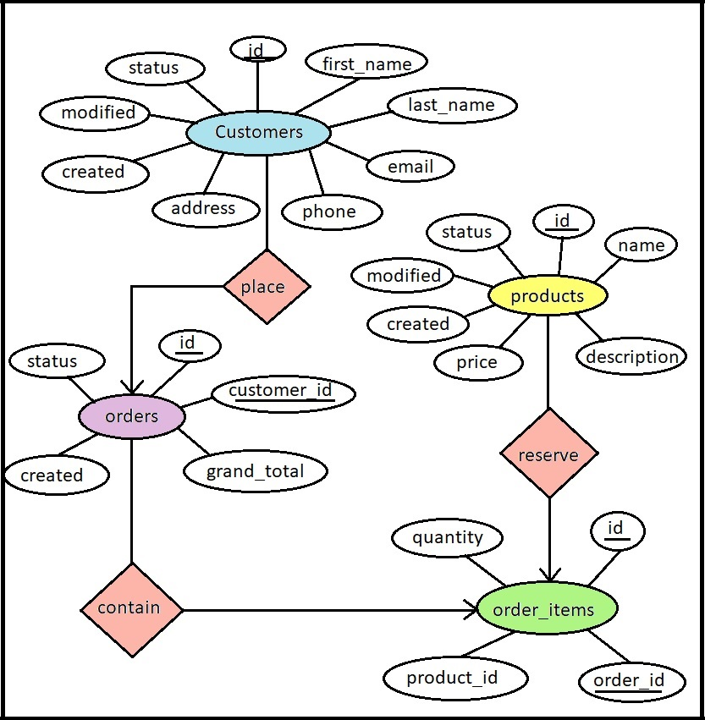

Figure 5: Database Relationship Diagram

# **SCREENS**

* **Home Page:** The user can open any category from millet, millet cookies, other products and recipes. The user can search for any product in the search bar.

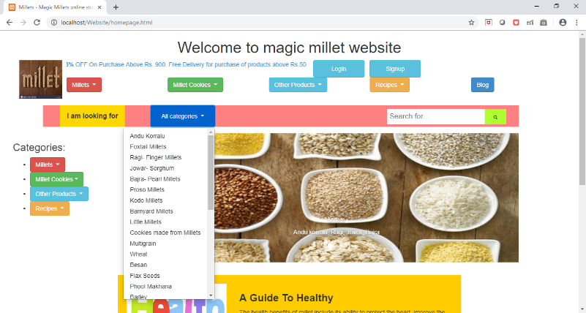

Figure 6: Home Page with Search Bar

* **Login Page:** The user can log in to their accounts by entering their e-mail id and password after registering.

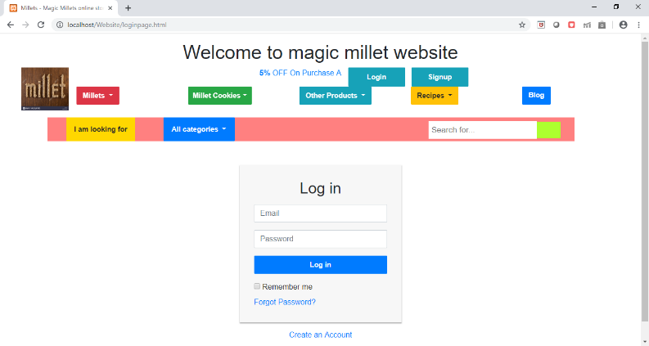

Figure 7: Login

* **Sign Up Page:** The user can register their accounts by entering their first name, last name, email and a password. If they have an account already, then they can log in directly.

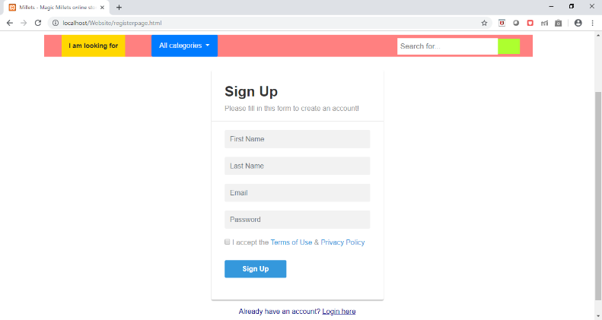

Figure 8: Sign Up

* **Andu Korralu Page (under Millets Category):** The customer can view the products in a detailed manner and add them to a shopping cart.

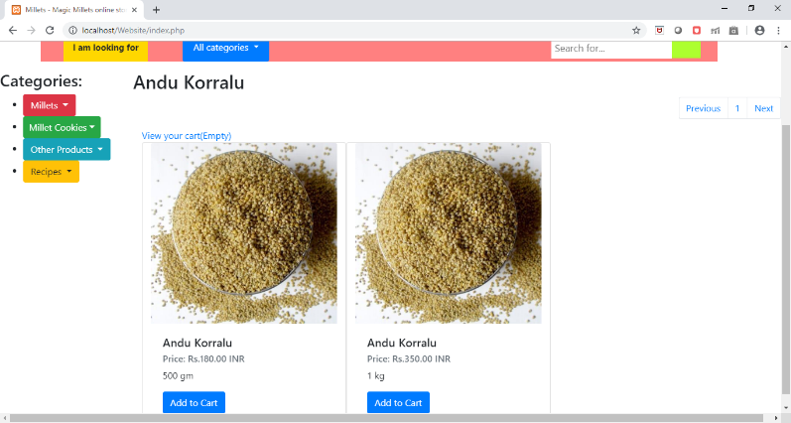

Figure 9: Andu Korralu

* **Shopping Cart Page:** The customer can view their shopping cart at any time. The cart shows the product name, price of the product, quantity of the product, total amount of each product and the total amount of all the products. The customer can increase or decrease the quantity of each product at their will. They can also add or remove products. After viewing the shopping cart, the customer may continue shopping or may check out at will.

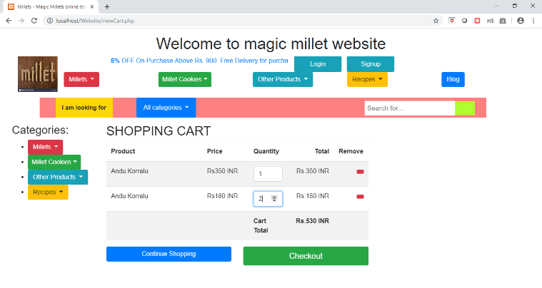

Figure 10: Shopping Cart

* **Check-Out Page:** When the customer decides to checkout, the contact details page appears where the customer must enter their first name, last name, e-mail, phone number and their detailed address to place the order. The customer’s cart is visible on the right side of the page so that the customer can view their cart once again and add items if they wish. After placing the order, order status page appears where the order information is displayed in detail.

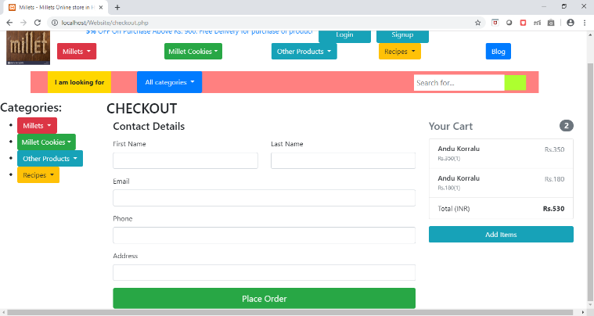

Figure 4.6: Check Out

# **GLOSSARY**

|  |  |
| --- | --- |
| **CSS** | Stands for Cascading Style Sheets and is a style sheet language used for describing the look and formatting of a document written in a markup language. |
| **ECMAScript** | ECMAScript (or ES) is a scripting-language specification standardized by ECMA International. It was created to standardize JavaScript. |
| **HTML** | Stands for Hyper Text Markup Language and is a markup language designed for creating web pages. |
| **HTTP** | The Hypertext Transfer Protocol (HTTP) is an application protocol for distributed, collaborative, hypermedia information systems. |
| **Internet** | Global system of interconnected computer networks that use the standard TCP/IP to communicate. |
| **JS** | JavaScript often abbreviated as JS, is a high-level, interpreted programming language that conforms to the ECMAScript specification. |
| **PHP** | Stands for PHP: Hypertext Preprocessor and is a server-side scripting language originally designed for web development. |
| **RDBMS** | A relational database is a digital database based on the relational model of data. A software system used to maintain relational databases is a relational database management system (RDBMS). |
| **URL** | Stands for Uniform Resource Locator and is a specific character string that constitutes a reference to a resource, also known as web address, when used with HTTP. |
| **WWW** | Stands for World Wide Web, also known as W3 or simply the Web, and is a system of interlinked hypertext documents accessed via the Internet with a web browser. |
| **XAMPP** | XAMPP is a free and open-source cross-platform web server solution stack package developed by Apache Friends. |