# DSA

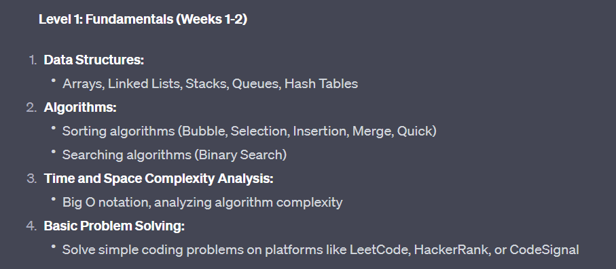

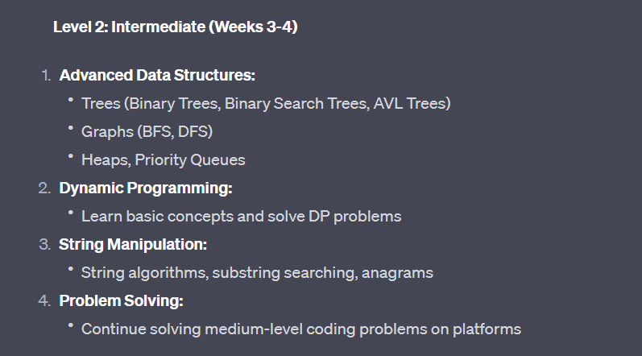

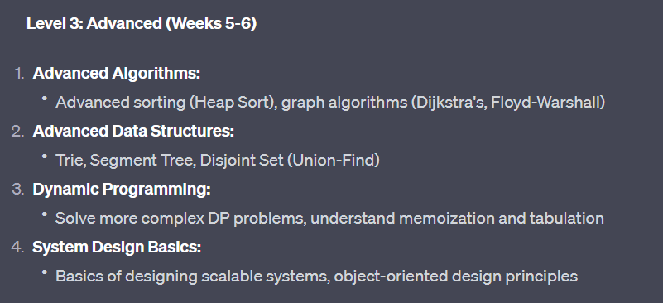

# JAVA

## Core Java

## Advanced Java

# Spring Framework

## Spring Modules

## Spring Projects

# Microservices

# SQL

# Messaging

# AWS

# Git and GitHub

# Frontend Skills