ESP32 C++ in the Browser/ Design log
SparkFun ESP32-S3 Thing Plus · Espressif GCC 14.2.0 and binutils 2.43.1 built as WebAssembly · started Nov 8, 2026

Goal and Logic
KaloLab's desktop app can already turn a MATLAB script or an Arduino sketch into C++, compile it with the Arduino IDE's arduino-cli, and flash an ESP32. The website can't. Compiling C++ for the ESP32 needs a compiler, and a browser doesn't have one. Flashing is the easy half: the site already flashes MicroPython over USB with esptool-js.
So the goal is simple to say and hard to do: press Flash as C++ on the website and have it compile inside the browser, with no server and no desktop app. I had three ways to get there:
Route | What I found
Desktop app + arduino-cli | Works today, but needs the Arduino IDE and its ESP32 package installed. It is not the website.
Compile on the Railway server | I checked: the server has 8 GB of memory and 8 vCPUs, so about 4 builds at once is realistic. It adds 1–2 GB of toolchain, costs money while people compile, and the build has to be sandboxed because C++ can #include any file on the server.
Compile in the browser (WebAssembly) | No server, and it can work offline once cached. I couldn't find anyone who had done it for the ESP32-S3. That is what I wanted to find out.

Compiler Reasoning
The S3 is an Xtensa chip, not RISC-V, so the compiler has to understand Xtensa. A spec I was handed suggested clang and lld compiled to WebAssembly. Before building anything I checked the real S3 link line in my Arduino install, and it changed my mind:
- The link uses GNU-linker features (--wrap, --orphan-handling, --cref, ROM linker scripts) and GCC-only flags such as -mdisable-hardware-atomics.
- The linker script has 352 rules that place code by library and file name, like *libapp_trace.a:app_trace.*. There are 69 for libspi_flash.a alone.
- The S3 SDK is 168 libraries and 226 MB of .a files, plus 61 MB of headers.
D1. Don't use clang and lld. Run Espressif's own GCC and GNU binutils, built to WebAssembly, so every flag and linker script behaves exactly like the native toolchain.
D2. Keep the SDK libraries as separate .a files. One suggestion was to merge them into a single object with ld -r. That would erase the file names those 352 rules match, and code that must live in fast internal memory would end up in flash, crashing whenever flash is busy.
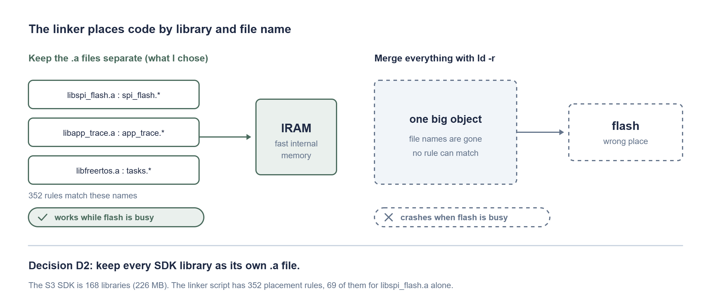
Why the SDK libraries stay as separate .a files.
D3. The test is bytes, not vibes. If the WebAssembly tools give the same bytes as the native ones, they are right. If not, they are wrong.
The risky part: I found no one who had run GCC's C++ compiler as WebAssembly (two searches). GNU binutils had been done by others. The compiler itself had not.

Ground Truth First
Before building anything I captured exactly what the real toolchain does for a blink sketch on my board: esp32:esp32:sparkfun_esp32s3_thing_plus:CDCOnBoot=cdc, ESP32 core 3.3.12, Espressif GCC 14.2.0, esptool 5.3.1. It built to 299,952 bytes (22% of flash).
What I found | Why it matters
Re-running the link command gives a byte-identical ELF (SHA-256 starts 224f616f446e1ee3, 6,883,032 bytes). | A pass/fail test for everything I build.
Compiling one file is three programs in a row: cc1plus writes assembly, as makes the object file, and collect2 runs ld to link. | WebAssembly can't start programs, so JavaScript has to run each step.
Every tool runs with --dynconfig=xtensa_esp32s3.so, a 0.9 MB shared library. | The chip's instruction set is loaded at run time. WebAssembly can't load libraries.
The driver hides most arguments in a temporary file that it deletes. | I needed a wrapper to capture what the tools are really given.
After linking: elf2image, a partition table, boot_app0.bin, then a merge. | Flashing needs four files: bootloader at 0x0, partitions at 0x8000, boot_app0 at 0xe000, the app at 0x10000.

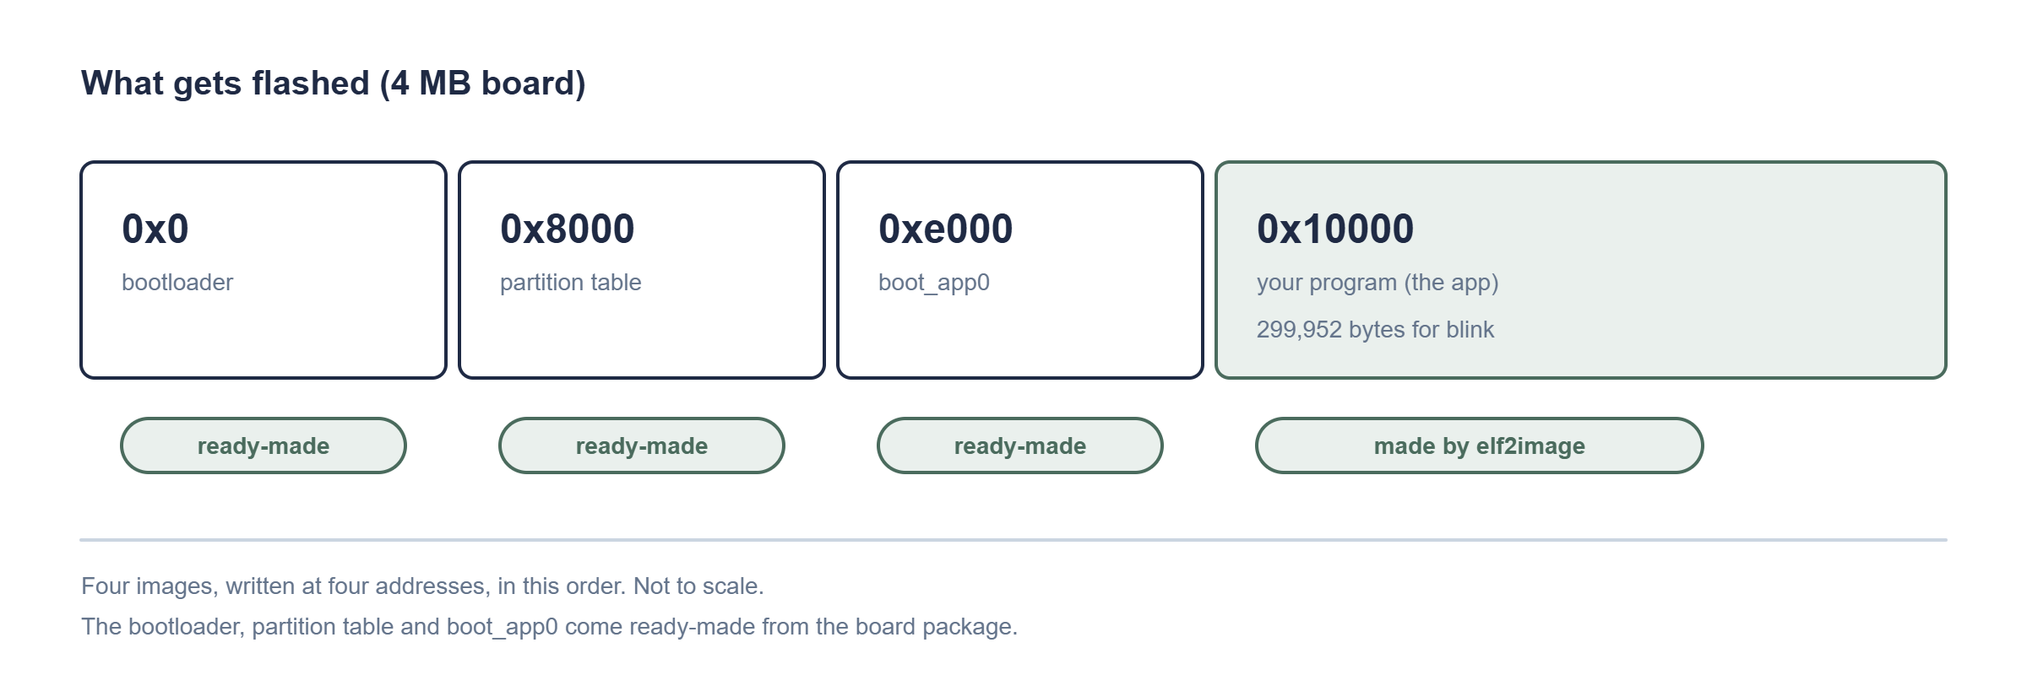
The four images a flash writes, and the addresses they go to.
D4. Build the chip definition in. I read the loader's source (bfd/xtensa-dynconfig.c). If the XTENSA_GNU_CONFIG variable isn't set, it returns a compiled-in default made from include/xtensa-config.h, and only the plugin path calls dlopen. Espressif's xtensa-overlays repo has an xtensa_esp32s3 folder, and for binutils it is exactly two files: bfd/xtensa-modules.c (43,686 lines, against 20,896 for the default) and include/xtensa-config.h. So the plan is to swap those two files in, build, and never set the variable.
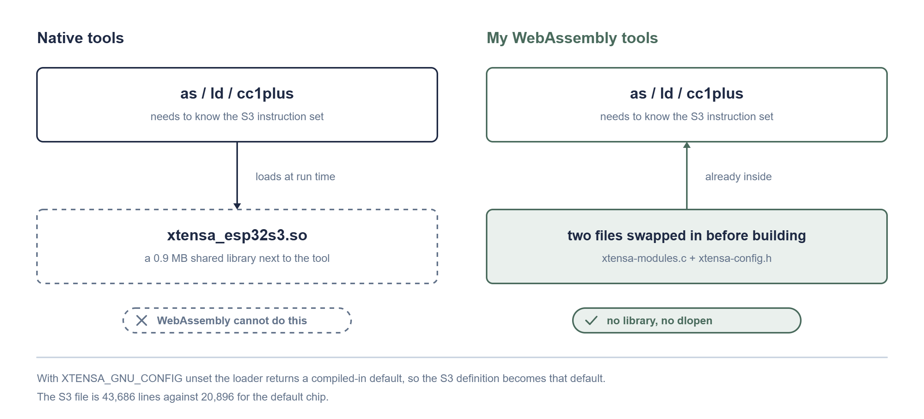
How the S3 chip definition gets into the tools.

Setting Up the Build Machine
Windows can't build this, it needs Linux. WSL was switched on but had no Linux installed, so I installed Ubuntu 24.04 LTS. Everything below ran inside it, and every build step is a script file so I can repeat it.
Thing | Value
Ubuntu | 24.04.5 LTS (WSL 2)
CPUs / memory / disk | 16 / about 7 GB / 955 GB free
Compiler that makes WebAssembly | Emscripten 7.0.0 (Node 18.19.1)
Native compiler (for the build tools) | GCC 13.3

A rule I picked up fast: anything I type into the shell that contains quotes goes in a script file instead. PowerShell mangled my quotes twice.

Step 1: Assembler, Linker and objcopy

Build
Espressif's binutils at tag esp-2.43.1_20260121 matches my toolchain's esp-14.2.0_20260121 (binutils 2.43.1). I copied the S3 overlay's two files in and configured with Emscripten. Configure took 23 seconds.

Small problem resolved
The first make failed in libiberty: its own psignal() clashed with the one Emscripten already declares. Telling configure the function exists (ac_cv_func_psignal=yes) fixed it. The second build finished in under 4 minutes.
File | Size
as-new.wasm (assembler) | 1.1 MB
ld-new.wasm (linker) | 1.3 MB
objcopy.wasm | 0.9 MB

Test: the assembler
I took the 6,298-line assembly file the native compiler wrote for my sketch (sketch.s, 97,551 bytes) and assembled it with the native assembler and with mine. Mine ran in 0.18 seconds and accepted every S3 instruction, and the object file was the same size (26,276 bytes). But 1,284 bytes differed.
Comparing section by section, every code and data section was identical. Only .debug_line differed. The cause: one .file line in the assembly has a Windows path with backslashes. The Windows assembler treats a backslash as a folder separator and the Linux-style one does not, so its directory table was one entry short and everything after it shifted. After I wrote that one path with forward slashes:
native sketch_fwd_native.o 26276 bytes cd82c6894d0dd49d6d84ef29
wasm sketch_fwd_wasm.o 26276 bytes cd82c6894d0dd49d6d84ef29
BYTE-FOR-BYTE IDENTICAL OBJECT FILES

Test: the linker
This is the hard one: link the whole firmware. 883 arguments, the full 226 MB SDK, the ROM linker scripts and all the --wrap flags. The arguments were hidden in two temporary files, so I wrote a small wrapper (GCC's -wrapper option) to record them, then mapped the Windows paths to Linux ones and handed them to my ld.
exit status: 0 (1m30s)
link_wasm.elf 6883032 bytes 224f616f446e1ee3
native ELF 6883032 bytes 224f616f446e1ee3
ELF FILES: BYTE-FOR-BYTE IDENTICAL
D5. The linker is done. GNU ld as WebAssembly links the real S3 firmware to the identical ELF.

Step 2: The Compiler (cc1plus)
This is the part nobody seems to have published. It needs GCC's source (Espressif's tag esp-14.2.0_20260121, 1.3 GB, with the S3 overlay's gcc/include/xtensa-config.h), a native Linux copy of the Xtensa assembler (GCC's configure probes one), and the three math libraries GCC depends on, GMP 6.2.1, MPFR 4.1.0 and MPC 1.2.1, built for WebAssembly. Getting all of that ready took about five minutes.

Build
Configure took 28 seconds. The first make ran for 10 minutes and compiled 515 files, then stopped on gcov-tool, a code-coverage utility that needs a Unix function (ftw) that WebAssembly doesn't have. I don't need that tool, but its failure stopped the build before the compiler was linked. Running make -k (keep going) finished the compiler in 1 minute 16 seconds.
File | Size
cc1plus.wasm (C++ compiler) | 18.1 MB
cc1.wasm (C compiler) | 16.3 MB
xgcc.wasm (driver) | 0.8 MB

Test: compile my sketch
The first runs failed in ways worth writing down.

Small problems resolved
- Arguments. GCC passes most of them in a temporary @file. GCC's rule is that a backslash always escapes the next character. I had parsed it with a simpler rule and ended up with paths like /mnt/c////Users.
- Missing ~stdbool.h~. The native compiler finds its own header folders relative to where it is installed, and mine was configured for a different folder. I added the six built-in folders explicitly, in the same order the native compiler searches them (taken from its -v output).
- 25 minutes and not finished. The next run was reading thousands of headers from Windows through WSL's /mnt/c bridge. It had used 24 minutes 45 seconds of wall time but only 1 minute 25 seconds of CPU. I stopped it, copied the folders onto Ubuntu's own disk, and the same compile took 5.5 seconds.
- Line endings. Every line of the native assembly ends in \r\n and mine uses \n. I stripped the carriage returns before comparing.
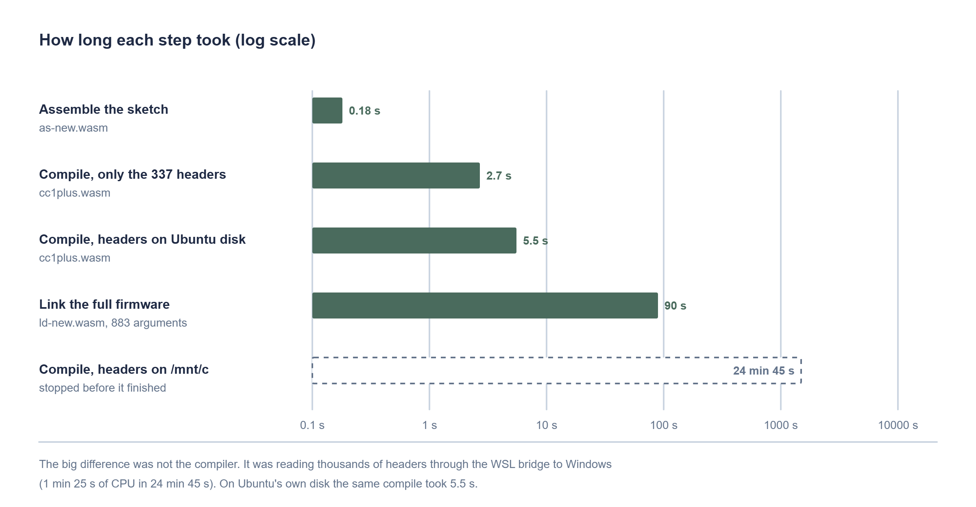
How long each step took. The slow one was the file bridge, not the compiler.
Result: 6,297 lines of assembly, the same count as the native compiler. The first 5,600 lines, all the code, data and debug tables, are identical. Only 16 lines of debug strings differ:
- the compiler's flag list recorded in the debug info lacks -mdynconfig=xtensa_esp32s3.so, because I left that flag out on purpose
- the working-folder path (/root/work/test-cc against C:\Users\you\Downloads)
- the order of those three strings, which shifts as a result
D6. The compiler works. GCC's C++ compiler for the ESP32-S3 runs as WebAssembly and produces the same code as the native one.

How Much Would a Browser Download?
All of it compresses well. The whole C++ toolchain is about 6.2 MB with Brotli, smaller than the 9–12 MB I had been told to expect.
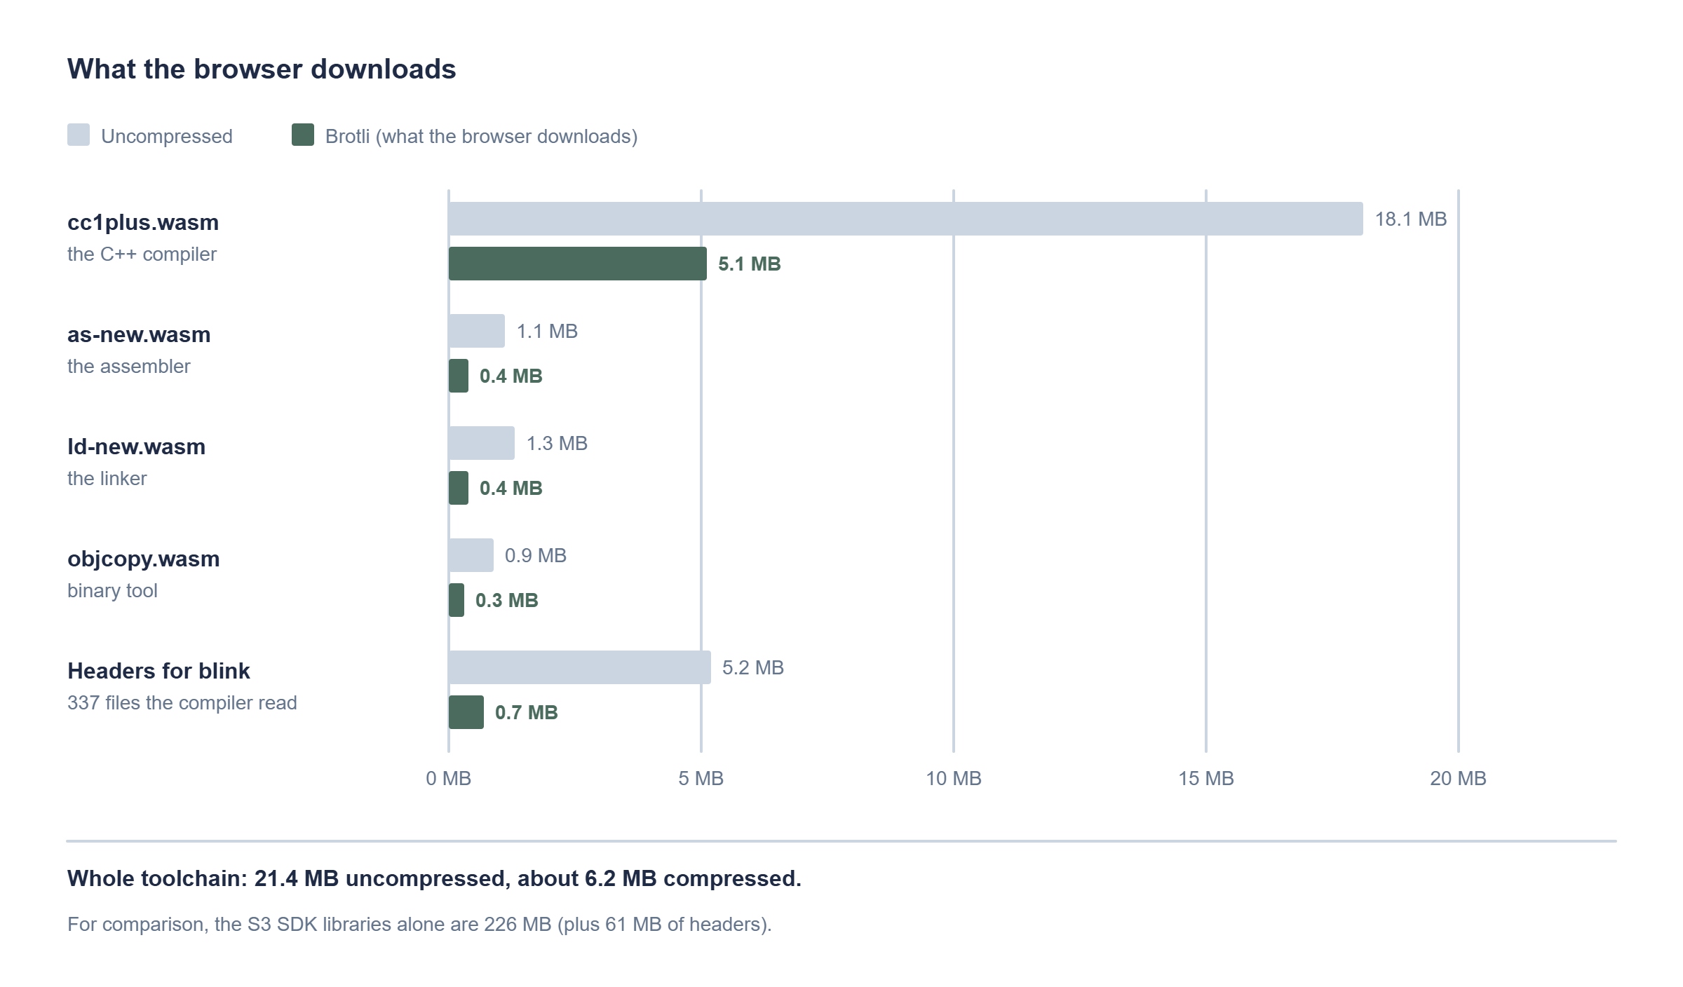
Sizes of the four tools and of the headers my blink sketch actually reads.
I asked the compiler to list every header it opens (-H): 337 files, 5.2 MB, which compress to 0.7 MB (162 from the compiler, 131 from the SDK, 44 from the Arduino core). With only those 337 files present, the compile still works and takes 2.7 seconds. So a browser does not need the whole SDK to build a simple sketch. It can fetch each header the first time the compiler asks for it.
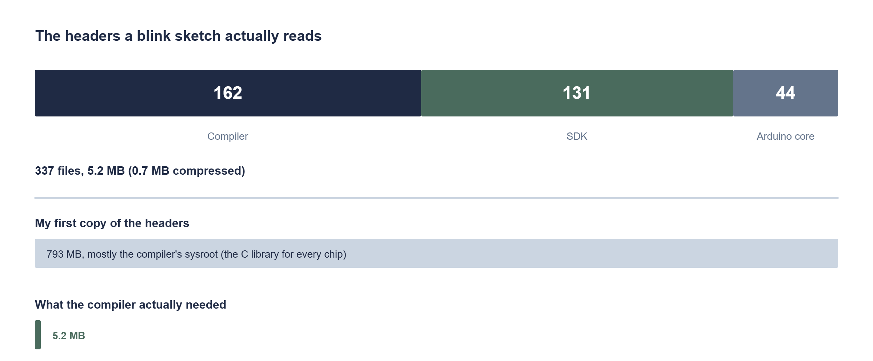
Where the 337 headers come from, and how small they are next to my first copy.
One mistake worth noting: my first copy of the headers was 793 MB. Most of that was the compiler's sysroot folder, which holds the C library for every chip. The headers it actually reads are tiny.

FINAL RESULTS
The toolchain passes every test I could run on this PC.
Check | Result
Source | Espressif binutils 2.43.1 and GCC 14.2.0, tag esp-14.2.0_20260121, with the xtensa_esp32s3 overlay compiled in
Built with | Emscripten 7.0.0 in Ubuntu 24.04 (WSL)
Compile | cc1plus.wasm: first 5,600 lines of assembly identical, 16 debug-string lines differ. 5.5 s (2.7 s with only the 337 headers it needs)
Assemble | as-new.wasm: byte-for-byte identical object file (0.18 s)
Link | ld-new.wasm: byte-for-byte identical 6,883,032-byte ELF from 883 arguments and the full SDK (90 s)
Download | About 6.2 MB compressed for the four tools, 0.7 MB for the blink sketch's headers
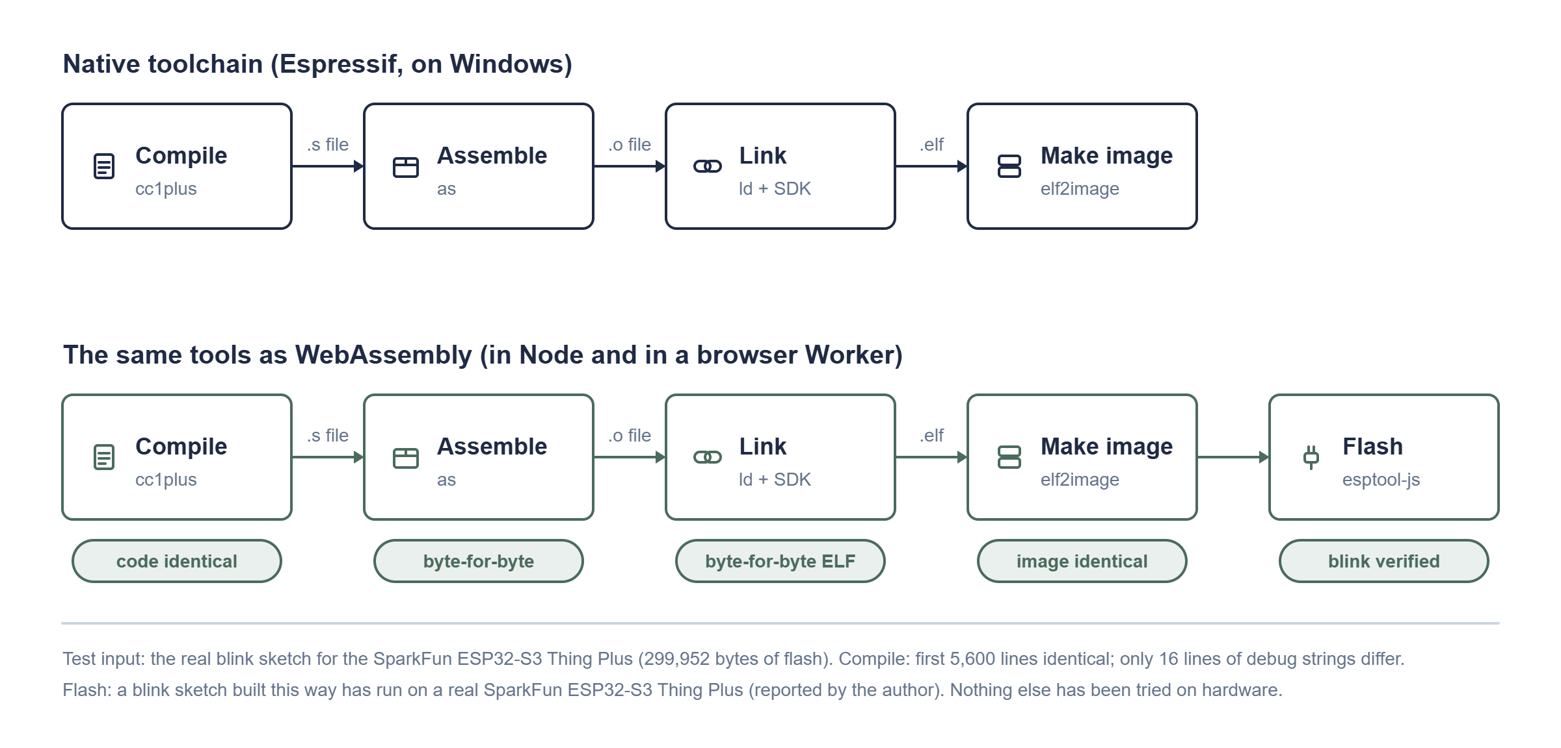
The four stages of a build. Teal means the WebAssembly tool matched the native one. (This figure was updated on Nov 9, after elf2image was written and the pipeline ran in a browser; the list below is as of Nov 8.)
DO NOT SHIP THIS YET (as of Nov 8)
- There is still no flashable .bin: elf2image isn't built
- The Arduino core and libraries aren't precompiled into an archive yet
- Nothing has run in a browser. Every test used Node with direct file access
- Nothing has been flashed to a real board
- GCC and binutils are GPL, so a site that serves them must also offer their source

Next, as of Nov 8: Building It Into KaloLab
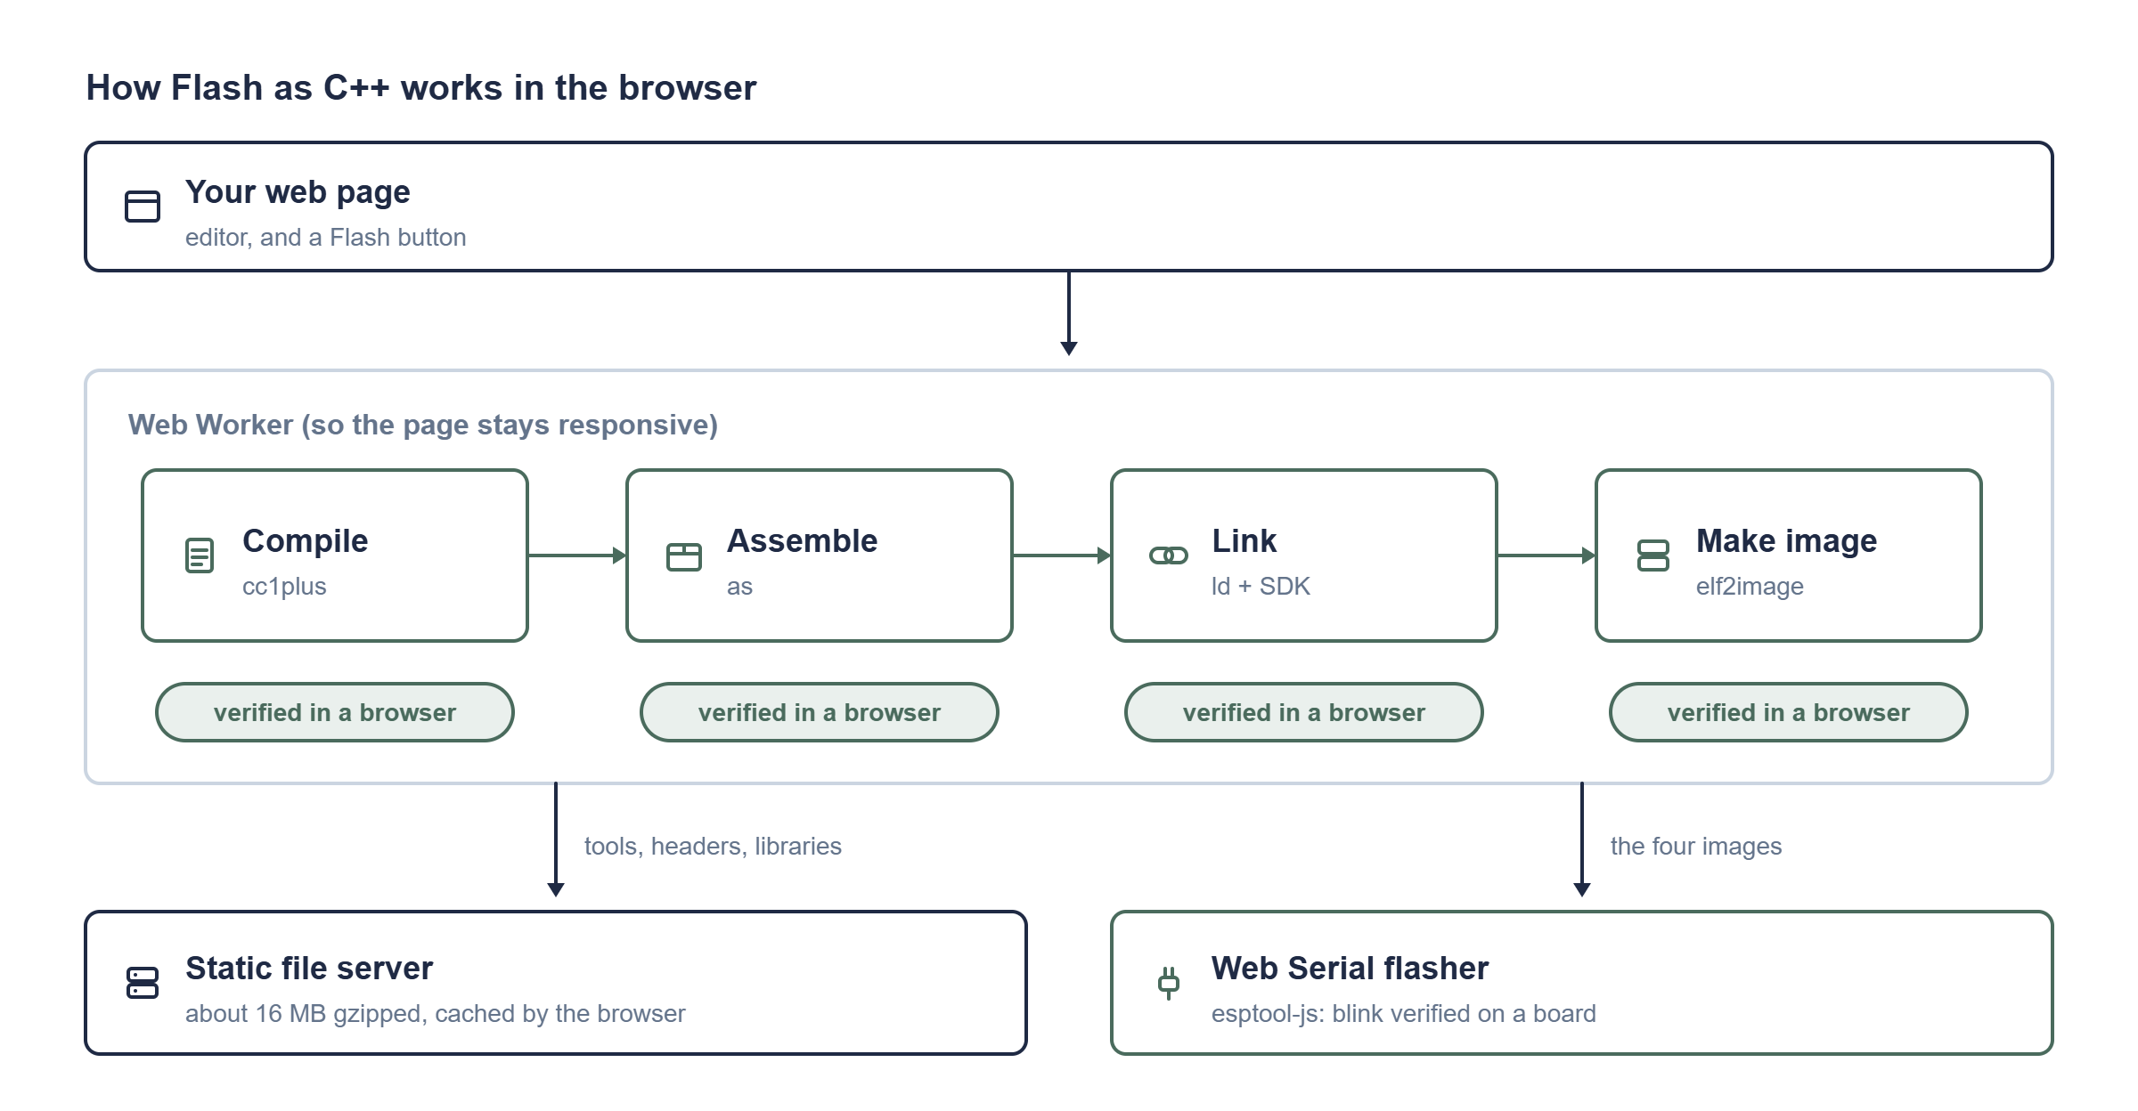
The plan, with where each piece stands today.
Progress, Nov 9: I relinked cc1plus, as and ld with an in-memory file system, a modular loader and the worker environment, and the assembler turned a small S3 file into an object in Node. The other two have not been re-run yet, and objcopy is not relinked.
- Rebuild the four tools for the browser: an in-memory file system instead of direct file access.
- Serve the tools (about 6.2 MB) and the header and library bundles from KaloLab's server, and load headers on demand.
- Write elf2image in JavaScript and check it against the reference .bin from the native build.
- A Web Worker that runs compile, assemble, link and make-image, and reports progress.
- Flash the four images with the Web Serial flasher the site already has.
- Hook it up to Flash as C++ in the Device panel, for both MATLAB scripts and .ino sketches.
I'll add each of these here as I finish it.

Update, Nov 9 and 10: It Runs in the Browser
The list above was written on Nov 8, when nothing had run in a browser. Everything on it has now been done, and one thing happened that I didn't plan for: I flashed a blink to my SparkFun ESP32-S3 Thing Plus from the browser, and the LED blinks.

The image maker, in JavaScript
elf2image turns the linked ELF into the file the chip boots. Espressif's version is Python, so I wrote it in JavaScript with its own SHA-256. The layout rules were the interesting part: flash segments must sit at a file offset with the same low 16 bits as their address, so a RAM segment is split to fill the gap (the blink image splits its data segment at 3,464 bytes for exactly that reason). I read them out of the native image instead of guessing.
elf2image blink ELF -> 300,096 bytes
native image 300,096 bytes
IDENTICAL (every byte, including the checksum and the digest)
D7. The image maker is done and matches the native one byte for byte. It is part of KaloLab (src/core/elf2image.js) and has tests.

The same tools in a browser
I relinked the compiler, assembler and linker with Emscripten's in-memory file system instead of direct file access, and wrote a Worker that puts the headers and libraries into memory, runs each tool, and reads the result back. The first run took 1.7 seconds to compile and produced 91,624 bytes of assembly, byte-identical to the same compile in Node (it was 45 bytes off until I set the working folder, which is recorded in the debug info). The assembler's object file matched Node's too.
The whole pipeline, compile, assemble, link and image, ran in 12.8 seconds in a browser Worker. The image differed from the native one in 65 bytes: the embedded ELF hash (32), the checksum (1) and the digest (32), because my ELF has different debug paths. Everything else was identical.
D8. The pipeline works in a browser. It needs no 4 GB of memory, which I had worried about.

How small can the libraries get?
Linking needs the SDK libraries, and the whole set is 243 MB. A linker map showed what a blink actually uses: 22.6 MB of members out of 243 MB. I built "thin" libraries holding only those members (an empty archive for everything else, because the linker script matches file names). Linking against them gives the identical ELF, in 6 seconds instead of 90.
One bug cost an hour: libhal.a has several members called efuse_hal.c.obj, and ar x by name takes only the first. Thin archives have to be built by copying members, not by name.
Program | SDK members used | Gzipped | Native app
Blink | 22.6 MB | about 7 MB | 299,952 bytes
WiFiScan | 42.1 MB | 12.9 MB | 842,928 bytes
HTTPS client (WiFi and TLS) | 42.4 MB | 13.0 MB | 1,028,704 bytes
BLE Server | 23.2 MB | 7.0 MB | 561,968 bytes

D9. Ship thin libraries, built from the programs the toolchain supports, and require that every one re-links to the identical result.

Loading libraries on demand: measured, and rejected
The tempting idea was to keep the whole SDK on the server and let the browser fetch only the pieces the linker reads. I traced the linker's file reads with a small hook. It opens all 176 library files and reads scattered pieces of each:
Chunk size | Bytes fetched | Requests
4 KB | 31.0 MB | 7,583
64 KB | 45.7 MB | 729
1 MB (the built-in default) | 114.8 MB | 210

Raw, that is far more than the thin libraries (about 7 MB), and 729 one-at-a-time requests would cost minutes on a real network. D10. Not worth building. If I want generality later, the idea is an index of which library member defines which symbol, and fetching whole members.

Flashing, and my first real result
KaloLab got a Flash as C++ (in browser) button, and the Device panel's sketch section got Verify and Upload that build in the browser. The first board test was a blink on the SparkFun ESP32-S3 Thing Plus. It blinks. I haven't attached sensors or tried anything else on the board yet, so that is all I can claim.
A mistake of mine that is worth recording: the on-board "LED" on this board is a WS2812 RGB LED on pin 46, so a plain digitalWrite doesn't blink it. And a sketch that declares its own LED_PIN clashes with the board's definition and fails to compile, in the Arduino IDE too.

WiFi, HTTP and BLE
The libraries beyond the Arduino core are packs: a pack holds an Arduino library's compiled objects (debug info stripped, so 10.6 MB of BLE objects became 0.8 MB) and its headers. The Worker reads the sketch's #include lines and fetches only the packs it needs, so a blink stays at about 16 MB, and a WiFi sketch downloads about 23 MB. HTTPClient.h pulls in WiFi, because it depends on it.
To check it, I built the three Arduino examples (WiFiScan, BasicHttpsClient, BLE Server) with the Arduino IDE's tools as the reference. First I proved I could rebuild each link exactly: with the native objects and the full SDK my link equalled the native ELF byte for byte, for all three. Then I linked them against the thin SDK variants. Those were not byte-identical, and the reason was interesting: each native build had compiled its own copy of the Arduino core at a different time, so the ELFs carry different build timestamps. Comparing the flash images instead, the only differences are 6 or 7 timestamp bytes, plus the checksum and digest that depend on them.
The three examples then built in the browser in 4.7 to 9.1 seconds, and their app images are exactly the size of the Arduino IDE's, with the same few differing bytes.
D11. Packs per feature, a larger SDK variant for WiFi, and a message that names an unsupported library. Nothing has run on a board except blink: WiFi and BLE need real hardware and a router.

Licences
Before publishing anything I read Espressif's public licence statements. The radio blobs (the Wi-Fi, PHY and Bluetooth controller libraries) are stated to be Apache-2.0 by their own repositories, the same as ESP-IDF. But the repository that packages the Arduino SDK states no licence, and I couldn't match each library to a licensed repository, so the conclusion rests on an assumption. The Arduino core and four of its libraries are LGPL-2.1, BLE is Apache-2.0, and the rest are ESP-IDF or third-party components under Apache-2.0, BSD or MIT. D12. Don't publish the SDK bundle until Espressif confirms. The review is in docs/LICENCE_REVIEW.md in the project repository.

What is left
- Run WiFi, BLE and a sensor on the board.
- More libraries (Wire for I2C sensors, SPI, a web server) as packs.
- Sketches with more than one file.
- A reply from Espressif on the Arduino SDK licence, then a release with the binaries.

