**Project Plan**

***Parking Software***

*Sioux*

|  |
| --- |
| **Date : 03.10.2020** |
| **Version : 3.0** |
| **State : Proposal** |
| **Author : S3-CB03 Group 2** |

#### Version history

|  |  |  |  |  |
| --- | --- | --- | --- | --- |
| **Version** | **Date** | **Author(s)** | **Changes** | **State** |
| 1.0 | 04.09.2020 | **S3-CB03 Group 2** | - | **Proposal** |
| 2.0 | 03.10.2020 | **Branimir Sandalski** | Incorporated feedback from agile coach | **Proposal** |
| 3.0 | 09.12.2020 | Kaloyan Aleksiev | Additional information | Proposal |

Contents

1. Project assignment 3

1.1 Context 3

1.2 Goal of the project 3

1.3 Scope and preconditions 3

1.4 Strategy 3

1.5 Research questions 4

1.6 End products 4

2. Project organisation 5

2.1 Stakeholders and team members 5

2.2 Communication 6

3. Activities and time plan 7

3.1 Phases of the project / Time plan & Milestones 7

4. Testing strategy and configuration management 8

4.1 Testing strategy 8

4.2 Test environment and required resources 8

4.3 Configuration management 8

5. Risks 9

5.1 Risk and mitigation 9

6. Business Process Analysis 10

# Project assignment

## Context

Sioux Technologies is a global technology partner that supports high-tech companies. Due to the company’s strength, being a unique combination of high-quality competences in software, mathware, mechatronics, electronics and assembly, they have the expertise to contribute to the success of high-tech products and production systems..

Our team of software engineering students has been given the task to develop a car parking software system for them.

## Goal of the project

The company plans to ease the process of finding a parking spot for incoming visitors. In order to accomplish this, they intend to use the help of a software system.

In order to solve this problem for them, our goal is to develop a system, which allows a camera to scan the license plate of an incoming visitor’s car and then send an sms to the driver (as long as they have registered in advance) to instruct them how to find the parking spot allocated to them.

The success of our project would likely have a positive impact on Sioux’s organizational system and speed up the workflow, while minimizing customer frustrations.

## Scope and preconditions

|  |  |
| --- | --- |
| **Inside scope:** | **Outside scope:** |
| 1. Desktop application to schedule appointments | 1. A system which gives information regarding the free/taken parking spots (provided by Sioux) |
| 1. An interface for the camera recognition technology |  |
| 1. Create a database which stores all the information |  |
| 1. Communication between the system and the visitor |  |

## Strategy

The working strategy we are going to use for this project is Agile Scrum. It allows us to work in sprints and get regular feedback in order to constantly improve our product and ensure that we are moving in the right direction. We start off by having an initial conversation with the POs with the goal of figuring out what their requirements are (this way we can formulate user stories). We also discuss what we will show them at the end of the first sprint. After giving a demo of what we achieved during the past three weeks, we also discuss what will be done in the following three. And this cycle gets repeated a total of 6 times until a final version of the product is reached.

## Research questions

* *DOT Framework*
* *Library research*
* *SMS Gateway*
* *Java REST API*

## End products

* A desktop application used to schedule appointments and register information about visitors
* A database used to store all relevant information used by the system
* A software solution which enables the camera to recognize and read license plates
* An interface which sends the visitor a text message with their allocated parking spot and directions to reach it

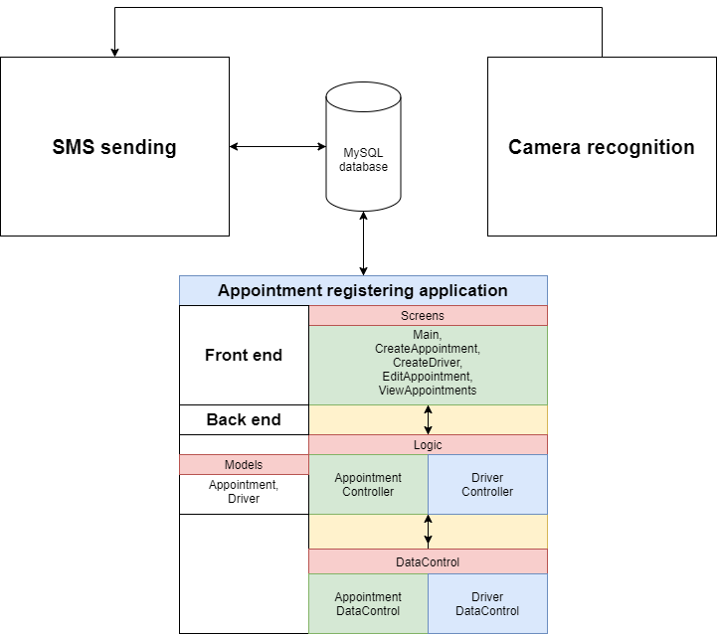

# Project organisation

## Stakeholders and team members

|  |  |  |  |
| --- | --- | --- | --- |
| **Name** | **Abbreviation** | **Role and functions** | **Availability** |
| Colin Lambrechts |  | Product Owner | Available for questions by email, as well as the end of each sprint. |
| Jan Willem Van Silfhout |  | Product Owner | Available for questions by email, as well as the end of each sprint. |
| Xuemei Pu |  | Agile Coach | Available every Wednesday and Friday for a progress meeting |
| Aleksandar Georgiev |  | Developer | Available every Wednesday and Friday for a progress meeting and also when team meetings take place throughout the week. |
| Aleksandar Popov |  | Developer | Available every Wednesday and Friday for a progress meeting and also when team meetings take place throughout the week. |
| Velimir Vukasinovic |  | Developer/Technical Leader | Available every Wednesday and Friday for a progress meeting and also when team meetings take place throughout the week. |
| Branimir Sandalski |  | Developer/Documentation | Available every Wednesday and Friday for a progress meeting and also when team meetings take place throughout the week. |
| Kaloyan Aleksiev |  | Developer/SCRUM master | Available every Wednesday and Friday for a progress meeting and also when team meetings take place throughout the week. |

## Communication

Due to COVID-19 measures, most of our communication is going to take place online. We will have regular meetings with our Project Leader every Wednesday and Friday on MS Teams. This is also where we will be demonstrating our progress to the Product Owners at the end of every sprint,

Apart from that, communication inside the team will also take place on Discord and WhatsApp multiple times throughout the week.

From time to time we are also going to meet in person with the team and the Project Leader at the Fontys R.10 building.

# Activities and time plan

## Phases of the project / Time plan & Milestones

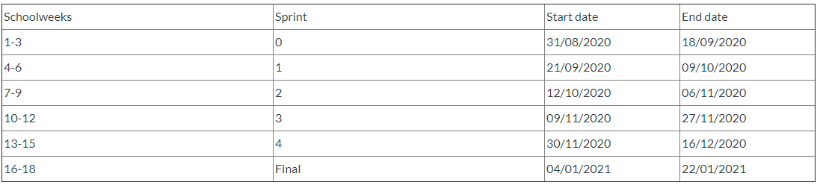

The work on the project will be broken down into 6 sprints, each with a duration of 3 weeks

After the end of each sprint, the team will discuss with Product Owners what will be worked on and delivered for the following one. Afterward, the milestones segment of this documentation will be updated accordingly.

**Milestones:**

* Sprint 0 – Initial Project Plan + Database Setup + Wireframes for the registration app
* Sprint 1 – Functioning customer registration application
* Sprint 2 – Improved version of the appointment register app + First version of the SMS-API
* Sprint 3 – Final version of the appointment register app + Prototype of the license plate software
* Sprint 4 – Final version of the SMS-API, Integration between the different components, License plate app working with a web camera and Deployed appointment register app
* Sprint 5 – Final version of everything, fully integrated components working as one whole system, Project hosted through AWS so that it’s fully accessible to the POs and Fully deployed system

# Testing strategy and configuration management

## Testing strategy

The main testing will take place after every major fully functional task we complete, for instance complete registration app. Apart from that, we may run unit tests on individual parts of the code depending on whether there is an unresolved issue or something we need to test right away.

Finally, when we are done with working on the project, we are going to test the functionality of the entire system.

## Test environment and required resources

Our team is going to make use of the CI/CD approach. We intend to keep track of our work and progress by using a GIT repository.

## Configuration management

We are going to to keep track of key versions of the product we are creating. Key version stands for a stable version that has a lot more features than the previous one. If something goes wrong during development, we would be able to get back to the previous stable version of the product.

# Risks

## Risk and mitigation

|  |  |  |  |  |
| --- | --- | --- | --- | --- |
| **Risk** | **Prevention activities** | **Mitigation activities** | **Severity** | **Probability** |
| 1. Miscommunication between the client and the software team | Preparing questions for the client in advance, also making sure that the team fully understands what the client wants, and if there is something unclear, they make sure to bring it up. | Schedule another meeting with client to discuss requirements one more time | High | Moderate |
| 1. Miscommunication between the agile coach and the software team | The team makes sure to attend and prepare for meetings, as well as pay attention to what is being discussed and asking if there is anything unclear | Write an email to Project Leader or discuss unclarity during a following meeting | Moderate | Moderate |
| 1. Team member unavailable for a meeting | Setting up a regular meeting schedule at specific times in advance | Group members will ensure that the missing person gets to learn everything that he has missed from the meeting. | Low | Moderate to High |

# Business Process Analysis



When a customer calls Sioux to make an appointment, the receptionist gets the client’s name, phone number and license plate, as well as the details for the appointment. Then the whole information is stored in the database.

When the customer arrives at the parking lot for the meeting, a camera scans their license plate and sends the information to an application which searches for an appointment with that plate and, if there is such, sends a SMS back to the customer which contains information about a parking spot allocated to them and the details of the appointment.