Animation on Canvas:

* In order to produce animation, we must use a technique -- named redrawing, which is where we repeatedly draw something, in this case the element, to the screen as often as possible.
* Before we do new draw we need to clear canvas context.clearRect(0,0, 400,400);
* Try to remove comments from line : **context.clearRect(0,0, 400,400);** Test it and compare

<head>

<meta charset="utf-8">

<title>canvas Example Move</title> </head>

<body onLoad="init();">

<canvas id="myCanvas" width="400" height="400" >

</canvas>

<script>

var context;

var x=10;

var y=10;

var dx=20;

var dy=20;

var myMove;

function init()

{

context= myCanvas.getContext('2d');

myMove=setInterval(draw,110);

}

function draw()

{

//context.clearRect(0,0, 400,400);

context.beginPath();

context.fillStyle="#FF00FF";

// Draws a circle of radius 10 at the coordinates 10,10 on the canvas

context.arc(x,y,10,0,2*Math.PI,true);

context.closePath();

context.fill();

x+=dx;

//y+=dy;

if (x>300) { clearInterval(myMove);}

}

</script></body>

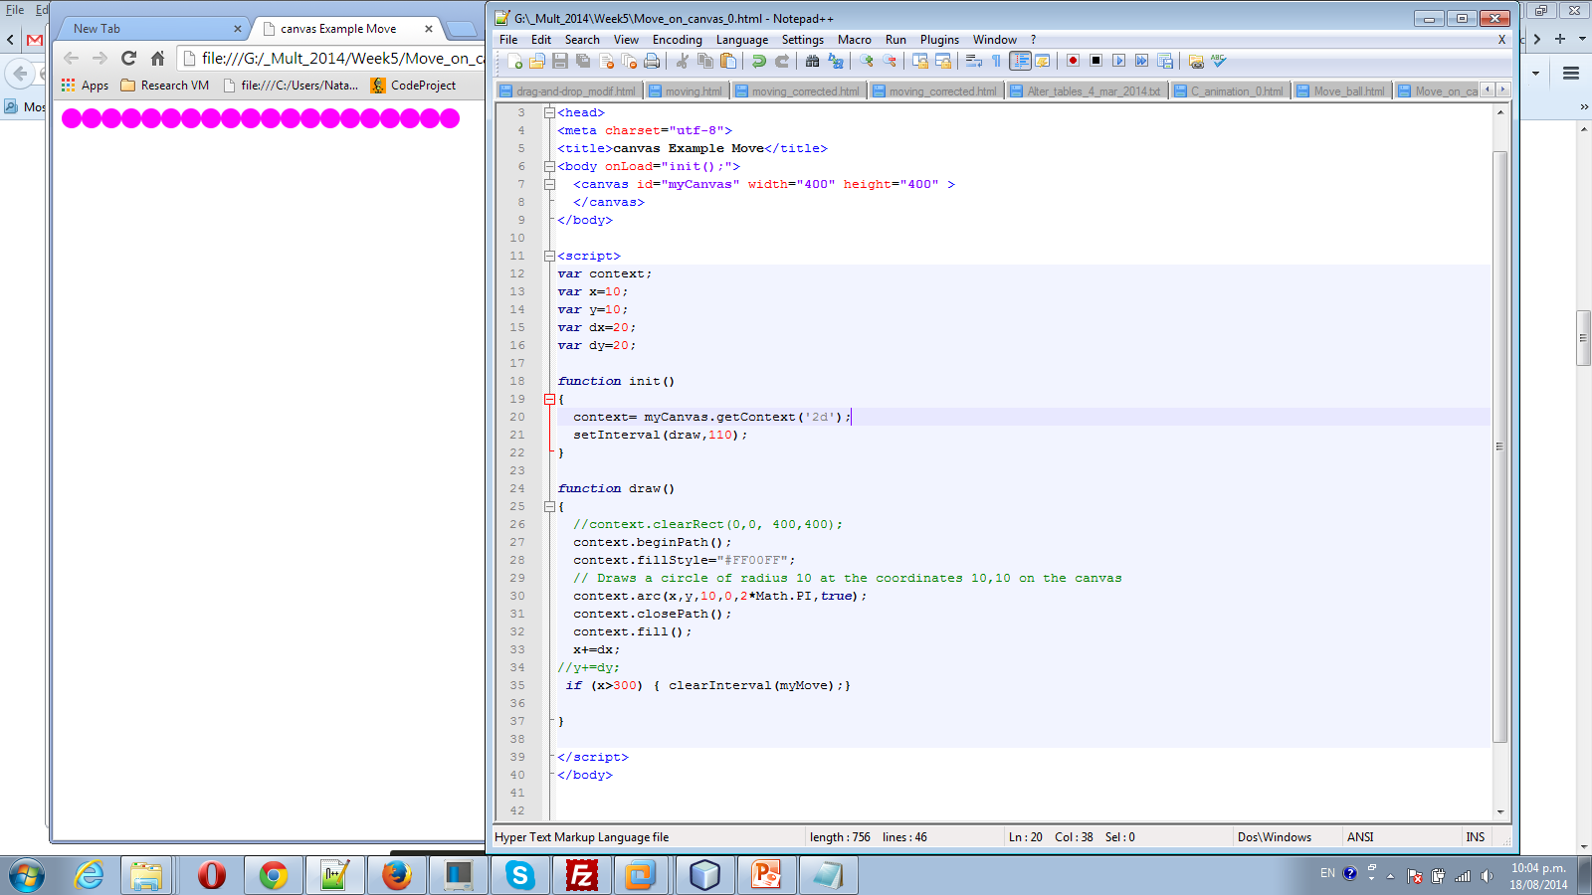

Animation Gradient

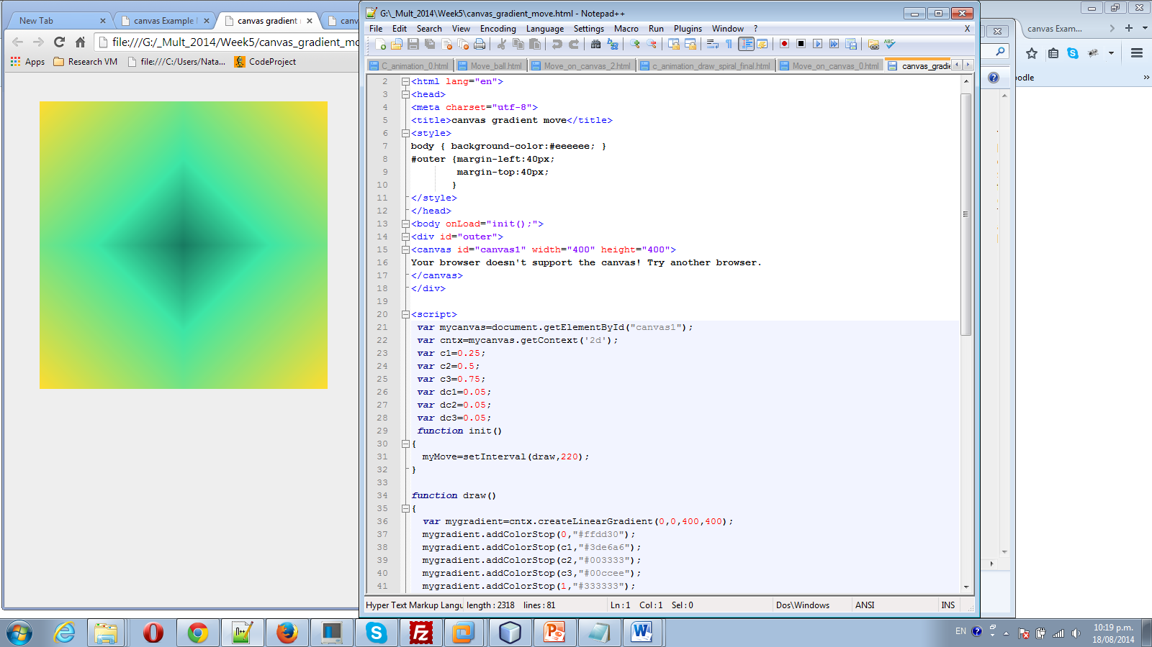

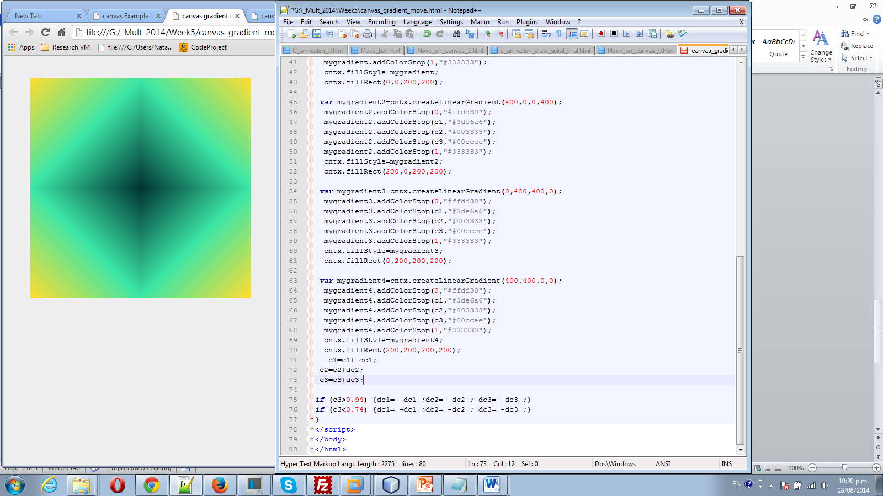

Challenge: try to animate change of colours as well

Draw spiral:

