**Canvas – Start Drawing**

1 Please create new html file and save it on your week5 folder. You will produce next drawing:

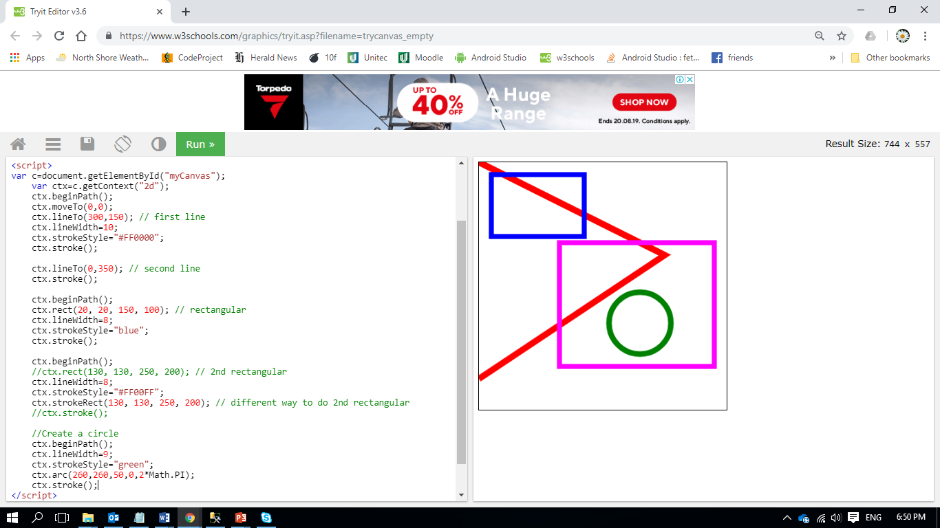

|  |  |
| --- | --- |
| We need to declare canvas element and draw a line <!doctype html>  <html lang="en">  <head>  <meta charset="utf-8">  <title>canvas Start</title>  <style>  body { background-color:#eeeeee; }  #outer {margin-left:40px;  margin-top:40px;  }  </style>  </head>  <body>  <div id="outer">  **<canvas id="myCanvas" width="400" height="400">**  Your browser doesn't support the canvas! Try another browser.  </canvas>  </div>  <script>  **var c=document.getElementById("myCanvas");**  **var ctx=c.getContext("2d");**  ctx.beginPath();  ctx.moveTo(0,0);  ctx.lineTo(300,150); // first line  //ctx.lineWidth=10;  //ctx.strokeStyle="#FF0000";  ctx.stroke();  </script>  </body>  </html> |  |
| 2 Please remove comments and test it, after add two more lines  ctx.lineTo(0, 350);  ctx.stroke();  and test it |  |
| 2 We want to draw a rectangular  With coordinates x=20 and y=20  Width =150 and height=100  ctx.rect(20, 20, 150, 100); ctx.stroke(); |  |
| To change rectangular colour update code and different stroke width:  ctx.beginPath();  ctx.rect(20, 20, 150, 100); // rectangular  ctx.lineWidth=8;  ctx.strokeStyle="blue";  ctx.stroke(); |  |
| To add other line, you can put next code after your first line drawning  ctx.lineTo(0,350);  ctx.stroke();  all code here: |  |
| 3 We can change colour   |  | | --- | | ctx.strokeStyle="green"; //or any hexadecimal colour number like #FF00FF |   Check on <http://www.w3schools.com/html/html_colors.asp>  For example add a second rectangular with colour #FF00FF :  ctx.beginPath();  ctx.rect(130, 130, 250, 200); // 2nd rectangular  ctx.lineWidth=8;  ctx.strokeStyle="#FF00FF";  ctx.stroke(); |  |
| **we can draw a rectangular in different way as well**  ctx.strokeStyle="#FF00FF";  ctx.strokeRect(130, 130, 250, 200); // different way to //do 2nd rectangular |  |
| To draw a circle:  ctx.beginPath();  ctx.lineWidth=9;  ctx.strokeStyle="green";  ctx.arc(260,260,50,0,2*Math.PI); //Create a circle  ctx.stroke(); |  |
|  |  |
| More information about circle here:  <http://www.w3schools.com/tags/canvas_arc.asp>  Center: arc(**100,75**,50,0*Math.PI,1.5*Math.PI)  Start angle: arc(100,75,50,**0**,1.5*Math.PI)  End angle: arc(100,75,50,0*Math.PI,**1.5*Math.PI**) |  |

All code:

