 | HTML5 Test  Semester 1, 2020  ISCG6420 IWD  Task 1
School of Computing & Information Technology | Date: Thursday, 4 June, 2020  Commencement Time: 11:30 AM  Time Allowed: 40 min  Marks: 34

Please fill in your name and your student ID.
Name: | student ID:
Instructions:

1. | This is semi-open book test. IWD demo website is closed.
2. | There are 3 tasks in this test. Each task is 40 min, You need to upload each task after 40 min. Submission will be allowed for 10 min only. You should complete all the tasks. You should attempt all the requirements.
3 | Please keep each test part in corresponded folder, for example Part_1. Please save all files during the test frequently. In the end of each 40 minutes, re-name your folder with your name (example: Part_1_Mary_popins), Zip this folder and submit.

Task 1 Canvas 34 MARKS

Instructions

1. Create an HTML file named canvas_head.html. Based on using HTML5, define a canvas element with the following properties:
Width: 600px
Height: 600px
Border: Blue, solid, 10px.
Background: #FFFF80
(2 marks)

2. Write a java-script function to draw a square with following properties:
Size: 460x180
Position x=70 and y=400
Fill colour: DarkCyan;
The square should be representing a body in the canvas.
(2 marks)

3. Write a java-script function to draw one semi-circle with the following properties:
Colour: Gold;
Radius: 225
Position x=300 and y=400
Border: 4px, black
The semi-circle represents a head. Please see an example in the next page.
(3 marks)

4. Write a java-script function(s) to draw two green semi-circles (hands of the person) with the following properties:
fill colour: LawnGreen.
Border: 4px, #663300
Radius: 50
Position for one x=70 and y=450, a second x=530 and y =450
(4 marks)

5. Write a java-script function to draw a red semi-circle with the following properties:
Radius: 22
Border: 13px, stroke Style: "red".
The semi-circle represents a mouth.
(3 marks)

6. Write a java-script function(s) to draw two blue circles (eyes of the person) with the following properties:
fill colour: PowderBlue.
Border: 4px, #663300
Radius: 40
Position for one x=250 and y=240, a second x=350 and y =240
(3 marks)
blue
Red,
Background colour: Linen
Gold
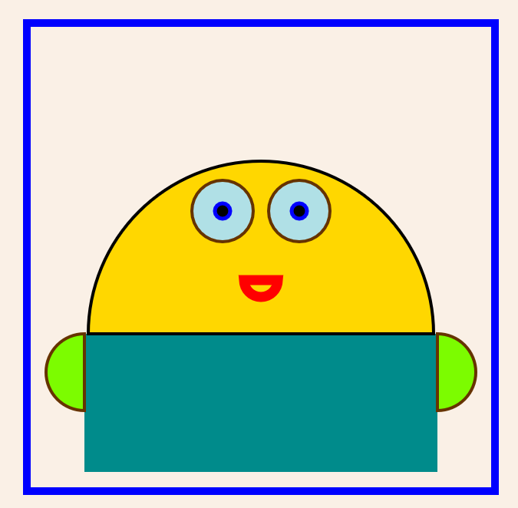
Blue,
border : #663300
Black, border- Blue
DarkCyan
LawnGreen
border: #663300
Mouth movement
Radios change from 22 to 52

10. Write a java-script function(s) to draw two black circles (middle eyes of the person) with the following properties:
fill colour: Black.
Border: 5px, blue
Radius: 10
With corresponded position in the middle of blue eyes.
(3 marks)

11. Write a java-script function to move mouth, with radius change from 22px to 52px. Set interval (timer) for every 200 milliseconds for movement. Remember to clear the area of previously drawn mouth-semi-circle.
(12 marks)

