 | HTML5 Test  Semester 1, 2020  ISCG6420 IWD  Part 3
School of Computing & Information Technology | Date: Thursday, 4 June, 2020  Commencement Time: 11:30 AM  Time Allowed: 40 min  Marks: 33

Please fill in your name and your student ID.
Name: | student ID:

Instructions:

1. | This is semi-open book test. IWD demo website is closed.
2. | There are 3 tasks in this test. Each task is 40 min, You need to upload each task after 40 min. Submission will be allowed for 10 min only. You should complete all the tasks. You should attempt all the requirements.
3 | Please keep each test part in corresponded folder, for example Part_1. Please save all files during the test frequently. In the end of each 40 minutes, re-name your folder with your name (example: Part_1_Mary_popins), Zip this folder and submit.

Task | Topic | Possible Marks | Mark Awarded
Task 3 | Dynamically creating elements using DOM | 33

Task 3 Dynamically creating elements 33 MARKS

Instructions

Using a file named display_staff.html.
On button click it should invoke a Java-script function display_staff(). This function should dynamically create next four staff member images within a table. Each dynamically created table cell must have a staff name and a staff image. If user click on staff image- system display a message “I am [Staff Name]”. Please refer to the images below.
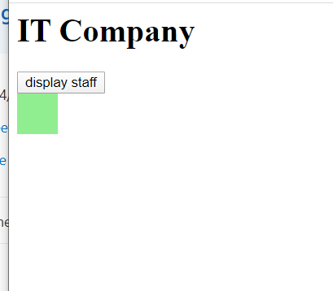 | 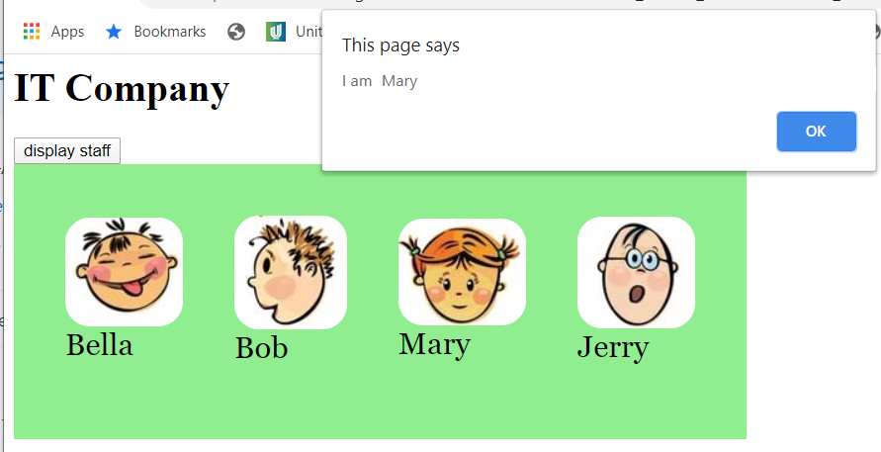  User click on “Mary” image

- You will need to define object “staff” with two properties: staffName, image.
(6 marks)
- Declare staffArray and create four instances of staff objects with next properties.
Staff Name | Staff image
Bella | bella.jpg
Bob | bob.jpg
Mary | mary.jpg
Jerry | jerry.jpg
(4 marks)

- You will need to write Java-Script function display_staff(). The user can click on image and message will be displayed. The text of the message is a string which state “I am “ and image name. Please see example below.
(23 marks)
Example - user click on “Bob” image:
