Avira

Your Mercedes-Benz dealer



Introduction

Web application topic

1. What is the age range of your target audience? - Usually our audience variety is from 18 to 100 with driver license;
2. Will your site appeal to more women or men? What is the mix? - Our magazine is for both genders;
3. Which country do your visitors live in? - Our visitors live in Los Angeles;
4. Do they live in urban or rural areas? - Some of our customers live in rural areas;
5. What is the average income of visitors? - The average income of our customers is 10k per month;
6. What level of education do they have? - The average customer has a master’s degree in Fontys;
7. What is their marital or family status? – Usually people married with children;
8. What is their occupation? - Our customers are businessmen’s;
9. How many hours do they work per week? – At least 56 hours per week;
10. How often do they use the web? - Our customers are using web every day;
11. What kind of device do they use to access the web? - They can use laptop, smartphone, tv, tablet;
12. What is the size of the company or relevant department? - Our company is huge, and we have departments in almost all over the word;
13. What is the position of people in the company who visit your site? - The average visitor of our site is person that has a well-paid and high-status job;
14. Will visitors be using the site for themselves or for someone else? - The visitors will use the site for themselves;
15. How large is the budget they control? - The budget is around 1 billion $;

Target Audience

1. Why people visit our website? – The people visit our website because we sell cars cheaper than our competitors;
2. What your visitors trying to achieve? – Our visitors are trying to achieve more comfort in their life and our cars will help them in it;
3. What information your visitors need? – Our visitors need the name of the car, the color of the interior and the price of the car;
4. How often people will visit your site? - We think one person will visit our website approximately 3 times per year;

Sitemap

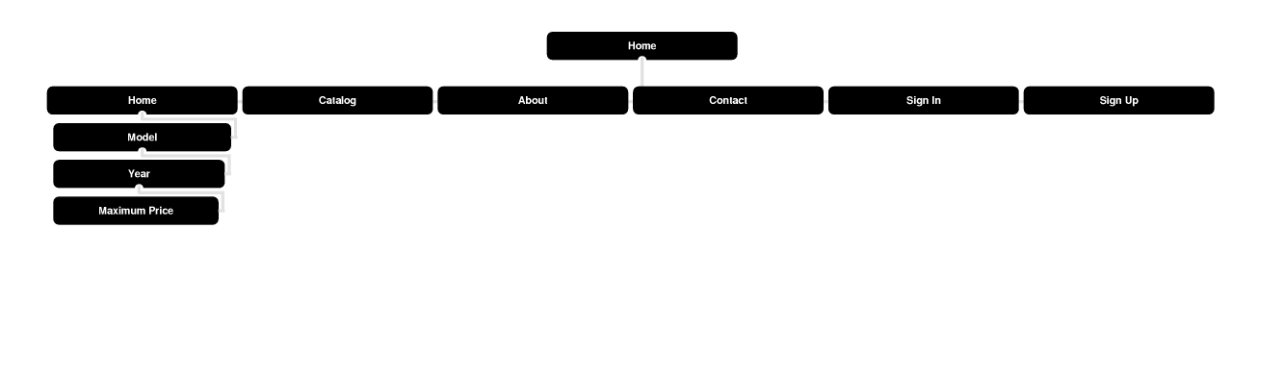

Wireframes

Home page

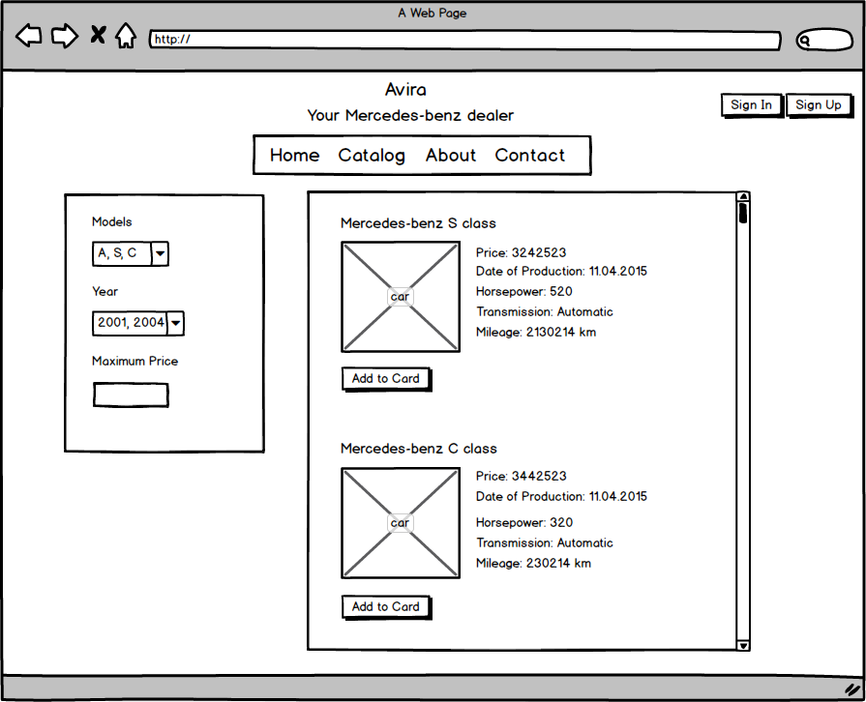

Catalog page

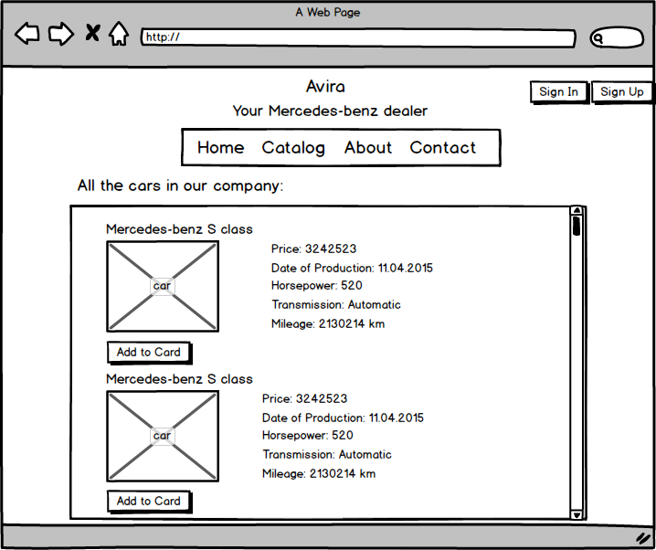

About page

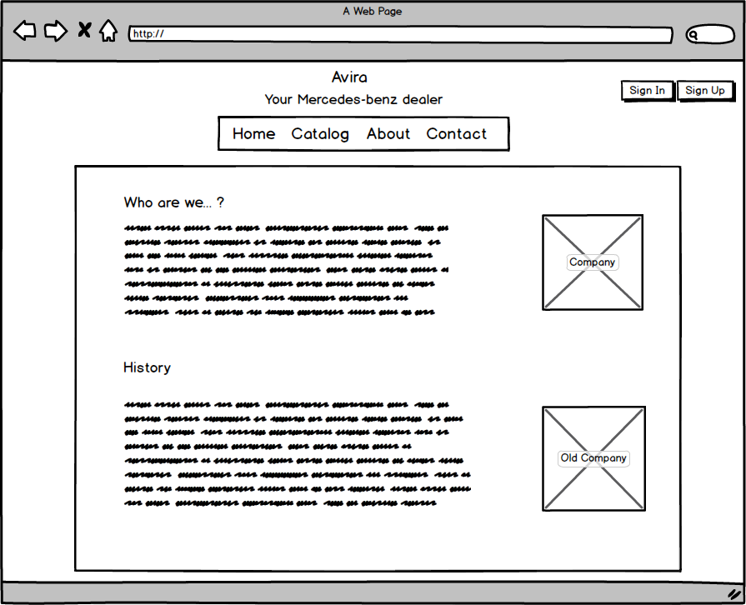

Contact page

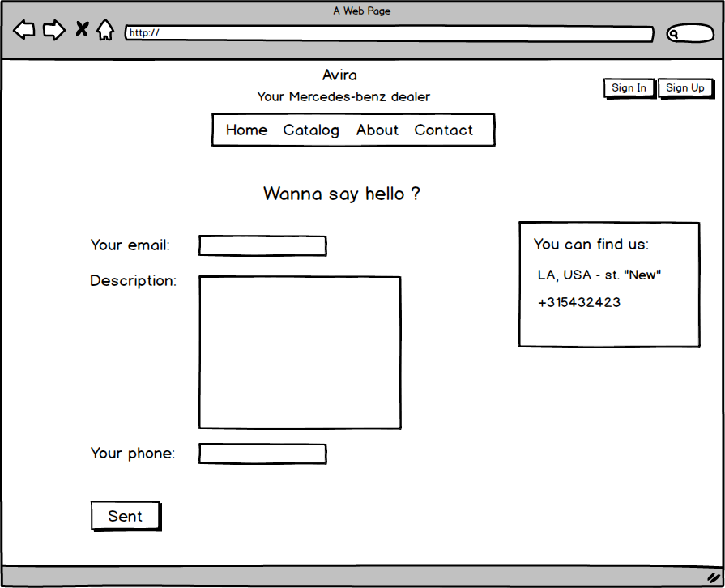

Visual Design

