Spelling Correction for Search Engine Queries

# Kalp Patel

*Software Engineering, DTU 2K20/SE/66*

kalppankajkumarpatel_ se20b158@dtu.ac.in

# 

*Abstract*— Search Engines are the most important and used way to access information from the internet. However Statistics, surveys and recent studies show that Spelling mistakes are extremely common occurrence when searching for queries using these systems. Often times when user misspells the query, the results are uncomprehensive or inconclusive. In this work, we discuss the integration of a spelling correction component into tumba!, An algorithm is presented that attempts to select the best choice among all possible corrections for a misspelled term, and discuss its implementation based on a ternary search tree data structure.

1. INTRODUCTION

Millions of people use the Web to find needed information, and search engines now answer tens of millions of questions every day. However, with the increasing popularity of these tools, spelling errors are also becoming more common. Between 10 and 12 percent of the query terms typed into Web search engines are incorrectly typed. A large number of Web pages also contain misspellings. Web search is therefore the task of finding information in the area of ​​texts with incorrect questions. Although there are misspelled words in queries, search engines often find a few identical documents - those that contain spelling errors themselves. However, the leading and “authoritative” pages are often missed, as they may only contain well-written forms. A collaborative spelling center that informs users of potential spellings and reveals correct corrections to their queries can bring improvements in accuracy, memory, and user effort. Google is the first search engine to provide this facility. One of the requirements set by the Web environment for a spell checker is that it should be able to select the best possible replacement for a misspelled word, instead of providing a list of options as spelling check tools. Users of Web search engines have become increasingly uninvolved in simulation questions, and we feel that their uploading through the interactive editing process will not be well received. It is therefore important to make the right choice among all possible remedies independently. This project introduces the construction of the tumba spelling correction section! , Portuguese Web search engine. E-tumba! we test the question with misspellings while the results are obtained. When errors are found, we provide a seggested link to the new "possible" question, as well as the original search results.

TERMS USED

Information Retrieval (IR) concerns with the problem of providing relevant documents in response to a user’s query . The most commonly used IR tools are Web search engines, which have become a fact of life for most Internet users. Search engines use software robots to survey the Web, retrieving and indexing HTML documents. Queries are checked against the keyword indexes, and the best matches are returned. Precision and Recall are the most popular metrics in evaluating IR systems. Precision is the percentage of retrieved documents that the searcher is actually interested on. Recall, on the other hand, is the percentage of relevant documents retrieved from the set of all documents, this way referring to how much information is retrieved by the search. The ultimate goal of an information retrieval system is to achieve recall with high precision. Spelling has constantly been an issue in pc-based totally text equipment. two important hassle test be identiﬁed on this context: mistakes detection, that is the process of ﬁnding mis-spelled phrases, and blunders correction, that is the method of suggesting accurate words to a misspelled one. despite the fact that other approaches exist, maximum spelling checking equipment are based totally on a dictionary which includes a set of phrases that are considered to be correct. The hassle of spelling correction may be deﬁned abstractly as follows: Given analphabet σ, a dictionary such as strings in σ∗and a string s, in which s/∈D ands ∈σ∗, ﬁnd the word w∈D that is maximum probably to have been erroneously input as Spelling mistakes may be divided into wide classes: typographic errors, which arise due to the fact the typist accidentally presses the incorrect key, presses keys, presses the keys inside the wrong order, and so forth; and phonetic errors, in which the misspelling is suggested the same as the meant word but the spelling is incorrect. Phonetic mistakes are tougher to accurate because they distort the phrase more than a single insertion, deletion or substitution. In this example, we want so one can key in some thing that sounds just like the misspelled phrase (a “phonetic code”) and carry out a “fuzzy” look for close fits.

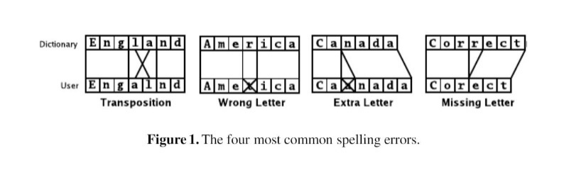

METHODOLOGY

In the paper, they use a ternary search tree (TST) data structure for storing the dictionary in memory. TSTs are a type of trie that is limited to three children per node .Trie is the common deﬁnition for a tree storing strings, in which there is one node for every common preﬁx and the strings are stored in extra leaf nodes. TSTs have been successfully used for several years in searching dictionaries. Search times in this structure are O(log(n) + k) in the worst case, where n is the number of strings in the tree and k is the length of the string being searched for. In a detailed analysis of various implementations of trie structures, the authors concluded that “Ternary Search Tries are an effective data structure from the information theoretic point of view since a search costs typically about log(n)comparisons on real life textual data. [...] This justiﬁes using ternary search tries as a method of choice for managing textual data” .Figure 2 illustrates a TST. The structure stores key-value pairs, where keys are the words and values are integers corresponding to the word frequency. As we can see, each node of the tree stores one letter and has three children. A search compares the current character in the search string with the character at the node. If the search character comes lexically ﬁrst, the search goes to the left child; if the search character comes after, the search goes to the right child. When the search character is equal, the search goes to the middle child, and proceeds to the next character in the search string. TSTs combine the time efﬁciency of tries with the space efﬁciency of binary search trees. They are faster than hashing for many typical search problems, and support abroad range of useful operations, like ﬁnding all keys having a given preﬁx, sufﬁx, or inﬁx, or ﬁnding those keys that closely match a given pattern node.

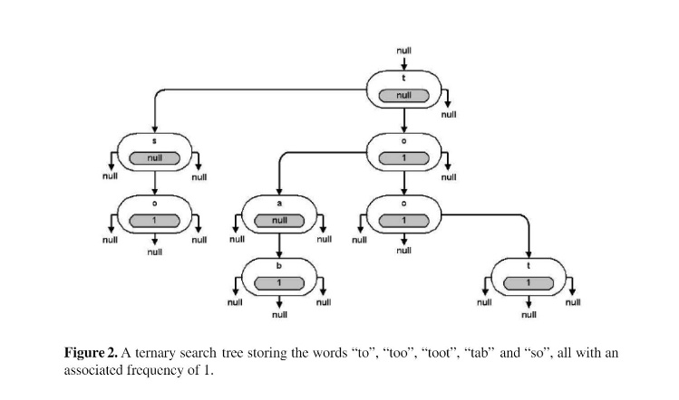

CONCLUSION

This paper presented the integration of a spelling correction component into tumba!, a

Portuguese community Web search engine. The key challenge in this work was deter-

mining how to pick the most appropriate spelling correction for a mistyped query from

a number of possible candidates

This paper presented the integration of a spelling correction component into tumba!, a

Portuguese community Web search engine. The key challenge in this work was deter-

mining how to pick the most appropriate spelling correction for a mistyped query from

a number of possible candidates

The authors presented the integration of a spelling correction component into tumba! , a Portuguese community Web search engine. The key challenge in this work was deter-mining how to pick the most appropriate spelling correction for a mistyped query from a number of possible candidates.

The spelling checker uses a ternary search tree data structure for storing the dictio-

nary. As source data, we used a large textual corpus of from two popular Portuguese

newspapers. The evaluation showed that our system gives results of acceptable quality,

and that integrating spelling correction in Web search tools can be beneﬁcial.

The spelling checker uses a ternary search tree data structure for storing the dictionary. As source data, they used a large textual cory of popular Portuguese newspapers. The evaluation showed that their system gives results of acceptable quality , and that integrating spelling correction in Web search tools can be beneﬁcial.

REFRENCES

1. A. Arasu, J. Cho, H. Garcia-Molina, A. Paepcke, and S. Raghavan. Searching the web. ACMTransactions on Internet Technology, 1(1):2–43, 2001.

2. R. Baeza-Yates and B. Ribeiro-Neto. Modern Information Retrieval. ACM Press, 1999.

3. J. Bentley and R. Sedgewick. Fast algorithms for sorting and searching strings. In Proceed-ings of SODA-97, the 8th ACM-SIAM Symposium on Discrete Algorithms, 1997.

4. J. Bentley and R. Sedgewick. Ternary search trees. Dr. Dobb’s Journal, 23(4):20–25, April1998

ACKNOWLEGMENT

In performing our study based Research project, we had to take the help and guideline of some respected persons, who deserve our greatest gratitude. The completion of this assignment gives us much pleasure. We would like to show our gratitude Dr. Divyashikha Sethia, Supervisor for our Innovative Project. Giving us a good guideline for report throughout numerous consultations. We would also like to extend our deepest gratitude to all those who have directly and indirectly guided us in writing this Summary paper. Many people, including our classmates and have made valuable comment suggestions on this proposal which gave us an inspiration to improve our Summary paper. We thank all the people for their help directly and indirectly to complete this paper.

1. A. Arasu, J. Cho, H. Garcia-Molina, A. Paepcke, and S. Raghavan. Searching the web. ACM

Transactions on Internet Technology, 1(1):2–43, 2001.

2. R. Baeza-Yates and B. Ribeiro-Neto. Modern Information Retrieval. ACM Press, 1999.

3. J. Bentley and R. Sedgewick. Fast algorithms for sorting and searching strings. In Proceed-

ings of SODA-97, the 8th ACM-SIAM Symposium on Discrete Algorithms, 1997.

4. J. Bentley and R. Sedgewick. Ternary search trees. Dr. Dobb’s Journal, 23(4):20–25, April

1998