Header

**Banner 1:**

Certera SSL

Most Trusted Certificate Authority

Secure your website and online transactions by enabling the strongest 256-bit encryption offered by Certera. Turn your visitors into Customers.

* 256-Bit Strong Encryption
* Free Site Seal
* 99.99% Browser Compatibility
* Unlimited Server License

**Buy Now**

About Us Section

# **Branded SSL Provider**

## **Get Access to Globally Accepted & Recognized SSL Certificates to Secure Your Website**

CerteraSSL.com offers a range of SSL certificates for your business. With the widest selection of options from globally respected certificate authorities, you get the best options for SSL certificates according to your need for all types and sized websites.

CerteraSSL.com, made up of professionals like you, works to keep web connections secure and brand reputation clean. Committed to providing digital security for any size website, you get industry expert support with great pricing.

Product Grid Section (Need to create brand wise product grid like below screen shots and Certera, Comodo, Sectigo, DigiCert etc… are SSL brands)

**CERTERA SSL CERTIFICATES**

Looking for a powerful yet affordable SSL Certificate solution to protect your website, Certera SSL is an ultimate solution. From security of a single domain to multiple domains and sub-domains, Certera has all range of SSL Certificates. Certera SSL Certificates comes with 256-bit encryption, Site Seal, Padlock and HTTPS in URL, unlimited server license and more.

**Comodo SSL Certificates**

Comodo is the most trusted and cost-effective SSL Certificate Authority offering DV SSL, OV SSL, EV SSL, Multi-Domain SSL, and Wildcard SSL certs. Comodo certificates comes with powerful 256-bit encryption strength and 2048-bit signature strength to secure to secure single website, multiple domains, and sub-domains under same SSL.

**Sectigo SSL Certificates**

Sectigo is a globally recognized SSL Certificate Authority that offers the highest level of encryption and trust to secure websites in minutes. Whether it’s security of single domain, multiple domains, multiple sub-domains, email/document, software/app, Sectigo’s SSL certificates are top in the industry.

**DigiCert SSL Certificates**

DigiCert SSL certificates offer superior security with up to 256-bit encryption and a range of validation levels as Organization Validation and Extended Validation. DigiCert certificates come with built-in unlimited server licenses, and a free certificate management tool, a large amount of warranty, desktop/mobile device compatibility and multi-language support.

**RapidSSL Certificates**

RapidSSL is one of a popular SSL Certificate Authority which offers the basic domain validation solution to your website and sub-domains. RapidSSL comes with two different SSL, one for single domain and other one is for multiple sub-domains. With RapidSSL certificates you will get strong 256-bit encryption, free site seal, unlimited server license, and more.

**GeoTrust SSL Certificates**

GeoTrust SSL Certificates are highly recommended to secure business websites at affordable pricing. GeoTrust comes with a range of SSL certificates, including Domain Validation, Organization Certificates, Extended Validation, Multi-Domain SSL, and Wildcard SSL. All GeoTrust certificates come with the strongest 256-bit encryption and 2048-bit signature.

**Thawte SSL Certificates**

Thawte is a powerful SSL certificate Authority recommended to secure small to medium level startups and business websites. It offers a range of SSL certificates including DV SSL, OV SSL, Wildcard SSL, EV SSL and Multi-Domain SSL. You will get the strongest 256-bit encryption, unlimited server license and Free site seal with a Thawte SSL Certificate.

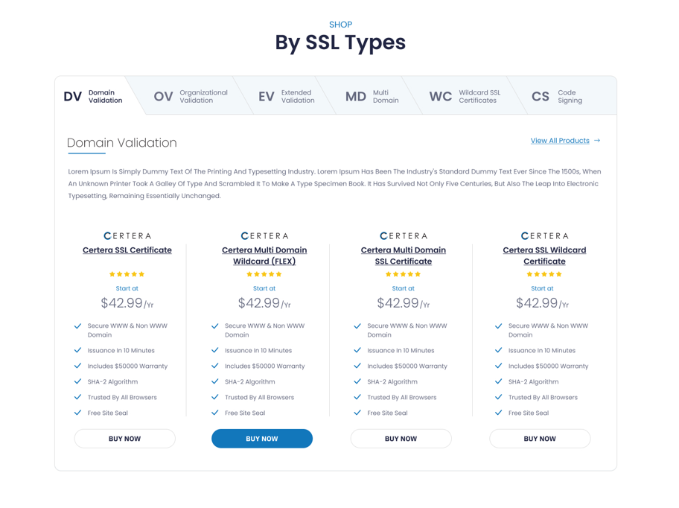

Services Section (You can use dummy text)

**Our Services**

## **We Provide Best SSL Solution**???

Display IT Sevices

CTA Section

## **Need to design Support CTA with dummy text**