

NEET (UG) MARKS

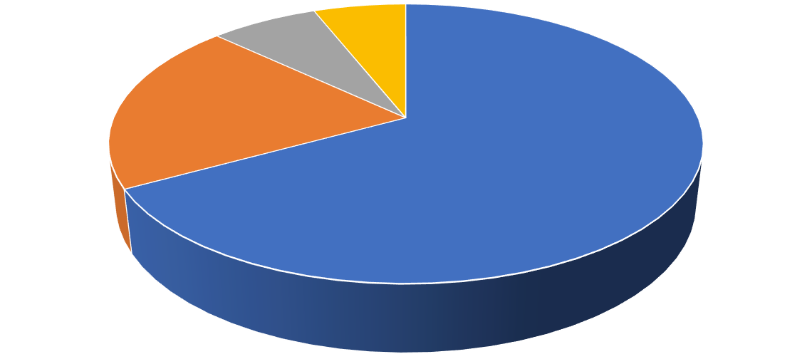

Standard 11/12

general Stream

,

67

%

Standard 11/12

Science Stream

,

20

%

Diploma

,

%

7

Others

,

6

%

**what students choose after 10th standard?**

Standard 11/12 general Stream

Standard 11/12 Science Stream

Diploma

Others



15000

18000

21500

24000

26000

30000

34000

38000

43000

58000

25000

30000

36000

43000

50000

57000

63000

70000

80000

90000

20000

35000

42000

55000

65000

80000

95000

110000

130000

150000

0

50000

100000

150000

200000

250000

300000

350000

1

2

3

4

5

6

7

8

9

10

SALARY PER MONTH(IN RS.)

EXPERIENCE

Chart Title

BCA-Programmer

BCA-NON PROGRAMMER

MCA

NEET (UG) Marks