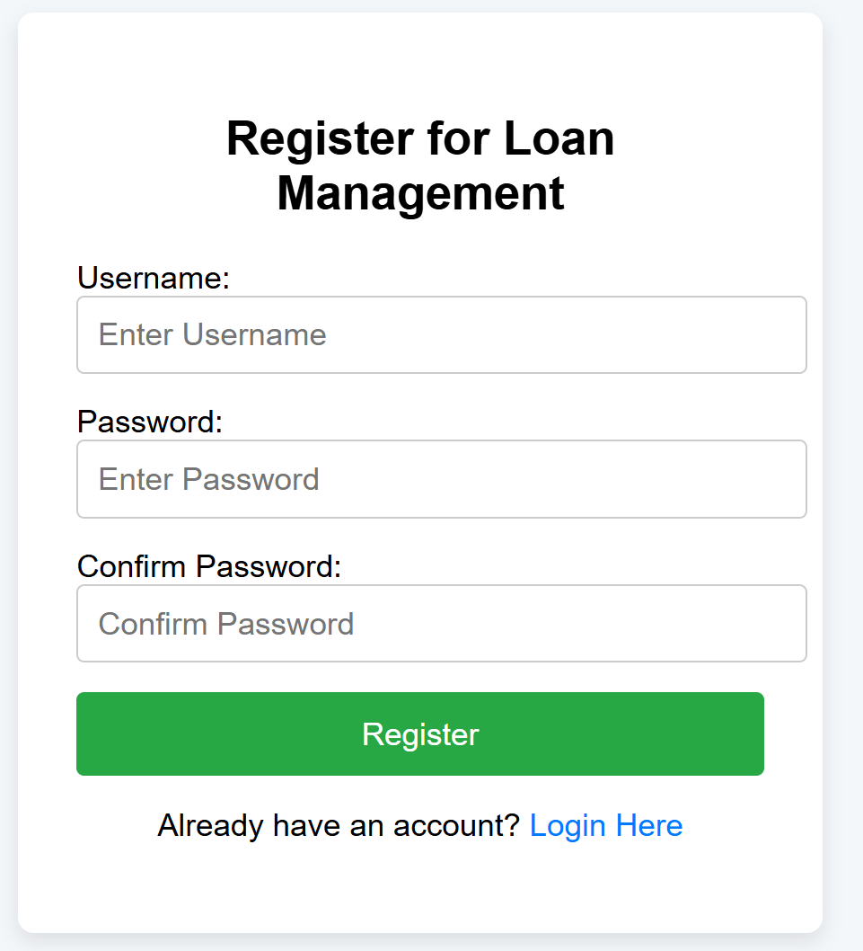
Sr. | Screen Element | Input Type | O/M | 1/N | Description
1 | Username | Textbox | M | 1 | Username field should be editable and accept the Username.
2 | Email | Textbox | M | 1 | Email field should be editable and accept the email with proper format.
3 | Password | Password | M | 1 | Password field should be editable and accept the password and display as star or dot.
4 | Confirm password | Password | M | 1 | Confirm Password field should be editable and accept the password and display as star or dot.
6 | Register | Button | ------ | ------ | Register is a button for store the entered data into database.
7 | Login Here | Button | ------ | ------ | Login Here is a button to change the screen from register to login
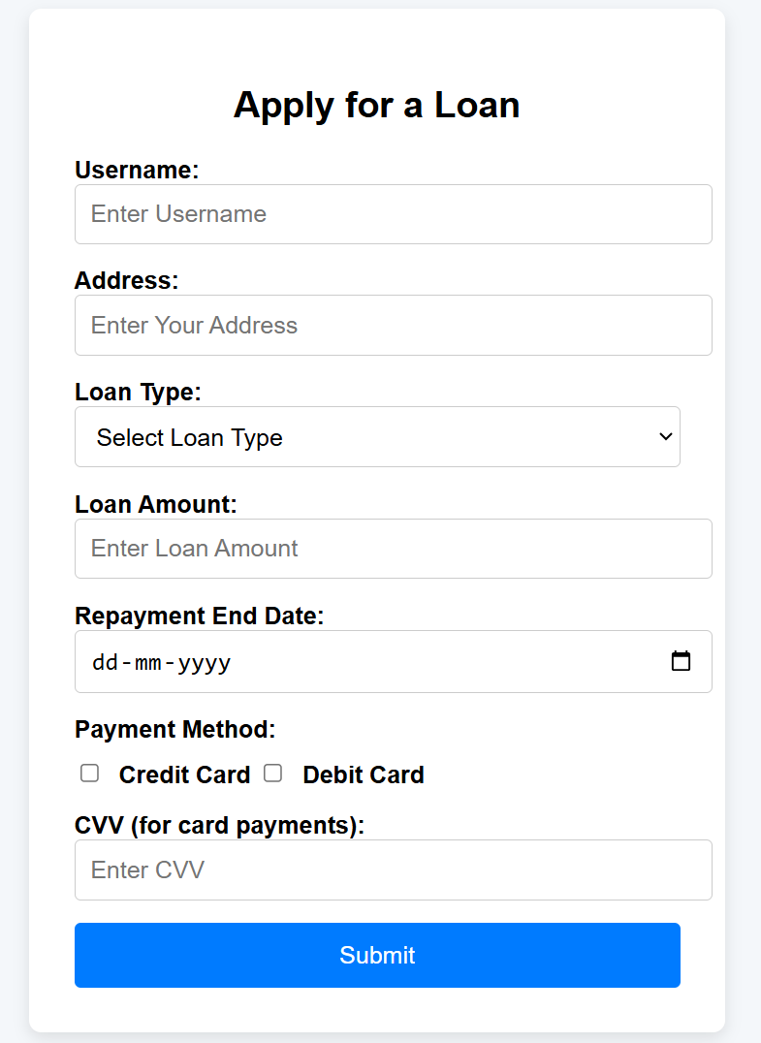
Sr. | Screen Element | Input Type | O/M | 1/N | Description
1 | Username | Textbox | M | 1 | Username field should be editable and accept the Username.
2 | Address | Textbox | M | 1 | Address field should be editable and accept the Address.
3 | Loan Type | Dropdown | M | 1 | Loan Type field should be editable and allow the user to select from options.
4 | Loan Amount | Number Input | M | 1 | Loan Amount field should be editable and accept numeric values for the loan amount.
5 | Repayment End Date | Checkbox Group | M | 1 | Repayment End Date field should be editable and allow the user to select a date.
6 | Payment Method | Checkbox Group | O | 1 | A group of checkboxes to select payment methods.
7 | CVV | Password | M | 1 | CVV field should be editable and accept the 3 or 4 digit CVV.
8 | Submit | Button | ------ | ------ | Submit button to send the loan application data to the backend.
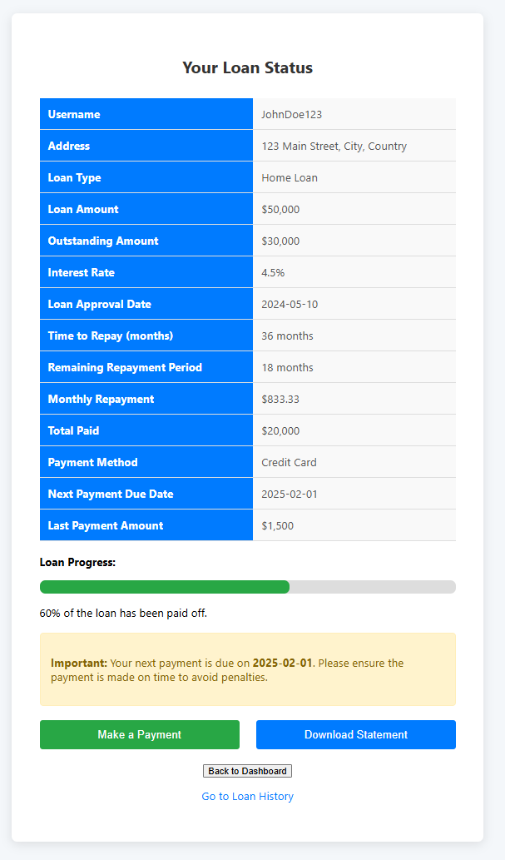

Sr. | Screen Element | Input Type | O/M | 1/N | Description
1 | Username | Textbox | M | 1 | Displays the username of the user.
2 | Address | Textbox | M | 1 | Displays the address of the user.
3 | Loan Type | Text | M | 1 | Displays the type of loan.
4 | Loan Amount | Text | M | 1 | Displays the total loan amount granted to the user.
5 | Outstanding Amount | Text | M | 1 | Displays the remaining loan balance that is yet to be paid.
6 | Interest Rate | Text | M | 1 | Displays the interest rate applied to the loan.
7 | Loan Approval Date | Text | M | 1 | Displays the date on which the loan was approved.
8 | Time to Repay | Text | M | 1 | Displays the total repayment time in months.
9 | Remaining Repayment Period | Text | M | 1 | Displays the remaining repayment period in months.
10 | Monthly Repayment | Text | M | 1 | Displays the amount that the user needs to repay monthly.
11 | Total Paid | Text | M | 1 | Displays the total amount the user has already paid toward the loan.
12 | Payment Method | Text | M | 1 | Displays the payment method used by the user.
13 | Next Payment Due Date | Date | M | 1 | Displays the next due date for the loan repayment.
14 | Last Payment Amount | Text | M | 1 | Displays the amount of the last payment made by the user.
15 | Loan Progress Bar | Progress Bar | M | 1 | Displays the loan repayment progress visually.
16 | Notifications | Text | O | 1 | Displays important notifications related to the loan status.
17 | Make a Payment | Button | ------ | ------ | Button to redirect the user to a payment gateway.
18 | Download Statement | Button | ------ | ------ | Button to allow the user to download the loan statement.
19 | Back to Dashboard | Button | ------ | ------ | Button to return the user to the dashboard or previous page.
20 | Go to Loan History | Link | ------ | ------ | Link to navigate to the loan history page.

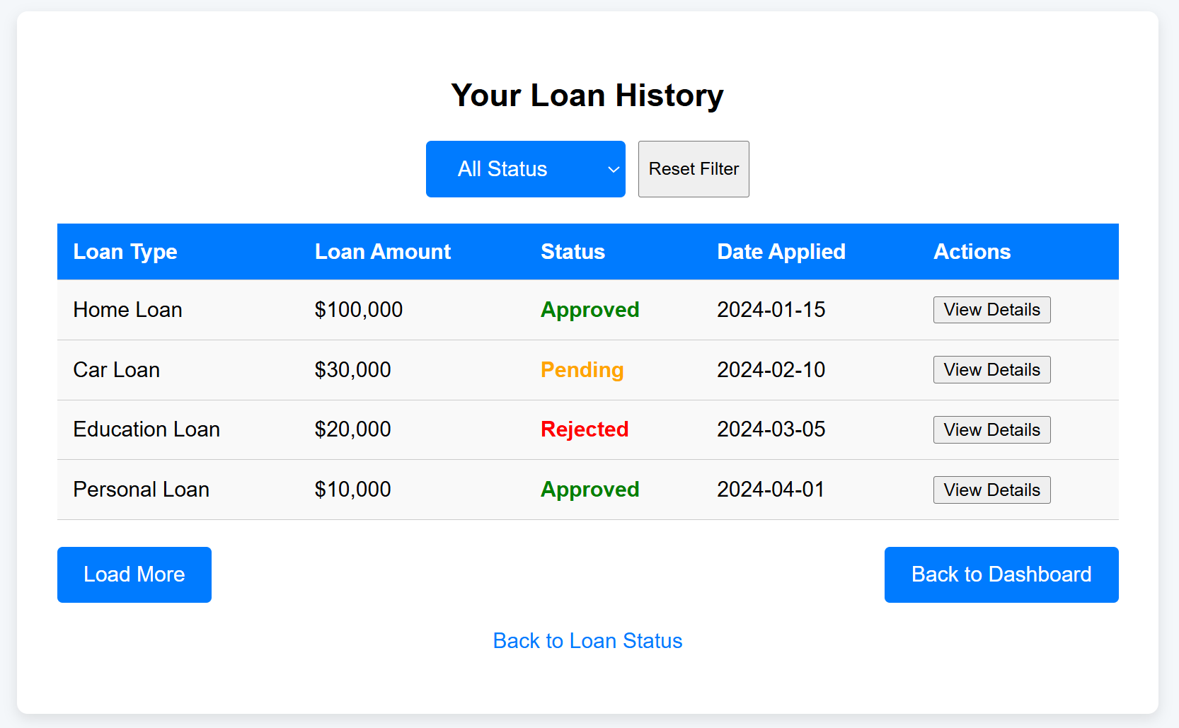
Sr. | Screen Element | Input Type | O/M | 1/N | Description
1 | Loan Type | Text | M | 1 | Displays the type of loan.
2 | Loan Amount | Text | M | 1 | Displays the loan amount applied for each loan.
3 | Status | Text | M | 1 | Displays the current status of the loan.
4 | Date Applied | Date | M | 1 | Displays the date the loan application was submitted.
5 | Actions | Button | ------ | ------ | Button to view the loan details.
6 | Filter Dropdown | Dropdown | ------ | 1 | Allows the user to filter loans by status
7 | Reset Filter Button | Button | ------ | 1 | Button to reset the status filter to show all loans.
8 | Loan More Button | Button | ------ | 1 | Button to load more loan history entries.
9 | Back to Dashboard Button | Button | ------ | 1 | Button to navigate the user back to the dashboard page.
10 | Back to Loan Link | Link | ------ | 1 | Link to go back to the Loan Status page.

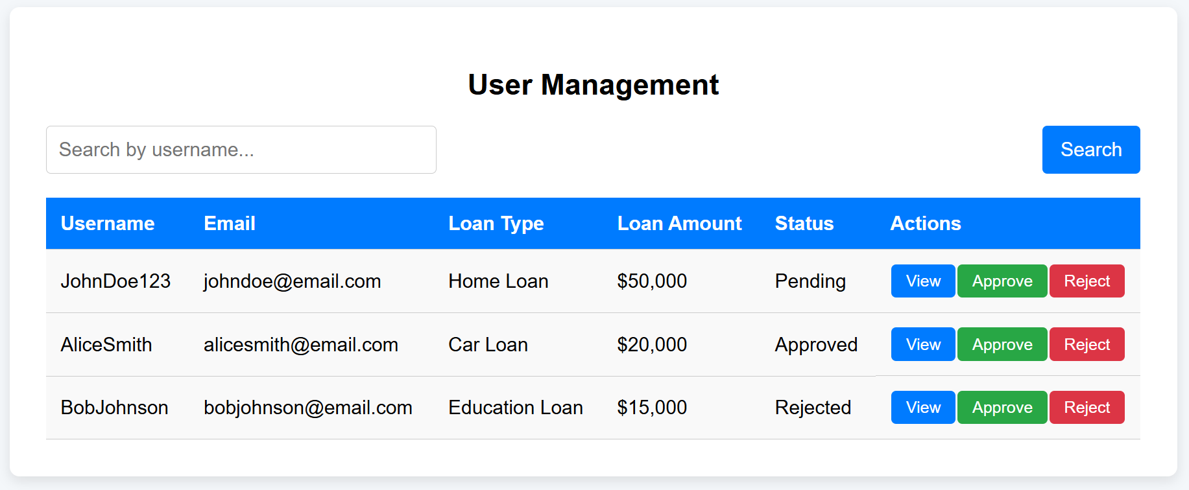
Sr. | Screen Element | Input Type | O/M | 1/N | Description
1 | Username | Text | M | 1 | Displays the username of the user in each row.
2 | Email | Text | M | 1 | Displays the email address of the user.
3 | Loan Type | Text | M | 1 | Displays the type of loan the user has applied for.
4 | Loan Amount | Text | M | 1 | Displays the loan amount the user has applied for.
5 | Status | Text | M | 1 | Displays the current loan status.
6 | Actions | Buttons | M | N | Provides buttons for viewing details, approving, and rejecting loans.
7 | View Button | Button | ------ | 1 | A button to view more details of the user's loan.
8 | Approve Button | Button | ------ | 1 | A button to approve the user's loan application.
9 | Reject Button | Button | ------ | 1 | A button to reject the user's loan application.
10 | Search Bar | Text Input + Button | ------ | 1 | Allows searching for users by username.
11 | Search Button | Button | ------ | 1 | A button that triggers the search functionality.

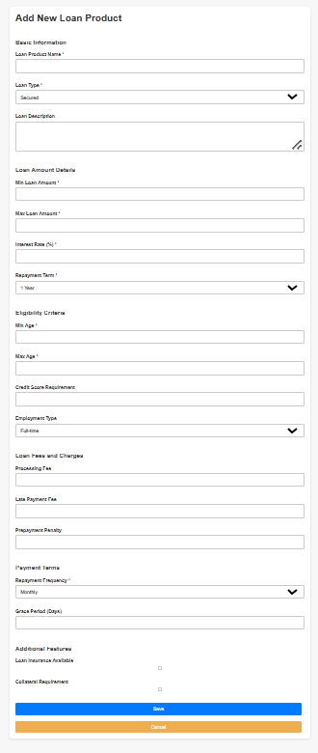

Sr. | Screen Element | Input Type | O/M | 1/N | Description
1 | Loan Product Name | Textbox | M | 1 | Displays the name of the loan product.
2 | Loan Type | Dropdown | M | 1 | Displays the type of loan.
3 | Loan Description | Textarea | O | 1 | Provides a description of the loan product.
4 | Min Loan Amount | Number Input | M | 1 | Specifies the minimum loan amount.
5 | Max Loan Amount | Number Input | M | 1 | Specifies the maximum loan amount.
6 | Interest Rate | Number Input | M | 1 | Specifies the interest rate for the loan.
7 | Repayment Term | Dropdown | M | 1 | Specifies the repayment term for the loan.
8 | Min Age | Number Input | M | 1 | Specifies the minimum age for eligibility.
9 | Max Age | Number Input | M | 1 | Specifies the maximum age for eligibility.
10 | Credit Score Requirement | Number Input | O | 1 | Specifies the required credit score for eligibility.
11 | Employment Type | Dropdown | O | 1 | Specifies the employment type.
12 | Processing Fee | Number Input | O | 1 | Specifies any processing fee for the loan.
13 | Late Payment Fee | Number Input | O | 1 | Specifies any late payment fee for the loan.
14 | Prepayment Penalty | Number Input | O | 1 | Specifies any prepayment penalty for the loan.
15 | Repayment Frequency | Dropdown | M | 1 | Specifies the frequency of loan repayment.
16 | Grace Period (Days) | Number Input | O | 1 | Specifies the grace period (in days) for loan repayment.
17 | Loan Insurance Available | Checkbox | O | 1 | Indicates if loan insurance is available.
18 | Collateral Requirement | Checkbox | O | 1 | Indicates if collateral is required for the loan.
19 | Save Button | Button | ------ | ------ | Button to save the new loan product details.
20 | Cancel Button | Button | ------ | ------ | Button to cancel and return to the previous page.

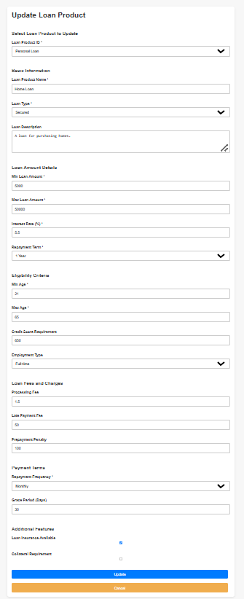
Sr. | Screen Element | Input Type | O/M | 1/N | Description
1 | Loan Product ID | Dropdown (Select) | M | 1 | Select the loan product to update from existing options.
2 | Loan Product Name | Textbox | M | 1 | Displays and allows editing of the loan product name.
3 | Loan Type | Dropdown (Select) | M | 1 | Displays and allows selecting the loan type (Secured, Unsecured, Student).
4 | Loan Description | Textarea | O | 1 | Displays and allows editing of the loan description.
5 | Min Loan Amount | Number Input | M | 1 | Specifies and allows editing the minimum loan amount.
6 | Max Loan Amount | Number Input | M | 1 | Specifies and allows editing the maximum loan amount.
7 | Interest Rate | Number Input | M | 1 | Specifies and allows editing the interest rate for the loan.
8 | Repayment Term | Dropdown (Select) | M | 1 | Specifies and allows selecting the repayment term (e.g., 1 year, 2 years).
9 | Min Age | Number Input | M | 1 | Specifies and allows editing the minimum age for eligibility.
10 | Max Age | Number Input | M | 1 | Specifies and allows editing the maximum age for eligibility.
11 | Credit Score Requirement | Number Input | O | 1 | Specifies and allows editing the required credit score for eligibility.
12 | Employment Type | Dropdown (Select) | O | 1 | Specifies and allows selecting the employment type (Full-time, Part-time, Self-employed).
13 | Processing Fee | Number Input | O | 1 | Specifies and allows editing the processing fee for the loan.
14 | Late Payment Fee | Number Input | O | 1 | Specifies and allows editing the late payment fee for the loan.
15 | Prepayment Penalty | Number Input | O | 1 | Specifies and allows editing the prepayment penalty for the loan.
16 | Repayment Frequency | Dropdown (Select) | M | 1 | Specifies and allows selecting the repayment frequency (e.g., Monthly, Quarterly).
17 | Grace Period (Days) | Number Input | O | 1 | Specifies and allows editing the grace period (in days) for loan repayment.
18 | Loan Insurance Available | Checkbox | O | 1 | Specifies and allows editing if loan insurance is available for the loan.
19 | Collateral Requirement | Checkbox | O | 1 | Specifies and allows editing if collateral is required for the loan.
20 | Update Button | Button | ---- | ---- | Button to submit the updated loan product details.
21 | Cancel Button | Button | ---- | ---- | Button to cancel and return to the previous page.

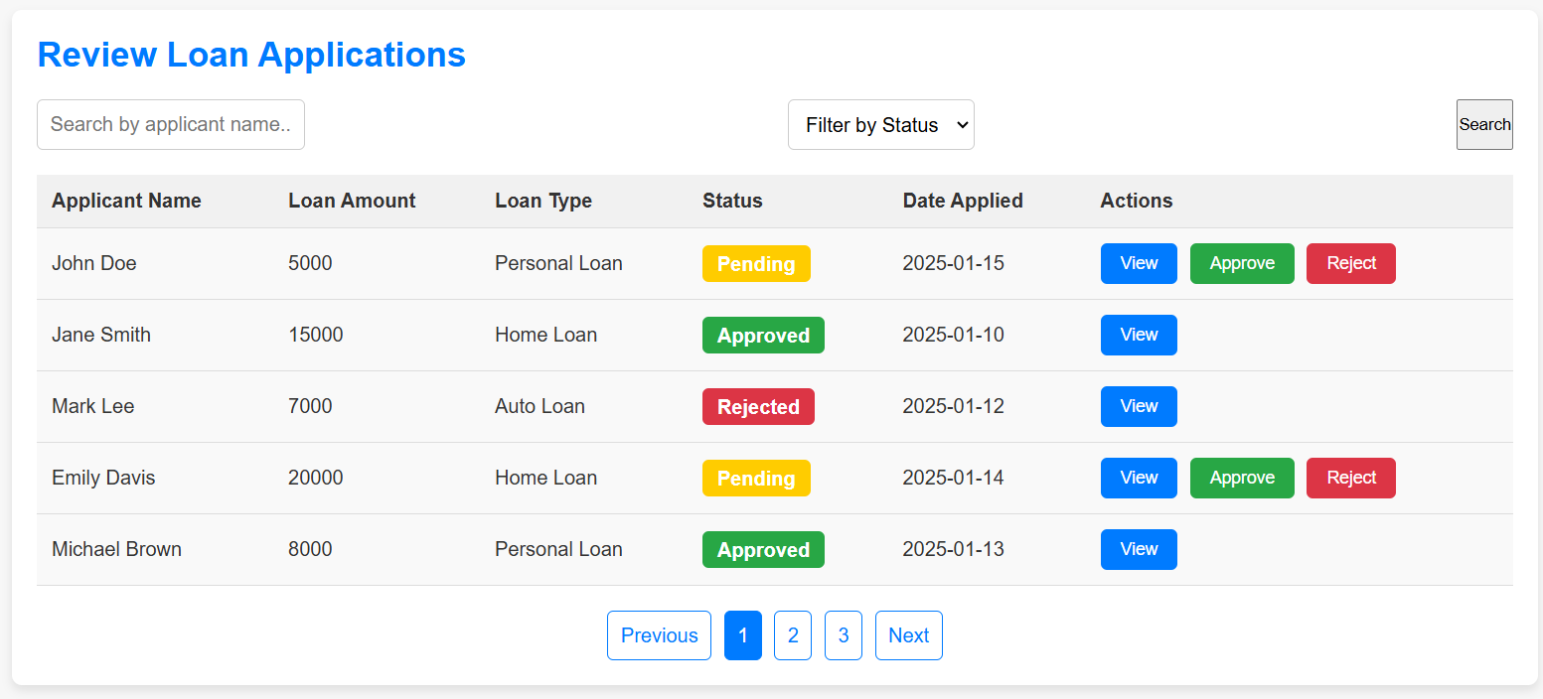
Sr. | Screen Element | Input Type | O/M | 1/N | Description
1 | Search by Applicant Name | Textbox | O | 1 | Input field for searching by applicant name.
2 | Filter by Status | Dropdown (Select) | O | 1 | Dropdown to filter loan applications by status (Pending, Approved, Rejected).
3 | Search Button | Button | ---- | 1 | Button to trigger the search functionality based on the entered name and selected status.
4 | Applicant Name (Table Column) | Static Text | ---- | N | Displays the name of the loan applicant in the table.
5 | Loan Amount (Table Column) | Static Text | ---- | N | Displays the loan amount in the table.
6 | Loan Type (Table Column) | Static Text | ---- | N | Displays the type of loan in the table.
7 | Loan Status (Table Column) | Static Text (Status Badge) | ---- | N | Displays the loan status with a badge (Pending, Approved, Rejected).
8 | Date Applied (Table Column) | Static Text | ---- | N | Displays the date when the loan was applied.
9 | View Loan Button | Button | ---- | N | Button to view the details of a specific loan application.
10 | Approve Loan Button | Button | O | N | Button to approve a loan application (only visible for pending applications).
11 | Reject Loan Button | Button | O | N | Button to reject a loan application (only visible for pending applications).
12 | Previous Pagination Button | Button/Link | ---- | 1 | Button/link to navigate to the previous page of loan applications.
13 | Page Number (Pagination) | Button/Link | ---- | N | Buttons for pagination to move between pages of loan applications.
14 | Next Pagination Button | Button/Link | ---- | 1 | Button/link to navigate to the next page of loan applications.

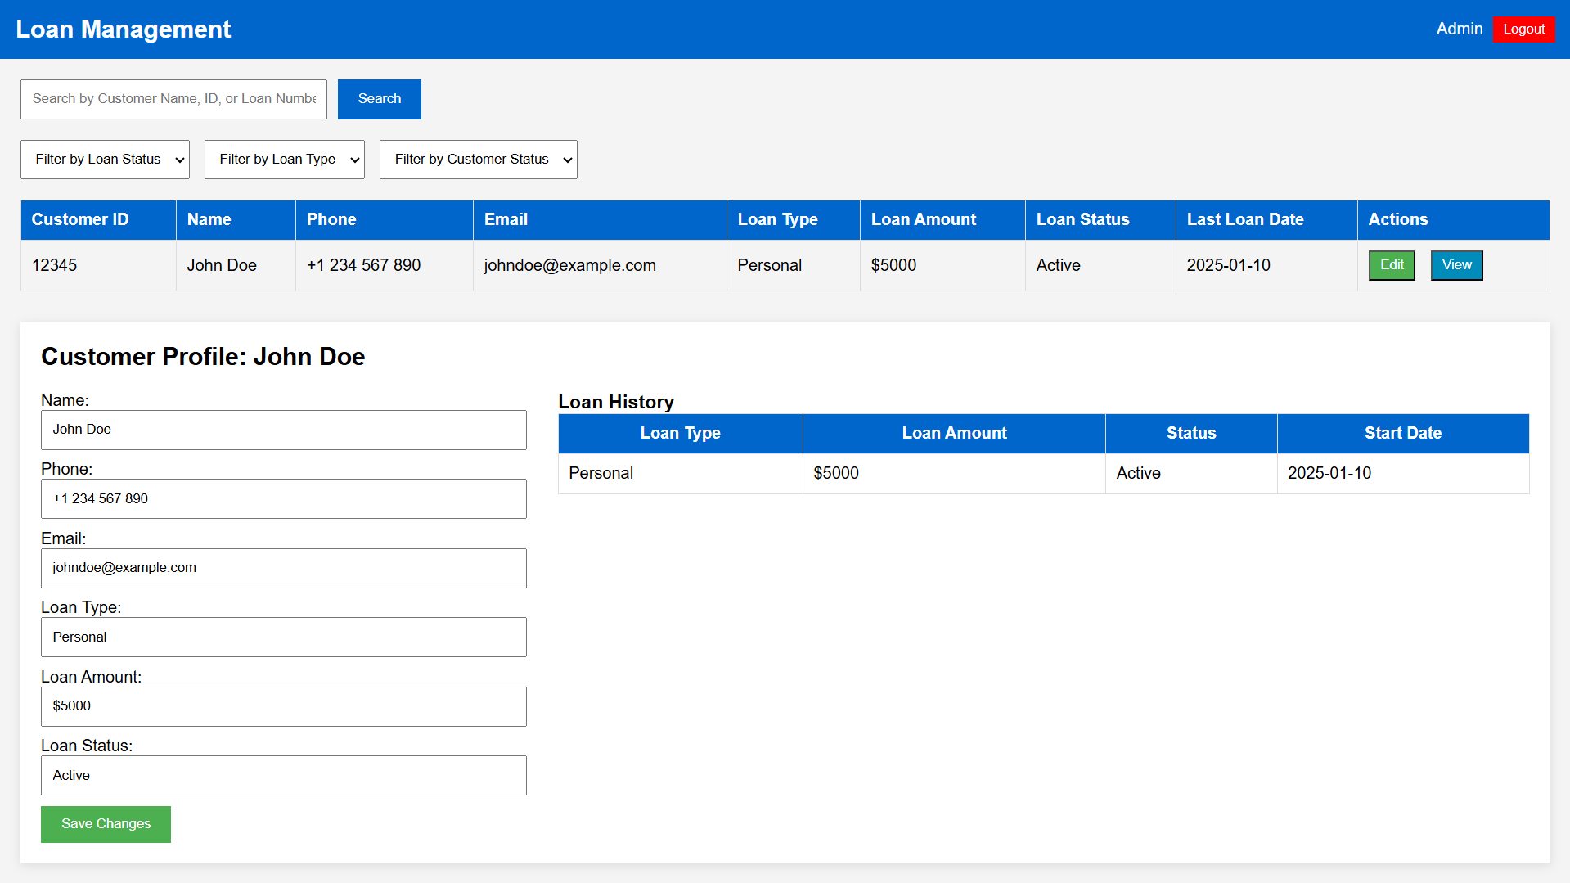

Sr. | Screen Element | Input Type | O/M | 1/N | Description
1 | Customer ID | Textbox | M | 1 | Displays the unique customer ID for reference.
2 | Customer Name | Textbox | M | 1 | Displays and allows editing of the customer’s name.
3 | Customer Phone | Textbox | M | 1 | Displays and allows editing of the customer's phone number.
4 | Customer Email | Textbox | M | 1 | Displays and allows editing of the customer's email address.
5 | Loan Type | Textbox | M | 1 | Displays the loan type (Personal, Auto, Home) for the customer.
6 | Loan Amount | Number Input | M | 1 | Displays and allows editing of the loan amount for the customer.
7 | Loan Status | Textbox | M | 1 | Displays the current loan status (Active, Closed, Pending).
8 | Last Loan Date | Date Input | M | 1 | Displays the last loan date (when the loan was granted).
9 | Edit Button | Button | ---- | 1 | Button to edit the customer’s loan information.
10 | View Button | Button | ---- | 1 | Button to view the detailed loan and customer information.
11 | Customer Profile - Name | Textbox | M | 1 | Editable text field for the customer’s name in the profile section.
12 | Customer Profile - Phone | Textbox | M | 1 | Editable text field for the customer’s phone number in the profile section.
13 | Customer Profile - Email | Textbox | M | 1 | Editable text field for the customer’s email address in the profile section.
14 | Loan Type (Profile Section) | Textbox | M | 1 | Editable text field for the loan type (e.g., Personal, Auto) in the customer profile section.
15 | Loan Amount (Profile Section) | Textbox | M | 1 | Editable text field for the loan amount in the customer profile section.
16 | Loan Status (Profile Section) | Textbox | M | 1 | Editable text field for the loan status (e.g., Active, Pending) in the customer profile section.
17 | Save Changes Button | Button | ---- | 1 | Button to save the edited customer details and loan information.
18 | Loan History Table | Table | M | 1 | Displays a table with loan history information for the customer, including loan type, amount, and status.
19 | Loan History - Loan Type | Textbox (Read-Only) | ---- | N | Displays the type of loan for each entry in the loan history.
20 | Loan History - Loan Amount | Textbox (Read-Only) | ---- | N | Displays the amount of the loan in the loan history table.
21 | Loan History - Loan Status | Textbox (Read-Only) | ---- | N | Displays the loan status for each loan entry in the loan history table.
22 | Loan History - Start Date | Date Input (Read-Only) | ---- | N | Displays the start date of each loan in the loan history table.

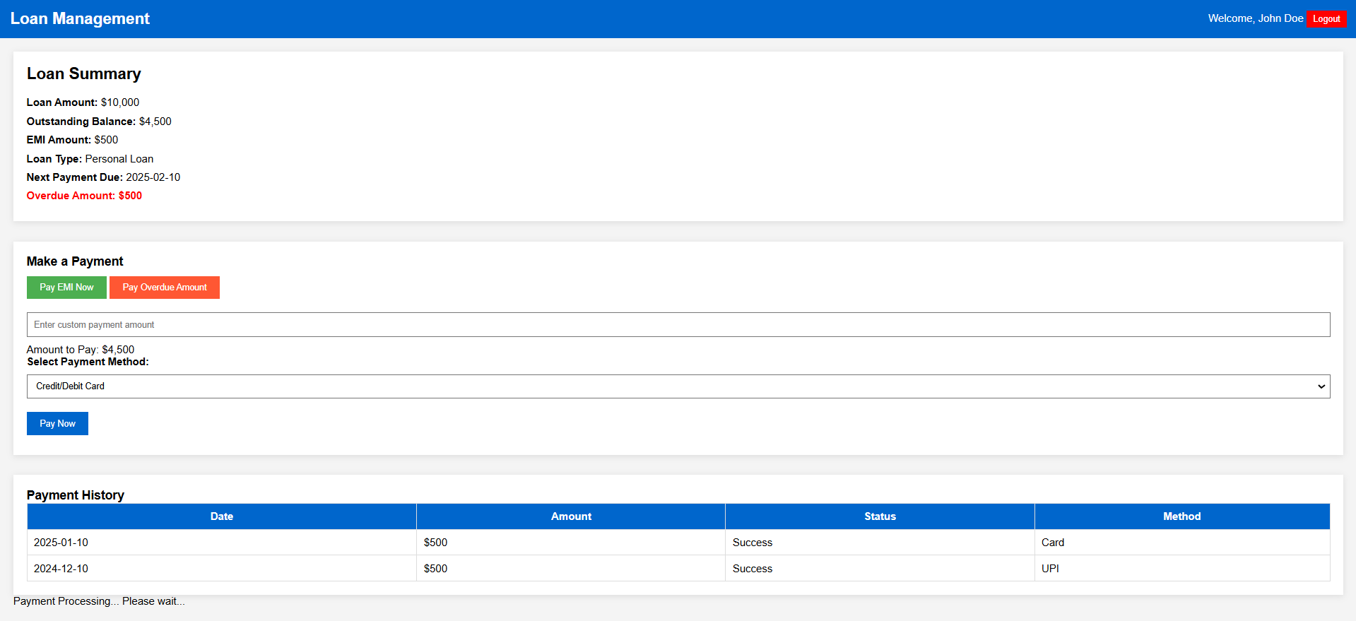
Sr. | Screen Element | Input Type | O/M | 1/N | Description
1 | Loan Amount | Textbox (Read-Only) | M | 1 | Displays the total loan amount for the customer.
2 | Outstanding Balance | Textbox (Read-Only) | M | 1 | Displays the outstanding balance that the customer owes.
3 | EMI Amount | Textbox (Read-Only) | M | 1 | Displays the monthly EMI amount to be paid by the customer.
4 | Loan Type | Textbox (Read-Only) | M | 1 | Displays the type of loan (e.g., Personal Loan).
5 | Next Payment Due | Date Input (Read-Only) | M | 1 | Displays the due date for the next payment.
6 | Overdue Amount | Textbox (Read-Only) | O | 1 | Displays the overdue amount, if any, with emphasis (e.g., in red colour).
7 | Pay EMI Now Button | Button | ---- | 1 | Button to make payment for the EMI amount due.
8 | Pay Overdue Amount Button | Button | ---- | 1 | Button to make a payment for the overdue amount.
9 | Custom Payment Amount Field | Number Input | O | 1 | Field to enter a custom payment amount if the customer wishes to pay an amount different from the EMI or overdue balance.
10 | Amount to Pay | Textbox (Read-Only) | M | 1 | Displays the total amount to be paid (either the EMI amount, overdue, or custom entered amount).
11 | Payment Method Dropdown | Dropdown (Select) | M | 1 | Dropdown to select the payment method (Credit/Debit Card, Net Banking, UPI, Wallet).
12 | Pay Now Button | Button | ---- | 1 | Button to initiate the payment process after selecting the payment method.
13 | Payment History Table | Table | M | 1 | Table showing the history of previous payments, including date, amount, status, and payment method.
14 | Payment History - Date | Date Input (Read-Only) | ---- | N | Displays the date of the payment in the payment history table.
15 | Payment History - Amount | Textbox (Read-Only) | ---- | N | Displays the payment amount in the payment history table.
16 | Payment History - Status | Textbox (Read-Only) | ---- | N | Displays the payment status (e.g., Success, Failed) in the payment history table.
17 | Payment History - Method | Textbox (Read-Only) | ---- | N | Displays the payment method (e.g., Card, UPI) used for the transaction in the payment history table.
18 | Payment Processing Message | Text | ---- | 1 | Message displayed while the payment is being processed (e.g., "Payment Processing... Please wait...").

