Lab Practical #03:
Study of different types of network cables & connectors and crimping a LAN.
Practical Assignment #03:
- List various networks cable. Also, write short description.
- Difference between guided and unguided media.
- Give cross-wired cable and straight through cable diagram (Color Code wise).

List various networks cable and connectors. Also, write short description.
- Twisted Pair Cable:
  - Description:
Used in LANs. UTP (Unshielded Twisted Pair) is common in homes/offices. STP (Shielded Twisted Pair) includes shielding to prevent interference.
  - Diagram: 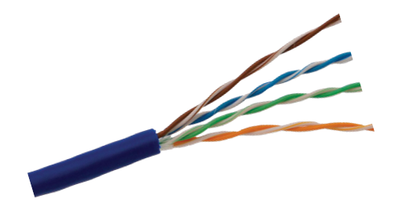
- Coaxial Cable:
  - Description:
Contains a core conductor surrounded by insulation, shielding, and outer jacket. Used in cable TV and early Ethernet.
  - Diagram:
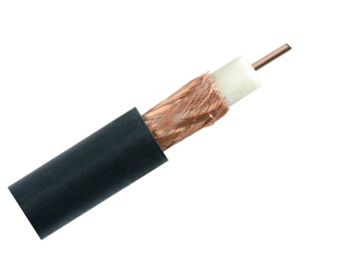
- Fiber Optic Cable:
  - Description:
Transmits data as light. Offers very high speed and long-distance transmission. Immune to electromagnetic interference.
  - Diagram:
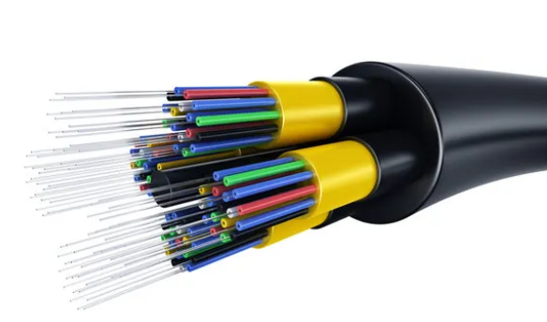

- Difference between guided and unguided media.
No. | Guided Media | Unguided Media
1 | Uses physical path (cables) to transmit signals. | Transmits signals wirelessly through air.
2 | Examples: Twisted Pair, Coaxial, Fiber Optic. | Examples: Radio waves, Microwaves, Infrared.
3 | High security and less susceptible to interference. | More vulnerable to interference and signal loss.
4 | Installation cost is higher. | Cheaper and easier to deploy over large areas.
5 | Directional; point-to-point or point-to-multipoint. | Mostly omnidirectional broadcast.

Give cross-wired cable and straight through cable diagram (Color Code wise).
- Cross-wired Cable Diagram (Color Code)

- Straight Through Cable Diagram (Color Code)
