**What is Scripting?**

A script is program code that doesn’t need pre-processing (e.g. compiling) before being run. In the context of a Web browser, scripting usually refers to program code written in JavaScript that is executed by the browser when a page is loaded, or in response to an event triggered by the user.

Scripting can make Web pages more dynamic. For example, without reloading a new version of a page it may allow modifications to the content of that page, or allow content to be added to or sent from that page. The former has been called DHTML (Dynamic HTML), and the latter AJAX (Asynchronous JavaScript and XML).

**What scripting interfaces are available?**

The most basic scripting interface developed at **W3C** is the DOM, the **D**ocument **O**bject **M**odel which allows programs and scripts to dynamically access and updates the content, structure and style of documents. DOM specifications form the core of DHTML.

Modifications of the content using the DOM by the user and by scripts trigger events that developers can make use of to build rich user interfaces.

**Types of script**: Scripts are classified into the following two types.

* Client-side script
* Server-side script

**Client-side script**: These scripts are getting executed within the web Browser (client). Here we don’t need any software. These scripts are used for client-side validations.

**Ex:** JavaScript, VBScript etc…

**Server-side script**: A script which executes in server machine with support of the web-server/app-server software’s like **IIS**(Internet information services), Tomcat, JBOSS, etc. These scripts are used for server-side validations.

**Ex:** php, jsp, asp.net, nodeJS, etc…

**What are the differences between script and language?**

|  |  |
| --- | --- |
| Script | Language |
| Weakly or loosely typed programming  And lightweight | **Strong or closely typed programming and HW** |
| Easy to understand compare to PL | **Complex to understand compare to Script** |
| External libraries not required | **Required** |
| No special compiler required | **Special compiler mandatory** |
| Client side validation | **Server/client side validation/verifications** |
| Ex: JavaScript, VBScript, TypeScript, Perl, Shell etc. | **Ex: C, CPP, vb.net, Java etc.** |

**JavaScript Introduction**

* JavaScript was invented by **“Brendan Eich”** in 1995, and became an **ECMA** (**E**uropean **C**omputer **M**anufacturers **A**ssociation) standard in 1997. **ECMAScript** is the official name of the language.
* **Netscape** first introduced a JavaScript interpreter in **Navigator**2.
* **JavaScript** is implementation of ECMAScript; ECMAScript is the specification of JavaScript.
* **JavaScript** is an object-based or prototype-based scripting language.

> POPs

> OOPs

> OBPs/Prototype

AJAX

JQuery

JSON

**JavaScript**

Ang

Node

React

* JavaScript is a light weight, free ware and open source.
* JavaScript is client-side (browser-side) programming. That means it executes on the browser.
* It can also be used in server-side by using **NodeJs** or **ReactJS**
* JavaScript Translator is responsible to translate the JavaScript code which is embedded in browser.
* JavaScript is “interpreter-based” programming, means the code will be converted into machine language line-by-line. JavaScript interpreter is already embedded in Browsers.
* JavaScript is a case sensitive programme.

**Why we Use JavaScript?**

Using HTML, we can only design a web page but it’s not supported to perform logical operation such as calculations, decision making and repetitive tasks, dynamically displaying output, reading inputs from the user, and updating content on webpage at client side. Hence to perform these entire tasks at client side we need to use JavaScript.

**Where it is used?**

There are so many web applications running on the web that are using JavaScript like Google, Facebook, twitter, amazon, YouTube etc.

It is used to create interactive websites. It is mainly used for:

1. Client-side verifications and validation
2. Dynamic drop-down menus
3. Displaying date and time
4. Build forms that respond to user input without accessing a server.
5. Displaying popup windows and dialog boxes (like alert dialog box, confirm dialog box and prompt dialog box)
6. Manipulate HTML "layers" including hiding, moving, and allowing the user to drag them around a browser window.

**etc...**

**Limitations of JavaScript**

JavaScript have some limitations which are given below;

1. Client-side JavaScript does not allow reading and writing of files.
2. It cannot be used for networking applications.
3. It doesn't have any multithreading or multiprocessing capabilities.
4. it doesn't support db connections.

**JavaScript Versions**

|  |  |  |
| --- | --- | --- |
| Version | Officeal Name | Release Date |
| 1 | ECMAScript 1 | June-1997 |
| 2 | ECMAScript 2 | June-1998 |
| 3 | ECMAScript 3 | Dec-1998 |
| 4 | ECMAScript 4 | 2004 (not released) |
| 5 | ECMAScript 5 | Dec-2009 |
| 5.1 | ECMAScript 5.1 | June-2011 |
| 6 | ECMAScript | June-2015 |
| 7 | ECMAScript | June-2016 |
| 8 | ECMAScript | June-2017 |
|  |  |  |

**how many ways to imp js?**

**JS we can develop/imp in 3 ways, but in 4place.**

**those are:**

**> inline scripting**

inline script nothing but writing code within the tag, by using event/dynamic attributes

for this we need tag & event attribute

onclick, onsubmit, onfocus, oninput etc..

Syn: **<tag attributes event="js code">**

**>internal scripting**

Internal script is nothing but html code and javascript code both are placed in the same file, but not in same line.

Internal script must be implemented inside **<script>** tag, <script> is a paired tag.

**> scripting in head sec**

head is first executed part of html, hence javascript is also executes first.

<head>

**<script type="text/javascript”>**

**JS code**

**</script>**

</head>

**> scripting in body sec**

body level script is executed after head section

<body>

**<script type="text/javascript”>**

**JS code**

**</script>**

</body>

**> external scripting**

> external script is nothing but html code and javascript code designed in separate files

> type js code in sep file and save that file with "filename.js"

> re-use

>while writing external script don’t use <script> tag and event attribute.

**External file Syn:**

**function fun-name()**

**{**

**Steps**

**}**

**Note: external file should be saved with an extension “.js”**

**>**we canaccess external script by using <script> tag from html.

> from either head nor body section

Syn:

**<script src="filename1.js"> </script>**

**<script src="filename2.js"> </script>**

Comments in JavaScript

Comment is nothing but it is a statement which is not display on browser window. It is useful to understand which code is written for what purpose.

Comments are useful in every programming language to deliver message. It is used to add information about the code, warnings or suggestions so that the end user or other developer can easily interpret the code.

**Types of Comments:**

There are two types of comments are in JavaScript

1. Single-line Comment ex: **//comment**
2. Multi-line Comment ex: **/* comments */**

**Single-line Comment**

It is represented by double forward slashes //. It can be used before any statement.

**Example:**

<script>

// It is single line comment

document.write("Hello Javascript");

</script>

**Multi-line Comment**

It can be used to add single as well as multi line comments.

It is represented by forward slash / with asterisk * then asterisk with forward slash.

**Example:**

<script>

/* It is multi line comment.

It will not be displayed */

document.write("Javascript multiline comment");

</script>

DOM => loading page

window based object for all other DOM objects.

**write() method**: The write() method writes HTML expressions or javascript code to a document without line breaking.

**Syn:** document.write(exp1, exp2, exp3, ...);

document.write(exp1 + exp2 + exp3 + ...);

1) document ---> implicit object ---> webpage

2) write() ---> is method ---> webpage level

**writeln() method**: The writeln() method writes HTML expressions or javascript code to a document with line breaking.

**Syn:** document.writeln(exp1, exp2, exp3, ...);

document.writeln(exp1 + exp2 + exp3 + ...);

**log() method**: The log() method writes HTML expressions or javascript code on browser’s console (press F12) with line break.

**Syn:** console.log(exp1, exp2, exp3, ...);

console.log(exp1 + exp2 + exp3 + ...);

**Example:**

**<html>**

**<head>**

**<script type='text/javascript'>**

**document.write("<h1>hello world!</h1><p> have a nice day ! </p>");**

**</script>**

**</head>**

**</html>**

**Can we use HTML tags in write() method?**

Yes, we can use tags in write().

**writeln() method**: The writeln() method is similar to the write method, with the addition of writing a newline character after each statement.

**Syn:**document.writeln(exp1,exp2,exp3 ...)

**Example:**

**<!DOCTYPE html>**

**<html>**

**<body>**

**<pre>**

**<script type='text/javascript'>**

**document.writeln("Welcome to JS");**

**document.writeln("Welcome to JS");**

**</script>**

**</pre>**

**</head>**

**</html>**

**Note: You have to place writeln() in pre tag to see difference between write() and writeln().**

**Writeln() actually produces the output in new line (\n) but browser will not detect the \n as linebreak, hence to show it correctly and keep format as it is we will use pre tag.**

**Example:**

**<!DOCTYPE html>**

**<html>**

**<head>**

**<script type='text/javascript'>**

**document.write("<h1 style='color:blue; font-size:30px; font-family:tahoma'> Welcome To JS</h1>");**

**document.write("<font color='green' size='16px' face='Arial'> Welcome To JS</font>");**

**</script>**

**</head>**

**<body>**

**</body>**

**</html>**

**Note:**

* the above type of code is known as DHTML
* In JavaScript a string should be in single or double quotes.
* Double quotes inside using single quotes are valid, single quotes inside using double quotes valid.

**Example**

**<!DOCTYPE html>**

**<html>**

**<body>**

**<script>**

**document.write("JavaScript is client side script");**

**document.write("<br>");**

**document.write("JavScript is 'ECMA' Implementation<br>");**

**document.write('JavScript released by NetScape<br>');**

**document.write('NetScape release "Mocha"<br>');**

**//document.write('NetScape release 'Mocha'<br>'); Error**

**//document.write("NetScape release "Mocha"<br>"); Error**

**</script>**

**</body>**

**</html>**

**JavaScript string with escape sequences**: An escape character is consisting of backslash "/" symbol with an alphabet. The following are frequently using escape characters.

1. \n : inserts a new line
2. \t : inserts a tab
3. \r : carriage return
4. \b : backspace
5. \f : form feed
6. \' : single quote
7. \”: double quote
8. \\ : Backslash

**Example**:

**Difference between window.document.write&document.write**:

There is no difference between these two statements,window is highest level object. It contains child objects & their methods

child object/sub object

|

window.document.write();

| | |

browser page method

document.write();

| |

page method

browser is default object, master object, super object.

write() is a method related to document object

ex:

<head>

<script type='text/javascript'>

window.document.write("livescript is javascript");

document.write("<br>");

document.write('livescript is javascript');

</script>

</head>

**JavaScript semicolon(;)**:

In javascript every statements ends with semicolon(;). It is an optional notation.

ex:

<head>

<script type='text/javascript'>

document.write=("livescript is javascript");

</script>

</head>

ex:

<head>

<script type='text/javascript'>

document.write("javascript");

document.write('livescript');

document.write('livescript is javascript');

</script>

</head>

Note:

1) In the above script semicolon(;) is mandatory.

2) It is a good programming practice to use the semicolon.

**JavaScript place in HTML file**:

There is a flexibility given to include javascript code any where in a html document but the follow ways are most prefered in the live environment.

* script in <head>-----</head> section
* script in <body>-----</body> section
* script in <body>-----</body>&<head>-----</head> section
* script in & external file & then include in <head>-----</head> section.

ex:

<head>

<script type='text/javascript'>

document.write("welcome to head section");

</script>

</head>

<body>

<script language="javascript">

document.write("welcome to the body section");

</script>

</body>

**External javascript**:

Javascript can also be placed in a external files,these files contains javascript code. This code we can apply on different webpages. External javascript files extensions is .js

Note:

1) External script cann't contain the <script></script> tags.

2) To use an external script,point to the .js file in the "src" attribute of the <script> tag.

**how to run external js**:

***Creating javascript file***:

document.write("<h1 style='color:blue'> welcome to external javascript....!</h1>");

document.write("<br/>");

document.write("thank u----");

save with **example.js** extension @any location.

***creating html files***:

<html>

<head>

<script type="text/javascript" src="example.js"></script>

</head>

<body>

</body>

</html>

save with .html or .htm extensions.

**Javascript code**: It is a sequence of javascript statements, each statement is executed by the browser in the sequence they are returned.

<head>

<script type="text/javascript">

document.write("<p>This is paragraph</p>") //js code

</script>

</head>

**Javascript blocks**: JavaScript sentences can be group together in blocks. Blocks starts with a left curly bracket { and end with a right curly bracket }. The purpose of your block is to make the sequence of statement excute together.

<head>

<script type="text/javascript">

{

document.write(This is a block);

}

</script>

</head>

**JavaScript popup boxes**: JavaScript has 3 kinds of popup boxes.

1. Alert box
2. Confirm box
3. Prompt box

**Alert box**: An alert box is often used if you want to make sure information comes through the user. When an alert box pops up, the user will have to click "ok" to proceed.

**Syn: window.alert("message");**

ex:

<body>

<script type='text/javascript'>

alert("invalid entry");

</script>

</body>

**Note:** html tags we can’t use in alert() function.

**How to display multiple line on the alert**:

We cann't the use <br> tag here because alert is a method of the windows object, that cann't be interpret html tag. Insted we use the new line escape character.

<head>

<script type="text/javascript">

- alert("javascript \n is\n a\n client-side \n programming \n language");

</script>

</head>

ex: **Alert with functions**

<head>

<script type='text/javascript'>

functionmyAlert(){

alert("javascript \n is \n a \n client-side \n programming \n language");

alert("1 \n \t 2 \n \t \t3");

}

</script>

</head>

<body>

<p> click the button to display alert messages ....</p>

<button onclick="myAlert()"> click me</button>

</body>

**confirm box:**

It is often used, if you want the user to verify and accept something. When a confirm box pops up, the user will have to click either "ok" or "cancel" to proceed. If the user clicks "**ok**" the box returns “**true”**. If the user clicks **"cancel"** the box returns **"false".**

**Syntax: window.confirm("message");**

ex:

<head>

<script type='text/javascript'>

confirm("click ok or cancel");

</script>

</head>

ex:

<head>

<script type='text/javascript'>

var x=confirm("click ok or cancel");

alert("user selected option is:"+x);

</script>

</head>

ex:

<head>

<script type='text/javascript'>

var x=confirm("click ok or cancle");

alert("user selected option is:"+x);

if(x==true) {

alert("user clicked on OK button");

}

else{

alert("user clicked on cancel button");

}

</script>

</head>

ex: **confirm with function**

<head>

<script type='text/javascript'>

functionmyConfirm(){

var x=confirm("click ok or cancel");

alert("user selected option is:"+x);

if(x==true) {

alert("user clicked on ok button");

}

}

</script>

</head>

<body>

<p> click the button to display the user selected result..</p>

<button onclick="myConfirm()">confirm</button>

</body>

**Prompt Box**: It is used to, if you want the user to input a value while entering a page. When a prompt box pops up the user will have to click either "**ok**" or "**cancel**" to proceed after entering an input value. If the user clicks "ok" the box returns the **value/empty**. If the user clicks "cancel" the box returns **"null".**

**Syntax: window.prompt("sometext", defaultvalue);**

ex:

<head>

<script type='text/javascript'>

prompt("Enter Any Number:");

</script>

</head>

ex:

<head>

<script type='text/javascript'>

varMyVal=prompt("Enter Any Number:");

alert("User Entered value is:"+MyVal);

</script>

</head>

**Note:** these 3methods are provided by window object.

**parseInt()**

predefine function => window

text based int ==> number based int

"100" 🡺 100

"10.78" 🡺 10

"rama" 🡺 NaN (Not a Numeric)

Syn:

parseInt("value")

parseFloat()

predefine function => window

text based float ==> number based float

“100" 🡺 100.0

"10.78" 🡺 10.78

"rama" 🡺 NaN (Not a Numeric)

Syn:

parseFloat("value")

**Note:** both are global functions

**Naming Conventions**

JS case => java/.net

JS case: mixed

class name => TitleCase/Capitalilze

**ex:** SimlaGreenApple

fun/method => 1st word is lowercase, rest of words(2-n) are TitleCase/Capitalilze

**ex:** simlaGreenApple()

variables => 1st word is lowercase, rest of words(2-n) are TitleCase/Capitalilze

**Ex:** simlaGreenApple

const => uppercase

**Ex:** SIMLAGREENAPPLE

**External JavaScript with popup boxes**:

step1: *Create a required js file*

functionMyAlert(){

alert("welcome to externaljs");

}

functionMyConfirm(){

confirm("click ok or cancel");

}

functionMyPrompt(){

prompt("Enter Any Value");

}

Save with .js extension @ any location....!!

step2: preparing required html file.

<html>

<head>

<script type="text/javascript" src="myscript.js">

</script>

</head>

<body>

<p>Click the button to display alert message..</p>

<button onclick="MyAlert()">Alert</button>

<p>click the button to display confirm message...</p>

<button onclick="MyConfirm()">confirm</button>

<p>click the button to display prompt value..</p>

<button onclick="MyPrompt()">prompt</button>

</body>

</html>

**Inline JavaScript**

When java script was written within the html element using attributes related to events of the element then it is called as inline java script.

Example of Inline JavaScript

<html>

<form>

<input type="button" value="Click" onclick="alert('Button Clicked')"/>

</form>

</html>

**Internal JavaScript**

When java script was written within the section using element then it is called as internal java script.

Example of Internal JavaScript

<html>

<head>

<script>

functionmsg()

{

alert("Welcome in JavaScript");

}

</script>

</head>

<form>

<input type="button" value="Click" onclick="msg()"/>

</form>

</html>

**External JavaScript**

Writing java script in a separate file with extension .js is called as external java script. For adding the reference of an external java script file to your html page, use tag with src attribute as follows

Example

<script type="text/javascript" src="filename.js"/>

* Create a file with name functions.js and write the following java script functions in it.

**a.js**

functionmsg()

{

alert("Welcome to JavaScript");

}

* Create a html page and use the file functions.js as follows

**index.html**

<html>

<head>

<script type="text/javascript" src="a.js"></script>

</head>

<body>

<form>

<input type="button" value="click" onclick="msg()"/>

</form>

</body>

</html>

**JavaScript Reserved Words:**

The following are reserved words in JavaScript. They cannot be used as JavaScript variables, functions, methods, loop labels, or any object names.

abstract, boolean, break, byte, case, catch, char, class, const, continue, debugger, default, delete, do, double, else, enum, export, extends, false, final, finally, float, for, function, goto, if, implements, import, instanceof, int, interface, let, long, native, new, null, package, private, protected, public, return, short, static, super, switch, synchronized, this, throw, throws, transient, true, try, typeof, var, void, volatile, while, with.

# Variable Declaration

variable is a reference name of a memory block.

*variables are created or stored* in RAM.

variables are used to store/to hold a value for reuse purpose.

Java script did not provide any **data types** for declaring variables and a variable in javascript can store any type of value. Hence java script is loosely typed programme.

We can use a variable directly without declaring it in javascript.

how to declare a variable?

we can define vars in JS two ways, those are:

> by using **"var"** keyword

Syn: var varname;

OR

var varname=value; 🡸 init

> by using **"let"** keyword (since js6) ES6

Syn: let varname;

OR

let varname=value; 🡸 init

> by using **"const"** keyword (since js6) ES6

Syn: const varname=value;

**Rules to declaring a variable**

* Name should start with a letter (a to z or A to Z), underscore(_ ), or dollar( $ ) sign.
* After first letter we can use digits (0 to 9).
* variables are case sensitive. for example, a and A are different variables.
* space is not allowed, means name should be single word.
* special chars (symbols) are not allowed in name, except _ and $.
* keywords we can't use as a name.

**where do we declare variables?**

We can declare variables in open script or with in function or with in block.

**Variable declaration**

Example

var x = 10; // Valid

var _value="porter"; // Valid

var 123=20; // Invalid

var #a=220; // Invalid

var user name="siva"; // Invalid

var case=10.56;

**Example of Variable declaration in JavaScript**

<script>

var a=10;

var b=20;

var c=a+b;

document.write(c);

</script>

Output

30

**Types of Variable in JavaScript**

* Local Variable
* Global Variable

**Local Variable**

A variable which is declared inside block or function is called local variable. It is accessible within the function or block only.

**For example:**

<script>

function abc()

{

var x=10; //local variable

}

</script>

or

Example

<script>

If(10<13)

{

var y=20;//javascript local variable

}

</script>

**Global Variable**

var is declared with in script tag but outside function & block those are global variables.

these global variables are accessible from anywhere in program.

declared with **window** object is known as global variable.

For example:

<script>

var value=10;//global variable

function a()

{

alert(value);

}

function b()

{

alert(value);

}

</script>

Declaring global variable through window object

The best way to declare global variable in javascript is through the window object.

**Syntax**

window.var=value;

Now it can be declared inside any function and can be accessed from any function.

For example:

function m()

{

window.value=200; //declaring global variable by window object

}

function n()

{

alert(window.value); //accessing global variable from other function

}

In JS we can declare the variables the following two ways.

1. Implicit declaration
2. Explicit declaration

**Implicit declaration**: In every scripting it is the default declaration.

ex: y=100;

**Explicit declaration**: All programming languages default declaration

ex: int a=5;

Scripts are able to support implicit declaration but languages are only explicit declaration.

**Note**: Explicit declaration is always recommended as a good programming practice.

**Javascript datatypes:**

In javascript data types are classified into the following two types.

1. primitive datatypes
2. non-primitive datatypes

**primitive data types**: javascript has a five primitive data types.

1. string **Ex:** "siva" 'apples123' "Dno: 1-2-3/1a"
2. number **Ex:** 10 -25 100.56 -3.7
3. boolean **Ex:** true false
4. undefined datatype is not identified
5. object null

**Non-primitive datatypes**: These are popularly known as reference or composite data types.

**Primitive data types**:

***Strings***: In javascript a String should be within a single or double quote.

var name="nit";

var name='nit';

***Number***: Javascript has only one type of numbers, they can be return with or without decimals

var x1=34.00; with decimals

var x2=34 without decimals

***Boolean***: It is used to represent a Boolean value,These are as follows.

var x = true //equivalent to true, yes or on

var y = false //equivalent to false, no or off

***undefined***: It is a value of variable with no value.

var x; //now x is undefined

***Null***: variables can be emptied by setting the value to null.

ex: var x=null; //now x is null

**typeof**

typeof is predefine function, and it's used to identify datatype of a variable.

Syn: **typeof** var-name

**typeof** value

**Dynamic data types**: Javascript has dynamic types. This means that the same variable can be used as different types.

ex:

var x; //now x is undefined

var x=5; // now x is a number

var x="ram"; // now x is a String

**<!-- example on variable declaration -->**

<!DOCTYPE html>

<html lang="en">

<head>

<title>JS Ex13</title>

</head>

<body>

<h1> **Demo on difference between var and let** </h1>

<script>

var a=10; //define

document.write(a +"<br>");

var a=20.56; //re-defination

document.write(a +"<br>");

var a="apple"; //re-defination

document.write(a +"<br>");

let n=101; //define

document.write(n +"<br>");

//let n=202; re-defination ==> Error: Identifier 'n' has already been declared

n=202; //changing value

document.write(n +"<br>");

</script>

</body>

</html>

**Non-primitive data types**: When a variable is declared with the keyword **new**, the variable is an object.

**new** is used for dynamic memory allocations (for creating objects and arrays).

these datatypes are also called as reference datatype.

**Ex:**

var st = **new** String();

var x = **new** Number();

let y = **new** Boolean();

here **LHS** are reference variables, and **RHS** are objects.

reference variables are storing address of dynamic memory (object)

**spechar/symbol 🡺 operator**

**JavaScript operators**

operator is a symbol (special char) and it is used to perform certain operation(task).

every operator is a symbol, but every symbol is not operator.

every operator requires some values, those are called as operands.

**Ex:**

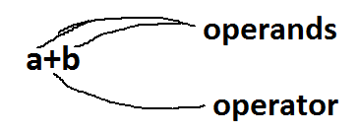

Expression

Its combination of one operator and some operands

Javascript supports the following list of operators:

* arithmetic operators
* relational operators
* logical operators
* assignment operators
* incre/decre operators
* ternary operator
* concatenation operator etc...

***Arithmetical operators***: using these operators we can perform the basic math calculations.

operators are:

operator Description example

+ addition j+12

- subtraction j-22

* multiplication j*7

/ division j/3

% modulus j%6

***relational operators***: these operators are used to provide comparison between two operands. these are boolean operators (true/false).

operators are:

operator Description example

== is equal to j==42

!= is not equal to j!=17

> is greater than j>0

< is less than j<100

>= is greater than or equal to j>=23

<= is less than or equal to j<=13

***Logical operators***: these operators are used to perform multiple comparisons @time. these are boolean operators (true/false).

operators are:

operator Description example

&& And j==1 && k==2

|| OR j<100 || j>0

! Not !(j==k)

***assignment operators***: these operators are used to store/assign value.

operator is:

operator Description example

= store a=10

shorthand:

+= addition & assign a+=10

-= subtract & assign a-=5

*= product & assign a*=20

/= division & assign a/=7

%= modulus & assign a%=6

***unary operators***: these operators are used to increment or to decrement a value. operators are ++ and --

**++** (increment) ==> it adding 1 to an existing value **Ex:** a++ or ++a

**--** (decrement) ==> it subtracting 1 from an existing value**Ex:** a-- --a

***ternary operator***: this operator is used to decision making operation. operator is **?:,** this operator also called as conditional operator.

**(condition) ? statement1 : statement2**

***concatenation operator***: this operator is used to concatenation multiple strings then formed into a single string. one operand should be string to perform concatenation. resultant value comes in string format.

operator is +.

**Ex: "rama"+"rao” ==> "ramarao"**

**"mangos"+123 ==> "mangos123"**

100+”siva” 🡺 “100siva”

**Control Statement**

**control statements are used to control(change) execution flow of program based on user input data.**

**types:**

**> conditional statements (dm)**

**> loops (iterations)**

# Conditional Statements:

# If Statement

The if statement is used to perform decision making operations. means if condition is true it executes some statements, if condition is false it executes some other statements.

There are three forms of if statement.

* simple if
* If else
* if else if (ladder if)

**If statement**

if is most basic statement of Decision-making statements. It tells to program to execute a certain part of code only if particular condition or test case is true.

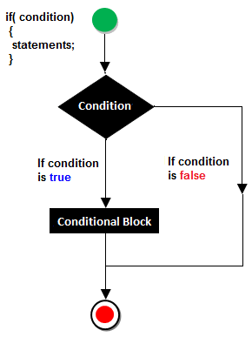

Example

<script>

var a=10;

if(a>5)

{

document.write("value of a is greater than 5");

}

</script>

**if-else statement**

In general it can be used to execute one block of statement among two blocks.

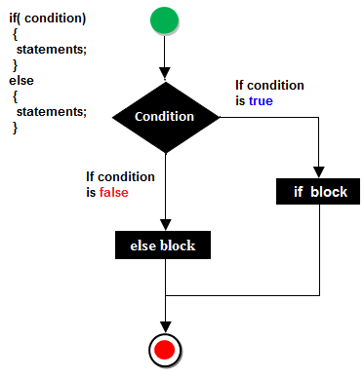

Example of if else statement

<script>

var a=40;

if(a%2==0)

{

document.write("a is even number");

}

else{

document.write("a is odd number");

}

</script>

Result

a is even number

**JavaScript If...else if statement**

It evaluates the content only if expression is true from several expressions.

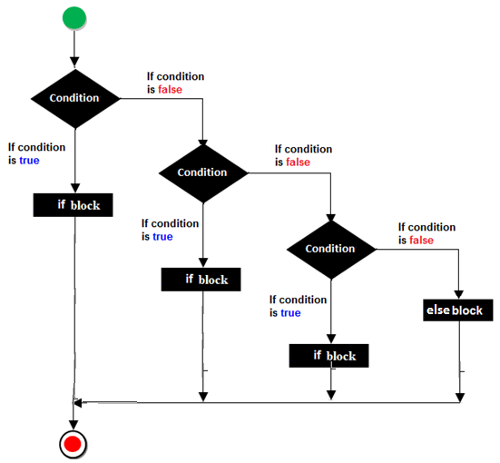

**Syntax**

if(expression1)

{

//content to be evaluated if expression1 is true

}

else

if(expression2)

{

//content to be evaluated if expression2 is true

}

else

{

//content to be evaluated if no expression is true

}

Example of if..else if statement

<script>

var a=40;

if(a==20)

{

document.write("a is equal to 20");

}

else if(a==5)

{

document.write("a is equal to 5");

}

else if(a==30)

{

document.write("a is equal to 30");

}

else

{

document.write("a is not equal to 20, 5 or 30");

}

</script>

**Note:**

> if support 6types relational operators (condition)

> comp styles:

> var to var

> var to val

> val to val

> val to var

> if supports all4

> if supports all datatypes

**switch statement**

> switch is selection statement, but it's not decision making.

> its better performance.

Syn:

**switch(var/expr)**

**{**

**case value: statements...**

**break;**

**case value: statements...**

**break;**

**case ...**

**default: statements...**

**}**

Looping Statement

Set of instructions given to the interpreter to execute until condition becomes false is called loops. The basic purpose of loop is code repetition.

The way of the repetition will be forming a circle that's why repetition statements are called loops. Some loops are available In JavaScript which are given below.

* while loop (top testing/entry level)
* for loop
* do-while (bottom testing/exit level)

**while loop**

When we are working with “while loop” always pre-checking process will be occurred. Pre-checking process means before evolution of statement block condition part will be executed. “While loop” will repeat in clock wise direction.

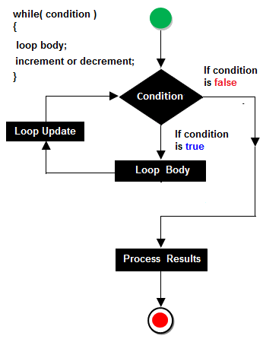

Example of while loop

<script>

var i=10;

while (i<=13)

{

document.write(i + "<br/>");

i++;

}

</script>

**do-while loop**

In implementation when we need to repeat the statement block at least 1 then go for do-while. In do-while loop post checking of the statement block condition part will be executed.

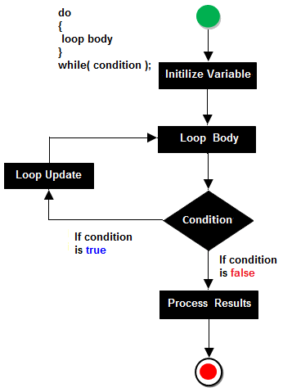

Example of do-while loop

<script>

var i=11;

do{

document.write(i + "<br/>");

i++;

}while (i<=15);

</script>

**for Loop**

For loop is a simplest loop first we initialized the value then check condition and then increment and decrements occurred.

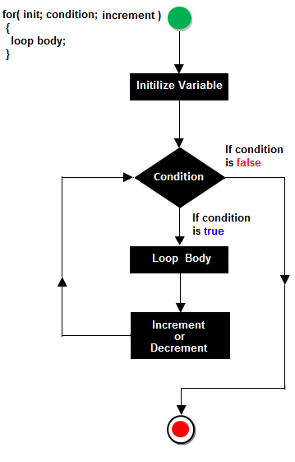

**Steps of for loop**

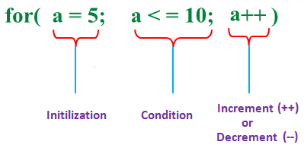

Example of for loop

<script>

for (i=1; i<=5; i++)

{

document.write(i + "<br/>")

}

</script>

**<noscript> tag**: It is used to provide an alternate contains for users when script is disabled or not supporting, It is a paired tag. It is always declared within the body section.

syntax: <noscript>------</noscript>

ex:

<head>

<script type='text/javascript'>

alert("welcome to js");

</script>

</head>

<body>

<noscript>

<p style='color:red'>oops your browser not supporting javascript

update/change the script settings and try..</p>

</noscript>

</body>