Resume Web page using HTML and CSS
Aim:
To design and develop an online Resume Web Page using HTML5 and CSS3, incorporating semantic HTML elements such as text formatting, hyperlinks, images, lists, and tables, along with modern page layout techniques such as CSS Flexbox and Grid.
Theory:
1. HTML parsing and DOM construction: The browser reads the file as UTF-8 (declared through the meta charset tag), splits it into tags and text, and builds a tree of nodes called the Document Object Model (DOM). Nesting such as header, nav and main inside body mirrors the logical structure of the page.
2. Semantic structure: Elements such as header, nav, main, section, article, table and footer describe the meaning of content, not only its appearance. This improves accessibility for screen readers, search engine indexing and code maintainability. The details and summary elements provide expandable FAQ items without any JavaScript.
3. CSS parsing and the CSS Object Model (CSSOM): Rules inside the style element are parsed into the CSSOM. Selectors are matched against DOM nodes, and conflicts are resolved through the cascade and specificity. CSS custom properties declared on :root (colours, maximum width) let a single value be reused across every component.
4. Box model and reset: The universal selector with box-sizing: border-box and zeroed margin and padding removes default browser spacing. Each element is laid out as a box made of content, padding, border and margin, which keeps widths predictable.
5. Layout engine: The browser combines the DOM with computed styles to form a render tree (elements with display: none are excluded) and calculates the geometry of each box. Flexbox aligns the navigation bar and button groups, while CSS Grid with repeat(auto-fit, minmax(300px, 1fr)) creates responsive card columns that stack on narrow screens without explicit media queries.
6. Painting and rendering pipeline: After layout, the browser paints the boxes and composites them onto the screen. Hover and transition effects on links and buttons affect only paint properties, whereas a change in size, such as a window resize, triggers a reflow. Images load asynchronously, so the layout adjusts as each resource arrives.
Code:
index.html:
<!DOCTYPE html>
<html lang="en">
<head>
<meta charset="UTF-8">
<meta name="viewport" content="width=device-width, initial-scale=1.0">
<title>Home | Kalpana Bhaskar — AI/ML Engineer & Developer</title>
<style>
/* Modern Minimalist CSS Architecture */
:root {
--bg-color: #f8f9fa;
--card-bg: #ffffff;
--text-main: #212529;
--text-muted: #6c757d;
--primary: #4f46e5;
--primary-hover: #4338ca;
--border-color: #e5e7eb;
--max-width: 1000px;
}
* {
box-sizing: border-box;
margin: 0;
padding: 0;
}
body {
font-family: -apple-system, BlinkMacSystemFont, "Segoe UI", Roboto,
Helvetica, Arial, sans-serif;
background-color: var(--bg-color);
color: var(--text-main);
line-height: 1.6; padding: 0 20px;
}
header {
max-width: var(--max-width);
margin: 0 auto;
padding: 30px 0 10px 0;
}
/* Navigation Style */
nav {
background-color: var(--card-bg);
padding: 15px 25px;
border-radius: 12px;
box-shadow: 0 4px 6px -1px rgba(0,0,0,0.05);
display: flex;
flex-wrap: wrap;
gap: 15px;
justify-content: center;
border: 1px solid var(--border-color);
}
nav a {
color: var(--text-main);
text-decoration: none;
font-weight: 500;
font-size: 0.95rem;
padding: 6px 12px;
border-radius: 6px;
transition: all 0.2s ease;
}
nav a:hover, nav a.active {
background-color: var(--primary);
color: #ffffff;
}
/* Layout */
main { max-width: var(--max-width);
margin: 40px auto;
display: flex;
flex-direction: column;
gap: 40px;
}
section {
background-color: var(--card-bg);
padding: 40px;
border-radius: 16px;
border: 1px solid var(--border-color);
box-shadow: 0 10px 15px -3px rgba(0,0,0,0.02);
}
h1, h2, h3 {
margin-bottom: 20px;
color: #111827;
}
h1 { font-size: 2.5rem; font-weight: 800; }
h2 { font-size: 1.75rem; border-bottom: 2px solid var(--border-color); padding-bottom: 10px; margin-bottom: 25px; }
p { margin-bottom: 15px; color: var(--text-muted); font-size: 1.05rem; }
/* Component Elements */
.hero-banner {
width: 100%;
height: 250px;
object-fit: cover;
border-radius: 12px;
margin-bottom: -75px;
background-color: #ddd;
}
.hero-profile-area {
display: flex;
flex-direction: column; align-items: center;
text-align: center;
padding-top: 0;
}
.profile-img {
width: 150px;
height: 150px;
border-radius: 50%;
object-fit: cover;
border: 5px solid var(--card-bg);
box-shadow: 0 4px 10px rgba(0,0,0,0.1);
margin-bottom: 20px;
background-color: #eee;
}
.btn-group {
display: flex;
gap: 15px;
justify-content: center;
margin-top: 25px;
flex-wrap: wrap;
}
.btn {
display: inline-block;
padding: 12px 24px;
border-radius: 8px;
text-decoration: none;
font-weight: 600;
font-size: 0.95rem;
transition: background 0.2s;
cursor: pointer;
border: none;
}
.btn-primary { background-color: var(--primary); color: #fff; }
.btn-primary:hover { background-color: var(--primary-hover); }
.btn-secondary { background-color: #f3f4f6; color: var(--text-main); border: 1px solid var(--border-color); }
.btn-secondary:hover { background-color: #e5e7eb; }
.grid-2 {
display: grid;
grid-template-columns: repeat(auto-fit, minmax(300px, 1fr));
gap: 30px;
}
.tag-list {
display: flex;
flex-wrap: wrap;
gap: 10px;
list-style: none;
}
.tag {
background-color: #f3f4f6;
color: #1f2937;
padding: 6px 14px;
border-radius: 20px;
font-size: 0.875rem;
font-weight: 500;
}
.featured-card {
border: 1px solid var(--border-color);
padding: 20px;
border-radius: 8px;
margin-top: 15px;
}
footer {
text-align: center;
padding: 40px 0;
color: var(--text-muted);
font-size: 0.9rem;
border-top: 1px solid var(--border-color); max-width: var(--max-width);
margin: 0 auto;
}
.social-links {
margin-bottom: 15px;
}
.social-links a {
color: var(--text-muted);
margin: 0 10px;
text-decoration: none;
}
.social-links a:hover { color: var(--primary); }
</style>
</head>
<body>
<header>
<!-- Consistent Navigation Bar -->
<nav>
<a href="index.html" class="active">Home</a>
<a href="about.html">About</a>
<a href="education.html">Education</a>
<a href="experience.html">Experience</a>
<a href="projects.html">Projects</a>
<a href="portfolio.html">Portfolio</a>
<a href="contact.html">Contact</a>
</nav>
</header>
<main>
<!-- Hero Section -->
<div style="max-width: var(--max-width); margin: 0 auto; width:100%;">
<img src="assets/background.jpg" alt="Cover Banner" class="hero-banner">
</div>
<section class="hero-profile-area">
<img src="assets/profilepic.webp" alt="Kalpana Bhaskar Profile Photo" class="profile-img">
<h1>Kalpana Bhaskar</h1>
<p style="font-weight: 600; color: var(--primary); font-size: 1.25rem; margin-top:-15px;">Aspiring AI/ML Engineer | B.Tech in AI &amp; Data Science</p>
<p style="max-width: 650px; margin: 15px auto;">
Welcome to my digital portfolio! I am an aspiring AI/ML Engineer passionate about engineering scalable data science systems and delivering high-impact projects across Agentic AI, Machine Learning, and LLMs. Currently pursuing B.Tech in Artificial Intelligence and Data Science at Shiv Nadar University Chennai.
</p>
<div class="btn-group">
<a href="about.html" class="btn btn-secondary">About Me</a>
<a href="projects.html" class="btn btn-primary">View Projects</a>
<a href="assets/resume_sample.pdf" download class="btn btn-secondary">Download Resume</a>
<a href="contact.html" class="btn btn-primary">Contact Me</a>
</div>
</section>
<!-- Dynamic Summary Grid -->
<div class="grid-2">
<section>
<h2>Featured Skills</h2>
<p>A high-level glance at my primary capabilities:</p>
<ul class="tag-list">
<li class="tag">Python</li>
<li class="tag">Machine Learning</li>
<li class="tag">React / Next.js</li>
<li class="tag">FastAPI</li>
<li class="tag">PyTorch</li>
<li class="tag">LangChain</li>
<li class="tag">Google Cloud (GCP)</li>
<li class="tag">Docker</li>
<li class="tag">Firebase</li>
<li class="tag">RAG Pipelines</li>
</ul>
</section>
<section>
<h2>Featured Project</h2>
<div class="featured-card">
<h3>UIDAI Intelligent Policy Dashboard</h3>
<p>Accelerated data processing by saving 30 hours/week via a Velocity Governance ETL pipeline, parsing 232,000+ unified logs into an intelligent dashboard with K-Means clustering and regression forecasting.</p>
<a href="projects.html" style="color: var(--primary); font-weight:600; text-decoration:none;">Learn More &rarr;</a>
</div>
</section>
</div>
</main>
<footer>
<div class="social-links">
<a href="https://github.com/KalpanaBhaskar" target="_blank">GitHub</a> |
<a href="https://www.linkedin.com/in/kalpana-bhaskar-815549330/" target="_blank">LinkedIn</a> |
<a href="https://www.kaggle.com/kalpanabhaskar" target="_blank">Kaggle</a>
</div>
<p>&copy; 2026 Kalpana Bhaskar. All Rights Reserved.</p>
<p style="font-size: 0.8rem; margin-top: 5px;">Last Updated: July, 2026</p>
</footer>
</body>
</html>
about.html:
<!DOCTYPE html>
<html lang="en">
<head>
<meta charset="UTF-8">
<meta name="viewport" content="width=device-width, initial-scale=1.0">
<title>About Me | Kalpana Bhaskar</title>
<style>
:root {
--bg-color: #f8f9fa;
--card-bg: #ffffff;
--text-main: #212529;
--text-muted: #6c757d;
--primary: #4f46e5;
--border-color: #e5e7eb;
--max-width: 1000px;
}
* { box-sizing: border-box; margin: 0; padding: 0; }
body { font-family: -apple-system, BlinkMacSystemFont, "Segoe UI", Roboto, sans-serif; background-color: var(--bg-color); color: var(--text-main); line-height: 1.6; padding: 0 20px; }
header { max-width: var(--max-width); margin: 0 auto; padding: 30px 0 10px 0; }
nav { background-color: var(--card-bg); padding: 15px 25px; border-radius: 12px; box-shadow: 0 4px 6px -1px rgba(0,0,0,0.05); display: flex; flex-wrap: wrap; gap: 15px; justify-content: center; border: 1px solid var(--border-color); }
nav a { color: var(--text-main); text-decoration: none; font-weight: 500; font-size: 0.95rem; padding: 6px 12px; border-radius: 6px; }
nav a:hover, nav a.active { background-color: var(--primary); color: #ffffff; }
main { max-width: var(--max-width); margin: 40px auto; display: flex; flex-direction: column; gap: 30px; }
section { background-color: var(--card-bg); padding: 40px; border-radius: 16px; border: 1px solid var(--border-color); }
h2 { font-size: 1.75rem; border-bottom: 2px solid var(--border-color); padding-bottom: 10px; margin-bottom: 25px; }
h3 { margin: 20px 0 10px 0; color: #111827; }
p { margin-bottom: 15px; color: var(--text-muted); }
/* Table Layout Configuration */
table { width: 100%; border-collapse: collapse; margin: 20px 0; font-size: 0.95rem; }
th, td { padding: 12px 15px; text-align: left; border-bottom: 1px solid var(--border-color); }
th { background-color: #f9fafb; font-weight: 600; color: #374151; width: 35%; }
.grid-2 { display: grid; grid-template-columns: repeat(auto-fit, minmax(300px, 1fr)); gap: 25px; }
ul { margin-left: 20px; color: var(--text-muted); margin-bottom: 15px; }
li { margin-bottom: 5px; }
blockquote { border-left: 4px solid var(--primary); padding-left: 20px; font-style: italic; color: #4b5563; margin: 25px 0; font-size: 1.1rem; }
footer { text-align: center; padding: 40px 0; color: var(--text-muted); font-size: 0.9rem; border-top: 1px solid var(--border-color); max-width: var(--max-width); margin: 0 auto; }
</style>
</head>
<body>
<header>
<nav>
<a href="index.html">Home</a>
<a href="about.html" class="active">About</a>
<a href="education.html">Education</a>
<a href="experience.html">Experience</a>
<a href="projects.html">Projects</a>
<a href="portfolio.html">Portfolio</a>
<a href="contact.html">Contact</a>
</nav>
</header>
<main>
<!-- Personal Characteristics and Profiles -->
<div class="grid-2">
<section>
<h2>Personal Details</h2>
<table>
<tr><th>Full Name:</th><td>Kalpana Bhaskar</td></tr>
<tr><th>Location:</th><td>Chennai, Tamil Nadu, India</td></tr>
<tr><th>Nationality:</th><td>Indian</td></tr>
<tr><th>Current Role:</th><td>B.Tech Student &amp; Software Engineering Intern</td></tr>
<tr><th>University:</th><td>Shiv Nadar University Chennai</td></tr>
</table>
</section>
<section>
<h2>Contact &amp; Networks</h2>
<table>
<tr><th>Email:</th><td>kalpana.bhaskar.v@gmail.com</td></tr>
<tr><th>Phone:</th><td>+91 7397492723</td></tr>
<tr><th>LinkedIn:</th><td><a href="https://www.linkedin.com/in/kalpana-bhaskar-815549330/" style="color: var(--primary); text-decoration: none;">linkedin.com/in/kalpana-bhaskar</a></td></tr>
<tr><th>GitHub:</th><td><a href="https://github.com/KalpanaBhaskar" style="color: var(--primary); text-decoration: none;">github.com/KalpanaBhaskar</a></td></tr>
<tr><th>Kaggle:</th><td><a href="https://www.kaggle.com/kalpanabhaskar" style="color: var(--primary); text-decoration: none;">kaggle.com/kalpanabhaskar</a></td></tr>
<tr><th>LeetCode:</th><td><a href="https://leetcode.com/u/kalpana_bhaskar_916/" style="color: var(--primary); text-decoration: none;">leetcode.com/kalpana_bhaskar_916</a></td></tr>
</table>
</section>
</div>
<!-- Mindset & Passions -->
<section>
<h2>Personality, Hobbies &amp; Interests</h2>
<h3>Strengths &amp; Focus Areas</h3>
<p><strong>Strengths:</strong> Analytical mindset, rapid learner, detail-oriented problem solving, strong competitive programming skills (200+ LeetCode problems), and cross-functional team collaboration.</p>
<p><strong>Focus:</strong> Engineering scalable data science systems and delivering high-impact projects across Agentic AI, Machine Learning, and LLMs.</p>
<h3>Favorite Quote</h3>
<blockquote>
"Simplicity is the ultimate sophistication."
<br><span style="font-size: 0.85rem; color: var(--text-muted); font-style: normal; font-weight: 600;">— Leonardo da Vinci</span>
</blockquote>
<div class="grid-2">
<div>
<h3>Hobbies</h3>
<ul>
<li>Competitive Programming</li>
<li>Open Source Contribution</li>
<li>Hackathon Participation</li>
</ul>
</div>
<div>
<h3>Interests</h3>
<ul>
<li>Artificial Intelligence &amp; Machine Learning</li>
<li>Agentic AI &amp; Large Language Models</li>
<li>Data Science &amp; Full Stack Development</li>
</ul>
</div>
</div>
</section>
</main>
<footer>
<p>&copy; 2026 Kalpana Bhaskar. All Rights Reserved.</p>
</footer>
</body>
</html>
education.html:
<!DOCTYPE html>
<html lang="en">
<head>
<meta charset="UTF-8">
<meta name="viewport" content="width=device-width, initial-scale=1.0">
<title>Education & Skills | Kalpana Bhaskar</title>
<style>
:root {
--bg-color: #f8f9fa;
--card-bg: #ffffff;
--text-main: #212529;
--text-muted: #6c757d;
--primary: #4f46e5;
--border-color: #e5e7eb;
--max-width: 1000px;
}
* { box-sizing: border-box; margin: 0; padding: 0; }
body { font-family: -apple-system, BlinkMacSystemFont, "Segoe UI", Roboto, sans-serif; background-color: var(--bg-color); color: var(--text-main); line-height: 1.6; padding: 0 20px; }
header { max-width: var(--max-width); margin: 0 auto; padding: 30px 0 10px 0; }
nav { background-color: var(--card-bg); padding: 15px 25px; border-radius: 12px; box-shadow: 0 4px 6px -1px rgba(0,0,0,0.05); display: flex; flex-wrap: wrap; gap: 15px; justify-content: center; border: 1px solid var(--border-color); }
nav a { color: var(--text-main); text-decoration: none; font-weight: 500; font-size: 0.95rem; padding: 6px 12px; border-radius: 6px; }
nav a:hover, nav a.active { background-color: var(--primary); color: #ffffff; }
main { max-width: var(--max-width); margin: 40px auto; display: flex; flex-direction: column; gap: 30px; }
section { background-color: var(--card-bg); padding: 40px; border-radius: 16px; border: 1px solid var(--border-color); }
h2 { font-size: 1.75rem; border-bottom: 2px solid var(--border-color); padding-bottom: 10px; margin-bottom: 25px; }
h3 { margin: 20px 0 10px 0; color: #111827; }
p { margin-bottom: 15px; color: var(--text-muted); }
table { width: 100%; border-collapse: collapse; margin: 20px 0; }
th, td { padding: 14px; text-align: left; border-bottom: 1px solid var(--border-color); }
th { background-color: #f9fafb; font-weight: 600; color: #374151; }
/* Timeline style modification */
.timeline { list-style: none; padding-left: 0; position: relative; border-left: 2px solid var(--border-color); margin-left: 10px; }
.timeline-item { margin-bottom: 30px; padding-left: 25px; position: relative; }
.timeline-item::before { content: ""; position: absolute; left: -6px; top: 6px; width: 10px; height: 10px; border-radius: 50%; background-color: var(--primary); }
.grid-2 { display: grid; grid-template-columns: repeat(auto-fit, minmax(300px, 1fr)); gap: 25px; }
.list-unstyled { list-style: none; }
.list-unstyled li { padding: 6px 0; border-bottom: 1px dashed var(--border-color); color: var(--text-muted); }
.cert-card { border: 1px solid var(--border-color); padding: 20px; border-radius: 8px; margin-bottom: 15px; }
footer { text-align: center; padding: 40px 0; color: var(--text-muted); font-size: 0.9rem; border-top: 1px solid var(--border-color); max-width: var(--max-width); margin: 0 auto; }
</style>
</head>
<body>
<header>
<nav>
<a href="index.html">Home</a>
<a href="about.html">About</a>
<a href="education.html" class="active">Education</a>
<a href="experience.html">Experience</a>
<a href="projects.html">Projects</a>
<a href="portfolio.html">Portfolio</a>
<a href="contact.html">Contact</a>
</nav>
</header>
<main>
<!-- Educational History -->
<section>
<h2>Education Details</h2>
<div style="overflow-x:auto;">
<table>
<thead>
<tr>
<th>Institution</th>
<th>Course / Degree</th>
<th>Board/University</th>
<th>Year</th>
<th>Grade/CGPA</th>
</tr>
</thead>
<tbody>
<tr>
<td>Shiv Nadar University Chennai</td>
<td>B.Tech in Artificial Intelligence and Data Science</td>
<td>Shiv Nadar University</td>
<td>08/2024 – Present</td>
<td>CGPA: 8.77</td>
</tr>
<tr>
<td>PSBB Senior Secondary School, Chennai</td>
<td>CBSE Class XII (Computer Science, PCM, English)</td>
<td>CBSE</td>
<td>06/2012 – 05/2024</td>
<td>95.2%</td>
</tr>
<tr>
<td>PSBB Senior Secondary School, Chennai</td>
<td>CBSE Class X</td>
<td>CBSE</td>
<td>–</td>
<td>97%</td>
</tr>
</tbody>
</table>
</div>
</section>
<!-- Academic Deep-Dive and Roadmap -->
<div class="grid-2">
<section>
<h2>Academic Timeline &amp; Activities</h2>
<ul class="timeline">
<li class="timeline-item">
<strong>B.Tech Year 2 (2025 – Present)</strong>
<p>Software Engineering Intern at Experiqs (Weatherex.ai). Active hackathon participant across UIDAI, GDG, SIH, Bajaj HackRx, GuideWire, and Unisys Innovation Program.</p>
</li>
<li class="timeline-item">
<strong>B.Tech Year 1 (2024 – 2025)</strong>
<p>Foundation year at Shiv Nadar University Chennai. ML Vertical Junior Core member of SNUC Coding Club. POC of Science Club SNUC. NSO club member.</p>
</li>
<li class="timeline-item">
<strong>School Years (2012 – 2024)</strong>
<p>Completed CBSE Class XII with 95.2% and Class X with 97% at PSBB Senior Secondary School, Chennai.</p>
</li>
</ul>
<h3>Key Coursework &amp; Concepts</h3>
<p>Data Science, Machine Learning, AI Search Algorithms, Full Stack Web Development, RESTful APIs, Data Structures &amp; Algorithms, Object Oriented Programming, Operating Systems, Database Management, Computer Networks, Data Mining, RAG Pipeline</p>
</section>
<section>
<h2>Technical Skills</h2>
<h3>Languages</h3>
<ul class="list-unstyled">
<li>Python, Java, C++, JavaScript, TypeScript, C</li>
</ul>
<h3>Frameworks &amp; Libraries</h3>
<ul class="list-unstyled">
<li>React, Node.js, Next.js, FastAPI, LangChain, Pandas, PyTorch, Scikit-learn, NumPy</li>
</ul>
<h3>Databases</h3>
<ul class="list-unstyled">
<li>MySQL, MongoDB</li>
</ul>
<h3 style="margin-top: 25px;">Cloud &amp; Tools</h3>
<ul class="list-unstyled">
<li>Google Cloud Platform (GCP), Git/GitHub, Docker, Firebase, MediaPipe, Postman, Google Gemini API, Sarvam AI API, Excel, Tableau, Hugging Face</li>
</ul>
</section>
</div>
<!-- Certifications & Achievements -->
<section>
<h2>Achievements &amp; Certifications</h2>
<div class="cert-card">
<h3>Unisys Innovation Program 17</h3>
<p style="margin-bottom: 5px;"><strong>Achievement:</strong> Top 60 out of 3000+ teams for Federated Agentic Fraud Detection System</p>
<p style="margin-bottom: 5px;"><strong>Date:</strong> June 2026</p>
<a href="https://github.com/UnisysUIP/2026-Federated-Knowledge-Graph-Enhanced-Agentic-AI-Platform-for-Secure-Explainable-Cross-Enterprise" target="_blank" style="color: var(--primary); text-decoration: none; font-size: 0.9rem; font-weight: 600;">View on GitHub &rarr;</a>
</div>
<div class="cert-card">
<h3>HackerRank Orchestrate</h3>
<p style="margin-bottom: 5px;"><strong>Achievement:</strong> Participant &amp; Project Contributor</p>
<p style="margin-bottom: 5px;"><strong>Date:</strong> June 2026</p>
<a href="https://github.com/KalpanaBhaskar/hackerrank-orchestrate-june26" target="_blank" style="color: var(--primary); text-decoration: none; font-size: 0.9rem; font-weight: 600;">View on GitHub &rarr;</a>
</div>
<div class="cert-card">
<h3>Kaggle 5-Day Agentic AI Intensive with Google</h3>
<p style="margin-bottom: 5px;"><strong>Achievement:</strong> Completed Smart Customer Analytics Capstone Project</p>
<p style="margin-bottom: 5px;"><strong>Date:</strong> November 2025</p>
<a href="https://www.kaggle.com/certification/badges/kalpanabhaskar/105" target="_blank" style="color: var(--primary); text-decoration: none; font-size: 0.9rem; font-weight: 600;">View Badge &rarr;</a>
</div>
<div class="cert-card">
<h3>IBM AI and Cloud Internship (via EduNet - AICTE)</h3>
<p style="margin-bottom: 5px;"><strong>Issuing Organization:</strong> IBM (via EduNet Foundation - AICTE)</p>
<p style="margin-bottom: 5px;"><strong>Date:</strong> September – October 2025</p>
<a href="https://drive.google.com/file/d/1gXruo8Y_00M4qPt067yjYaEDMtbybye5/view?usp=sharing" target="_blank" style="color: var(--primary); text-decoration: none; font-size: 0.9rem; font-weight: 600;">View Certificate &rarr;</a>
</div>
<div class="cert-card">
<h3>NPTEL Elite+ Silver Certifications</h3>
<p style="margin-bottom: 5px;"><strong>Issuing Organization:</strong> NPTEL (IIT)</p>
<p style="margin-bottom: 5px;"><strong>Courses:</strong> Modern C++ (Apr 2025) | Java (Nov 2025) | Ethical Hacking (Oct 2025)</p>
<a href="https://drive.google.com/file/d/1Si3O3XmOtlmqmNvYLR9ch4irQPkyj1Qb/view" target="_blank" style="color: var(--primary); text-decoration: none; font-size: 0.9rem; font-weight: 600;">C++ Cert &rarr;</a>&nbsp;&nbsp;
<a href="https://drive.google.com/file/d/1UkQeDZ7DAfzzryaK79VOz9yY3SVBuCR_/view" target="_blank" style="color: var(--primary); text-decoration: none; font-size: 0.9rem; font-weight: 600;">Java Cert &rarr;</a>&nbsp;&nbsp;
<a href="https://drive.google.com/file/d/1UcOxABaV-3eM_HzSDpjM_vbk-RVrjAS0/view" target="_blank" style="color: var(--primary); text-decoration: none; font-size: 0.9rem; font-weight: 600;">Ethical Hacking Cert &rarr;</a>
</div>
<div class="cert-card">
<h3>GEAR Google Career Launchpad &amp; Google Skills Boost</h3>
<p style="margin-bottom: 5px;"><strong>Status:</strong> Ongoing (GEAR) | AI &amp; ML courses completed (Skills Boost)</p>
<a href="https://www.skills.google/public_profiles/3ec91ab5-2d06-4d96-8add-ca8966985dcd" target="_blank" style="color: var(--primary); text-decoration: none; font-size: 0.9rem; font-weight: 600;">Google Skills Profile &rarr;</a>&nbsp;&nbsp;
<a href="https://www.credly.com/badges/3894bd9a-73cb-4d83-8fe7-1c7b0b46d288/public_url" target="_blank" style="color: var(--primary); text-decoration: none; font-size: 0.9rem; font-weight: 600;">Credly Badge &rarr;</a>
</div>
<div class="cert-card">
<h3>ICSC Qualifier</h3>
<p style="margin-bottom: 5px;"><strong>Achievement:</strong> Qualified for International Computer Science Competition (ICSC)</p>
<p style="margin-bottom: 5px;"><strong>Date:</strong> September 2025</p>
<a href="https://drive.google.com/file/d/1uOLXTXWeB40GqLJA7zRuDN4a8lTvubtc/view?usp=sharing" target="_blank" style="color: var(--primary); text-decoration: none; font-size: 0.9rem; font-weight: 600;">View Certificate &rarr;</a>
</div>
</section>
</main>
<footer>
<p>&copy; 2026 Kalpana Bhaskar. All Rights Reserved.</p>
</footer>
</body>
</html>
experience.html:
<!DOCTYPE html>
<html lang="en">
<head>
<meta charset="UTF-8">
<meta name="viewport" content="width=device-width, initial-scale=1.0">
<title>Experience | Kalpana Bhaskar</title>
<style>
:root {
--bg-color: #f8f9fa;
--card-bg: #ffffff;
--text-main: #212529;
--text-muted: #6c757d;
--primary: #4f46e5;
--border-color: #e5e7eb;
--max-width: 1000px;
}
* { box-sizing: border-box; margin: 0; padding: 0; }
body { font-family: -apple-system, BlinkMacSystemFont, "Segoe UI", Roboto, sans-serif; background-color: var(--bg-color); color: var(--text-main); line-height: 1.6; padding: 0 20px; }
header { max-width: var(--max-width); margin: 0 auto; padding: 30px 0 10px 0; }
nav { background-color: var(--card-bg); padding: 15px 25px; border-radius: 12px; box-shadow: 0 4px 6px -1px rgba(0,0,0,0.05); display: flex; flex-wrap: wrap; gap: 15px; justify-content: center; border: 1px solid var(--border-color); }
nav a { color: var(--text-main); text-decoration: none; font-weight: 500; font-size: 0.95rem; padding: 6px 12px; border-radius: 6px; }
nav a:hover, nav a.active { background-color: var(--primary); color: #ffffff; }
main { max-width: var(--max-width); margin: 40px auto; display: flex; flex-direction: column; gap: 30px; }
section { background-color: var(--card-bg); padding: 40px; border-radius: 16px; border: 1px solid var(--border-color); }
h2 { font-size: 1.75rem; border-bottom: 2px solid var(--border-color); padding-bottom: 10px; margin-bottom: 25px; }
h3 { margin-bottom: 5px; color: #111827; }
p { margin-bottom: 12px; color: var(--text-muted); }
.exp-item { border-left: 3px solid var(--primary); padding-left: 20px; margin-bottom: 35px; position: relative; }
.exp-meta { font-size: 0.9rem; color: var(--text-muted); font-weight: 500; margin-bottom: 10px; }
ul { margin-left: 20px; color: var(--text-muted); }
li { margin-bottom: 6px; }
.grid-2 { display: grid; grid-template-columns: repeat(auto-fit, minmax(300px, 1fr)); gap: 25px; }
footer { text-align: center; padding: 40px 0; color: var(--text-muted); font-size: 0.9rem; border-top: 1px solid var(--border-color); max-width: var(--max-width); margin: 0 auto; }
</style>
</head>
<body>
<header>
<nav>
<a href="index.html">Home</a>
<a href="about.html">About</a>
<a href="education.html">Education</a>
<a href="experience.html" class="active">Experience</a>
<a href="projects.html">Projects</a>
<a href="portfolio.html">Portfolio</a>
<a href="contact.html">Contact</a>
</nav>
</header>
<main>
<!-- Professional Work Roles -->
<section>
<h2>Work Experience &amp; Internships</h2>
<div class="exp-item">
<h3>Software Engineering Intern</h3>
<div class="exp-meta"><strong>Experiqs — <a href="https://weatherex.ai/" target="_blank" style="color: var(--primary); text-decoration: none;">Weatherex.ai</a></strong> &bull; Internship &bull; May 2026 – Present</div>
<p>Working on the Weatherex weather data API platform, focusing on data ingestion optimization and live dashboard engineering.</p>
<ul>
<li><strong>Retrieved third-party data ingestion</strong> for the Weatherex API, optimizing download time by 50% using Dask task graphs and reducing storage by 70% in TileDB with Zstd compression. API tested using Postman.</li>
<li><strong>Engineered a live weather alerts dashboard</strong> backed by the Weatherex API, applying statistical bias correction to ensure seamless data consistency with historical site records.</li>
</ul>
</div>
<div class="exp-item" style="margin-bottom: 0;">
<h3>AI and Cloud Intern</h3>
<div class="exp-meta"><strong>IBM (via EduNet Foundation - AICTE)</strong> &bull; Internship &bull; September 2025 – October 2025</div>
<p>Completed AI and Cloud internship program covering cloud computing fundamentals and AI/ML model deployment.</p>
<ul>
<li>Gained hands-on experience with AI and cloud technologies through structured coursework and project-based learning.</li>
<li>Earned official certification from IBM via EduNet Foundation.</li>
</ul>
</div>
</section>
<!-- Dynamic Events Grid -->
<div class="grid-2">
<!-- Leadership & Roles -->
<section>
<h2>Leadership &amp; Club Activities</h2>
<div class="exp-item" style="margin-bottom:20px;">
<h3>ML Vertical Junior Core Member</h3>
<div class="exp-meta">SNUC Coding Club &bull; 2024 – Present</div>
<p>Contributing to the Machine Learning vertical of the university coding club, organizing ML workshops and study sessions.</p>
</div>
<div class="exp-item" style="margin-bottom:20px;">
<h3>Point of Contact (POC)</h3>
<div class="exp-meta">Science Club SNUC &bull; 2024 – Present</div>
<p>Coordinating science club events, managing communication between club members and administration.</p>
</div>
<div class="exp-item" style="margin-bottom:0;">
<h3>NSO Club Member</h3>
<div class="exp-meta">Shiv Nadar University Chennai &bull; 2024 – Present</div>
<p>Active member of the National Service Organization club, participating in community service activities.</p>
</div>
</section>
<!-- Hackathons & Awards -->
<section>
<h2>Hackathons &amp; Competitions</h2>
<div class="exp-item" style="margin-bottom:20px;">
<h3>Unisys Innovation Program 17 — Top 60 / 3000+</h3>
<div class="exp-meta">Unisys &bull; June 2026</div>
<p>Developed a Federated Agentic Fraud Detection System, achieving Top 60 placement out of 3000+ participating teams.</p>
</div>
<div class="exp-item" style="margin-bottom:20px;">
<h3>GuideWire Hackathon</h3>
<div class="exp-meta">GuideWire &bull; April 2026</div>
<p>Developed an automated insurance platform for gig workers, reducing fraud by 50%.</p>
</div>
<div class="exp-item" style="margin-bottom:20px;">
<h3>UIDAI Data Hackathon</h3>
<div class="exp-meta">UIDAI &bull; January 2026</div>
<p>Built an Intelligent Policy Dashboard accelerating data processing and saving 30 hours/week.</p>
</div>
<div class="exp-item" style="margin-bottom:0;">
<h3>ICSC Qualifier</h3>
<div class="exp-meta">International Computer Science Competition &bull; September 2025</div>
<p>Qualified for the International Computer Science Competition (ICSC).</p>
</div>
</section>
</div>
</main>
<footer>
<p>&copy; 2026 Kalpana Bhaskar. All Rights Reserved.</p>
</footer>
</body>
</html>
projects.html:
<!DOCTYPE html>
<html lang="en">
<head>
<meta charset="UTF-8">
<meta name="viewport" content="width=device-width, initial-scale=1.0">
<title>Projects | Kalpana Bhaskar</title>
<style>
:root {
--bg-color: #f8f9fa;
--card-bg: #ffffff;
--text-main: #212529;
--text-muted: #6c757d;
--primary: #4f46e5;
--border-color: #e5e7eb;
--max-width: 1000px;
}
* { box-sizing: border-box; margin: 0; padding: 0; }
body { font-family: -apple-system, BlinkMacSystemFont, "Segoe UI", Roboto, sans-serif; background-color: var(--bg-color); color: var(--text-main); line-height: 1.6; padding: 0 20px; }
header { max-width: var(--max-width); margin: 0 auto; padding: 30px 0 10px 0; }
nav { background-color: var(--card-bg); padding: 15px 25px; border-radius: 12px; box-shadow: 0 4px 6px -1px rgba(0,0,0,0.05); display: flex; flex-wrap: wrap; gap: 15px; justify-content: center; border: 1px solid var(--border-color); }
nav a { color: var(--text-main); text-decoration: none; font-weight: 500; font-size: 0.95rem; padding: 6px 12px; border-radius: 6px; }
nav a:hover, nav a.active { background-color: var(--primary); color: #ffffff; }
main { max-width: var(--max-width); margin: 40px auto; display: flex; flex-direction: column; gap: 40px; }
/* Master Project Container Block */
.project-block { background-color: var(--card-bg); padding: 40px; border-radius: 16px; border: 1px solid var(--border-color); }
h2 { font-size: 2rem; color: #111827; margin-bottom: 20px; }
h3 { font-size: 1.25rem; color: #374151; margin: 20px 0 10px 0; border-bottom: 1px solid var(--border-color); padding-bottom: 5px; }
p { margin-bottom: 15px; color: var(--text-muted); }
.tech-list { display: flex; flex-wrap: wrap; gap: 8px; list-style: none; margin-bottom: 15px; }
.tech-pill { background-color: #eff6ff; color: #1e40af; padding: 4px 12px; border-radius: 4px; font-size: 0.85rem; font-weight: 600; border: 1px solid #bfdbfe; }
.links-container { display: flex; flex-wrap: wrap; gap: 12px; margin: 20px 0; }
.proj-link { display: inline-block; padding: 8px 16px; font-size: 0.9rem; font-weight: 500; text-decoration: none; border-radius: 6px; border: 1px solid var(--border-color); color: var(--text-main); background: #f9fafb; transition: all 0.2s; }
.proj-link:hover { background: #f3f4f6; border-color: #d1d5db; color: var(--primary); }
.grid-2 { display: grid; grid-template-columns: repeat(auto-fit, minmax(300px, 1fr)); gap: 25px; }
ul { margin-left: 20px; color: var(--text-muted); }
li { margin-bottom: 5px; }
.project-date { font-size: 0.9rem; color: var(--text-muted); font-weight: 500; margin-bottom: 15px; }
footer { text-align: center; padding: 40px 0; color: var(--text-muted); font-size: 0.9rem; border-top: 1px solid var(--border-color); max-width: var(--max-width); margin: 0 auto; }
</style>
</head>
<body>
<header>
<nav>
<a href="index.html">Home</a>
<a href="about.html">About</a>
<a href="education.html">Education</a>
<a href="experience.html">Experience</a>
<a href="projects.html" class="active">Projects</a>
<a href="portfolio.html">Portfolio</a>
<a href="contact.html">Contact</a>
</nav>
</header>
<main>
<!-- PROJECT 1: UIDAI Intelligent Policy Dashboard -->
<article class="project-block">
<h2>UIDAI Intelligent Policy Dashboard</h2>
<p class="project-date">UIDAI Hackathon &bull; January 2026</p>
<h3>Description &amp; Objective</h3>
<p><strong>Objective:</strong> To build an intelligent dashboard that accelerates data processing for UIDAI policy governance, eliminating manual analysis through ML-powered insights.</p>
<p><strong>Description:</strong> Implemented a Velocity Governance ETL pipeline with automated data cleaning, parsing 232,000+ unified logs into an intelligent dashboard. Used K-Means clustering visualized on maps and linear regression forecasting to generate Priority Intervention Lists for high-risk migration zones.</p>
<h3>Technology Stack</h3>
<ul class="tech-list">
<li class="tech-pill">Python</li>
<li class="tech-pill">Scikit-Learn</li>
<li class="tech-pill">Dash</li>
<li class="tech-pill">K-Means Clustering</li>
<li class="tech-pill">Linear Regression</li>
</ul>
<div class="grid-2">
<div>
<h3>Key Achievements</h3>
<ul>
<li><strong>Accelerated data processing</strong>, saving 30 hours/week with automated ETL pipeline.</li>
<li><strong>Eliminated manual demographic analysis</strong> through ML-based clustering and forecasting.</li>
<li>Parsed and processed 232,000+ unified log records.</li>
</ul>
</div>
<div>
<h3>Technical Highlights</h3>
<ul>
<li><strong>ETL Pipeline:</strong> Velocity Governance with automated data cleaning</li>
<li><strong>ML Models:</strong> K-Means clustering, Linear regression</li>
<li><strong>Visualization:</strong> Interactive maps, Priority Intervention Lists</li>
</ul>
</div>
</div>
<h3>Resource Links</h3>
<div class="links-container">
<a href="https://github.com/KalpanaBhaskar/UIDAI_Data_Hack" class="proj-link" target="_blank">&#128193; GitHub Repository</a>
</div>
</article>
<!-- PROJECT 2: Drishti - AI-Powered Crowd Safety App -->
<article class="project-block">
<h2>Drishti — AI-Powered Crowd Safety App</h2>
<p class="project-date">GDG Hackathon &bull; December 2025</p>
<h3>Description &amp; Objective</h3>
<p><strong>Objective:</strong> To create a real-time crowd safety monitoring system using computer vision and AI for anomaly detection in crowded environments.</p>
<p><strong>Description:</strong> Implemented a client-side computer vision pipeline utilizing OpenCV for video frame extraction and MediaPipe for real-time crowd density counting (MAPE under 20%) and bottleneck prediction. Designed a multi-modal situational awareness agent that processes critical frames through Google Gemini 1.5 Flash for anomaly detection, with Firebase for authentication and event logging.</p>
<h3>Technology Stack</h3>
<ul class="tech-list">
<li class="tech-pill">OpenCV</li>
<li class="tech-pill">MediaPipe</li>
<li class="tech-pill">Firebase</li>
<li class="tech-pill">Google Gemini 1.5 Flash</li>
<li class="tech-pill">Python</li>
</ul>
<div class="grid-2">
<div>
<h3>Key Achievements</h3>
<ul>
<li>Real-time crowd density counting with MAPE under 20%.</li>
<li>Multi-modal AI agent for anomaly detection using Gemini 1.5 Flash.</li>
<li>Secure user authentication and event data logging via Firebase.</li>
</ul>
</div>
<div>
<h3>Technical Highlights</h3>
<ul>
<li><strong>CV Pipeline:</strong> OpenCV frame extraction + MediaPipe</li>
<li><strong>AI Model:</strong> Google Gemini 1.5 Flash for anomaly detection</li>
<li><strong>Backend:</strong> Firebase for auth and data logging</li>
</ul>
</div>
</div>
<h3>Resource Links</h3>
<div class="links-container">
<a href="https://drishti-database.web.app/" class="proj-link" target="_blank">&#127760; Live Application</a>
</div>
</article>
<!-- PROJECT 3: Safety First Tourism App -->
<article class="project-block">
<h2>Safety First Tourism App</h2>
<p class="project-date">Smart India Hackathon 2025 &bull; September – October 2025</p>
<h3>Description &amp; Objective</h3>
<p><strong>Objective:</strong> To develop a full-stack tracking platform for safe tourism with real-time monitoring, geo-fencing, and dynamic safety scoring.</p>
<p><strong>Description:</strong> Built a full-stack tracking platform featuring reliable anomaly flagging, real-time traveler monitoring via OpenStreetMap, and geo-fencing to secure user journeys through dynamic safety scores. Engineered a risk-aware itinerary planner with a self-curated SQLite database of 250 mapped Indian locations for secure and customized travel routing.</p>
<h3>Technology Stack</h3>
<ul class="tech-list">
<li class="tech-pill">React</li>
<li class="tech-pill">Express.js</li>
<li class="tech-pill">OpenStreetMap API</li>
<li class="tech-pill">SQLite</li>
<li class="tech-pill">JavaScript</li>
</ul>
<div class="grid-2">
<div>
<h3>Key Achievements</h3>
<ul>
<li>Real-time traveler monitoring with anomaly flagging and geo-fencing.</li>
<li>Dynamic safety scores for secure user journeys.</li>
<li>Self-curated database of 250 mapped Indian locations.</li>
</ul>
</div>
<div>
<h3>Technical Highlights</h3>
<ul>
<li><strong>Frontend:</strong> React with OpenStreetMap integration</li>
<li><strong>Backend:</strong> Express.js with SQLite database</li>
<li><strong>Features:</strong> Geo-fencing, risk-aware itinerary planner</li>
</ul>
</div>
</div>
<h3>Resource Links</h3>
<div class="links-container">
<a href="https://smart-tourist-app.pages.dev/" class="proj-link" target="_blank">&#127760; Live Application</a>
</div>
</article>
<!-- PROJECT 4: Intelligent QnA System -->
<article class="project-block">
<h2>Intelligent QnA System</h2>
<p class="project-date">Bajaj HackRx 6.0 &bull; June – July 2025</p>
<h3>Description &amp; Objective</h3>
<p><strong>Objective:</strong> To build a Retrieval-Augmented Generation (RAG) pipeline for processing and answering questions from unstructured insurance documents.</p>
<p><strong>Description:</strong> Engineered a FastAPI RAG pipeline integrating vector chunking and Named Entity Recognition (NER) to process and index unstructured insurance documents up to 30 pages long. Reduced natural language query response times by 40% by architecting an efficient FAISS vector search system, using the Gemini API to synthesize top-k retrieved chunks into precise, context-aware answers.</p>
<h3>Technology Stack</h3>
<ul class="tech-list">
<li class="tech-pill">Python</li>
<li class="tech-pill">FastAPI</li>
<li class="tech-pill">Gemini API</li>
<li class="tech-pill">FAISS</li>
<li class="tech-pill">NER</li>
<li class="tech-pill">RAG Pipeline</li>
</ul>
<div class="grid-2">
<div>
<h3>Key Achievements</h3>
<ul>
<li>Reduced query response times by 40% with efficient FAISS vector search.</li>
<li>Processes unstructured insurance documents up to 30 pages long.</li>
<li>Context-aware answer synthesis using Gemini API.</li>
</ul>
</div>
<div>
<h3>Technical Highlights</h3>
<ul>
<li><strong>Backend:</strong> FastAPI with RAG pipeline architecture</li>
<li><strong>Vector Search:</strong> FAISS for efficient retrieval</li>
<li><strong>NLP:</strong> Named Entity Recognition + Gemini API</li>
</ul>
</div>
</div>
<h3>Resource Links</h3>
<div class="links-container">
<a href="https://huggingface.co/spaces/kb-916/bajaj_file" class="proj-link" target="_blank">&#127760; Hugging Face Demo</a>
</div>
</article>
</main>
<footer>
<p>&copy; 2026 Kalpana Bhaskar. All Rights Reserved.</p>
</footer>
</body>
</html>
portfolio.html:
<!DOCTYPE html>
<html lang="en">
<head>
<meta charset="UTF-8">
<meta name="viewport" content="width=device-width, initial-scale=1.0">
<title>Portfolio &amp; Gallery | Kalpana Bhaskar</title>
<style>
:root {
--bg-color: #f8f9fa;
--card-bg: #ffffff;
--text-main: #212529;
--text-muted: #6c757d;
--primary: #4f46e5;
--border-color: #e5e7eb;
--max-width: 1000px;
}
* { box-sizing: border-box; margin: 0; padding: 0; }
body { font-family: -apple-system, BlinkMacSystemFont, "Segoe UI", Roboto, sans-serif; background-color: var(--bg-color); color: var(--text-main); line-height: 1.6; padding: 0 20px; }
header { max-width: var(--max-width); margin: 0 auto; padding: 30px 0 10px 0; }
nav { background-color: var(--card-bg); padding: 15px 25px; border-radius: 12px; box-shadow: 0 4px 6px -1px rgba(0,0,0,0.05); display: flex; flex-wrap: wrap; gap: 15px; justify-content: center; border: 1px solid var(--border-color); }
nav a { color: var(--text-main); text-decoration: none; font-weight: 500; font-size: 0.95rem; padding: 6px 12px; border-radius: 6px; }
nav a:hover, nav a.active { background-color: var(--primary); color: #ffffff; }
main { max-width: var(--max-width); margin: 40px auto; display: flex; flex-direction: column; gap: 30px; }
section { background-color: var(--card-bg); padding: 40px; border-radius: 16px; border: 1px solid var(--border-color); }
h2 { font-size: 1.75rem; border-bottom: 2px solid var(--border-color); padding-bottom: 10px; margin-bottom: 25px; }
h3 { margin: 20px 0 10px 0; color: #111827; }
p { margin-bottom: 15px; color: var(--text-muted); }
.grid-2 { display: grid; grid-template-columns: repeat(auto-fit, minmax(300px, 1fr)); gap: 25px; }
details { background: #f9fafb; border: 1px solid var(--border-color); padding: 15px; border-radius: 8px; margin-bottom: 10px; }
summary { font-weight: 600; cursor: pointer; color: #374151; }
.btn { display: inline-block; padding: 12px 24px; border-radius: 8px; text-decoration: none; font-weight: 600; background-color: var(--primary); color: #fff; border: none; }
.btn:hover { background-color: #4338ca; }
.profile-links { list-style: none; }
.profile-links li { margin-bottom: 10px; }
.profile-links a { color: var(--primary); text-decoration: none; font-weight: 500; }
.profile-links a:hover { text-decoration: underline; }
footer { text-align: center; padding: 40px 0; color: var(--text-muted); font-size: 0.9rem; border-top: 1px solid var(--border-color); max-width: var(--max-width); margin: 0 auto; }
</style>
</head>
<body>
<header>
<nav>
<a href="index.html">Home</a>
<a href="about.html">About</a>
<a href="education.html">Education</a>
<a href="experience.html">Experience</a>
<a href="projects.html">Projects</a>
<a href="portfolio.html" class="active">Portfolio</a>
<a href="contact.html">Contact</a>
</nav>
</header>
<main>
<!-- Resume Preview -->
<section style="text-align: center;">
<h2>Resume Preview &amp; Access</h2>
<p>Download or view my full resume below.</p>
<div style="border: 1px solid var(--border-color); border-radius: 8px; background: #eee; padding: 40px; margin-bottom: 20px;">
<p style="font-style: italic;">Resume preview — click the button below to download the full PDF.</p>
</div>
<a href="assets/resume_sample.pdf" download class="btn">Download Resume (PDF)</a>
</section>
<div class="grid-2">
<!-- Online Profiles & Platforms -->
<section>
<h2>Online Profiles &amp; Platforms</h2>
<p>My presence across various coding and learning platforms:</p>
<ul class="profile-links">
<li>&#128187; <a href="https://github.com/KalpanaBhaskar" target="_blank">GitHub — KalpanaBhaskar</a></li>
<li>&#128200; <a href="https://www.kaggle.com/kalpanabhaskar" target="_blank">Kaggle — kalpanabhaskar</a></li>
<li>&#128736; <a href="https://leetcode.com/u/kalpana_bhaskar_916/" target="_blank">LeetCode — 200+ problems solved</a></li>
<li>&#127891; <a href="https://www.skills.google/public_profiles/3ec91ab5-2d06-4d96-8add-ca8966985dcd" target="_blank">Google Skills Profile</a></li>
<li>&#128218; <a href="https://learn.microsoft.com/en-us/users/kalpanabhaskar-0242/" target="_blank">Microsoft Learn Profile</a></li>
<li>&#129303; <a href="https://huggingface.co/spaces/kb-916/bajaj_file" target="_blank">Hugging Face — kb-916</a></li>
<li>&#127941; <a href="https://www.credly.com/badges/3894bd9a-73cb-4d83-8fe7-1c7b0b46d288/public_url" target="_blank">Credly — Google AI/ML Badge</a></li>
<li>&#127941; <a href="https://www.credly.com/badges/b3c4f83f-7b64-47e9-9bb7-a6a6d601d2c2/public_url" target="_blank">Credly — IBM AI Badge</a></li>
</ul>
<h3 style="margin-top:25px;">Future Goals</h3>
<p>Continuing to deepen expertise in Agentic AI, scalable ML systems, and contributing to open source projects while pursuing my B.Tech in AI &amp; Data Science.</p>
</section>
<!-- FAQs -->
<section>
<h2>Frequently Asked Questions</h2>
<details>
<summary>Where are you located?</summary>
<p style="padding-top:10px;">I am based in Chennai, Tamil Nadu, India. Currently studying at Shiv Nadar University Chennai.</p>
</details>
<details>
<summary>What are your areas of expertise?</summary>
<p style="padding-top:10px;">AI/ML Engineering, Data Science, Full Stack Web Development, RAG Pipelines, Agentic AI, and Computer Vision. I work with Python, React, FastAPI, PyTorch, and cloud platforms like GCP and Firebase.</p>
</details>
<details>
<summary>Are you open to collaboration?</summary>
<p style="padding-top:10px;">Yes! I am actively looking for hackathon teams, open source projects, and internship opportunities. Feel free to reach out via the <a href="contact.html" style="color: var(--primary);">Contact page</a>.</p>
</details>
<h3 style="margin-top:25px;">Recommended Resources</h3>
<p><strong>Books:</strong> Clean Code by Robert C. Martin</p>
<p><strong>Platforms:</strong> Kaggle, LeetCode, Hugging Face</p>
</section>
</div>
</main>
<footer>
<p>&copy; 2026 Kalpana Bhaskar. All Rights Reserved.</p>
</footer>
</body>
</html>
contact.html:
<!DOCTYPE html>
<html lang="en">
<head>
<meta charset="UTF-8">
<meta name="viewport" content="width=device-width, initial-scale=1.0">
<title>Contact Me | Kalpana Bhaskar</title>
<style>
:root {
--bg-color: #f8f9fa;
--card-bg: #ffffff;
--text-main: #212529;
--text-muted: #6c757d;
--primary: #4f46e5;
--primary-hover: #4338ca;
--border-color: #e5e7eb;
--max-width: 1000px;
}
* { box-sizing: border-box; margin: 0; padding: 0; }
body { font-family: -apple-system, BlinkMacSystemFont, "Segoe UI", Roboto, sans-serif; background-color: var(--bg-color); color: var(--text-main); line-height: 1.6; padding: 0 20px; }
header { max-width: var(--max-width); margin: 0 auto; padding: 30px 0 10px 0; }
nav { background-color: var(--card-bg); padding: 15px 25px; border-radius: 12px; box-shadow: 0 4px 6px -1px rgba(0,0,0,0.05); display: flex; flex-wrap: wrap; gap: 15px; justify-content: center; border: 1px solid var(--border-color); }
nav a { color: var(--text-main); text-decoration: none; font-weight: 500; font-size: 0.95rem; padding: 6px 12px; border-radius: 6px; }
nav a:hover, nav a.active { background-color: var(--primary); color: #ffffff; }
main { max-width: var(--max-width); margin: 40px auto; display: grid; grid-template-columns: repeat(auto-fit, minmax(320px, 1fr)); gap: 30px; }
section { background-color: var(--card-bg); padding: 40px; border-radius: 16px; border: 1px solid var(--border-color); }
h2 { font-size: 1.75rem; border-bottom: 2px solid var(--border-color); padding-bottom: 10px; margin-bottom: 25px; color: #111827; }
h3 { margin: 20px 0 10px 0; color: #374151; font-size: 1.15rem; }
p { margin-bottom: 15px; color: var(--text-muted); }
/* Interactive Data Form Fields Controls */
fieldset { border: 1px solid var(--border-color); padding: 20px; border-radius: 8px; margin-bottom: 20px; }
legend { padding: 0 10px; font-weight: 600; color: var(--primary); }
.form-group { margin-bottom: 15px; display: flex; flex-direction: column; }
label { margin-bottom: 6px; font-size: 0.9rem; font-weight: 500; color: #374151; }
input[type="text"], input[type="email"], input[type="tel"], select, textarea { width: 100%; padding: 10px 14px; border: 1px solid var(--border-color); border-radius: 6px; font-family: inherit; font-size: 0.95rem; color: var(--text-main); background-color: #f9fafb; }
input:focus, textarea:focus, select:focus { outline: 2px solid var(--primary); background-color: #fff; }
.btn-group { display: flex; gap: 10px; margin-top: 10px; }
.btn { padding: 12px 24px; border-radius: 6px; font-weight: 600; font-size: 0.95rem; cursor: pointer; border: none; transition: background 0.2s; }
.btn-submit { background-color: var(--primary); color: #fff; }
.btn-submit:hover { background-color: var(--primary-hover); }
.btn-reset { background-color: #f3f4f6; color: var(--text-main); }
.btn-reset:hover { background-color: #e5e7eb; }
.contact-method-list { list-style: none; }
.contact-method-list li { margin-bottom: 12px; font-size: 0.95rem; color: var(--text-muted); }
.contact-method-list strong { color: var(--text-main); }
.contact-method-list a { color: var(--primary); text-decoration: none; }
.contact-method-list a:hover { text-decoration: underline; }
footer { text-align: center; padding: 40px 0; color: var(--text-muted); font-size: 0.9rem; border-top: 1px solid var(--border-color); max-width: var(--max-width); margin: 40px auto 0 auto; grid-column: 1 / -1; }
</style>
</head>
<body>
<header>
<nav>
<a href="index.html">Home</a>
<a href="about.html">About</a>
<a href="education.html">Education</a>
<a href="experience.html">Experience</a>
<a href="projects.html">Projects</a>
<a href="portfolio.html">Portfolio</a>
<a href="contact.html" class="active">Contact</a>
</nav>
</header>
<main>
<!-- Form Communication -->
<section>
<h2>Contact Form</h2>
<form action="mailto:kalpana.bhaskar.v@gmail.com" method="POST" enctype="text/plain">
<fieldset>
<legend>Send Me A Message</legend>
<div class="form-group">
<label for="frm-name">Full Name:</label>
<input type="text" id="frm-name" name="name" placeholder="Your Name" required>
</div>
<div class="form-group">
<label for="frm-email">Email Address:</label>
<input type="email" id="frm-email" name="email" placeholder="your.email@example.com" required>
</div>
<div class="form-group">
<label for="frm-phone">Phone Number (Optional):</label>
<input type="tel" id="frm-phone" name="phone" placeholder="+91 XXXXX XXXXX">
</div>
<div class="form-group">
<label for="frm-subject">Subject Matter:</label>
<select id="frm-subject" name="subject">
<option value="General Consultation">General Consultation</option>
<option value="Project Collaboration">Project Collaboration</option>
<option value="Employment Inquiries">Employment Inquiries</option>
<option value="Hackathon Teaming">Hackathon Teaming</option>
</select>
</div>
<div class="form-group">
<label for="frm-msg">Detailed Message:</label>
<textarea id="frm-msg" name="message" rows="5" placeholder="Write your message here..." required></textarea>
</div>
<div class="btn-group">
<button type="submit" class="btn btn-submit">Submit Message</button>
<button type="reset" class="btn btn-reset">Reset Form</button>
</div>
</fieldset>
</form>
</section>
<!-- Contact Information -->
<section>
<h2>Reach Details &amp; Networks</h2>
<p>Feel free to reach out via any platform listed below:</p>
<h3>Direct Contact</h3>
<ul class="contact-method-list">
<li><strong>Email:</strong> <a href="mailto:kalpana.bhaskar.v@gmail.com">kalpana.bhaskar.v@gmail.com</a></li>
<li><strong>Phone:</strong> +91 7397492723</li>
</ul>
<h3>Professional Profiles</h3>
<ul class="contact-method-list">
<li><strong>GitHub:</strong> <a href="https://github.com/KalpanaBhaskar" target="_blank">github.com/KalpanaBhaskar</a></li>
<li><strong>LinkedIn:</strong> <a href="https://www.linkedin.com/in/kalpana-bhaskar-815549330/" target="_blank">linkedin.com/in/kalpana-bhaskar</a></li>
<li><strong>Kaggle:</strong> <a href="https://www.kaggle.com/kalpanabhaskar" target="_blank">kaggle.com/kalpanabhaskar</a></li>
<li><strong>LeetCode:</strong> <a href="https://leetcode.com/u/kalpana_bhaskar_916/" target="_blank">leetcode.com/kalpana_bhaskar_916</a></li>
<li><strong>Hugging Face:</strong> <a href="https://huggingface.co/spaces/kb-916/bajaj_file" target="_blank">huggingface.co/kb-916</a></li>
<li><strong>Microsoft Learn:</strong> <a href="https://learn.microsoft.com/en-us/users/kalpanabhaskar-0242/" target="_blank">Profile</a></li>
<li><strong>Google Skills:</strong> <a href="https://www.skills.google/public_profiles/3ec91ab5-2d06-4d96-8add-ca8966985dcd" target="_blank">Profile</a></li>
</ul>
<h3>Location</h3>
<address style="font-style: normal; color: var(--text-muted); font-size: 0.95rem; margin-top: 10px;">
Chennai, Tamil Nadu<br>
India
</address>
<div style="margin-top: 25px; padding: 15px; background-color: #eff6ff; border: 1px solid #bfdbfe; border-radius: 8px;">
<p style="margin-bottom:0; color:#1e40af; font-weight:600; font-size:0.95rem; text-align:center;">
Thank you for reviewing my portfolio!
</p>
</div>
</section>
</main>
<footer>
<p>&copy; 2026 Kalpana Bhaskar. All Rights Reserved.</p>
</footer>
</body>
</html>
GitHub Repository:
https://github.com/KalpanaBhaskar/Web-Technologies-Laboratory/tree/main/week_1
Output:
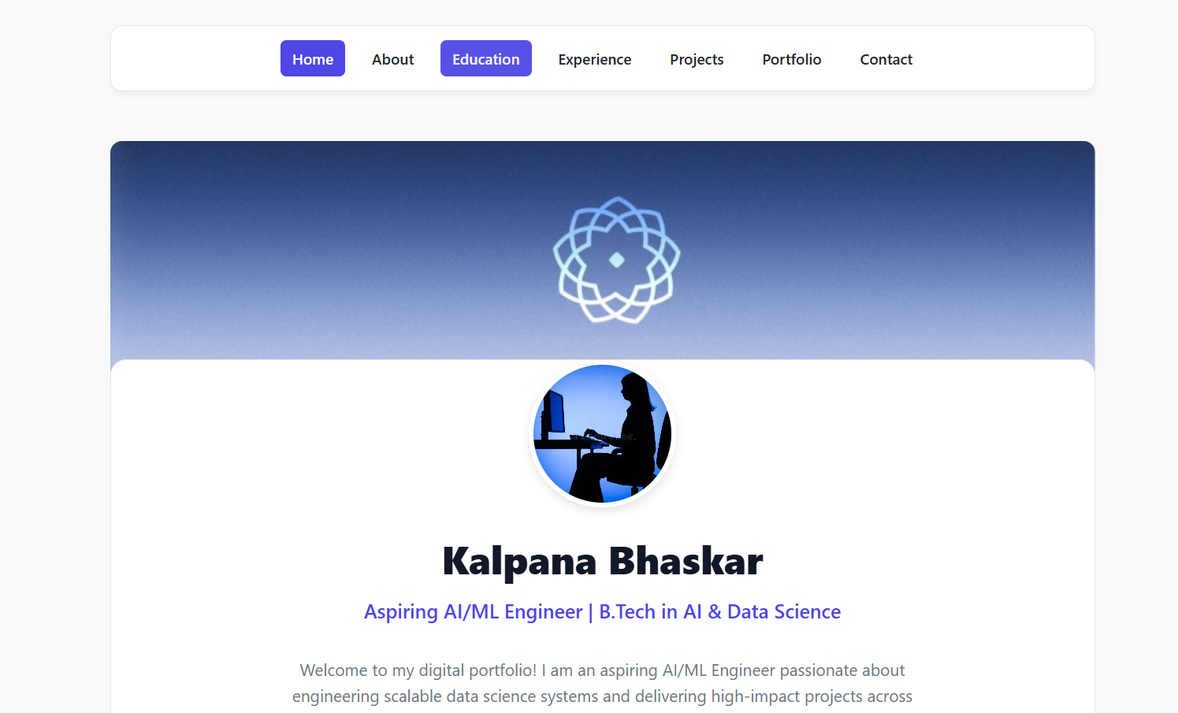
Home page (index.html)
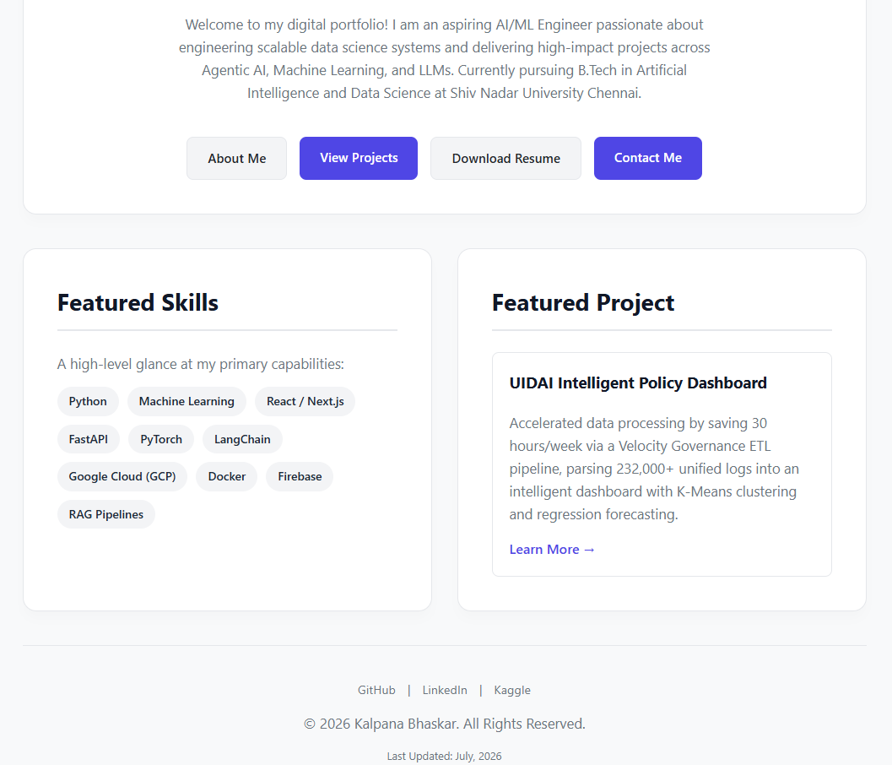
Home page (index.html), continued
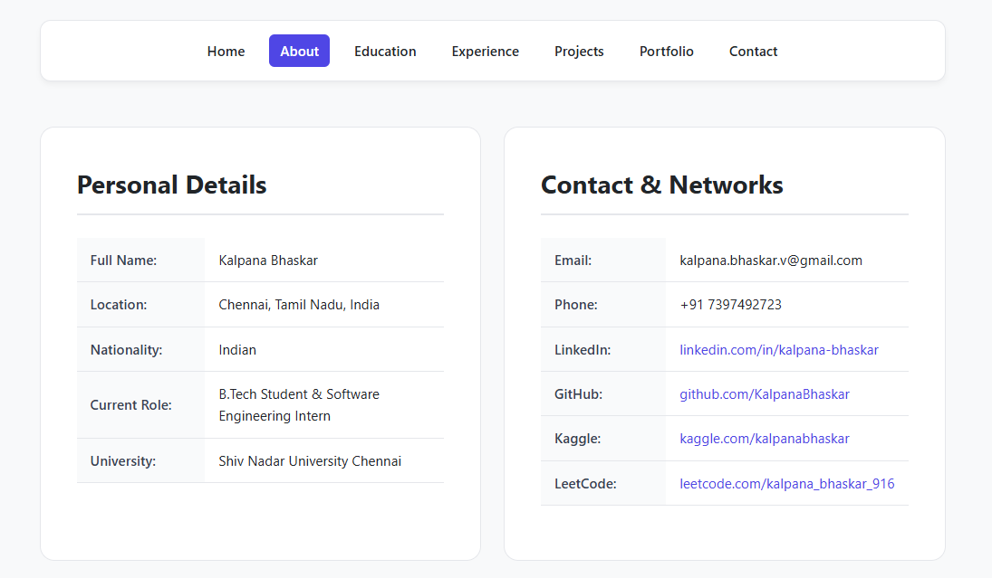
About page (about.html)
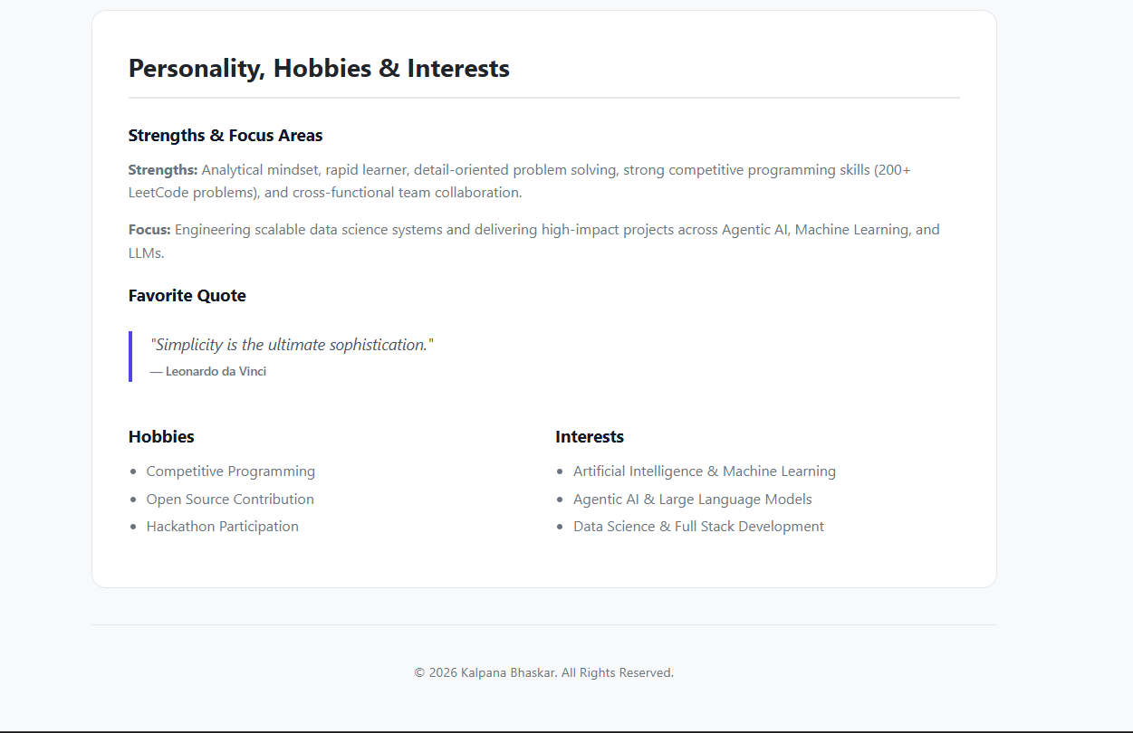
About page (about.html), continued
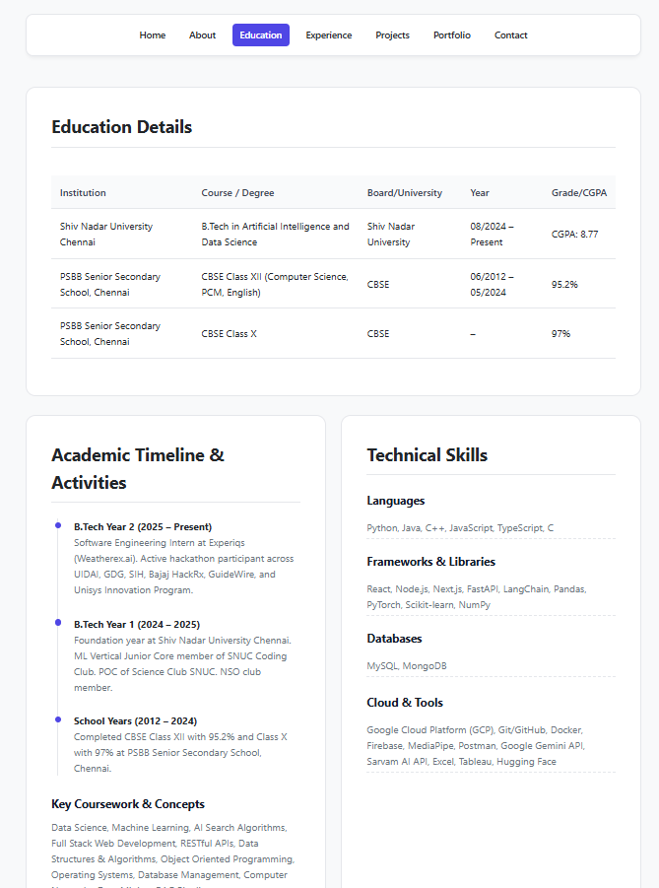
Education page (education.html)
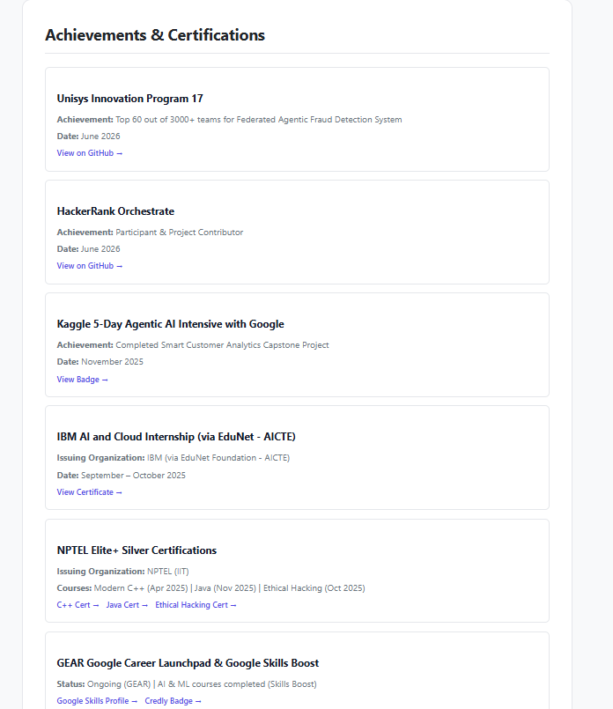
Achievements and certifications (education.html)
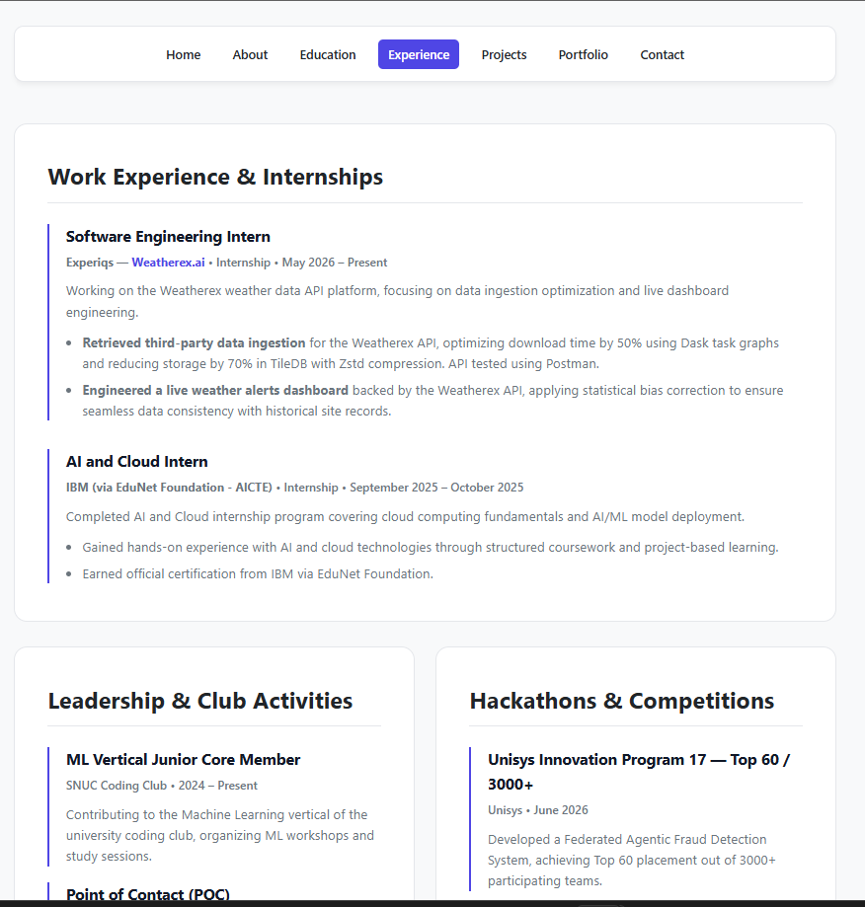
Experience page (experience.html)
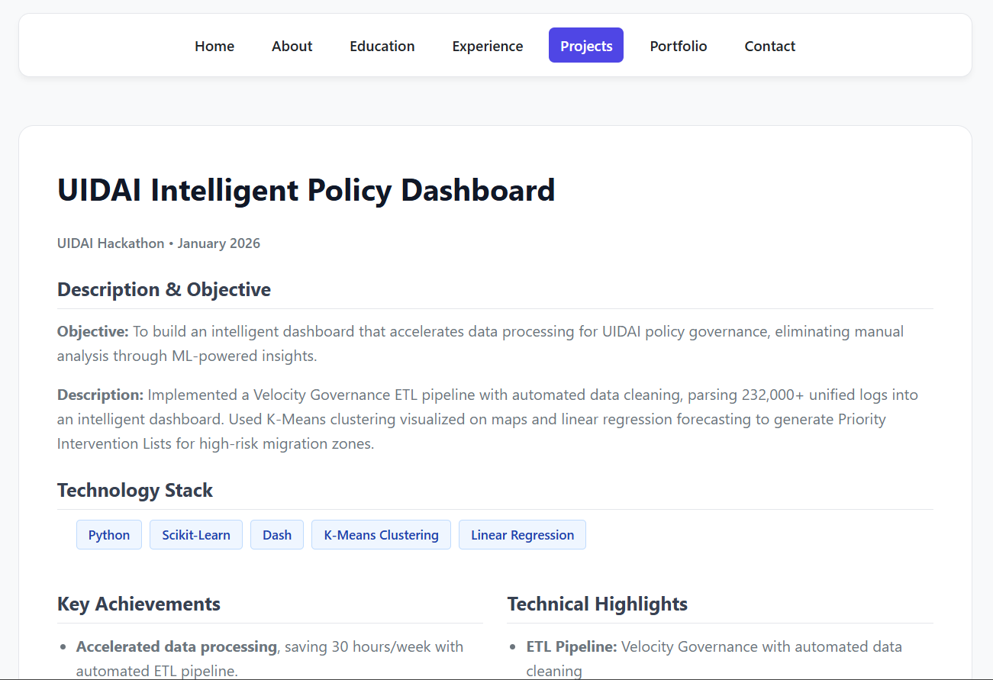
Projects page (projects.html)
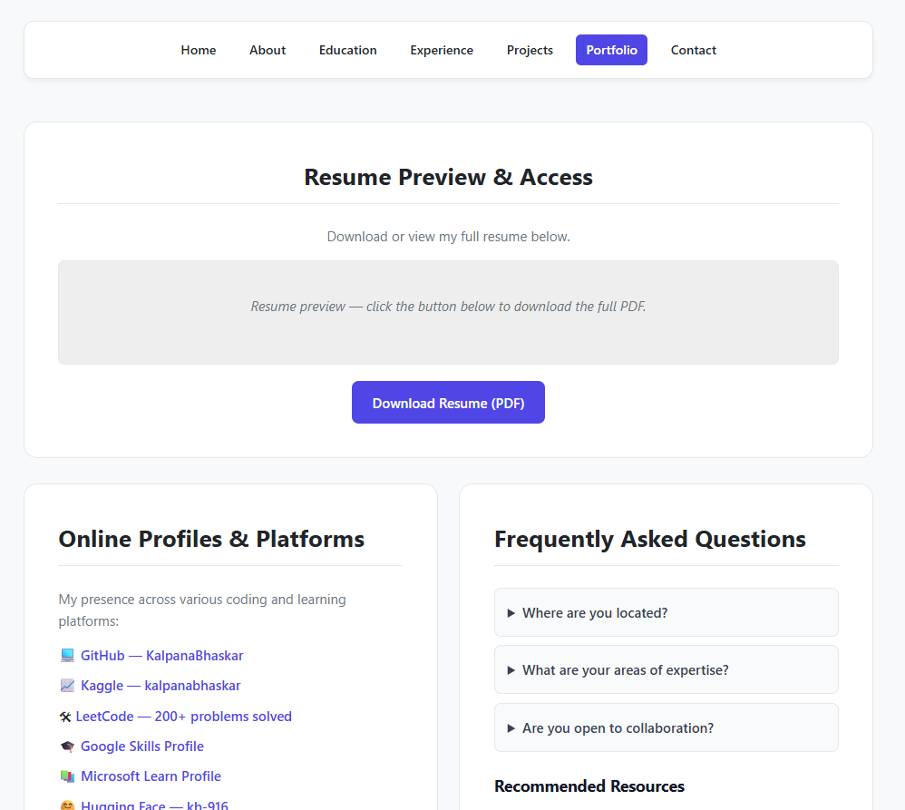
Portfolio page (portfolio.html)
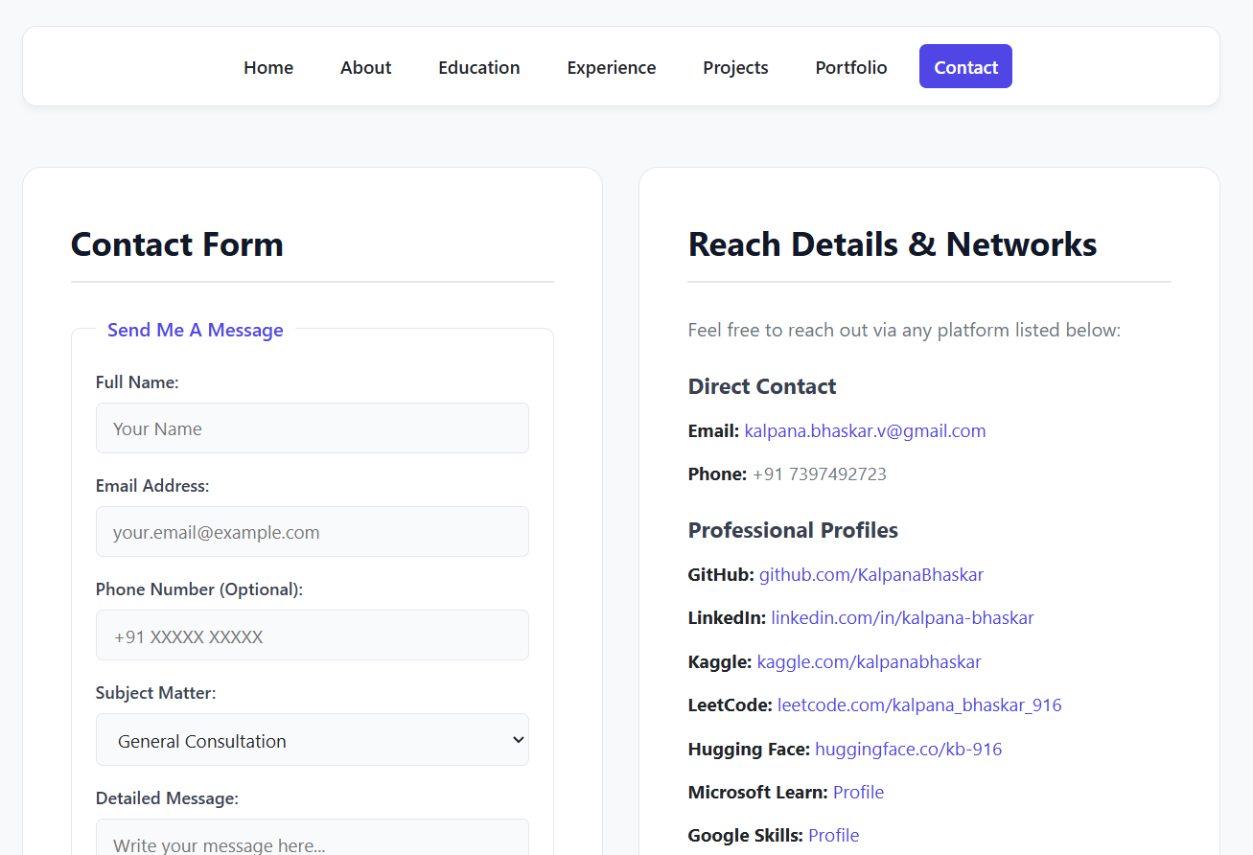
Contact page (contact.html)

