Online Job Application Portal
Aim:
Multi-step form validation system for an Online Job Application Portal
Theory:
1. DOM and multi-step navigation: The portal is a single HTML document holding three form blocks: registration, job application and success. Only one block carries the active class at a time, and CSS display rules hide the rest, so the page moves between stages without reloading.
2. Event-driven validation: Each form listens for its submit event. The handler calls preventDefault() to stop the browser from sending the form, then runs the validation function. The stage advances only when that function returns true, which acts as the workflow guard.
3. Field-level rules with regular expressions: Full name is checked with /^[A-Za-z\s]+$/, phone with /^\d{10}$/ and email with a structural pattern. The password pattern uses lookahead assertions to require a lowercase letter, an uppercase letter, a digit and a special character within a minimum length of eight.
4. Value checks and feedback: Dropdowns must hold a non-empty value, experience is parsed as an integer and bounded between 0 and 30, skills and project text are trimmed before checking, and the project description must reach 50 characters. Failed fields receive the invalid class and a visible error message through setValidity().
5. File validation: The resume input exposes the selected file through the files property. The script reads the file name, converts it to lower case and accepts it only when it ends with .pdf or .docx. The accept attribute on the input filters the file picker, and the script check enforces the rule.
6. Interactive controls: Password fields toggle between type password and type text, and the eye icon switches between the fa-eye and fa-eye-slash classes. Font Awesome supplies the icons through a stylesheet link, and CSS transitions and keyframes give the stage change a short fade-in.
Code:
portal.html:
<!DOCTYPE html>
<html lang="en">
<head>
<meta charset="UTF-8">
<meta name="viewport" content="width=device-width, initial-scale=1.0">
<title>Online Job Application Portal</title>
<!-- Font Awesome for eye icons -->
<link rel="stylesheet" href="https://cdnjs.cloudflare.com/ajax/libs/font-awesome/6.4.0/css/all.min.css">
<style>
:root {
--primary: #4f46e5;
--primary-hover: #4338ca;
--bg: #f3f4f6;
--card-bg: #ffffff;
--text: #1f2937;
--text-muted: #6b7280;
--error: #dc2626;
--success: #16a34a;
--border: #d1d5db;
}
* {
box-sizing: border-box;
margin: 0;
padding: 0;
font-family: 'Segoe UI', Tahoma, Geneva, Verdana, sans-serif;
}
body {
background-color: var(--bg);
color: var(--text);
display: flex;
justify-content: center;
align-items: center;
min-height: 100vh;
padding: 20px;
}
.container {
background: var(--card-bg);
width: 100%;
max-width: 550px;
padding: 30px;
border-radius: 12px;
box-shadow: 0 4px 6px -1px rgba(0, 0, 0, 0.1), 0 2px 4px -1px rgba(0, 0, 0, 0.06);
}
h2 {
margin-bottom: 20px;
text-align: center;
color: var(--primary);
}
/* Form Steps Visibility */
.form-step {
display: none;
}
.form-step.active {
display: block;
animation: fadeIn 0.4s ease-in-out;
}
@keyframes fadeIn {
from { opacity: 0; transform: translateY(10px); }
to { opacity: 1; transform: translateY(0); }
}
/* Form groups & styling */
.form-group {
margin-bottom: 18px;
position: relative;
}
label {
display: block;
margin-bottom: 6px;
font-weight: 600;
font-size: 0.9rem;
}
input[type="text"],
input[type="email"],
input[type="password"],
input[type="number"],
select,
textarea {
width: 100%;
padding: 10px 12px;
border: 1px solid var(--border);
border-radius: 6px;
font-size: 1rem;
outline: none;
transition: border-color 0.2s;
}
input:focus, select:focus, textarea:focus {
border-color: var(--primary);
box-shadow: 0 0 0 3px rgba(79, 70, 229, 0.1);
}
/* Password field wrapper for eye icon */
.password-wrapper {
position: relative;
}
.password-wrapper input {
padding-right: 40px;
}
.toggle-password {
position: absolute;
right: 12px;
top: 50%;
transform: translateY(-50%);
cursor: pointer;
color: var(--text-muted);
}
/* Error Messages */
.error-msg {
color: var(--error);
font-size: 0.825rem;
margin-top: 4px;
display: none;
}
input.invalid, select.invalid, textarea.invalid {
border-color: var(--error);
background-color: #fef2f2;
}
/* Buttons */
button {
width: 100%;
padding: 12px;
background-color: var(--primary);
color: white;
border: none;
border-radius: 6px;
font-size: 1rem;
font-weight: 600;
cursor: pointer;
transition: background-color 0.2s;
margin-top: 10px;
}
button:hover {
background-color: var(--primary-hover);
}
/* Success Screen */
.success-screen {
text-align: center;
padding: 20px 0;
}
.success-icon {
font-size: 4rem;
color: var(--success);
margin-bottom: 15px;
}
.success-title {
color: var(--success);
margin-bottom: 10px;
}
</style>
</head>
<body>
<div class="container">
<!-- STEP 1: Registration Form -->
<form id="registrationForm" class="form-step active" novalidate>
<h2>Register to Access Portal</h2>
<div class="form-group">
<label for="regName">Full Name</label>
<input type="text" id="regName" placeholder="John Doe">
<div class="error-msg" id="nameError">Full name should contain only alphabets and spaces.</div>
</div>
<div class="form-group">
<label for="regEmail">Email Address</label>
<input type="email" id="regEmail" placeholder="john@example.com">
<div class="error-msg" id="emailError">Please enter a valid email format.</div>
</div>
<div class="form-group">
<label for="regPhone">Phone Number</label>
<input type="text" id="regPhone" placeholder="10-digit number" maxlength="10">
<div class="error-msg" id="phoneError">Phone number must contain exactly 10 digits.</div>
</div>
<div class="form-group">
<label for="regPassword">Password</label>
<div class="password-wrapper">
<input type="password" id="regPassword" placeholder="••••••••">
<i class="fa-solid fa-eye toggle-password" data-target="regPassword"></i>
</div>
<div class="error-msg" id="passwordError">Must be 8+ chars with 1 uppercase, 1 lowercase, 1 number, and 1 special character.</div>
</div>
<div class="form-group">
<label for="regConfirmPassword">Confirm Password</label>
<div class="password-wrapper">
<input type="password" id="regConfirmPassword" placeholder="••••••••">
<i class="fa-solid fa-eye toggle-password" data-target="regConfirmPassword"></i>
</div>
<div class="error-msg" id="confirmPasswordError">Passwords do not match.</div>
</div>
<button type="submit">Register</button>
</form>
<!-- STEP 2: Job Application Form -->
<form id="jobApplicationForm" class="form-step" novalidate>
<h2>Job Application Form</h2>
<div class="form-group">
<label for="jobPosition">Position</label>
<select id="jobPosition">
<option value="">-- Select Position --</option>
<option value="frontend">Frontend Developer</option>
<option value="backend">Backend Developer</option>
<option value="qa">QA Engineer</option>
<option value="pm">Product Manager</option>
</select>
<div class="error-msg" id="positionError">Position must be selected.</div>
</div>
<div class="form-group">
<label for="jobLevel">Job Level</label>
<select id="jobLevel">
<option value="">-- Select Job Level --</option>
<option value="junior">Entry / Junior</option>
<option value="mid">Mid-Level</option>
<option value="senior">Senior</option>
</select>
<div class="error-msg" id="jobLevelError">Job Level must be selected.</div>
</div>
<div class="form-group">
<label for="jobExperience">Experience (Years)</label>
<input type="number" id="jobExperience" placeholder="0 - 30">
<div class="error-msg" id="experienceError">Experience should be between 0 and 30 years.</div>
</div>
<div class="form-group">
<label for="jobSkills">Skills</label>
<input type="text" id="jobSkills" placeholder="e.g. JavaScript, Python, SQL">
<div class="error-msg" id="skillsError">Skills field should not be empty.</div>
</div>
<div class="form-group">
<label for="jobProjects">Describe Your Projects</label>
<textarea id="jobProjects" rows="4" placeholder="Minimum 50 characters required..."></textarea>
<div class="error-msg" id="projectsError">Project description must contain at least 50 characters.</div>
</div>
<div class="form-group">
<label for="jobResume">Resume Upload (PDF or DOCX)</label>
<input type="file" id="jobResume" accept=".pdf,.docx">
<div class="error-msg" id="resumeError">Please upload your resume in PDF or DOCX format.</div>
</div>
<button type="submit">Submit Application</button>
</form>
<!-- STEP 3: Success View -->
<div id="successScreen" class="form-step success-screen">
<i class="fa-solid fa-circle-check success-icon"></i>
<h2 class="success-title">Application Submitted Successfully!</h2>
<p>Your registration and job application data have been accepted.</p>
</div>
</div>
<script>
// --- UTILITIES & SYSTEM STATE ---
const regForm = document.getElementById('registrationForm');
const jobForm = document.getElementById('jobApplicationForm');
const successScreen = document.getElementById('successScreen');

// Helper to toggle visibility of errors dynamically
function setValidity(inputEl, errorEl, isValid) {
if (isValid) {
inputEl.classList.remove('invalid');
errorEl.style.display = 'none';
} else {
inputEl.classList.add('invalid');
errorEl.style.display = 'block';
}
return isValid;
}

// --- PASSWORD EYE TOGGLE CONTROLLER ---
document.querySelectorAll('.toggle-password').forEach(icon => {
icon.addEventListener('click', function() {
const targetId = this.getAttribute('data-target');
const passwordInput = document.getElementById(targetId);
if (passwordInput.type === 'password') {
passwordInput.type = 'text';
this.classList.remove('fa-eye');
this.classList.add('fa-eye-slash');
} else {
passwordInput.type = 'password';
this.classList.remove('fa-eye-slash');
this.classList.add('fa-eye');
}
});
});

// --- STEP 1: REGISTRATION FIELD VALIDATORS ---
function validateRegistration() {
let isValid = true;

// 1. Full Name: Alphabets and Spaces only
const nameEl = document.getElementById('regName');
const nameErr = document.getElementById('nameError');
const nameRegex = /^[A-Za-z\s]+$/;
if (!setValidity(nameEl, nameErr, nameRegex.test(nameEl.value.trim()))) isValid = false;

// 2. Email Verification
const emailEl = document.getElementById('regEmail');
const emailErr = document.getElementById('emailError');
const emailRegex = /^[^\s@]+@[^\s@]+\.[^\s@]+$/;
if (!setValidity(emailEl, emailErr, emailRegex.test(emailEl.value.trim()))) isValid = false;

// 3. Phone: Exactly 10 digits
const phoneEl = document.getElementById('regPhone');
const phoneErr = document.getElementById('phoneError');
const phoneRegex = /^\d{10}$/;
if (!setValidity(phoneEl, phoneErr, phoneRegex.test(phoneEl.value.trim()))) isValid = false;

// 4. Password Check: 8+ length, Upper, Lower, Num, Special
const passEl = document.getElementById('regPassword');
const passErr = document.getElementById('passwordError');
const passRegex = /^(?=.*[a-z])(?=.*[A-Z])(?=.*\d)(?=.*[@$!%*?&])[A-Za-z\d@$!%*?&]{8,}$/;
if (!setValidity(passEl, passErr, passRegex.test(passEl.value))) isValid = false;

// 5. Confirm Password Match
const confirmEl = document.getElementById('regConfirmPassword');
const confirmErr = document.getElementById('confirmPasswordError');
const matches = (passEl.value === confirmEl.value) && confirmEl.value !== "";
if (!setValidity(confirmEl, confirmErr, matches)) isValid = false;

return isValid;
}

// --- STEP 2: JOB APPLICATION FIELD VALIDATORS ---
function validateJobApplication() {
let isValid = true;

// Position Selection
const posEl = document.getElementById('jobPosition');
const posErr = document.getElementById('positionError');
if (!setValidity(posEl, posErr, posEl.value !== "")) isValid = false;

// Job Level Selection
const lvlEl = document.getElementById('jobLevel');
const lvlErr = document.getElementById('jobLevelError');
if (!setValidity(lvlEl, lvlErr, lvlEl.value !== "")) isValid = false;

// Experience: 0 - 30 bounds Check
const expEl = document.getElementById('jobExperience');
const expErr = document.getElementById('experienceError');
const expVal = parseInt(expEl.value, 10);
const expValid = !isNaN(expVal) && expVal >= 0 && expVal <= 30;
if (!setValidity(expEl, expErr, expValid)) isValid = false;

// Skills Empty String Evaluation
const skillsEl = document.getElementById('jobSkills');
const skillsErr = document.getElementById('skillsError');
if (!setValidity(skillsEl, skillsErr, skillsEl.value.trim() !== "")) isValid = false;

// Project Description: >= 50 chars length
const projEl = document.getElementById('jobProjects');
const projErr = document.getElementById('projectsError');
if (!setValidity(projEl, projErr, projEl.value.trim().length >= 50)) isValid = false;

// Resume: Extension evaluation (.pdf or .docx)
const fileEl = document.getElementById('jobResume');
const fileErr = document.getElementById('resumeError');
let fileValid = false;
if (fileEl.files.length > 0) {
const fileName = fileEl.files[0].name.toLowerCase();
if (fileName.endsWith('.pdf') || fileName.endsWith('.docx')) {
fileValid = true;
}
}
if (!setValidity(fileEl, fileErr, fileValid)) isValid = false;

return isValid;
}

// --- FORM TRANSITION TRIGGERS ---
regForm.addEventListener('submit', function(e) {
e.preventDefault();
if (validateRegistration()) {
regForm.classList.remove('active');
jobForm.classList.add('active');
}
});

jobForm.addEventListener('submit', function(e) {
e.preventDefault();
if (validateJobApplication()) {
jobForm.classList.remove('active');
successScreen.classList.add('active');
}
});
</script>
</body>
</html>
GitHub Repository:
https://github.com/KalpanaBhaskar/Web-Technologies-Laboratory
Output:
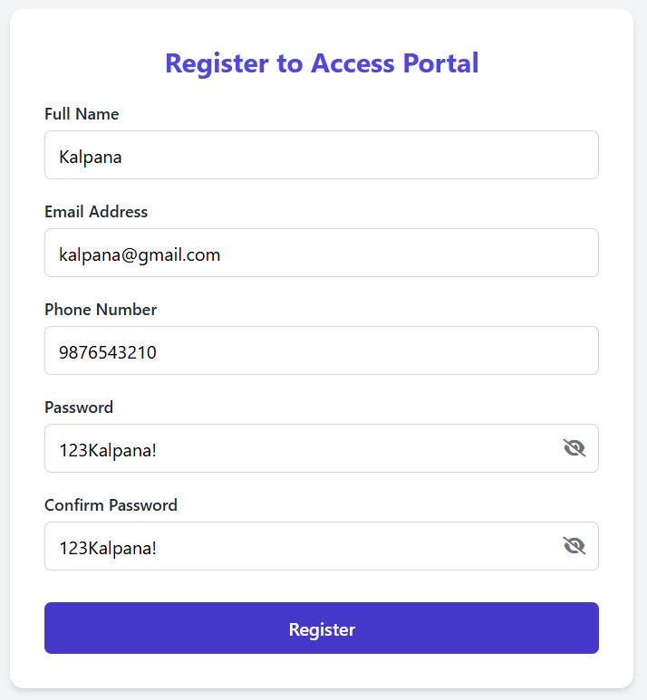
Registration page (Step 1)
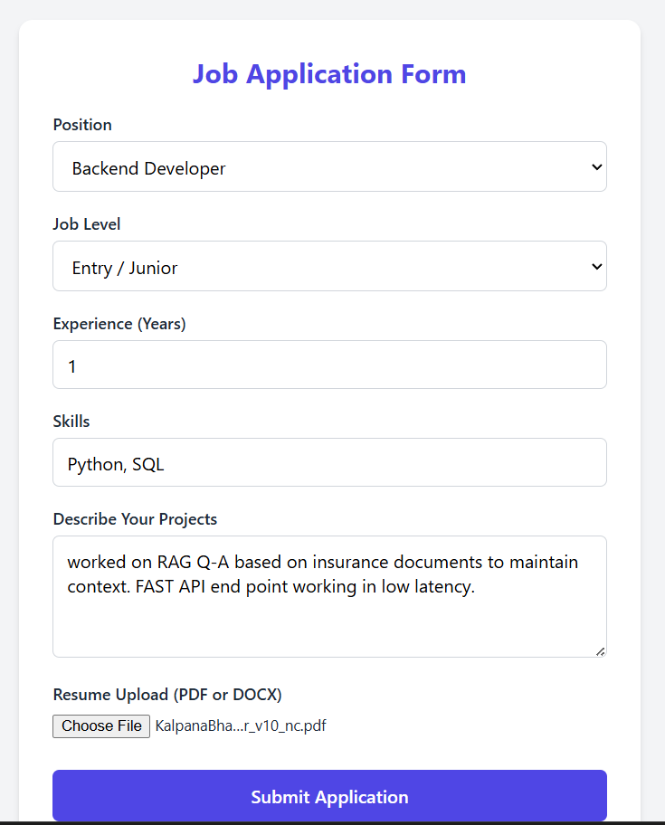
Job application form (Step 2)
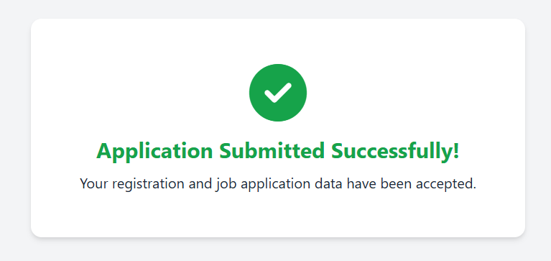
Submission success screen (Step 3)

