CSS Dark and Light Theme using JavaScript
Aim:
To design and implement a CSS dark and light theme using JavaScript, with the default stylesheet in light mode, implemented over the Lab 1 portfolio website. The theme is changed by directly manipulating DOM elements and their classes, using classList.toggle().
Theory:
1. Default light theme: The base rules in style.css define the light palette (body background #f4f7f6, white cards, dark text). The page therefore opens in light mode without any script running. Dark styles are added separately, so the light design is never overwritten by default.
2. Class-scoped dark styles: Every dark rule is written as a descendant of body.dark-theme, for example body.dark-theme .card. These selectors are more specific than the base rules, so they win the cascade only while the dark-theme class is present on the body element. Removing the class restores the light values automatically.
3. classList.toggle(): The method adds the named class if it is absent and removes it if it is present. It returns true when the class was added and false when it was removed. The script stores this return value in isDarkMode and uses it to set the button label to Light Mode or Dark Mode, so the label and the theme always agree.
4. Direct DOM manipulation: The script obtains the button with getElementById, attaches a handler to its onclick property, and updates the button's innerHTML inside the handler. The theme itself is changed only through the class list of the body element. The page is not reloaded, and the current state is held in the DOM.
5. Transitions between themes: A shared transition rule applies to body, header, cards, table cells, the footer and the download button. Background-color, color and border-color change over 0.4 seconds instead of switching instantly, which makes the change smooth for the viewer.
6. Integration with the Lab 1 portfolio: The theme is applied to the existing portfolio sections, including the header with profile and contact links, the education table, project cards, skills and certifications lists, and the footer. Theme state is not saved, so a page reload returns the site to light mode. Saving the choice would require localStorage, which is outside this lab's scope.
Code:
index.html:
<!DOCTYPE html>
<html lang="en">
<head>
<meta charset="UTF-8">
<meta name="viewport" content="width=device-width, initial-scale=1.0">
<title>My First Online Resume</title>
<link rel="stylesheet" href="style.css">
</head>
<body>
<!-- Header Section -->
<header>
<!-- Theme Button -->
<button id="themeBtn">Dark Mode</button>
<div class="header-container">
<img src="profilepic.webp" alt="Profile Picture" class="profile-img">
<div class="header-text">
<h1>Kalpana Bhaskar</h1>
<p class="subtitle">
Aspiring AI Engineer, AI & Data Science Student
</p>
<p class="contact-info">
Email:
<a href="mailto:kalpanabhaskar@email.com">
kalpanabhaskar@email.com
</a>
|
LinkedIn:
<a href="https://linkedin.com" target="_blank">
linkedin.com/in/kalpanabhaskar
</a>
|
GitHub:
<a href="https://github.com" target="_blank">
github.com/kalpanabhaskar
</a>
</p>
</div>
</div>
</header>
<!-- Main Content -->
<main class="main-container">
<div class="left-column">
<section class="card">
<h2>Education</h2>
<table>
<thead>
<tr>
<th>Degree / Course</th>
<th>Institution</th>
<th>Year</th>
<th>GPA / %</th>
</tr>
</thead>
<tbody>
<tr>
<td>B.Tech in AI and Data Science</td>
<td>University of Technology</td>
<td>2024 - Present</td>
<td>9.0 CGPA</td>
</tr>
<tr>
<td>Higher Secondary (12th)</td>
<td>State CBSE School</td>
<td>2022 - 2024</td>
<td>95%</td>
</tr>
</tbody>
</table>
</section>
<section class="card">
<h2>Projects</h2>
<div class="project-item">
<h3>Portfolio Website</h3>
<p>
Designed a responsive personal portfolio using
<strong>HTML5</strong> and
<strong>CSS3 Flexbox</strong>.
</p>
</div>
<div class="project-item">
<h3>Task Manager App</h3>
<p>
Built a JavaScript To-Do application with local storage.
</p>
</div>
</section>
</div>
<div class="right-column">
<section class="card">
<h2>Technical Skills</h2>
<ul>
<li><strong>Languages:</strong> HTML5, CSS3, JavaScript, Python</li>
<li><strong>Frameworks & Tools:</strong> Git, GitHub, VS Code</li>
<li><strong>Concepts:</strong> Responsive Web Design, UI/UX Basics</li>
</ul>
</section>
<section class="card">
<h2>Certifications & Achievements</h2>
<ol>
<li>Responsive Web Design - freeCodeCamp</li>
<li>Python for Everybody - Coursera</li>
<li>Core member of Coding Club (Web Dev Vertical)</li>
</ol>
</section>
</div>
</main>
<!-- Download Resume -->
<div class="download-section">
<a href="sampleresume.pdf" download class="download-btn">
Download Sample Resume
</a>
</div>
<!-- Footer -->
<footer>
<p>
&copy; 2026 Kalpana Bhaskar.
Built for Web Technologies Lab.
</p>
</footer>
<!-- JavaScript -->
<script src="script.js"></script>
</body>
</html>
style.css:
/* Reset and Base Styles */
* {
margin: 0;
padding: 0;
box-sizing: border-box;
font-family: 'Segoe UI', Tahoma, Geneva, Verdana, sans-serif;
}
body {
background-color: #f4f7f6;
color: #333;
line-height: 1.6;
padding: 20px;
}
/* Header Section with Flexbox */
header {
background-color: #2c3e50;
color: #fff;
padding: 30px;
border-radius: 8px;
margin-bottom: 20px;
}
.header-container {
display: flex;
align-items: center;
gap: 30px;
flex-wrap: wrap; /* Ensures responsiveness on smaller screens */
}
.profile-img {
border-radius: 50%;
width: 120px;
height: 120px;
object-fit: cover;
border: 3px solid #fff;
}
.header-text h1 {
font-size: 2.5rem;
margin-bottom: 5px;
}
.subtitle {
font-size: 1.2rem;
color: #1abc9c;
font-weight: 600;
margin-bottom: 10px;
}
.contact-info a {
color: #fff;
text-decoration: none;
border-bottom: 1px dashed #1abc9c;
}
.contact-info a:hover {
color: #1abc9c;
}
/* Main Layout using Flexbox */
.main-container {
display: flex;
gap: 20px;
flex-wrap: wrap;
}
.left-column {
flex: 2; /* Takes up 2/3 of the width */
min-width: 300px;
}
.right-column {
flex: 1; /* Takes up 1/3 of the width */
min-width: 250px;
}
/* Card Styling for Sections */
.card {
background: #fff;
padding: 20px;
margin-bottom: 20px;
border-radius: 8px;
box-shadow: 0 4px 6px rgba(0,0,0,0.05);
}
.card h2 {
color: #2c3e50;
border-bottom: 2px solid #1abc9c;
padding-bottom: 5px;
margin-bottom: 15px;
}
/* Table Styling */
table {
width: 100%;
border-collapse: collapse;
margin-top: 10px;
}
th, td {
padding: 12px;
text-align: left;
border-bottom: 1px solid #ddd;
}
th {
background-color: #f8f9fa;
color: #2c3e50;
}
/* Lists and Project Styles */
ul, ol {
padding-left: 20px;
}
li {
margin-bottom: 10px;
}
.project-item {
margin-bottom: 15px;
}
.project-item h3 {
color: #34495e;
margin-bottom: 5px;
}
/* Footer Section */
footer {
text-align: center;
padding: 20px;
color: #7f8c8d;
font-size: 0.9rem;
margin-top: 20px;
}
/* Download Button Section */
.download-section {
text-align: center;
margin: 30px 0;
}
/* Download Button */
.download-btn {
display: inline-block;
background-color: #0077b6;
color: white;
text-decoration: none;
padding: 10px 22px;
border-radius: 6px;
font-size: 16px;
font-weight: bold;
transition: background-color 0.3s ease, transform 0.2s ease;
}
.download-btn:hover {
background-color: #023e8a;
transform: translateY(-2px);
}
.download-btn:active {
transform: scale(0.98);
}
/* ===========================
Theme Button
=========================== */
#themeBtn {
float: right;
background-color: white;
color: #2c3e50;
border: none;
padding: 10px 18px;
font-size: 15px;
font-weight: bold;
border-radius: 6px;
cursor: pointer;
transition: 0.3s;
margin-bottom: 15px;
}
#themeBtn:hover {
background-color: #1abc9c;
color: white;
}
/* Smooth transition while changing theme */
body,
header,
.card,
footer,
th,
td,
.download-btn,
.contact-info a,
.card h2,
.project-item h3 {
transition: background-color 0.4s ease,
color 0.4s ease,
border-color 0.4s ease;
}
/* ===========================
Dark Theme using classList.toggle()
=========================== */
body.dark-theme {
background-color: #1e1e1e;
color: #ffffff;
}
body.dark-theme header {
background-color: #111111;
}
body.dark-theme .card {
background-color: #2d2d2d;
color: #ffffff;
}
body.dark-theme .card h2,
body.dark-theme .project-item h3 {
color: #00e5ff;
}
body.dark-theme .contact-info a {
color: #00e5ff;
}
body.dark-theme th {
background-color: #444;
color: #ffffff;
}
body.dark-theme td {
border-bottom-color: #666;
}
body.dark-theme footer {
color: #ffffff;
}
script.js:
// Get the theme button
const themeBtn = document.getElementById("themeBtn");

// Toggle the dark theme class when the button is clicked
themeBtn.onclick = function () {
const isDarkMode = document.body.classList.toggle("dark-theme");
themeBtn.innerHTML = isDarkMode ? "Light Mode" : "Dark Mode";
};
GitHub Repository:
https://github.com/KalpanaBhaskar/Web-Technologies-Laboratory/tree/main/week_3
Output:
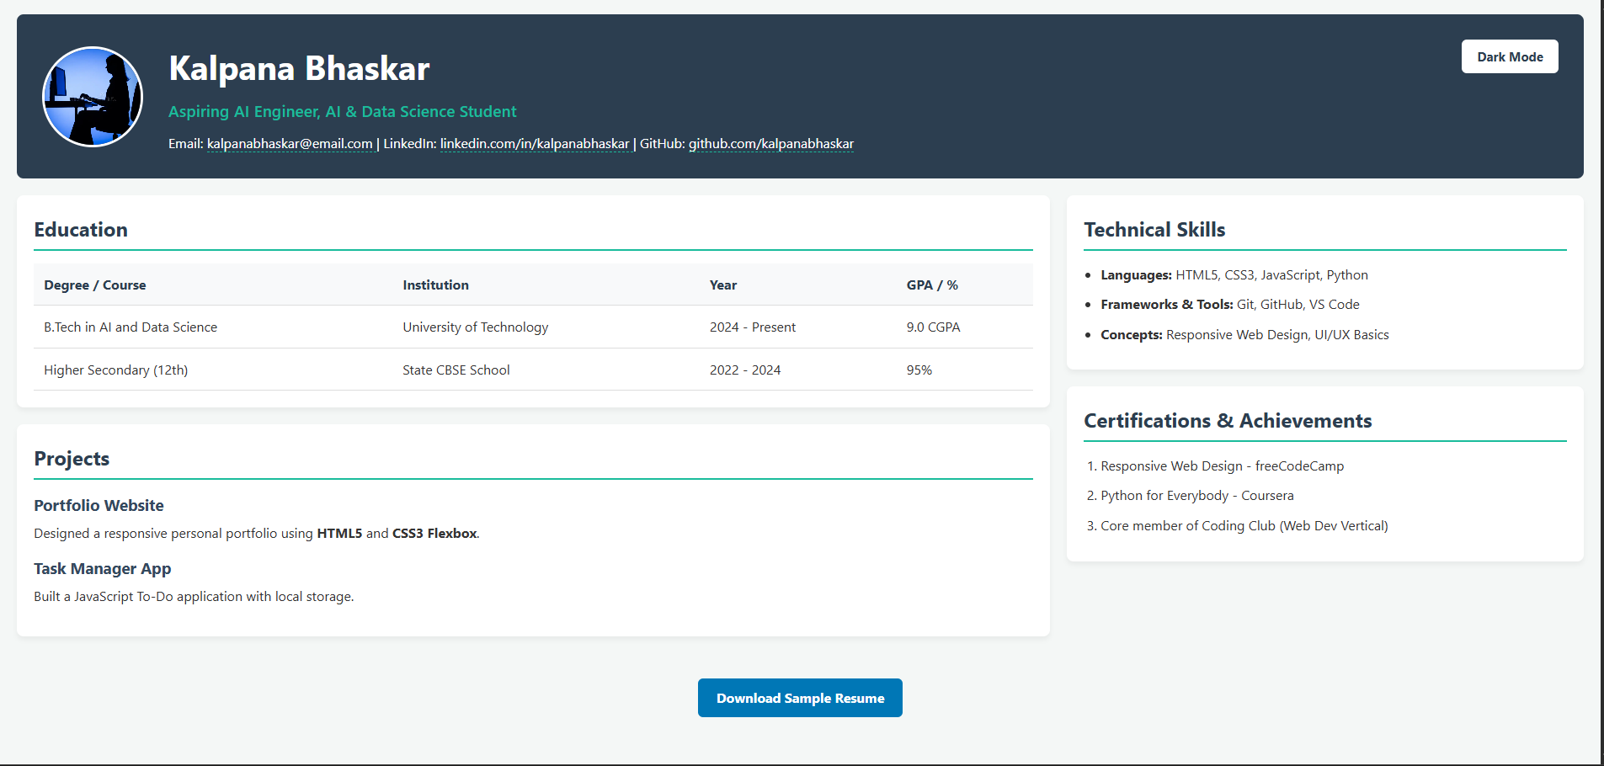
Light mode (default)
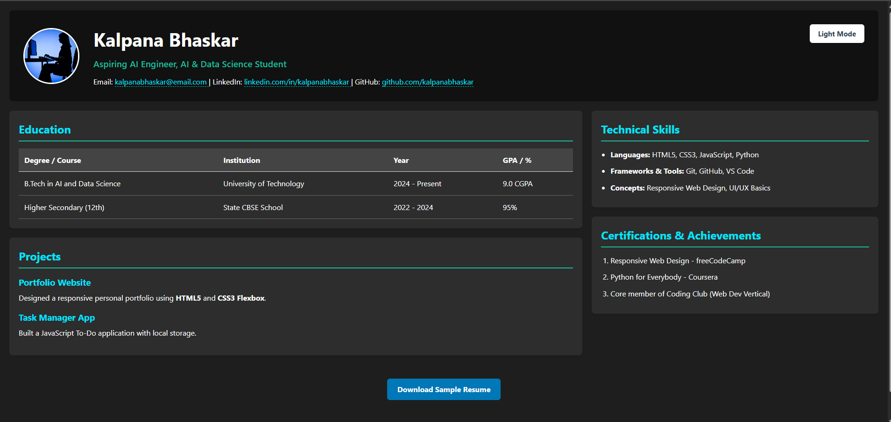
Dark mode (after clicking the theme button)

