Online Shopping Product Catalog using React
Aim:
To develop a React-based Online Shopping Product Catalog that demonstrates dynamic searching, filtering and conditional rendering using React state management. The catalog supports searching products by name, filtering by category (Electronics, Clothing, Grocery) and by price range, showing "Out of Stock" when quantity is 0, and displaying the product count.
Theory:
1. Component structure and props: The application is split into an App root component and a ProductCard child component. App owns the product data and the filter state, and passes each product to ProductCard through the product prop. The card only displays what it receives, so presentation and logic stay separate.
2. State with useState: Three state variables, search, category and priceRange, hold the current filter values. Each input is a controlled element, with its value bound to state and updated through onChange. A change to any filter updates state, which triggers a re-render of the catalog.
3. Derived data with filter(): The filtered list is not stored in state. It is recalculated on every render by calling products.filter(). Each product must pass three checks: the name contains the search text (case-insensitive), the category matches or is All, and the price falls in the selected range. The checks are combined with a logical AND, so every active filter applies at once.
4. Multiple filters and price conditions: The price range is handled by a chain of if and else if branches that map the option values Below500, 500-1000 and Above1000 to comparisons on product.price. The All Prices option leaves matchesPrice as true, so the price filter has no effect.
5. Rendering lists with map() and keys: The filtered array is converted to JSX with map(), which returns one ProductCard per product. Each element receives a key equal to product.id, which lets React track items across updates and reuse their DOM nodes. The product count is shown with filteredProducts.length.
6. Conditional rendering: The stock status is decided by a ternary expression in ProductCard. If quantity equals 0, the card shows the Out of Stock span with the out class, and otherwise it shows In Stock with the in class. The same pattern hides or shows content based on state, so the displayed output always matches the data.
Code:
App.jsx:
import { useState } from "react";
import products from "./data/products";
import ProductCard from "./components/ProductCard";
import "./App.css";

function App() {
const [search, setSearch] = useState("");
const [category, setCategory] = useState("All");
const [priceRange, setPriceRange] = useState("All");

const filteredProducts = products.filter((product) => {
const matchesSearch = product.name
.toLowerCase()
.includes(search.toLowerCase());

const matchesCategory =
category === "All" || product.category === category;

let matchesPrice = true;

if (priceRange === "Below500") {
matchesPrice = product.price < 500;
} else if (priceRange === "500-1000") {
matchesPrice = product.price >= 500 && product.price <= 1000;
} else if (priceRange === "Above1000") {
matchesPrice = product.price > 1000;
}

return matchesSearch && matchesCategory && matchesPrice;
});

return (
<div className="container">
<h1>Online Shopping Product Catalog</h1>

<div className="filters">
<input
type="text"
placeholder="Search Product"
value={search}
onChange={(e) => setSearch(e.target.value)}
/>

<select
value={category}
onChange={(e) => setCategory(e.target.value)}
>
<option>All</option>
<option>Electronics</option>
<option>Clothing</option>
<option>Grocery</option>
</select>

<select
value={priceRange}
onChange={(e) => setPriceRange(e.target.value)}
>
<option value="All">All Prices</option>
<option value="Below500">Below ₹500</option>
<option value="500-1000">₹500 - ₹1000</option>
<option value="Above1000">Above ₹1000</option>
</select>
</div>

<h3>Products Found: {filteredProducts.length}</h3>

<div className="products">
{filteredProducts.map((product) => (
<ProductCard
key={product.id}
product={product}
/>
))}
</div>
</div>
);
}

export default App;
main.jsx:
import React from "react";
import ReactDOM from "react-dom/client";
import App from "./App";
import "./index.css";

ReactDOM.createRoot(document.getElementById("root")).render(
<React.StrictMode>
<App />
</React.StrictMode>
);
ProductCard.jsx:
function ProductCard({ product }) {
return (
<div className="card">
<h3>{product.name}</h3>

<p>Category: {product.category}</p>
<p>Price: ₹{product.price}</p>
<p>Quantity: {product.quantity}</p>

<p>
{product.quantity === 0 ? (
<span className="out">Out of Stock</span>
) : (
<span className="in">In Stock</span>
)}
</p>
</div>
);
}

export default ProductCard;
Products.js:
const products = [
{
id: 1,
name: "Laptop",
category: "Electronics",
price: 55000,
quantity: 5,
},
{
id: 2,
name: "Mobile",
category: "Electronics",
price: 18000,
quantity: 0,
},
{
id: 3,
name: "T-Shirt",
category: "Clothing",
price: 700,
quantity: 10,
},
{
id: 4,
name: "Jeans",
category: "Clothing",
price: 1200,
quantity: 2,
},
{
id: 5,
name: "Rice",
category: "Grocery",
price: 450,
quantity: 15,
},
{
id: 6,
name: "Bread",
category: "Grocery",
price: 50,
quantity: 0,
},
];

export default products;
GitHub Repository:
https://github.com/KalpanaBhaskar/Web-Technologies-Laboratory/tree/main/week_4
Output:
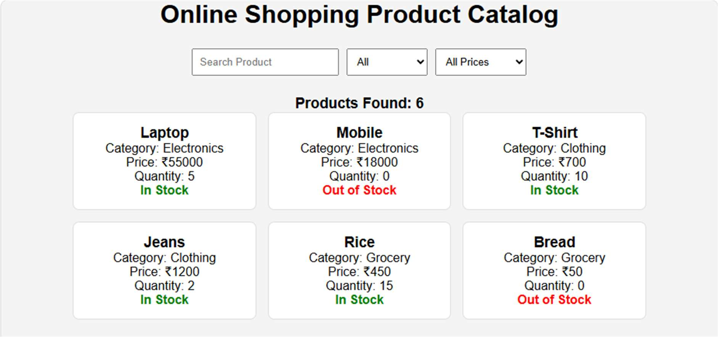
Full catalog with no filters applied (6 products)
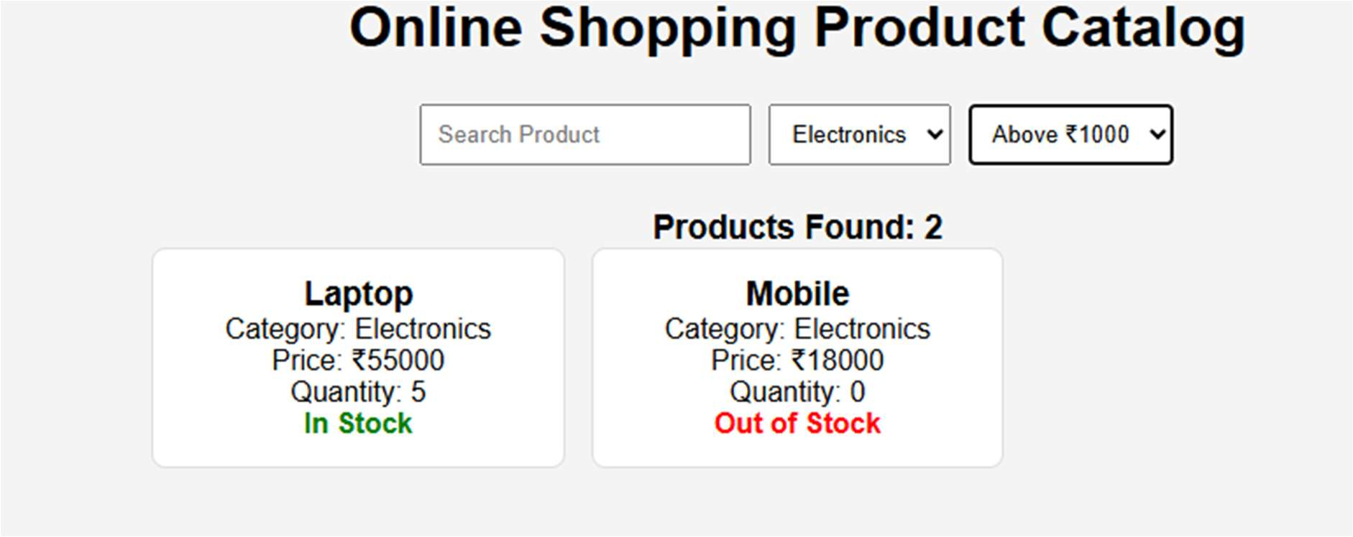
Category: Electronics, Price: Above ₹1000
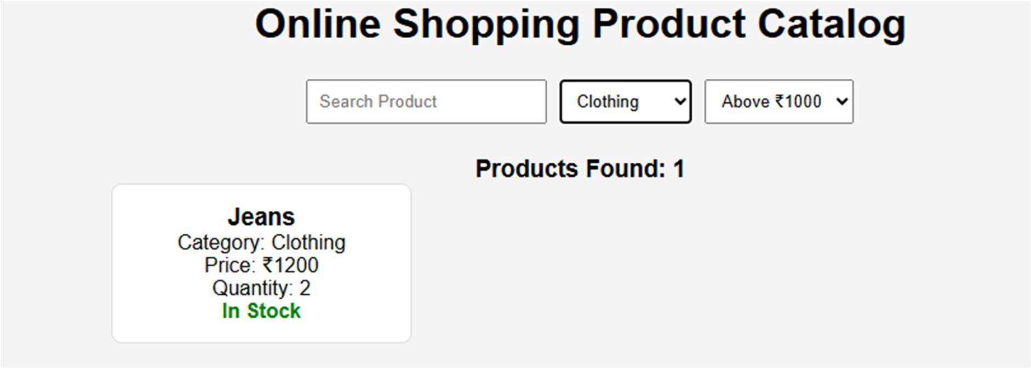
Category: Clothing, Price: Above ₹1000
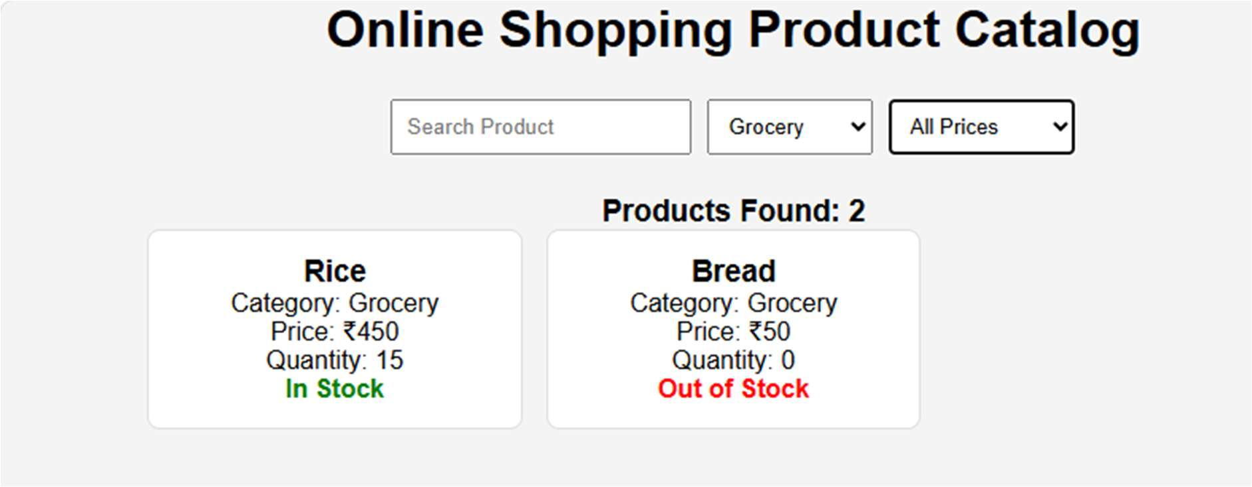
Category: Grocery, Price: All Prices

