React.js Menu Navigation System for a University Website
Aim:
To design and implement a React.js-based menu navigation system for a university website containing menus such as About Us, Academics, Admissions, Research, Campus Life, Placements and Contact Us. Dropdown menus are implemented for the relevant sections, and React components, props, JSX, event handling and React Router are used to provide smooth navigation between pages.
Theory:
1. Components and props: The navigation bar is built from reusable React components. Each menu item receives its label, route path and dropdown entries through props, so the same component renders every menu without repeated markup. The parent component passes data down, and the child component only displays it.
2. JSX and data-driven menus: The menu structure is stored as an array of objects, and map() converts that array into JSX elements. Each menu item is rendered with a unique key. Adding or changing a menu entry therefore requires editing the data, not the layout code.
3. Event handling and dropdown state: Each dropdown is controlled by a useState value that stores the currently open menu. Mouse or click events update this state through event handlers such as onMouseEnter, onMouseLeave and onClick. The dropdown panel renders only when its state matches the menu, which keeps the interface consistent.
4. React Router setup: The application wraps its components in BrowserRouter and defines a route for each page using Routes and Route. Each route maps a URL path such as /about, /academics or /admissions to a page component. Navigation changes the displayed page without a full browser reload.
5. Client-side navigation with Link and NavLink: Menu items use the Link component in place of anchor tags, which prevents full page requests and keeps the single-page application running. The NavLink component adds an active class to the current route, which produces the red underline shown on the active menu item in the results.
6. Shared layout and page composition: The header navigation and footer are placed in a shared layout that remains on screen while the page content changes. Each page, such as Academics, Admissions or Campus Life, is a separate component with its own hero banner and content sections. This keeps the navigation consistent across all pages of the site.
Code:
The source code for this assignment is available in the GitHub repository listed below.
GitHub Repository:
https://github.com/KalpanaBhaskar/Web-Technologies-Laboratory/tree/main/week_5
Output:
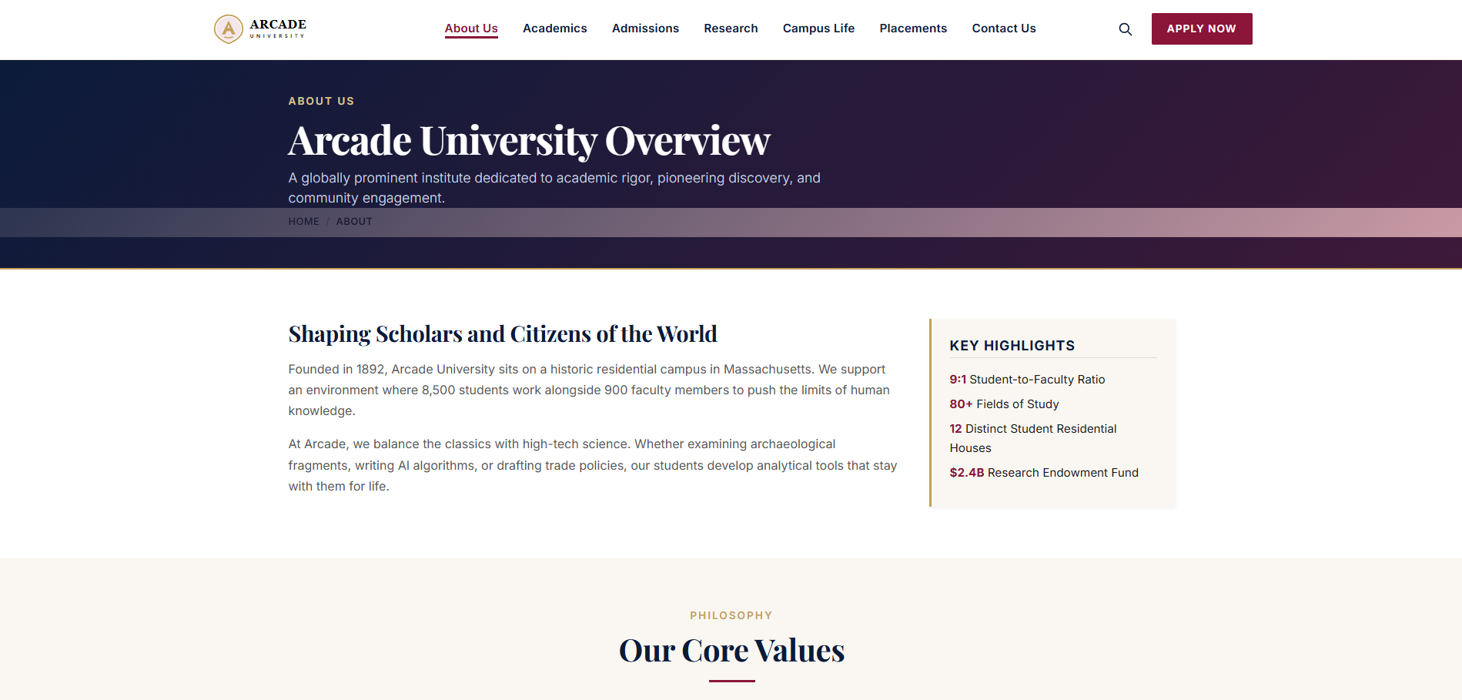
About Us: university overview
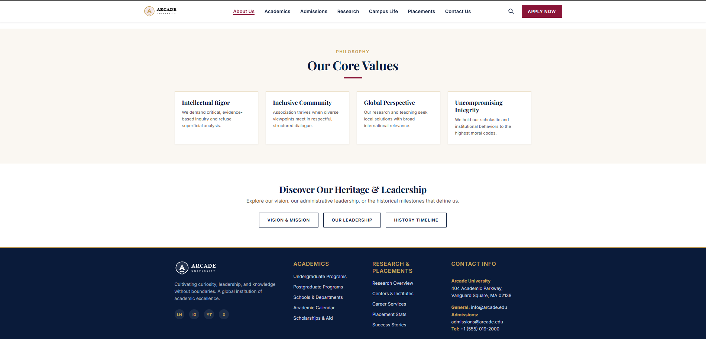
About Us: core values and heritage
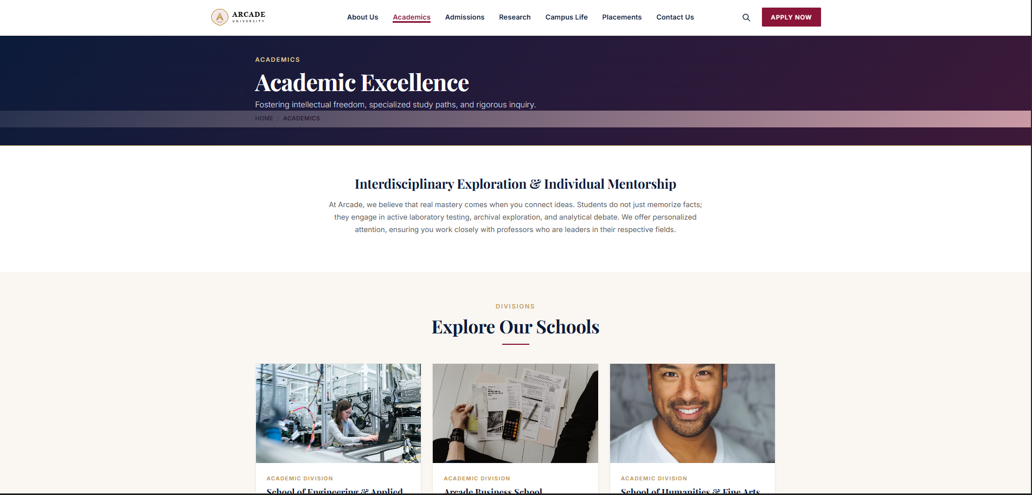
Academics: academic excellence and school divisions
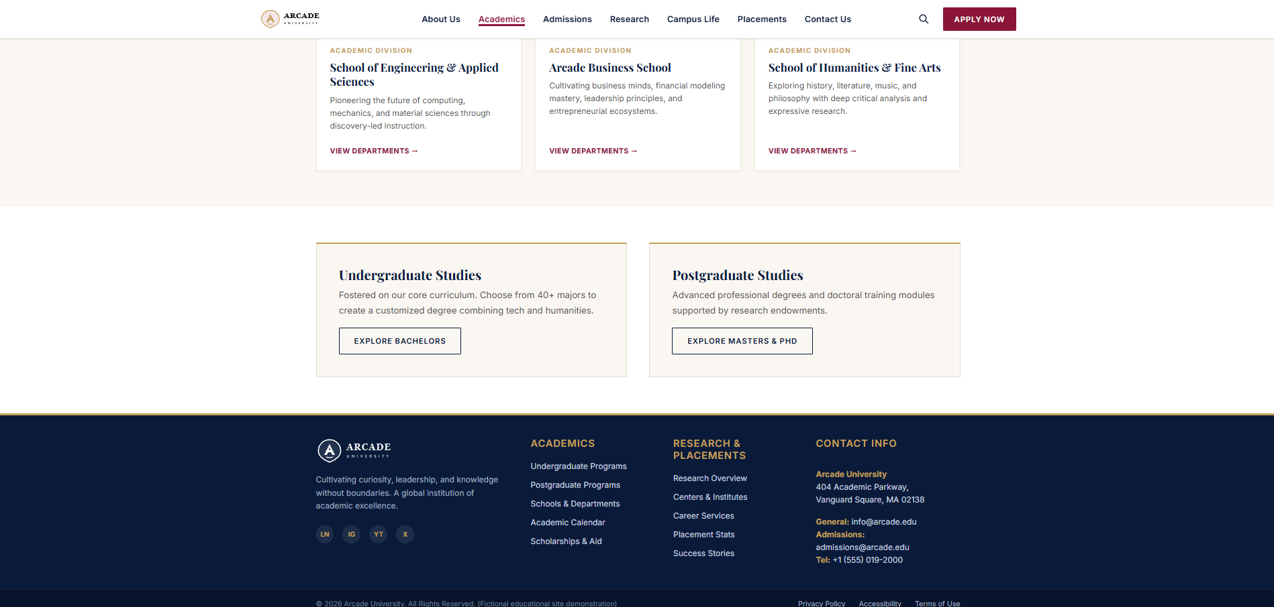
Academics: undergraduate and postgraduate studies
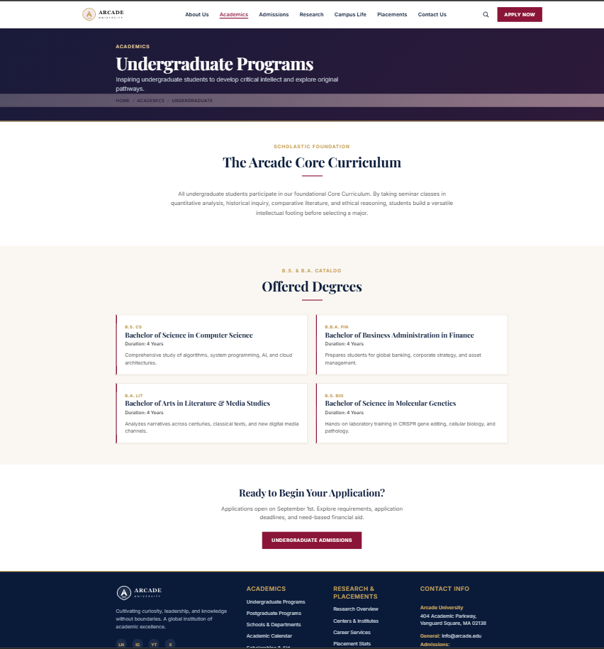
Academics: undergraduate programs
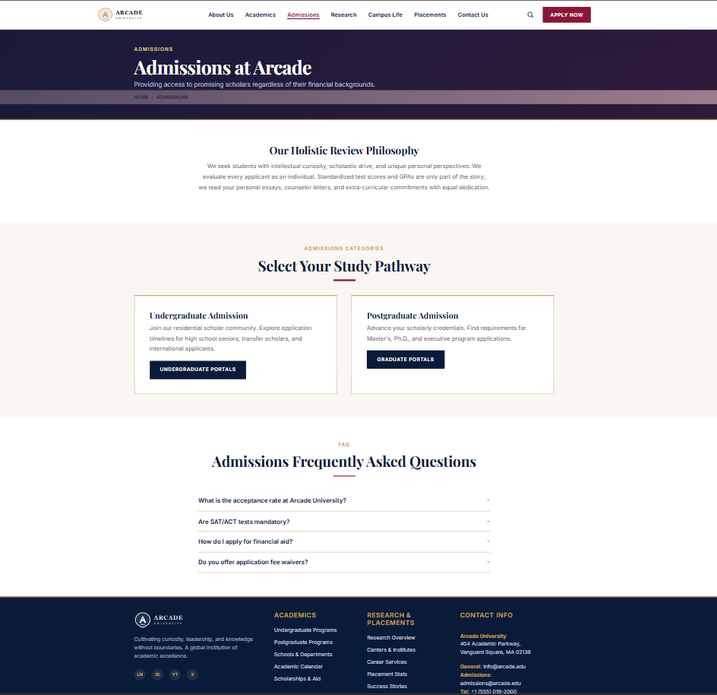
Admissions: admissions at Arcade
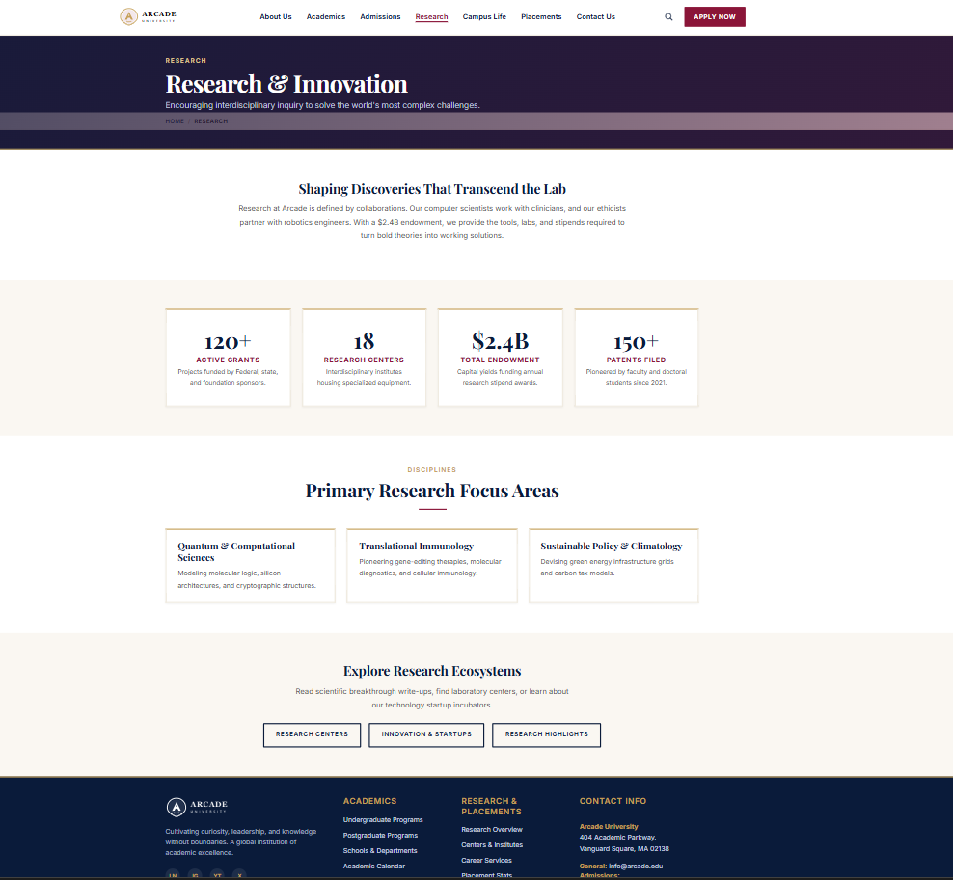
Research: research and innovation
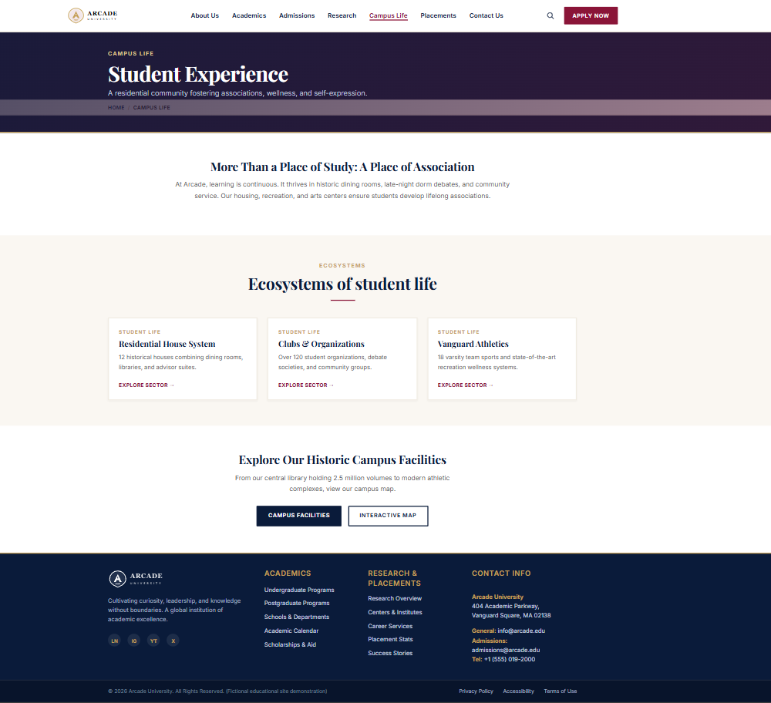
Campus Life: student experience
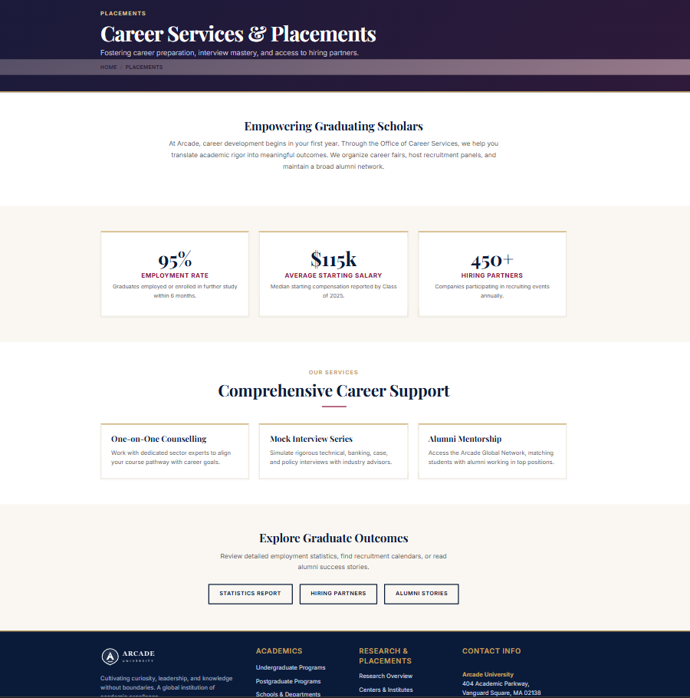
Placements: career services and placements
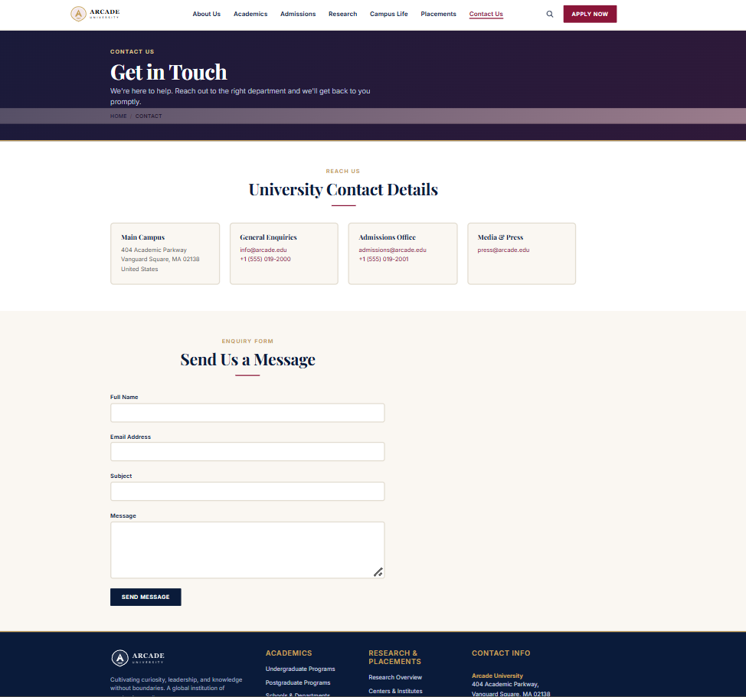
Contact Us: get in touch
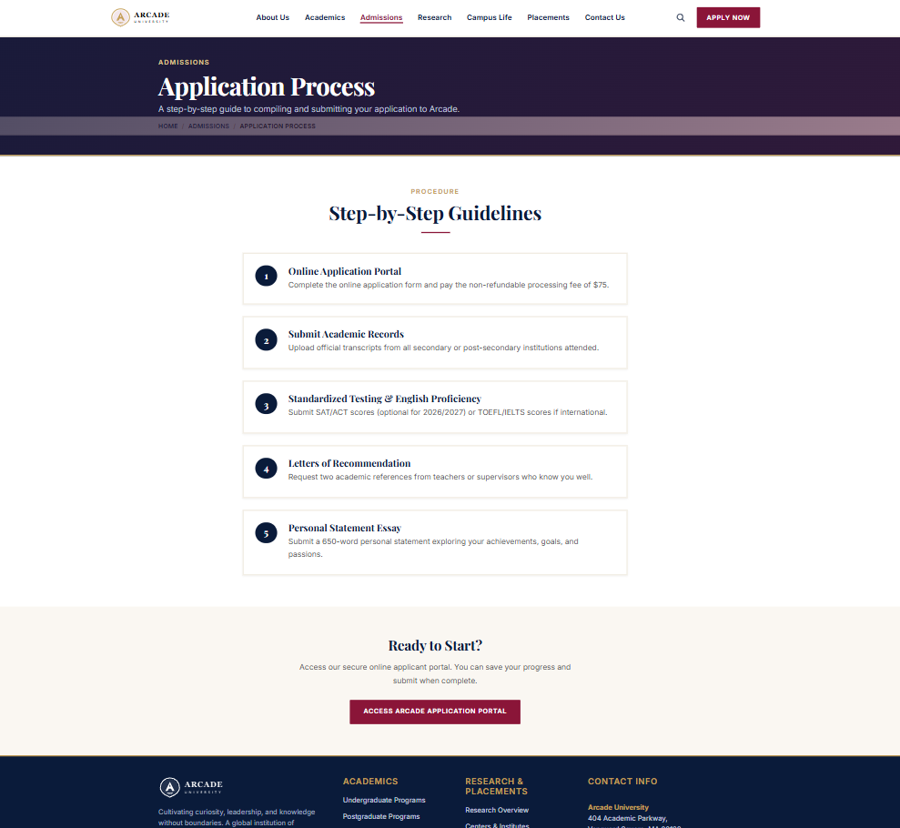
Admissions: application process

