React Counter Application
Aim:
To implement a React counter application with increment and decrement controls that update the displayed value as the user interacts with the buttons.
Theory:
1. Component and JSX structure: The counter is built as a single functional component that returns JSX. The layout consists of a heading, the current count, and two buttons, all nested in one container. The component renders from its state, so the markup describes the interface for any value.
2. State with useState: The count is stored in a state variable created with useState(0), which returns the current value and a setter function. The initial value is 0, matching the result screenshot. React keeps this value between renders, while ordinary variables would reset on every render.
3. Event handling with onClick: The Increment and Decrement buttons each receive an onClick handler. When a button is clicked, React calls its handler, which passes the event to the setter. Clicking a button therefore triggers the update cycle without any manual DOM access.
4. State updates and re-rendering: The increment handler calls setCount with the new value, and the decrement handler does the same in reverse. React schedules a re-render after each update, so the displayed number changes to match the new state. The UI always reflects the stored value, and the component does not change the DOM directly.
5. Functional updates: A safer way to change state is to pass a function to the setter, such as setCount(prev => prev + 1). This uses the latest state value, even when several updates run before a render. The lab uses the simpler direct form, which works correctly for single clicks.
6. Conditional and inline styling: The green Increment button and red Decrement button are styled with inline style objects or class names. Each button's colour communicates its action, while the counter display uses a larger font to make the value easy to read. Styling is separate from the state logic, so changing the look does not affect the counter behaviour.
Code:
The source code for this assignment is available in the GitHub repository listed below.
GitHub Repository:
https://github.com/KalpanaBhaskar/Web-Technologies-Laboratory/tree/main/week_6/counter-app
Output:
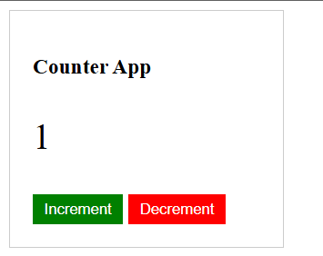
Counter after one increment (value 1)
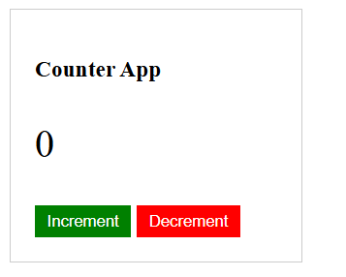
Counter after one decrement (value 0)

