Node.js Server with Routing, Error Handling and Request Logging
Aim:
To create a Node.js server with two pages, Homepage and About. The server handles invalid routes with a 404 status code, and a middleware logs every incoming request to the console.
Theory:
1. Built-in modules and the HTTP server: The program uses the http, fs and path modules, all built into Node.js. http.createServer() takes a request handler that receives the incoming request and the response object. server.listen(3000) keeps the process running and accepts connections on port 3000.
2. Request logging as middleware: The first statement in the request handler logs the method and URL of every request, for example [REQUEST] GET /about.html. Because this runs before any routing, it records requests for valid pages, invalid routes and the browser's favicon request alike. The terminal output shows each of these in order.
3. Mapping URLs to files: path.join() combines the public folder with the requested path, so the file location does not depend on the directory the server is started from. The root URL and /index.html both resolve to public/index.html, and /about.html resolves to public/about.html. Any other URL keeps the default path built from req.url.
4. Asynchronous file reading and error codes: fs.readFile() reads the file without blocking the server, and its callback receives an error object when the read fails. An error with the code ENOENT means the file does not exist, so the server responds with a 404 status and a message in HTML. Any other error code leads to a 500 response.
5. Response headers and content: On success the server calls writeHead(200) with a Content-Type header and then sends the file contents with res.end(). The content type is set to text/html, which suits both pages. The extension is read with path.extname() but not used to choose the type, so a request for a non-HTML file would still be labelled as HTML.
6. Limits of the current design: Routing is a fixed set of if comparisons, so each new page needs its own branch unless the path is used directly. The server also has no listener for errors raised by the server itself, which is listed in the algorithm as a required step. Adding a server.on('error') handler would close that gap.
Code:
server.js:
const http = require('http');
const fs = require('fs');
const path = require('path');

const server = http.createServer((req, res) => {
// Middleware: Log incoming requests to the console
console.log(`[REQUEST] ${req.method} ${req.url}`);

// Construct file path based on request URL
let filePath = path.join(__dirname, 'public', req.url === '/' ? 'index.html' : req.url);

// Route handling
if (req.url === '/' || req.url === '/index.html') {
filePath = path.join(__dirname, 'public', 'index.html');
} else if (req.url === '/about.html') {
filePath = path.join(__dirname, 'public', 'about.html');
}

// Determine file extension and content type
const extname = path.extname(filePath);
let contentType = 'text/html';

// Read file asynchronously
fs.readFile(filePath, (err, content) => {
if (err) {
// If file not found (error), return 404 response
if (err.code === 'ENOENT') {
res.writeHead(404, { 'Content-Type': 'text/html' });
res.end('<h1>404 Not Found</h1><p>The page you requested does not exist on this server.</p>', 'utf8');
} else {
// Handle other server errors
res.writeHead(500);
res.end(`Server Error: ${err.code}`);
}
} else {
// Write 200 OK header and send file content
res.writeHead(200, { 'Content-Type': contentType });
res.end(content, 'utf8');
}
});
});

// Server listens on port 3000
const PORT = 3000;
server.listen(PORT, () => {
console.log(`Server running at http://localhost:${PORT}/`);
});
public/index.html:
<!DOCTYPE html>
<html lang="en">
<head>
<meta charset="UTF-8">
<meta name="viewport" content="width=device-width, initial-scale=1.0">
<title>Homepage - Node.js Server</title>
<style>
body { font-family: Arial, sans-serif; text-align: center; padding: 50px; background-color: #f4f7f6; }
h1 { color: #2c3e50; }
a { text-decoration: none; color: #1abc9c; font-weight: bold; }
</style>
</head>
<body>
<h1>Welcome to the Homepage!</h1>
<p>This is a simplistic Node.js web server created by Kalpana Bhaskar.</p>
<a href="/about.html">Go to About Page</a>
</body>
</html>
public/about.html:
<!DOCTYPE html>
<html lang="en">
<head>
<meta charset="UTF-8">
<meta name="viewport" content="width=device-width, initial-scale=1.0">
<title>About - Node.js Server</title>
<style>
body { font-family: Arial, sans-serif; text-align: center; padding: 50px; background-color: #eef2f3; }
h1 { color: #2c3e50; }
a { text-decoration: none; color: #0077b6; font-weight: bold; }
</style>
</head>
<body>
<h1>About This Project</h1>
<p>This project demonstrates routing, file serving, and error handling in Node.js.</p>
<a href="/">Back to Homepage</a>
</body>
</html>
GitHub Repository:
https://github.com/KalpanaBhaskar/Web-Technologies-Laboratory/tree/main/week_7
Output:
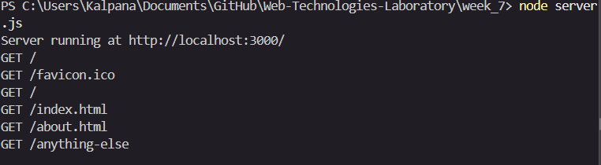
Terminal showing server start and request logs
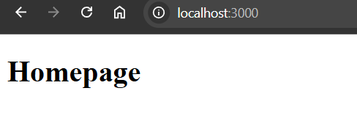
Homepage at http://localhost:3000/
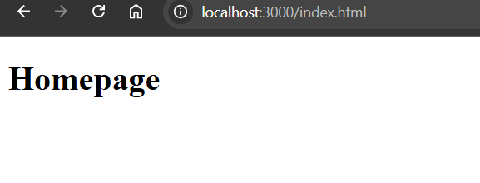
Homepage at http://localhost:3000/index.html
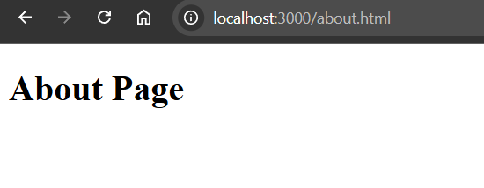
About page at http://localhost:3000/about.html
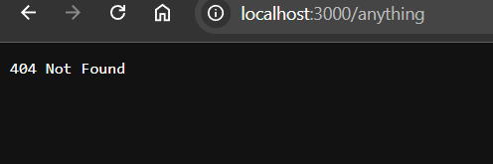
404 response for an unknown route

