Full-Stack MERN Web Application with MongoDB Integration
Aim:
To develop a full-stack web application using the MERN stack and implement client-side and server-side integration with MongoDB.
Theory:
1. Three-layer architecture: The MERN stack separates the application into a React frontend, a Node.js and Express backend, and a MongoDB database. Each layer has one job. React renders the interface and collects input, Express handles HTTP requests and business logic, and MongoDB stores the records. Keeping the layers apart lets each one change without rewriting the others.
2. Schema and model in MongoDB: MongoDB stores data as documents grouped into collections. A Mongoose schema defines the fields of each record, such as the task text and a completed flag, and the model built from it provides methods for creating, reading, updating and deleting documents. The schema gives the application a consistent data shape even though MongoDB itself does not enforce one.
3. REST API endpoints with Express: Each CRUD operation is exposed as an HTTP endpoint. A POST request creates a record, a GET request retrieves the list, a PUT or PATCH request updates a record such as its completion status, and a DELETE request removes it. Express matches each request to its route, runs the model method, and returns the result as JSON with an appropriate status code.
4. Backend connection to MongoDB: The Express server connects to the database when it starts, usually through Mongoose, and only begins accepting requests once the connection succeeds. This is the step that confirms the database link required by the testing section. Errors in the connection or query are returned to the frontend as error responses rather than being left unhandled.
5. State management and API calls in React: The React application keeps the list of records in state. On load, it sends a GET request to the backend and stores the response. Creating, toggling or deleting a record sends a request to the matching endpoint, and the state is updated from the response. The page then reflects the database contents, as shown by the task list in the output.
6. Testing the full workflow: The lab requires each CRUD operation to be tested through the web interface and confirmed in MongoDB. In the output, tasks can be added with the Add Task control, marked complete with the checkbox, and removed with the Delete button. Checking the same changes in the database confirms that data is stored and modified, not only displayed.
Code:
The source code for this assignment is available in the GitHub repository listed below.
GitHub Repository:
https://github.com/KalpanaBhaskar/Web-Technologies-Laboratory/tree/main/week_8
Output:
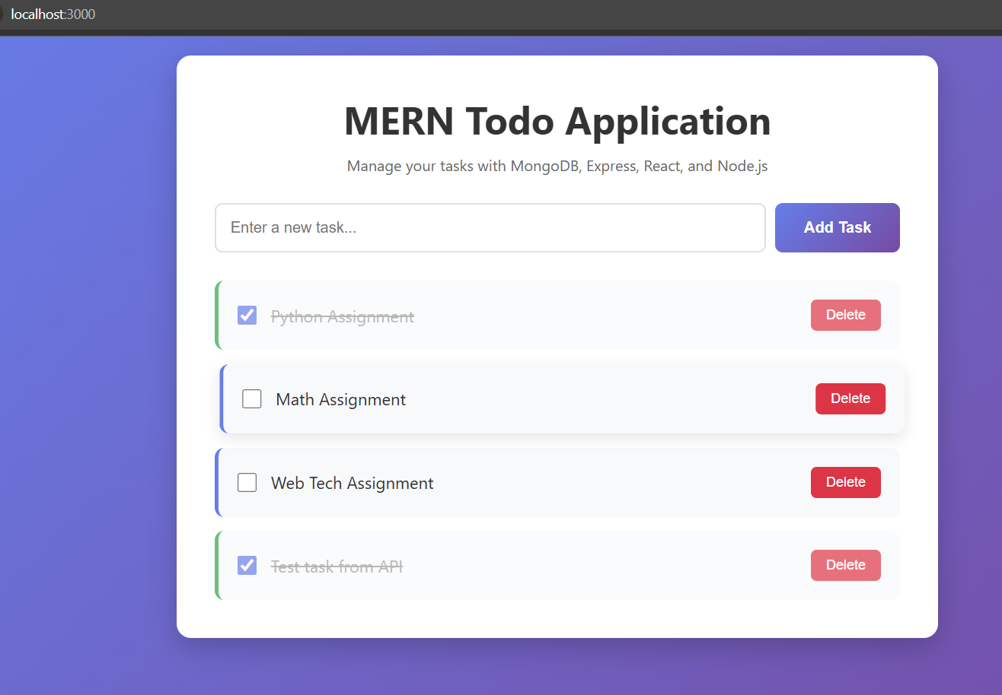
MERN Todo application running at localhost:3000, showing task creation, completion and deletion
Working MERN stack web application with frontend, backend, and MongoDB integration.

