Blog Website using MERN Stack
Aim:
To develop a full-stack Blog/Post Management web application using React, Express.js, Node.js and MongoDB Atlas, implementing CRUD operations over a REST API using the native MongoDB Node.js driver and the browser's native fetch() method.
Project Structure:
project/
├── app/
│ └── src/
│ ├── App.jsx
│ ├── components/
│ │ └── PostSummary.jsx
│ └── pages/
│ ├── Home.jsx
│ ├── Create.jsx
│ ├── Post.jsx
│ └── Archive.jsx
│
└── server/
├── .env
├── db/
│ └── conn.mjs
├── index.mjs
├── loadEnvironment.mjs
└── routes/
└── posts.mjs
Design / Algorithm:
1. Configure environment variables in server/.env for the MongoDB Atlas connection string and server port.
2. Load environment variables using loadEnvironment.mjs and establish a persistent connection to MongoDB Atlas in server/db/conn.mjs using the native MongoDB Node.js driver (MongoClient).
3. Initialize the Express server in server/index.mjs, mounting CORS, JSON parsing middleware, and the posts router (routes/posts.mjs).
4. Define RESTful API routes in routes/posts.mjs handling GET / (fetch all posts), GET /:id (fetch single post), POST / (create post), PATCH /:id or PUT /:id (update post), and DELETE /:id (delete post).
5. Set up React client routing in App.jsx to manage navigation between Home, Create, Post, and Archive pages.
6. In Home.jsx and Archive.jsx, use the native fetch() API inside useEffect hooks to retrieve post listings and render them using the PostSummary component.
7. In Create.jsx, capture title and content input, then issue a POST request using fetch() to insert a new document into MongoDB Atlas.
8. In Post.jsx, query a single post by ID using fetch(), displaying full post details with options to update or delete the record.
9. Dynamically re-render UI state upon successful HTTP response status codes.
Frontend Components & Pages (React):
• App.jsx: Main application container handling route definitions and navigation layout.
• PostSummary.jsx: Reusable UI component for displaying individual post cards and summaries in listings.
• Home.jsx: Main page displaying active post listings fetched from the database.
• Create.jsx: Page containing form inputs for creating and submitting new blog posts.
• Post.jsx: Detailed view page for displaying, editing and deleting an individual blog post.
• Archive.jsx: View page dedicated to archived or historical blog posts.
Frontend Functionality (React):
• State management for storing retrieved posts, individual post details, and form fields.
• Asynchronous data fetching using the browser's native fetch() method for all HTTP methods (GET, POST, PUT/PATCH, DELETE).
• Form validation and real-time input handling for post creation and updates.
• Client-side routing across page views using React Router.
Backend (Node.js with Express - ES Modules .mjs):
• loadEnvironment.mjs: Parses configuration variables from server/.env.
• db/conn.mjs: Instantiates MongoClient and exports the connected database instance.
• routes/posts.mjs: Express Router defining REST endpoints for blog operations using native MongoDB collection methods (find, findOne, insertOne, updateOne, deleteOne).
• index.mjs: Primary entry point running the Express server on designated ports.
Database (MongoDB Atlas):
• Hosting post data on MongoDB Atlas cloud infrastructure.
• Interfacing via the official native MongoDB Node.js driver (mongodb package) instead of an ORM/ODM.
• Collections storing post documents containing fields such as _id, title, content, author, and creation timestamp.
Theory:
1. Native driver instead of an ODM: The server uses the official mongodb package and calls collection methods such as find, findOne, insertOne, updateOne and deleteOne directly. No schema layer such as Mongoose sits between the code and the database, so the route handlers and the React forms are responsible for checking the shape of each post.
2. Environment configuration: The Atlas connection string and the server port are stored in server/.env. loadEnvironment.mjs reads this file at startup, which keeps database credentials out of the source code and lets the same code run against different environments.
3. Persistent connection: conn.mjs creates a single MongoClient, connects it to MongoDB Atlas, and exports the database instance. The routes import this shared instance, so each request reuses one connection rather than opening a new one.
4. REST routes with an Express Router: posts.mjs maps each HTTP method and path to one CRUD operation, such as POST / for create and DELETE /:id for delete. Routes that accept an :id must convert the string to an ObjectId before querying _id. Express handles the JSON body and CORS through the middleware mounted in index.mjs.
5. Client requests with fetch() in useEffect: Home.jsx and Archive.jsx fetch the post list when the page loads, while Create.jsx, Post.jsx and the update and delete actions send POST, PATCH or PUT and DELETE requests. Each response status code decides whether the component updates its state, so the displayed data follows what the server confirms.
6. Client-side routing and reusable components: React Router maps the paths for Home, Create, Post and Archive to their page components without reloading the browser. PostSummary is shared by the listing pages, so the same card layout appears on Home and Archive. The output screenshots show these four views.
Code:
The source code for this assignment is available in the GitHub repository listed below.
GitHub Repository:
https://github.com/KalpanaBhaskar/Web-Technologies-Laboratory/tree/main/week_9
Output:
A working full-stack Blog/Post Management Application featuring a React multi-page frontend interacting with an Express REST API using native fetch(), powered by MongoDB Atlas.
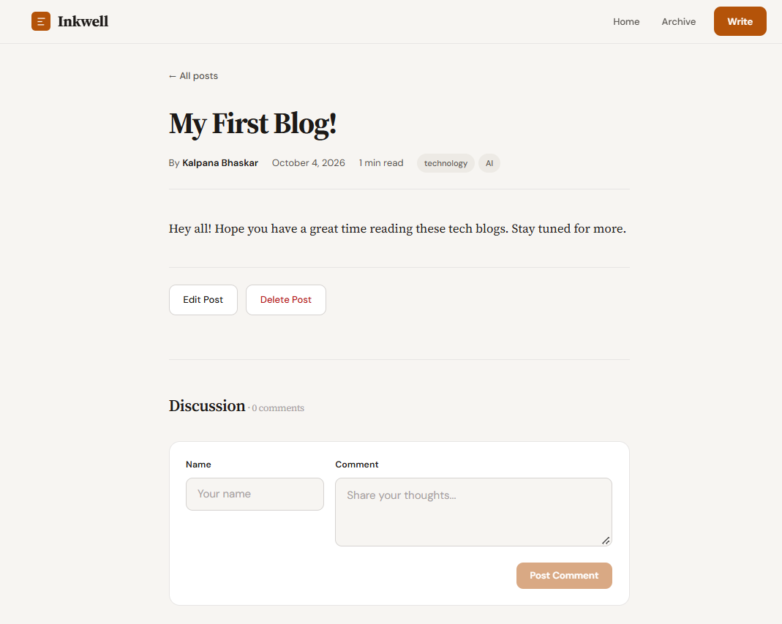
Post detail page with edit, delete and comment controls
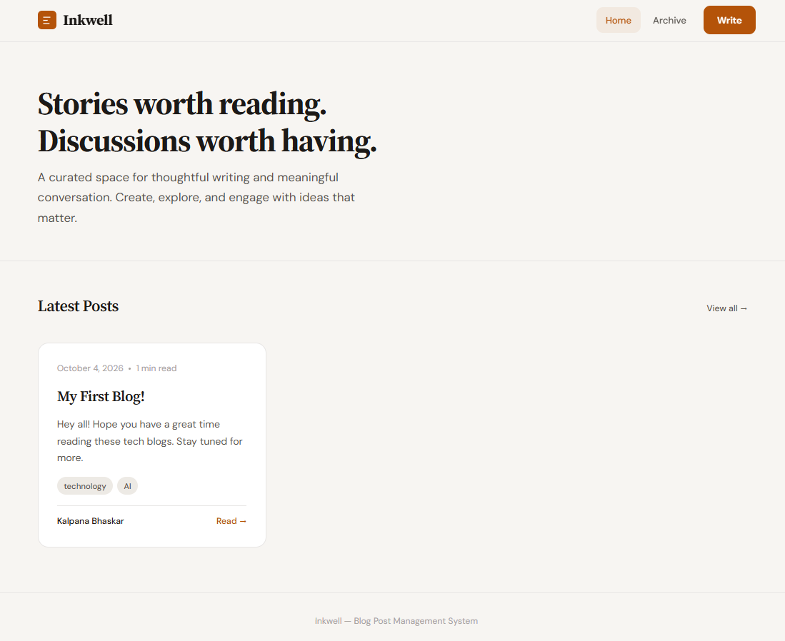
Home page showing the latest posts
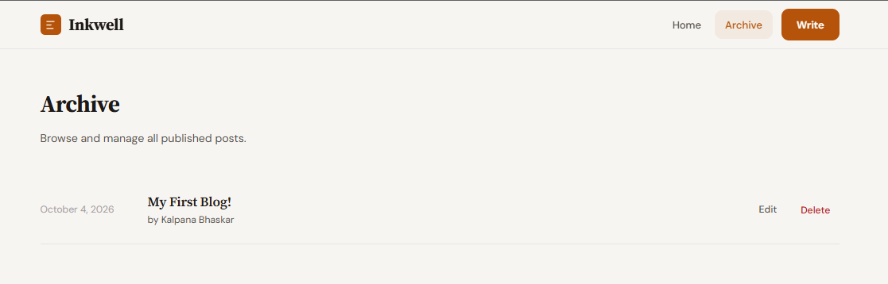
Archive page listing all published posts
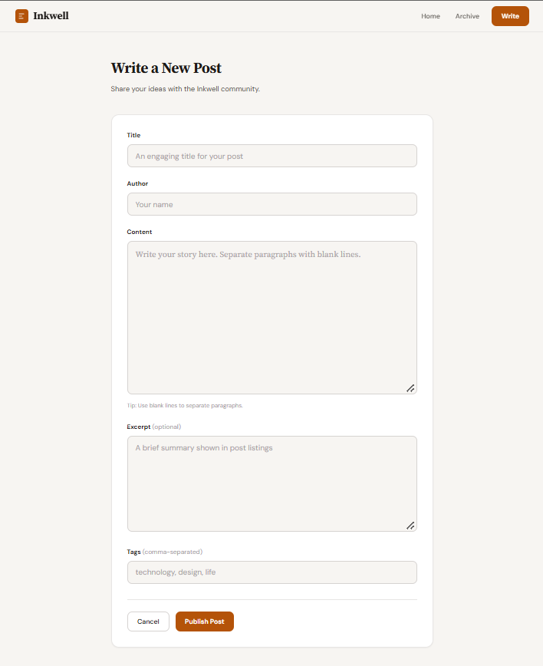
Create page with the new post form

