Resume Web page using HTML and CSS
Aim:
To design and develop an online Resume Web Page using HTML5 and CSS3, incorporating semantic HTML elements such as text formatting, hyperlinks, images, lists, and tables, along with modern page layout techniques such as CSS Flexbox and Grid.
Theory:
1. HTML parsing and DOM construction: The browser reads the file as UTF-8 (declared through the meta charset tag), splits it into tags and text, and builds a tree of nodes called the Document Object Model (DOM). Nesting such as header, nav and main inside body mirrors the logical structure of the page.
2. Semantic structure: Elements such as header, nav, main, section, article, table and footer describe the meaning of content, not only its appearance. This improves accessibility for screen readers, search engine indexing and code maintainability. The details and summary elements provide expandable FAQ items without any JavaScript.
3. CSS parsing and the CSS Object Model (CSSOM): Rules inside the style element are parsed into the CSSOM. Selectors are matched against DOM nodes, and conflicts are resolved through the cascade and specificity. CSS custom properties declared on :root (colours, maximum width) let a single value be reused across every component.
4. Box model and reset: The universal selector with box-sizing: border-box and zeroed margin and padding removes default browser spacing. Each element is laid out as a box made of content, padding, border and margin, which keeps widths predictable.
5. Layout engine: The browser combines the DOM with computed styles to form a render tree (elements with display: none are excluded) and calculates the geometry of each box. Flexbox aligns the navigation bar and button groups, while CSS Grid with repeat(auto-fit, minmax(300px, 1fr)) creates responsive card columns that stack on narrow screens without explicit media queries.
6. Painting and rendering pipeline: After layout, the browser paints the boxes and composites them onto the screen. Hover and transition effects on links and buttons affect only paint properties, whereas a change in size, such as a window resize, triggers a reflow. Images load asynchronously, so the layout adjusts as each resource arrives.
Code:
index.html:
<!DOCTYPE html>
<html lang="en">
<head>
<meta charset="UTF-8">
<meta name="viewport" content="width=device-width, initial-scale=1.0">
<title>Home | Kalpana Bhaskar — AI/ML Engineer & Developer</title>
<style>
/* Modern Minimalist CSS Architecture */
:root {
--bg-color: #f8f9fa;
--card-bg: #ffffff;
--text-main: #212529;
--text-muted: #6c757d;
--primary: #4f46e5;
--primary-hover: #4338ca;
--border-color: #e5e7eb;
--max-width: 1000px;
}
* {
box-sizing: border-box;
margin: 0;
padding: 0;
}
body {
font-family: -apple-system, BlinkMacSystemFont, "Segoe UI", Roboto,
Helvetica, Arial, sans-serif;
background-color: var(--bg-color);
color: var(--text-main);
line-height: 1.6; padding: 0 20px;
}
header {
max-width: var(--max-width);
margin: 0 auto;
padding: 30px 0 10px 0;
}
/* Navigation Style */
nav {
background-color: var(--card-bg);
padding: 15px 25px;
border-radius: 12px;
box-shadow: 0 4px 6px -1px rgba(0,0,0,0.05);
display: flex;
flex-wrap: wrap;
gap: 15px;
justify-content: center;
border: 1px solid var(--border-color);
}
nav a {
color: var(--text-main);
text-decoration: none;
font-weight: 500;
font-size: 0.95rem;
padding: 6px 12px;
border-radius: 6px;
transition: all 0.2s ease;
}
nav a:hover, nav a.active {
background-color: var(--primary);
color: #ffffff;
}
/* Layout */
main { max-width: var(--max-width);
margin: 40px auto;
display: flex;
flex-direction: column;
gap: 40px;
}
section {
background-color: var(--card-bg);
padding: 40px;
border-radius: 16px;
border: 1px solid var(--border-color);
box-shadow: 0 10px 15px -3px rgba(0,0,0,0.02);
}
h1, h2, h3 {
margin-bottom: 20px;
color: #111827;
}
h1 { font-size: 2.5rem; font-weight: 800; }
h2 { font-size: 1.75rem; border-bottom: 2px solid var(--border-color); padding-bottom: 10px; margin-bottom: 25px; }
p { margin-bottom: 15px; color: var(--text-muted); font-size: 1.05rem; }
/* Component Elements */
.hero-banner {
width: 100%;
height: 250px;
object-fit: cover;
border-radius: 12px;
margin-bottom: -75px;
background-color: #ddd;
}
.hero-profile-area {
display: flex;
flex-direction: column; align-items: center;
text-align: center;
padding-top: 0;
}
.profile-img {
width: 150px;
height: 150px;
border-radius: 50%;
object-fit: cover;
border: 5px solid var(--card-bg);
box-shadow: 0 4px 10px rgba(0,0,0,0.1);
margin-bottom: 20px;
background-color: #eee;
}
.btn-group {
display: flex;
gap: 15px;
justify-content: center;
margin-top: 25px;
flex-wrap: wrap;
}
.btn {
display: inline-block;
padding: 12px 24px;
border-radius: 8px;
text-decoration: none;
font-weight: 600;
font-size: 0.95rem;
transition: background 0.2s;
cursor: pointer;
border: none;
}
.btn-primary { background-color: var(--primary); color: #fff; }
.btn-primary:hover { background-color: var(--primary-hover); }
.btn-secondary { background-color: #f3f4f6; color: var(--text-main); border: 1px solid var(--border-color); }
.btn-secondary:hover { background-color: #e5e7eb; }
.grid-2 {
display: grid;
grid-template-columns: repeat(auto-fit, minmax(300px, 1fr));
gap: 30px;
}
.tag-list {
display: flex;
flex-wrap: wrap;
gap: 10px;
list-style: none;
}
.tag {
background-color: #f3f4f6;
color: #1f2937;
padding: 6px 14px;
border-radius: 20px;
font-size: 0.875rem;
font-weight: 500;
}
.featured-card {
border: 1px solid var(--border-color);
padding: 20px;
border-radius: 8px;
margin-top: 15px;
}
footer {
text-align: center;
padding: 40px 0;
color: var(--text-muted);
font-size: 0.9rem;
border-top: 1px solid var(--border-color); max-width: var(--max-width);
margin: 0 auto;
}
.social-links {
margin-bottom: 15px;
}
.social-links a {
color: var(--text-muted);
margin: 0 10px;
text-decoration: none;
}
.social-links a:hover { color: var(--primary); }
</style>
</head>
<body>
<header>
<!-- Consistent Navigation Bar -->
<nav>
<a href="index.html" class="active">Home</a>
<a href="about.html">About</a>
<a href="education.html">Education</a>
<a href="experience.html">Experience</a>
<a href="projects.html">Projects</a>
<a href="portfolio.html">Portfolio</a>
<a href="contact.html">Contact</a>
</nav>
</header>
<main>
<!-- Hero Section -->
<div style="max-width: var(--max-width); margin: 0 auto; width:100%;">
<img src="assets/background.jpg" alt="Cover Banner" class="hero-banner">
</div>
<section class="hero-profile-area">
<img src="assets/profilepic.webp" alt="Kalpana Bhaskar Profile Photo" class="profile-img">
<h1>Kalpana Bhaskar</h1>
<p style="font-weight: 600; color: var(--primary); font-size: 1.25rem; margin-top:-15px;">Aspiring AI/ML Engineer | B.Tech in AI &amp; Data Science</p>
<p style="max-width: 650px; margin: 15px auto;">
Welcome to my digital portfolio! I am an aspiring AI/ML Engineer passionate about engineering scalable data science systems and delivering high-impact projects across Agentic AI, Machine Learning, and LLMs. Currently pursuing B.Tech in Artificial Intelligence and Data Science at Shiv Nadar University Chennai.
</p>
<div class="btn-group">
<a href="about.html" class="btn btn-secondary">About Me</a>
<a href="projects.html" class="btn btn-primary">View Projects</a>
<a href="assets/resume_sample.pdf" download class="btn btn-secondary">Download Resume</a>
<a href="contact.html" class="btn btn-primary">Contact Me</a>
</div>
</section>
<!-- Dynamic Summary Grid -->
<div class="grid-2">
<section>
<h2>Featured Skills</h2>
<p>A high-level glance at my primary capabilities:</p>
<ul class="tag-list">
<li class="tag">Python</li>
<li class="tag">Machine Learning</li>
<li class="tag">React / Next.js</li>
<li class="tag">FastAPI</li>
<li class="tag">PyTorch</li>
<li class="tag">LangChain</li>
<li class="tag">Google Cloud (GCP)</li>
<li class="tag">Docker</li>
<li class="tag">Firebase</li>
<li class="tag">RAG Pipelines</li>
</ul>
</section>
<section>
<h2>Featured Project</h2>
<div class="featured-card">
<h3>UIDAI Intelligent Policy Dashboard</h3>
<p>Accelerated data processing by saving 30 hours/week via a Velocity Governance ETL pipeline, parsing 232,000+ unified logs into an intelligent dashboard with K-Means clustering and regression forecasting.</p>
<a href="projects.html" style="color: var(--primary); font-weight:600; text-decoration:none;">Learn More &rarr;</a>
</div>
</section>
</div>
</main>
<footer>
<div class="social-links">
<a href="https://github.com/KalpanaBhaskar" target="_blank">GitHub</a> |
<a href="https://www.linkedin.com/in/kalpana-bhaskar-815549330/" target="_blank">LinkedIn</a> |
<a href="https://www.kaggle.com/kalpanabhaskar" target="_blank">Kaggle</a>
</div>
<p>&copy; 2026 Kalpana Bhaskar. All Rights Reserved.</p>
<p style="font-size: 0.8rem; margin-top: 5px;">Last Updated: July, 2026</p>
</footer>
</body>
</html>
about.html:
<!DOCTYPE html>
<html lang="en">
<head>
<meta charset="UTF-8">
<meta name="viewport" content="width=device-width, initial-scale=1.0">
<title>About Me | Kalpana Bhaskar</title>
<style>
:root {
--bg-color: #f8f9fa;
--card-bg: #ffffff;
--text-main: #212529;
--text-muted: #6c757d;
--primary: #4f46e5;
--border-color: #e5e7eb;
--max-width: 1000px;
}
* { box-sizing: border-box; margin: 0; padding: 0; }
body { font-family: -apple-system, BlinkMacSystemFont, "Segoe UI", Roboto, sans-serif; background-color: var(--bg-color); color: var(--text-main); line-height: 1.6; padding: 0 20px; }
header { max-width: var(--max-width); margin: 0 auto; padding: 30px 0 10px 0; }
nav { background-color: var(--card-bg); padding: 15px 25px; border-radius: 12px; box-shadow: 0 4px 6px -1px rgba(0,0,0,0.05); display: flex; flex-wrap: wrap; gap: 15px; justify-content: center; border: 1px solid var(--border-color); }
nav a { color: var(--text-main); text-decoration: none; font-weight: 500; font-size: 0.95rem; padding: 6px 12px; border-radius: 6px; }
nav a:hover, nav a.active { background-color: var(--primary); color: #ffffff; }
main { max-width: var(--max-width); margin: 40px auto; display: flex; flex-direction: column; gap: 30px; }
section { background-color: var(--card-bg); padding: 40px; border-radius: 16px; border: 1px solid var(--border-color); }
h2 { font-size: 1.75rem; border-bottom: 2px solid var(--border-color); padding-bottom: 10px; margin-bottom: 25px; }
h3 { margin: 20px 0 10px 0; color: #111827; }
p { margin-bottom: 15px; color: var(--text-muted); }
/* Table Layout Configuration */
table { width: 100%; border-collapse: collapse; margin: 20px 0; font-size: 0.95rem; }
th, td { padding: 12px 15px; text-align: left; border-bottom: 1px solid var(--border-color); }
th { background-color: #f9fafb; font-weight: 600; color: #374151; width: 35%; }
.grid-2 { display: grid; grid-template-columns: repeat(auto-fit, minmax(300px, 1fr)); gap: 25px; }
ul { margin-left: 20px; color: var(--text-muted); margin-bottom: 15px; }
li { margin-bottom: 5px; }
blockquote { border-left: 4px solid var(--primary); padding-left: 20px; font-style: italic; color: #4b5563; margin: 25px 0; font-size: 1.1rem; }
footer { text-align: center; padding: 40px 0; color: var(--text-muted); font-size: 0.9rem; border-top: 1px solid var(--border-color); max-width: var(--max-width); margin: 0 auto; }
</style>
</head>
<body>
<header>
<nav>
<a href="index.html">Home</a>
<a href="about.html" class="active">About</a>
<a href="education.html">Education</a>
<a href="experience.html">Experience</a>
<a href="projects.html">Projects</a>
<a href="portfolio.html">Portfolio</a>
<a href="contact.html">Contact</a>
</nav>
</header>
<main>
<!-- Personal Characteristics and Profiles -->
<div class="grid-2">
<section>
<h2>Personal Details</h2>
<table>
<tr><th>Full Name:</th><td>Kalpana Bhaskar</td></tr>
<tr><th>Location:</th><td>Chennai, Tamil Nadu, India</td></tr>
<tr><th>Nationality:</th><td>Indian</td></tr>
<tr><th>Current Role:</th><td>B.Tech Student &amp; Software Engineering Intern</td></tr>
<tr><th>University:</th><td>Shiv Nadar University Chennai</td></tr>
</table>
</section>
<section>
<h2>Contact &amp; Networks</h2>
<table>
<tr><th>Email:</th><td>kalpana.bhaskar.v@gmail.com</td></tr>
<tr><th>Phone:</th><td>+91 7397492723</td></tr>
<tr><th>LinkedIn:</th><td><a href="https://www.linkedin.com/in/kalpana-bhaskar-815549330/" style="color: var(--primary); text-decoration: none;">linkedin.com/in/kalpana-bhaskar</a></td></tr>
<tr><th>GitHub:</th><td><a href="https://github.com/KalpanaBhaskar" style="color: var(--primary); text-decoration: none;">github.com/KalpanaBhaskar</a></td></tr>
<tr><th>Kaggle:</th><td><a href="https://www.kaggle.com/kalpanabhaskar" style="color: var(--primary); text-decoration: none;">kaggle.com/kalpanabhaskar</a></td></tr>
<tr><th>LeetCode:</th><td><a href="https://leetcode.com/u/kalpana_bhaskar_916/" style="color: var(--primary); text-decoration: none;">leetcode.com/kalpana_bhaskar_916</a></td></tr>
</table>
</section>
</div>
<!-- Mindset & Passions -->
<section>
<h2>Personality, Hobbies &amp; Interests</h2>
<h3>Strengths &amp; Focus Areas</h3>
<p><strong>Strengths:</strong> Analytical mindset, rapid learner, detail-oriented problem solving, strong competitive programming skills (200+ LeetCode problems), and cross-functional team collaboration.</p>
<p><strong>Focus:</strong> Engineering scalable data science systems and delivering high-impact projects across Agentic AI, Machine Learning, and LLMs.</p>
<h3>Favorite Quote</h3>
<blockquote>
"Simplicity is the ultimate sophistication."
<br><span style="font-size: 0.85rem; color: var(--text-muted); font-style: normal; font-weight: 600;">— Leonardo da Vinci</span>
</blockquote>
<div class="grid-2">
<div>
<h3>Hobbies</h3>
<ul>
<li>Competitive Programming</li>
<li>Open Source Contribution</li>
<li>Hackathon Participation</li>
</ul>
</div>
<div>
<h3>Interests</h3>
<ul>
<li>Artificial Intelligence &amp; Machine Learning</li>
<li>Agentic AI &amp; Large Language Models</li>
<li>Data Science &amp; Full Stack Development</li>
</ul>
</div>
</div>
</section>
</main>
<footer>
<p>&copy; 2026 Kalpana Bhaskar. All Rights Reserved.</p>
</footer>
</body>
</html>
education.html:
<!DOCTYPE html>
<html lang="en">
<head>
<meta charset="UTF-8">
<meta name="viewport" content="width=device-width, initial-scale=1.0">
<title>Education & Skills | Kalpana Bhaskar</title>
<style>
:root {
--bg-color: #f8f9fa;
--card-bg: #ffffff;
--text-main: #212529;
--text-muted: #6c757d;
--primary: #4f46e5;
--border-color: #e5e7eb;
--max-width: 1000px;
}
* { box-sizing: border-box; margin: 0; padding: 0; }
body { font-family: -apple-system, BlinkMacSystemFont, "Segoe UI", Roboto, sans-serif; background-color: var(--bg-color); color: var(--text-main); line-height: 1.6; padding: 0 20px; }
header { max-width: var(--max-width); margin: 0 auto; padding: 30px 0 10px 0; }
nav { background-color: var(--card-bg); padding: 15px 25px; border-radius: 12px; box-shadow: 0 4px 6px -1px rgba(0,0,0,0.05); display: flex; flex-wrap: wrap; gap: 15px; justify-content: center; border: 1px solid var(--border-color); }
nav a { color: var(--text-main); text-decoration: none; font-weight: 500; font-size: 0.95rem; padding: 6px 12px; border-radius: 6px; }
nav a:hover, nav a.active { background-color: var(--primary); color: #ffffff; }
main { max-width: var(--max-width); margin: 40px auto; display: flex; flex-direction: column; gap: 30px; }
section { background-color: var(--card-bg); padding: 40px; border-radius: 16px; border: 1px solid var(--border-color); }
h2 { font-size: 1.75rem; border-bottom: 2px solid var(--border-color); padding-bottom: 10px; margin-bottom: 25px; }
h3 { margin: 20px 0 10px 0; color: #111827; }
p { margin-bottom: 15px; color: var(--text-muted); }
table { width: 100%; border-collapse: collapse; margin: 20px 0; }
th, td { padding: 14px; text-align: left; border-bottom: 1px solid var(--border-color); }
th { background-color: #f9fafb; font-weight: 600; color: #374151; }
/* Timeline style modification */
.timeline { list-style: none; padding-left: 0; position: relative; border-left: 2px solid var(--border-color); margin-left: 10px; }
.timeline-item { margin-bottom: 30px; padding-left: 25px; position: relative; }
.timeline-item::before { content: ""; position: absolute; left: -6px; top: 6px; width: 10px; height: 10px; border-radius: 50%; background-color: var(--primary); }
.grid-2 { display: grid; grid-template-columns: repeat(auto-fit, minmax(300px, 1fr)); gap: 25px; }
.list-unstyled { list-style: none; }
.list-unstyled li { padding: 6px 0; border-bottom: 1px dashed var(--border-color); color: var(--text-muted); }
.cert-card { border: 1px solid var(--border-color); padding: 20px; border-radius: 8px; margin-bottom: 15px; }
footer { text-align: center; padding: 40px 0; color: var(--text-muted); font-size: 0.9rem; border-top: 1px solid var(--border-color); max-width: var(--max-width); margin: 0 auto; }
</style>
</head>
<body>
<header>
<nav>
<a href="index.html">Home</a>
<a href="about.html">About</a>
<a href="education.html" class="active">Education</a>
<a href="experience.html">Experience</a>
<a href="projects.html">Projects</a>
<a href="portfolio.html">Portfolio</a>
<a href="contact.html">Contact</a>
</nav>
</header>
<main>
<!-- Educational History -->
<section>
<h2>Education Details</h2>
<div style="overflow-x:auto;">
<table>
<thead>
<tr>
<th>Institution</th>
<th>Course / Degree</th>
<th>Board/University</th>
<th>Year</th>
<th>Grade/CGPA</th>
</tr>
</thead>
<tbody>
<tr>
<td>Shiv Nadar University Chennai</td>
<td>B.Tech in Artificial Intelligence and Data Science</td>
<td>Shiv Nadar University</td>
<td>08/2024 – Present</td>
<td>CGPA: 8.77</td>
</tr>
<tr>
<td>PSBB Senior Secondary School, Chennai</td>
<td>CBSE Class XII (Computer Science, PCM, English)</td>
<td>CBSE</td>
<td>06/2012 – 05/2024</td>
<td>95.2%</td>
</tr>
<tr>
<td>PSBB Senior Secondary School, Chennai</td>
<td>CBSE Class X</td>
<td>CBSE</td>
<td>–</td>
<td>97%</td>
</tr>
</tbody>
</table>
</div>
</section>
<!-- Academic Deep-Dive and Roadmap -->
<div class="grid-2">
<section>
<h2>Academic Timeline &amp; Activities</h2>
<ul class="timeline">
<li class="timeline-item">
<strong>B.Tech Year 2 (2025 – Present)</strong>
<p>Software Engineering Intern at Experiqs (Weatherex.ai). Active hackathon participant across UIDAI, GDG, SIH, Bajaj HackRx, GuideWire, and Unisys Innovation Program.</p>
</li>
<li class="timeline-item">
<strong>B.Tech Year 1 (2024 – 2025)</strong>
<p>Foundation year at Shiv Nadar University Chennai. ML Vertical Junior Core member of SNUC Coding Club. POC of Science Club SNUC. NSO club member.</p>
</li>
<li class="timeline-item">
<strong>School Years (2012 – 2024)</strong>
<p>Completed CBSE Class XII with 95.2% and Class X with 97% at PSBB Senior Secondary School, Chennai.</p>
</li>
</ul>
<h3>Key Coursework &amp; Concepts</h3>
<p>Data Science, Machine Learning, AI Search Algorithms, Full Stack Web Development, RESTful APIs, Data Structures &amp; Algorithms, Object Oriented Programming, Operating Systems, Database Management, Computer Networks, Data Mining, RAG Pipeline</p>
</section>
<section>
<h2>Technical Skills</h2>
<h3>Languages</h3>
<ul class="list-unstyled">
<li>Python, Java, C++, JavaScript, TypeScript, C</li>
</ul>
<h3>Frameworks &amp; Libraries</h3>
<ul class="list-unstyled">
<li>React, Node.js, Next.js, FastAPI, LangChain, Pandas, PyTorch, Scikit-learn, NumPy</li>
</ul>
<h3>Databases</h3>
<ul class="list-unstyled">
<li>MySQL, MongoDB</li>
</ul>
<h3 style="margin-top: 25px;">Cloud &amp; Tools</h3>
<ul class="list-unstyled">
<li>Google Cloud Platform (GCP), Git/GitHub, Docker, Firebase, MediaPipe, Postman, Google Gemini API, Sarvam AI API, Excel, Tableau, Hugging Face</li>
</ul>
</section>
</div>
<!-- Certifications & Achievements -->
<section>
<h2>Achievements &amp; Certifications</h2>
<div class="cert-card">
<h3>Unisys Innovation Program 17</h3>
<p style="margin-bottom: 5px;"><strong>Achievement:</strong> Top 60 out of 3000+ teams for Federated Agentic Fraud Detection System</p>
<p style="margin-bottom: 5px;"><strong>Date:</strong> June 2026</p>
<a href="https://github.com/UnisysUIP/2026-Federated-Knowledge-Graph-Enhanced-Agentic-AI-Platform-for-Secure-Explainable-Cross-Enterprise" target="_blank" style="color: var(--primary); text-decoration: none; font-size: 0.9rem; font-weight: 600;">View on GitHub &rarr;</a>
</div>
<div class="cert-card">
<h3>HackerRank Orchestrate</h3>
<p style="margin-bottom: 5px;"><strong>Achievement:</strong> Participant &amp; Project Contributor</p>
<p style="margin-bottom: 5px;"><strong>Date:</strong> June 2026</p>
<a href="https://github.com/KalpanaBhaskar/hackerrank-orchestrate-june26" target="_blank" style="color: var(--primary); text-decoration: none; font-size: 0.9rem; font-weight: 600;">View on GitHub &rarr;</a>
</div>
<div class="cert-card">
<h3>Kaggle 5-Day Agentic AI Intensive with Google</h3>
<p style="margin-bottom: 5px;"><strong>Achievement:</strong> Completed Smart Customer Analytics Capstone Project</p>
<p style="margin-bottom: 5px;"><strong>Date:</strong> November 2025</p>
<a href="https://www.kaggle.com/certification/badges/kalpanabhaskar/105" target="_blank" style="color: var(--primary); text-decoration: none; font-size: 0.9rem; font-weight: 600;">View Badge &rarr;</a>
</div>
<div class="cert-card">
<h3>IBM AI and Cloud Internship (via EduNet - AICTE)</h3>
<p style="margin-bottom: 5px;"><strong>Issuing Organization:</strong> IBM (via EduNet Foundation - AICTE)</p>
<p style="margin-bottom: 5px;"><strong>Date:</strong> September – October 2025</p>
<a href="https://drive.google.com/file/d/1gXruo8Y_00M4qPt067yjYaEDMtbybye5/view?usp=sharing" target="_blank" style="color: var(--primary); text-decoration: none; font-size: 0.9rem; font-weight: 600;">View Certificate &rarr;</a>
</div>
<div class="cert-card">
<h3>NPTEL Elite+ Silver Certifications</h3>
<p style="margin-bottom: 5px;"><strong>Issuing Organization:</strong> NPTEL (IIT)</p>
<p style="margin-bottom: 5px;"><strong>Courses:</strong> Modern C++ (Apr 2025) | Java (Nov 2025) | Ethical Hacking (Oct 2025)</p>
<a href="https://drive.google.com/file/d/1Si3O3XmOtlmqmNvYLR9ch4irQPkyj1Qb/view" target="_blank" style="color: var(--primary); text-decoration: none; font-size: 0.9rem; font-weight: 600;">C++ Cert &rarr;</a>&nbsp;&nbsp;
<a href="https://drive.google.com/file/d/1UkQeDZ7DAfzzryaK79VOz9yY3SVBuCR_/view" target="_blank" style="color: var(--primary); text-decoration: none; font-size: 0.9rem; font-weight: 600;">Java Cert &rarr;</a>&nbsp;&nbsp;
<a href="https://drive.google.com/file/d/1UcOxABaV-3eM_HzSDpjM_vbk-RVrjAS0/view" target="_blank" style="color: var(--primary); text-decoration: none; font-size: 0.9rem; font-weight: 600;">Ethical Hacking Cert &rarr;</a>
</div>
<div class="cert-card">
<h3>GEAR Google Career Launchpad &amp; Google Skills Boost</h3>
<p style="margin-bottom: 5px;"><strong>Status:</strong> Ongoing (GEAR) | AI &amp; ML courses completed (Skills Boost)</p>
<a href="https://www.skills.google/public_profiles/3ec91ab5-2d06-4d96-8add-ca8966985dcd" target="_blank" style="color: var(--primary); text-decoration: none; font-size: 0.9rem; font-weight: 600;">Google Skills Profile &rarr;</a>&nbsp;&nbsp;
<a href="https://www.credly.com/badges/3894bd9a-73cb-4d83-8fe7-1c7b0b46d288/public_url" target="_blank" style="color: var(--primary); text-decoration: none; font-size: 0.9rem; font-weight: 600;">Credly Badge &rarr;</a>
</div>
<div class="cert-card">
<h3>ICSC Qualifier</h3>
<p style="margin-bottom: 5px;"><strong>Achievement:</strong> Qualified for International Computer Science Competition (ICSC)</p>
<p style="margin-bottom: 5px;"><strong>Date:</strong> September 2025</p>
<a href="https://drive.google.com/file/d/1uOLXTXWeB40GqLJA7zRuDN4a8lTvubtc/view?usp=sharing" target="_blank" style="color: var(--primary); text-decoration: none; font-size: 0.9rem; font-weight: 600;">View Certificate &rarr;</a>
</div>
</section>
</main>
<footer>
<p>&copy; 2026 Kalpana Bhaskar. All Rights Reserved.</p>
</footer>
</body>
</html>
experience.html:
<!DOCTYPE html>
<html lang="en">
<head>
<meta charset="UTF-8">
<meta name="viewport" content="width=device-width, initial-scale=1.0">
<title>Experience | Kalpana Bhaskar</title>
<style>
:root {
--bg-color: #f8f9fa;
--card-bg: #ffffff;
--text-main: #212529;
--text-muted: #6c757d;
--primary: #4f46e5;
--border-color: #e5e7eb;
--max-width: 1000px;
}
* { box-sizing: border-box; margin: 0; padding: 0; }
body { font-family: -apple-system, BlinkMacSystemFont, "Segoe UI", Roboto, sans-serif; background-color: var(--bg-color); color: var(--text-main); line-height: 1.6; padding: 0 20px; }
header { max-width: var(--max-width); margin: 0 auto; padding: 30px 0 10px 0; }
nav { background-color: var(--card-bg); padding: 15px 25px; border-radius: 12px; box-shadow: 0 4px 6px -1px rgba(0,0,0,0.05); display: flex; flex-wrap: wrap; gap: 15px; justify-content: center; border: 1px solid var(--border-color); }
nav a { color: var(--text-main); text-decoration: none; font-weight: 500; font-size: 0.95rem; padding: 6px 12px; border-radius: 6px; }
nav a:hover, nav a.active { background-color: var(--primary); color: #ffffff; }
main { max-width: var(--max-width); margin: 40px auto; display: flex; flex-direction: column; gap: 30px; }
section { background-color: var(--card-bg); padding: 40px; border-radius: 16px; border: 1px solid var(--border-color); }
h2 { font-size: 1.75rem; border-bottom: 2px solid var(--border-color); padding-bottom: 10px; margin-bottom: 25px; }
h3 { margin-bottom: 5px; color: #111827; }
p { margin-bottom: 12px; color: var(--text-muted); }
.exp-item { border-left: 3px solid var(--primary); padding-left: 20px; margin-bottom: 35px; position: relative; }
.exp-meta { font-size: 0.9rem; color: var(--text-muted); font-weight: 500; margin-bottom: 10px; }
ul { margin-left: 20px; color: var(--text-muted); }
li { margin-bottom: 6px; }
.grid-2 { display: grid; grid-template-columns: repeat(auto-fit, minmax(300px, 1fr)); gap: 25px; }
footer { text-align: center; padding: 40px 0; color: var(--text-muted); font-size: 0.9rem; border-top: 1px solid var(--border-color); max-width: var(--max-width); margin: 0 auto; }
</style>
</head>
<body>
<header>
<nav>
<a href="index.html">Home</a>
<a href="about.html">About</a>
<a href="education.html">Education</a>
<a href="experience.html" class="active">Experience</a>
<a href="projects.html">Projects</a>
<a href="portfolio.html">Portfolio</a>
<a href="contact.html">Contact</a>
</nav>
</header>
<main>
<!-- Professional Work Roles -->
<section>
<h2>Work Experience &amp; Internships</h2>
<div class="exp-item">
<h3>Software Engineering Intern</h3>
<div class="exp-meta"><strong>Experiqs — <a href="https://weatherex.ai/" target="_blank" style="color: var(--primary); text-decoration: none;">Weatherex.ai</a></strong> &bull; Internship &bull; May 2026 – Present</div>
<p>Working on the Weatherex weather data API platform, focusing on data ingestion optimization and live dashboard engineering.</p>
<ul>
<li><strong>Retrieved third-party data ingestion</strong> for the Weatherex API, optimizing download time by 50% using Dask task graphs and reducing storage by 70% in TileDB with Zstd compression. API tested using Postman.</li>
<li><strong>Engineered a live weather alerts dashboard</strong> backed by the Weatherex API, applying statistical bias correction to ensure seamless data consistency with historical site records.</li>
</ul>
</div>
<div class="exp-item" style="margin-bottom: 0;">
<h3>AI and Cloud Intern</h3>
<div class="exp-meta"><strong>IBM (via EduNet Foundation - AICTE)</strong> &bull; Internship &bull; September 2025 – October 2025</div>
<p>Completed AI and Cloud internship program covering cloud computing fundamentals and AI/ML model deployment.</p>
<ul>
<li>Gained hands-on experience with AI and cloud technologies through structured coursework and project-based learning.</li>
<li>Earned official certification from IBM via EduNet Foundation.</li>
</ul>
</div>
</section>
<!-- Dynamic Events Grid -->
<div class="grid-2">
<!-- Leadership & Roles -->
<section>
<h2>Leadership &amp; Club Activities</h2>
<div class="exp-item" style="margin-bottom:20px;">
<h3>ML Vertical Junior Core Member</h3>
<div class="exp-meta">SNUC Coding Club &bull; 2024 – Present</div>
<p>Contributing to the Machine Learning vertical of the university coding club, organizing ML workshops and study sessions.</p>
</div>
<div class="exp-item" style="margin-bottom:20px;">
<h3>Point of Contact (POC)</h3>
<div class="exp-meta">Science Club SNUC &bull; 2024 – Present</div>
<p>Coordinating science club events, managing communication between club members and administration.</p>
</div>
<div class="exp-item" style="margin-bottom:0;">
<h3>NSO Club Member</h3>
<div class="exp-meta">Shiv Nadar University Chennai &bull; 2024 – Present</div>
<p>Active member of the National Service Organization club, participating in community service activities.</p>
</div>
</section>
<!-- Hackathons & Awards -->
<section>
<h2>Hackathons &amp; Competitions</h2>
<div class="exp-item" style="margin-bottom:20px;">
<h3>Unisys Innovation Program 17 — Top 60 / 3000+</h3>
<div class="exp-meta">Unisys &bull; June 2026</div>
<p>Developed a Federated Agentic Fraud Detection System, achieving Top 60 placement out of 3000+ participating teams.</p>
</div>
<div class="exp-item" style="margin-bottom:20px;">
<h3>GuideWire Hackathon</h3>
<div class="exp-meta">GuideWire &bull; April 2026</div>
<p>Developed an automated insurance platform for gig workers, reducing fraud by 50%.</p>
</div>
<div class="exp-item" style="margin-bottom:20px;">
<h3>UIDAI Data Hackathon</h3>
<div class="exp-meta">UIDAI &bull; January 2026</div>
<p>Built an Intelligent Policy Dashboard accelerating data processing and saving 30 hours/week.</p>
</div>
<div class="exp-item" style="margin-bottom:0;">
<h3>ICSC Qualifier</h3>
<div class="exp-meta">International Computer Science Competition &bull; September 2025</div>
<p>Qualified for the International Computer Science Competition (ICSC).</p>
</div>
</section>
</div>
</main>
<footer>
<p>&copy; 2026 Kalpana Bhaskar. All Rights Reserved.</p>
</footer>
</body>
</html>
projects.html:
<!DOCTYPE html>
<html lang="en">
<head>
<meta charset="UTF-8">
<meta name="viewport" content="width=device-width, initial-scale=1.0">
<title>Projects | Kalpana Bhaskar</title>
<style>
:root {
--bg-color: #f8f9fa;
--card-bg: #ffffff;
--text-main: #212529;
--text-muted: #6c757d;
--primary: #4f46e5;
--border-color: #e5e7eb;
--max-width: 1000px;
}
* { box-sizing: border-box; margin: 0; padding: 0; }
body { font-family: -apple-system, BlinkMacSystemFont, "Segoe UI", Roboto, sans-serif; background-color: var(--bg-color); color: var(--text-main); line-height: 1.6; padding: 0 20px; }
header { max-width: var(--max-width); margin: 0 auto; padding: 30px 0 10px 0; }
nav { background-color: var(--card-bg); padding: 15px 25px; border-radius: 12px; box-shadow: 0 4px 6px -1px rgba(0,0,0,0.05); display: flex; flex-wrap: wrap; gap: 15px; justify-content: center; border: 1px solid var(--border-color); }
nav a { color: var(--text-main); text-decoration: none; font-weight: 500; font-size: 0.95rem; padding: 6px 12px; border-radius: 6px; }
nav a:hover, nav a.active { background-color: var(--primary); color: #ffffff; }
main { max-width: var(--max-width); margin: 40px auto; display: flex; flex-direction: column; gap: 40px; }
/* Master Project Container Block */
.project-block { background-color: var(--card-bg); padding: 40px; border-radius: 16px; border: 1px solid var(--border-color); }
h2 { font-size: 2rem; color: #111827; margin-bottom: 20px; }
h3 { font-size: 1.25rem; color: #374151; margin: 20px 0 10px 0; border-bottom: 1px solid var(--border-color); padding-bottom: 5px; }
p { margin-bottom: 15px; color: var(--text-muted); }
.tech-list { display: flex; flex-wrap: wrap; gap: 8px; list-style: none; margin-bottom: 15px; }
.tech-pill { background-color: #eff6ff; color: #1e40af; padding: 4px 12px; border-radius: 4px; font-size: 0.85rem; font-weight: 600; border: 1px solid #bfdbfe; }
.links-container { display: flex; flex-wrap: wrap; gap: 12px; margin: 20px 0; }
.proj-link { display: inline-block; padding: 8px 16px; font-size: 0.9rem; font-weight: 500; text-decoration: none; border-radius: 6px; border: 1px solid var(--border-color); color: var(--text-main); background: #f9fafb; transition: all 0.2s; }
.proj-link:hover { background: #f3f4f6; border-color: #d1d5db; color: var(--primary); }
.grid-2 { display: grid; grid-template-columns: repeat(auto-fit, minmax(300px, 1fr)); gap: 25px; }
ul { margin-left: 20px; color: var(--text-muted); }
li { margin-bottom: 5px; }
.project-date { font-size: 0.9rem; color: var(--text-muted); font-weight: 500; margin-bottom: 15px; }
footer { text-align: center; padding: 40px 0; color: var(--text-muted); font-size: 0.9rem; border-top: 1px solid var(--border-color); max-width: var(--max-width); margin: 0 auto; }
</style>
</head>
<body>
<header>
<nav>
<a href="index.html">Home</a>
<a href="about.html">About</a>
<a href="education.html">Education</a>
<a href="experience.html">Experience</a>
<a href="projects.html" class="active">Projects</a>
<a href="portfolio.html">Portfolio</a>
<a href="contact.html">Contact</a>
</nav>
</header>
<main>
<!-- PROJECT 1: UIDAI Intelligent Policy Dashboard -->
<article class="project-block">
<h2>UIDAI Intelligent Policy Dashboard</h2>
<p class="project-date">UIDAI Hackathon &bull; January 2026</p>
<h3>Description &amp; Objective</h3>
<p><strong>Objective:</strong> To build an intelligent dashboard that accelerates data processing for UIDAI policy governance, eliminating manual analysis through ML-powered insights.</p>
<p><strong>Description:</strong> Implemented a Velocity Governance ETL pipeline with automated data cleaning, parsing 232,000+ unified logs into an intelligent dashboard. Used K-Means clustering visualized on maps and linear regression forecasting to generate Priority Intervention Lists for high-risk migration zones.</p>
<h3>Technology Stack</h3>
<ul class="tech-list">
<li class="tech-pill">Python</li>
<li class="tech-pill">Scikit-Learn</li>
<li class="tech-pill">Dash</li>
<li class="tech-pill">K-Means Clustering</li>
<li class="tech-pill">Linear Regression</li>
</ul>
<div class="grid-2">
<div>
<h3>Key Achievements</h3>
<ul>
<li><strong>Accelerated data processing</strong>, saving 30 hours/week with automated ETL pipeline.</li>
<li><strong>Eliminated manual demographic analysis</strong> through ML-based clustering and forecasting.</li>
<li>Parsed and processed 232,000+ unified log records.</li>
</ul>
</div>
<div>
<h3>Technical Highlights</h3>
<ul>
<li><strong>ETL Pipeline:</strong> Velocity Governance with automated data cleaning</li>
<li><strong>ML Models:</strong> K-Means clustering, Linear regression</li>
<li><strong>Visualization:</strong> Interactive maps, Priority Intervention Lists</li>
</ul>
</div>
</div>
<h3>Resource Links</h3>
<div class="links-container">
<a href="https://github.com/KalpanaBhaskar/UIDAI_Data_Hack" class="proj-link" target="_blank">&#128193; GitHub Repository</a>
</div>
</article>
<!-- PROJECT 2: Drishti - AI-Powered Crowd Safety App -->
<article class="project-block">
<h2>Drishti — AI-Powered Crowd Safety App</h2>
<p class="project-date">GDG Hackathon &bull; December 2025</p>
<h3>Description &amp; Objective</h3>
<p><strong>Objective:</strong> To create a real-time crowd safety monitoring system using computer vision and AI for anomaly detection in crowded environments.</p>
<p><strong>Description:</strong> Implemented a client-side computer vision pipeline utilizing OpenCV for video frame extraction and MediaPipe for real-time crowd density counting (MAPE under 20%) and bottleneck prediction. Designed a multi-modal situational awareness agent that processes critical frames through Google Gemini 1.5 Flash for anomaly detection, with Firebase for authentication and event logging.</p>
<h3>Technology Stack</h3>
<ul class="tech-list">
<li class="tech-pill">OpenCV</li>
<li class="tech-pill">MediaPipe</li>
<li class="tech-pill">Firebase</li>
<li class="tech-pill">Google Gemini 1.5 Flash</li>
<li class="tech-pill">Python</li>
</ul>
<div class="grid-2">
<div>
<h3>Key Achievements</h3>
<ul>
<li>Real-time crowd density counting with MAPE under 20%.</li>
<li>Multi-modal AI agent for anomaly detection using Gemini 1.5 Flash.</li>
<li>Secure user authentication and event data logging via Firebase.</li>
</ul>
</div>
<div>
<h3>Technical Highlights</h3>
<ul>
<li><strong>CV Pipeline:</strong> OpenCV frame extraction + MediaPipe</li>
<li><strong>AI Model:</strong> Google Gemini 1.5 Flash for anomaly detection</li>
<li><strong>Backend:</strong> Firebase for auth and data logging</li>
</ul>
</div>
</div>
<h3>Resource Links</h3>
<div class="links-container">
<a href="https://drishti-database.web.app/" class="proj-link" target="_blank">&#127760; Live Application</a>
</div>
</article>
<!-- PROJECT 3: Safety First Tourism App -->
<article class="project-block">
<h2>Safety First Tourism App</h2>
<p class="project-date">Smart India Hackathon 2025 &bull; September – October 2025</p>
<h3>Description &amp; Objective</h3>
<p><strong>Objective:</strong> To develop a full-stack tracking platform for safe tourism with real-time monitoring, geo-fencing, and dynamic safety scoring.</p>
<p><strong>Description:</strong> Built a full-stack tracking platform featuring reliable anomaly flagging, real-time traveler monitoring via OpenStreetMap, and geo-fencing to secure user journeys through dynamic safety scores. Engineered a risk-aware itinerary planner with a self-curated SQLite database of 250 mapped Indian locations for secure and customized travel routing.</p>
<h3>Technology Stack</h3>
<ul class="tech-list">
<li class="tech-pill">React</li>
<li class="tech-pill">Express.js</li>
<li class="tech-pill">OpenStreetMap API</li>
<li class="tech-pill">SQLite</li>
<li class="tech-pill">JavaScript</li>
</ul>
<div class="grid-2">
<div>
<h3>Key Achievements</h3>
<ul>
<li>Real-time traveler monitoring with anomaly flagging and geo-fencing.</li>
<li>Dynamic safety scores for secure user journeys.</li>
<li>Self-curated database of 250 mapped Indian locations.</li>
</ul>
</div>
<div>
<h3>Technical Highlights</h3>
<ul>
<li><strong>Frontend:</strong> React with OpenStreetMap integration</li>
<li><strong>Backend:</strong> Express.js with SQLite database</li>
<li><strong>Features:</strong> Geo-fencing, risk-aware itinerary planner</li>
</ul>
</div>
</div>
<h3>Resource Links</h3>
<div class="links-container">
<a href="https://smart-tourist-app.pages.dev/" class="proj-link" target="_blank">&#127760; Live Application</a>
</div>
</article>
<!-- PROJECT 4: Intelligent QnA System -->
<article class="project-block">
<h2>Intelligent QnA System</h2>
<p class="project-date">Bajaj HackRx 6.0 &bull; June – July 2025</p>
<h3>Description &amp; Objective</h3>
<p><strong>Objective:</strong> To build a Retrieval-Augmented Generation (RAG) pipeline for processing and answering questions from unstructured insurance documents.</p>
<p><strong>Description:</strong> Engineered a FastAPI RAG pipeline integrating vector chunking and Named Entity Recognition (NER) to process and index unstructured insurance documents up to 30 pages long. Reduced natural language query response times by 40% by architecting an efficient FAISS vector search system, using the Gemini API to synthesize top-k retrieved chunks into precise, context-aware answers.</p>
<h3>Technology Stack</h3>
<ul class="tech-list">
<li class="tech-pill">Python</li>
<li class="tech-pill">FastAPI</li>
<li class="tech-pill">Gemini API</li>
<li class="tech-pill">FAISS</li>
<li class="tech-pill">NER</li>
<li class="tech-pill">RAG Pipeline</li>
</ul>
<div class="grid-2">
<div>
<h3>Key Achievements</h3>
<ul>
<li>Reduced query response times by 40% with efficient FAISS vector search.</li>
<li>Processes unstructured insurance documents up to 30 pages long.</li>
<li>Context-aware answer synthesis using Gemini API.</li>
</ul>
</div>
<div>
<h3>Technical Highlights</h3>
<ul>
<li><strong>Backend:</strong> FastAPI with RAG pipeline architecture</li>
<li><strong>Vector Search:</strong> FAISS for efficient retrieval</li>
<li><strong>NLP:</strong> Named Entity Recognition + Gemini API</li>
</ul>
</div>
</div>
<h3>Resource Links</h3>
<div class="links-container">
<a href="https://huggingface.co/spaces/kb-916/bajaj_file" class="proj-link" target="_blank">&#127760; Hugging Face Demo</a>
</div>
</article>
</main>
<footer>
<p>&copy; 2026 Kalpana Bhaskar. All Rights Reserved.</p>
</footer>
</body>
</html>
portfolio.html:
<!DOCTYPE html>
<html lang="en">
<head>
<meta charset="UTF-8">
<meta name="viewport" content="width=device-width, initial-scale=1.0">
<title>Portfolio &amp; Gallery | Kalpana Bhaskar</title>
<style>
:root {
--bg-color: #f8f9fa;
--card-bg: #ffffff;
--text-main: #212529;
--text-muted: #6c757d;
--primary: #4f46e5;
--border-color: #e5e7eb;
--max-width: 1000px;
}
* { box-sizing: border-box; margin: 0; padding: 0; }
body { font-family: -apple-system, BlinkMacSystemFont, "Segoe UI", Roboto, sans-serif; background-color: var(--bg-color); color: var(--text-main); line-height: 1.6; padding: 0 20px; }
header { max-width: var(--max-width); margin: 0 auto; padding: 30px 0 10px 0; }
nav { background-color: var(--card-bg); padding: 15px 25px; border-radius: 12px; box-shadow: 0 4px 6px -1px rgba(0,0,0,0.05); display: flex; flex-wrap: wrap; gap: 15px; justify-content: center; border: 1px solid var(--border-color); }
nav a { color: var(--text-main); text-decoration: none; font-weight: 500; font-size: 0.95rem; padding: 6px 12px; border-radius: 6px; }
nav a:hover, nav a.active { background-color: var(--primary); color: #ffffff; }
main { max-width: var(--max-width); margin: 40px auto; display: flex; flex-direction: column; gap: 30px; }
section { background-color: var(--card-bg); padding: 40px; border-radius: 16px; border: 1px solid var(--border-color); }
h2 { font-size: 1.75rem; border-bottom: 2px solid var(--border-color); padding-bottom: 10px; margin-bottom: 25px; }
h3 { margin: 20px 0 10px 0; color: #111827; }
p { margin-bottom: 15px; color: var(--text-muted); }
.grid-2 { display: grid; grid-template-columns: repeat(auto-fit, minmax(300px, 1fr)); gap: 25px; }
details { background: #f9fafb; border: 1px solid var(--border-color); padding: 15px; border-radius: 8px; margin-bottom: 10px; }
summary { font-weight: 600; cursor: pointer; color: #374151; }
.btn { display: inline-block; padding: 12px 24px; border-radius: 8px; text-decoration: none; font-weight: 600; background-color: var(--primary); color: #fff; border: none; }
.btn:hover { background-color: #4338ca; }
.profile-links { list-style: none; }
.profile-links li { margin-bottom: 10px; }
.profile-links a { color: var(--primary); text-decoration: none; font-weight: 500; }
.profile-links a:hover { text-decoration: underline; }
footer { text-align: center; padding: 40px 0; color: var(--text-muted); font-size: 0.9rem; border-top: 1px solid var(--border-color); max-width: var(--max-width); margin: 0 auto; }
</style>
</head>
<body>
<header>
<nav>
<a href="index.html">Home</a>
<a href="about.html">About</a>
<a href="education.html">Education</a>
<a href="experience.html">Experience</a>
<a href="projects.html">Projects</a>
<a href="portfolio.html" class="active">Portfolio</a>
<a href="contact.html">Contact</a>
</nav>
</header>
<main>
<!-- Resume Preview -->
<section style="text-align: center;">
<h2>Resume Preview &amp; Access</h2>
<p>Download or view my full resume below.</p>
<div style="border: 1px solid var(--border-color); border-radius: 8px; background: #eee; padding: 40px; margin-bottom: 20px;">
<p style="font-style: italic;">Resume preview — click the button below to download the full PDF.</p>
</div>
<a href="assets/resume_sample.pdf" download class="btn">Download Resume (PDF)</a>
</section>
<div class="grid-2">
<!-- Online Profiles & Platforms -->
<section>
<h2>Online Profiles &amp; Platforms</h2>
<p>My presence across various coding and learning platforms:</p>
<ul class="profile-links">
<li>&#128187; <a href="https://github.com/KalpanaBhaskar" target="_blank">GitHub — KalpanaBhaskar</a></li>
<li>&#128200; <a href="https://www.kaggle.com/kalpanabhaskar" target="_blank">Kaggle — kalpanabhaskar</a></li>
<li>&#128736; <a href="https://leetcode.com/u/kalpana_bhaskar_916/" target="_blank">LeetCode — 200+ problems solved</a></li>
<li>&#127891; <a href="https://www.skills.google/public_profiles/3ec91ab5-2d06-4d96-8add-ca8966985dcd" target="_blank">Google Skills Profile</a></li>
<li>&#128218; <a href="https://learn.microsoft.com/en-us/users/kalpanabhaskar-0242/" target="_blank">Microsoft Learn Profile</a></li>
<li>&#129303; <a href="https://huggingface.co/spaces/kb-916/bajaj_file" target="_blank">Hugging Face — kb-916</a></li>
<li>&#127941; <a href="https://www.credly.com/badges/3894bd9a-73cb-4d83-8fe7-1c7b0b46d288/public_url" target="_blank">Credly — Google AI/ML Badge</a></li>
<li>&#127941; <a href="https://www.credly.com/badges/b3c4f83f-7b64-47e9-9bb7-a6a6d601d2c2/public_url" target="_blank">Credly — IBM AI Badge</a></li>
</ul>
<h3 style="margin-top:25px;">Future Goals</h3>
<p>Continuing to deepen expertise in Agentic AI, scalable ML systems, and contributing to open source projects while pursuing my B.Tech in AI &amp; Data Science.</p>
</section>
<!-- FAQs -->
<section>
<h2>Frequently Asked Questions</h2>
<details>
<summary>Where are you located?</summary>
<p style="padding-top:10px;">I am based in Chennai, Tamil Nadu, India. Currently studying at Shiv Nadar University Chennai.</p>
</details>
<details>
<summary>What are your areas of expertise?</summary>
<p style="padding-top:10px;">AI/ML Engineering, Data Science, Full Stack Web Development, RAG Pipelines, Agentic AI, and Computer Vision. I work with Python, React, FastAPI, PyTorch, and cloud platforms like GCP and Firebase.</p>
</details>
<details>
<summary>Are you open to collaboration?</summary>
<p style="padding-top:10px;">Yes! I am actively looking for hackathon teams, open source projects, and internship opportunities. Feel free to reach out via the <a href="contact.html" style="color: var(--primary);">Contact page</a>.</p>
</details>
<h3 style="margin-top:25px;">Recommended Resources</h3>
<p><strong>Books:</strong> Clean Code by Robert C. Martin</p>
<p><strong>Platforms:</strong> Kaggle, LeetCode, Hugging Face</p>
</section>
</div>
</main>
<footer>
<p>&copy; 2026 Kalpana Bhaskar. All Rights Reserved.</p>
</footer>
</body>
</html>
contact.html:
<!DOCTYPE html>
<html lang="en">
<head>
<meta charset="UTF-8">
<meta name="viewport" content="width=device-width, initial-scale=1.0">
<title>Contact Me | Kalpana Bhaskar</title>
<style>
:root {
--bg-color: #f8f9fa;
--card-bg: #ffffff;
--text-main: #212529;
--text-muted: #6c757d;
--primary: #4f46e5;
--primary-hover: #4338ca;
--border-color: #e5e7eb;
--max-width: 1000px;
}
* { box-sizing: border-box; margin: 0; padding: 0; }
body { font-family: -apple-system, BlinkMacSystemFont, "Segoe UI", Roboto, sans-serif; background-color: var(--bg-color); color: var(--text-main); line-height: 1.6; padding: 0 20px; }
header { max-width: var(--max-width); margin: 0 auto; padding: 30px 0 10px 0; }
nav { background-color: var(--card-bg); padding: 15px 25px; border-radius: 12px; box-shadow: 0 4px 6px -1px rgba(0,0,0,0.05); display: flex; flex-wrap: wrap; gap: 15px; justify-content: center; border: 1px solid var(--border-color); }
nav a { color: var(--text-main); text-decoration: none; font-weight: 500; font-size: 0.95rem; padding: 6px 12px; border-radius: 6px; }
nav a:hover, nav a.active { background-color: var(--primary); color: #ffffff; }
main { max-width: var(--max-width); margin: 40px auto; display: grid; grid-template-columns: repeat(auto-fit, minmax(320px, 1fr)); gap: 30px; }
section { background-color: var(--card-bg); padding: 40px; border-radius: 16px; border: 1px solid var(--border-color); }
h2 { font-size: 1.75rem; border-bottom: 2px solid var(--border-color); padding-bottom: 10px; margin-bottom: 25px; color: #111827; }
h3 { margin: 20px 0 10px 0; color: #374151; font-size: 1.15rem; }
p { margin-bottom: 15px; color: var(--text-muted); }
/* Interactive Data Form Fields Controls */
fieldset { border: 1px solid var(--border-color); padding: 20px; border-radius: 8px; margin-bottom: 20px; }
legend { padding: 0 10px; font-weight: 600; color: var(--primary); }
.form-group { margin-bottom: 15px; display: flex; flex-direction: column; }
label { margin-bottom: 6px; font-size: 0.9rem; font-weight: 500; color: #374151; }
input[type="text"], input[type="email"], input[type="tel"], select, textarea { width: 100%; padding: 10px 14px; border: 1px solid var(--border-color); border-radius: 6px; font-family: inherit; font-size: 0.95rem; color: var(--text-main); background-color: #f9fafb; }
input:focus, textarea:focus, select:focus { outline: 2px solid var(--primary); background-color: #fff; }
.btn-group { display: flex; gap: 10px; margin-top: 10px; }
.btn { padding: 12px 24px; border-radius: 6px; font-weight: 600; font-size: 0.95rem; cursor: pointer; border: none; transition: background 0.2s; }
.btn-submit { background-color: var(--primary); color: #fff; }
.btn-submit:hover { background-color: var(--primary-hover); }
.btn-reset { background-color: #f3f4f6; color: var(--text-main); }
.btn-reset:hover { background-color: #e5e7eb; }
.contact-method-list { list-style: none; }
.contact-method-list li { margin-bottom: 12px; font-size: 0.95rem; color: var(--text-muted); }
.contact-method-list strong { color: var(--text-main); }
.contact-method-list a { color: var(--primary); text-decoration: none; }
.contact-method-list a:hover { text-decoration: underline; }
footer { text-align: center; padding: 40px 0; color: var(--text-muted); font-size: 0.9rem; border-top: 1px solid var(--border-color); max-width: var(--max-width); margin: 40px auto 0 auto; grid-column: 1 / -1; }
</style>
</head>
<body>
<header>
<nav>
<a href="index.html">Home</a>
<a href="about.html">About</a>
<a href="education.html">Education</a>
<a href="experience.html">Experience</a>
<a href="projects.html">Projects</a>
<a href="portfolio.html">Portfolio</a>
<a href="contact.html" class="active">Contact</a>
</nav>
</header>
<main>
<!-- Form Communication -->
<section>
<h2>Contact Form</h2>
<form action="mailto:kalpana.bhaskar.v@gmail.com" method="POST" enctype="text/plain">
<fieldset>
<legend>Send Me A Message</legend>
<div class="form-group">
<label for="frm-name">Full Name:</label>
<input type="text" id="frm-name" name="name" placeholder="Your Name" required>
</div>
<div class="form-group">
<label for="frm-email">Email Address:</label>
<input type="email" id="frm-email" name="email" placeholder="your.email@example.com" required>
</div>
<div class="form-group">
<label for="frm-phone">Phone Number (Optional):</label>
<input type="tel" id="frm-phone" name="phone" placeholder="+91 XXXXX XXXXX">
</div>
<div class="form-group">
<label for="frm-subject">Subject Matter:</label>
<select id="frm-subject" name="subject">
<option value="General Consultation">General Consultation</option>
<option value="Project Collaboration">Project Collaboration</option>
<option value="Employment Inquiries">Employment Inquiries</option>
<option value="Hackathon Teaming">Hackathon Teaming</option>
</select>
</div>
<div class="form-group">
<label for="frm-msg">Detailed Message:</label>
<textarea id="frm-msg" name="message" rows="5" placeholder="Write your message here..." required></textarea>
</div>
<div class="btn-group">
<button type="submit" class="btn btn-submit">Submit Message</button>
<button type="reset" class="btn btn-reset">Reset Form</button>
</div>
</fieldset>
</form>
</section>
<!-- Contact Information -->
<section>
<h2>Reach Details &amp; Networks</h2>
<p>Feel free to reach out via any platform listed below:</p>
<h3>Direct Contact</h3>
<ul class="contact-method-list">
<li><strong>Email:</strong> <a href="mailto:kalpana.bhaskar.v@gmail.com">kalpana.bhaskar.v@gmail.com</a></li>
<li><strong>Phone:</strong> +91 7397492723</li>
</ul>
<h3>Professional Profiles</h3>
<ul class="contact-method-list">
<li><strong>GitHub:</strong> <a href="https://github.com/KalpanaBhaskar" target="_blank">github.com/KalpanaBhaskar</a></li>
<li><strong>LinkedIn:</strong> <a href="https://www.linkedin.com/in/kalpana-bhaskar-815549330/" target="_blank">linkedin.com/in/kalpana-bhaskar</a></li>
<li><strong>Kaggle:</strong> <a href="https://www.kaggle.com/kalpanabhaskar" target="_blank">kaggle.com/kalpanabhaskar</a></li>
<li><strong>LeetCode:</strong> <a href="https://leetcode.com/u/kalpana_bhaskar_916/" target="_blank">leetcode.com/kalpana_bhaskar_916</a></li>
<li><strong>Hugging Face:</strong> <a href="https://huggingface.co/spaces/kb-916/bajaj_file" target="_blank">huggingface.co/kb-916</a></li>
<li><strong>Microsoft Learn:</strong> <a href="https://learn.microsoft.com/en-us/users/kalpanabhaskar-0242/" target="_blank">Profile</a></li>
<li><strong>Google Skills:</strong> <a href="https://www.skills.google/public_profiles/3ec91ab5-2d06-4d96-8add-ca8966985dcd" target="_blank">Profile</a></li>
</ul>
<h3>Location</h3>
<address style="font-style: normal; color: var(--text-muted); font-size: 0.95rem; margin-top: 10px;">
Chennai, Tamil Nadu<br>
India
</address>
<div style="margin-top: 25px; padding: 15px; background-color: #eff6ff; border: 1px solid #bfdbfe; border-radius: 8px;">
<p style="margin-bottom:0; color:#1e40af; font-weight:600; font-size:0.95rem; text-align:center;">
Thank you for reviewing my portfolio!
</p>
</div>
</section>
</main>
<footer>
<p>&copy; 2026 Kalpana Bhaskar. All Rights Reserved.</p>
</footer>
</body>
</html>
GitHub Repository:
https://github.com/KalpanaBhaskar/Web-Technologies-Laboratory/tree/main/week_1
Output:
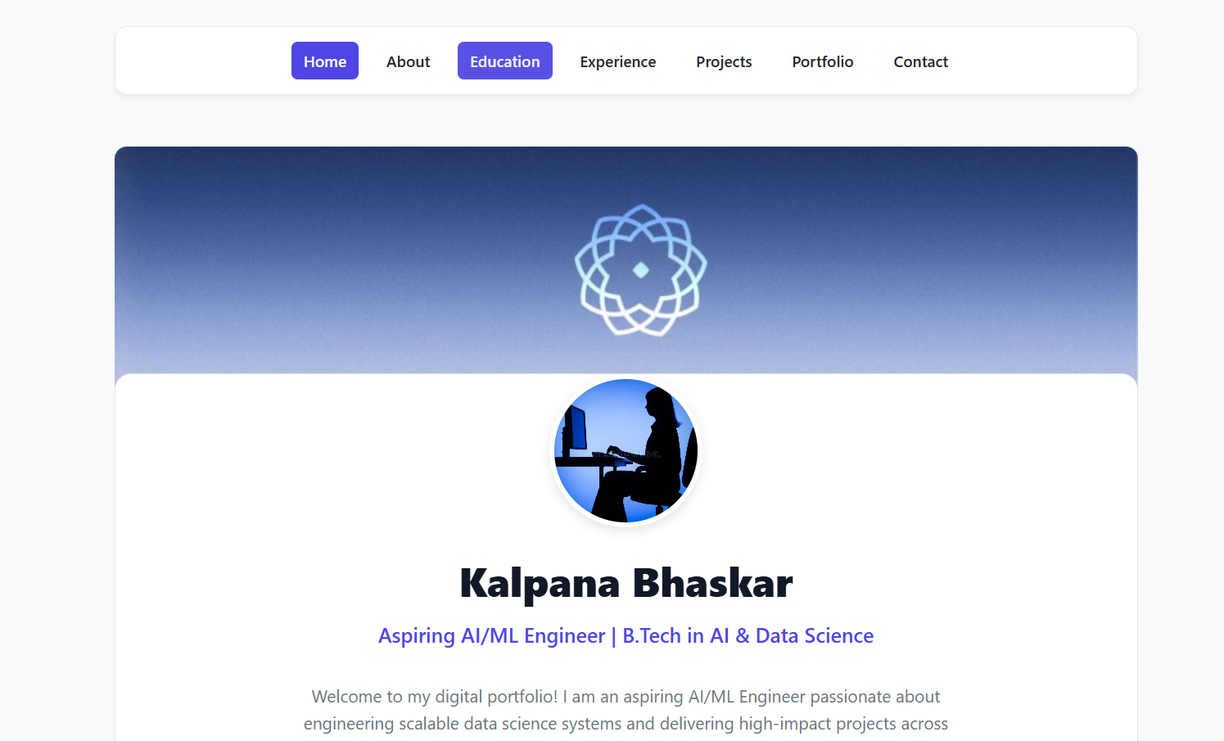
Home page (index.html)
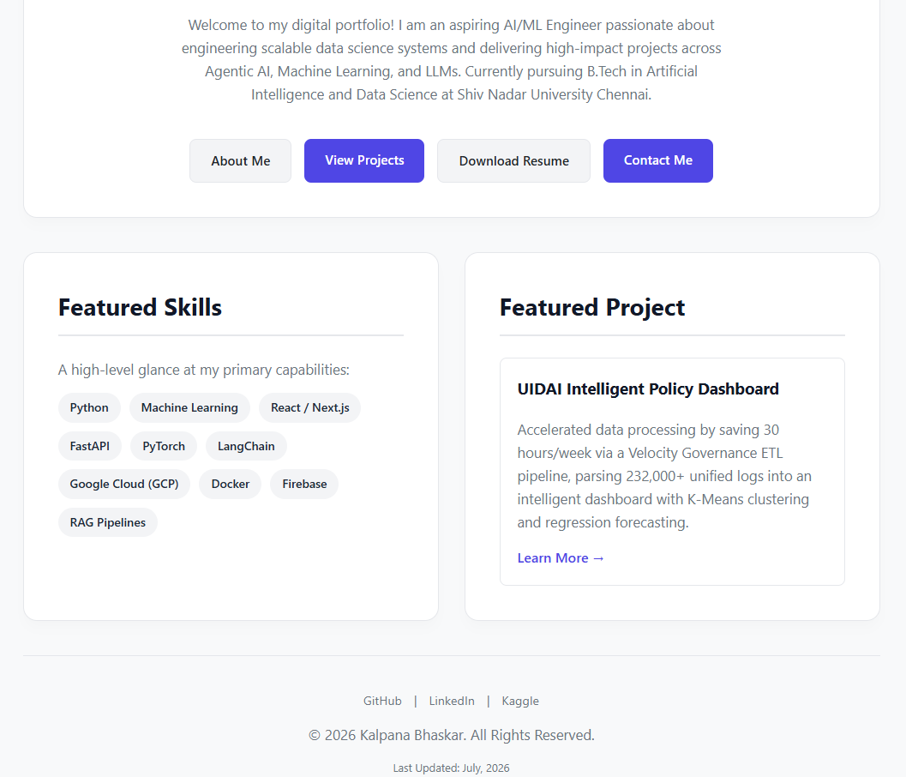
Home page (index.html), continued
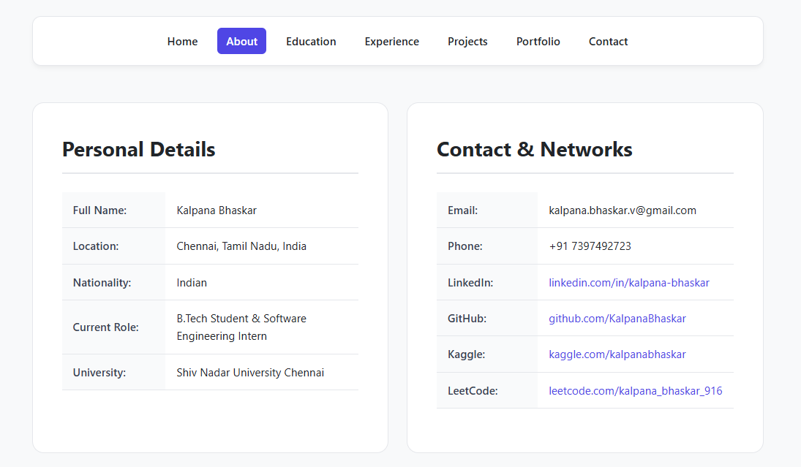
About page (about.html)
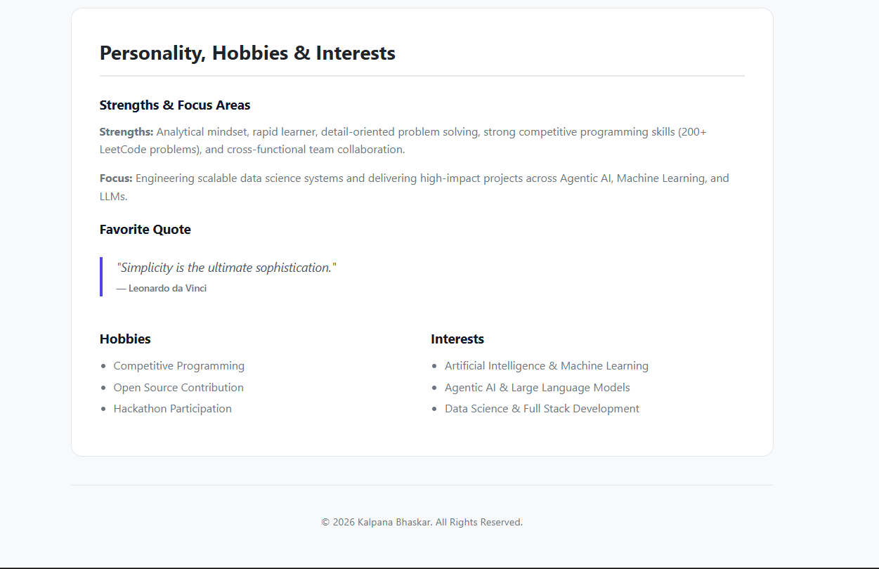
About page (about.html), continued
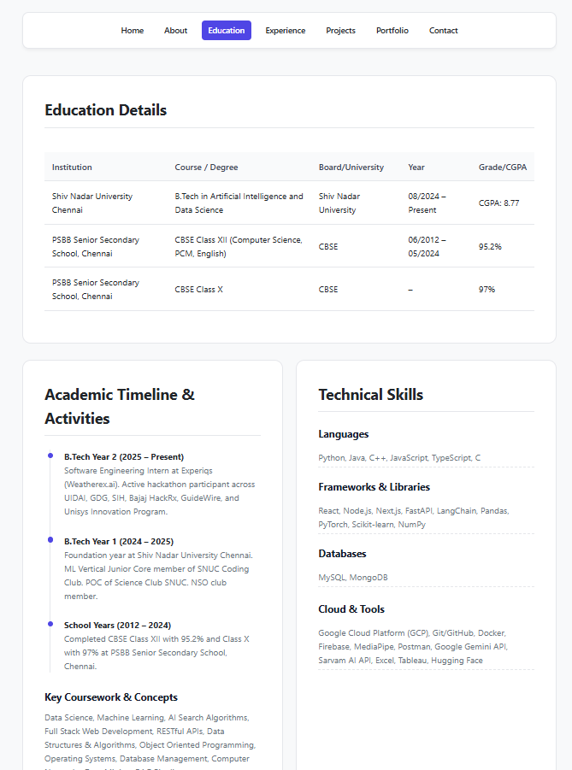
Education page (education.html)
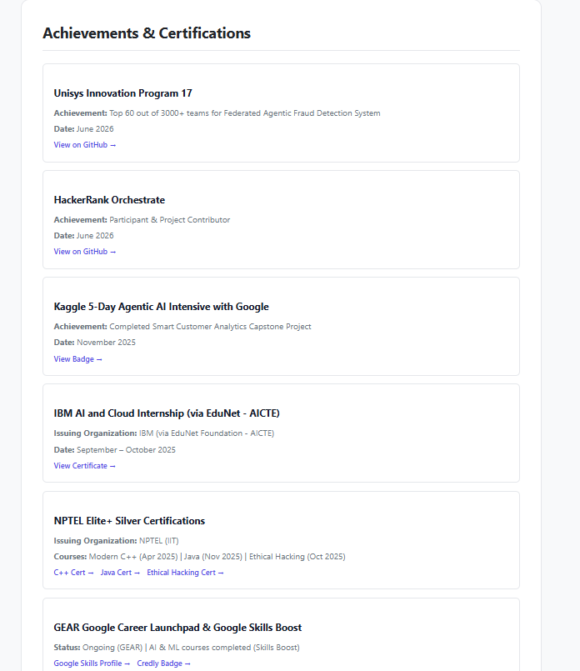
Achievements and certifications (education.html)
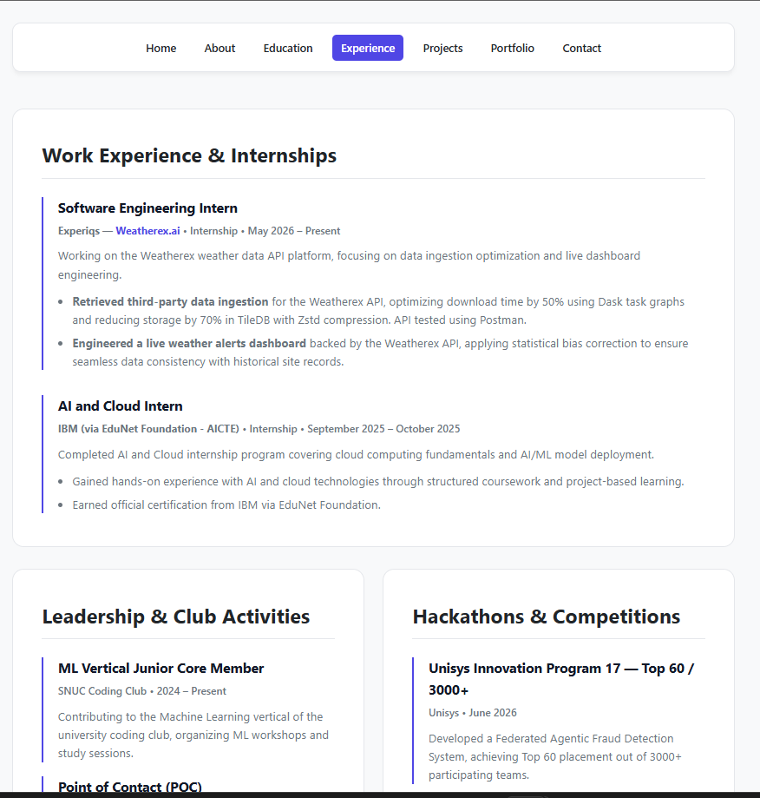
Experience page (experience.html)
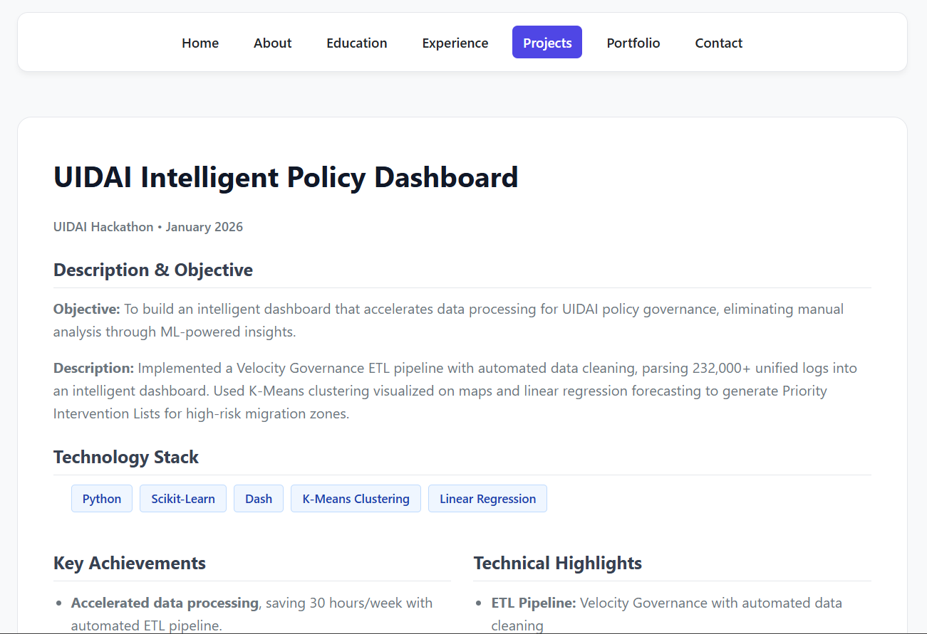
Projects page (projects.html)
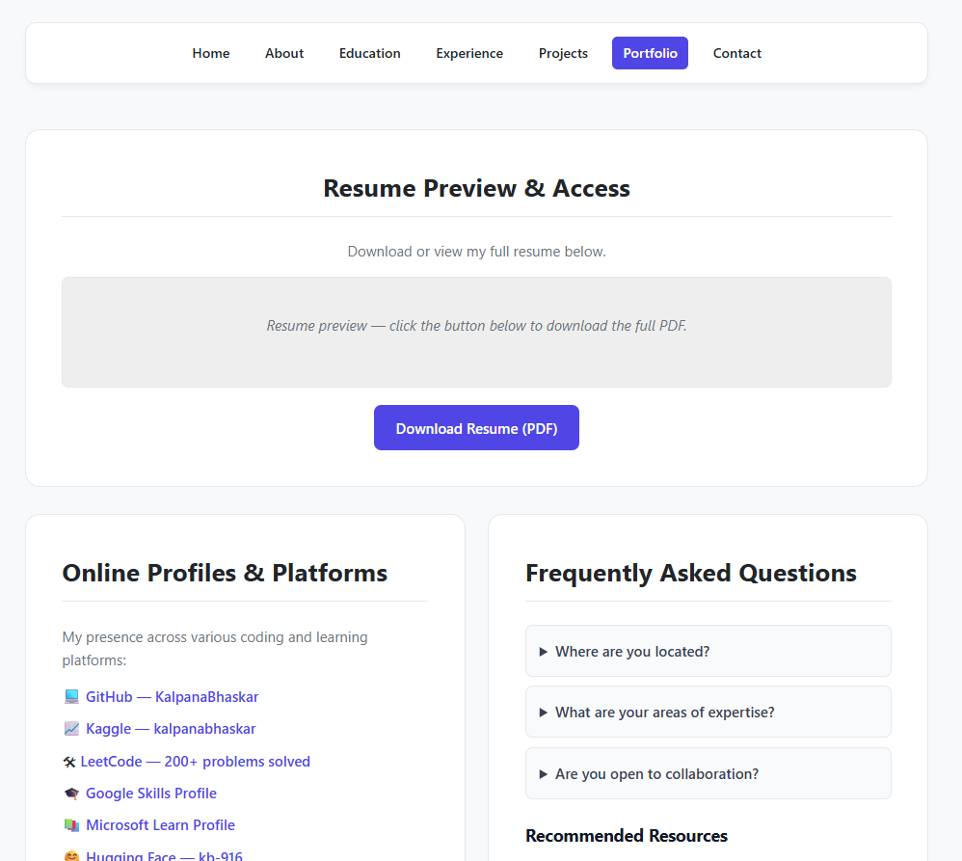
Portfolio page (portfolio.html)
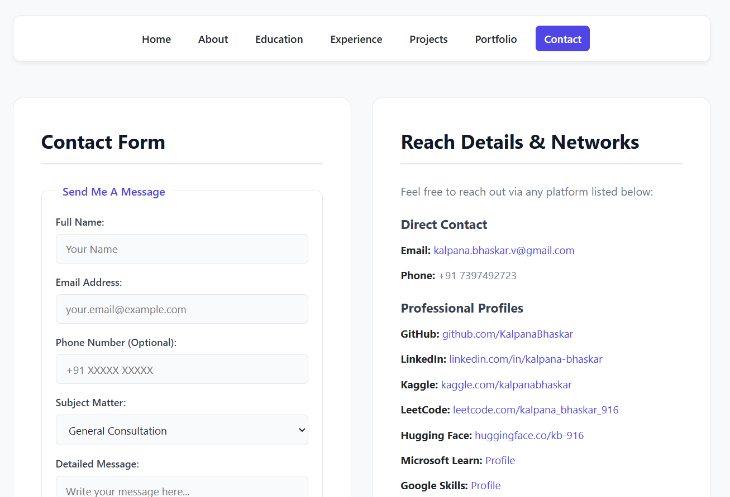
Contact page (contact.html)
Online Job Application Portal
Aim:
Multi-step form validation system for an Online Job Application Portal
Theory:
1. DOM and multi-step navigation: The portal is a single HTML document holding three form blocks: registration, job application and success. Only one block carries the active class at a time, and CSS display rules hide the rest, so the page moves between stages without reloading.
2. Event-driven validation: Each form listens for its submit event. The handler calls preventDefault() to stop the browser from sending the form, then runs the validation function. The stage advances only when that function returns true, which acts as the workflow guard.
3. Field-level rules with regular expressions: Full name is checked with /^[A-Za-z\s]+$/, phone with /^\d{10}$/ and email with a structural pattern. The password pattern uses lookahead assertions to require a lowercase letter, an uppercase letter, a digit and a special character within a minimum length of eight.
4. Value checks and feedback: Dropdowns must hold a non-empty value, experience is parsed as an integer and bounded between 0 and 30, skills and project text are trimmed before checking, and the project description must reach 50 characters. Failed fields receive the invalid class and a visible error message through setValidity().
5. File validation: The resume input exposes the selected file through the files property. The script reads the file name, converts it to lower case and accepts it only when it ends with .pdf or .docx. The accept attribute on the input filters the file picker, and the script check enforces the rule.
6. Interactive controls: Password fields toggle between type password and type text, and the eye icon switches between the fa-eye and fa-eye-slash classes. Font Awesome supplies the icons through a stylesheet link, and CSS transitions and keyframes give the stage change a short fade-in.
Code:
portal.html:
<!DOCTYPE html>
<html lang="en">
<head>
<meta charset="UTF-8">
<meta name="viewport" content="width=device-width, initial-scale=1.0">
<title>Online Job Application Portal</title>
<!-- Font Awesome for eye icons -->
<link rel="stylesheet" href="https://cdnjs.cloudflare.com/ajax/libs/font-awesome/6.4.0/css/all.min.css">
<style>
:root {
--primary: #4f46e5;
--primary-hover: #4338ca;
--bg: #f3f4f6;
--card-bg: #ffffff;
--text: #1f2937;
--text-muted: #6b7280;
--error: #dc2626;
--success: #16a34a;
--border: #d1d5db;
}
* {
box-sizing: border-box;
margin: 0;
padding: 0;
font-family: 'Segoe UI', Tahoma, Geneva, Verdana, sans-serif;
}
body {
background-color: var(--bg);
color: var(--text);
display: flex;
justify-content: center;
align-items: center;
min-height: 100vh;
padding: 20px;
}
.container {
background: var(--card-bg);
width: 100%;
max-width: 550px;
padding: 30px;
border-radius: 12px;
box-shadow: 0 4px 6px -1px rgba(0, 0, 0, 0.1), 0 2px 4px -1px rgba(0, 0, 0, 0.06);
}
h2 {
margin-bottom: 20px;
text-align: center;
color: var(--primary);
}
/* Form Steps Visibility */
.form-step {
display: none;
}
.form-step.active {
display: block;
animation: fadeIn 0.4s ease-in-out;
}
@keyframes fadeIn {
from { opacity: 0; transform: translateY(10px); }
to { opacity: 1; transform: translateY(0); }
}
/* Form groups & styling */
.form-group {
margin-bottom: 18px;
position: relative;
}
label {
display: block;
margin-bottom: 6px;
font-weight: 600;
font-size: 0.9rem;
}
input[type="text"],
input[type="email"],
input[type="password"],
input[type="number"],
select,
textarea {
width: 100%;
padding: 10px 12px;
border: 1px solid var(--border);
border-radius: 6px;
font-size: 1rem;
outline: none;
transition: border-color 0.2s;
}
input:focus, select:focus, textarea:focus {
border-color: var(--primary);
box-shadow: 0 0 0 3px rgba(79, 70, 229, 0.1);
}
/* Password field wrapper for eye icon */
.password-wrapper {
position: relative;
}
.password-wrapper input {
padding-right: 40px;
}
.toggle-password {
position: absolute;
right: 12px;
top: 50%;
transform: translateY(-50%);
cursor: pointer;
color: var(--text-muted);
}
/* Error Messages */
.error-msg {
color: var(--error);
font-size: 0.825rem;
margin-top: 4px;
display: none;
}
input.invalid, select.invalid, textarea.invalid {
border-color: var(--error);
background-color: #fef2f2;
}
/* Buttons */
button {
width: 100%;
padding: 12px;
background-color: var(--primary);
color: white;
border: none;
border-radius: 6px;
font-size: 1rem;
font-weight: 600;
cursor: pointer;
transition: background-color 0.2s;
margin-top: 10px;
}
button:hover {
background-color: var(--primary-hover);
}
/* Success Screen */
.success-screen {
text-align: center;
padding: 20px 0;
}
.success-icon {
font-size: 4rem;
color: var(--success);
margin-bottom: 15px;
}
.success-title {
color: var(--success);
margin-bottom: 10px;
}
</style>
</head>
<body>
<div class="container">
<!-- STEP 1: Registration Form -->
<form id="registrationForm" class="form-step active" novalidate>
<h2>Register to Access Portal</h2>
<div class="form-group">
<label for="regName">Full Name</label>
<input type="text" id="regName" placeholder="John Doe">
<div class="error-msg" id="nameError">Full name should contain only alphabets and spaces.</div>
</div>
<div class="form-group">
<label for="regEmail">Email Address</label>
<input type="email" id="regEmail" placeholder="john@example.com">
<div class="error-msg" id="emailError">Please enter a valid email format.</div>
</div>
<div class="form-group">
<label for="regPhone">Phone Number</label>
<input type="text" id="regPhone" placeholder="10-digit number" maxlength="10">
<div class="error-msg" id="phoneError">Phone number must contain exactly 10 digits.</div>
</div>
<div class="form-group">
<label for="regPassword">Password</label>
<div class="password-wrapper">
<input type="password" id="regPassword" placeholder="••••••••">
<i class="fa-solid fa-eye toggle-password" data-target="regPassword"></i>
</div>
<div class="error-msg" id="passwordError">Must be 8+ chars with 1 uppercase, 1 lowercase, 1 number, and 1 special character.</div>
</div>
<div class="form-group">
<label for="regConfirmPassword">Confirm Password</label>
<div class="password-wrapper">
<input type="password" id="regConfirmPassword" placeholder="••••••••">
<i class="fa-solid fa-eye toggle-password" data-target="regConfirmPassword"></i>
</div>
<div class="error-msg" id="confirmPasswordError">Passwords do not match.</div>
</div>
<button type="submit">Register</button>
</form>
<!-- STEP 2: Job Application Form -->
<form id="jobApplicationForm" class="form-step" novalidate>
<h2>Job Application Form</h2>
<div class="form-group">
<label for="jobPosition">Position</label>
<select id="jobPosition">
<option value="">-- Select Position --</option>
<option value="frontend">Frontend Developer</option>
<option value="backend">Backend Developer</option>
<option value="qa">QA Engineer</option>
<option value="pm">Product Manager</option>
</select>
<div class="error-msg" id="positionError">Position must be selected.</div>
</div>
<div class="form-group">
<label for="jobLevel">Job Level</label>
<select id="jobLevel">
<option value="">-- Select Job Level --</option>
<option value="junior">Entry / Junior</option>
<option value="mid">Mid-Level</option>
<option value="senior">Senior</option>
</select>
<div class="error-msg" id="jobLevelError">Job Level must be selected.</div>
</div>
<div class="form-group">
<label for="jobExperience">Experience (Years)</label>
<input type="number" id="jobExperience" placeholder="0 - 30">
<div class="error-msg" id="experienceError">Experience should be between 0 and 30 years.</div>
</div>
<div class="form-group">
<label for="jobSkills">Skills</label>
<input type="text" id="jobSkills" placeholder="e.g. JavaScript, Python, SQL">
<div class="error-msg" id="skillsError">Skills field should not be empty.</div>
</div>
<div class="form-group">
<label for="jobProjects">Describe Your Projects</label>
<textarea id="jobProjects" rows="4" placeholder="Minimum 50 characters required..."></textarea>
<div class="error-msg" id="projectsError">Project description must contain at least 50 characters.</div>
</div>
<div class="form-group">
<label for="jobResume">Resume Upload (PDF or DOCX)</label>
<input type="file" id="jobResume" accept=".pdf,.docx">
<div class="error-msg" id="resumeError">Please upload your resume in PDF or DOCX format.</div>
</div>
<button type="submit">Submit Application</button>
</form>
<!-- STEP 3: Success View -->
<div id="successScreen" class="form-step success-screen">
<i class="fa-solid fa-circle-check success-icon"></i>
<h2 class="success-title">Application Submitted Successfully!</h2>
<p>Your registration and job application data have been accepted.</p>
</div>
</div>
<script>
// --- UTILITIES & SYSTEM STATE ---
const regForm = document.getElementById('registrationForm');
const jobForm = document.getElementById('jobApplicationForm');
const successScreen = document.getElementById('successScreen');

// Helper to toggle visibility of errors dynamically
function setValidity(inputEl, errorEl, isValid) {
if (isValid) {
inputEl.classList.remove('invalid');
errorEl.style.display = 'none';
} else {
inputEl.classList.add('invalid');
errorEl.style.display = 'block';
}
return isValid;
}

// --- PASSWORD EYE TOGGLE CONTROLLER ---
document.querySelectorAll('.toggle-password').forEach(icon => {
icon.addEventListener('click', function() {
const targetId = this.getAttribute('data-target');
const passwordInput = document.getElementById(targetId);
if (passwordInput.type === 'password') {
passwordInput.type = 'text';
this.classList.remove('fa-eye');
this.classList.add('fa-eye-slash');
} else {
passwordInput.type = 'password';
this.classList.remove('fa-eye-slash');
this.classList.add('fa-eye');
}
});
});

// --- STEP 1: REGISTRATION FIELD VALIDATORS ---
function validateRegistration() {
let isValid = true;

// 1. Full Name: Alphabets and Spaces only
const nameEl = document.getElementById('regName');
const nameErr = document.getElementById('nameError');
const nameRegex = /^[A-Za-z\s]+$/;
if (!setValidity(nameEl, nameErr, nameRegex.test(nameEl.value.trim()))) isValid = false;

// 2. Email Verification
const emailEl = document.getElementById('regEmail');
const emailErr = document.getElementById('emailError');
const emailRegex = /^[^\s@]+@[^\s@]+\.[^\s@]+$/;
if (!setValidity(emailEl, emailErr, emailRegex.test(emailEl.value.trim()))) isValid = false;

// 3. Phone: Exactly 10 digits
const phoneEl = document.getElementById('regPhone');
const phoneErr = document.getElementById('phoneError');
const phoneRegex = /^\d{10}$/;
if (!setValidity(phoneEl, phoneErr, phoneRegex.test(phoneEl.value.trim()))) isValid = false;

// 4. Password Check: 8+ length, Upper, Lower, Num, Special
const passEl = document.getElementById('regPassword');
const passErr = document.getElementById('passwordError');
const passRegex = /^(?=.*[a-z])(?=.*[A-Z])(?=.*\d)(?=.*[@$!%*?&])[A-Za-z\d@$!%*?&]{8,}$/;
if (!setValidity(passEl, passErr, passRegex.test(passEl.value))) isValid = false;

// 5. Confirm Password Match
const confirmEl = document.getElementById('regConfirmPassword');
const confirmErr = document.getElementById('confirmPasswordError');
const matches = (passEl.value === confirmEl.value) && confirmEl.value !== "";
if (!setValidity(confirmEl, confirmErr, matches)) isValid = false;

return isValid;
}

// --- STEP 2: JOB APPLICATION FIELD VALIDATORS ---
function validateJobApplication() {
let isValid = true;

// Position Selection
const posEl = document.getElementById('jobPosition');
const posErr = document.getElementById('positionError');
if (!setValidity(posEl, posErr, posEl.value !== "")) isValid = false;

// Job Level Selection
const lvlEl = document.getElementById('jobLevel');
const lvlErr = document.getElementById('jobLevelError');
if (!setValidity(lvlEl, lvlErr, lvlEl.value !== "")) isValid = false;

// Experience: 0 - 30 bounds Check
const expEl = document.getElementById('jobExperience');
const expErr = document.getElementById('experienceError');
const expVal = parseInt(expEl.value, 10);
const expValid = !isNaN(expVal) && expVal >= 0 && expVal <= 30;
if (!setValidity(expEl, expErr, expValid)) isValid = false;

// Skills Empty String Evaluation
const skillsEl = document.getElementById('jobSkills');
const skillsErr = document.getElementById('skillsError');
if (!setValidity(skillsEl, skillsErr, skillsEl.value.trim() !== "")) isValid = false;

// Project Description: >= 50 chars length
const projEl = document.getElementById('jobProjects');
const projErr = document.getElementById('projectsError');
if (!setValidity(projEl, projErr, projEl.value.trim().length >= 50)) isValid = false;

// Resume: Extension evaluation (.pdf or .docx)
const fileEl = document.getElementById('jobResume');
const fileErr = document.getElementById('resumeError');
let fileValid = false;
if (fileEl.files.length > 0) {
const fileName = fileEl.files[0].name.toLowerCase();
if (fileName.endsWith('.pdf') || fileName.endsWith('.docx')) {
fileValid = true;
}
}
if (!setValidity(fileEl, fileErr, fileValid)) isValid = false;

return isValid;
}

// --- FORM TRANSITION TRIGGERS ---
regForm.addEventListener('submit', function(e) {
e.preventDefault();
if (validateRegistration()) {
regForm.classList.remove('active');
jobForm.classList.add('active');
}
});

jobForm.addEventListener('submit', function(e) {
e.preventDefault();
if (validateJobApplication()) {
jobForm.classList.remove('active');
successScreen.classList.add('active');
}
});
</script>
</body>
</html>
GitHub Repository:
https://github.com/KalpanaBhaskar/Web-Technologies-Laboratory
Output:
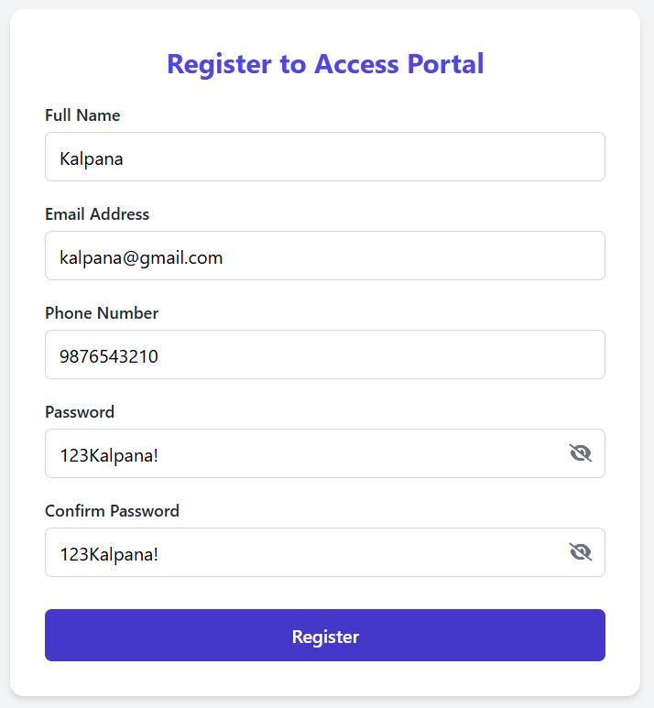
Registration page (Step 1)
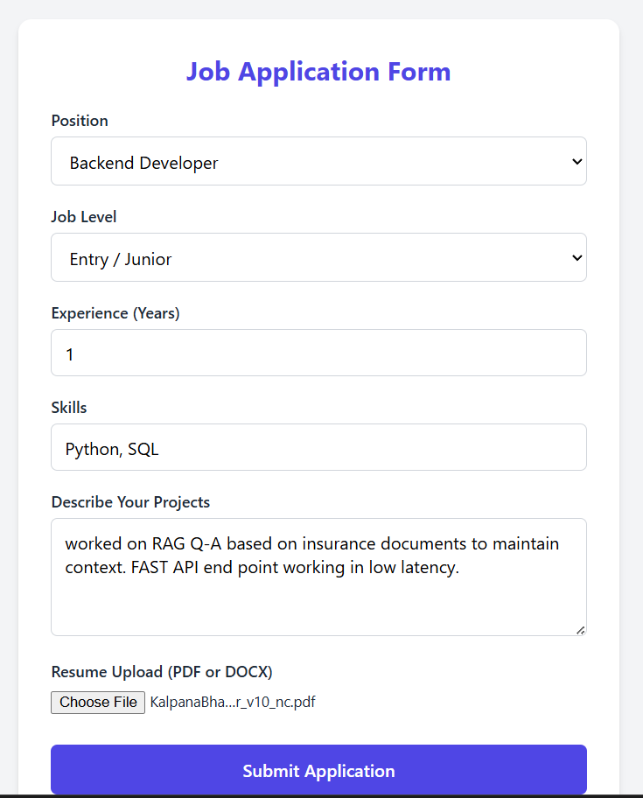
Job application form (Step 2)

Submission success screen (Step 3)
CSS Dark and Light Theme using JavaScript
Aim:
To design and implement a CSS dark and light theme using JavaScript, with the default stylesheet in light mode, implemented over the Lab 1 portfolio website. The theme is changed by directly manipulating DOM elements and their classes, using classList.toggle().
Theory:
1. Default light theme: The base rules in style.css define the light palette (body background #f4f7f6, white cards, dark text). The page therefore opens in light mode without any script running. Dark styles are added separately, so the light design is never overwritten by default.
2. Class-scoped dark styles: Every dark rule is written as a descendant of body.dark-theme, for example body.dark-theme .card. These selectors are more specific than the base rules, so they win the cascade only while the dark-theme class is present on the body element. Removing the class restores the light values automatically.
3. classList.toggle(): The method adds the named class if it is absent and removes it if it is present. It returns true when the class was added and false when it was removed. The script stores this return value in isDarkMode and uses it to set the button label to Light Mode or Dark Mode, so the label and the theme always agree.
4. Direct DOM manipulation: The script obtains the button with getElementById, attaches a handler to its onclick property, and updates the button's innerHTML inside the handler. The theme itself is changed only through the class list of the body element. The page is not reloaded, and the current state is held in the DOM.
5. Transitions between themes: A shared transition rule applies to body, header, cards, table cells, the footer and the download button. Background-color, color and border-color change over 0.4 seconds instead of switching instantly, which makes the change smooth for the viewer.
6. Integration with the Lab 1 portfolio: The theme is applied to the existing portfolio sections, including the header with profile and contact links, the education table, project cards, skills and certifications lists, and the footer. Theme state is not saved, so a page reload returns the site to light mode. Saving the choice would require localStorage, which is outside this lab's scope.
Code:
index.html:
<!DOCTYPE html>
<html lang="en">
<head>
<meta charset="UTF-8">
<meta name="viewport" content="width=device-width, initial-scale=1.0">
<title>My First Online Resume</title>
<link rel="stylesheet" href="style.css">
</head>
<body>
<!-- Header Section -->
<header>
<!-- Theme Button -->
<button id="themeBtn">Dark Mode</button>
<div class="header-container">
<img src="profilepic.webp" alt="Profile Picture" class="profile-img">
<div class="header-text">
<h1>Kalpana Bhaskar</h1>
<p class="subtitle">
Aspiring AI Engineer, AI & Data Science Student
</p>
<p class="contact-info">
Email:
<a href="mailto:kalpanabhaskar@email.com">
kalpanabhaskar@email.com
</a>
|
LinkedIn:
<a href="https://linkedin.com" target="_blank">
linkedin.com/in/kalpanabhaskar
</a>
|
GitHub:
<a href="https://github.com" target="_blank">
github.com/kalpanabhaskar
</a>
</p>
</div>
</div>
</header>
<!-- Main Content -->
<main class="main-container">
<div class="left-column">
<section class="card">
<h2>Education</h2>
<table>
<thead>
<tr>
<th>Degree / Course</th>
<th>Institution</th>
<th>Year</th>
<th>GPA / %</th>
</tr>
</thead>
<tbody>
<tr>
<td>B.Tech in AI and Data Science</td>
<td>University of Technology</td>
<td>2024 - Present</td>
<td>9.0 CGPA</td>
</tr>
<tr>
<td>Higher Secondary (12th)</td>
<td>State CBSE School</td>
<td>2022 - 2024</td>
<td>95%</td>
</tr>
</tbody>
</table>
</section>
<section class="card">
<h2>Projects</h2>
<div class="project-item">
<h3>Portfolio Website</h3>
<p>
Designed a responsive personal portfolio using
<strong>HTML5</strong> and
<strong>CSS3 Flexbox</strong>.
</p>
</div>
<div class="project-item">
<h3>Task Manager App</h3>
<p>
Built a JavaScript To-Do application with local storage.
</p>
</div>
</section>
</div>
<div class="right-column">
<section class="card">
<h2>Technical Skills</h2>
<ul>
<li><strong>Languages:</strong> HTML5, CSS3, JavaScript, Python</li>
<li><strong>Frameworks & Tools:</strong> Git, GitHub, VS Code</li>
<li><strong>Concepts:</strong> Responsive Web Design, UI/UX Basics</li>
</ul>
</section>
<section class="card">
<h2>Certifications & Achievements</h2>
<ol>
<li>Responsive Web Design - freeCodeCamp</li>
<li>Python for Everybody - Coursera</li>
<li>Core member of Coding Club (Web Dev Vertical)</li>
</ol>
</section>
</div>
</main>
<!-- Download Resume -->
<div class="download-section">
<a href="sampleresume.pdf" download class="download-btn">
Download Sample Resume
</a>
</div>
<!-- Footer -->
<footer>
<p>
&copy; 2026 Kalpana Bhaskar.
Built for Web Technologies Lab.
</p>
</footer>
<!-- JavaScript -->
<script src="script.js"></script>
</body>
</html>
style.css:
/* Reset and Base Styles */
* {
margin: 0;
padding: 0;
box-sizing: border-box;
font-family: 'Segoe UI', Tahoma, Geneva, Verdana, sans-serif;
}
body {
background-color: #f4f7f6;
color: #333;
line-height: 1.6;
padding: 20px;
}
/* Header Section with Flexbox */
header {
background-color: #2c3e50;
color: #fff;
padding: 30px;
border-radius: 8px;
margin-bottom: 20px;
}
.header-container {
display: flex;
align-items: center;
gap: 30px;
flex-wrap: wrap; /* Ensures responsiveness on smaller screens */
}
.profile-img {
border-radius: 50%;
width: 120px;
height: 120px;
object-fit: cover;
border: 3px solid #fff;
}
.header-text h1 {
font-size: 2.5rem;
margin-bottom: 5px;
}
.subtitle {
font-size: 1.2rem;
color: #1abc9c;
font-weight: 600;
margin-bottom: 10px;
}
.contact-info a {
color: #fff;
text-decoration: none;
border-bottom: 1px dashed #1abc9c;
}
.contact-info a:hover {
color: #1abc9c;
}
/* Main Layout using Flexbox */
.main-container {
display: flex;
gap: 20px;
flex-wrap: wrap;
}
.left-column {
flex: 2; /* Takes up 2/3 of the width */
min-width: 300px;
}
.right-column {
flex: 1; /* Takes up 1/3 of the width */
min-width: 250px;
}
/* Card Styling for Sections */
.card {
background: #fff;
padding: 20px;
margin-bottom: 20px;
border-radius: 8px;
box-shadow: 0 4px 6px rgba(0,0,0,0.05);
}
.card h2 {
color: #2c3e50;
border-bottom: 2px solid #1abc9c;
padding-bottom: 5px;
margin-bottom: 15px;
}
/* Table Styling */
table {
width: 100%;
border-collapse: collapse;
margin-top: 10px;
}
th, td {
padding: 12px;
text-align: left;
border-bottom: 1px solid #ddd;
}
th {
background-color: #f8f9fa;
color: #2c3e50;
}
/* Lists and Project Styles */
ul, ol {
padding-left: 20px;
}
li {
margin-bottom: 10px;
}
.project-item {
margin-bottom: 15px;
}
.project-item h3 {
color: #34495e;
margin-bottom: 5px;
}
/* Footer Section */
footer {
text-align: center;
padding: 20px;
color: #7f8c8d;
font-size: 0.9rem;
margin-top: 20px;
}
/* Download Button Section */
.download-section {
text-align: center;
margin: 30px 0;
}
/* Download Button */
.download-btn {
display: inline-block;
background-color: #0077b6;
color: white;
text-decoration: none;
padding: 10px 22px;
border-radius: 6px;
font-size: 16px;
font-weight: bold;
transition: background-color 0.3s ease, transform 0.2s ease;
}
.download-btn:hover {
background-color: #023e8a;
transform: translateY(-2px);
}
.download-btn:active {
transform: scale(0.98);
}
/* ===========================
Theme Button
=========================== */
#themeBtn {
float: right;
background-color: white;
color: #2c3e50;
border: none;
padding: 10px 18px;
font-size: 15px;
font-weight: bold;
border-radius: 6px;
cursor: pointer;
transition: 0.3s;
margin-bottom: 15px;
}
#themeBtn:hover {
background-color: #1abc9c;
color: white;
}
/* Smooth transition while changing theme */
body,
header,
.card,
footer,
th,
td,
.download-btn,
.contact-info a,
.card h2,
.project-item h3 {
transition: background-color 0.4s ease,
color 0.4s ease,
border-color 0.4s ease;
}
/* ===========================
Dark Theme using classList.toggle()
=========================== */
body.dark-theme {
background-color: #1e1e1e;
color: #ffffff;
}
body.dark-theme header {
background-color: #111111;
}
body.dark-theme .card {
background-color: #2d2d2d;
color: #ffffff;
}
body.dark-theme .card h2,
body.dark-theme .project-item h3 {
color: #00e5ff;
}
body.dark-theme .contact-info a {
color: #00e5ff;
}
body.dark-theme th {
background-color: #444;
color: #ffffff;
}
body.dark-theme td {
border-bottom-color: #666;
}
body.dark-theme footer {
color: #ffffff;
}
script.js:
// Get the theme button
const themeBtn = document.getElementById("themeBtn");

// Toggle the dark theme class when the button is clicked
themeBtn.onclick = function () {
const isDarkMode = document.body.classList.toggle("dark-theme");
themeBtn.innerHTML = isDarkMode ? "Light Mode" : "Dark Mode";
};
GitHub Repository:
https://github.com/KalpanaBhaskar/Web-Technologies-Laboratory/tree/main/week_3
Output:
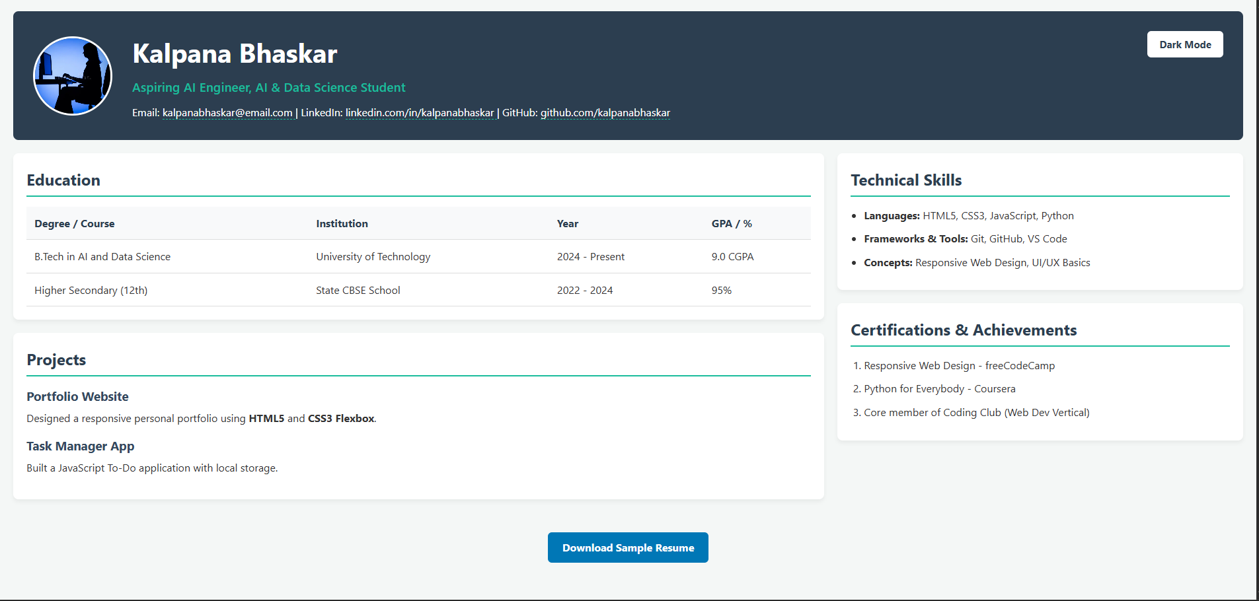
Light mode (default)
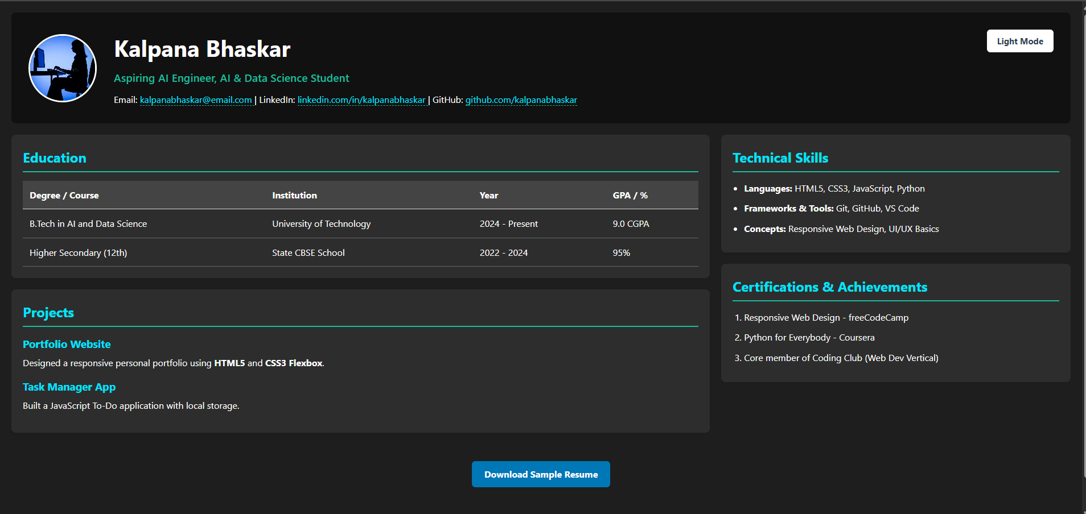
Dark mode (after clicking the theme button)
Online Shopping Product Catalog using React
Aim:
To develop a React-based Online Shopping Product Catalog that demonstrates dynamic searching, filtering and conditional rendering using React state management. The catalog supports searching products by name, filtering by category (Electronics, Clothing, Grocery) and by price range, showing "Out of Stock" when quantity is 0, and displaying the product count.
Theory:
1. Component structure and props: The application is split into an App root component and a ProductCard child component. App owns the product data and the filter state, and passes each product to ProductCard through the product prop. The card only displays what it receives, so presentation and logic stay separate.
2. State with useState: Three state variables, search, category and priceRange, hold the current filter values. Each input is a controlled element, with its value bound to state and updated through onChange. A change to any filter updates state, which triggers a re-render of the catalog.
3. Derived data with filter(): The filtered list is not stored in state. It is recalculated on every render by calling products.filter(). Each product must pass three checks: the name contains the search text (case-insensitive), the category matches or is All, and the price falls in the selected range. The checks are combined with a logical AND, so every active filter applies at once.
4. Multiple filters and price conditions: The price range is handled by a chain of if and else if branches that map the option values Below500, 500-1000 and Above1000 to comparisons on product.price. The All Prices option leaves matchesPrice as true, so the price filter has no effect.
5. Rendering lists with map() and keys: The filtered array is converted to JSX with map(), which returns one ProductCard per product. Each element receives a key equal to product.id, which lets React track items across updates and reuse their DOM nodes. The product count is shown with filteredProducts.length.
6. Conditional rendering: The stock status is decided by a ternary expression in ProductCard. If quantity equals 0, the card shows the Out of Stock span with the out class, and otherwise it shows In Stock with the in class. The same pattern hides or shows content based on state, so the displayed output always matches the data.
Code:
App.jsx:
import { useState } from "react";
import products from "./data/products";
import ProductCard from "./components/ProductCard";
import "./App.css";

function App() {
const [search, setSearch] = useState("");
const [category, setCategory] = useState("All");
const [priceRange, setPriceRange] = useState("All");

const filteredProducts = products.filter((product) => {
const matchesSearch = product.name
.toLowerCase()
.includes(search.toLowerCase());

const matchesCategory =
category === "All" || product.category === category;

let matchesPrice = true;

if (priceRange === "Below500") {
matchesPrice = product.price < 500;
} else if (priceRange === "500-1000") {
matchesPrice = product.price >= 500 && product.price <= 1000;
} else if (priceRange === "Above1000") {
matchesPrice = product.price > 1000;
}

return matchesSearch && matchesCategory && matchesPrice;
});

return (
<div className="container">
<h1>Online Shopping Product Catalog</h1>

<div className="filters">
<input
type="text"
placeholder="Search Product"
value={search}
onChange={(e) => setSearch(e.target.value)}
/>

<select
value={category}
onChange={(e) => setCategory(e.target.value)}
>
<option>All</option>
<option>Electronics</option>
<option>Clothing</option>
<option>Grocery</option>
</select>

<select
value={priceRange}
onChange={(e) => setPriceRange(e.target.value)}
>
<option value="All">All Prices</option>
<option value="Below500">Below ₹500</option>
<option value="500-1000">₹500 - ₹1000</option>
<option value="Above1000">Above ₹1000</option>
</select>
</div>

<h3>Products Found: {filteredProducts.length}</h3>

<div className="products">
{filteredProducts.map((product) => (
<ProductCard
key={product.id}
product={product}
/>
))}
</div>
</div>
);
}

export default App;
main.jsx:
import React from "react";
import ReactDOM from "react-dom/client";
import App from "./App";
import "./index.css";

ReactDOM.createRoot(document.getElementById("root")).render(
<React.StrictMode>
<App />
</React.StrictMode>
);
ProductCard.jsx:
function ProductCard({ product }) {
return (
<div className="card">
<h3>{product.name}</h3>

<p>Category: {product.category}</p>
<p>Price: ₹{product.price}</p>
<p>Quantity: {product.quantity}</p>

<p>
{product.quantity === 0 ? (
<span className="out">Out of Stock</span>
) : (
<span className="in">In Stock</span>
)}
</p>
</div>
);
}

export default ProductCard;
Products.js:
const products = [
{
id: 1,
name: "Laptop",
category: "Electronics",
price: 55000,
quantity: 5,
},
{
id: 2,
name: "Mobile",
category: "Electronics",
price: 18000,
quantity: 0,
},
{
id: 3,
name: "T-Shirt",
category: "Clothing",
price: 700,
quantity: 10,
},
{
id: 4,
name: "Jeans",
category: "Clothing",
price: 1200,
quantity: 2,
},
{
id: 5,
name: "Rice",
category: "Grocery",
price: 450,
quantity: 15,
},
{
id: 6,
name: "Bread",
category: "Grocery",
price: 50,
quantity: 0,
},
];

export default products;
GitHub Repository:
https://github.com/KalpanaBhaskar/Web-Technologies-Laboratory/tree/main/week_4
Output:
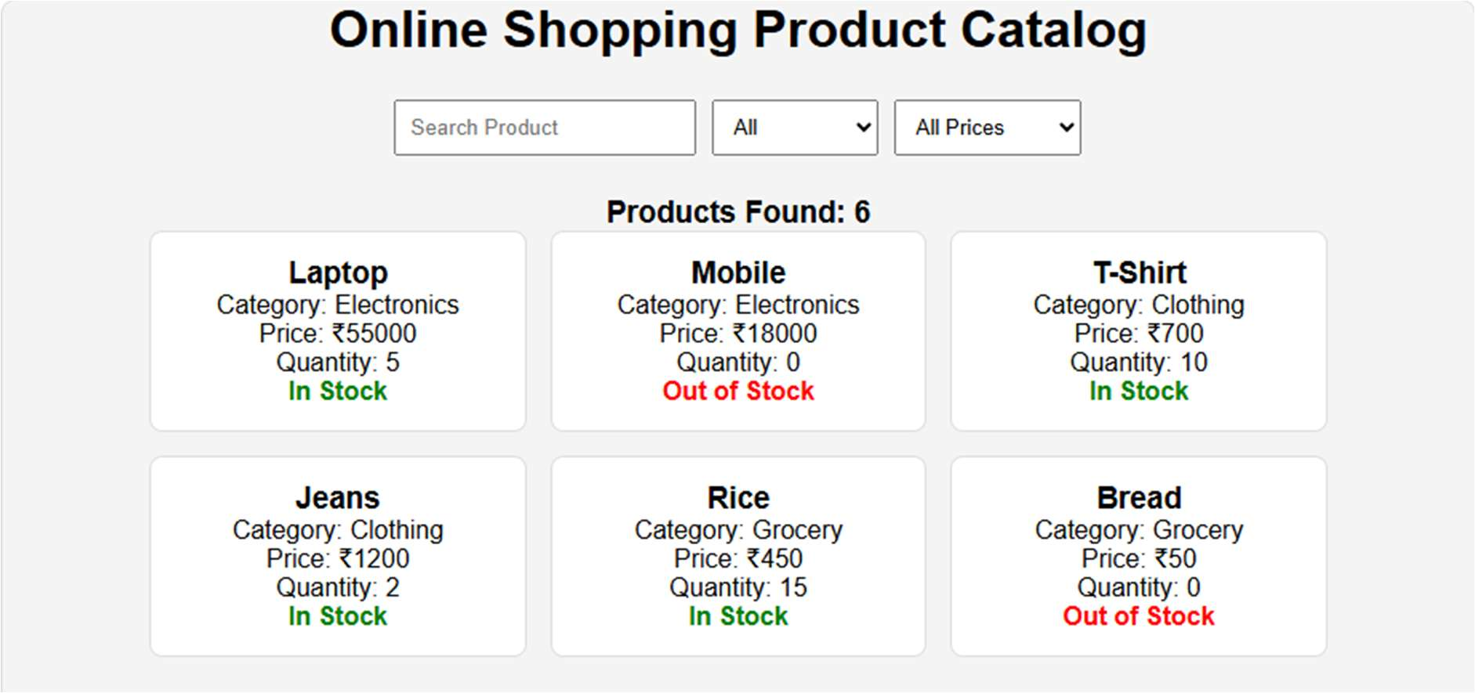
Full catalog with no filters applied (6 products)
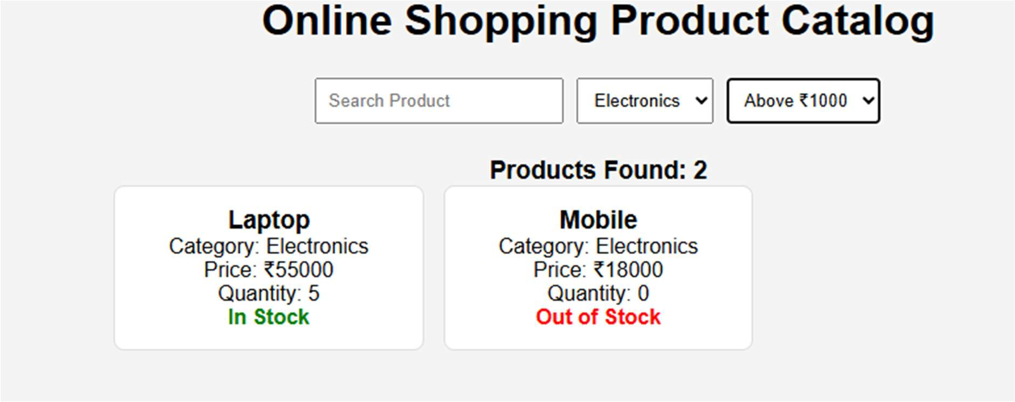
Category: Electronics, Price: Above ₹1000
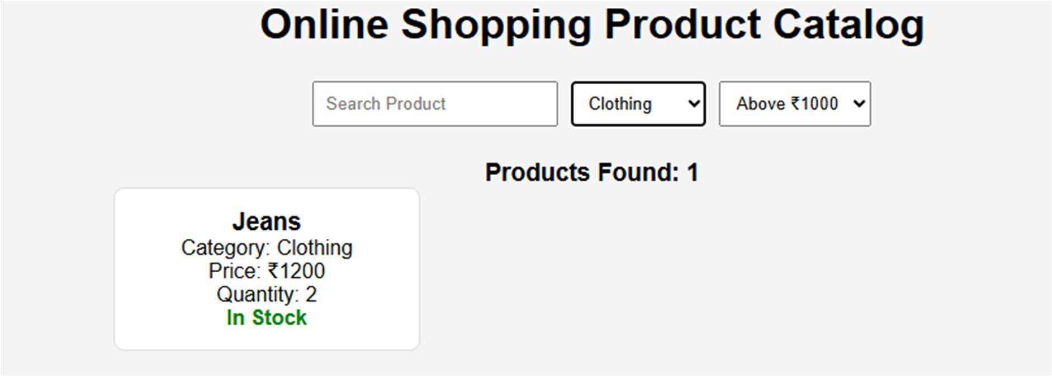
Category: Clothing, Price: Above ₹1000
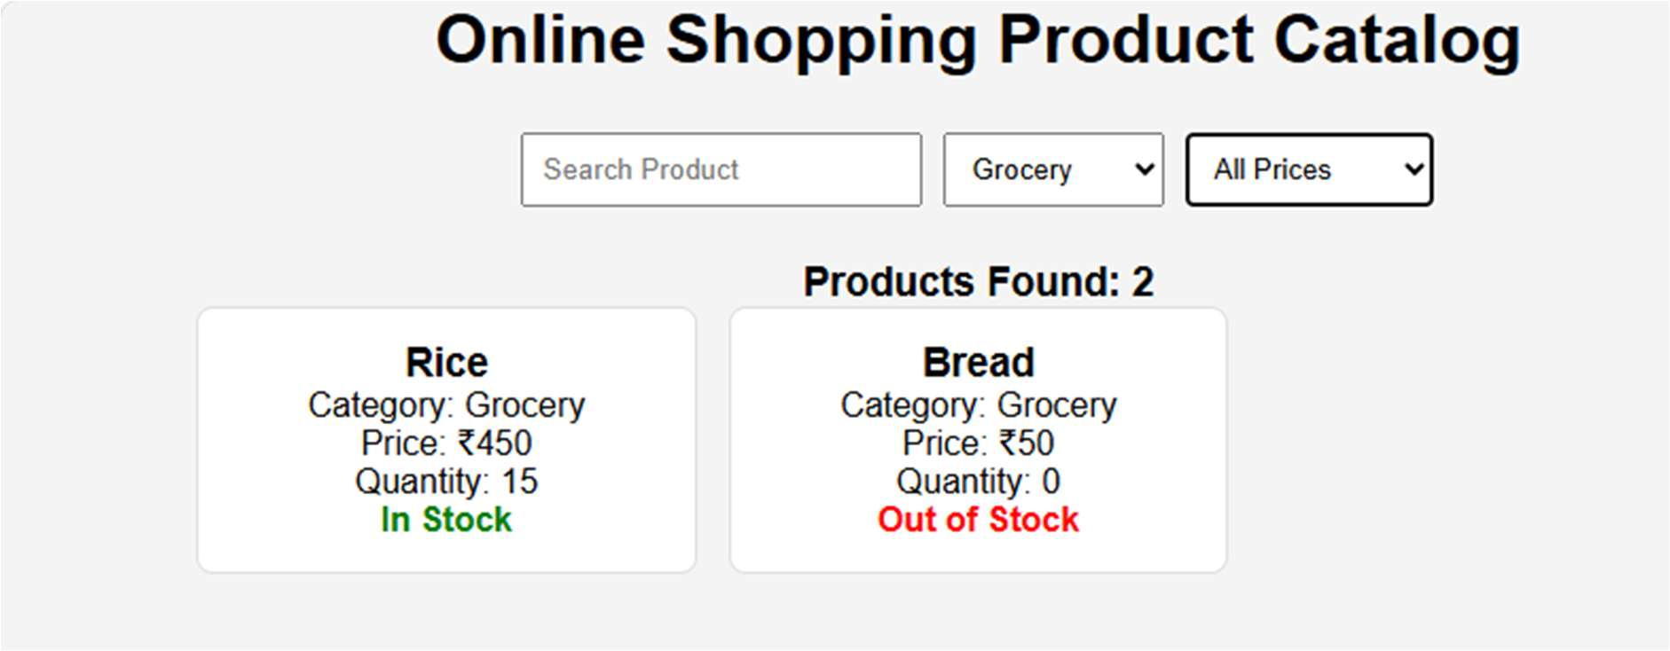
Category: Grocery, Price: All Prices
React.js Menu Navigation System for a University Website
Aim:
To design and implement a React.js-based menu navigation system for a university website containing menus such as About Us, Academics, Admissions, Research, Campus Life, Placements and Contact Us. Dropdown menus are implemented for the relevant sections, and React components, props, JSX, event handling and React Router are used to provide smooth navigation between pages.
Theory:
1. Components and props: The navigation bar is built from reusable React components. Each menu item receives its label, route path and dropdown entries through props, so the same component renders every menu without repeated markup. The parent component passes data down, and the child component only displays it.
2. JSX and data-driven menus: The menu structure is stored as an array of objects, and map() converts that array into JSX elements. Each menu item is rendered with a unique key. Adding or changing a menu entry therefore requires editing the data, not the layout code.
3. Event handling and dropdown state: Each dropdown is controlled by a useState value that stores the currently open menu. Mouse or click events update this state through event handlers such as onMouseEnter, onMouseLeave and onClick. The dropdown panel renders only when its state matches the menu, which keeps the interface consistent.
4. React Router setup: The application wraps its components in BrowserRouter and defines a route for each page using Routes and Route. Each route maps a URL path such as /about, /academics or /admissions to a page component. Navigation changes the displayed page without a full browser reload.
5. Client-side navigation with Link and NavLink: Menu items use the Link component in place of anchor tags, which prevents full page requests and keeps the single-page application running. The NavLink component adds an active class to the current route, which produces the red underline shown on the active menu item in the results.
6. Shared layout and page composition: The header navigation and footer are placed in a shared layout that remains on screen while the page content changes. Each page, such as Academics, Admissions or Campus Life, is a separate component with its own hero banner and content sections. This keeps the navigation consistent across all pages of the site.
Code:
The source code for this assignment is available in the GitHub repository listed below.
GitHub Repository:
https://github.com/KalpanaBhaskar/Web-Technologies-Laboratory/tree/main/week_5
Output:
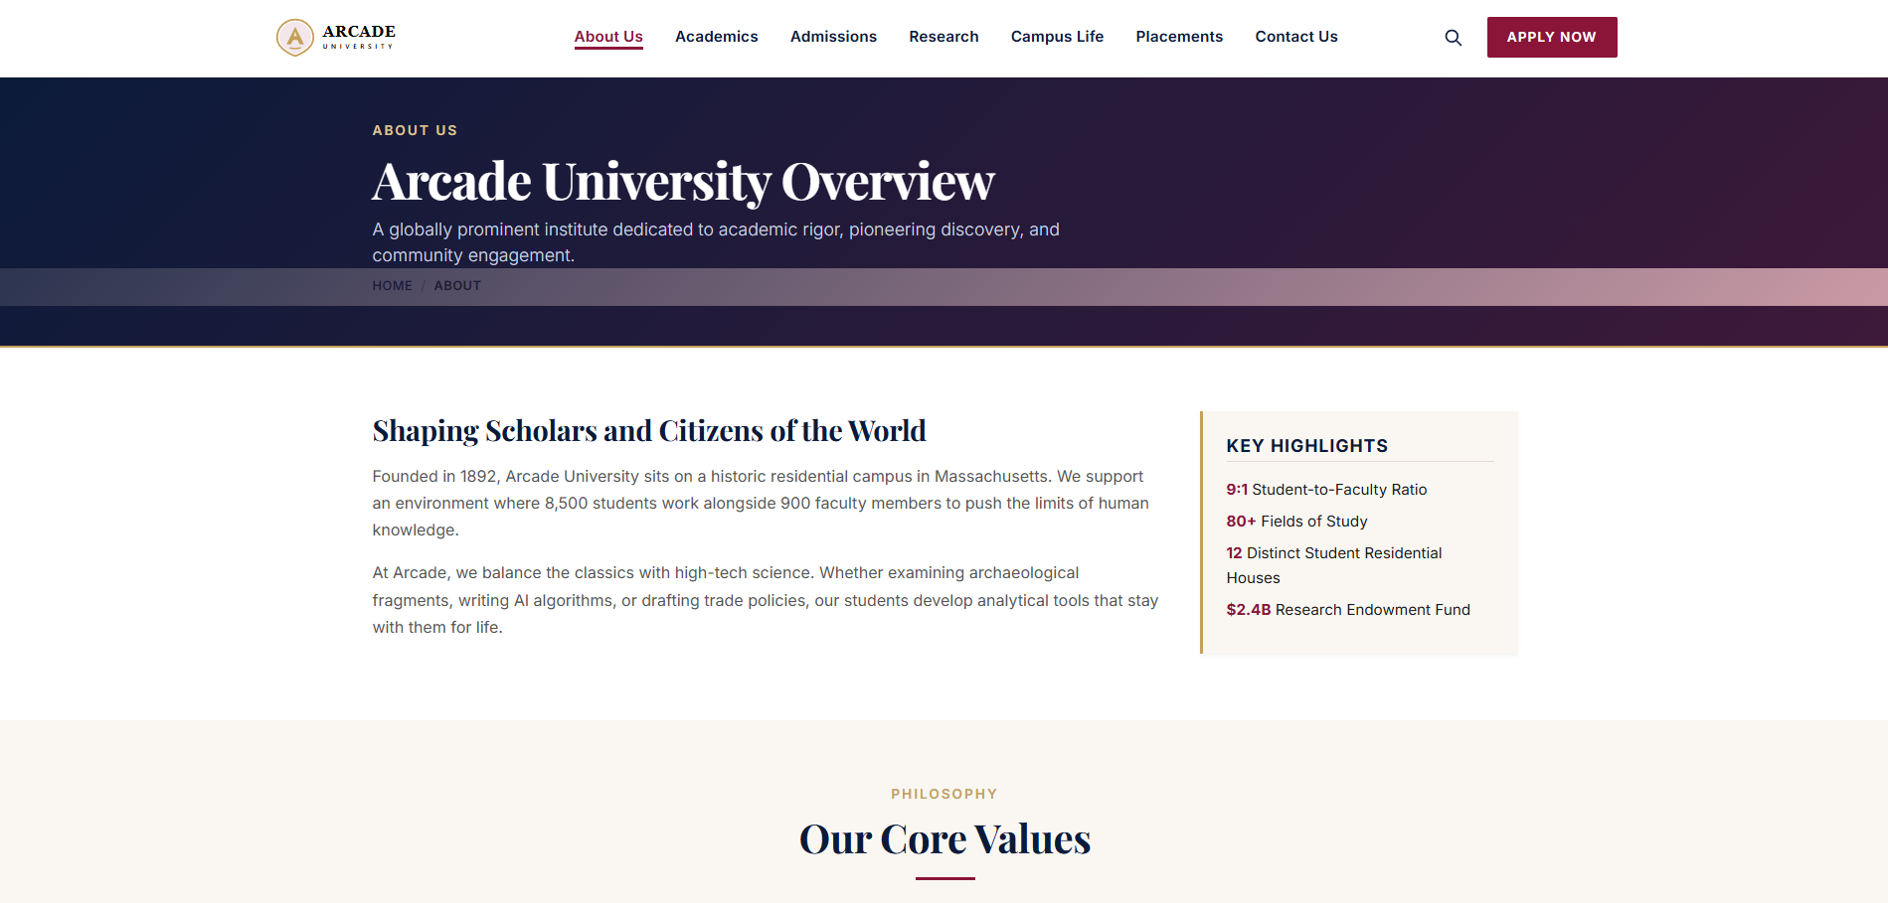
About Us: university overview
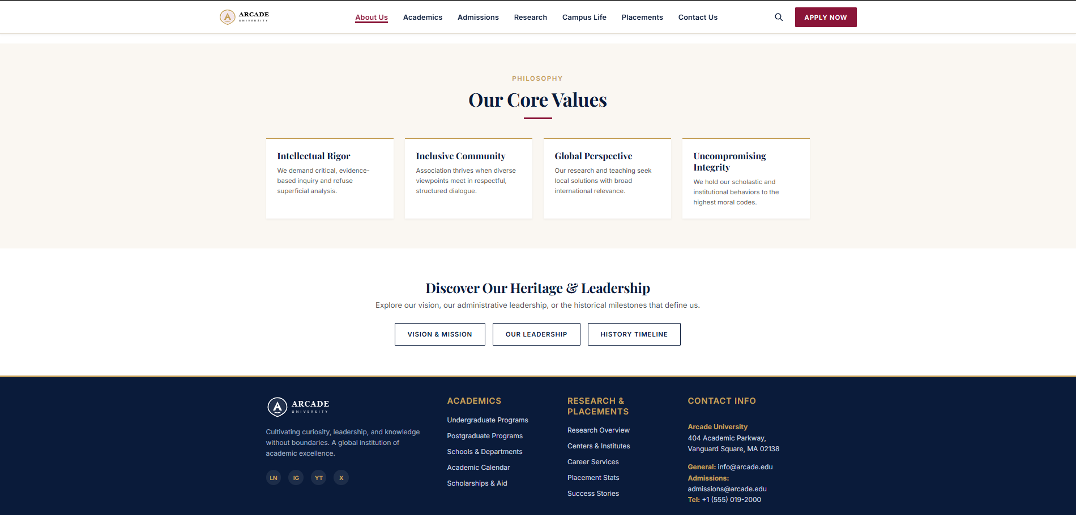
About Us: core values and heritage
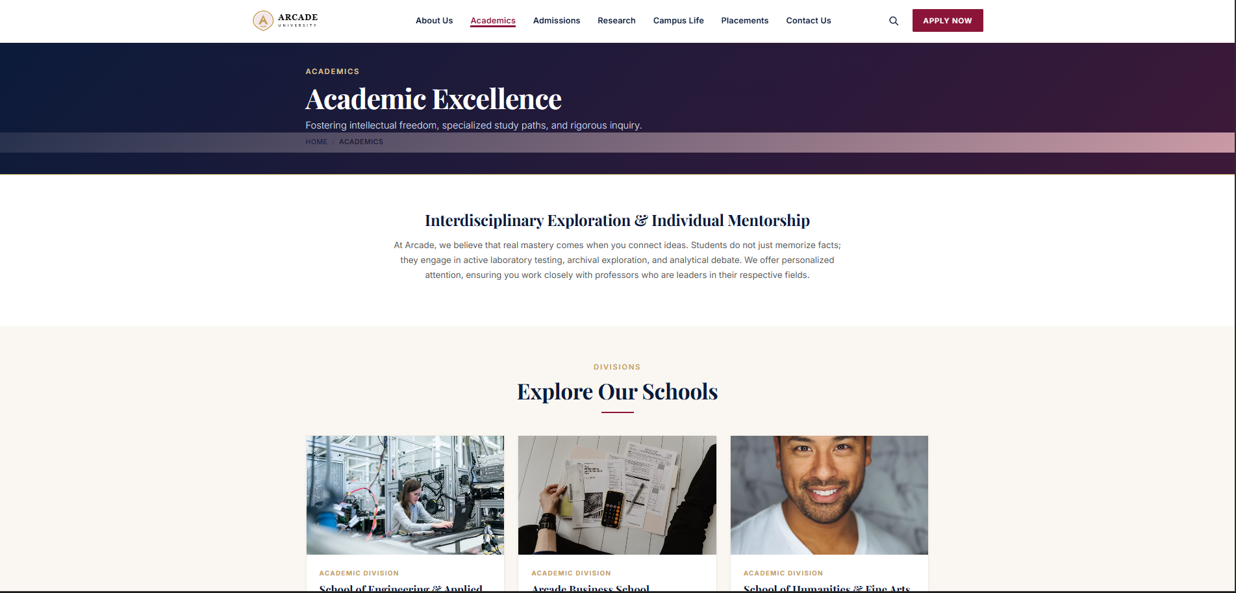
Academics: academic excellence and school divisions
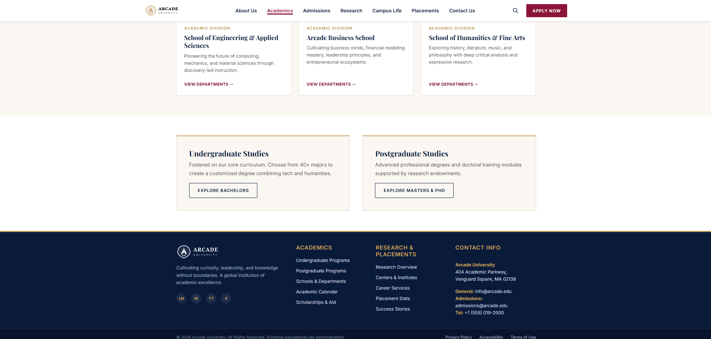
Academics: undergraduate and postgraduate studies
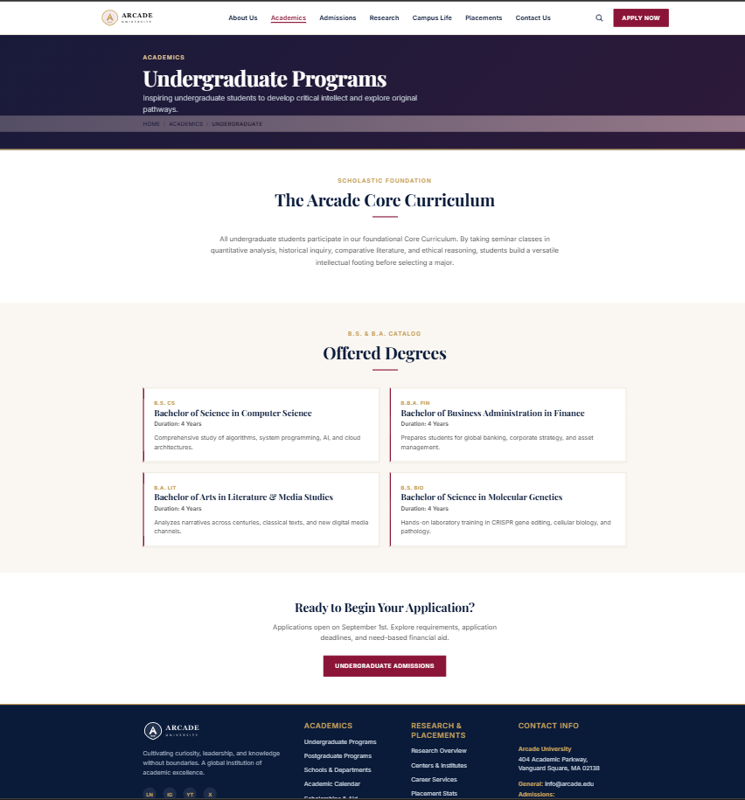
Academics: undergraduate programs
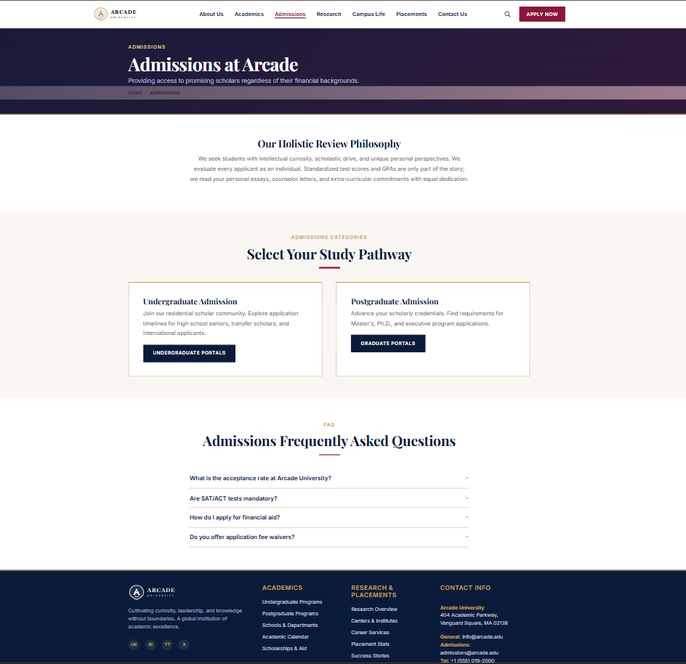
Admissions: admissions at Arcade
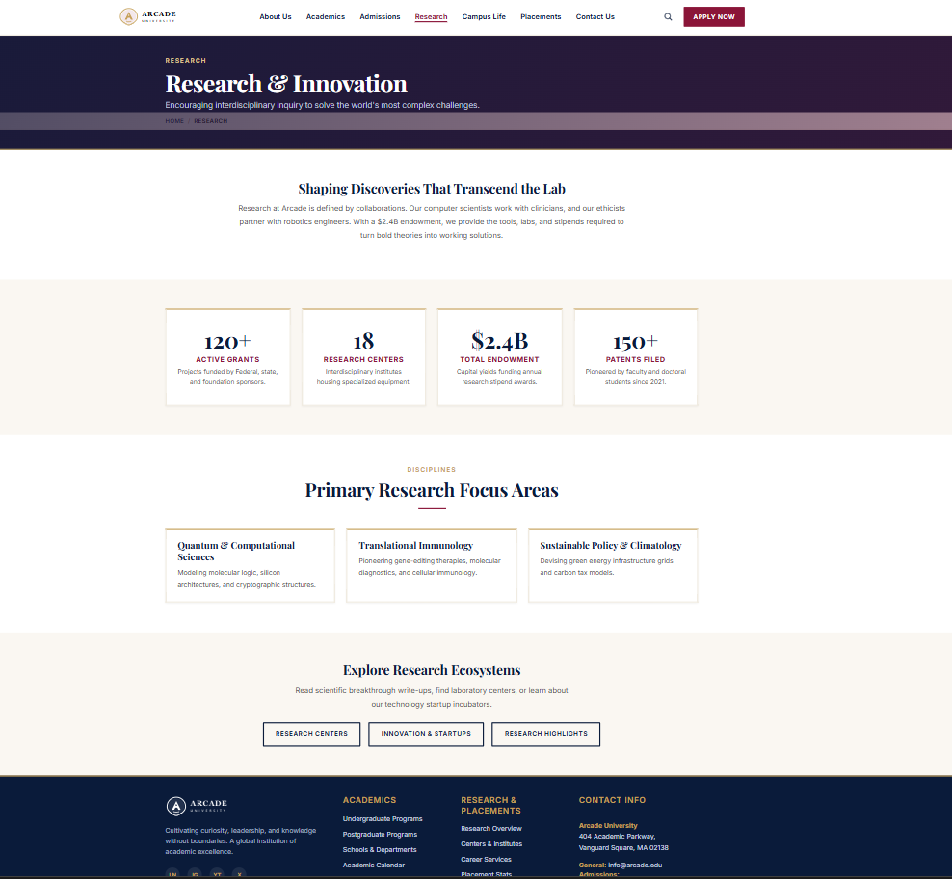
Research: research and innovation
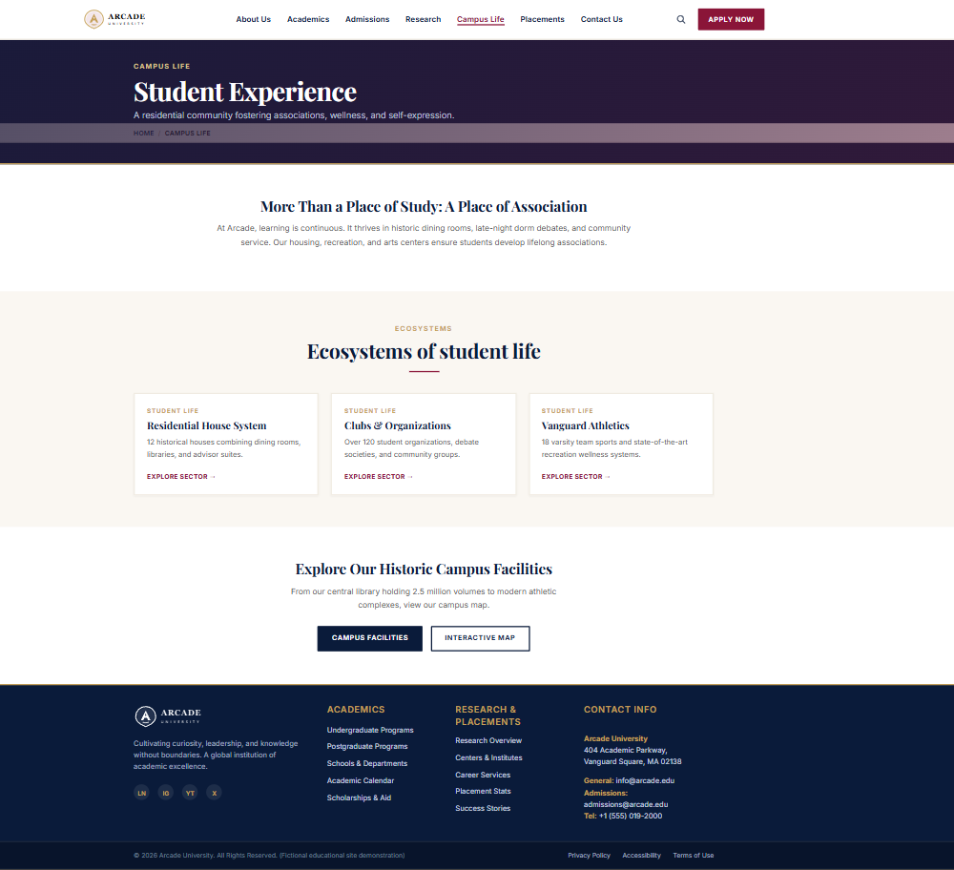
Campus Life: student experience
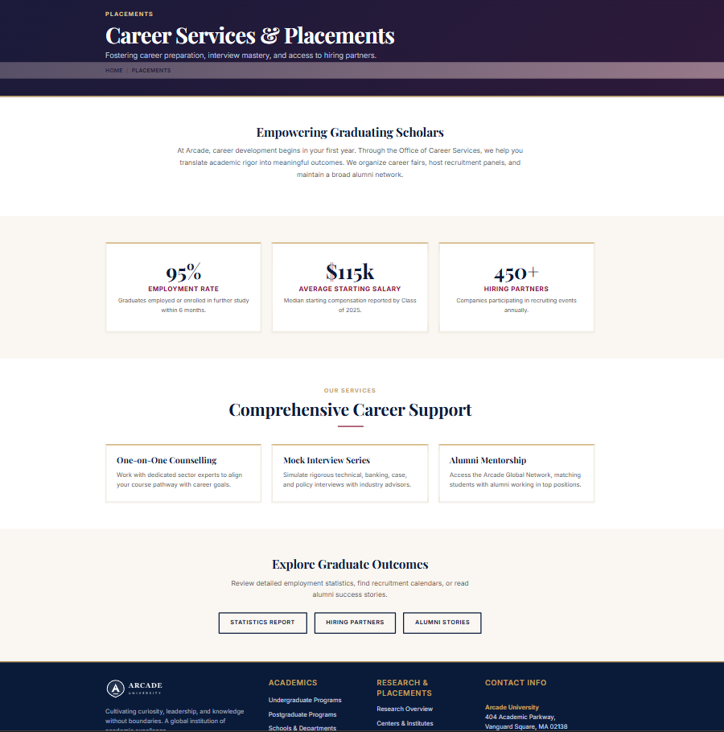
Placements: career services and placements
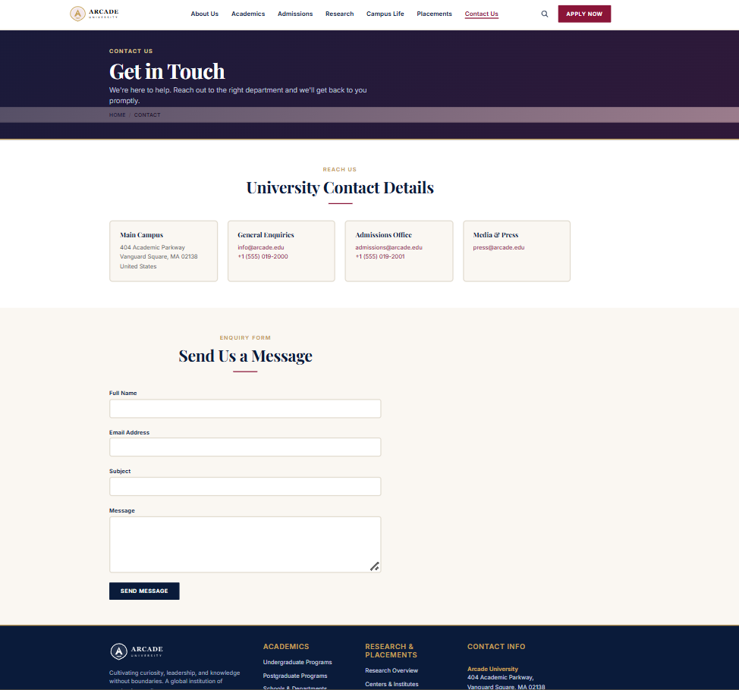
Contact Us: get in touch
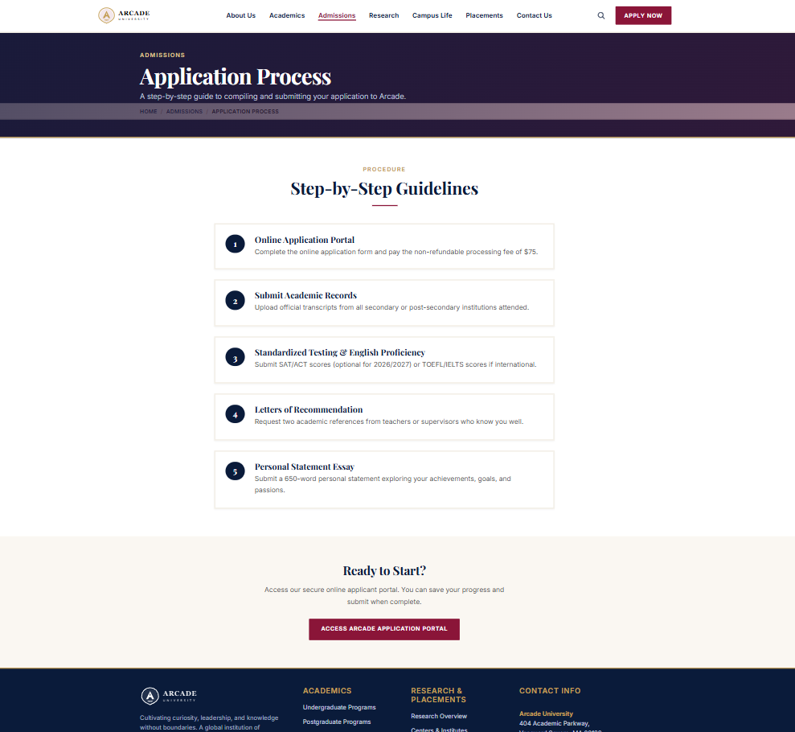
Admissions: application process
React Counter Application
Aim:
To implement a React counter application with increment and decrement controls that update the displayed value as the user interacts with the buttons.
Theory:
1. Component and JSX structure: The counter is built as a single functional component that returns JSX. The layout consists of a heading, the current count, and two buttons, all nested in one container. The component renders from its state, so the markup describes the interface for any value.
2. State with useState: The count is stored in a state variable created with useState(0), which returns the current value and a setter function. The initial value is 0, matching the result screenshot. React keeps this value between renders, while ordinary variables would reset on every render.
3. Event handling with onClick: The Increment and Decrement buttons each receive an onClick handler. When a button is clicked, React calls its handler, which passes the event to the setter. Clicking a button therefore triggers the update cycle without any manual DOM access.
4. State updates and re-rendering: The increment handler calls setCount with the new value, and the decrement handler does the same in reverse. React schedules a re-render after each update, so the displayed number changes to match the new state. The UI always reflects the stored value, and the component does not change the DOM directly.
5. Functional updates: A safer way to change state is to pass a function to the setter, such as setCount(prev => prev + 1). This uses the latest state value, even when several updates run before a render. The lab uses the simpler direct form, which works correctly for single clicks.
6. Conditional and inline styling: The green Increment button and red Decrement button are styled with inline style objects or class names. Each button's colour communicates its action, while the counter display uses a larger font to make the value easy to read. Styling is separate from the state logic, so changing the look does not affect the counter behaviour.
Code:
The source code for this assignment is available in the GitHub repository listed below.
GitHub Repository:
https://github.com/KalpanaBhaskar/Web-Technologies-Laboratory/tree/main/week_6/counter-app
Output:
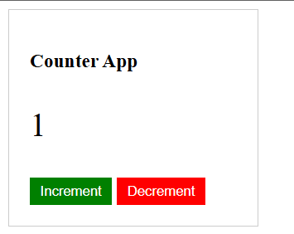
Counter after one increment (value 1)
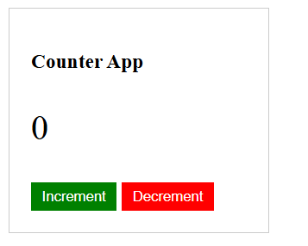
Counter after one decrement (value 0)
Node.js Server with Routing, Error Handling and Request Logging
Aim:
To create a Node.js server with two pages, Homepage and About. The server handles invalid routes with a 404 status code, and a middleware logs every incoming request to the console.
Theory:
1. Built-in modules and the HTTP server: The program uses the http, fs and path modules, all built into Node.js. http.createServer() takes a request handler that receives the incoming request and the response object. server.listen(3000) keeps the process running and accepts connections on port 3000.
2. Request logging as middleware: The first statement in the request handler logs the method and URL of every request, for example [REQUEST] GET /about.html. Because this runs before any routing, it records requests for valid pages, invalid routes and the browser's favicon request alike. The terminal output shows each of these in order.
3. Mapping URLs to files: path.join() combines the public folder with the requested path, so the file location does not depend on the directory the server is started from. The root URL and /index.html both resolve to public/index.html, and /about.html resolves to public/about.html. Any other URL keeps the default path built from req.url.
4. Asynchronous file reading and error codes: fs.readFile() reads the file without blocking the server, and its callback receives an error object when the read fails. An error with the code ENOENT means the file does not exist, so the server responds with a 404 status and a message in HTML. Any other error code leads to a 500 response.
5. Response headers and content: On success the server calls writeHead(200) with a Content-Type header and then sends the file contents with res.end(). The content type is set to text/html, which suits both pages. The extension is read with path.extname() but not used to choose the type, so a request for a non-HTML file would still be labelled as HTML.
6. Limits of the current design: Routing is a fixed set of if comparisons, so each new page needs its own branch unless the path is used directly. The server also has no listener for errors raised by the server itself, which is listed in the algorithm as a required step. Adding a server.on('error') handler would close that gap.
Code:
server.js:
const http = require('http');
const fs = require('fs');
const path = require('path');

const server = http.createServer((req, res) => {
// Middleware: Log incoming requests to the console
console.log(`[REQUEST] ${req.method} ${req.url}`);

// Construct file path based on request URL
let filePath = path.join(__dirname, 'public', req.url === '/' ? 'index.html' : req.url);

// Route handling
if (req.url === '/' || req.url === '/index.html') {
filePath = path.join(__dirname, 'public', 'index.html');
} else if (req.url === '/about.html') {
filePath = path.join(__dirname, 'public', 'about.html');
}

// Determine file extension and content type
const extname = path.extname(filePath);
let contentType = 'text/html';

// Read file asynchronously
fs.readFile(filePath, (err, content) => {
if (err) {
// If file not found (error), return 404 response
if (err.code === 'ENOENT') {
res.writeHead(404, { 'Content-Type': 'text/html' });
res.end('<h1>404 Not Found</h1><p>The page you requested does not exist on this server.</p>', 'utf8');
} else {
// Handle other server errors
res.writeHead(500);
res.end(`Server Error: ${err.code}`);
}
} else {
// Write 200 OK header and send file content
res.writeHead(200, { 'Content-Type': contentType });
res.end(content, 'utf8');
}
});
});

// Server listens on port 3000
const PORT = 3000;
server.listen(PORT, () => {
console.log(`Server running at http://localhost:${PORT}/`);
});
public/index.html:
<!DOCTYPE html>
<html lang="en">
<head>
<meta charset="UTF-8">
<meta name="viewport" content="width=device-width, initial-scale=1.0">
<title>Homepage - Node.js Server</title>
<style>
body { font-family: Arial, sans-serif; text-align: center; padding: 50px; background-color: #f4f7f6; }
h1 { color: #2c3e50; }
a { text-decoration: none; color: #1abc9c; font-weight: bold; }
</style>
</head>
<body>
<h1>Welcome to the Homepage!</h1>
<p>This is a simplistic Node.js web server created by Kalpana Bhaskar.</p>
<a href="/about.html">Go to About Page</a>
</body>
</html>
public/about.html:
<!DOCTYPE html>
<html lang="en">
<head>
<meta charset="UTF-8">
<meta name="viewport" content="width=device-width, initial-scale=1.0">
<title>About - Node.js Server</title>
<style>
body { font-family: Arial, sans-serif; text-align: center; padding: 50px; background-color: #eef2f3; }
h1 { color: #2c3e50; }
a { text-decoration: none; color: #0077b6; font-weight: bold; }
</style>
</head>
<body>
<h1>About This Project</h1>
<p>This project demonstrates routing, file serving, and error handling in Node.js.</p>
<a href="/">Back to Homepage</a>
</body>
</html>
GitHub Repository:
https://github.com/KalpanaBhaskar/Web-Technologies-Laboratory/tree/main/week_7
Output:
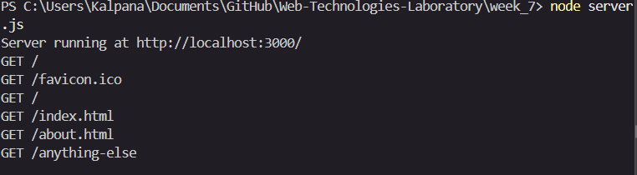
Terminal showing server start and request logs
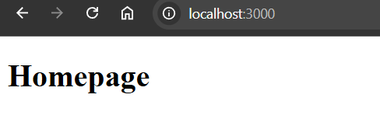
Homepage at http://localhost:3000/
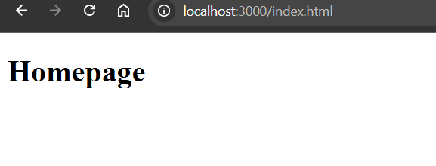
Homepage at http://localhost:3000/index.html
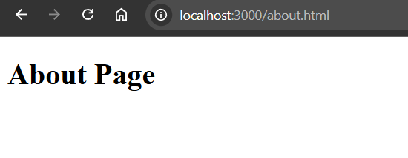
About page at http://localhost:3000/about.html
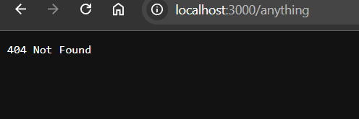
404 response for an unknown route
Full-Stack MERN Web Application with MongoDB Integration
Aim:
To develop a full-stack web application using the MERN stack and implement client-side and server-side integration with MongoDB.
Theory:
1. Three-layer architecture: The MERN stack separates the application into a React frontend, a Node.js and Express backend, and a MongoDB database. Each layer has one job. React renders the interface and collects input, Express handles HTTP requests and business logic, and MongoDB stores the records. Keeping the layers apart lets each one change without rewriting the others.
2. Schema and model in MongoDB: MongoDB stores data as documents grouped into collections. A Mongoose schema defines the fields of each record, such as the task text and a completed flag, and the model built from it provides methods for creating, reading, updating and deleting documents. The schema gives the application a consistent data shape even though MongoDB itself does not enforce one.
3. REST API endpoints with Express: Each CRUD operation is exposed as an HTTP endpoint. A POST request creates a record, a GET request retrieves the list, a PUT or PATCH request updates a record such as its completion status, and a DELETE request removes it. Express matches each request to its route, runs the model method, and returns the result as JSON with an appropriate status code.
4. Backend connection to MongoDB: The Express server connects to the database when it starts, usually through Mongoose, and only begins accepting requests once the connection succeeds. This is the step that confirms the database link required by the testing section. Errors in the connection or query are returned to the frontend as error responses rather than being left unhandled.
5. State management and API calls in React: The React application keeps the list of records in state. On load, it sends a GET request to the backend and stores the response. Creating, toggling or deleting a record sends a request to the matching endpoint, and the state is updated from the response. The page then reflects the database contents, as shown by the task list in the output.
6. Testing the full workflow: The lab requires each CRUD operation to be tested through the web interface and confirmed in MongoDB. In the output, tasks can be added with the Add Task control, marked complete with the checkbox, and removed with the Delete button. Checking the same changes in the database confirms that data is stored and modified, not only displayed.
Code:
The source code for this assignment is available in the GitHub repository listed below.
GitHub Repository:
https://github.com/KalpanaBhaskar/Web-Technologies-Laboratory/tree/main/week_8
Output:
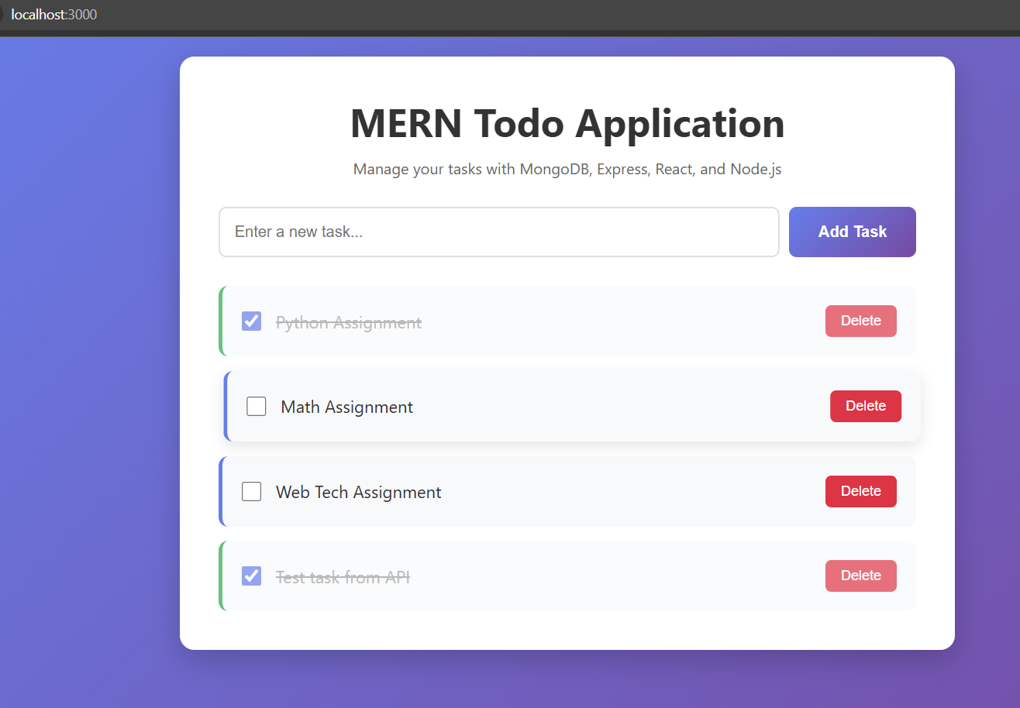
MERN Todo application running at localhost:3000, showing task creation, completion and deletion
Working MERN stack web application with frontend, backend, and MongoDB integration.
Blog Website using MERN Stack
Aim:
To develop a full-stack Blog/Post Management web application using React, Express.js, Node.js and MongoDB Atlas, implementing CRUD operations over a REST API using the native MongoDB Node.js driver and the browser's native fetch() method.
Project Structure:
project/
├── app/
│ └── src/
│ ├── App.jsx
│ ├── components/
│ │ └── PostSummary.jsx
│ └── pages/
│ ├── Home.jsx
│ ├── Create.jsx
│ ├── Post.jsx
│ └── Archive.jsx
│
└── server/
├── .env
├── db/
│ └── conn.mjs
├── index.mjs
├── loadEnvironment.mjs
└── routes/
└── posts.mjs
Design / Algorithm:
1. Configure environment variables in server/.env for the MongoDB Atlas connection string and server port.
2. Load environment variables using loadEnvironment.mjs and establish a persistent connection to MongoDB Atlas in server/db/conn.mjs using the native MongoDB Node.js driver (MongoClient).
3. Initialize the Express server in server/index.mjs, mounting CORS, JSON parsing middleware, and the posts router (routes/posts.mjs).
4. Define RESTful API routes in routes/posts.mjs handling GET / (fetch all posts), GET /:id (fetch single post), POST / (create post), PATCH /:id or PUT /:id (update post), and DELETE /:id (delete post).
5. Set up React client routing in App.jsx to manage navigation between Home, Create, Post, and Archive pages.
6. In Home.jsx and Archive.jsx, use the native fetch() API inside useEffect hooks to retrieve post listings and render them using the PostSummary component.
7. In Create.jsx, capture title and content input, then issue a POST request using fetch() to insert a new document into MongoDB Atlas.
8. In Post.jsx, query a single post by ID using fetch(), displaying full post details with options to update or delete the record.
9. Dynamically re-render UI state upon successful HTTP response status codes.
Frontend Components & Pages (React):
• App.jsx: Main application container handling route definitions and navigation layout.
• PostSummary.jsx: Reusable UI component for displaying individual post cards and summaries in listings.
• Home.jsx: Main page displaying active post listings fetched from the database.
• Create.jsx: Page containing form inputs for creating and submitting new blog posts.
• Post.jsx: Detailed view page for displaying, editing and deleting an individual blog post.
• Archive.jsx: View page dedicated to archived or historical blog posts.
Frontend Functionality (React):
• State management for storing retrieved posts, individual post details, and form fields.
• Asynchronous data fetching using the browser's native fetch() method for all HTTP methods (GET, POST, PUT/PATCH, DELETE).
• Form validation and real-time input handling for post creation and updates.
• Client-side routing across page views using React Router.
Backend (Node.js with Express - ES Modules .mjs):
• loadEnvironment.mjs: Parses configuration variables from server/.env.
• db/conn.mjs: Instantiates MongoClient and exports the connected database instance.
• routes/posts.mjs: Express Router defining REST endpoints for blog operations using native MongoDB collection methods (find, findOne, insertOne, updateOne, deleteOne).
• index.mjs: Primary entry point running the Express server on designated ports.
Database (MongoDB Atlas):
• Hosting post data on MongoDB Atlas cloud infrastructure.
• Interfacing via the official native MongoDB Node.js driver (mongodb package) instead of an ORM/ODM.
• Collections storing post documents containing fields such as _id, title, content, author, and creation timestamp.
Theory:
1. Native driver instead of an ODM: The server uses the official mongodb package and calls collection methods such as find, findOne, insertOne, updateOne and deleteOne directly. No schema layer such as Mongoose sits between the code and the database, so the route handlers and the React forms are responsible for checking the shape of each post.
2. Environment configuration: The Atlas connection string and the server port are stored in server/.env. loadEnvironment.mjs reads this file at startup, which keeps database credentials out of the source code and lets the same code run against different environments.
3. Persistent connection: conn.mjs creates a single MongoClient, connects it to MongoDB Atlas, and exports the database instance. The routes import this shared instance, so each request reuses one connection rather than opening a new one.
4. REST routes with an Express Router: posts.mjs maps each HTTP method and path to one CRUD operation, such as POST / for create and DELETE /:id for delete. Routes that accept an :id must convert the string to an ObjectId before querying _id. Express handles the JSON body and CORS through the middleware mounted in index.mjs.
5. Client requests with fetch() in useEffect: Home.jsx and Archive.jsx fetch the post list when the page loads, while Create.jsx, Post.jsx and the update and delete actions send POST, PATCH or PUT and DELETE requests. Each response status code decides whether the component updates its state, so the displayed data follows what the server confirms.
6. Client-side routing and reusable components: React Router maps the paths for Home, Create, Post and Archive to their page components without reloading the browser. PostSummary is shared by the listing pages, so the same card layout appears on Home and Archive. The output screenshots show these four views.
Code:
The source code for this assignment is available in the GitHub repository listed below.
GitHub Repository:
https://github.com/KalpanaBhaskar/Web-Technologies-Laboratory/tree/main/week_9
Output:
A working full-stack Blog/Post Management Application featuring a React multi-page frontend interacting with an Express REST API using native fetch(), powered by MongoDB Atlas.
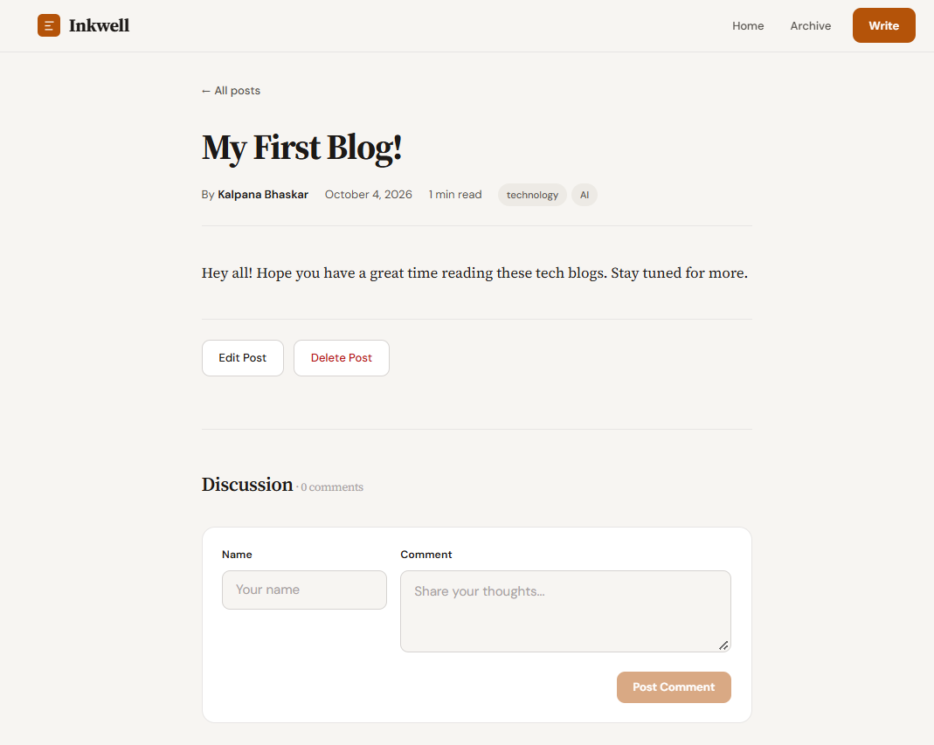
Post detail page with edit, delete and comment controls
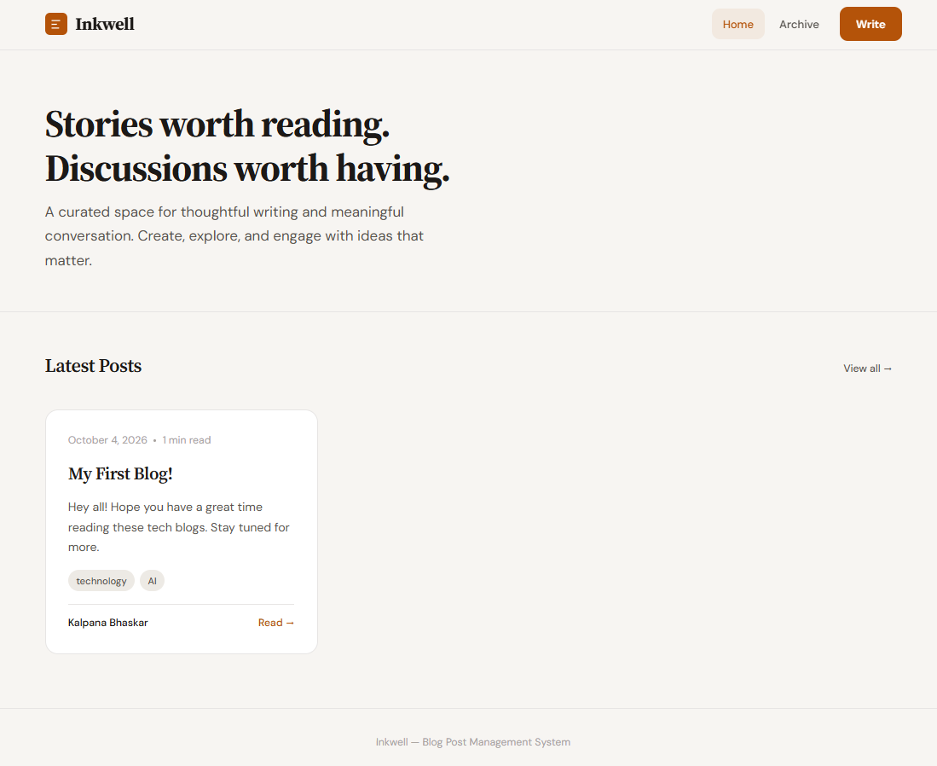
Home page showing the latest posts
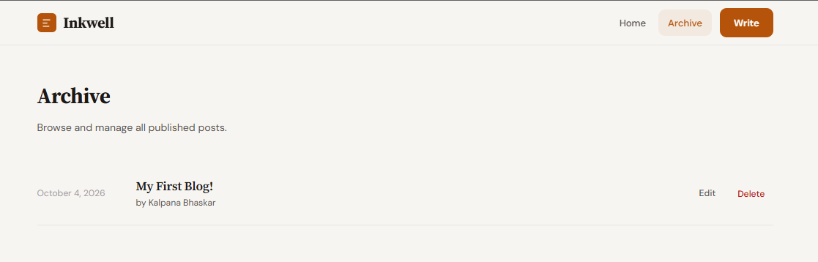
Archive page listing all published posts
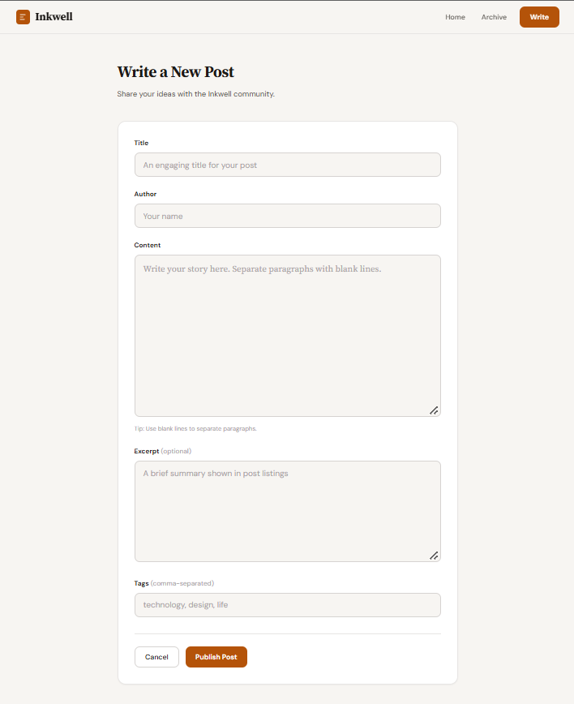
Create page with the new post form

