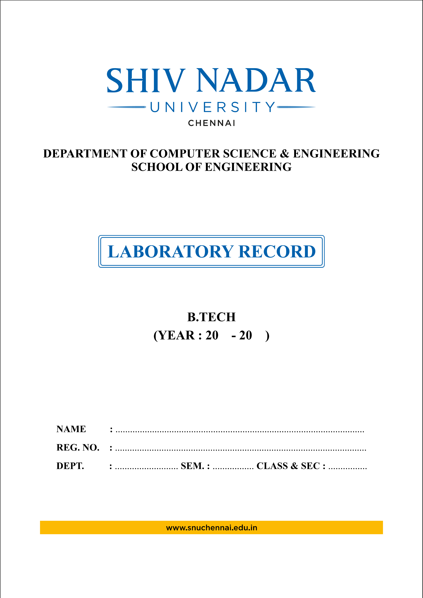
26 27
C.S.E
24011101049
AI -DS : A
5
Kalpana Bhaskar
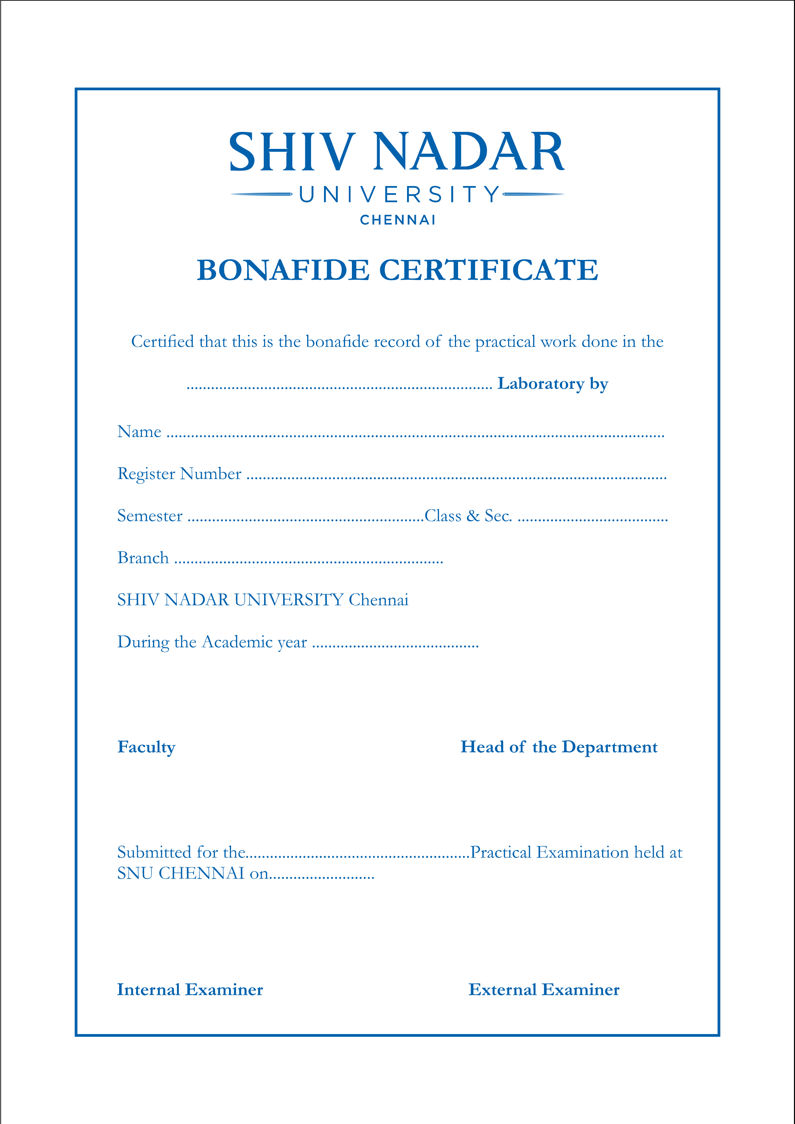
2026 -27
Artificial Intelligence and Data Science
Web Technologies
AI -DS : A
5
Kalpana Bhaskar
24011101049

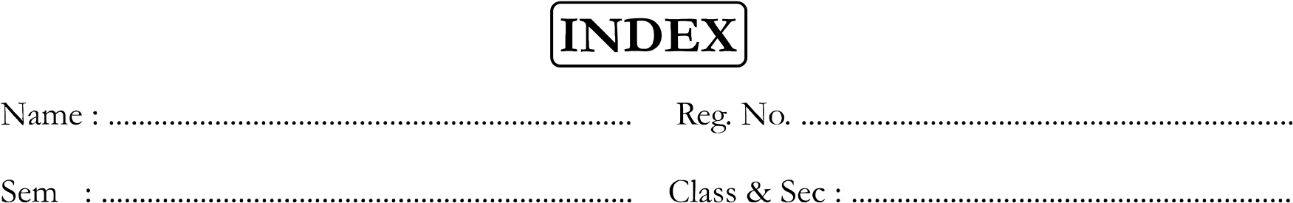
AI -DS : A
5
24011101049
Kalpana Bhaskar
Ex. No. | Date of Expt. | Title of the Experiment | Page No. | Signature of the Faculty | Remarks
1. | 13.7.26 | Resume Web page using HTML and CSS | 1
2. | 20.7.2026 | Multi-step form validation system for an Online Job Application Portal | 40
3. | 27.7.2026 | Design and implement a CSS with dark and light theme using JavaScript | 51
4. | 3.8.26 | Online Shopping Product Catalog | 60
5. | 17.8.2026 | Menu Navigation System using React | 66
6. | 24.8.26 | Implement a react counter app | 76
7. | 31.8.26 | To create a Node JS server that has 2 pages - Homepage, and About | 78
8. | 21.9.26 | To learn and implement the MERN stack based on the provided documentation and convert one of the previous React and Node.js projects into a MERN application | 83
9. | 28.9.26 | Full-Stack REST API using React, Express.js and MongoDB | 85

