Student Information Web Server using Node.js
Aim:
To develop a backend web server using Node.js built-in modules (http, fs, url) to serve student information via a RESTful API and static HTML, reading data from a local JSON file.
Project Structure:
project/
├── students.json
└── server.js
Design / Algorithm:
1. Configure environment variables and initialize project, creating a students.json file to store sample student data.
2. Import built-in Node.js modules in server.js: http, fs, and url.
3. Define the server port and initialize the HTTP server using http.createServer().
4. Parse incoming request URLs using the url.parse() method to extract the pathname and query parameters.
5. Implement routing logic based on the pathname:
- GET /: Serve a welcome HTML page.
- GET /students: Read students.json asynchronously using fs.readFile().
6. Inside the /students route, check for an 'id' query parameter (e.g., ?id=1). If present, filter the JSON data to return the specific student. If absent, return all students.
7. Handle unknown routes by returning a 404 Not Found response.
8. Start the server to listen on the designated port.
Theory:
1. Native Modules instead of Frameworks: The server uses Node's official built-in modules (http, fs, url) instead of an external framework like Express. The route handlers are responsible for manually parsing URLs and setting headers.
2. Built-in http Module: Provides functionality to create the server, listen for client requests, and send back responses using res.writeHead (for status codes) and res.end (to transmit data).
3. Built-in url Module: Used to break down the raw URL string. url.parse(req.url, true) splits the base path (pathname) from the query string (query), enabling route filtering.
4. Built-in fs Module: fs.readFile is used asynchronously to read the students.json database from the file system without blocking the single-threaded Node.js event loop.
5. JSON Data Handling: The application parses raw JSON text read from the file system into JavaScript objects using JSON.parse(), filters them based on client requests, and serializes them back to the client as JSON strings via JSON.stringify().

Code:
The source code for this assignment is available in the GitHub repository listed below.
GitHub Repository:
https://github.com/KalpanaBhaskar/Web-Technologies-Laboratory/tree/main/week_10
Output:
A working Node.js backend server returning HTML and JSON data based on URL routing and query parameters.
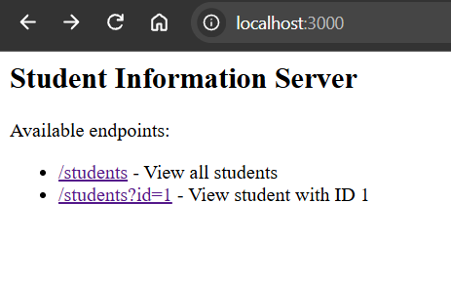
Home page showing the welcome message and available endpoints
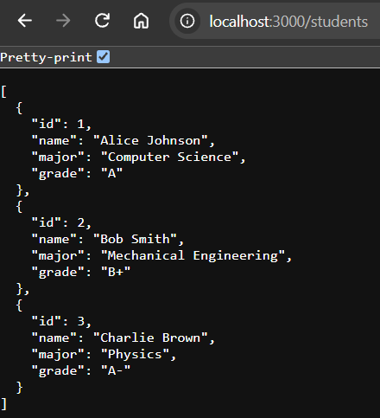
Browser view of /students endpoint returning all students in JSON format
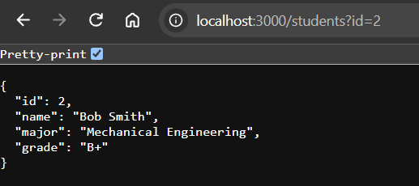
Browser view of /students?id=2 endpoint returning a specific student's JSON data
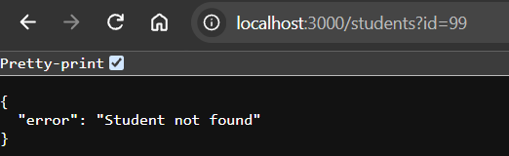
404 Error page handling invalid routes or missing students

