LAB ASSIGNMENT 1.3 — AI Assisted Problem Solving Using Python
GitHub Copilot & VS Code Integration
Name:Garige.kalpana
Roll No:2503B05117
Course: M.Tech(C.S.E)
Subject: AI Assisted Problem Solving Using Python
Week: 1
Assignment No: 1.3/24

Task 1: Install and Configure GitHub Copilot in VS Code
Steps Performed
- Installed Visual Studio Code.
- Opened Extensions panel.
- Searched for GitHub Copilot.
- Clicked Install.
- Signed in with GitHub account.
- Authorized the Copilot extension.
- Enabled:
  - Copilot inline suggestions
  - Copilot chat

Prompt Used
"Install and configure GitHub Copilot in VS Code."

Expected Output / Explanation
Copilot assists in suggesting steps, commands, and hints on setup inside VS Code.

Screenshots (Insert your screenshots here)
- Screenshot 1: Opening Extensions
- 
- Screenshot 2: Searching GitHub Copilot
- 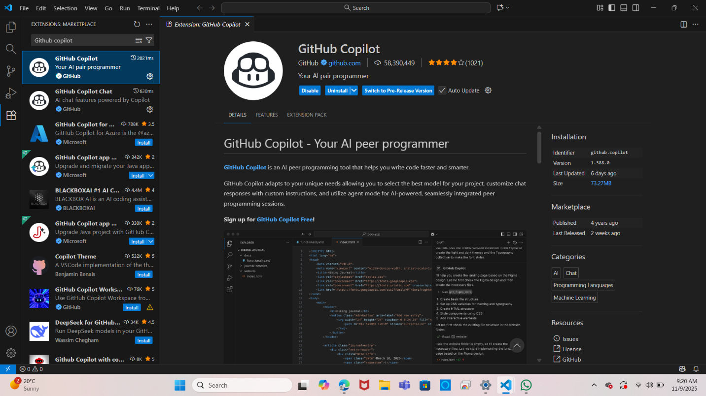

Task 2: Generate an is_prime() Python Function Using Copilot
Prompt Used
# Function to check if a number is prime
Copilot-Generated Code:
def is_prime(n):
if n <= 1:
return False
for i in range(2, int(n ** 0.5) + 1):
if n % i == 0:
return False
return True

Sample Output
is_prime(8) → False
is_prime(9) → False
is_prime(10) → False

Task 3: Reverse a String Using Copilot
Prompt Used
# Function to reverse a string
Copilot-Generated Code
def reverse_string(s):
return s[::-1]

Sample Output
reverse_string("hello") → "olleh"

Task 4: Generate Recursive and Iterative Factorial Functions
Prompt Used
# Recursive factorial function
# Iterative factorial function

Recursive Version (Generated by Copilot)
def factorial_recursive(n):
if n == 0 or n == 1:
return 1
return n * factorial_recursive(n - 1)
Iterative Version (Generated by Copilot)
def factorial_iterative(n):
result = 1
for i in range(1, n + 1):
result *= i
return result

Sample Output
factorial_recursive(5) → 120
factorial_iterative(5) → 120

Task 5: Find the Largest Number in a List Using Copilot
Prompt Used
# Function to find the largest number in a list
Copilot-Generated Code
def find_largest(numbers):
if not numbers:
return None
largest = numbers[0]
for num in numbers:
if num > largest:
largest = num
return largest

Sample Output
find_largest([3, 7, 2, 9, 5]) → 9

Conclusion
In this lab:
- GitHub Copilot was successfully set up in VS Code.
- AI-assisted code generation was used to create Python functions.
- Outputs were verified and explained.
- Copilot’s suggestions were analyzed for readability and correctness.

