Name: Garige Kalpana
Roll Number 2503B05117
Set number 2

Set 2
Q1. Write a Python function `is_prime(n)` to check if a number is prime. Use an AI coding tool to generate and justify a set of test cases before implementation. Pass all generated test cases.
(Each question carries 5 marks)
Q2. Develop a Python class `Rectangle` with methods for area and perimeter. Use an AI assistant for auto-generating docstrings and inline comments. Compare them with your manual documentation.
(Each question carries 5 marks)

Q1. Write a Python function `is_prime(n)` to check if a number is prime. Use an AI coding tool to generate and justify a set of test cases before implementation. Pass all generated test cases.

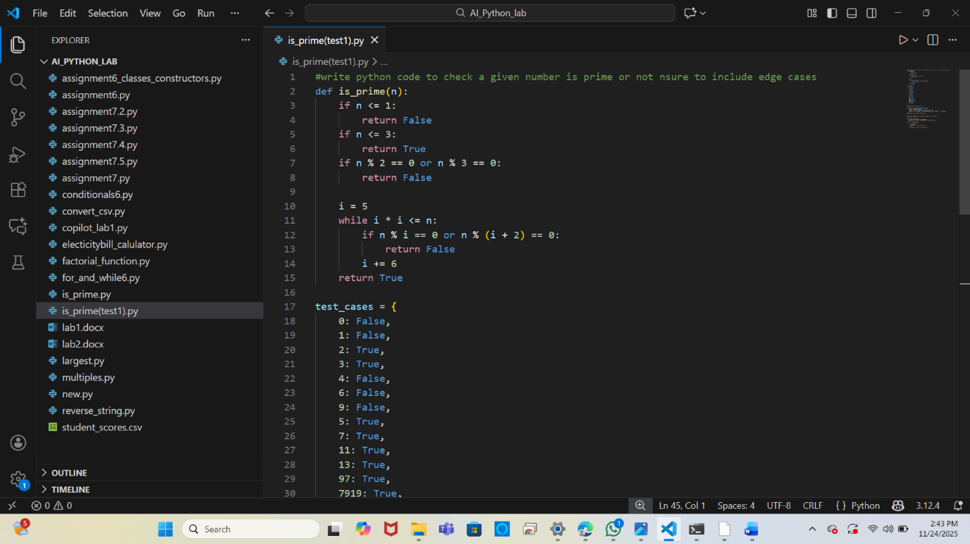
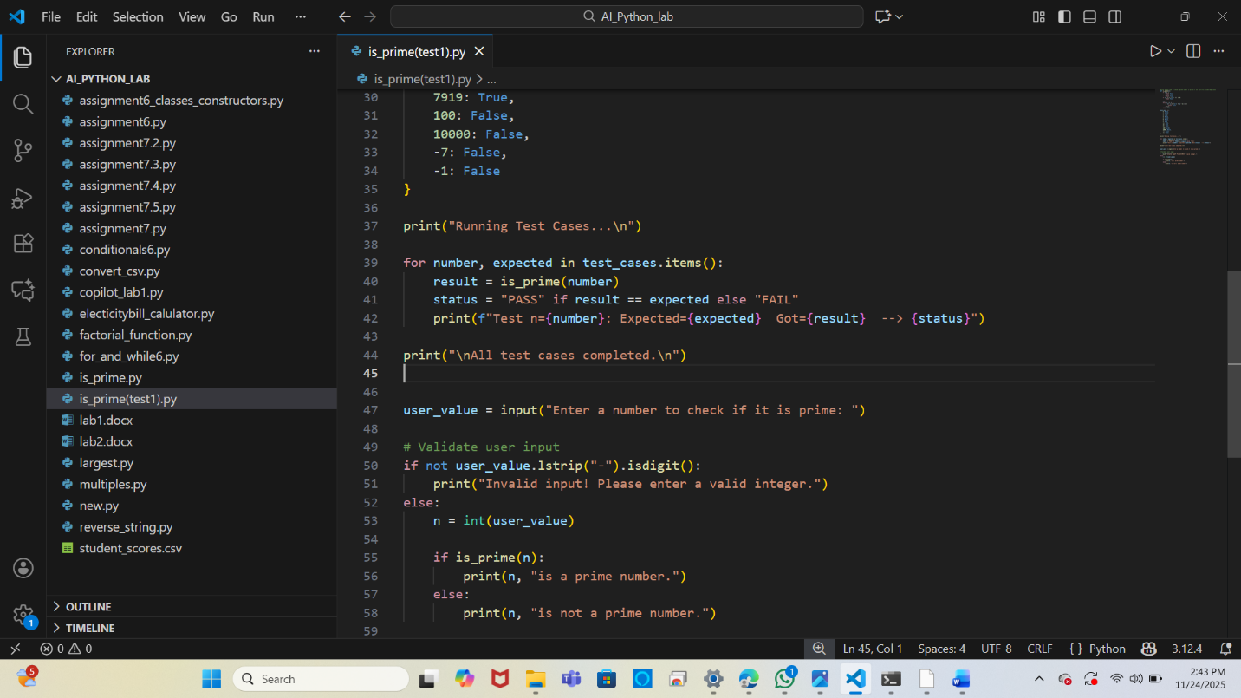
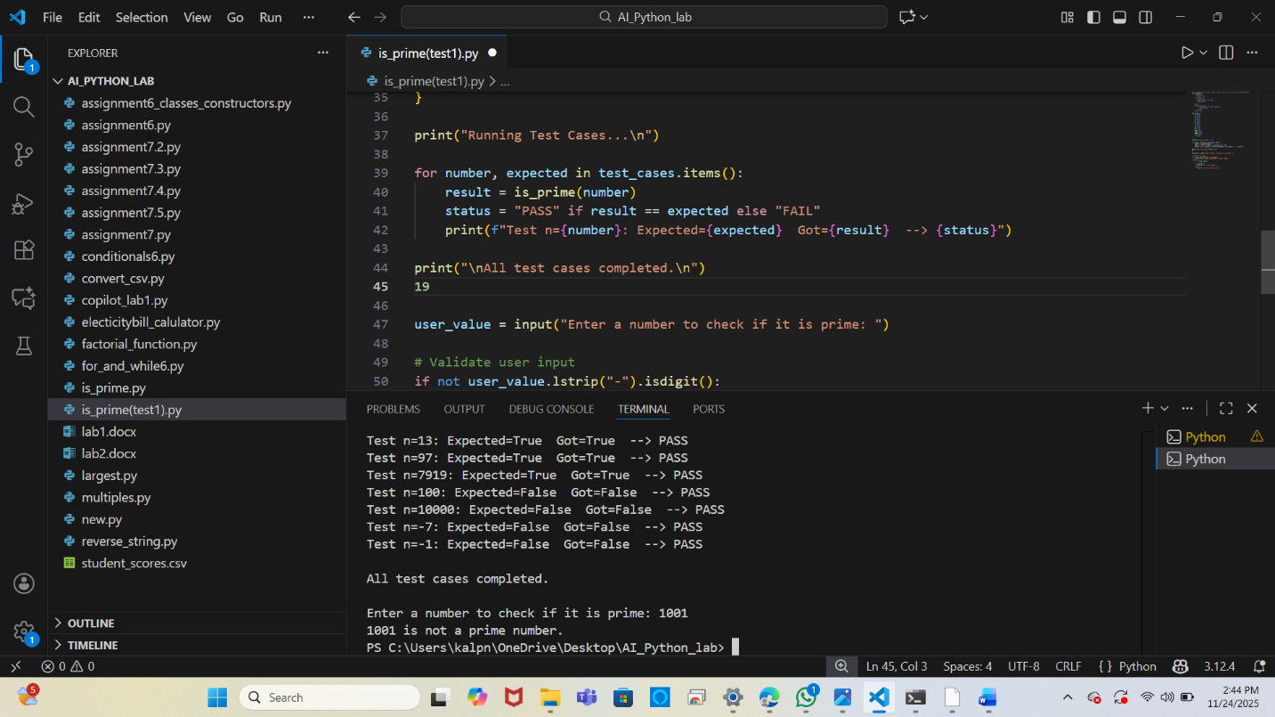

Q2. Develop a Python class `Rectangle` with methods for area and perimeter. Use an AI assistant for auto-generating docstrings and inline comments. Compare them with your manual documentation.

Below are the AI-generated and manually written versions of the Rectangle class.
1. AI-generated versions of the Rectangle class to find area and perimeter.

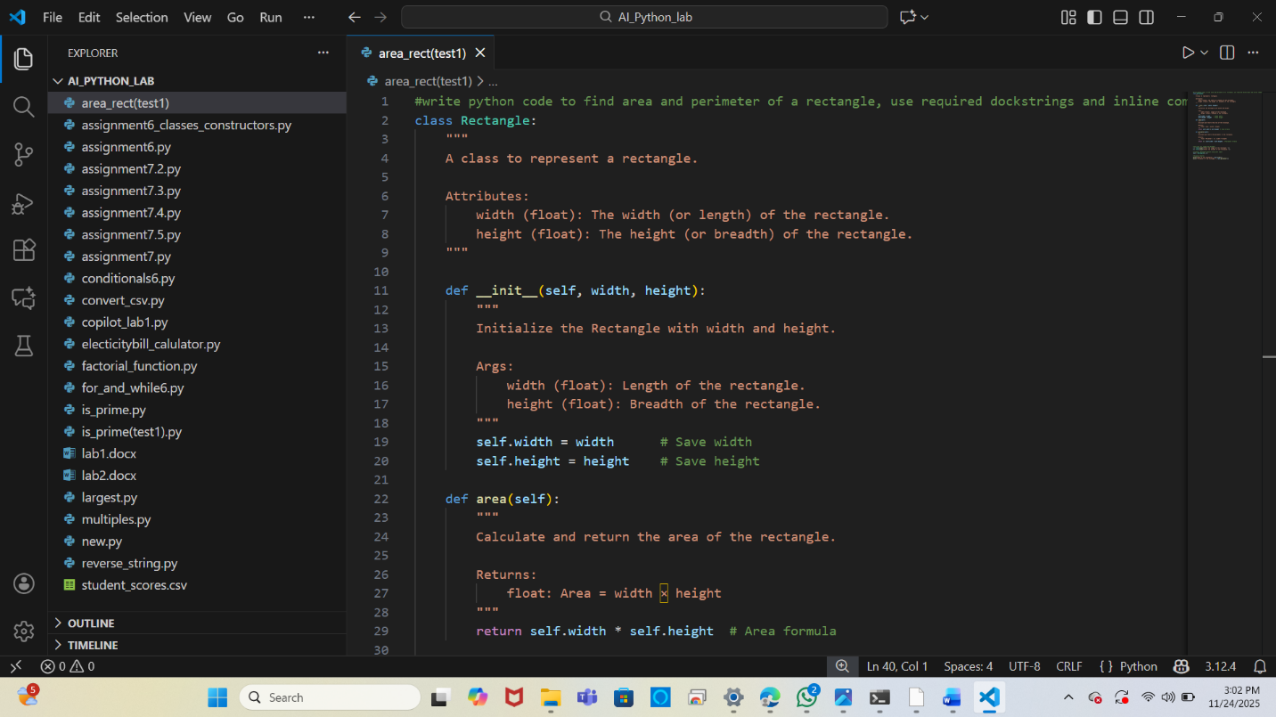
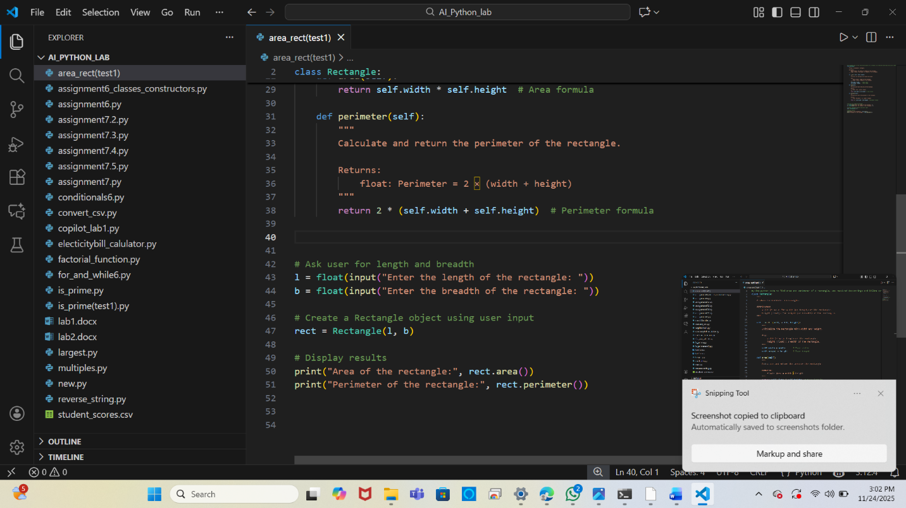

2.Manually written versions of the Rectangle class to find area and perimeter.

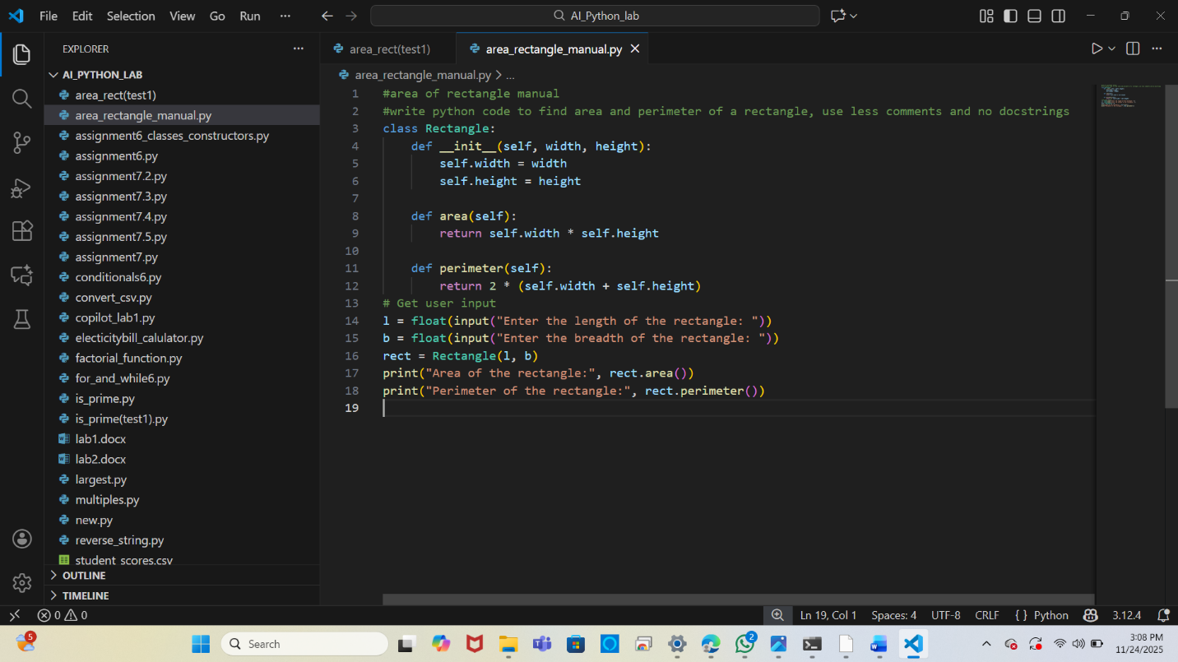

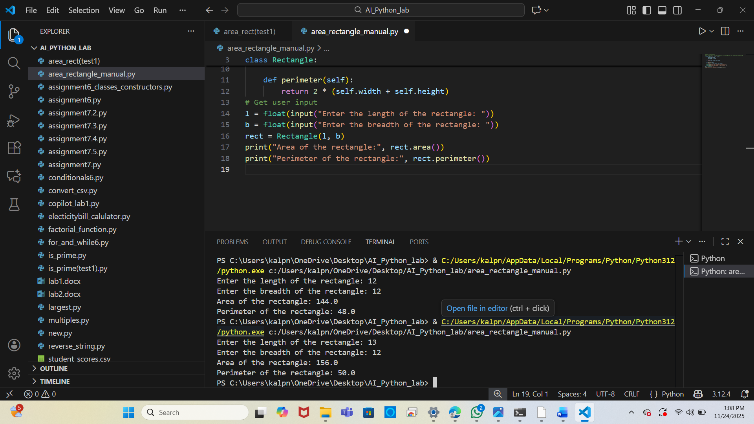

Comparison:
The AI-generated documentation is longer, more detailed, and includes explanations, argument details, and inline comments.
The manual version is shorter and more natural, focusing only on essential information.

