Name: Garige.Kalpana
Roll Number: 2503B05117
Certification#1
Title: Introduction to Git and GitHub

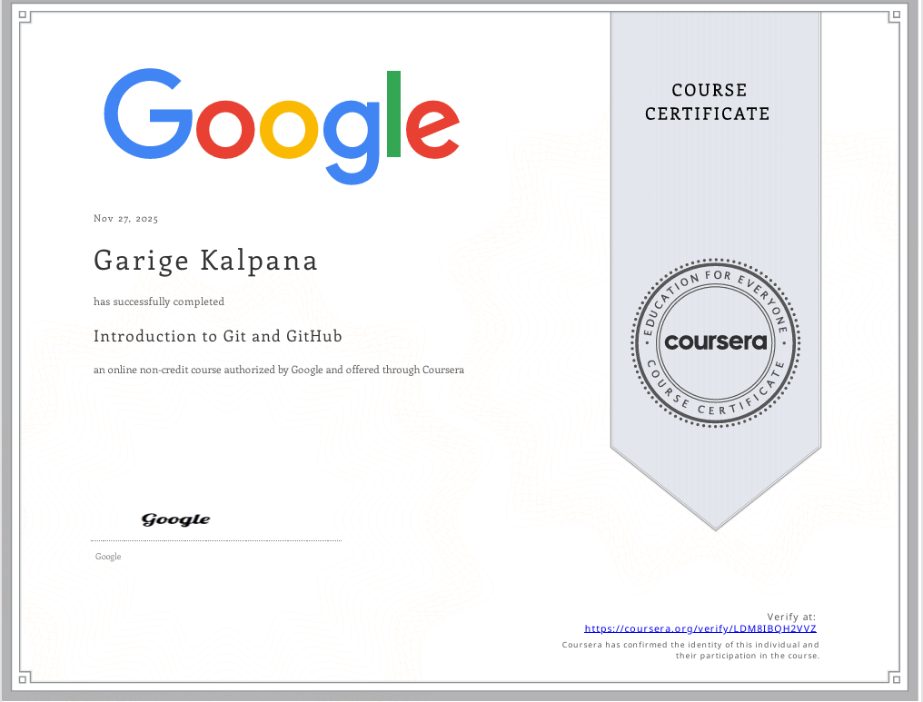

Certification 2:
Title: Prompt Engineering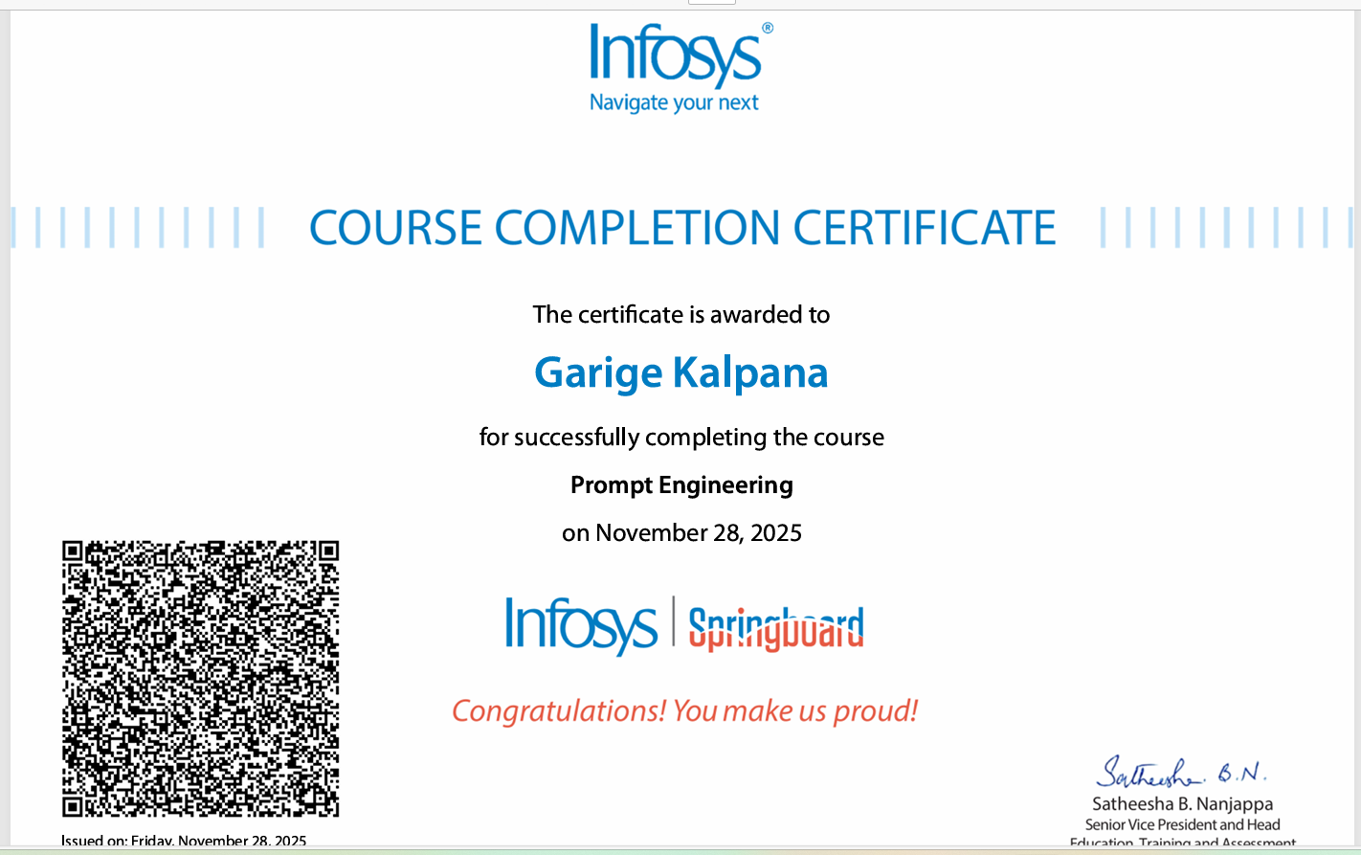

Certification 3:
Title: GitHub Copilot for developers
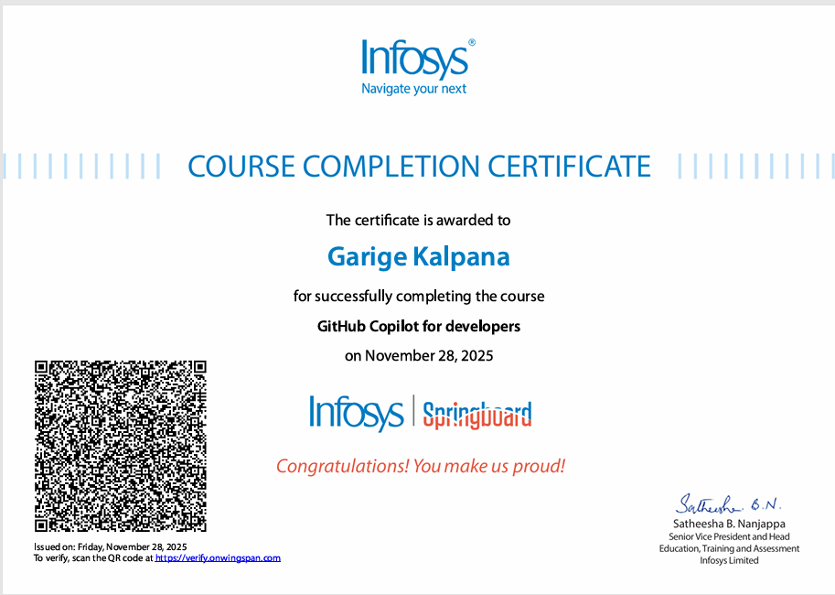

Certification 4:
Title: Build Generative AI Apps and Solutions with No-Code Tools
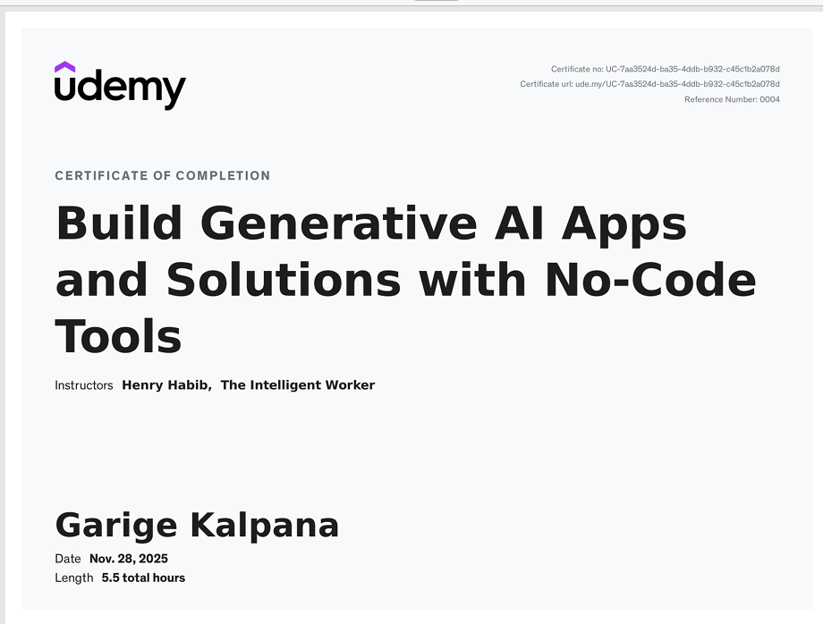

Certification 5:
Title: GenAI for IT: Transforming IT with Generative AI
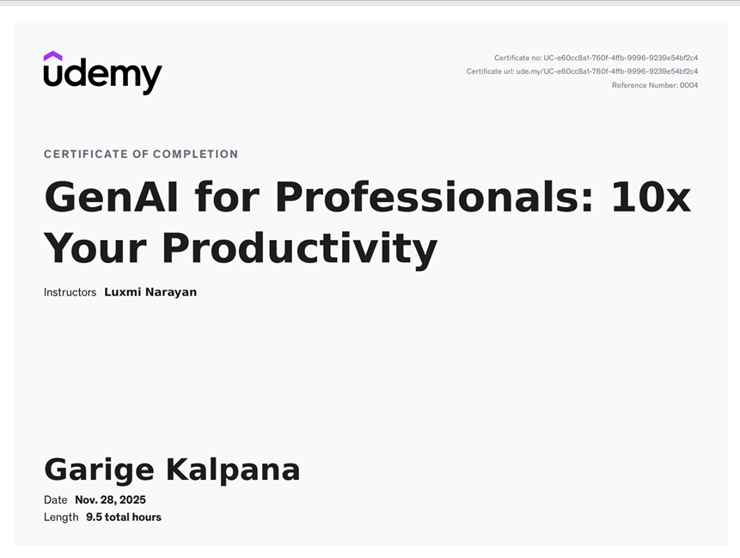

Certification 6:
Title: Github Copilot with Python: Creating Text Games

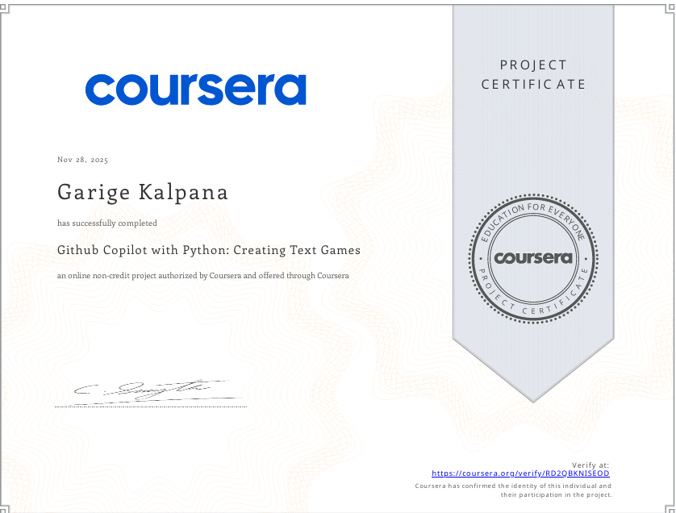

Certification 7:
Title: Software Development with ChatGPT: Generating Code with AI
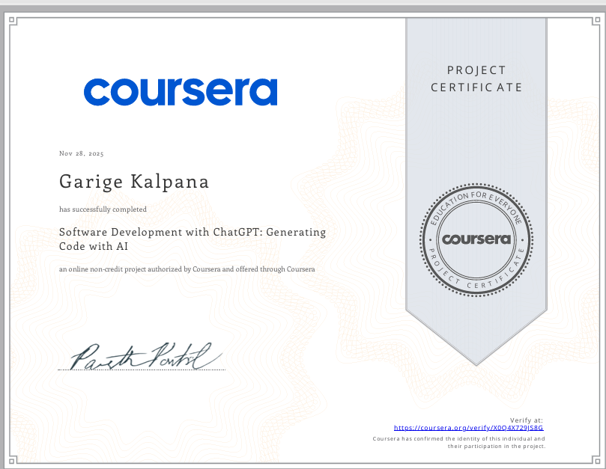

Certification 8:
Title: Gen AI for developers: Web development with Python & Copilot
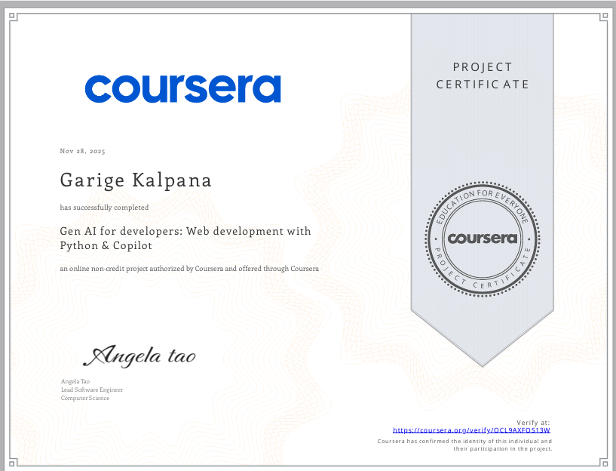

Certification 9:
Title: Using JavaScript with AI: Enhancing Development Workflows
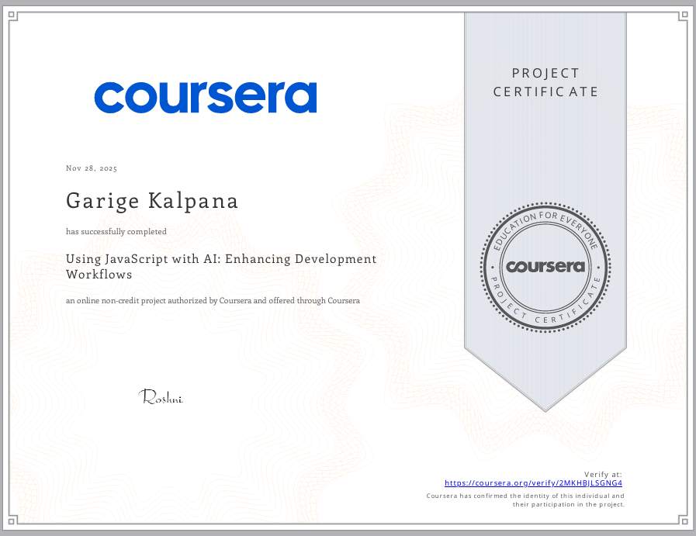

Certification 10
Title: Gen AI for Software Development: Code Generation for Python
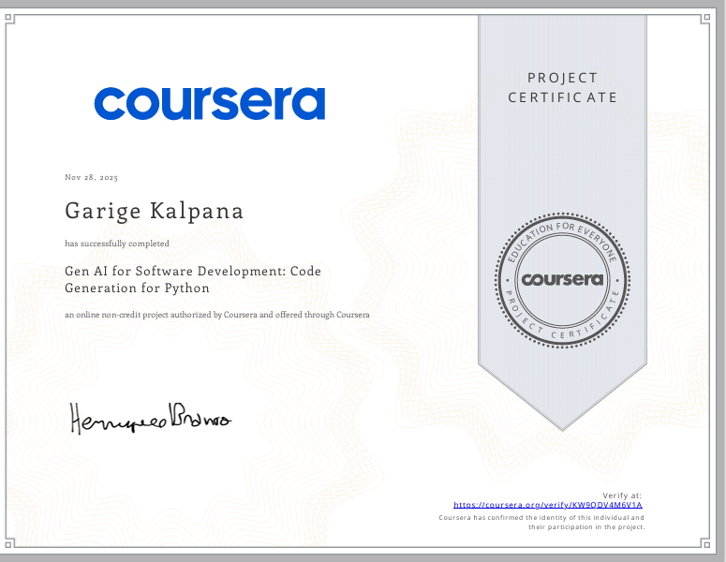

Certification 11:
Title: Master Generative AI & Generative AI tools (ChatGPT & more)
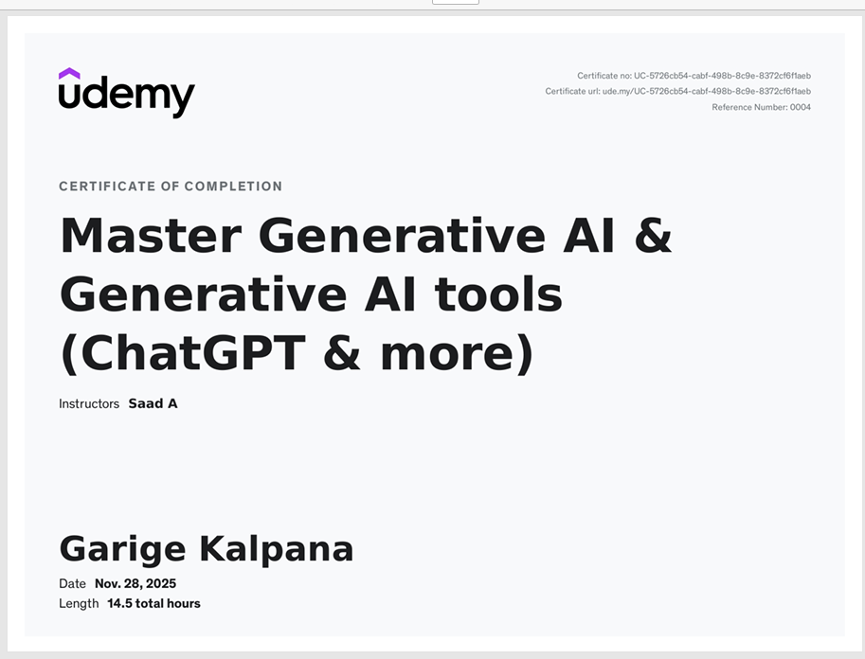

Certification 12:
Title: Python Development with ChatGPT: Fullstack App Development
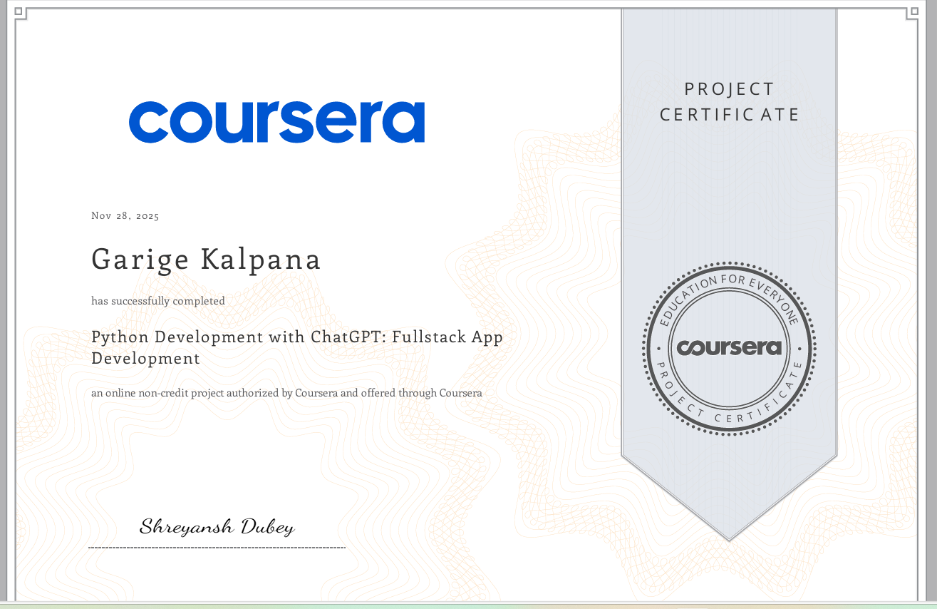

Certification 13:
Title: PHP Development with ChatGPT: Practical Web Development
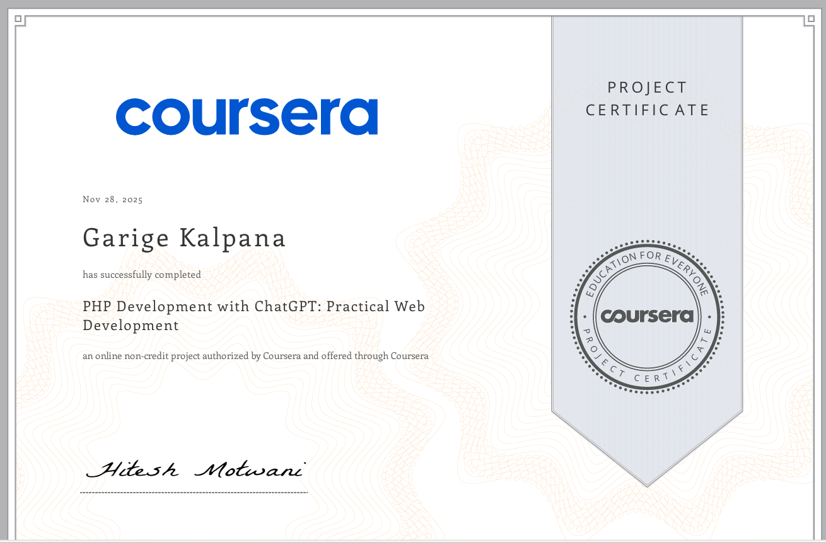

Certification 14:
Title: AI-Powered Development with Codepal: Write & Test To-Do App
