Credit Approval & Applicant Risk Analysis
A Data Analytics and Machine Learning Project

1. Introduction
This project analyzes the UCI Credit Approval dataset containing anonymized credit-card application attributes. The goal is to understand approval and rejection patterns and build a simple classification model for credit approval.

2. Dataset
The dataset contains 690 applications and 15 anonymized predictor attributes. The target A16 contains two classes: Approved and Rejected. Initial analysis found 307 approved applications and 383 rejected applications, giving an approval rate of 44.49%.

3. Data Preparation
The original dataset uses '?' for missing values. Missing values are converted to null values. Continuous attributes are converted to numeric form. For machine learning, numerical missing values are imputed using the median, while categorical missing values are imputed using the most frequent category. Categorical variables are one-hot encoded and numerical variables are standardized.

4. Exploratory Analysis
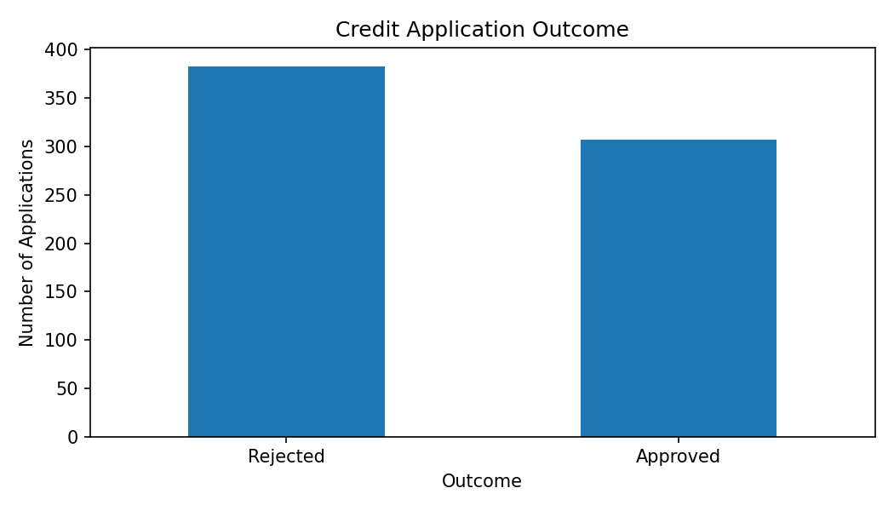
Figure 1: Distribution of credit application outcomes.
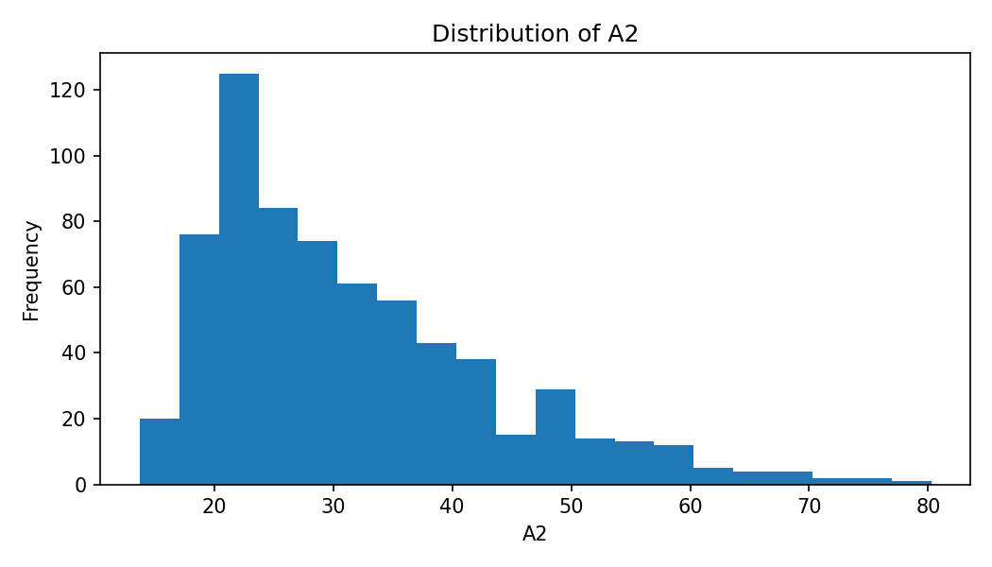
Figure 2: Distribution of anonymized continuous attribute A2.

5. Machine Learning
A Logistic Regression classifier is used as a simple and interpretable baseline model. The dataset is divided into training and testing sets using an 80:20 stratified split. Performance is evaluated using accuracy, precision, recall and F1-score.

6. Business/Decision Insights
The analysis can support a credit-screening workflow by identifying patterns in approved and rejected applications. Because the UCI attributes are anonymized, this project intentionally avoids claiming that any particular A1-A15 variable represents income, age, credit score or another specific real-world factor.

7. Conclusion
The project demonstrates an end-to-end data analytics workflow: data loading, cleaning, exploratory analysis, visualization and machine-learning classification. The resulting model can serve as a baseline for automated credit-approval classification, while the analysis provides a foundation for further risk analysis.

8. Dataset Citation
Quinlan, J. (1987). Credit Approval [Dataset]. UCI Machine Learning Repository. https://doi.org/10.24432/C5FS30

