Contents

1. About Bethesda E-Consent. 2

2. Business logic behind E-Consent forms 3

3. Pre-requesties 5

4. Deployment 6

5. Setup and configuration 17

1. **Bethesda E-Consents**

Bethesda E-Consents is an electronic signature solution, it will enable nurse and/or physician to select the appropriate patient information and get signatures from patients before starts his/her medical procedures. It would provide patients and doctors the ability to electronically sign the required fields of the defined consent forms.

Here is the list of consent forms implemented in this release

• Surgical Consent Form

• Blood Consent/Refusal

• Cardiac Cath Lab Consent

• Endoscopy Consent

• Outside OR Consent

• PICC Consent

• Plasma Apheresis Consent

Screen shot of home page:

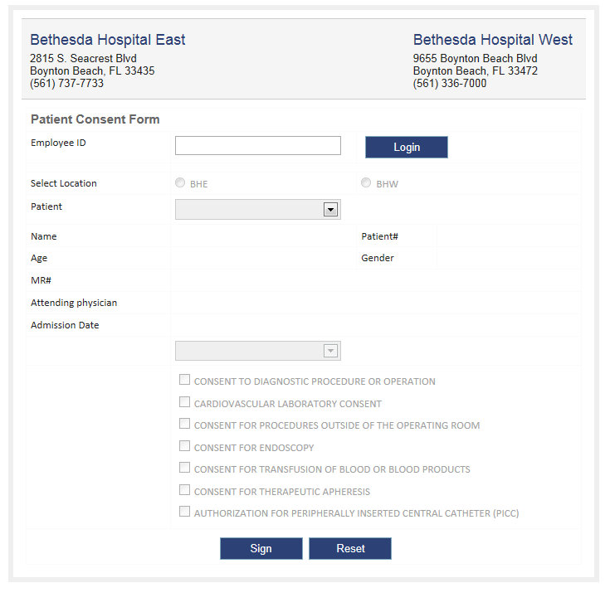

2. **Business logic behind E-Consents forms**

1. The application will validate the employee [nurse / doctor] information.
2. It will allow getting patient information for selected patient.
3. It will allow choosing E-Consent form type.
4. It will allow signing electronically for nurses / doctors, patients, patient authorized persons and witnesses.
5. It will allow adding multiple medical procedures and physicians for a consent.
6. It will convert the E-Consent form into PDF file and stored in a disk for references.

Screen shot 1of sample consent page:

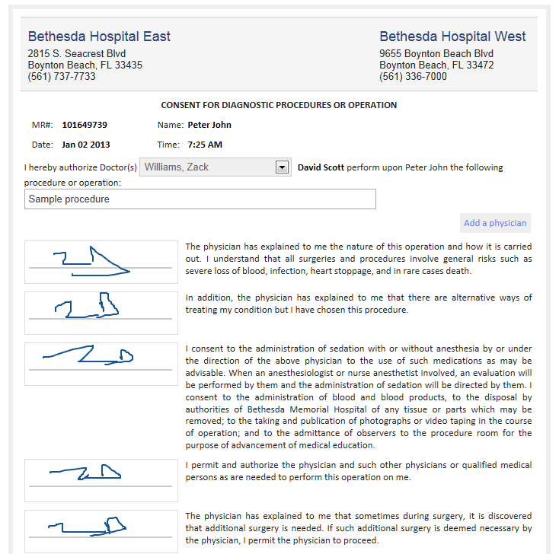

Screen shot 2of sample consent page:

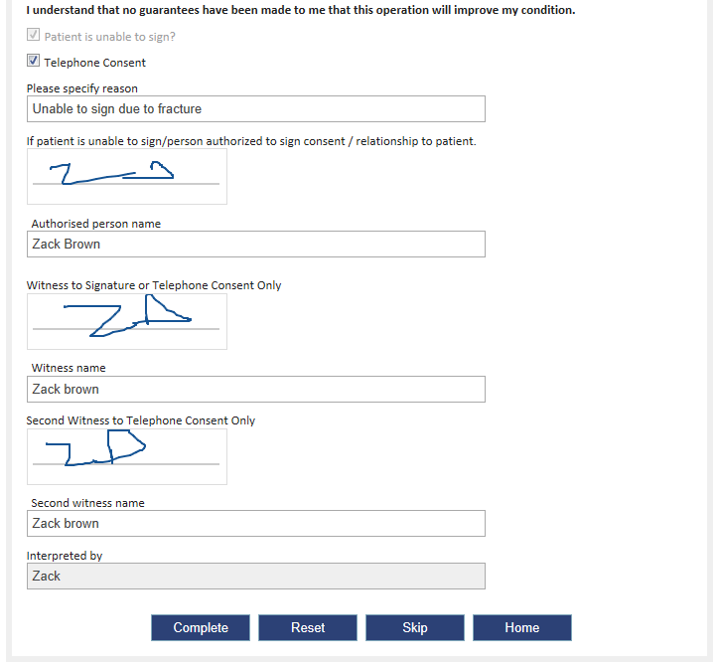

3. **Pre-requisites:**

The following are the pre-requisites for installing E-Consents form.

1. Server:

It requires windows Server [Windows 2003/2008/2012] with IIS role enabled.

1. Database:

It requires Microsoft SQL server 2005/08

1. Dot net framework 4.0 should be available in server.
2. Muhimbi PDF Converter needs to installed and configured in the server.

4. **Deployment:**

The following steps will guide you to set up the application in your hosting server.

Deployment steps for Bethesda E-Consents:

**Step 1:** Go to dev1 server and navigate to the folder

“**C:\Software\Santhosh\BethesdaConsentForms\WindowsCEConsentForms**” and open the “**WindowsCEConsentForms**” solution using visual studio.

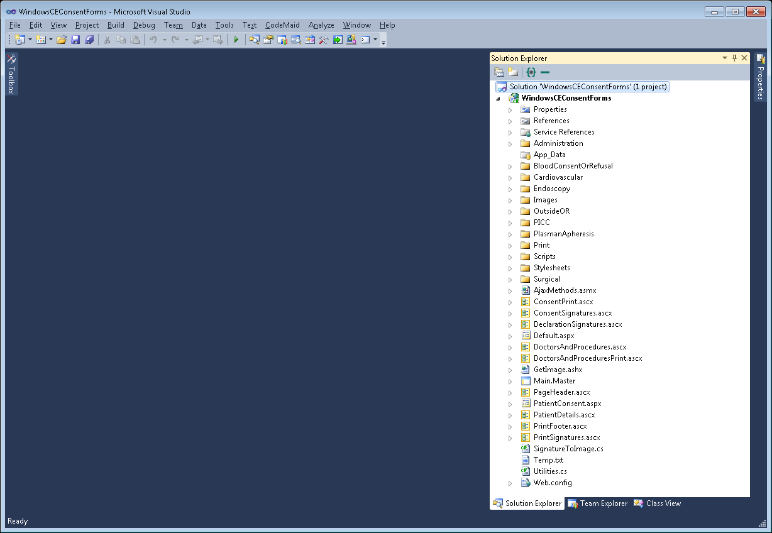

**Step 2:** Right on solution and click ‘Rebuild’

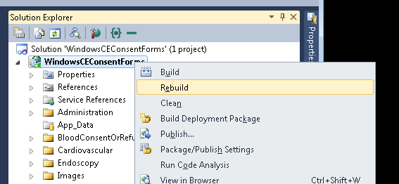

**Step 3:** Once the build is successful, right click on the project below to ‘WindowsCEConsentForms’ called ‘**BethesdaEConsentsSetup**’ and click ‘Rebuild’ to get setup files for installation.

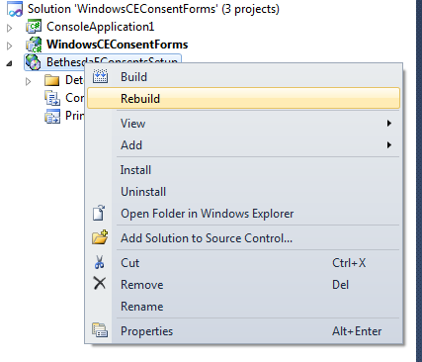

**Step 5:** Now in the same quick launch menu click on ‘**Open Folder in Windows Explorer**’. It will explore the setup folder for our installer project.

**Step 6:** Similarly **‘**Rebuild’ the project called ‘**BethesdaConsentFormWCFSvc**’ in the same solution.

**Step 7:** Similarly **‘**Rebuild’ the project called ‘**BethesdaConsentFormWCFSvcSetup**’ in the same solution.

**Step 8:** Now go to project folder 🡪 IsToolInstaller folder and right click on ‘Setup.iss’ file then select ‘Open with ISTool’.

**Step 9:** It will opens ISTool to build the latest installer for our solution.

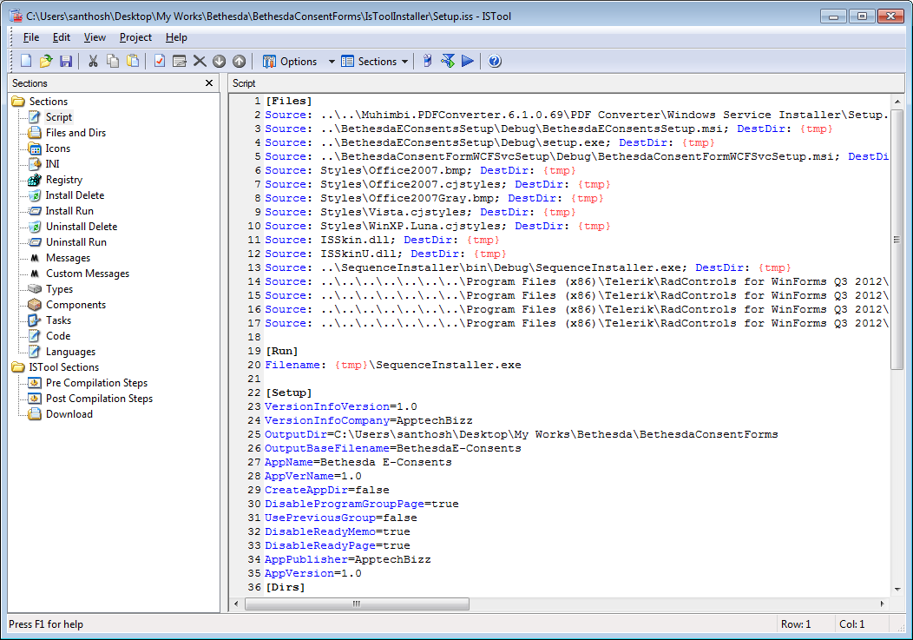

**Step 10**: Click on ‘**Compile Setup**’ icon on tool bar to start building setup file.

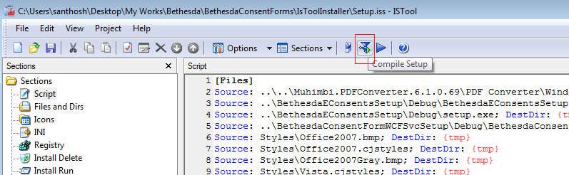

**Step 11**: Wait until building process completed.

**Step 12:** Now open the project folder, you will find a file called ‘**BethesdaE-Consents.exe**’

**Step 13**: Copy this setup files and bring to server where we need to deploy the application.

**Step 14:** Now go to deployment server, open **IIS** manager. On left hand side panel select ‘**Sites**’ and right on it and select ‘**Add Web Site**’

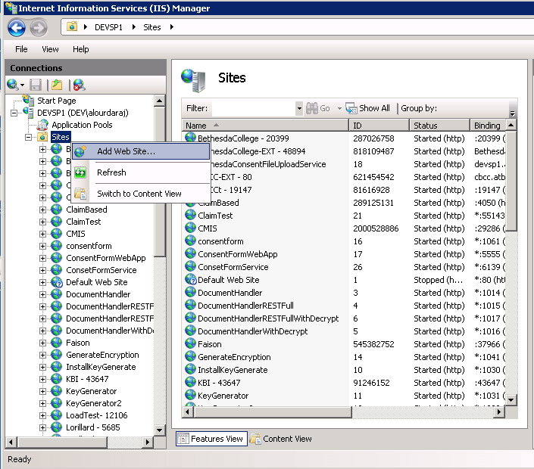

**Step 15:** It will prompt a window to configure site name, port, physical folder path, application pool and host header for your site.

Configure the settings as per your requirement.

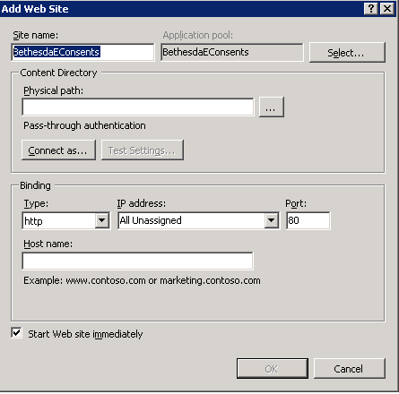

**Step 16:** Click on OK once you completed your settings.

**Step 17:** Repeat step 14 and 15 for creating WCF service application.

**Step 18:** Now run the installation setup file ‘**BethesdaE-Consents.exe’** with administrative privileges.

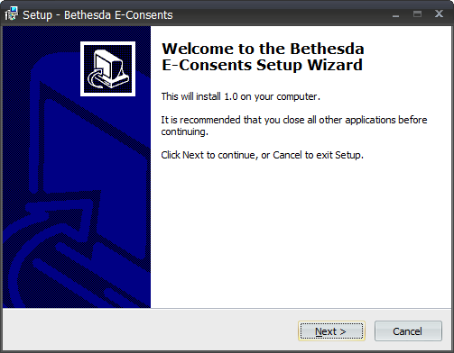

**Step 19:** Click on ‘Next’ to start installation.

**Step 20:** Wait until the installation wizard completes.

**Step 21:** First it will start / run the setup for installing E-Consent application deployment.

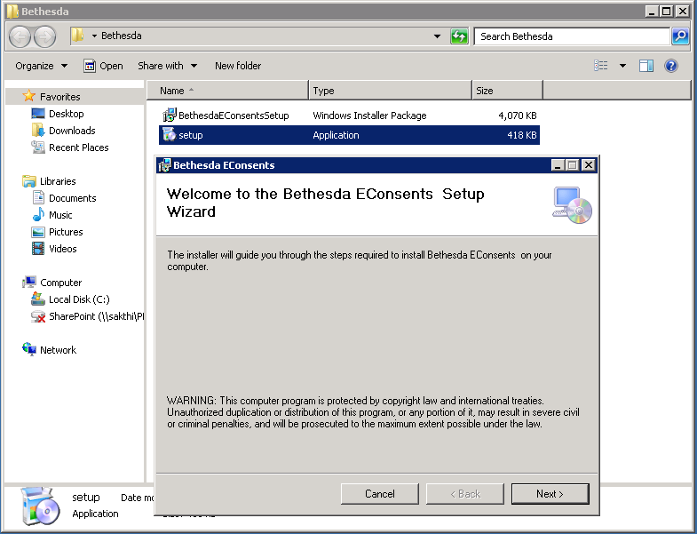

**Step 22:** Click next for site configuration screen.

**Step 23:** Nowstart your configured web application in IIS.

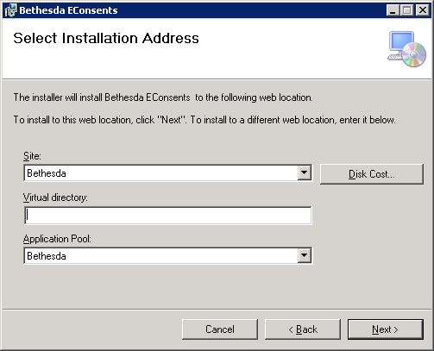

Remove ‘Virtual Directory’ configuration in installer wizard and press ‘next’ again.

**Step 24:** Click on Next on confirmation wizard.

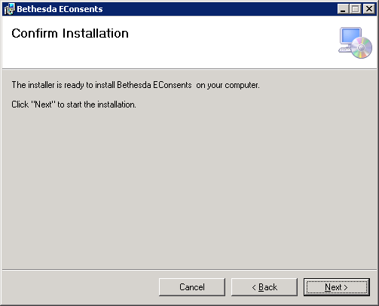

It will deploy the web application pages into the virtual directory.

**Deployment steps for Bethesda E-Consent WCF Application:**

**Step 25:** Once it completes, the next deployment setup will run automatically for deploying WCF service application.

**Step 26:** Similar to step 22 to 24 configure the WCF service application configuration.

**Step 27:** Once it completes the WCF service deployment, it will automatically starts deployment of Muhimbi.

**Deployment steps for Muhimbi PDF conversion utility:**

**Step 28:** It willopen the following wizard to install.

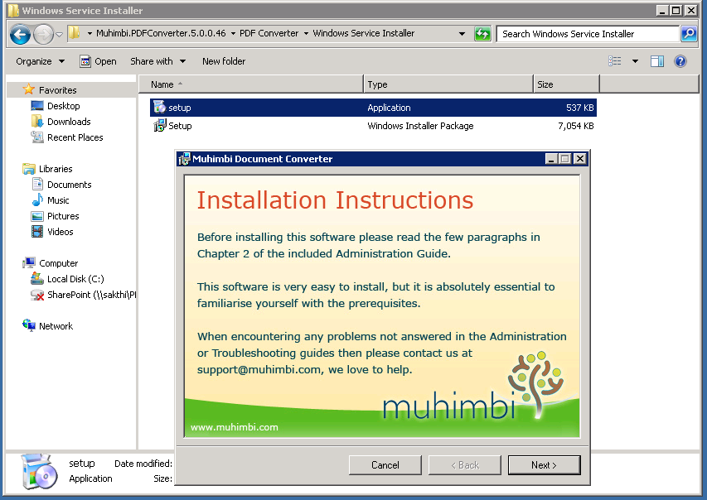

**Step 29**: Click ‘Next’ for continue the wizard.

**Step 30**: Select the installation path and then select ‘Next’

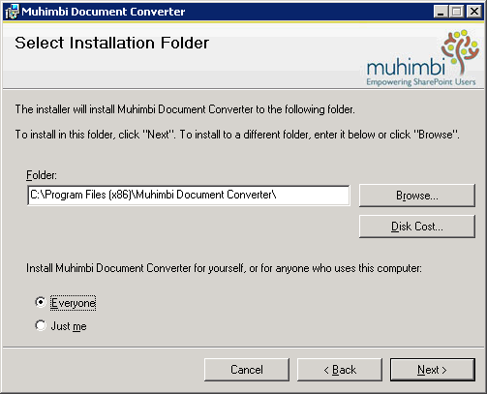

**Step 31**: It will installs the required service files in to the server. After this it will prompt for credentials to run the service with the given privileges.

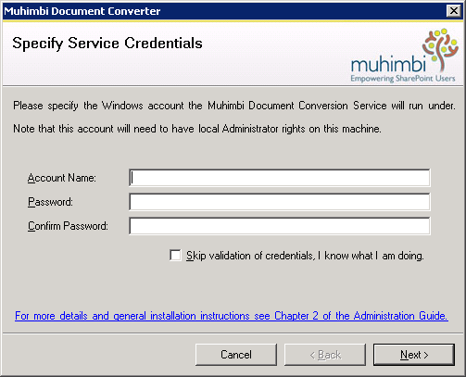

Note: All the PDF conversion will be done by this service and generate the PDF file and places in the specified disk location so you must specify the administrative credentials who is having all the rights for file operation.

Click on ‘Next’ to continue.

**Step 32**: Once you entered the credentials it will starts to configure the service and prompt the following window.

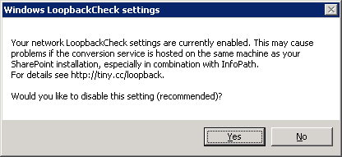

**Step 33**: Click ‘Yes’ for recommended option. It shows the following

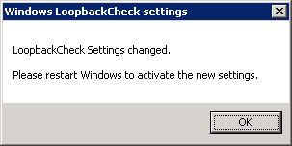

Click OK to continue.

**Step 34**: Finally it will complete the installation.

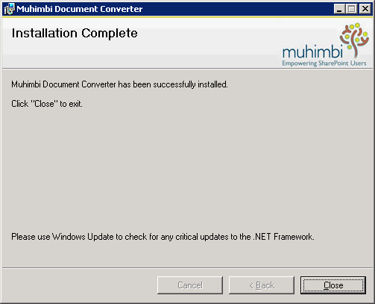

**Step 35**: Click ‘Close’ and restart the server for successful installation of Muhimbi.

**Step 36:** Now the main installer will be closed automatically.

4. **Setup and configuration:**

This section will guide to setup connection between WCF and database server, both internal and external [Bethesda Solarian Database Server] databases. And also for PDF export paths in your local disks.

Open administration page using with the following URL

<<site URL>>/administration/setup.aspx.

You can see the following sections in the page.

1. WCF Service Configuration:

Here you need to specify the WCF service URL which will stores in the app.config file and use this for communication.

1. Internal Database Information:

Here you need to specify the database connection settings for setting up database for our application. This connection string should specify the application database server.

1. External Database Information:

Here you need to specify the Bethesda’s Solarian database connection settings for getting patient and physician information from their existing data source.

1. Exports path:

Here you need to specify the disk location where you need to store the consent PDF forms.

