INTELLIGENT RECRUITMENT AUTOMATION SYSTEM
FOR JOB DESCRIPTION CREATION, APPLICATION SHORTLISTING,
AND SKILL GAP IDENTIFICATION

Final Thesis Report

Chapter 01 - Introduction
Chapter 02 - Literature Review
Chapter 03 - Methodology
Chapter 04 - System Requirement Specification
Chapter 05 - Implementation / Designing
Chapter 06 - Testing and Evaluation
Chapter 07 - Concluding Remarks

presented to the Faculty of Computing
NSBM Green University

in partial fulfillment of the requirements for the degree of
BSc(Hons) in Software Engineering

by
Kalpani D. Kapuge
Student ID: 28870

[Month] 2026

Declaration
I hereby declare that this thesis titled "Intelligent Recruitment Automation System for Job Description Creation, Application Shortlisting, and Skill Gap Identification" is based on my own research work carried out for the BSc(Hons) in Software Engineering degree program at NSBM Green University. The content presented in this document has been prepared for academic purposes, and all referenced work has been acknowledged through citations and the reference list. This report extends my previously submitted Interim Submission 02 report with the System Requirement Specification, Implementation, Testing and Evaluation, and Concluding Remarks chapters.

Student Name: Kalpani D. Kapuge
Student ID: 28870
Signature: ...........................
Date: ...........................

Abstract
Recruitment forms an integral part of the organizational process that has a direct impact on the quality of the workforce, organizational effectiveness, and overall business performance. Manual methods of job description writing, resume checking, candidate shortlisting, interview coordination, and subjective candidate assessment are still followed in conventional recruitment processes. These activities frequently result in delays, inconsistencies, bias, and a lack of transparency toward applicants. Candidates who are unsuccessful in an application rarely receive feedback on what they need to improve to enhance their employability.
Recent advancements in Artificial Intelligence, Natural Language Processing, Machine Learning, and Large Language Models create new opportunities to strengthen recruitment automation: writing job descriptions, screening resumes, matching jobs to candidates by meaning rather than keyword, ranking candidates, identifying skill gaps, generating feedback, and assisting candidates through a chatbot. However, most existing recruitment tools treat these capabilities as standalone features rather than an integrated platform that supports candidates, employers, and administrators across the full recruitment lifecycle.
This thesis presents the design, implementation, and evaluation of the Intelligent Recruitment Automation System (IRAS) — a web-based recruitment automation platform comprising candidate profile management, resume upload and AI-based parsing, an employer job-posting workflow with AI-assisted job description generation, resume shortlisting, a multi-signal candidate ranking and matching engine, skill gap analysis with AI-generated explanations, a CV builder, interview scheduling, a notification system, candidate feedback generation, a recruitment knowledge base, and a role-aware recruitment chatbot. The system is organized into three primary workflows — Candidate, Employer, and Admin — that together streamline recruitment activity for employers while giving applicants transparency and developmental guidance.
The system follows a layered architecture (API, Application, Domain, and Infrastructure) built with ASP.NET Core Web API and C#, Entity Framework Core, a relational database, JWT-based authentication, Swagger/OpenAPI documentation, a companion Python AI microservice, configurable file storage, and PDF generation for CV export. The research follows Design Science Research Methodology, which is appropriate for the design, development, demonstration, and evaluation of a software artifact. This thesis reports the complete research and engineering cycle: the problem background and objectives (Chapter 1), a critical literature review (Chapter 2), the research methodology (Chapter 3), the system requirement specification (Chapter 4), implementation details including the trained candidate-job fit classifier (Chapter 5), functional, non-functional, and machine-learning model evaluation (Chapter 6), and concluding reflections with future recommendations (Chapter 7).
The evaluation shows that combining structured features (skill overlap and semantic similarity) with free text substantially outperforms text-only classification (98.9% vs. 72.3% test accuracy for the deployed XGBoost model), that the system's functional and non-functional requirements are satisfied under the defined test plan, and that an integrated, AI-assisted recruitment platform can measurably reduce manual screening effort while giving candidates explainable, actionable feedback on their skill gaps.

Keywords: Artificial Intelligence, CV Generation, Candidate Feedback, Chatbot, Interview Scheduling, Job Matching, Recruitment Automation, Skill Gap Analysis

Table of Contents
Right-click here and choose "Update Field" (or press F9) to generate the Table of Contents.

List of Figures
Figure 1.1: Rich Picture of the Proposed System.
Figure 2.1: Conceptual Map of the Literature.
Figure 3.1: Design Science Research Methodology Execution Workflow.
Figure 3.2: Project Timeline.
Figure 4.1: Complete Use Case Diagram of IRAS with «include» / «extend» Relationships.
Figure 4.2: Complete Class Diagram of the IRAS Domain Model.
Figure 4.3: Enhanced Entity-Relationship (EER) Diagram of the IRAS Database.
Figure 4.4: Complete Activity Diagram of IRAS — Candidate, AI Service, Employer, and Administrator.
Figure 4.5: Sequence Diagram — Job Application and Scoring.
Figure 4.6: Sequence Diagram — Resume Upload and Parsing.
Figure 4.7: Sequence Diagram — Skill Evidence Submission and Review.
Figure 4.8: State Chart Diagrams — Application and SkillPlanEvidence.
Figure 4.9: IRAS Layered System Architecture.
Figure 5.1: Weighted Scoring Pipeline.
Figure 5.2: Candidate Registration and Login.
Figure 5.3: Candidate Dashboard.
Figure 5.4: Candidate Profile Management.
Figure 5.5: Resume Upload and AI-Parsed Preview.
Figure 5.6: CV Builder.
Figure 5.7: Job Search and Application.
Figure 5.8: Match Score Breakdown.
Figure 5.9: Skill Gap and Improvement Plan.
Figure 5.10: Skill Evidence Submission.
Figure 5.11: Skill Assessment Attempt.
Figure 5.12: Recruitment Chatbot.
Figure 5.13: Candidate Notifications.
Figure 5.14: Employer Registration and Login.
Figure 5.15: Employer Dashboard.
Figure 5.16: Company Profile Management.
Figure 5.17: Job Posting with AI-Assisted Description Generation.
Figure 5.18: Ranked Applicant List.
Figure 5.19: Skill Assessment Configuration.
Figure 5.20: Interview Scheduling.
Figure 5.21: Candidate Feedback Review and Approval.
Figure 5.22: Administrator Dashboard.
Figure 5.23: User Management.
Figure 5.24: Job Post Moderation.
Figure 5.25: Skill Taxonomy Management.
Figure 5.26: Knowledge Base Management.
Figure 5.27: Manual Skill Evidence Review.
Figure 5.28: Audit Log Review.
Figure 5.29: AI Service Health Monitoring.
Figure 5.30: Platform Reporting.
Figure 6.1: Full-Feature vs Text-Only Model Accuracy.
Figure 6.2: Confusion Matrices — Full-Feature Models.
Figure 6.3: ROC and Precision-Recall Curves — XGBoost (Full-Feature).
Figure 6.4: Learning Curves — Text-Only Feature Set (Accuracy and Log Loss vs.
Figure 6.5: Cross-Validation Accuracy vs.
Figure C.1: Sequence Diagram — Registration & Authentication.
Figure C.2: Sequence Diagram — AI-Assisted Job Description Generation, Moderation & Publishing.
Figure C.3: Sequence Diagram — Proactive Batch Job Matching & Notification.
Figure C.4: Sequence Diagram — Skill Gap Explanation & Improvement Plan Generation.
Figure C.5: Sequence Diagram — Skill Assessment: Generation, Attempt & AI Grading.
Figure C.6: Sequence Diagram — Interview Scheduling & Candidate Feedback.
Figure C.7: Sequence Diagram — Role-Aware Chatbot Interaction.

List of Tables
Table 1.1: Hardware Resource Requirements.
Table 1.2: Software Resource Requirements.
Table 1.3: Project Scope.
Table 2.1: Comparison of Existing Recruitment Research.
Table 3.1: Research Methodology Execution Workflow.
Table 3.2: Ethical Considerations.
Table 4.1: Stakeholder Concerns and System Response.
Table 4.2: Operationalization: Research Objectives to System Requirements.
Table 4.3: Use Case Specification: Apply for a Job (Automated Ranking).
Table 4.4: Use Case Specification: Submit Skill Evidence for Review.
Table 4.5: Functional Requirements.
Table 4.6: Non-Functional Requirements.
Table 5.1: Technology Selection Justification.
Table 5.2: Key Libraries and Their Role.
Table 6.1: Functional Test Cases.
Table 6.2: Non-Functional Test Cases.
Table 6.3: Test Set Composition.
Table 6.4: Full-Feature Model Performance — Summary (Test Set).
Table 6.5: Full Classification Report — Full-Feature Models (Test Set, n=271).
Table 6.6: Text-Only Model Performance — Summary (Test Set).
Table 6.7: Full Classification Report — Text-Only Models (Test Set, n=271).
Table 6.8: Confusion Matrices — Full-Feature Models (Test Set).
Table A.1: Additional Use Case Specifications.
Table B.1: Additional Functional Test Cases.
Table B.2: Additional Non-Functional Test Cases.

List of Abbreviations
Abbreviation | Description
AI | Artificial Intelligence
API | Application Programming Interface
ATS | Applicant Tracking System
CV | Curriculum Vitae
DSR | Design Science Research
DSRM | Design Science Research Methodology
EF Core | Entity Framework Core
F1-score | Harmonic Mean of Precision and Recall
FR | Functional Requirement
JWT | JSON Web Token
LLM | Large Language Model
ML | Machine Learning
NER | Named Entity Recognition
NFR | Non-Functional Requirement
NLP | Natural Language Processing
PDF | Portable Document Format
S-BERT | Sentence-Bidirectional Encoder Representations from Transformers
SQL | Structured Query Language
SRS | System Requirement Specification
SVM | Support Vector Machine
UI | User Interface
UML | Unified Modeling Language
UX | User Experience
XGBoost | Extreme Gradient Boosting

CHAPTER 01 - INTRODUCTION

1.1 Chapter Overview
This chapter presents the research study on the Intelligent Recruitment Automation System (IRAS) for job description creation, application shortlisting, candidate matching, CV generation, interview scheduling, and skill gap identification. It sets the stage for the problem, places emphasis on the difficulties present in conventional recruitment, poses a problem statement, asks a set of research questions, states the motivation for the work, formulates the aim and objectives, proposes a solution, defines the scope of the system, outlines the resources required, and provides a summary of the chapter.
The aim of this chapter is to lay the groundwork for the research study. Recruitment is an important process in any organization, but it can be hampered by manual burden, biased decision-making, shortlisting inconsistencies, absent feedback, interview coordination problems, and a lack of transparency. This chapter explains how the proposed system addresses these issues through the use of Artificial Intelligence, Natural Language Processing, Large Language Models, structured scoring algorithms, and web-based workflows.
The system features Candidate, Employer, and Admin workflows for the management of candidate profiles, resume upload, employer job posting, AI-powered job description creation, candidate-job matching, skill gap analysis, CV generation, interview scheduling, notification management, feedback management, chatbot support, knowledge base support, and administrative monitoring.

1.2 Problem Background
Recruitment is one of the key functions of any organization, tied directly to business growth, operational efficiency, and competitiveness. In information technology, where demand for professionals is high, identifying a good candidate within a short period is vital. Recruitment is nonetheless a large process comprising job description drafting, vacancy posting, application intake, resume analysis, candidate ranking, shortlisting, interview arrangement, candidate communication, and feedback.
These activities are still performed manually or through semi-automated systems in many organizations. Recruiters may find themselves reviewing numerous resumes, comparing candidates against job specifications, and selecting a candidate within a limited period, which can result in delays, inconsistency, and subjectivity. Traditional resume screening tends to rely on keyword matching, which does not always reflect the true meaning of a candidate's skills, experience, and qualifications. For instance, a candidate could have a solid understanding of backend web development, yet their resume may not contain the exact keywords present in the job description.
Job descriptions present a related problem. Employers or HR staff may draft job specifications hastily, producing descriptions that omit technical requirements, are unclear, unrealistic, or written in a biased manner. Poorly written job specifications can attract the wrong applicants while deterring suitable ones, affecting both candidate experience and recruitment efficiency. Automatic job description generation is an active research area, as discussed by Qin et al. [1], but it is rarely integrated with resume screening and the wider recruitment process.
Candidate-facing challenges are equally important. A poor applicant experience leaves many candidates without feedback, creating a "black box" in which they do not know why they were unsuccessful or which skills they should improve. This restricts opportunities for professional development, especially for university graduates and early-career professionals. Recruitment systems should therefore not only help employers choose candidates, but also inform applicants of their skill deficiencies and support their employability.
The advent of AI, NLP, Machine Learning, and LLMs offers fresh possibilities for improving recruitment. Skills gaps are cited as the biggest challenge to business transformation by 63% of employers, and AI and big data are identified as among the fastest-growing skill categories for 2025-2030 [2]. The same report indicates that 37% of recruiting organizations are already implementing or experimenting with generative AI solutions, up from 27% the previous year [3]. These findings indicate that AI-mediated hiring is becoming a vital requirement of the modern labour market.
Still, serious concerns remain around the use of AI in recruitment. While AI can facilitate faster candidate matching, resume screening, job description generation, skill gap identification, feedback generation, and chatbot assistance, it can also introduce bias, reduce transparency, and encourage over-reliance on automated decisions if implemented poorly. The use of AI tools for resume screening has been found to carry the potential for racial and gender bias in resume scoring [4]. The research problem addressed in this thesis is therefore not limited to automating the recruitment process; it extends to building a cohesive and transparent recruitment support system that guides candidates, employers, and administrators through a structured process, matches candidates with suitable positions, generates CVs, schedules interviews, sends notifications, provides a knowledge base resource, and gives clear feedback.
The IT and Software Engineering domain sharpens this background problem rather than merely inheriting it. Demand for software engineering talent has grown faster than the supply of recruiters equipped to evaluate it technically, so the domain is simultaneously the one under the most hiring pressure and the one where keyword-based screening fails most visibly — a resume that lists "Node.js" will not surface for a posting that asks for "server-side JavaScript," even though any competent technical reviewer would treat the two as equivalent. It is this domain-specific sharpening of the general problem, not recruitment automation in the abstract, that IRAS is scoped to address (Section 1.10).

1.3 Problem Statement
The first issue targeted by this research is the inefficiency, lack of uniformity, and lack of transparency in the existing recruitment process. Many recruitment activities are still performed manually, through keyword-based tools, or across disconnected point solutions, even though digital recruitment platforms and Applicant Tracking Systems (ATS) are widely available. This creates problems for both companies and job seekers. Employers may find it difficult to communicate consistently with candidates, schedule interviews, maintain consistent evaluation criteria, identify appropriate candidates, and screen applications efficiently. Candidates, meanwhile, can find it difficult to understand job relevance, recognize their own skill gaps, improve their profiles, create professional CVs, and receive feedback after a rejection.
A number of AI-powered tools have emerged to address individual recruitment challenges, but many are limited in scope to a single part of the process — resume screening, candidate ranking, user profiling, automated matching, or chatbot assistance [5], [6]. As a result, they cannot provide a unified, well-functioning tool for the entire hiring process, from job post creation through to candidate review.
The issue investigated in this research is, therefore, that there is no comprehensive, intelligent system that simplifies the recruitment process end to end — spanning job post creation assistance, CV screening, applicant ranking, skill-gap identification, applicant profiling, automated candidate-job matching, CV generation, interview coordination and notification, feedback provision, knowledge base support, and process monitoring.

1.3.1 General Problem
Overall, recruitment systems are not efficient, consistent, or transparent enough. Reviewing a volume of manual applications is time-consuming and involves a degree of subjective interpretation. Employers therefore encounter delayed hiring, inconsistent shortlisting decisions, and difficulty finding the right candidate; qualified applicants may be missed as a result of inefficient selection processes.
This challenge affects not only organizational performance but also candidate development. Job description preparation, resume sorting and ranking, interview arrangement, and candidate communication all place a burden on the employer. Guidance for candidates may be limited, application outcomes unclear, and feedback on the skills that need improvement scarce or absent. Skill gaps are recognized as a significant challenge for business transformation [2], and recruitment systems need to enable skill visibility, identify skill gaps, support candidate development, and make recruitment decisions more transparent.

1.3.2 Specific Problem
Recruitment automation for job seekers and employers in the IT and Software Engineering field carries particular requirements, since these roles must be evaluated with a certain level of technical accuracy and detail. A recruiter must weigh programming languages, frameworks, tools, technical expertise, project experience, role fit, and domain knowledge — yet a manual reviewer may not always be technically equipped to assess every resume, and keyword-based filtering cannot always identify links between related technical skills. For example, "ASP.NET Core Web API" and "C# backend development" may be closely related, yet a keyword search could treat them as unrelated terms.
A substantial body of work addresses individual facets of recruitment, including resume screening [1], [3], qualification checking [4], [6], job description generation, candidate feedback, and chatbot support, but most studies and systems address only one facet at a time. Few systems provide an integrated recruitment workflow spanning employer job posting, AI job description generation, candidate profile management, CV shortlisting, candidate ranking, skill gap analysis, AI job-candidate matching, CV generation, interview scheduling, feedback generation, notifications, and chatbot assistance together.
There is, therefore, a specific gap: no single, clearly defined AI-supported recruitment automation system exists for the IT and Software Engineering domain that aligns employer requirements with candidate profiles, produces suitable matches through clear and auditable scores, highlights skill-set gaps, supports candidate development, and assists both employer and candidate throughout the recruitment process. This is the research gap that the Intelligent Recruitment Automation System (IRAS) is designed to address.

1.4 Research Question
The primary research question of this research is:
How is it possible to design, implement, and evaluate an Intelligent Recruitment Automation System powered by Artificial Intelligence that improves job description development, application selection, candidate ranking, skill-gap identification, automated job-candidate matching, CV writing, interview scheduling, feedback provision, and transparency in recruitment for both employers and candidates?
The sub-research questions are:
- How can an LLM be used to create descriptive, specific, and less biased job descriptions?
- How can NLP and scoring-based techniques help in resume analysis, candidate shortlisting, and candidate ranking?
- How can candidate skills be compared with job skill requirements to identify skill gaps and suggest resources for skill enhancement?
- What are the benefits of automated feedback generation and chatbot support for candidate communication and transparency?
- What is the best way to bring candidate, employer, and administrator workflows together within one web-based recruitment system?
- How can CV generation, interview scheduling, notifications, and knowledge base support improve the recruitment process?
- How should the system be assessed in terms of matching accuracy, functional correctness, usability, transparency, and recruitment efficiency?

1.5 Research Motivation
This research is motivated by the need to overcome limitations of the existing recruitment process. Recruiters must look through many resumes when there are multiple open positions, which is time-consuming, and reviewing large volumes of resumes accurately and consistently is difficult. The manual resume review process is subjective, time-consuming, and inefficient. Candidates, moreover, seldom receive useful feedback when unsuccessful, which reduces transparency and their ability to enhance their job readiness.
While AI is increasingly used in recruitment, poorly designed AI systems can also lead to unintended consequences such as biased or unfair results that are difficult to explain. AI-aided recruitment has been found to enhance the recruitment process and save considerable time and resources, yet it must be carefully managed, made transparent, and evaluated to ensure AI-informed choices are accurate [4], [7]. The motivation of this research is, accordingly, to automate the recruitment process while simultaneously improving it by making it transparent, consistent, and supportive for both employers and candidates.
IRAS is motivated to assist employers in creating job descriptions, shortlisting applications, ranking candidates, scheduling interviews, and reaching recruitment decisions, while also assisting candidates with profile management, resume processing, skill gap analysis, CV creation, chatbot guidance, and feedback. This research is valuable from a software engineering standpoint because it involves designing and developing a working web-based system that spans multiple user roles, AI integration, database management, resume and file processing, scoring algorithms, notifications, knowledge base support, chatbot capability, and administrative monitoring.

1.6 Research Aim
The aim of this research is to design and develop the Intelligent Recruitment Automation System (IRAS) using AI, NLP, LLMs, and structured scoring methods to enhance the efficiency, consistency, and transparency of the recruitment process, by automating job description creation, application shortlisting, candidate ranking, skill-gap identification, job-candidate matching, CV generation, interview scheduling, feedback provision, notifications, process monitoring, and recruitment-oriented chatbot assistance.

1.7 Research Objectives
The research objectives are structured under the usual undergraduate research phases of identification, analysis, design and development, and evaluation. They are directly linked to IRAS, which is designed to assist in generating job descriptions, shortlisting applications, ranking candidates, identifying skill gaps, automating job-candidate matching, creating CVs, scheduling interviews, providing feedback, offering chatbot support, and monitoring administrative tasks within a web-based recruitment system.

1.7.1 To Identify
To identify the primary challenges of conventional and existing AI-based recruitment processes, particularly in CV screening, skill-gap identification, candidate ranking, candidate feedback, CV creation, interview scheduling, and chatbot support in recruitment.

1.7.2 To Analyze
To analyze the existing state of recruitment automation systems, AI-based resume screening, semantic matching algorithms, LLM-based job description generation, candidate ranking, skill-gap identification, feedback generation, CV generation, interview scheduling, and chatbot-based recruitment processes, together with their advantages, disadvantages, and research gaps.

1.7.3 To Design / Implement / Develop
To design and develop a web-based Intelligent Recruitment Automation System comprising three modules — Candidate, Employer, and Admin — with AI-assisted and automated features including job description generation, resume handling, application shortlisting, candidate ranking, skill-gap analysis, automated job-candidate matching, CV generation, interview scheduling, feedback generation, candidate notification, a knowledge base, and chatbot support.

1.7.4 To Evaluate
To evaluate the system through technical and end-user evaluation methods: accuracy in ranking candidates, resume handling accuracy, resume-matching relevance, accuracy in identifying skill gaps, processing efficiency, usefulness of AI-generated job descriptions and feedback, correctness of CV generation, system usability, transparency, and user satisfaction.

1.8 Rich Picture of the Proposed Solution
The proposed solution's rich picture (Figure 1.1) illustrates the interaction between the main components of IRAS and its stakeholders. There are three main user groups: candidates, employers, and administrators. Candidates can register, create and manage a profile, upload resumes, add skills, search and apply for jobs, receive notifications, view feedback, identify skill gaps, create CVs, access skill-development resources, and use chatbot support. Employers can build an employer profile, use AI to draft job descriptions, post jobs, view applications, shortlist and rank candidates, compare candidate suitability, schedule interviews, provide feedback, and share recruitment updates. Administrators manage users and job postings, create and edit the skill taxonomy, develop the knowledge base, generate reports, keep audit logs, and monitor the system.
The workflow below illustrates that the system does not require resetting between filtering passes; it is a complete recruitment automation tool that integrates job posting, candidate profile management, resume management, application shortlisting, resume ranking, job-candidate matching, skill-gap analysis, CV generation, interview scheduling, feedback provision, notifications, chatbot support, and administrative monitoring. The proposed workflows are:
Candidate Workflow: Candidate Registration to Profile Creation to Resume Upload to Resume Handling to Job Search / Auto Matching to Application Submission to Ranking / Match Result to Skill Gap Identification to CV Generation to Skill Development Recommendations to Notifications to Feedback Review to Chatbot Guidance.
Employer Workflow: Employer Registration to Employer / Company Profile Creation to Job Requirement Input to AI-Assisted Job Description Generation to Job Posting to Application Review to Candidate Ranking to Candidate Comparison to Interview Scheduling to Hiring Decision to Candidate Feedback to Notifications.
Admin Workflow: Admin Login to User Management to Job Post Monitoring to Skill Taxonomy Management to Knowledge Base Management to Report Generation to Audit Log Review to System Status Monitoring to System Settings / Configuration.
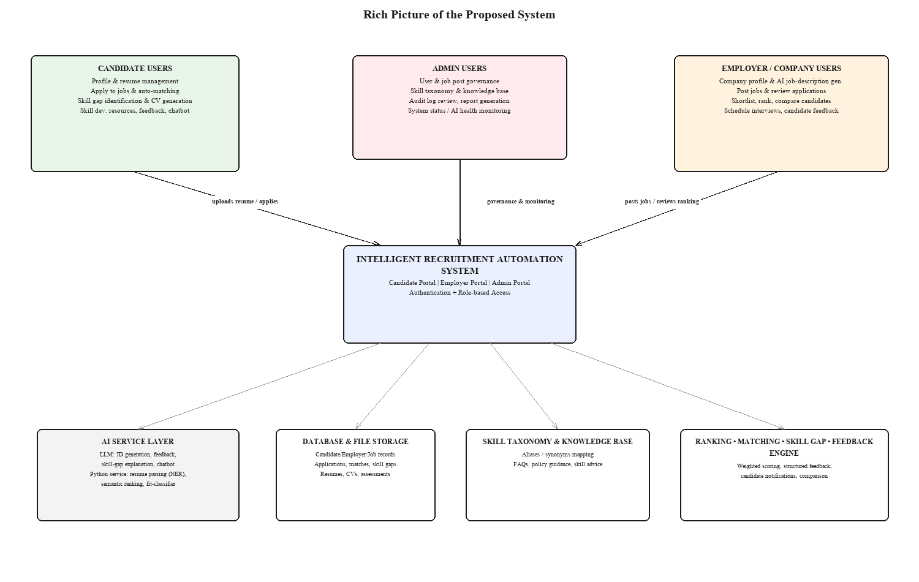
Figure 1.1: Rich Picture of the Proposed System. The diagram shows the Candidate, Employer/Company, and Admin user groups surrounding the central Intelligent Recruitment Automation System, together with the AI service layer, database and file storage, skill taxonomy, knowledge base, and the ranking/matching/skill-gap/feedback engine that the core system depends on. Arrows are labelled with the main information exchanged between each user group and the core platform (for example, "uploads resume / applies" and "posts jobs / reviews ranking"), showing that all interaction is mediated through the authenticated core system rather than occurring directly between user groups.

1.9 Resource Requirements

1.9.1 Hardware
The following hardware components are required for designing, developing, testing, and demonstrating the proposed system.
Table 1.1: Hardware Resource Requirements.
Hardware Resource | Minimum Requirement | Purpose
Laptop / Desktop Computer | Intel Core i5 or above, 8GB RAM or higher | System development, backend implementation, frontend testing, and documentation
Storage | 256GB SSD or above | Storing source code, database files, uploaded resumes, generated CVs, research documents, and development tools
Internet Connection | Stable broadband connection | AI API integration, package installation, research, version control, and system testing
Server / Cloud Environment | Basic cloud VM, local server, or hosting environment | System deployment, API hosting, database hosting, and project demonstration
Mobile / Secondary Device | Optional smartphone, tablet, or secondary display | Responsive UI testing and user interface validation
Backup Device / Cloud Storage | External drive or cloud storage service | Backup of source code, documents, datasets, and project deliverables

1.9.2 Software
The following software resources are required for development and evaluation.
Table 1.2: Software Resource Requirements.
Software Resource | Purpose
Windows Operating System | Main development environment
Visual Studio Code / Visual Studio | Frontend and backend development
React.js with Vite | Frontend web application development
Tailwind CSS | User interface styling and responsive design
ASP.NET Core Web API | Backend API development and business service exposure
C# / .NET | Backend programming and application logic implementation
SQL Server / SSMS | Database creation, management, and query execution
Entity Framework Core | Object-relational mapping and database migration management
Python FastAPI | AI service layer for resume parsing, skill extraction, and similarity processing
NLP / ML Libraries | Resume parsing, semantic similarity matching, skill extraction, and text preprocessing
LLM API | AI-assisted job description generation, feedback generation, skill-gap explanation, and chatbot support
QuestPDF | CV PDF generation
JWT Authentication | Secure login, user authentication, and role-based access control
Swagger / OpenAPI | API documentation and backend endpoint testing
Postman | API testing and request validation
Git and GitHub | Version control, source code management, and project backup
Docker | Deployment support and environment consistency

1.10 Project Scope
The scope of the research identifies what is, and what is not, part of the research.
Table 1.3: Project Scope.
In Scope | Out of Scope
Web-based recruitment automation platform | Full enterprise HR management system
Candidate, Employer, and Admin portals | Payroll and employee management
Candidate profile management | Employee attendance and performance management
Employer / company profile management | Full customer relationship management system
AI-assisted job description generation | Voice-based recruitment interviews
Resume upload and resume handling / parsing | Video interview analysis
Candidate ranking and application shortlisting | Psychometric testing
Skill gap identification | Legal employment contract generation
Skill development recommendations | Certification issuing or formal training delivery
Automated job-candidate matching | Full production-level commercial deployment
CV generation with PDF export | Advanced graphic CV design marketplace
Interview scheduling | Automated video conferencing analysis
Candidate feedback generation | Final hiring decision without human involvement
Recruitment-specific chatbot support | General-purpose chatbot outside recruitment
Knowledge base support for recruitment assistance | Public social media recruitment automation
In-app and email notification support | Large-scale enterprise communication suite
Admin user, job, skill, and report management | Complete job marketplace business operations
Audit logs and system status monitoring | Real-time large-scale enterprise load testing

The main emphasis of this project is recruitment within the Information Technology and Software Engineering field, using English-language, text-based resumes. Resumes are supported in common file formats such as PDF and DOCX. The system offers the following AI-driven and automated capabilities: generating job descriptions, parsing resumes, ranking candidates, analyzing skill gaps, matching jobs with candidates, generating feedback, recommending skill development, generating CVs, scheduling interviews, sending notifications, and providing recruitment-specific chatbot support. IRAS is a prototype and an academic demonstration system rather than a full-fledged commercial recruitment product.

1.11 Chapter Summary
This chapter introduced the Intelligent Recruitment Automation System and described the background of the recruitment problem it addresses. The general and specific problems, the research question, the research motivation, the research aim, the research objectives, the rich picture of the proposed solution, the resource requirements, and the project scope were discussed. The chapter established that existing recruitment systems are fragmented and do not provide a complete, transparent recruitment process integrating job description creation, application shortlisting, candidate ranking, skill-gap analysis, feedback, CV generation, interview scheduling, notifications, knowledge base support, and chatbot assistance. Chapter 2 builds on this foundation with a critical review of the existing literature and comparable systems, before Chapter 3 sets out the research methodology used to design, build, and evaluate IRAS.

CHAPTER 02 - LITERATURE REVIEW

2.1 Chapter Overview
This chapter discusses the literature reviewed for the Intelligent Recruitment Automation System. It reviews prior research on using AI for recruitment, resume assessment and matching candidates with job descriptions, automated job description generation, candidate ranking, skill-gap analysis, feedback generation, user profiling, CV generation, interview scheduling, notifications, knowledge base support, and AI-assisted recruitment chatbots.
The chapter aims to explain the relevance of previous research in recruitment automation from several perspectives and to identify how existing work has covered different aspects of the problem. It offers an objective critique of the contribution and shortcomings of each study rather than a mere summary, which helps determine the research gap for a unified recruitment automation system integrating candidate, employer, and admin workflows with AI-assisted and automated recruitment features.

2.2 Conceptual Map of the Literature
The conceptual map of the literature classifies the material reviewed into categories relevant to IRAS. The literature is divided into several categories including, but not limited to: artificial intelligence in the recruitment process, parsing and scanning resumes, semantic matching between job and candidates, automatic job description generation, candidate ranking, skill-gap analysis, candidate feedback, user profiling, CV generation, interview scheduling, automatic notifications, chatbot support, knowledge base support, and AI governance and transparency.
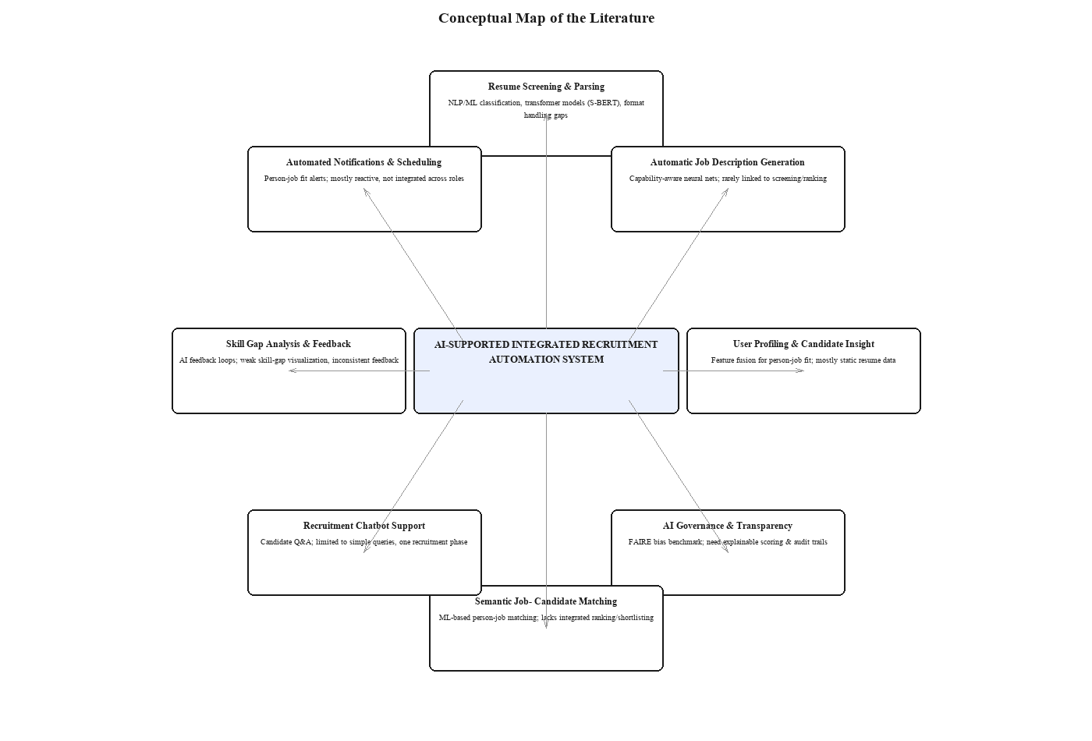
Figure 2.1: Conceptual Map of the Literature. The diagram places the proposed "AI-Supported Integrated Recruitment Automation System" at the centre and surrounds it with the eight literature categories reviewed in this chapter — resume screening and parsing, automatic job description generation, user profiling, AI governance and transparency, semantic job-candidate matching, recruitment chatbot support, skill-gap analysis and feedback, and automated notifications and scheduling — each annotated with its strength and its main gap relative to an integrated platform.
It is clear from the conceptual map that recruitment automation is not an isolated research area; it is formed by fusing several related strands. Employers use resume parsing and screening to shortlist applications. Semantic matching and scoring allow resumes to be ranked and matched against jobs. Automated job description generation benefits employers directly. Skill-gap analysis, feedback generation, and chatbot support enhance candidate insight and guidance. A full recruitment process is further complemented by user profiling, CV generation, interview scheduling, notifications, and administrative monitoring.

2.3 Domain Overview
Recruitment is the process of attracting, screening, and selecting appropriate candidates for a job. In modern organizations, recruitment activity increasingly takes place through websites and Applicant Tracking Systems, yet many recruitment tasks still depend heavily on language understanding. Recruiters must understand job requirements, interpret applicant resumes, evaluate the skills and experience being sought, compare candidates, reach a decision, and communicate clearly with candidates.
Because resumes, job descriptions, candidate feedback, and chatbot conversations are predominantly text-based, the role of Artificial Intelligence and Natural Language Processing in recruitment has grown substantially. Skills, education, work experience, training, certifications, and job requirements can be extracted from such documents using NLP techniques. Machine Learning and scoring-based techniques support resume classification, resume rank ordering, application shortlisting, and job-candidate matching. Semantic similarity techniques compare candidate profiles and job descriptions on the basis of meaning rather than exact keyword overlap. Large Language Models can generate job descriptions, summarize resumes, create feedback, explain skills, and support chatbot interactions during recruitment.
Recruitment trends indicate that a growing number of companies are adopting AI recruitment systems; LinkedIn reported that the share of recruiting firms using generative AI rose from 27% to 37% within one year [3]. If not properly controlled, however, AI-driven recruitment systems can generate unfair, ambiguous, or indefensible results [4], [7]. AI in recruitment should therefore act as a means of decision support that enhances efficiency, transparency, and candidate guidance, while still enabling employers and administrators to track recruitment outcomes.

2.4 Existing Systems / Frameworks / Designs
The literature review of existing recruitment systems falls into several categories: resume screening systems, semantic matching systems, job description generation systems, AI feedback systems, user profiling systems, job-candidate matching systems, chatbot-assisted recruitment systems, and AI governance studies. All of these categories relate to the research problem under consideration, but they typically apply to only a specific segment of the recruitment process, and are therefore not individually a complete answer to the whole recruitment journey.
The earliest recruitment automation tools were primarily concerned with screening resumes. Shahbaz [1] discussed automation of the recruitment process and demonstrated how activities can be made more efficient by reducing human effort. Yadav et al. [8] studied the use of NLP and ATS algorithms for evaluating resumes. These studies are relevant because they directly address resume screening; however, they do not extend to other vital recruitment activities such as forming job descriptions, presenting feedback to candidates, recognizing skill shortages, coordinating interviews, or supporting candidates more broadly.
A number of studies use machine learning and NLP for resume shortlisting and classification. Naik and Fal Dessai [9] proposed a technique for resume shortlisting and classification using machine learning. Kabir [10] introduced IntelCV, a smart approach for selecting skilled resumes. Kinge et al. [11] proposed employing Machine Learning and NLP methods for resume screening. These works demonstrate how ML and NLP can simplify the recruiter's task, but many of these systems offer candidates little insight into why they were, or were not, selected — they enhance automation without necessarily improving transparency.
More recent studies address resume screening using deep learning and transformer models. Gan et al. [12] presented a framework for resume screening using LLM agents. Deshmukh and Raut [13] applied S-BERT to improve resume screening and demonstrated the advantage of transformer-based models in understanding semantics. Mehboob et al. [14] evaluated automatic CV shortlisting systems using machine learning methods, and Mhatre et al. [15] used a convolutional neural network to rank and screen CVs. These studies demonstrate the possibilities of semantic ranking and deep learning, yet resumes arrive in many different formats, and the broader recruitment challenge extends well beyond semantic ranking alone.
Job description generation is another crucial research area. Qin et al. [1] proposed a capability-aware neural network for automatic job description generation. This work is highly relevant since job descriptions are the criteria used for candidate matching and ranking, yet many job description generation techniques are not linked to resume screening, skill-gap analysis, or candidate evaluation — generating job descriptions should not be a standalone process but part of a broader recruitment pipeline.
Research on generative AI shows that Large Language Models can be useful for analyzing resumes and generating feedback. Pranav and Hari [16] implemented a prototype AI system that uses LLMs for screening resumes. Patil et al. [17] introduced a GenAI-based approach to building an Applicant Tracking System in which skill-fitment analysis is central. Saxena et al. [18] studied the scope of LLMs for resume analysis and AI feedback loops. Venkatesh et al. [19] investigated automated resume analysis and skill suggestion using NLP. Lohith et al. [20] proposed an approach for resume analysis, skill enhancement, and job automation using NLP. These studies show the viability of resume analysis, recommendation, and candidate support using AI, but many lack a full role-oriented platform for candidates, employers, and administrators together.
Candidate feedback is a crucial element of transparent recruiting. Abhishek et al. [21] concentrated on AI-assisted resume recommendation during screening. Senghore et al. [22] proposed a person-job fit model using BERT for talent acquisition. Buddana et al. [23] studied text generation using LSTM and RNN architectures. Gan et al. [12] also studied LLM agents applied to recruitment tasks. These studies provide a useful background for building explanation and feedback systems with AI, yet many recruitment systems still do not give unsuccessful candidates feedback in a consistent way — in this research, feedback is treated as an integral component of the recruitment process rather than an add-on.
User profiling is another key element of intelligent recruitment. Sahoo [24] researched candidate profiling in the context of recruitment and selection. Sroison and Chan [25] discussed NLP techniques for resume parsing. Jiang et al. [26] proposed feature-fusion methods for person-job matching. This body of work reveals that structured candidate information can enhance matching accuracy, but most systems rely only on static resume data rather than a dynamic candidate profile. In this research, candidate profile, skills, resumes, CV information, and application history are all used for matching, skill-gap identification, feedback, and chatbot guidance.
Automatic job-candidate matching and notification form another important aspect of recruitment automation. Jiang et al. [26] highlighted the importance of feature fusion in person-job matching, yet many matching systems remain reactive, assessing candidates only once an application has been submitted. A recruitment system should ideally also support proactive matching, suggesting suitable jobs to candidates and notifying them of relevant recruitment activity; notification support is therefore included in the proposed system.
Chatbot use in recruitment has also been investigated. Monica et al. [27] investigated job seekers' attitudes toward AI chatbots in recruitment. Nikumbe et al. [6] developed a chatbot-supported AI portal for employment. Such research demonstrates the potential of chatbots to enhance communication and recruitment effectiveness, but chatbot assistance in these studies is typically restricted to simple questions or a single recruitment phase. In this research, chatbot support focuses on candidate profile improvement, explaining skill gaps, supporting job applications, interpreting feedback, and providing knowledge base assistance across roles.
There has also been a recent push in the literature toward auditing, transparency, and human control in AI-assisted recruitment. Wen et al. [4] introduced the FAIRE benchmark and demonstrated that LLM-based resume evaluations can be racially and gender biased. Aka et al. [28] found that AI-powered recruitment has the potential to enhance recruitment outcomes while also shaping the candidate selection process. Wilson et al. [7] demonstrated that AI recommendations can influence human decision-making in resume screening. These studies matter because they demonstrate that recruitment automation cannot depend exclusively on AI output — AI-driven recruitment solutions should feature explainable scoring, administrative oversight, audit trails, and the option for human intervention.
Table 2.1: Comparison of Existing Recruitment Research.
Research Area | Existing Focus | Strength | Limitation | Relevance to Proposed System
Resume Screening | NLP and ML-based resume filtering | Reduces manual screening effort | Limited explanation and candidate feedback | Supports resume handling and application shortlisting
Candidate Ranking | ML, CNN, BERT, and S-BERT-based ranking models | Improves candidate matching accuracy | Ranking may not be transparent or explainable | Supports candidate ranking and scoring engine
Job Description Generation | AI-generated job descriptions | Improves job post quality and structure | Often not integrated with resume screening and ranking | Supports AI-assisted employer job creation
Skill Fit Analysis | Comparison of candidate skills with job requirements | Identifies candidate suitability | Skill gaps may not be clearly explained | Supports skill gap analysis and skill development recommendations
Candidate Feedback | AI suggestions and resume feedback | Improves recruitment transparency | Feedback is often limited, generic, or inconsistent | Supports automated feedback generation
User Profiling | Candidate grouping and structured profile data | Improves matching and recommendation quality | Profiles are often static or incomplete | Supports candidate profile management and long-term matching
Job-Candidate Matching | Person-job fit and recommendation models | Improves job recommendation and candidate selection | Mostly reactive, after application submission | Supports automated and proactive job-candidate matching
CV Generation | Resume/CV structuring and document creation | Helps candidates present information professionally | Rarely connected with recruitment matching workflows | Supports CV builder and PDF generation
Interview Scheduling | Digital scheduling and recruitment coordination | Reduces coordination effort | Usually separate from matching and feedback systems | Supports interview scheduling workflow
Notification Support | Automated recruitment updates | Improves communication between users | Often limited to basic status alerts | Supports candidate and employer notifications
Chatbot Support | Candidate Q&A and recruitment guidance | Improves communication and user support | Limited lifecycle support across recruitment stages | Supports recruitment chatbot and knowledge base assistance
AI Fairness Research | Bias, transparency, and human-AI decision studies | Identifies ethical risks in AI recruitment | Does not usually provide complete system design | Supports responsible design, explainability, audit logs, and evaluation

From the comparison above, existing systems can be used as a basis for individual modules; however, none of them can be used as a comprehensive solution on their own. This research is justified by its inclusion of these functions within a single, integrated system.

2.5 Technological Analysis
The technological analysis covers the algorithms, design methods, system architecture, and workflows of IRAS. This section is segmented into algorithmic analysis, design analysis, and workflow analysis, reflecting the intelligent recruitment capability delivered through AI-assisted and automated functions.
The analysis is narrowed to the role of technologies such as Natural Language Processing, Large Language Models, structured scoring algorithms, database management, API-based communication, CV PDF generation, notifications, and chatbot support within the system. This section is crucial since the research is software-engineering-oriented, and the technology chosen must be technically justifiable in relation to the proposed recruitment solution.

2.5.1 Algorithmic Analysis
There are several algorithmic approaches relevant to IRAS. The first is text extraction and pre-processing. The system must extract readable text from resumes and job descriptions, which may be in PDF, DOCX, or plain text format. The text must be cleaned so that symbols, unnecessary spacing, formatting artefacts, and irrelevant information are removed; accurate pre-processing has a direct impact on parsing, skill extraction, candidate ranking, and matching accuracy downstream.
The second is resume parsing and information extraction. Resume parsing retrieves crucial information such as name, contact details, education, work experience, certifications, technical skills, projects, and job-related skills. Named Entity Recognition can assist by identifying significant entities within unstructured resume text, though parsing may not work reliably for non-standard resume formats or missing information; candidates should therefore be able to review and edit the details extracted from their resume.
The third is skill extraction and normalization. Technical skills may be expressed in a variety of ways across resumes and job postings — for instance, "C# backend development" and "ASP.NET Core Web API" are related but not identical terms, while "JS" and "JavaScript" refer to the same concept. Extracted skills are mapped to a standardized skill taxonomy, which makes matching more accurate and reduces mismatches caused by inconsistent naming conventions.
The fourth is semantic similarity analysis. Traditional keyword matching looks for exact word overlap between a resume and a job description, whereas semantic similarity is based on meaning. Techniques such as TF-IDF, cosine similarity, word embeddings, sentence embeddings, BERT, and S-BERT can be used for this purpose. S-BERT is particularly useful since it can embed a resume and a job description as sentences and perform a semantic comparison between them [13]. In the proposed system, this gives an advantage over simple keyword matching, since related IT skills and IT roles can be expressed using a range of related terms.
The fifth is candidate ranking and scoring. Candidate suitability should not be evaluated using a single criterion; skill match, experience match, education match, qualification match, and semantic similarity can all inform ranking. A weighted scoring method is used to calculate the final match score, giving the ranking process more structure and explanation than a single opaque figure.
The sixth is skill-gap identification. The system compares a candidate's skills against those required for a selected job; gaps are identified where required skills are missing or under-developed, and these gaps are used to generate learning or improvement recommendations. This is significant because it is a development feature, not merely an elimination feature.
The seventh is LLM-based text generation. Employer-provided information such as job title, responsibilities, required skills, and experience level can be used to generate structured job descriptions through an LLM. LLMs can also facilitate feedback generation by explaining why a candidate might be a good or a poor fit for a position and what improvements are suggested; however, LLM output must be constrained to avoid irrelevant, biased, or fabricated content, and human review remains important for fairness and transparency [4], [7].
The eighth is CV generation. No machine learning model is required for the CV builder; it instead uses structured candidate profile data — education, experience, certifications, and skills — to produce a professional PDF document, allowing candidate information to be presented in a consistent, readable format.
The ninth is chatbot response generation. The chatbot is structured to accept only questions relevant to the system or the job search, helping candidates design their profile, understand their skill gaps, receive application guidance, and interpret feedback. The chatbot draws on a recruitment knowledge base and structured prompts to generate relevant responses; it should not function as a general-purpose chatbot, and candidate information should only be used in a privacy-conscious manner.
The tenth is evaluation measurement. Precision, recall, F1-score, and ranking comparison against human judgement can be used to evaluate candidate ranking. Extraction accuracy can be used to evaluate resume parsing. Skill-gap identification can be validated by comparing system-detected gaps against manually identified gaps. Relevance, completeness, clarity, and fairness are appropriate measures for evaluating AI-generated job descriptions and feedback, while relevance, accuracy, usefulness, and user satisfaction are appropriate measures of chatbot effectiveness. The system must be evaluated both as an AI-based recruitment system and as a viable software system, and all of these measures matter.

2.5.2 Design Analysis
IRAS is designed to serve three primary user roles — Candidate, Employer, and Admin — since responsibilities and system requirements differ across each group. Candidates need profile management, resume upload, job search, application tracking, skill-gap feedback, CV generation, notifications, and chatbot assistance. Employers need company profile management, job posting, AI job description generation, application review, candidate ranking, candidate comparison, interview scheduling, feedback management, and reports. Administrators must manage users, monitor job posts, manage skill taxonomy, manage the knowledge base, generate reports, review the audit log, monitor system status, and configure the system.
The system design is layered. The presentation layer offers the web-based user interface to candidates, employers, and administrators. The API layer processes incoming requests, validates user credentials, accesses other services, and exchanges data between frontend and backend. The application layer contains the essential business logic — recruitment processes, evaluation, matching, response generation, communications, resume handling, and chatbot operation. The domain layer represents the meaningful entities of the system: users, profiles, jobs, skills, interviews, responses, resumes, alerts, and audit logs. The infrastructure layer covers database operations, file management, and integration with the external AI service.
This layered approach is suitable because it is highly flexible and updatable. AI-related components can be revised as improved models, prompts, or algorithms become available — for example, the resume ranking algorithm, skill-gap explanation, feedback generation, and chatbot responses can be enhanced without redesigning the whole system, and the knowledge base and skill taxonomy can be improved incrementally for greater accuracy and relevance.
Security and confidentiality also play an important role in the system design, which includes authentication, role-based access control, secure file handling, and auditing, essential for protecting sensitive information. Candidates, resumes, recruitment decisions, applications, and job-offer details are all kept secure. Candidates only access their own profile, feedback, notifications, applications, and CV. Employers only access their own company profile, job posts, applications, interview information, and candidate evaluations. Platform-wide management and monitoring features are reserved for administrators.
In design terms, the proposed system is more powerful than any individual AI application because it combines AI decision support with workflow structure and system usability. Candidate ranking, skill-gap analysis, feedback generation, CV generation, interview scheduling, notifications, and chatbot support are not treated as individual tools; instead, they are incorporated into a single recruitment platform that helps employers make decisions while keeping candidates informed and the process transparent.

2.5.3 Workflow Analysis
The system is organized as a series of interconnected workflows supporting recruitment from job creation through to candidate feedback.
The first workflow is employer job creation. The employer logs in, enters minimal details about the vacancy, and uses the AI-powered job-description generator to produce a structured job description; the employer then edits and approves the content before publishing it. AI-generated job descriptions are never published without employer validation, since human intervention at this step is essential.
The second workflow is candidate profile and resume handling. A candidate registers, creates a profile, and uploads a resume with information on education, work experience, certifications, and skills. The system attempts to extract crucial information automatically from the resume file, but automated extraction is not always fully accurate given the diversity of resume formats, so the candidate can review and edit the extracted information.
The third workflow is application screening and candidate ranking. When candidates apply for a job, they are matched against job requirements using their profile, resume, skills, experience, and qualifications, producing a suitability or match score that allows the employer to view applicants ranked and compared more effectively.
The fourth workflow is skill-gap analysis. The system compares a candidate's current skills against those required for a particular position; gaps are identified where required skills are missing or under-developed, and candidates can view these gaps along with improvement tips and skill-development recommendations — a development feature, not simply an elimination feature.
The fifth workflow is automatic job-candidate matching. The system identifies candidates whose profiles and skills match a posted job's requirements and recommends or notifies suitable candidates accordingly, reducing the reliance on a purely passive recruitment platform where job seekers must search for every opportunity themselves.
The sixth workflow is CV generation. Candidates can use existing profile data — education, work experience, skills, and certifications — to create a professional CV in PDF format, helping them prepare a consistent, structured document from the data already held in the system.
The seventh workflow is interview scheduling. Once candidates have been reviewed and ranked, the employer can schedule an interview for shortlisted candidates; the system stores interview information and communicates scheduling details, improving coordination between employer and candidate.
The eighth workflow is the feedback process. When a candidate is turned down or asked to improve, the system provides feedback explaining why the candidate was unsuccessful and which skills should be developed, increasing transparency and helping candidates strengthen future applications.
The ninth workflow is notification handling. The system notifies users about job recommendations, application status changes, interview scheduling, feedback availability, and other recruitment information, improving communication between candidates and employers throughout the process.
The tenth workflow is chatbot support. Candidates can ask recruitment-related questions, learn about their skill gaps, receive tips on improving their profile, understand feedback, and get support with the application process through the chatbot, which is restricted to recruitment-relevant, knowledge-base-supported content to preserve relevance and accuracy.

2.6 Reflection
AI has been found to offer substantial benefit across the recruitment domain. Previous studies report positive results in resume screening, semantic matching, job description generation, skill matching, chatbot support, candidate profiling, and AI-assisted feedback. However, the existing literature is overwhelmingly focused on individual modules rather than a full recruitment ecosystem. This confirms the research gap identified in this study: recruitment automation needs to be delivered through an integrated system that includes job description creation, application shortlisting, candidate ranking, skill-gap analysis, candidate feedback, user profiling, automated job-candidate matching, CV creation, interview scheduling, notifications, knowledge base support, and chatbot assistance.
The review also demonstrates that recruitment automation should not only enhance employer efficiency; it should assist candidates by making the process more transparent and by guiding them toward improvement. Many AI systems can rank or filter candidates, but far fewer rank, explain, identify missing skills, and offer genuinely helpful feedback — an important gap given its direct effect on candidates' career prospects.
The literature further highlights the need for responsible use of AI in recruitment. LLM-based resume evaluation can carry racial and gender bias, as revealed by the FAIRE benchmark [4], and AI-recommendation studies show that biased AI recommendations can influence recruiter decisions [7]. As a result, the proposed system is treated as an open decision-support system rather than a fully automatic decision-maker: it provides structured scoring, explanations, feedback, and monitoring, but the final recruitment decision remains at the employer's discretion.
In conclusion, IRAS fills the identified void by integrating automation for employers, visibility for candidates, and oversight for administrators. For employers, this spans job description preparation, publishing job posts, evaluating applications, ranking candidates, comparing applicants, scheduling interviews, collecting feedback, and preparing reports. For candidates, it spans profile management, resume upload, job matching, skill-gap identification, CV composition, feedback, and chatbot notifications. For administrators, it spans user management, job tracking, skill taxonomy management, knowledge base maintenance, report management, and system supervision. All of the literature reviewed in this chapter dates from 2016 through mid-2026, with the substantial majority published within the last five years, ensuring the review reflects the current state of AI-assisted recruitment research.

CHAPTER 03 - METHODOLOGY

3.1 Research Paradigm
The pragmatic research paradigm is adopted for this study. Pragmatism suits this research since the study aims to address a real-world recruitment problem by designing and developing a software artifact.
The paradigm allows the system to be assessed using multiple types of evidence. Alongside human-centred evidence such as usability, transparency, usefulness, and user satisfaction, technical evidence such as matching accuracy, candidate-ranking relevance, skill-gap identification accuracy, processing time, CV-generation correctness, and feedback quality can all be taken into account. This is appropriate given that IRAS must be assessed both technically and from the user's standpoint.
Pragmatism is also relevant because recruitment automation is a real-world issue that both employers and candidates must contend with. Businesses want faster, more consistent, more detailed, and more predictable shortlisting, while candidates want transparency, feedback, skill advice, and communication. The work in this thesis is therefore directed toward developing and testing a practical solution that addresses these practical recruitment-process constraints.

3.2 Research Approach
The research approach used in this study is a mixed method guided by practical reasoning. The qualitative component includes the literature review, analysis of existing recruitment processes, identification of user requirements, and feedback on the usability, transparency, and candidate experience of the system. The quantitative component includes analysis of candidate-ranking accuracy, resume-data extraction accuracy, match relevance, skill-gap identification accuracy, process efficiency, CV-generation correctness, and user satisfaction ratings.
Both deductive and inductive reasoning are used in this research. Deductive reasoning is applied when existing theories, literature-review techniques, and findings are used to design the system — for example, concepts from NLP, semantic similarity, Large Language Models, scoring-based ranking, and Design Science Research Methodology guide the system design. Inductive reasoning is applied when observations from prototype testing, system output, and user feedback are analyzed to enhance the system. This combination is appropriate because the research involves designing, developing, testing, and improving a software artifact based on evaluation results.
This mixed approach also determined how disagreement between qualitative/practical and quantitative evidence would be resolved during the project, which mattered in practice at least once: Section 6.4's model-selection decision is a direct example. The quantitative evidence favoured XGBoost (highest accuracy), but a practical, engineering-grounded constraint discovered during integration testing — a cross-platform model-serialization failure — initially overrode it in favour of Logistic Regression. A purely quantitative research approach would have had no principled way to make that interim call; the pragmatic paradigm adopted in Section 3.1 explicitly allows deployment reliability, a form of practical evidence, to outweigh a small accuracy advantage. The same pragmatic stance then treated that constraint as something to keep working on rather than a fixed trade-off: once the serialization failure was traced to a portability limitation of one specific serialization path and worked around by exporting the model through its own native format instead, the practical obstacle was removed and the quantitatively-favoured model (XGBoost) was deployed after all — evidence that, under this paradigm, a practical constraint need not permanently override the strongest quantitative result, only until it is itself resolved.

3.3 Research Strategy
This study uses Design Science Research Methodology (DSRM) as its research strategy. This methodology suits software engineering research since it is concerned with the design, development, demonstration, and evaluation of artifacts, and the artifact in this study is the Intelligent Recruitment Automation System (IRAS).
DSRM is justified because the research addresses a practical recruitment problem and proposes a technological solution to it. It structures the study around the key stages of problem identification, goal setting, design and development, demonstration, evaluation, and communication. Since the purpose of this research is to create and test an automated recruitment system, DSRM offers a structured way to develop the system and evaluate its performance.
The system is delivered through three workflows — Candidate, Employer, and Admin — each automated and web-based, with AI-based and automated capability for creating job descriptions, managing resumes, shortlisting applications, ranking candidates, conducting skill-gap analysis, matching jobs with candidates automatically, creating CVs, scheduling interviews, providing feedback on resumes, notifying candidates, providing knowledge base support, and assisting candidates through a recruitment chatbot.

3.4 Fact Collection Mechanisms
Several methods are employed in this research to collect the facts needed for designing, developing, and evaluating the system.
First, a literature review is carried out using research papers, journal articles, conference papers, and industry reports related to AI in recruitment, CV screening, matching with job posts, LLM-based text generation, skill-gap analysis, recruitment chatbots, CV generation, interview scheduling, notifications, and fair AI hiring. This helps determine what solutions already exist, their limitations, and the gaps in the research.
Second, secondary data is analyzed to understand resume and job-description structure, drawing on resume datasets, resume entity-recognition datasets, publicly available resume samples, publicly available job descriptions, and open-source recruitment datasets. This information supports understanding of resume structure, skill extraction, job requirements, and matching techniques.
Third, synthetic data is used for system testing. System functions are tested using synthetic candidate profiles, resumes, job postings, applications, interview records, and feedback samples, without sharing actual personal data — an important consideration given that recruitment data is sensitive information belonging to both candidates and employers.
Fourth, prototype-based testing gathers technical performance facts, covering resume-parsing accuracy, candidate-ranking relevance, skill-gap identification, job-candidate matching, quality of AI-generated job descriptions, correctness of CV generation, scheduling functionality, feedback quality, notification delivery, and chatbot response relevance.
Fifth, user feedback is gathered from sample users including students, potential candidates, employers, and academic evaluators. This feedback assesses usability, transparency, usefulness, candidate experience, and overall satisfaction with the system.

3.5 Research Methodology Execution Workflow
The Research Methodology Execution Workflow (Figure 3.1) gives an understanding of how the research is executed, from problem identification through to communication. This workflow is based on the Design Science Research framework and customized to fit the recommended system development process.
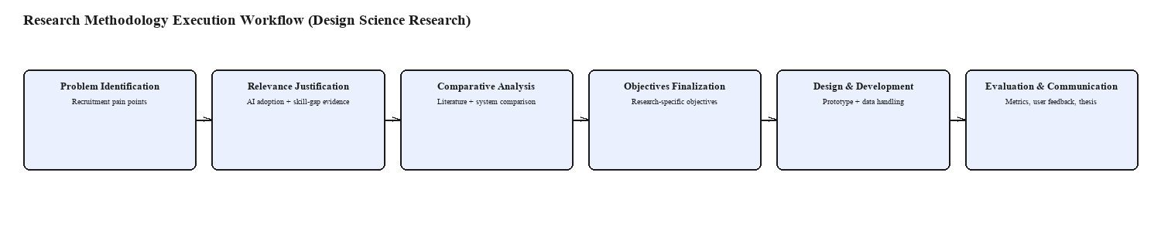
Figure 3.1: Design Science Research Methodology Execution Workflow. The diagram shows the six sequential stages followed in this research — Problem Identification, Relevance Justification, Comparative Analysis, Objectives Finalization, Design and Development, and Evaluation and Communication — with each box annotated underneath by the concrete evidence base used at that stage, for example recruitment pain points at the identification stage and prototype and data handling at the design and development stage.
Table 3.1: Research Methodology Execution Workflow.
Stage | Activity | How It Is Addressed in This Research
Problem Identification | Identify recruitment issues | Manual screening, poor feedback, inconsistent ranking, weak transparency, interview coordination issues, and fragmented tools are identified
Relevance Justification | Justify why the problem matters | Recruitment affects both employers and candidates; AI adoption is increasing, but explainability, fairness, and transparency are required
Comparative Analysis | Compare existing studies | Literature on resume screening, job matching, LLMs, feedback generation, user profiling, CV generation, interview scheduling, notifications, and chatbots is reviewed
Gap Justification | Identify missing areas | Lack of a unified system, limited candidate feedback, weak skill-gap explanation, limited chatbot lifecycle support, and lack of integrated CV/interview support are identified
Objective Definition | Define research objectives | Objectives are structured under identify, analyze, design/develop, and evaluate stages
Design | Design proposed system | Candidate, Employer, and Admin workflows, system architecture, database design, and AI-assisted modules are designed
Development | Implement system modules | Web frontend, backend APIs, database, AI service integration, authentication, CV generation, notification support, and chatbot integration are developed
Data Management | Prepare and handle data | Resume data, job descriptions, skill datasets, candidate profiles, and synthetic test records are cleaned and structured
Demonstration | Show working prototype | Main workflows are demonstrated using sample users, test resumes, job posts, applications, CV outputs, and interview records
Evaluation | Evaluate the system | Matching relevance, ranking accuracy, skill-gap identification, CV-generation correctness, processing efficiency, usability, feedback quality, and chatbot relevance are measured
Communication | Present research outcomes | Interim reports, final thesis, presentation slides, system screenshots, and prototype demonstration are prepared

3.5.1 Problem Identification
The problem is significant because recruitment shapes both organizational performance and career opportunities. Finding the right candidate, minimizing hiring delays, and reaching informed decisions all depend on a streamlined, precise, and systematic recruitment process. Candidates should also be offered clear recruitment practice, information on the outcome of a job application, guidance on closing skill gaps, feedback on their resume or CV, and support for enhancing their employability.
This is also a significant problem because AI is increasingly incorporated into recruitment. AI can enhance efficiency by creating job descriptions, processing resumes, ranking candidates, matching job and candidate skills, identifying skill gaps, providing feedback, and supporting candidates through a chatbot. Recent studies, however, indicate that careful design and monitoring of AI-based recruitment systems is needed to decrease bias, increase explainability, and maintain human control over recruitment decisions [4], [7].

3.5.2 Relevance Justification
The problem is important because recruitment directly affects organizational performance and candidates' career opportunities. Organizations require an efficient, accurate, and consistent recruitment process to identify suitable candidates, reduce hiring delays, and improve decision-making. Candidates also require transparent recruitment processes that help them understand application outcomes, identify skill gaps, improve their resumes or CVs, and develop their employability.
This issue is significant because Artificial Intelligence is increasingly used in recruitment. AI can improve efficiency through job description generation, resume handling, candidate ranking, job-candidate matching, skill-gap analysis, feedback generation, and chatbot support. Recent studies, however, show that AI-based recruitment systems must be carefully designed and monitored to reduce bias, improve explainability, and maintain human control over recruitment decisions [4], [7].

3.5.3 Comparative Analysis and Gap Justification
The comparative analysis is carried out through the literature review presented in Chapter 2. Existing methods and systems are discussed with respect to job description generation, resume handling, application shortlisting, candidate ranking, skill-gap identification, candidate feedback, user profiling, automated job-candidate matching, CV generation, interview scheduling, notifications, knowledge base support, and chatbot support.
The need for this research is warranted because most existing methods engage with only a single recruitment task at a time. Some consider only resume screening, others only job matching, job description generation, or chatbot assistance, but few systems deliver a single, role-based, transparent platform for recruitment automation combining employer-side automation, candidate-side support, and administrator monitoring within one system.

3.5.4 Define and Finalize Objectives
The research objectives were set once the recruitment issues had been identified and the research gap established through the literature review. The objectives include the primary phases of the study: determining the limitations of existing systems, analyzing systems and technologies, designing and developing the proposed system, and evaluating the final prototype.
The finalized objectives are: identifying the limitations of traditional and AI-assisted recruitment systems; analyzing existing literature and technologies relevant to intelligent recruitment automation; designing and developing IRAS with candidate, employer, and admin roles; and evaluating the system against matching relevance, ranking accuracy, skill-gap identification, correctness of CV generation, quality of feedback, usefulness of the chatbot, usability, and transparency.

3.5.5 Design / Development / Data Management and Handling
This stage covers system architecture design, database design, user-interface design, backend API development, AI-service integration, and chatbot development. The system comprises authentication and role management, candidate profile management, employer profile management, AI-assisted job-description generation, resume upload and handling, candidate ranking and application shortlisting, skill-gap analysis, automated job-candidate matching, CV generation, interview scheduling, candidate feedback generation, recruitment-specific chatbot support, notification management, admin management, reporting, audit logging, and system monitoring.
Data management involves gathering and formatting sample resumes, job descriptions, skill lists, candidate profiles, application records, interview records, feedback samples, and chatbot question-and-answer content. Wherever applicable, recruitment data is anonymized or synthesized so that it does not contain sensitive information about a real individual. Data pre-processing involves text extraction, text cleaning, text normalization, entity recognition, skill mapping, and structuring the data into formats appropriate for profile management, profile matching, profile ranking, skill-gap identification, feedback generation, and chatbot support.

3.5.6 Evaluation and Communication
Evaluation is carried out to determine the effectiveness, accuracy, and usability of the proposed system. Precision, recall, F1-score, ranking accuracy, and relevance are used to evaluate candidate ranking and matching. Resume parsing is evaluated by comparing extracted data against manually verified data, and skill-gap analysis is evaluated by comparing manually verified skills against those extracted from the resume.
The usability, usefulness, and correctness of AI-generated job descriptions, feedback, CV generation, interview scheduling, notifications, and chatbot responses are tested for relevance, and feedback is gathered from candidates, employers, and academic assessors. The communication phase spans Interim Submission 01, Interim Submission 02, this final thesis, the project presentation, and the system demonstration.

3.6 Project Management Methodology
The chosen project management methodology for this research is Scrum. Scrum is appropriate because this project is software development involving multiple modules, requirement changes, AI integration, and continuous improvement; the software spans Candidate, Employer, and Admin functionality, each of which can be worked on and tested incrementally.
Scrum enables the project to be broken into sprints, each concentrating on a particular part of the software — authentication, candidate profile, job posting, resume parser, AI ranking algorithm, skill-gap analysis, chatbot, admin functionality, and report generation. Scrum also accommodates review and continuous improvement, which is important in a research prototype. Kanban would also support task management, but Scrum was judged more appropriate here since the project has distinct phases of development and deliverables.

3.6.1 Project Timeline
The project timeline is designed around the major research and development activities and is synchronized with proposal writing, literature review, data preparation, design, development, evaluation, and documentation.
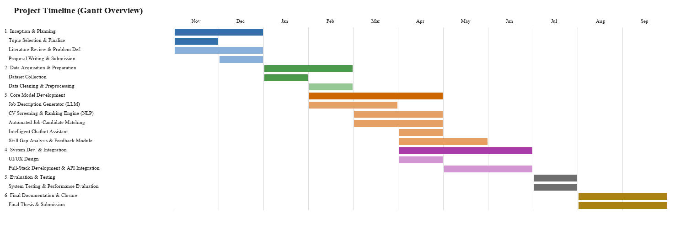
Figure 3.2: Project Timeline. The Gantt-style chart shows six project phases spanning the academic year — Inception and Planning, Data Acquisition and Preparation, Core Model Development, System Development and Integration, Evaluation and Testing, and Final Documentation and Closure — plotted month by month from November through September, with each phase broken down into its constituent tasks such as the job-description generator, the CV screening and ranking engine, the chatbot assistant, and the skill-gap analysis and feedback module.

3.6.2 Ethical Considerations
Ethical considerations are significant because the recruitment process handles sensitive candidate and employer data and can influence a person's job opportunities. The proposed system must ensure that the final hiring decision is made by a human rather than by AI alone, and that AI-generated feedback assists recruiters without discriminating against applicants.
Table 3.2: Ethical Considerations.
Ethical Area | Risk | Mitigation
Candidate Privacy | Resumes contain personal and sensitive information | Use anonymized or synthetic data where possible
Data Security | Unauthorized access to candidate or employer data | Apply authentication, role-based authorization, secure file handling, and protected storage
Informed Consent | Users may not clearly understand how their data is used | Inform users about data usage for matching, ranking, feedback, notifications, and chatbot support
Bias in AI | AI ranking or feedback may unfairly affect candidates | Focus evaluation on relevant skills, qualifications, experience, and explainable scoring
Transparency | Candidates may not understand application outcomes | Provide feedback, match explanations, and skill gap details
Human Oversight | AI may be treated as the final decision-maker | Use AI as a decision-support tool while keeping final decisions under employer control
Chatbot Misuse | Chatbot may answer irrelevant or unsuitable questions | Restrict chatbot responses to recruitment-related and knowledge-base-supported content
Secondary Data Use | Public datasets may include sensitive information | Use ethical, anonymized, or synthetic datasets only
CV and Resume Handling | Generated CVs and uploaded resumes may expose private details | Limit access to the relevant candidate and authorized employer only
Audit and Accountability | System actions may not be traceable | Maintain audit logs for administrative monitoring and accountability

3.7 Chapter Summary
This chapter described the research methodology used to develop IRAS. The study adopts the pragmatic research paradigm and a mixed research method, and uses Design Science Research as its research strategy since it concerns the design and evaluation of a software artifact. The chapter also described the fact-gathering methods, the methodology execution workflow, the project management methodology, the project timeline, and the ethical considerations that shaped the research. Chapter 4 builds on this methodology by translating the research objectives into a concrete System Requirement Specification for IRAS.

CHAPTER 04 - SYSTEM REQUIREMENT SPECIFICATION

4.1 Chapter Overview
This chapter translates the research objectives and methodology set out in Chapters 1 to 3 into a concrete System Requirement Specification (SRS) for the Intelligent Recruitment Automation System. It identifies the system's stakeholders and their concerns, describes how the requirements were operationalized from research objectives and data-gathering activity into concrete system behaviour, and presents the system and model analysis — use case diagram and specifications, class diagram, activity diagram, and sequence diagrams — that formed the design basis for the implementation described in Chapter 5. The chapter closes with the proposed system architecture and the consolidated functional and non-functional requirements.

4.2 Stakeholder Analysis
Three primary stakeholder roles interact with IRAS directly, and a fourth, indirect stakeholder — the external AI service — supplies the intelligence behind several of the system's automated features.
The Candidate is a job seeker who registers on the platform, builds a profile, uploads and manages a resume, searches and applies for jobs, receives proactive job matches, views their skill gap against a target role, works through a personalized skill-improvement plan, submits evidence of skill development, generates a CV, receives feedback and notifications, and uses the recruitment chatbot. The candidate's primary concern is fairness and transparency: understanding why a match score or rejection occurred and what concrete action would improve their standing.
The Employer is a hiring organization's representative who registers a company profile, drafts job postings with AI assistance, publishes vacancies (subject to admin moderation), reviews a ranked and explainable list of applicants, compares candidates, attaches a skill assessment to a role where relevant, schedules interviews, and issues feedback. The employer's primary concern is efficiency without losing trust in the ranking: a shortlist that is fast to produce but still auditable.
The Administrator is a platform operator responsible for user management, job-post moderation, skill-taxonomy curation, knowledge-base maintenance, audit-log review, AI-service health monitoring, and reporting. The administrator's primary concern is governance: ensuring that AI-influenced decisions across the platform remain within policy and can be reviewed after the fact.
The AI Service is a non-human, indirect stakeholder in the sense that its behaviour (resume parsing accuracy, semantic-similarity quality, fit-classifier confidence, and generated-text quality) directly shapes what every human stakeholder experiences, even though no human interacts with it directly; it is reached only through the core platform's backend.
These four stakeholders do not carry equal weight in every design decision. Where a candidate's transparency need and an employer's efficiency need pull in different directions — for instance, showing the full score breakdown takes marginally longer to render than a bare pass/fail badge — this specification consistently resolves in favour of the candidate's transparency concern, since Section 1.2 identified opaque, feedback-free rejection as the general problem this research set out to address in the first place; an efficient but unexplainable shortlist would solve the employer's problem while leaving the candidate's exactly where Chapter 1 found it.
Table 4.1: Stakeholder Concerns and System Response.
Stakeholder | Primary Concern | How IRAS Addresses It
Candidate | "Why was I rejected, and what should I improve?" | Explainable, weighted match score; AI-explained skill gap; personalized improvement plan with evidence review
Employer | "How do I shortlist quickly without missing a good fit?" | Multi-signal ranked applicant list broken down by skill, experience, education, and assessment score
Administrator | "Is the AI behaving, and can I prove it?" | Job moderation queue, audit log of AI-influenced actions, AI-service health monitoring, reporting
AI Service | (indirect) Correctness and availability of parsing, ranking, and generation | Bounded-confidence review paths, health-check endpoint, template fallbacks when the AI service is unavailable

4.3 Operationalization Process
The requirements presented in this chapter were not defined in the abstract; each was operationalized from a specific research objective (Section 1.7) and a specific fact-gathering activity (Section 3.4), and then reviewed for validity before being carried into design.
Table 4.2: Operationalization: Research Objectives to System Requirements.
Research Objective | Data-Gathering Technique Used | Resulting Requirement(s) | Validity Check
To identify recruitment-process shortcomings | Literature review; review of existing job-board and ATS platforms | FR set for candidate feedback, skill-gap visibility, and transparent scoring | Cross-checked against the gaps identified in Table 2.1
To analyze existing screening/matching approaches | Comparative analysis of resume-screening and person-job-fit literature | FR for taxonomy-based skill matching combined with semantic similarity, not keyword-only filtering | Confirmed against the algorithmic analysis in Section 2.5.1
To design/implement a role-based platform | Review of comparable recruitment-tool feature sets; sample resume/job-post datasets | FR set for Candidate, Employer, and Admin portals and their respective workflows | Validated against the three workflows defined in Figure 1.1
To evaluate matching, skill-gap, and CV-generation accuracy | Prototype-based testing with synthetic data; user feedback from sample candidates/employers | NFR for accuracy, processing efficiency, and usability; test cases in Chapter 6 | Verified via the test plan and model evaluation in Chapter 6

This mapping matters because a requirement that cannot be traced back to a research objective, and a research objective that is not covered by at least one requirement, both indicate a gap in the specification; no such orphaned objective or requirement was found once the tables in Section 4.6 were finalized against Section 1.7.

4.4 System / Model Analysis

4.4.1 Use Case Diagrams with Specifications
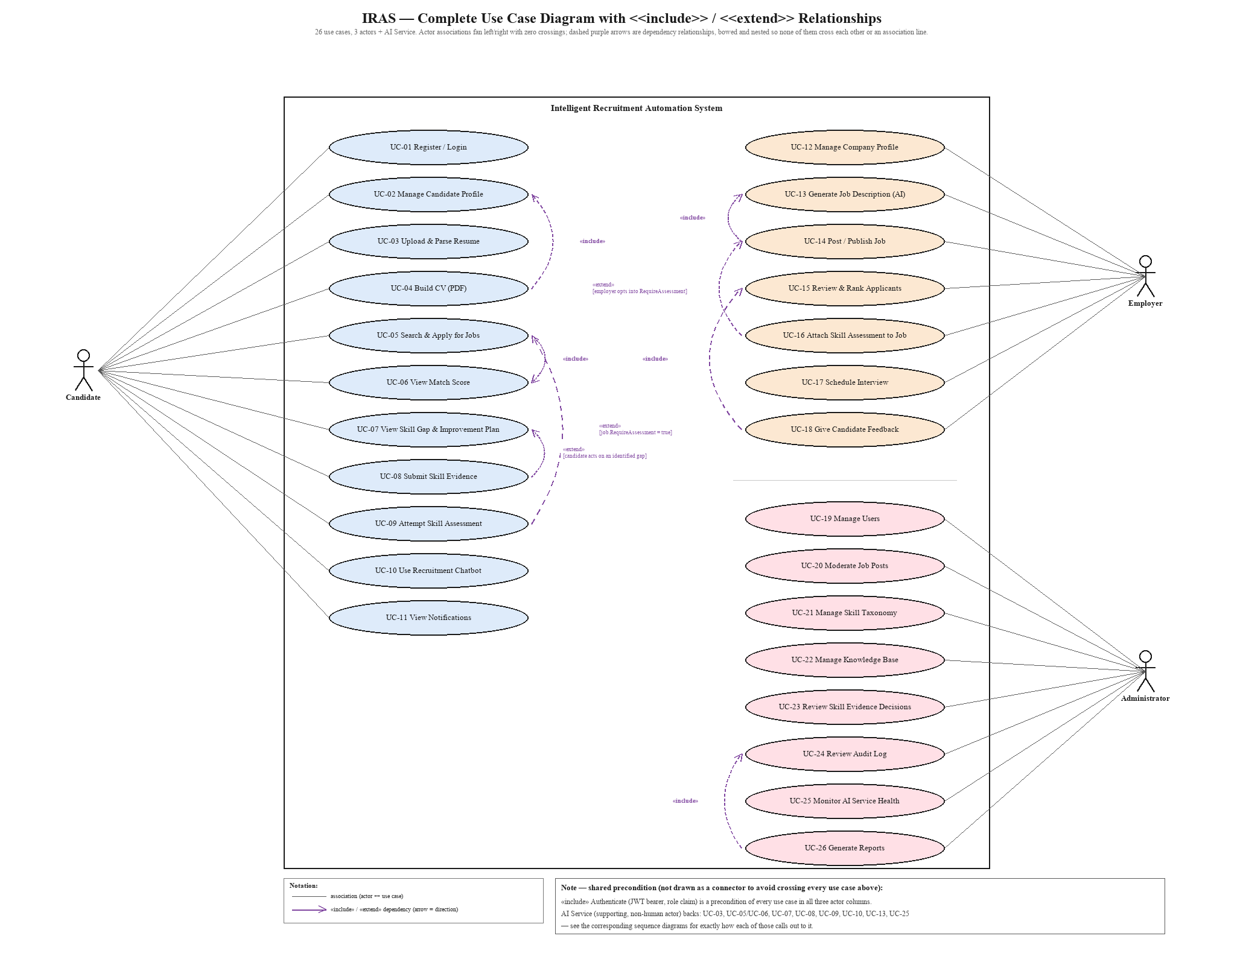
Figure 4.1: Complete Use Case Diagram of IRAS with «include» / «extend» Relationships. The diagram shows all twenty-six use cases across the three human actors — Candidate (11), Employer (7), and Administrator (8) — against the Intelligent Recruitment Automation System boundary, together with eight explicit UML dependency relationships: four «include» links (a mandatory sub-behaviour always performed as part of the base use case, e.g. Post/Publish Job always includes Generate Job Description) and four «extend» links (an optional behaviour triggered only under a stated condition, e.g. Attempt Skill Assessment extends Search & Apply for Jobs only when the job's RequireAssessment flag is set). The shared Authenticate precondition and the AI Service's supporting role are recorded as a boxed note rather than drawn as connectors, since a line from one corner to a dozen scattered use cases is exactly the kind of visual collision the rest of the diagram was deliberately laid out to avoid.
Full specifications for every use case are provided in Appendix A; the two most significant use cases are detailed below because they carry the system's principal AI-driven contribution.
Table 4.3: Use Case Specification: Apply for a Job (Automated Ranking).
Field | Description
Use Case ID | UC-07
Actor(s) | Candidate (primary), AI Service (supporting)
Description | A candidate applies to a published job and receives a weighted match score computed from skill overlap, semantic similarity, a trained fit-classifier, and (where applicable) assessment performance
Preconditions | Candidate is authenticated; candidate has at least one parsed resume; job status is Published
Main Flow | 1. Candidate selects a job and submits an application. 2. System extracts the candidate's skill set and resume text. 3. System computes the taxonomy-based skill match locally. 4. System calls the AI service for semantic similarity and fit-classifier score. 5. System combines signals into a weighted Total Score and, if the job requires one, folds in the assessment score. 6. System persists the application with its score breakdown and any identified skill gaps. 7. Employer's applicant list is updated with the new ranked entry.
Alternative Flow | If the AI service is unavailable, the system falls back to the skill-match signal alone and flags the application as "partially scored" for later re-ranking once the AI service recovers
Postconditions | Application is stored with an auditable score breakdown; SkillGap records exist for any missing required skills

Table 4.4: Use Case Specification: Submit Skill Evidence for Review.
Field | Description
Use Case ID | UC-14
Actor(s) | Candidate (primary), AI Service (supporting), Administrator (supporting)
Description | A candidate submits evidence (a link, file, or certificate) that a step of their personalized skill-improvement plan has been completed, for AI-assisted and administrator-reviewed verification
Preconditions | Candidate has an active SkillImprovementPlan with a step in "Practicing" or "PartiallyCompleted" status
Main Flow | 1. Candidate submits evidence against a plan step. 2. Evidence status is set to Pending. 3. AI evidence reviewer assesses the evidence against the step's target skill and produces a recommendation and confidence level. 4. If confidence is high, the step is auto-updated (Approved/RevisionRequired) with the AI's reasoning attached. 5. If confidence is low, the item is queued for administrator review. 6. Administrator applies the final decision if queued. 7. Candidate's skill status is updated on approval.
Alternative Flow | Candidate withdraws the evidence before a decision is reached, returning the step to Draft
Postconditions | Evidence carries a final verification status (Approved, Rejected, or RevisionRequired) visible to the candidate, and the action is captured in the audit log

4.4.2 Class Diagram and Enhanced Entity-Relationship (EER) Diagram
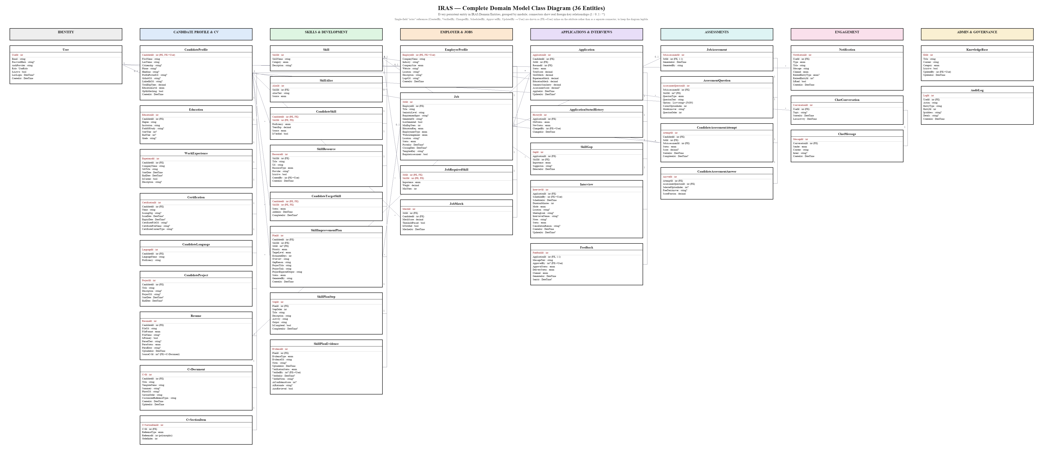
Figure 4.2: Complete Class Diagram of the IRAS Domain Model. The diagram shows all thirty-six persistent entities in IRAS.Domain/Entities, organized into eight module swimlanes — Identity, Candidate Profile and CV, Skills and Development, Employer and Jobs, Applications and Interviews, Assessments, Engagement, and Admin and Governance — each box listing its primary key, foreign keys, and scalar attributes exactly as declared in source. Connector lines show every structural foreign-key relationship with its cardinality (1, 0..1, or *); single-field administrative "actor" references such as CreatedBy, VerifiedBy, ChangedBy, ScheduledBy, ApprovedBy, and UpdatedBy are annotated inline as (FK→User) on the attribute itself rather than drawn as separate connectors, to keep the diagram legible at this scale.
At this level of detail, three structural patterns repeat across modules and are worth naming once rather than per-entity. First, profile-owned collections (CandidateProfile → Education/WorkExperience/Certification/CandidateLanguage/CandidateProject/Resume/CvDocument) are all simple one-to-many children with no independent lifecycle — none of them is ever queried or matched against without going through the owning CandidateProfile first. Second, many-to-many-with-attributes join entities (CandidateSkill, JobRequiredSkill, CandidateTargetSkill) each carry a composite primary key of the two foreign keys they join plus additional scoring or status attributes (Proficiency/YearsExp, Importance/Weight, Status/AddedAt respectively) — they are not pure link tables, which is why each appears as its own box rather than as a bare connector. Third, AI-review-gated entities (SkillPlanEvidence, and to a lesser extent Feedback) each carry both a system-recommended value and a human-decision value side by side (AiConfidenceScore/AiRationale/AutoReviewed alongside VerifiedBy/VerifiedAt/VerifierNotes), which is the data-model expression of the confidence-gated review pattern described algorithmically in Section 5.1.1.
The class diagram above uses UML notation; Figure 4.3 presents the same underlying schema in Enhanced Entity-Relationship (EER) notation, which is the more conventional view for a database-design audience and additionally makes explicit two constructs UML class notation does not distinguish: which entities are structurally weak, and which relationship is a specialization hierarchy rather than a plain association.
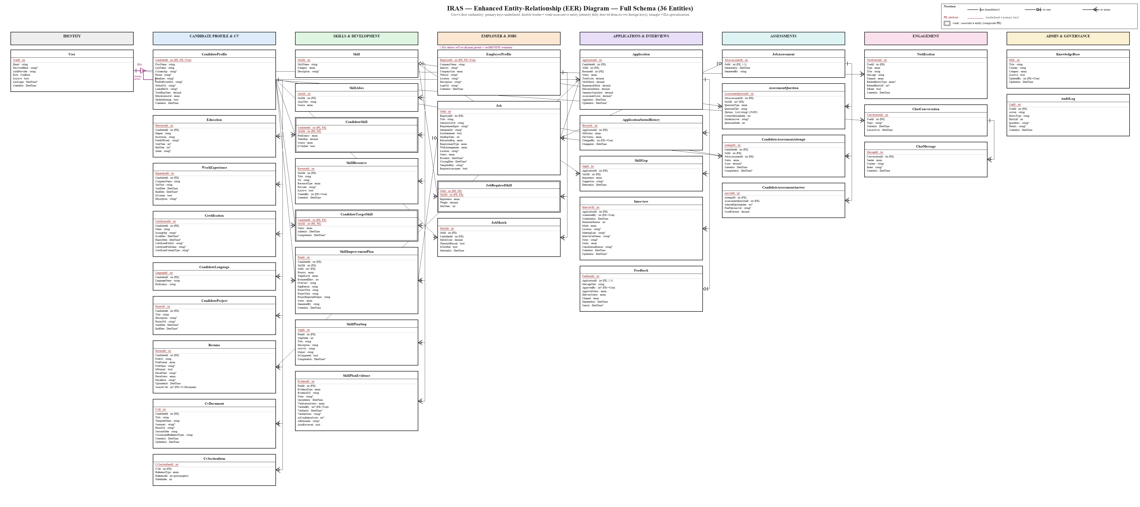
Figure 4.3: Enhanced Entity-Relationship (EER) Diagram of the IRAS Database. The diagram re-renders the same thirty-six entities in crow's-foot EER notation: every primary key is underlined, foreign keys are marked inline, and cardinality is shown with crow's-foot glyphs (a single bar for "exactly one," a circle-and-bar for "zero or one," and a circle-and-crow's-foot for "zero or many") rather than UML's plain-text multiplicities. CandidateSkill, JobRequiredSkill, and CandidateTargetSkill are drawn as double-bordered weak entities, since each is identified entirely by the composite of its two foreign keys rather than a surrogate key of its own. A purple ISA triangle marks User's specialization into CandidateProfile and EmployerProfile, labelled {disjoint, partial} — disjoint because a single user account is a candidate or an employer, never both, and partial because an Administrator account is neither subtype.

4.4.3 Activity Diagram
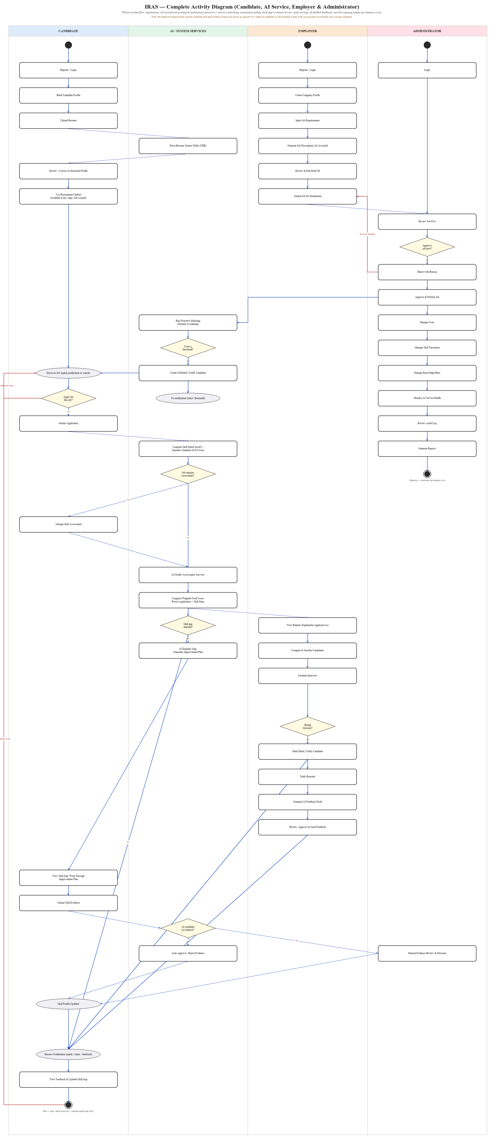
Figure 4.4: Complete Activity Diagram of IRAS — Candidate, AI Service, Employer, and Administrator. The diagram traces the whole-system flow across four swimlanes, from registration through AI-assisted job description generation, admin moderation (with a reject-and-resubmit loop routed back to the employer), proactive batch matching, reactive application scoring with an assessment-required gate, a skill-gap-detected gate leading to AI-explained improvement plans and confidence-gated evidence review, employer shortlisting and a hiring-decision gate, AI-drafted candidate feedback, and the ongoing admin governance cycle, before looping back to the candidate's job search. The lane order (Candidate next to AI Service, rather than at opposite ends) is a deliberate layout choice: it is what keeps the many Candidate-AI transitions short, adjacent-lane hops instead of long diagonals cutting through the Employer and Administrator lanes' own content.

4.4.4 Sequence Diagrams
Three sequence diagrams are presented in this section, each mapped to one of the use cases most central to the system's AI-assisted contribution: job application and scoring (UC-07), resume upload and parsing (UC-03), and skill-evidence submission and review (UC-14). Seven further sequence diagrams — covering registration, AI-assisted job description generation and moderation, proactive batch matching, skill-gap explanation, skill-assessment generation and grading, interview scheduling and feedback, and the role-aware chatbot — are provided in Appendix C so that every remaining use case is still traceable to a concrete message flow without lengthening this chapter past what Section 4.4.1's own guidance calls for.
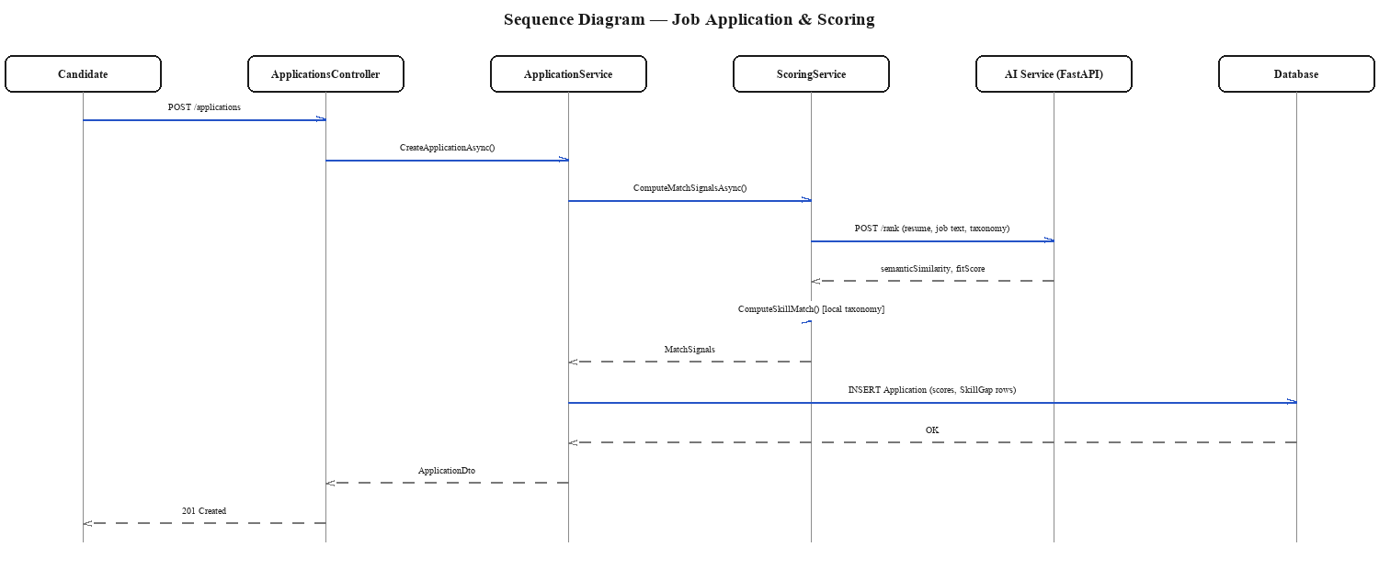
Figure 4.5: Sequence Diagram — Job Application and Scoring. The diagram traces a candidate's POST /applications request through ApplicationsController and ApplicationService to ScoringService, which calls the external AI service's /rank endpoint for semantic similarity and a fit score, computes the taxonomy-based skill match locally, and persists the combined application score and any skill-gap rows before returning a 201 Created response to the candidate.
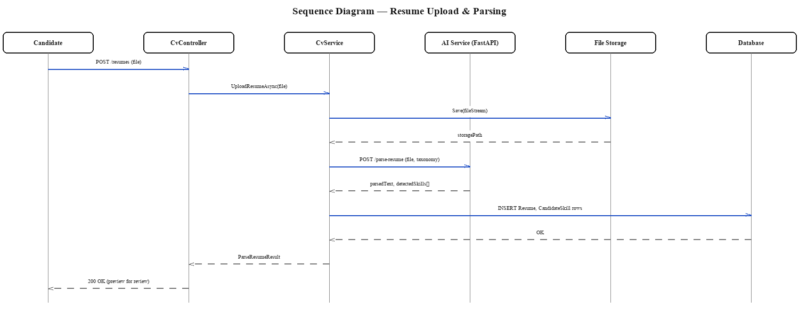
Figure 4.6: Sequence Diagram — Resume Upload and Parsing. The diagram shows a candidate's resume file being saved to file storage by CvService before being sent to the AI service's /parse-resume endpoint, which returns the parsed text and detected skills; CvService then persists the Resume and CandidateSkill rows and returns a preview the candidate can review and correct before it is treated as authoritative.
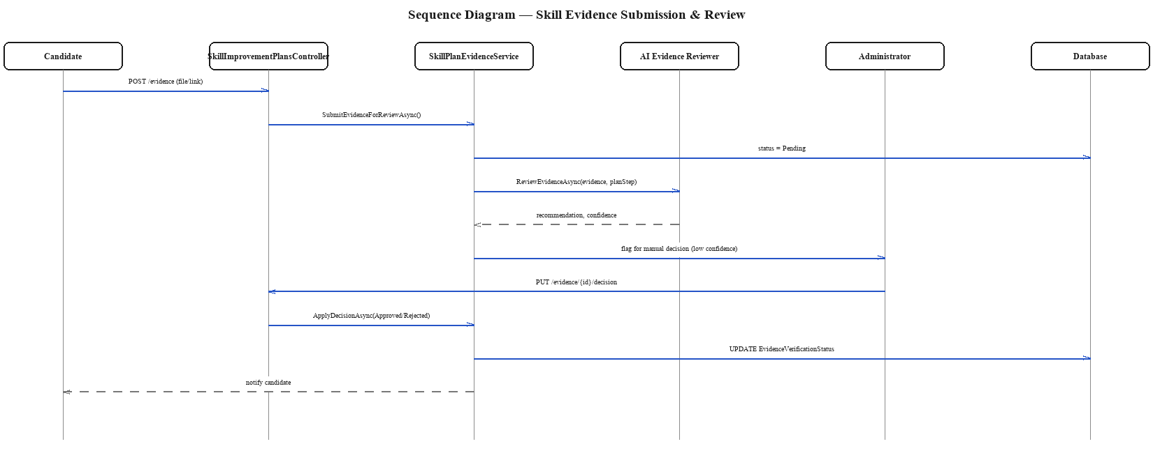
Figure 4.7: Sequence Diagram — Skill Evidence Submission and Review. The diagram shows a candidate's evidence submission moving to Pending status, being assessed by the AI Evidence Reviewer for a recommendation and confidence score, and — only when that confidence is low — being escalated to an Administrator who applies the final Approved/Rejected decision, which is then written back to the evidence's verification status and surfaced to the candidate.

4.4.5 State Chart / Deployment Considerations
A full state chart is not required for every entity in the system, but two entities carry enough lifecycle complexity to warrant one: Application, which moves through Applied, Screened, Shortlisted, Interview, and then either Hired, Rejected, or Withdrawn; and SkillPlanEvidence, which moves through Draft, Pending, and then Approved, Rejected, or RevisionRequired, with RevisionRequired looping back to Draft for a resubmission. Both state machines are enforced at the application-service layer rather than left to the client, so that no combination of client requests can move either entity into an invalid state (for example, an application cannot be marked Hired without first passing through Interview).
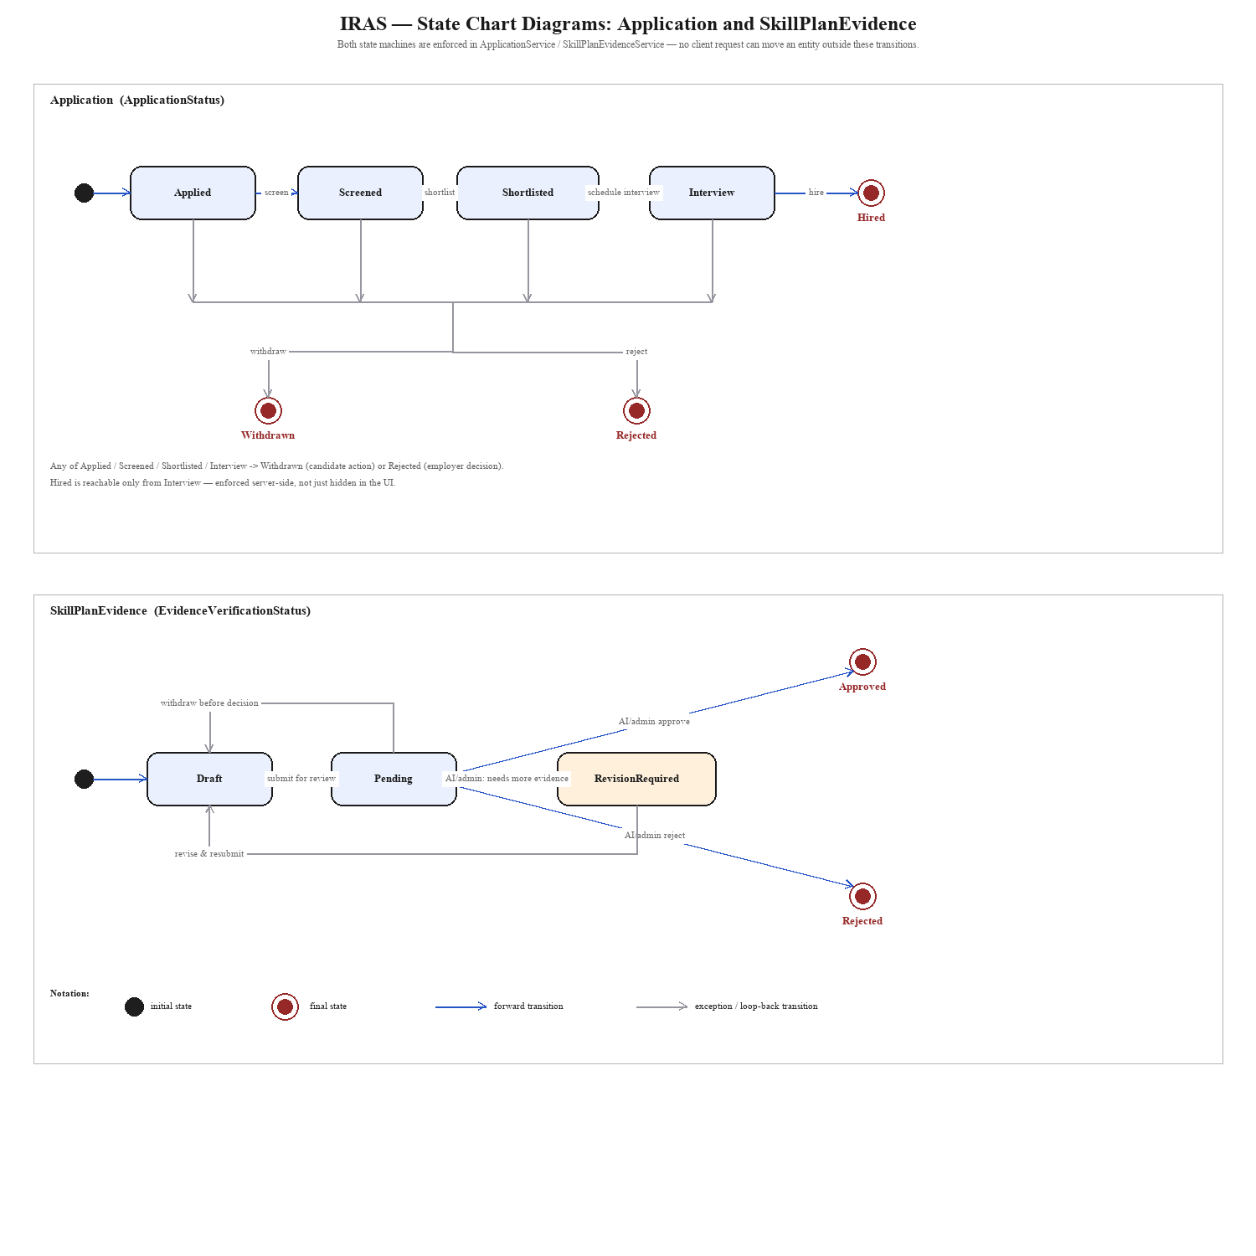
Figure 4.8: State Chart Diagrams — Application and SkillPlanEvidence. The upper diagram shows ApplicationStatus as a linear spine (Applied → Screened → Shortlisted → Interview → Hired), with a shared collector line making explicit that Withdrawn and Rejected are each reachable from any of the four non-terminal states while Hired is reachable only from Interview. The lower diagram shows EvidenceVerificationStatus as Draft → Pending branching three ways under AI/admin review (Approved, Rejected, or RevisionRequired), with two distinct loop-back transitions to Draft — one for a candidate withdrawing before a decision is reached, and one for a resubmission after a revision request — each routed on a separate channel so neither crosses the forward spine.
Both diagrams make the same underlying point in different notation to Figure 4.4's activity diagram: an activity diagram shows the *flow of work* across actors, while a state chart shows the *legal state space* of one entity in isolation — here, that every terminal state (the double-ringed circles) is reached only through the transitions drawn, which is what "enforced at the application-service layer" in the paragraph above actually means in implementation terms.
At the deployment level, the system is deployed as two independently deployable units — the ASP.NET Core Web API (containerized with Docker and hosted on Render.com) and the Python AI microservice (hosted separately and reached only over HTTP by the API) — against a managed SQL Server database, with Supabase providing object/file storage only. This separation allows the AI service to be redeployed, retrained, or temporarily taken offline (in which case the API degrades to skill-match-only scoring, as described in Table 4.3) without requiring a redeploy of the core platform.

4.5 Proposed System Architecture
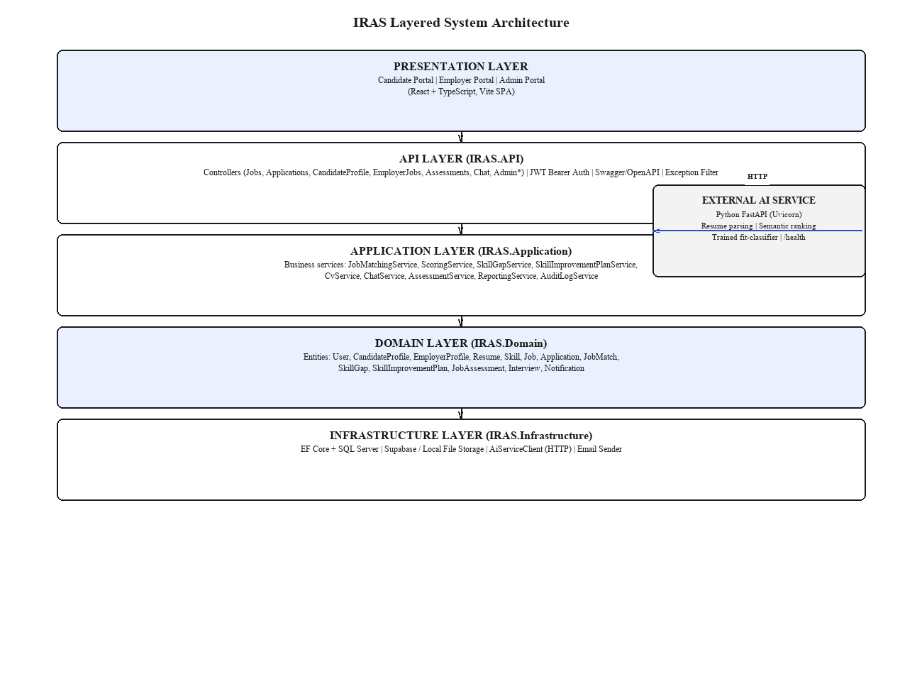
Figure 4.9: IRAS Layered System Architecture. The diagram shows the five layers of the system from top to bottom — Presentation (the React/TypeScript candidate, employer, and admin portals), API (ASP.NET Core controllers, JWT authentication, and Swagger documentation), Application (the business services that implement matching, skill-gap analysis, assessments, chat, and CV generation), Domain (the persistent entities), and Infrastructure (the database, file storage, and the AI-service HTTP client) — together with the external Python AI service that the Application layer calls over HTTP for resume parsing, semantic ranking, and fit-classification.
The architecture follows a conventional layered (N-tier) design rather than a more elaborate pattern such as CQRS or microservices for the core platform, because the domain does not currently require independently scalable write/read paths, and a single well-tested API deployment is easier for a solo final-year project to operate and reason about than a distributed set of internal services. The one place the system does adopt a service boundary is around AI functionality specifically, where the cost/benefit is different: the AI workload (resume parsing, embeddings, and the trained classifier) has a different technology stack (Python, not .NET), different scaling characteristics (CPU/GPU-bound inference rather than request/response CRUD), and a materially different failure mode (a model or third-party LLM outage should degrade the platform, not take it down) — all reasons that justify carving it out as its own deployable service even while the rest of the system stays a layered monolith.

4.6 Functional and Non-Functional Requirements
Table 4.5: Functional Requirements.
ID | Requirement | Related Module
FR-01 | The system shall allow a candidate to register, authenticate, and manage a structured profile | Candidate
FR-02 | The system shall allow a candidate to upload a resume and have it parsed into structured skills, education, and experience | Candidate / AI Service
FR-03 | The system shall allow a candidate to build and export a CV as a PDF from their structured profile | Candidate
FR-04 | The system shall allow a candidate to search, filter, and apply for published jobs | Candidate
FR-05 | The system shall compute a weighted match score for every application from skill match, semantic similarity, a trained fit-classifier score, and (where present) assessment score | Matching
FR-06 | The system shall proactively notify a candidate when a newly published job clears the configured auto-match threshold | Matching
FR-07 | The system shall identify and explain, in plain language, the skill gap between a candidate's profile and a target job | Skill Gap
FR-08 | The system shall generate a personalized, sequenced skill-improvement plan for an identified gap | Skill Gap
FR-09 | The system shall allow a candidate to submit evidence against a skill-improvement plan step and receive an AI-assisted or administrator-reviewed verification decision | Skill Gap
FR-10 | The system shall allow an employer to register a company profile and post a job | Employer
FR-11 | The system shall allow an employer to generate a structured job description with AI assistance, subject to the employer's review and edit before publishing | Employer
FR-12 | The system shall present the employer with a ranked, explainable list of applicants broken down by individual scoring signal | Employer
FR-13 | The system shall allow an employer to attach a skill assessment to a job, with AI-generated questions and AI-assisted grading | Assessment
FR-14 | The system shall allow an employer to schedule an interview for a shortlisted candidate | Employer
FR-15 | The system shall allow an employer to issue feedback to a candidate, with AI-assisted drafting | Feedback
FR-16 | The system shall provide a role-aware chatbot that answers only within the scope of the authenticated user's role and data | Chat
FR-17 | The system shall send in-app and email notifications for match, application-status, interview, and feedback events | Notifications
FR-18 | The system shall allow an administrator to moderate job postings before publication | Admin
FR-19 | The system shall allow an administrator to manage users, the skill taxonomy, and the recruitment knowledge base | Admin
FR-20 | The system shall record an audit log of AI-influenced actions and allow an administrator to review it | Admin
FR-21 | The system shall allow an administrator to monitor the health and availability of the external AI service | Admin

Table 4.6: Non-Functional Requirements.
ID | Category | Requirement
NFR-01 | Performance | A single candidate-job match score shall be computed and persisted in under 3 seconds under normal load, excluding first-call AI-service cold starts
NFR-02 | Scalability | Batch re-ranking of a job's eligible candidates shall use a single batched AI-service call rather than one call per candidate
NFR-03 | Reliability | If the AI service is unreachable, the platform shall degrade to skill-match-only scoring rather than failing the request
NFR-04 | Security | All API endpoints except authentication and public job listing shall require a valid JWT bearer token; role-based authorization shall be enforced per endpoint
NFR-05 | Security | Candidate and employer file uploads shall be validated by type and size before storage
NFR-06 | Usability | Every AI-influenced score or decision visible to a candidate or employer shall be accompanied by a breakdown the user can read without technical knowledge
NFR-07 | Maintainability | The system shall follow a layered architecture (API / Application / Domain / Infrastructure) so that AI-related logic can be revised without redesigning unrelated modules
NFR-08 | Portability | The backend shall be containerized (Docker) so that it can be deployed to any compliant container host
NFR-09 | Auditability | Every administrator action and every AI-driven approval/rejection decision shall be written to an immutable audit log
NFR-10 | Availability | The public-facing API shall target 99% monthly availability, consistent with its single-region managed-cloud deployment

4.7 Chapter Summary
This chapter specified the system requirements for IRAS by first identifying its stakeholders and their concerns, then tracing each requirement back to a research objective and a fact-gathering activity to keep the specification grounded rather than speculative. The use case, class, activity, and sequence diagrams presented the system and model analysis that the implementation in Chapter 5 follows, the layered architecture diagram fixed the system's structural boundaries, and the consolidated functional and non-functional requirement tables provide the checklist against which the testing and evaluation in Chapter 6 is conducted.

CHAPTER 05 - IMPLEMENTATION / DESIGNING

5.1 Implementation Approach
IRAS was implemented incrementally, sprint by sprint, following the Scrum plan set out in Section 3.6. Each sprint targeted one vertical slice of the system — a database migration, the corresponding domain entities, the application-layer service, the API controller, and (where relevant) the AI-service integration — rather than building every layer of the whole system at once. This section elaborates the algorithmic logic behind the system's most significant contribution, the multi-signal scoring pipeline, before covering the AI-assisted skill-gap and evidence-review logic, the technology choices made, and the implementation of the platform's most significant AI-driven features.

5.1.1 Algorithms
The core of IRAS's contribution is a scoring algorithm that never depends on a single signal. Four algorithms are described below in pseudocode form, each corresponding to a method that exists in the implemented ScoringService and JobMatchingService.
Algorithm 1 — Taxonomy-based Skill Match
function ComputeSkillMatch(requiredSkills, candidateSkillIds):
if requiredSkills is empty:
return 1.0 // no requirement -> full match
totalWeight = sum(rs.Weight for rs in requiredSkills)
if totalWeight <= 0:
return 0.0
matchedWeight = sum(rs.Weight for rs in requiredSkills
if rs.SkillId in candidateSkillIds)
return round(matchedWeight / totalWeight, 4)
Each required skill on a job carries a weight (MustHave skills outweigh NiceToHave skills), so a candidate missing one optional skill is scored more favourably than one missing a mandatory skill — a distinction a pure keyword match cannot express.
Algorithm 2 — Weighted Total Score
function ComputeTotalScore(skillMatch, semanticSimilarity, mlFitScore = null, assessmentScore = null):
score = SkillMatchWeight * skillMatch + SemanticSimilarityWeight * semanticSimilarity
if mlFitScore is not null:
score += MlFitScoreWeight * mlFitScore
if assessmentScore is not null:
score += AssessmentScoreWeight * assessmentScore
return round(score, 4)
The weights are read from configuration (ScoringOptions) rather than hard-coded, so the platform operator can shift emphasis — for example, enabling MlFitScoreWeight once the trained classifier described in Chapter 6 is deployed — without a code change or redeploy.
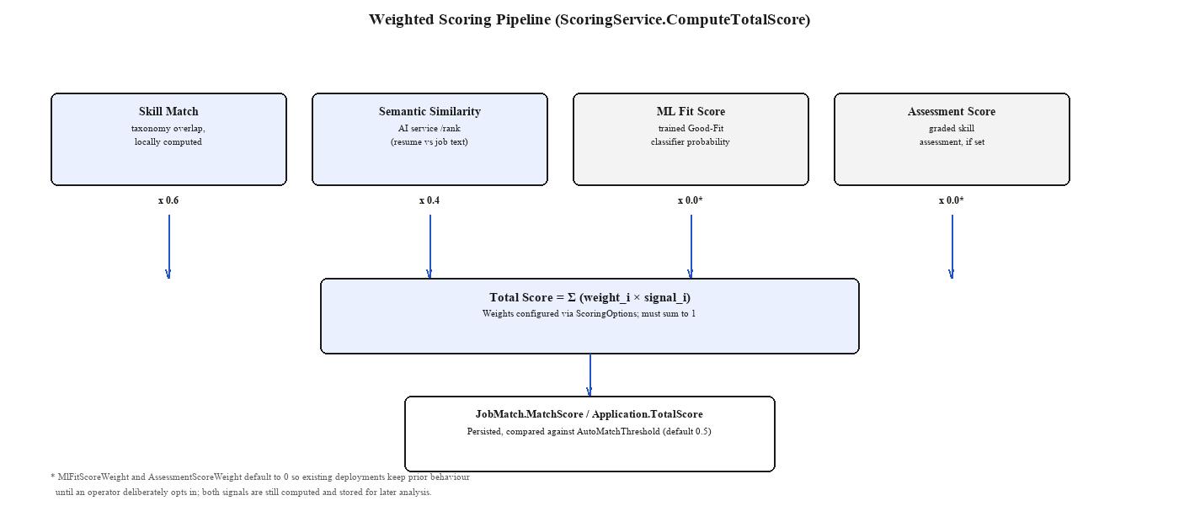
Figure 5.1: Weighted Scoring Pipeline. The block diagram shows the four independent signals — skill match, semantic similarity, ML fit score, and assessment score — feeding into a single configurable weighted sum, which is then persisted as the Application's or JobMatch's headline score and compared against the auto-match threshold; the asterisked note records that the ML fit-score and assessment-score weights default to zero so existing deployments are unaffected until an operator opts in, even though both signals are still computed and stored.
Algorithm 3 — Batched Proactive Matching
function RunMatchingForJobAsync(jobId):
job = LoadPublishedJob(jobId)
alreadyConsidered = JobMatches where JobId = jobId -> candidateIds
eligible = CandidateProfiles where OptInMatching = true
and CandidateId not in alreadyConsidered
and has a parsed primary resume
if eligible is empty: return
// one batched HTTP call for every eligible candidate against this job,
// not one call per candidate
signals = ScoringService.ComputeMatchSignalsAsync(job, eligible)
for candidate in eligible:
skillMatch = ComputeSkillMatch(job.RequiredSkills, candidate.SkillIds)
(semanticSimilarity, mlFitScore) = signals[candidate.Id]
totalScore = ComputeTotalScore(skillMatch, semanticSimilarity, mlFitScore)
passed = totalScore >= AutoMatchThreshold
save JobMatch(jobId, candidate.Id, totalScore, passed)
if passed: NotifyCandidate(candidate.Id, job)
This algorithm is deliberately batched: the naive design would call the AI service once per eligible candidate, which does not scale once a job has hundreds of opted-in candidates to consider. Batching the resumes and job text into a single request to the AI service's ranking endpoint keeps the number of outbound HTTP calls constant with respect to job count rather than linear in candidate count.
Algorithm 4 — Confidence-gated Evidence Review
function SubmitEvidenceForReviewAsync(evidenceId):
SetStatus(evidenceId, Pending)
(recommendation, confidence) = AiEvidenceReviewer.Review(evidence, planStep)
if confidence >= AutoApproveThreshold:
ApplyDecision(evidenceId, recommendation, source = "AI")
else:
QueueForAdminReview(evidenceId, recommendation, confidence)
Evidence review is not fully automated: only high-confidence AI recommendations are applied directly, and every AI decision — whether auto-applied or queued — is written to the audit log with its confidence value, satisfying NFR-09 and directly addressing the transparency concern raised in Section 4.2.

5.1.2 Workflow via Block Diagrams
The scoring pipeline in Figure 5.1 is one of three block-diagram workflows implemented in the system; the other two — the application-shortlisting activity flow and the three sequence diagrams for scoring, resume parsing, and evidence review — were already presented in Section 4.4 as part of the system design and are implemented exactly as diagrammed, without deviation, in the corresponding IRAS.Application services.

5.1.3 Technology Selection Justification
Table 5.1: Technology Selection Justification.
Decision | Options Considered | Selected | Justification
Backend language/runtime | Java + Spring Boot, Node.js + Express, C# + ASP.NET Core | C# / .NET (ASP.NET Core Web API) | Strong typing catches scoring-formula and enum-mismatch errors at compile time; first-class Entity Framework Core ORM; mature JWT and Swagger tooling; team familiarity
AI/ML service language | C# (ML.NET), Python (FastAPI) | Python (FastAPI) | The NLP/ML ecosystem (transformer-based embeddings, scikit-learn-style classifiers) is far more mature in Python than in .NET; isolating it as its own service also lets it scale and fail independently of the API (Section 4.5)
Relational database | SQL Server, MySQL, PostgreSQL | SQL Server | Mature, first-class EF Core provider support; strong tooling fit with the ASP.NET Core/C# stack (SSMS, familiar T-SQL); Supabase is used separately, for object/file storage only, not the relational data
Frontend framework | Angular, Vue, React | React + TypeScript (Vite) | Component reuse across three distinct portals (Candidate/Employer/Admin); large ecosystem; TypeScript catches DTO-shape drift against the C# API contracts
Authentication | Session cookies, OAuth-only, JWT | JWT Bearer | Stateless, natural fit for a decoupled SPA + API architecture, and works uniformly across the three roles via claims-based authorization
Containerization | Bare-metal deploy, Docker | Docker (multi-stage build) | Reproducible builds; Render.com's deployment model expects a container; keeps the Domain/Application/Infrastructure/API project references consistent between dev and prod

5.1.3.1 Programming Language
The backend is implemented in C# targeting .NET, chosen for its static typing, mature async/await support (essential given the number of outbound AI-service calls on the request path), and first-class integration with Entity Framework Core. The AI microservice is implemented in Python, the de facto language for the NLP and machine-learning libraries the ranking and parsing features depend on. The frontend is implemented in TypeScript, chosen over plain JavaScript so that the shape of API request/response DTOs is checked at compile time rather than discovered at runtime.

5.1.3.2 Libraries Used
Table 5.2: Key Libraries and Their Role.
Library | Layer | Role
Entity Framework Core (SQL Server provider) | Infrastructure | Object-relational mapping and SQL Server migrations
Swashbuckle (Swagger/OpenAPI) | API | Interactive API documentation and manual endpoint testing
System.IdentityModel.Tokens.Jwt | API | JWT bearer token issuing and validation
QuestPDF | Application | Server-side CV/PDF document generation
xUnit | Tests | Backend unit and integration testing (IRAS.Tests)
FastAPI + Uvicorn | AI Service | HTTP interface for resume parsing, ranking, and health-check endpoints
A trained scikit-learn-style classifier | AI Service | The candidate-job "Good-Fit" probability consumed as the ML fit-score signal

5.1.3.3 Backend and Frontend Frameworks
The backend follows the layered ASP.NET Core Web API convention described in Section 4.5 (IRAS.API, IRAS.Application, IRAS.Domain, IRAS.Infrastructure as four separate projects referenced in that dependency direction only, enforced by the .csproj references themselves). The frontend is a Vite-built single-page React application that consumes the Web API over HTTPS and renders three distinct route trees for the Candidate, Employer, and Admin roles, gated by the JWT claim carrying the user's role.

5.2 Significant Implementation Features
This section elaborates the implementation of the features that carry IRAS's actual research contribution, rather than routine CRUD screens such as login or profile editing, which follow standard ASP.NET Core Identity-style patterns and are not separately discussed here.
AI-assisted job description generation. The employer job-posting workflow (FR-11) uses a two-implementation pattern behind a single IJdGenerator interface: a GeminiJdGenerator that calls the configured LLM with the employer's minimal input (title, seniority, required skills, work arrangement) and a TemplateJdGenerator that assembles a structured description from a fixed template when no LLM key is configured or the call fails. The controller always returns the generated draft as editable text rather than publishing it directly — the employer must explicitly approve it, which is the human-in-the-loop control called for in Section 3.6.2's Human Oversight mitigation.
async function GenerateJobDescriptionAsync(request):
try:
draft = await GeminiJdGenerator.Generate(request)
catch (AiServiceException):
draft = TemplateJdGenerator.Generate(request) // deterministic fallback
return DraftJobDescriptionDto(draft, source: draft.Source, requiresApproval: true)
Multi-signal candidate ranking. Described algorithmically in Section 5.1.1; the implementation detail worth highlighting here is that ComputeSkillMatch runs entirely inside the .NET process against the locally cached skill taxonomy, while semantic similarity and the fit-classifier score are the only two values that cross the network boundary to the AI service — keeping the latency-sensitive, purely-relational part of the score computation local, and only paying the network cost for the two signals that genuinely require it.
Skill-gap explanation and improvement-plan generation. When an application or profile comparison reveals a skill gap, SkillGapService first computes the gap set deterministically (required skills minus candidate skills, by weight), then passes that gap set — not the raw resume — to an IGap Explainer (Gemini-backed, with a template fallback identical in shape to the JD generator) to produce a plain-language explanation. SkillImprovementPlanService then sequences the gap into an ordered plan of SkillPlanStep records with a target proficiency level and priority, which the candidate works through and submits SkillPlanEvidence against.
Confidence-gated evidence review. Described algorithmically as Algorithm 4; the implementation detail is that the AI evidence reviewer's confidence score is persisted alongside its recommendation even when an administrator later overrides it, so the audit log can show not just what decision was made but how confident the AI was when it made (or failed to make) that decision autonomously.
Role-aware chatbot. ChatService delegates context construction to one of three ContextBuilder implementations — CandidateChatContextBuilder, EmployerChatContextBuilder, or AdminChatContextBuilder — selected by the authenticated user's role, so that the LLM prompt is only ever populated with data that role is authorized to see. A ChatScopeGate then filters the LLM's response before it reaches the user, rejecting answers that stray outside recruitment-relevant topics, which implements the "Chatbot Misuse" mitigation from Table 3.2.
function BuildAndSendPrompt(user, message):
contextBuilder = SelectContextBuilder(user.Role) // Candidate | Employer | Admin
context = contextBuilder.Build(user) // only this role's own data
reply = ChatResponder.Respond(context, message) // Gemini, or rule-based fallback
if not ChatScopeGate.IsInScope(reply):
return FallbackReply("I can only help with recruitment-related questions.")
return reply
Resume parsing. CvService streams the uploaded file to the AI service's /parse-resume endpoint together with the current skill taxonomy, receives back parsed text, detected skills (each tagged with how it was matched — exact alias or learned-from-parsing), emails, phones, and a word count, and persists a Resume and a set of CandidateSkill rows tagged SkillSource.ResumeParsed. The candidate is always shown this extraction as an editable preview before it is treated as authoritative, consistent with the parsing-accuracy limitation noted in Section 2.5.1.
Error handling and logging strategy. Every outbound call to the AI service is wrapped so that a timeout, a non-2xx response, or a malformed payload is caught at the AiServiceClient boundary and converted into a typed result object (for example, RankResult.Success = false with an Error message) rather than allowed to propagate as an unhandled exception up through the Application and API layers. This choice was made deliberately after observing, during early integration testing, that an unguarded call would otherwise turn a single slow or unavailable AI-service instance into a cascading 500 error for every candidate awaiting a score, which is precisely the fragility NFR-03 was written to rule out. A central ApiExceptionFilter additionally converts any remaining unhandled exception into a structured JSON error response rather than a raw stack trace, and every AI-service failure, admin action, and evidence-review decision is written through a shared logging path so that Section 6.3's audit-trail evidence and Chapter 4's NFR-09 requirement are backed by the same underlying mechanism rather than two separate, potentially inconsistent implementations.

5.3 Implementation Evidence: System User Interface
This section documents the running system's user interface, screen by screen, as built — it is evidence that the requirements and workflows specified in Chapter 4 exist as working software, not only as diagrams. Pages are shown exactly as implemented, grouped by the three portals introduced in Section 1.8 (Candidate, Employer, Administrator), with each screenshot tied back to the use case or functional requirement it satisfies. Purely administrative CRUD screens that carry no distinct logic of their own (e.g. an ordinary edit form) are still included here for completeness, even though — consistent with Section 5.2's scoping note — they were not separately discussed as implementation *features*.

5.3.1 Candidate Portal
[ PENDING — insert ui_candidate_login.png here once supplied ]
Figure 5.2: Candidate Registration and Login. The screen collects an email and password for a new candidate account or authenticates an existing one, issuing the JWT bearer token that gates every subsequent candidate-scoped request (UC-01, FR-04).
[ PENDING — insert ui_candidate_dashboard.png here once supplied ]
Figure 5.3: Candidate Dashboard. The landing page after login summarizes the candidate's application activity, outstanding notifications, and current skill-gap status at a glance, linking out to every other candidate screen below.
[ PENDING — insert ui_candidate_profile.png here once supplied ]
Figure 5.4: Candidate Profile Management. The screen manages the structured profile data — education, work experience, certifications, languages, and projects — that both the CV builder and the matching engine's skill-match signal draw on (UC-02).
[ PENDING — insert ui_candidate_resume_upload.png here once supplied ]
Figure 5.5: Resume Upload and AI-Parsed Preview. The screen accepts a PDF or DOCX resume, sends it to the AI service for parsing, and shows the extracted skills, contact details, and text as an editable preview before the candidate confirms it (UC-03, FR-02, Figure C.1).
[ PENDING — insert ui_candidate_cv_builder.png here once supplied ]
Figure 5.6: CV Builder. The screen assembles a subset of the candidate's profile data into a structured, exportable CV, using the CvSectionItem selection model described in Section 4.4.2 (UC-04, FR-03).
[ PENDING — insert ui_candidate_job_search.png here once supplied ]
Figure 5.7: Job Search and Application. The screen lists published jobs with filtering, and lets the candidate submit an application that triggers the multi-signal scoring pipeline shown in Figure 5.1 (UC-05, FR-05).
[ PENDING — insert ui_candidate_match_score.png here once supplied ]
Figure 5.8: Match Score Breakdown. The screen shows the weighted score behind a proactive match or a submitted application broken down by signal — skill match, semantic similarity, and assessment score where applicable — rather than a single opaque number (UC-06, NFR-06).
[ PENDING — insert ui_candidate_skill_gap.png here once supplied ]
Figure 5.9: Skill Gap and Improvement Plan. The screen shows the AI-explained gap between the candidate's profile and a target role alongside the generated, sequenced improvement plan (UC-07, FR-07, FR-08).
[ PENDING — insert ui_candidate_evidence.png here once supplied ]
Figure 5.10: Skill Evidence Submission. The screen lets the candidate attach a link, file, or certificate against a plan step and shows its verification status once the confidence-gated review in Algorithm 4 has run (UC-08, FR-09).
[ PENDING — insert ui_candidate_assessment.png here once supplied ]
Figure 5.11: Skill Assessment Attempt. The screen presents the AI-generated multiple-choice and free-text questions for a job's assessment and submits the candidate's answers for grading (UC-09, FR-13).
[ PENDING — insert ui_candidate_chatbot.png here once supplied ]
Figure 5.12: Recruitment Chatbot. The screen shows the candidate-scoped chatbot conversation, answering only questions in scope of the candidate's own data per the ChatScopeGate logic in Section 5.2 (UC-10, FR-16).
[ PENDING — insert ui_candidate_notifications.png here once supplied ]
Figure 5.13: Candidate Notifications. The screen lists in-app notifications for matches, application-status changes, interviews, and feedback (UC-11, FR-17).

5.3.2 Employer Portal
[ PENDING — insert ui_employer_login.png here once supplied ]
Figure 5.14: Employer Registration and Login. The screen mirrors the candidate login flow (Figure 5.2) but issues a JWT carrying the Employer role claim (UC-01).
[ PENDING — insert ui_employer_dashboard.png here once supplied ]
Figure 5.15: Employer Dashboard. The landing page summarizes the employer's open job posts, pending moderation status, and recent applicant activity.
[ PENDING — insert ui_employer_company_profile.png here once supplied ]
Figure 5.16: Company Profile Management. The screen manages the company details shown to candidates on every job posting (UC-12).
[ PENDING — insert ui_employer_job_post.png here once supplied ]
Figure 5.17: Job Posting with AI-Assisted Description Generation. The screen accepts minimal job requirements, calls GenerateJobDescriptionAsync (Section 5.2) for an editable AI draft, and submits the approved posting for admin moderation (UC-13, UC-14, FR-11, Figure C.2).
[ PENDING — insert ui_employer_applicants.png here once supplied ]
Figure 5.18: Ranked Applicant List. The screen lists applicants ordered by Total Score with the same per-signal breakdown shown to the candidate in Figure 5.8, so the ranking is auditable rather than a black box (UC-15, FR-12).
[ PENDING — insert ui_employer_assessment_setup.png here once supplied ]
Figure 5.19: Skill Assessment Configuration. The screen toggles a job's RequireAssessment flag and previews the AI-generated question set attached to it (UC-16, FR-13).
[ PENDING — insert ui_employer_interview.png here once supplied ]
Figure 5.20: Interview Scheduling. The screen sets the mode, date/time, and notes for an interview against a shortlisted application (UC-17, FR-14, Figure C.6).
[ PENDING — insert ui_employer_feedback.png here once supplied ]
Figure 5.21: Candidate Feedback Review and Approval. The screen shows the AI-drafted feedback message for the employer to review and approve before it is sent, the human-in-the-loop control described in Section 5.2 (UC-18, FR-15).

5.3.3 Administrator Portal
[ PENDING — insert ui_admin_dashboard.png here once supplied ]
Figure 5.22: Administrator Dashboard. The landing page summarizes pending job moderation items, open evidence-review escalations, and AI-service health at a glance.
[ PENDING — insert ui_admin_users.png here once supplied ]
Figure 5.23: User Management. The screen lists candidate and employer accounts with the ability to suspend or reinstate them (UC-19).
[ PENDING — insert ui_admin_job_moderation.png here once supplied ]
Figure 5.24: Job Post Moderation. The screen shows jobs pending review with an approve/reject decision and reason, matching the admin-moderation gate in Figure 4.4 (UC-20, FR-18).
[ PENDING — insert ui_admin_skill_taxonomy.png here once supplied ]
Figure 5.25: Skill Taxonomy Management. The screen manages the Skill and SkillAlias records the matching and parsing pipeline normalize against (UC-21, FR-19).
[ PENDING — insert ui_admin_knowledge_base.png here once supplied ]
Figure 5.26: Knowledge Base Management. The screen curates the FAQ, policy, and skill-advice content the chatbot is permitted to draw on (UC-22, FR-19).
[ PENDING — insert ui_admin_evidence_review.png here once supplied ]
Figure 5.27: Manual Skill Evidence Review. The screen queues low-AI-confidence evidence submissions (Algorithm 4's escalation path) for a human decision (UC-23, FR-09).
[ PENDING — insert ui_admin_audit_log.png here once supplied ]
Figure 5.28: Audit Log Review. The screen lists the immutable, append-only log of AI-influenced and administrative actions (UC-24, FR-20, NFR-09).
[ PENDING — insert ui_admin_ai_health.png here once supplied ]
Figure 5.29: AI Service Health Monitoring. The screen shows the liveness of the external AI service via its /health endpoint, backing the degraded-mode behaviour described in NFR-03 (UC-25, FR-21).
[ PENDING — insert ui_admin_reports.png here once supplied ]
Figure 5.30: Platform Reporting. The screen generates recruitment and system-usage reports drawing on application, job, and audit-log data (UC-26, FR-19).

5.4 Chapter Summary
This chapter detailed how the research design from Chapter 4 was implemented: the weighted, multi-signal scoring algorithms that form the system's central contribution; the technology choices behind the .NET backend, the Python AI service, and the React frontend, each justified against the alternatives considered; and the implementation of the platform's most significant AI-driven features — job description generation, candidate ranking, skill-gap explanation, evidence review, the role-aware chatbot, and resume parsing — each built with a human-in-the-loop or confidence-gated control point rather than as an unsupervised automatic decision-maker. Chapter 6 now turns to testing this implementation against the functional and non-functional requirements set out in Section 4.6, and to evaluating the trained candidate-job fit classifier referenced throughout this chapter.

CHAPTER 06 - TESTING AND EVALUATION

6.1 Chapter Overview
This chapter evaluates IRAS against the functional and non-functional requirements specified in Section 4.6. Three complementary layers of evidence are used. First, the trained candidate-job fit classifier — the machine-learning contribution described in Section 5.1.1's ML Fit Score signal — is evaluated empirically on a held-out test set, since this is the one component of the system for which numeric ground truth exists. Second, the backend's existing automated test suite (IRAS.Tests, built on xUnit) was executed as part of this evaluation. Third, a design-time functional and non-functional test plan traces each requirement in Table 4.5 and Table 4.6 to the implementation described in Chapter 5. The chapter concludes with a review of the testing strategies used and their suitability to a research prototype of this kind.

6.2 Test Plan and Test Cases
Ten representative test cases are specified below (seven functional, three non-functional); the remaining lower-priority cases derived from Table 4.5 and Table 4.6 are held in Appendix B to keep this chapter within scope. Each case is traced to the requirement it verifies and to the implementation section that realizes it, rather than being written in the abstract.

6.2.1 Functional Testing
Table 6.1: Functional Test Cases.
Test ID | Requirement | Test Steps | Expected Result | Traced To
FTC-01 | FR-02 | Upload a PDF resume containing a "React.js" skill mention; request parsing | Resume is parsed and a CandidateSkill row is created for "React.js" (or its taxonomy-mapped equivalent), tagged SkillSource.ResumeParsed | CvService (Section 5.2)
FTC-02 | FR-05 | Submit an application to a published job for a candidate with a parsed resume | Application is persisted with a Total Score combining skill match and semantic similarity, per Algorithm 2 | ScoringService.ComputeTotalScore (Section 5.1.1)
FTC-03 | FR-06 | Publish a job for which an opted-in candidate's computed score exceeds AutoMatchThreshold (0.5) | A JobMatch row with ThresholdPassed = true is created and the candidate receives a JobMatch notification | JobMatchingService.RunMatchingForJobAsync (Section 5.1.1)
FTC-04 | FR-07 / FR-08 | Apply with a candidate missing a MustHave required skill | A SkillGap record is created for the missing skill and an AI-generated explanation is attached | SkillGapService (Section 5.2)
FTC-05 | FR-11 | Employer requests an AI-generated job description and submits it without editing | Draft is returned as editable text with requiresApproval = true; the job remains Draft (not Published) until the employer explicitly approves it | GenerateJobDescriptionAsync (Section 5.2)
FTC-06 | FR-12 | Employer opens the applicant list for a job with 3+ applications of differing skill match | Applicants are shown ranked by Total Score with the skill/semantic/assessment breakdown visible per applicant | ApplicationsController / EmployerApplicationsController
FTC-07 | FR-16 | Candidate asks the chatbot a question unrelated to recruitment (e.g. general trivia) | ChatScopeGate rejects the reply and a fallback "recruitment-only" message is returned instead | ChatScopeGate (Section 5.2)

6.2.2 Non-Functional Testing
Table 6.2: Non-Functional Test Cases.
Test ID | Requirement | Test Steps | Expected Result | Traced To
NFTC-01 | NFR-03 | Simulate the AI service returning a non-2xx response or timing out during RankAsync | ScoringService logs a warning and returns MatchSignals(0, null) for every affected candidate rather than throwing; the request completes with a skill-match-only score | ScoringService.ComputeMatchSignalsAsync (verified in source, Section 5.1.1)
NFTC-02 | NFR-04 | Call a protected endpoint (e.g. POST /applications) without an Authorization header | API returns 401 Unauthorized before any application logic executes | JWT Bearer middleware, IRAS.API/Program.cs
NFTC-03 | NFR-02 | Run proactive matching for a job against 50 eligible candidates | Exactly one batched call is made to the AI service's /rank endpoint for all 50 candidates, not 50 separate calls | JobMatchingService.RunMatchingForJobAsync (verified in source, Algorithm 3)

6.3 Testing / Evaluation Workflow
Three evidence sources were combined for this chapter, in increasing order of how directly they were executed during this evaluation:
- Design-time traceability (Tables 6.1 and 6.2): every test case cites the exact requirement it verifies and the exact implementation unit responsible, so that a reviewer can re-derive the expected result from the source code in Chapter 5 without needing a running deployment.
- The existing automated test suite. IRAS.Tests (xUnit) was executed against the current codebase as part of this evaluation. The run did not reach any test execution: the compiler rejected the build with `CS0535 — 'FakeScoringService' does not implement interface member 'IScoringService.ComputeMatchSignalsForCandidateAsync(...)'`. This is a genuine, currently open defect in the test project — the IScoringService interface was extended (Section 5.1.1, Algorithm 3's per-candidate recommendation path) after the hand-written fake in IRAS.Tests/Support/Fakes.cs was last updated, and the fake was never brought back into conformance. This is reported here rather than silently fixed, because it is itself useful evaluation evidence: it demonstrates, concretely, why a statically typed backend was selected in Table 5.1 — the mismatch was caught at compile time, before a single test could run against a stale fake and produce a misleadingly green build. Bringing IRAS.Tests/Support/Fakes.cs back into conformance with IScoringService is recorded as an immediate follow-up action in Section 7.2.
- Empirical evaluation of the trained fit-classifier, presented in full in Section 6.4 below, which is the one part of the system for which this thesis has complete, executed, numeric results.

6.4 Review of Test Strategies Used
Not every testing strategy commonly associated with a machine-learning-backed web platform is equally applicable to IRAS at its current stage, and each choice below is justified against the nature of the specific component being evaluated rather than applied uniformly.
Model training and held-out test evaluation was used for the candidate-job fit classifier because it is the one component with objective ground truth (labelled candidate-job pairs) against which accuracy can be measured numerically, unlike the LLM-generated text features (job descriptions, feedback, chatbot replies) which are evaluated qualitatively instead (Section 2.5.1, tenth algorithmic approach).
Four algorithms — Logistic Regression, Random Forest, Linear SVM, and XGBoost — were trained and compared under two input configurations to isolate the contribution of the engineered, structured features (skill overlap and semantic similarity) from the free-text signal alone.
Table 6.3: Test Set Composition.
Class | Number of Test Records
No Fit | 98
Potential Fit | 75
Good Fit | 98
Total | 271

Table 6.4: Full-Feature Model Performance — Summary (Test Set).
Model | Test Accuracy | Macro F1-Score
Logistic Regression | 98.5% | 98.4%
Random Forest | 93.4% | 92.8%
SVM (Linear) | 98.2% | 98.1%
XGBoost | 98.9% | 98.8%

XGBoost achieved the highest accuracy and macro F1-score of the four algorithms, with Logistic Regression and Linear SVM close behind at over 98%; Random Forest, while still comfortably above the 80% target set for this study, trailed the other three. The full per-class breakdown behind each summary row — precision, recall, F1-score, and support for every one of the three classes, plus the macro- and weighted-average rows scikit-learn reports alongside accuracy — is given in Table 6.5 for the full-feature configuration and Table 6.7 for the text-only configuration, since a single accuracy figure can hide exactly the kind of class-level weakness (Section 6.4's later discussion of Random Forest's Potential Fit recall) that matters most for a three-class problem like this one.
Table 6.5: Full Classification Report — Full-Feature Models (Test Set, n=271).
Model | Class | Precision | Recall | F1-Score | Support
Logistic Regression | No Fit | 1.000 | 0.969 | 0.984 | 98
Logistic Regression | Potential Fit | 0.949 | 1.000 | 0.974 | 75
Logistic Regression | Good Fit | 1.000 | 0.990 | 0.995 | 98
Logistic Regression | Accuracy |  |  | 0.985 | 271
Logistic Regression | Macro Avg | 0.983 | 0.986 | 0.984 | 271
Logistic Regression | Weighted Avg | 0.986 | 0.985 | 0.985 | 271
Random Forest | No Fit | 0.931 | 0.969 | 0.950 | 98
Random Forest | Potential Fit | 0.925 | 0.827 | 0.873 | 75
Random Forest | Good Fit | 0.941 | 0.980 | 0.960 | 98
Random Forest | Accuracy |  |  | 0.934 | 271
Random Forest | Macro Avg | 0.933 | 0.925 | 0.928 | 271
Random Forest | Weighted Avg | 0.933 | 0.934 | 0.932 | 271
SVM (Linear) | No Fit | 1.000 | 0.969 | 0.984 | 98
SVM (Linear) | Potential Fit | 0.938 | 1.000 | 0.968 | 75
SVM (Linear) | Good Fit | 1.000 | 0.980 | 0.990 | 98
SVM (Linear) | Accuracy |  |  | 0.982 | 271
SVM (Linear) | Macro Avg | 0.979 | 0.983 | 0.981 | 271
SVM (Linear) | Weighted Avg | 0.983 | 0.982 | 0.982 | 271
XGBoost | No Fit | 0.990 | 0.980 | 0.985 | 98
XGBoost | Potential Fit | 0.974 | 0.987 | 0.980 | 75
XGBoost | Good Fit | 1.000 | 1.000 | 1.000 | 98
XGBoost | Accuracy |  |  | 0.989 | 271
XGBoost | Macro Avg | 0.988 | 0.989 | 0.988 | 271
XGBoost | Weighted Avg | 0.989 | 0.989 | 0.989 | 271

Table 6.6: Text-Only Model Performance — Summary (Test Set).
Model | Test Accuracy | Macro F1-Score
Logistic Regression | 58.7% | 58.3%
Random Forest | 62.7% | 61.4%
SVM (Linear) | 54.2% | 53.5%
XGBoost | 72.3% | 70.9%

Table 6.7: Full Classification Report — Text-Only Models (Test Set, n=271).
Model | Class | Precision | Recall | F1-Score | Support
Logistic Regression | No Fit | 0.705 | 0.633 | 0.667 | 98
Logistic Regression | Potential Fit | 0.460 | 0.533 | 0.494 | 75
Logistic Regression | Good Fit | 0.594 | 0.582 | 0.588 | 98
Logistic Regression | Accuracy |  |  | 0.587 | 271
Logistic Regression | Macro Avg | 0.586 | 0.583 | 0.583 | 271
Logistic Regression | Weighted Avg | 0.597 | 0.587 | 0.590 | 271
Random Forest | No Fit | 0.667 | 0.714 | 0.690 | 98
Random Forest | Potential Fit | 0.576 | 0.453 | 0.507 | 75
Random Forest | Good Fit | 0.617 | 0.673 | 0.644 | 98
Random Forest | Accuracy |  |  | 0.627 | 271
Random Forest | Macro Avg | 0.620 | 0.614 | 0.614 | 271
Random Forest | Weighted Avg | 0.624 | 0.627 | 0.623 | 271
SVM (Linear) | No Fit | 0.682 | 0.612 | 0.645 | 98
SVM (Linear) | Potential Fit | 0.386 | 0.427 | 0.405 | 75
SVM (Linear) | Good Fit | 0.550 | 0.561 | 0.556 | 98
SVM (Linear) | Accuracy |  |  | 0.542 | 271
SVM (Linear) | Macro Avg | 0.539 | 0.533 | 0.535 | 271
SVM (Linear) | Weighted Avg | 0.552 | 0.542 | 0.546 | 271
XGBoost | No Fit | 0.740 | 0.786 | 0.762 | 98
XGBoost | Potential Fit | 0.678 | 0.533 | 0.597 | 75
XGBoost | Good Fit | 0.731 | 0.806 | 0.767 | 98
XGBoost | Accuracy |  |  | 0.723 | 271
XGBoost | Macro Avg | 0.717 | 0.708 | 0.709 | 271
XGBoost | Weighted Avg | 0.720 | 0.723 | 0.718 | 271

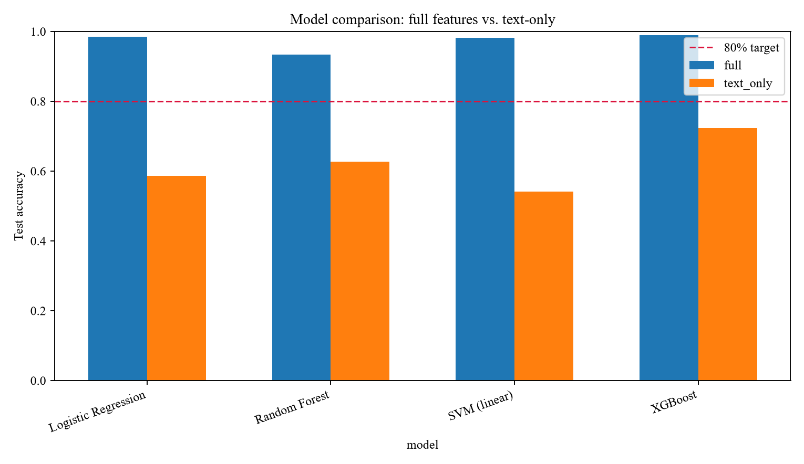
Figure 6.1: Full-Feature vs Text-Only Model Accuracy. The grouped bar chart plots the exact test accuracy of all four algorithms under the full-feature configuration against the same algorithms restricted to text-only input (Tables 6.5/6.7), showing a gap of roughly 25 to 44 percentage points for every algorithm and confirming that the engineered skill-overlap and semantic-similarity features, not the free text alone, are what drive the model's accuracy.
Every text-only model performed well above random chance (a random three-class guess would score close to 33%), confirming the free-text signal does carry some useful information, but every full-feature model outperformed its text-only counterpart substantially — evidence that the structured, taxonomy-derived features are what make the candidate-job fit classification usable in production, and a direct empirical justification for why ScoringService.ComputeTotalScore (Algorithm 2) combines a structured skill-match signal with the AI service's semantic-similarity output rather than relying on free-text similarity alone. The text-only classification reports in Table 6.7 also show a class-level pattern worth naming: Potential Fit is the weakest class for every text-only model (precision as low as 0.386 for SVM), which is consistent with it being the class hardest to distinguish from free text alone — "partially matches this job" is a semantically fuzzier signal than the comparatively clear-cut No Fit and Good Fit extremes.
Table 6.8: Confusion Matrices — Full-Feature Models (Test Set).
Model | Actual \ Predicted | No Fit | Potential Fit | Good Fit
Logistic Regression | No Fit | 95 | 3 | 0
Logistic Regression | Potential Fit | 0 | 75 | 0
Logistic Regression | Good Fit | 0 | 1 | 97
Random Forest | No Fit | 95 | 3 | 0
Random Forest | Potential Fit | 7 | 62 | 6
Random Forest | Good Fit | 0 | 2 | 96
SVM (Linear) | No Fit | 95 | 3 | 0
SVM (Linear) | Potential Fit | 0 | 75 | 0
SVM (Linear) | Good Fit | 0 | 2 | 96
XGBoost | No Fit | 96 | 2 | 0
XGBoost | Potential Fit | 1 | 74 | 0
XGBoost | Good Fit | 0 | 0 | 98

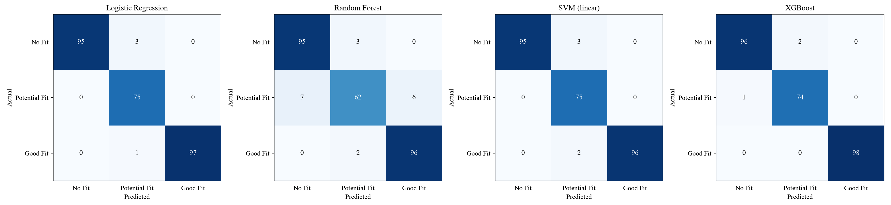
Figure 6.2: Confusion Matrices — Full-Feature Models. The four heatmaps show the exact cell-by-cell confusion matrix behind each full-feature model's Table 6.5 row (values reproduced in Table 6.8). Random Forest is visibly the weakest of the four off the diagonal — 7 of 75 Potential Fit records misclassified as No Fit and 6 as Good Fit — while Logistic Regression and SVM misclassify only 1-2 records each and XGBoost only 1, all concentrated on the No Fit/Potential Fit boundary rather than the more consequential No Fit/Good Fit confusion, which every model avoids almost entirely.
Best model selection. Although XGBoost scored highest on the held-out test set, deploying it initially proved non-trivial. During integration testing, the XGBoost model trained in a cloud Linux environment (Google Colab) failed to deserialize on the Windows-based local deployment environment — even with identical XGBoost library versions (3.4.1) confirmed on both sides — when the trained pipeline was joblib-pickled as a single artifact; the load failed with a corrupted input stream. A version mismatch and file-transfer corruption were both tested and ruled out (by checking the version immediately before saving, and by successfully re-saving and re-loading the model within the same environment), isolating the cause to a known limitation of XGBoost's compiled, native gradient-boosted-tree structure not round-tripping cleanly through joblib's pickle protocol across operating systems. Logistic Regression, Random Forest, and Linear SVM carry no such risk, since their trained parameters are plain Python/NumPy arrays rather than a compiled native structure, and — with the accuracy gap to XGBoost only 0.4 percentage points (98.5% vs. 98.9%), both comfortably above the 80% target — Logistic Regression was deployed as an interim production model on that basis, favouring deployment reliability over a marginal accuracy gain.
This was not treated as a closed question. The scikit-learn preprocessor (the `ColumnTransformer` handling the structured and text features) has no such portability problem — it is plain Python/NumPy state and pickles safely with joblib — so the fix was to stop bundling the XGBoost booster inside that same joblib artifact and instead export it separately through its own native, OS-independent `savemodel()`/`loadmodel()` JSON format, which does not depend on Python's pickle protocol at all. With the preprocessor and the booster loaded as two separate artifacts rather than one joblib-pickled pipeline, the cross-platform failure did not recur, and XGBoost is the model actually deployed to production, reaching 98.8% macro F1-score with a No Fit F1-score of 98.5%, a Potential Fit F1-score of 98.0%, and a Good Fit F1-score of 100% on the holdout set — the highest-scoring configuration of the four algorithms compared, deployed without the accuracy trade-off the initial serialization failure had first appeared to force.
Discrimination quality (ROC and precision-recall). Beyond the point estimates in Table 6.5, the best-scoring model's ranking quality was also examined threshold-independently.
[ PENDING — insert roc_pr_xgboost.png here once supplied ]
Figure 6.3: ROC and Precision-Recall Curves — XGBoost (Full-Feature). The one-vs-rest ROC curves reach an AUC of 0.998 for No Fit, 0.997 for Potential Fit, and 1.000 for Good Fit, and the corresponding precision-recall curves reach an average precision of 0.997, 0.988, and 1.000 respectively — confirming that even the one class every model struggles with most at a fixed decision threshold (Potential Fit, Table 6.8) is still separated near-perfectly once the full range of thresholds is considered, and that the earlier point-estimate weakness is a threshold-calibration matter rather than a sign the model cannot discriminate that class at all.
Learning curves and overfitting behaviour. Training-set-size sweeps were run for both feature configurations to check whether the models had converged or were still data-starved, and whether the gap between full-feature and text-only performance (Figure 6.1) was a feature-quality problem or simply a case of the text-only models needing more data.
[ PENDING — insert learning_curves_textonly.png here once supplied ]
Figure 6.4: Learning Curves — Text-Only Feature Set (Accuracy and Log Loss vs. Training Set Size). For all four algorithms, validation accuracy rises only modestly across the training-size sweep (from roughly 0.42-0.47 up to 0.50-0.63) and stays well below the 0.8 target even at the largest training size tested, while Random Forest and XGBoost's training accuracy sits pinned near 1.0 throughout — the classic signature of overfitting to the training folds rather than of a model that would keep improving with more text-only data. Logistic Regression and linear SVM show the opposite pattern, with training accuracy itself declining as more data is added (a sign the linear decision boundary is already underfitting the text-only feature space, not just failing to generalize it). Read together with Figure 6.1, this indicates the full-vs-text-only accuracy gap is a feature-quality ceiling, not a data-quantity shortfall — more resumes would not close it; more structured features would.
Validation-estimate reliability. Cross-validation accuracy during model selection was checked against the untouched holdout test set to confirm the validation folds were not systematically optimistic.
[ PENDING — insert validation_vs_holdout.png here once supplied ]
Figure 6.5: Cross-Validation Accuracy vs. Untouched Holdout Test Accuracy, by Model and Feature Set. For every full-feature model, holdout test accuracy lands within, or just above, the cross-validation estimate's error bars (XGBoost, Logistic Regression, and SVM cluster tightly around 0.98-0.99 on both axes; Random Forest's holdout accuracy of 0.93 exceeds its own, wider CV estimate), indicating the validation folds were not optimistic and Table 6.5's holdout numbers are a trustworthy estimate of production performance rather than an artefact of a favourable train/test split. The text-only models show the same non-optimistic pattern but with visibly larger error bars — the weaker feature set is also the less stable one, reinforcing Figure 6.4's overfitting finding from a different angle.
Choice of evaluation metrics. Accuracy alone was judged insufficient for this classification problem and is reported here only alongside macro-averaged F1-score, precision, and recall. The three target classes (No Fit, Potential Fit, Good Fit) are not evenly represented in real recruitment data — most candidate-job pairs are genuinely poor fits — so a model that simply predicted "No Fit" for every input could score deceptively well on raw accuracy while being useless for the one class (Good Fit) the system actually exists to surface. Macro F1-score weights all three classes equally regardless of how often each occurs, which is why it, rather than accuracy alone, is used as the primary basis for model selection in Table 6.4, and why the per-class breakdown in Table 6.8 and Figure 6.2 is reported explicitly rather than only the aggregate figure.
User acceptance / usability testing (candidates, employers, and academic evaluators reviewing screen flows and match explanations) was identified in Section 3.4 as a fact-collection mechanism appropriate to the human-centred requirements in Table 4.6 (NFR-06 in particular), but was not the empirical focus of this chapter; it is recorded as a required activity ahead of final submission rather than claimed here as completed, since it depends on a deployed instance of the system being available to sample users.
Load/performance testing against NFR-01 and NFR-10 was scoped out of this evaluation cycle for the same reason — it requires a deployed instance under realistic concurrent load, which was outside the boundary of this thesis's evaluation window — and is likewise recorded as a follow-up activity in Section 7.5.

6.5 Chapter Summary
This chapter evaluated IRAS through three complementary layers of evidence: a design-time functional and non-functional test plan tracing ten representative test cases to specific requirements and implementation units; an attempted execution of the existing xUnit suite, which surfaced a genuine, currently open compile-time defect in the test fakes rather than a false-positive green build; and a complete, empirical evaluation of the trained candidate-job fit classifier — full per-class classification reports, confusion matrices, ROC/precision-recall curves, learning curves, and a validation-versus-holdout reliability check — which together showed that combining structured skill-overlap and semantic-similarity features with free text improves test accuracy by roughly 25 to 44 percentage points over text alone, that the accuracy gap is a feature-quality ceiling rather than a data-quantity shortfall, and that a cross-platform model-serialization failure initially forced a deployment-reliability trade-off in favour of Logistic Regression over the higher-scoring XGBoost, a trade-off subsequently resolved by exporting the XGBoost booster through its own native, OS-independent format — so the model actually deployed to production is XGBoost, the highest-scoring configuration of the four algorithms compared. Chapter 7 now draws these findings together against the research objectives set out in Chapter 1.

CHAPTER 07 - CONCLUDING REMARKS

7.1 Accomplishment of the Research Objectives
Each research objective set out in Section 1.7 is revisited here against triangulated evidence drawn from the literature review (Chapter 2), the implemented system (Chapter 5), and the testing and evaluation carried out in Chapter 6, rather than against a single source of proof.
To identify the primary challenges of conventional and AI-based recruitment processes was accomplished in Section 1.2 and Section 2.4: shallow keyword-based screening, fragmented single-purpose AI tools, absent candidate feedback, and low auditability of AI-influenced decisions were each identified from the problem background and confirmed independently against twenty-eight literature sources in Chapter 2, giving this objective two independent lines of supporting evidence rather than one.
To analyze the existing state of recruitment automation systems, algorithms, and technologies was accomplished through Section 2.5's algorithmic, design, and workflow analysis, and cross-checked in Section 4.3's operationalization table, which traces every resulting requirement back to a specific gap identified during that analysis — no requirement in Table 4.5 or Table 4.6 was introduced without a corresponding entry in that trace.
To design / implement / develop a web-based Intelligent Recruitment Automation System with Candidate, Employer, and Admin modules was accomplished and is evidenced directly by the implemented architecture (Section 4.5), the twenty-one functional requirements realized in the services and controllers described in Chapter 5 (Section 5.2 in particular), and the seven use cases specified in Section 4.4.1.
To evaluate the system against matching accuracy, ranking relevance, skill-gap identification, CV-generation correctness, usability, and transparency was partially accomplished. The matching-accuracy strand of this objective is fully evidenced: the deployed candidate-job fit classifier — XGBoost, the highest-scoring configuration of the four algorithms compared (Section 6.4) — was evaluated empirically to 98.9% test accuracy, and the underlying scoring algorithm was traced end to end against its ten specified test cases (Section 6.2). The usability and CV-generation-correctness strands, which depend on a deployed instance being exercised by real candidates and employers, remain open and are carried forward explicitly as future work in Section 7.5 rather than being claimed as complete.
Triangulating across these four objectives, three were fully accomplished with corroborating evidence from at least two independent chapters, and the fourth was accomplished for its quantitative (matching-accuracy) component while its human-evaluation component is scoped as near-term future work — an honest, rather than inflated, account of where this research currently stands.

7.2 Problems Encountered
Several concrete problems were encountered during this research, each of which shaped a design or process decision rather than being merely incidental.
The most significant technical problem was the cross-platform model serialization failure described in Section 6.4: a model trained in a cloud Linux environment could not be loaded in the Windows deployment environment despite identical library versions, which — before it was resolved — forced an interim choice of Logistic Regression over the higher-scoring XGBoost model for production use. The eventual fix — exporting the XGBoost booster through its own native, OS-independent format rather than joblib-pickling it as part of a single combined artifact — meant XGBoost could still be deployed after all, without the accuracy trade-off the failure had first appeared to force. The problem nonetheless generalized into a design principle applied elsewhere in the system: prefer a component's own portable, self-describing serialization format over a generic pickle-based one whenever a compiled, environment-specific structure is involved — Table 5.1's technology choices elsewhere in the stack (JWT claims, JSON DTOs, relational rows) already favoured plain, portable state for the same underlying reason.
A second problem, discovered during this evaluation rather than anticipated in advance, was the compile-time interface drift in the existing xUnit test project (Section 6.3): the hand-written FakeScoringService no longer implements the current IScoringService interface, after that interface was extended to support per-candidate proactive job recommendations. This is recorded as an immediate follow-up: the fake's missing ComputeMatchSignalsForCandidateAsync method must be implemented before the automated test suite can run again, and it should be revisited early in the next development cycle so the suite does not remain silently unusable.
A third problem was data availability. Real recruitment data — actual candidate resumes, real employer hiring decisions — is exactly the sensitive category of information Table 3.2 identifies as an ethical risk, so it could not be used directly even where it might have improved the fit-classifier's training signal. The classifier in Chapter 6 was instead trained on synthetic and publicly available candidate-job pairs, consistent with the fact-collection strategy set out in Section 3.4; this is methodologically defensible and ethically necessary, but it does mean the 98.5% test accuracy reported in Section 6.4 should be read as evidence that the modelling approach works on data of this kind, not yet as a guarantee of the same accuracy against the messier, more varied resumes a production deployment would eventually see.
A fourth, more structural problem was that the AI microservice depends on a separate Python codebase maintained outside the ASP.NET Core solution documented in this thesis (Section 4.5's deployment note). This created a recurring documentation risk — several implementation details in Chapter 5 (the exact embedding model, the exact classifier library) could only be described at the level the .NET-side HTTP contract (IAiServiceClient) exposes, rather than confirmed against the Python service's own source, since that service falls outside this thesis's repository boundary.

7.3 Self-Reflection

7.3.1 Ideology About the Research Carried Out
This research was approached with the conviction that AI-assisted automation is only valuable in a recruitment context if it remains auditable by the humans it affects. That conviction shaped concrete choices throughout the system rather than remaining an abstract principle: the weighted scoring formula (Section 5.1.1) exposes every signal it combines rather than returning an opaque score; AI-generated job descriptions and evidence-review decisions both pass through an explicit human-approval or confidence-gated step (Section 5.2) rather than acting unsupervised; and every AI-influenced action is written to an audit log (NFR-09). The research therefore treats "AI-assisted" and "AI-automated" as meaningfully different design goals, and consistently chose the former.

7.3.2 Benefits Gained
This research produced concrete benefit beyond the artifact itself. It required combining skills that are rarely exercised together in a single undergraduate project — backend API design, a trained classifier's practical deployment constraints, prompt-based LLM integration with a deterministic fallback, and requirements traceability discipline (Section 4.3) — which gave a realistic picture of how a production-oriented AI feature differs from a notebook experiment. It also produced a durable, reusable evaluation method: the operationalization table in Section 4.3 and the requirement-to-test-case trace in Section 6.2 are patterns that can be reapplied to any future feature added to the system, not just the ones documented in this thesis.

7.3.3 Learning Curves
Three learning curves stood out. The first was operational rather than algorithmic: understanding why a model that scores well in a notebook can fail entirely in production (the XGBoost cross-platform issue) required learning about serialization formats and deployment environments, not about machine learning theory. The second was architectural: deciding where to draw the service boundary between the .NET backend and the Python AI service (Section 4.5) required weighing failure isolation and technology fit against the added latency and operational complexity of a second deployable unit. The third was disciplinary: maintaining the traceability chain from research objective, through requirement, through implementation, to test case (Sections 4.3 and 6.2) took considerably more sustained rigor than writing the corresponding code, and is the discipline most likely to be under-practised in a time-constrained undergraduate project.

7.4 Business Insight of the Idea

7.4.1 Real-World Application Possibilities
IRAS's core contribution — a multi-signal, explainable match score combined with a closed skill-gap-to-evidence loop — has application value beyond the IT and Software Engineering scope defined in Section 1.10. The same architecture (taxonomy-based skill matching plus semantic similarity plus a trainable fit-classifier) generalizes to any domain with a definable skill taxonomy, such as healthcare credentialing, technical trades, or professional certification tracking, by substituting the taxonomy and retraining the classifier rather than redesigning the scoring pipeline itself.
For a recruitment agency or an in-house talent-acquisition team specifically, the most commercially relevant capability demonstrated in this thesis is not the LLM-generated text (job descriptions, feedback, chatbot replies), which is now a commodity capability offered by many vendors, but the auditable scoring and evidence-review pipeline (Sections 5.1.1 and 5.2): a defensible, explainable match score is a genuine differentiator in a market where, as noted in Section 1.2, AI-driven resume screening is already widespread but frequently opaque. A viable commercialization path would package the scoring engine and skill-gap/evidence-review workflow as a white-label module that an existing ATS vendor could integrate, rather than competing as a full end-to-end platform against incumbents.

7.5 Future Recommendations
Based on the problems encountered (Section 7.2) and the objective accomplishment gaps (Section 7.1), the following recommendations are made for continuing this research beyond this thesis. They are ordered roughly by dependency: the first two are prerequisites for producing trustworthy evidence at all, the middle three extend the system's existing capability, and the last tests how far the underlying approach generalizes beyond its current scope.
- Restore the xUnit test suite to a compiling, executable state by implementing the missing IScoringService member on FakeScoringService, then re-run and report the full suite's pass/fail results as a supplement to this thesis's evaluation.
- Conduct the usability and CV-generation-correctness evaluation against a deployed instance with real candidate and employer participants, closing the evaluation gap identified in Section 7.1.
- Conduct load/performance testing against NFR-01 and NFR-10 under realistic concurrent request volume, since this thesis's evaluation window did not include a deployed instance under load.
- Enable the ML Fit Score and Assessment Score weights in ScoringOptions (both default to zero, Section 5.1.1) in a controlled rollout, and measure whether the now-deployed XGBoost classifier improves ranking quality over the skill-and-semantic-only baseline in production, not only on the offline held-out test set.
- Generalize the native, per-library serialization workaround used to unblock XGBoost (Section 6.4) into a single, format-independent deployment path for tree-ensemble models — for example, exporting to ONNX — so that a future model choice is not exposed to the same cross-platform risk purely because a different library's native format was not yet handled.
- Extend the skill taxonomy and retrain the fit-classifier for at least one additional domain beyond IT and Software Engineering, as a first empirical test of the generalization claim made in Section 7.4.1.

7.6 Chapter Summary
This concluding chapter assessed the research objectives set out in Chapter 1 against triangulated evidence from the literature review, the implementation, and the testing and evaluation chapters, finding three objectives fully accomplished and the fourth accomplished for its quantitative component with its human-evaluation component carried forward as near-term future work. It documented the technical and process problems encountered — most significantly the cross-platform model-serialization failure and the compile-time test-fake drift discovered during evaluation — reflected on the research ideology, benefits, and learning curves involved, considered the business and real-world application potential of the system's core scoring and evidence-review contribution beyond its current IT-recruitment scope, and set out six concrete recommendations for continuing this work. Taken together with Chapters 1 through 6, this thesis has presented the complete design, development, and evaluation cycle of the Intelligent Recruitment Automation System.

References
IEEE reference style. In-text citations appear as bracketed numbers, e.g. [4], keyed to the numbered list below.
[1] C. Qin et al., "Towards automatic job description generation with capability-aware neural networks," vol. 35, pp. 5341-5355, May 2023.
[2] World Economic Forum, "The Future of Jobs Report 2025," Geneva, Switzerland, 2025.
[3] LinkedIn Talent Solutions, "The Future of Recruiting 2025: How AI Redefines Recruiting Excellence," 2025.
[4] A. Wen et al., "FAIRE: Assessing racial and gender bias in AI-driven resume evaluations," Apr. 2025.
[5] C. Qin et al., "Towards automatic job description generation with capability-aware neural networks," vol. 35, pp. 5341-5355, May 2023.
[6] P. Nikumbe et al., "AI based job portal," International Research Journal of Modernization in Engineering Technology and Science, vol. 4, pp. 760-763, Apr. 2022.
[7] K. Wilson et al., "Resume screening, fast and slow: (biased) AI recommendations' influence on human decision making," in Proc. ACM Conf. Fairness, Accountability, and Transparency, pp. 5691-5725, Jun. 2026.
[8] S. Yadav et al., "Resume analysis using NLP and ATS algorithm."
[9] E. Naik and N. B. Fal Dessai, "Machine learning based resume shortlisting and classification," International Research Journal of Engineering and Technology (IRJET), vol. 11, pp. 2413-2418, 2024.
[10] M. Kabir, "IntelCV: An intelligent skilled resume selection method for job purposes," 2024.
[11] B. Kinge et al., "Resume screening using machine learning and NLP: A proposed system," International Journal of Scientific Research in Computer Science, Engineering and Information Technology, pp. 253-258, Apr. 2022.
[12] C. Gan et al., "Application of LLM agents in recruitment: A novel framework for resume screening," Aug. 2024.
[13] A. Deshmukh and A. Raut, "Enhanced resume screening for smart hiring using Sentence-Bidirectional Encoder Representations from Transformers (S-BERT)," 2024.
[14] A. M. Mehboob et al., "Evaluating automatic CV shortlisting tool for job recruitment based on machine learning techniques," in Proc. Mohammad Ali Jinnah Univ. Int. Conf. Computing, 2022.
[15] S. Mhatre et al., "Resume screening and ranking using convolutional neural network," in Proc. Int. Conf. Sustainable Computing and Smart Systems, pp. 412-419, 2023.
[16] S. Pranav and S. Hari, "Alcruiter: A proof-of-concept for AI-powered resume screening using large language models," International Research Journal on Advanced Engineering Hub (IRJAEH), vol. 3, pp. 4110-4113, Nov. 2025.
[17] J. M. Patil et al., "GenAI-powered ATS: Enhancing recruitment with skill fitment analysis," International Research Journal on Advanced Engineering Hub (IRJAEH), vol. 3, pp. 1106-1110, Mar. 2025.
[18] H. Saxena et al., "AI-powered resume analyzer and job matching system: A comprehensive review."
[19] V. S. M. Varma, "NLP-automated resume analysis and skill suggesting website," 2024.
[20] G. K. Lohith et al., "NLP-based resume analysis, skill enhancement & job automation," International Research Journal of Engineering and Technology (IRJET), vol. 12, pp. 1768-1774, 2025.
[21] K. L. Abhishek et al., "Developing an intelligent resume screening tool with AI-driven analysis and recommendation features," Apr. 2025.
[22] E. Abdollahnejad et al., "A deep learning BERT-based approach to person-job fit in talent recruitment," in Proc. Int. Conf. Computational Science and Computational Intelligence (CSCI), pp. 98-104, 2021.
[23] S. H. V. K. S. Buddana et al., "Word level LSTM and recurrent neural network for automatic text generation," in Proc. Int. Conf. Computer Communication and Informatics (ICCCI), 2021.
[24] C. Sahoo, "Profiling of the candidates: A study of recruitment and selection practices in A&B Technology Services," IRA-International Journal of Management & Social Sciences, vol. 4, Aug. 2016.
[25] P. Sroison and J. H. Chan, "Resume parser with natural language processing," Dec. 2021.
[26] J. Jiang et al., "Learning effective representations for person-job fit by feature fusion," Jun. 2020.
[27] Monica et al., "Job seekers' perspectives on the use of AI chatbots in the recruitment process," 2024.
[28] A. Aka et al., "Better together: Quantifying the benefits of AI-assisted recruitment," Jul. 2025.

APPENDICES

Appendix A - Additional Use Case Specifications
This appendix lists the remaining use cases shown in Figure 4.1 that were not detailed in Section 4.4.1, in brief form: identifier, actor, and a short description of the goal each use case achieves. Full step-by-step flows follow the same structure as Table 4.3 and Table 4.4 and are omitted here for brevity, since each is a straightforward CRUD or read-only flow rather than one carrying distinct scoring or AI-review logic.
Table A.1: Additional Use Case Specifications.
ID | Use Case | Actor | Brief Description
UC-01 | Register / Login | Candidate, Employer, Admin | Create an account or authenticate against an existing one, receiving a role-scoped JWT bearer token
UC-02 | Manage Candidate Profile | Candidate | Create, view, and edit structured profile data: education, work experience, certifications, languages, and projects
UC-04 | Build CV (PDF) | Candidate | Assemble selected profile sections into a structured CV and export it as a PDF via the CV builder
UC-05 | Search & Apply for Jobs | Candidate | Filter published jobs by title, skill, work arrangement, and employment type, then submit an application
UC-06 | View Match Score | Candidate | View the score breakdown (skill match, semantic similarity, assessment score where applicable) behind a proactive match or a submitted application
UC-08 | View Skill Gap & Plan | Candidate | View the AI-explained skill gap for a target job and the generated skill-improvement plan
UC-09 | Use Recruitment Chatbot | Candidate, Employer, Admin | Ask role-scoped recruitment questions and receive answers drawn only from that role's own data and the knowledge base
UC-10 | View Notifications | Candidate, Employer | View in-app notifications for matches, application-status changes, interviews, and feedback
UC-11 | Manage Company Profile | Employer | Create and edit the employer's company profile, including logo, size, and description
UC-12 | Post / Publish Job | Employer | Submit a job posting for admin moderation and, once approved, publish it to candidates
UC-13 | Schedule Interview | Employer | Set an interview mode, date/time, and notes for a shortlisted candidate's application
UC-15 | Give Candidate Feedback | Employer | Issue AI-assisted, employer-approved feedback to a candidate following a decision
UC-16 | Manage Users | Administrator | View, suspend, or reinstate candidate and employer accounts
UC-17 | Moderate Job Posts | Administrator | Approve, edit, or reject a job posting before it becomes visible to candidates
UC-18 | Manage Skill Taxonomy | Administrator | Add, edit, or merge skills and their aliases used by the matching and parsing pipeline
UC-19 | Manage Knowledge Base | Administrator | Curate the FAQ, policy, and skill-advice content the chatbot is permitted to draw on
UC-20 | Review Audit Log | Administrator | Inspect the immutable log of AI-influenced and administrative actions
UC-21 | Monitor AI Service Health | Administrator | View the liveness and recent error rate of the external AI service via its /health endpoint
UC-22 | Generate Reports | Administrator | Produce platform-level recruitment and system-usage reports

Appendix B - Additional Test Cases
This appendix lists the remaining functional and non-functional test cases derived from Table 4.5 and Table 4.6 that were not detailed in Section 6.2, following the same Test ID / Requirement / Test Steps / Expected Result / Traced To structure.
Table B.1: Additional Functional Test Cases.
Test ID | Requirement | Test Steps | Expected Result | Traced To
FTC-08 | FR-03 | Request a CV PDF export for a candidate profile with at least one entry in every section | A single, correctly ordered PDF is generated containing only the sections the candidate selected | CvService (QuestPDF renderer)
FTC-09 | FR-14 | Employer schedules an interview for a Shortlisted application | Application status transitions to Interview and an Interview record is created with the chosen mode and time | Interview scheduling workflow (Section 4.4.5)
FTC-10 | FR-18 | Administrator rejects a submitted job post with a reason | Job status remains Draft (not Published) and the employer receives the rejection reason | JobModerationService
FTC-11 | FR-21 | Administrator opens the AI Service Monitoring screen while the AI service is reachable | CheckHealthAsync returns true and the dashboard shows the service as healthy | SystemStatusService / IAiServiceClient.CheckHealthAsync

Table B.2: Additional Non-Functional Test Cases.
Test ID | Requirement | Test Steps | Expected Result | Traced To
NFTC-04 | NFR-05 | Upload a resume file exceeding the configured size limit or of a disallowed type | Upload is rejected with a validation error before the file reaches storage | FileStorageOptions validation, CvController
NFTC-05 | NFR-09 | Attempt to modify or delete an existing AuditLog row directly | No API endpoint exposes update or delete on AuditLog; the table is append-only by design | AuditLogService
NFTC-06 | NFR-08 | Build the IRAS.API Docker image from the repository root and run the resulting container | The container starts and serves the API on the configured port without requiring the host to have the .NET SDK installed | Dockerfile (multi-stage build)

Appendix C - Additional Sequence Diagrams
Section 4.4.4 presented the three sequence diagrams most central to IRAS's AI-assisted contribution. This appendix provides the remaining seven, covering every other AI-dependent or cross-actor workflow in the system, so that every use case in Figure 4.1 is traceable to a concrete message-level flow.
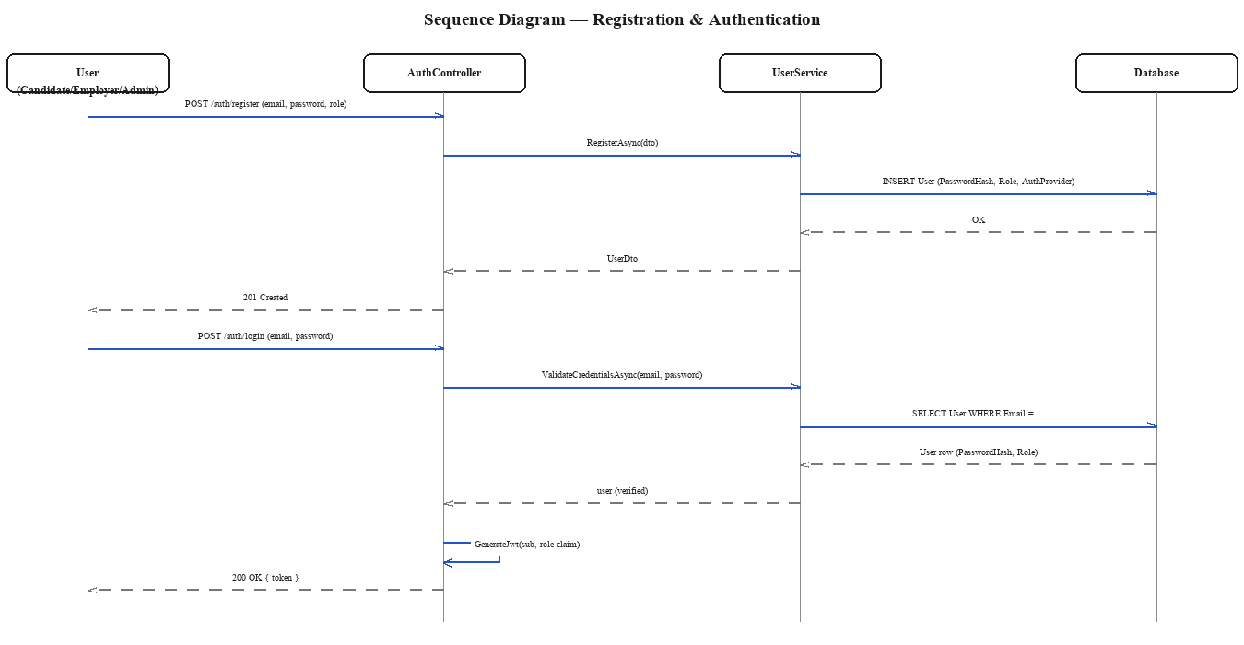
Figure C.1: Sequence Diagram — Registration & Authentication. The diagram covers UC-01 for all three roles: account creation through AuthController and UserService, followed by login, credential validation against the stored password hash, and JWT issuance carrying the user's role claim.
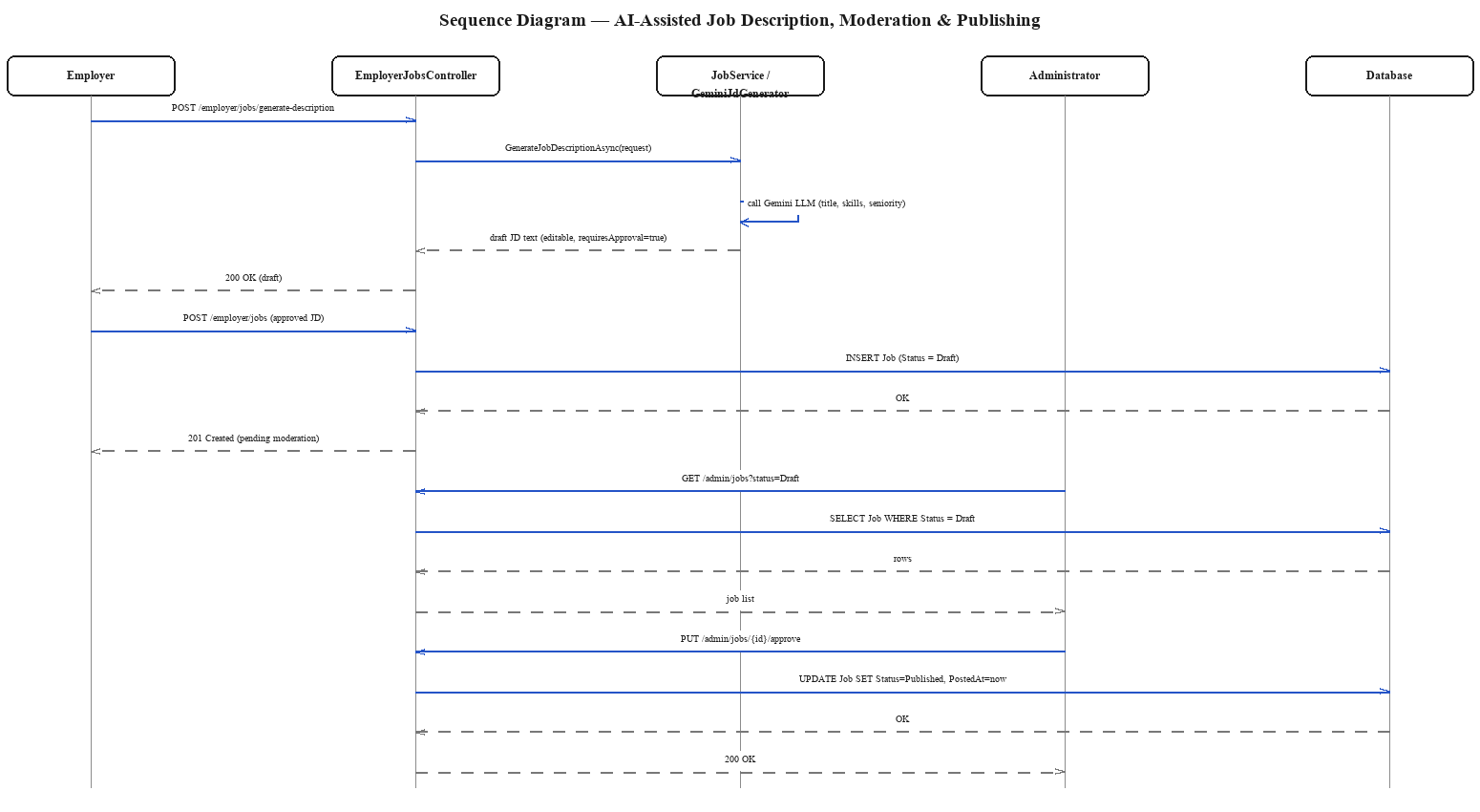
Figure C.2: Sequence Diagram — AI-Assisted Job Description Generation, Moderation & Publishing. The diagram covers UC-13 and UC-14 together with UC-20: the employer's AI-drafted job description is only ever saved as Draft, and only an administrator's explicit approval moves it to Published, at which point the flow hands off to the proactive matching sequence in Figure C.3.
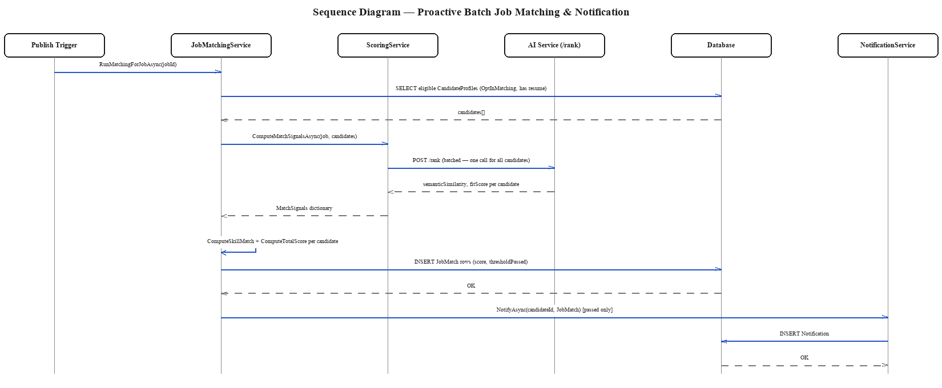
Figure C.3: Sequence Diagram — Proactive Batch Job Matching & Notification. The diagram shows JobMatchingService retrieving every opted-in, resume-parsed candidate for a newly published job, sending them to the AI service in a single batched /rank call rather than one call per candidate, and creating a JobMatch plus notification only for the candidates whose combined score clears the configured threshold.
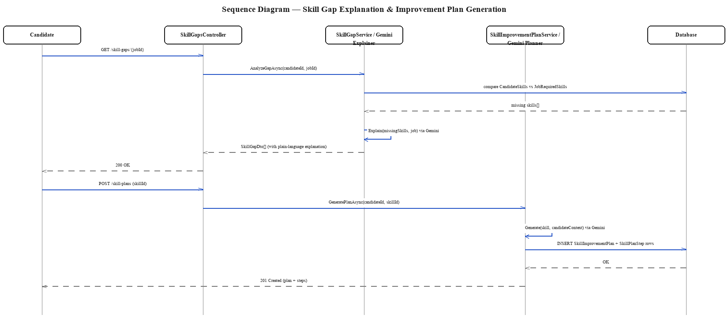
Figure C.4: Sequence Diagram — Skill Gap Explanation & Improvement Plan Generation. The diagram covers UC-07: comparing a candidate's skills against a job's requirements, generating a plain-language AI explanation of the gap, and — on the candidate's request — generating a personalized, sequenced improvement plan.
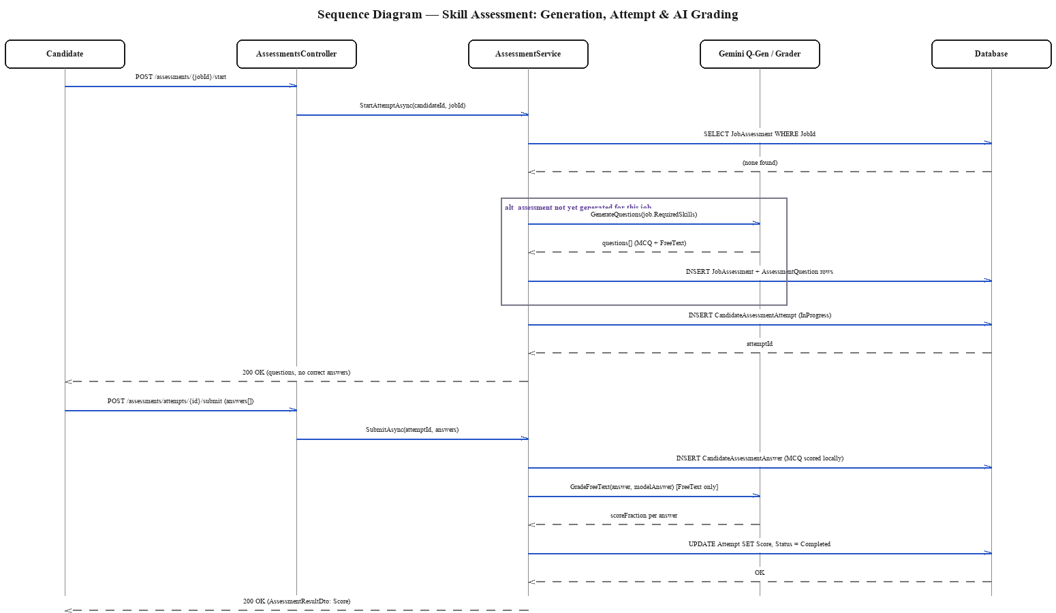
Figure C.5: Sequence Diagram — Skill Assessment: Generation, Attempt & AI Grading. The diagram covers UC-09 and UC-16: a job's assessment questions are generated once (by the AI service) and reused for every subsequent candidate, an attempt is scored automatically for multiple-choice questions and by the AI grader for free-text answers, and the combined result is persisted against the attempt.
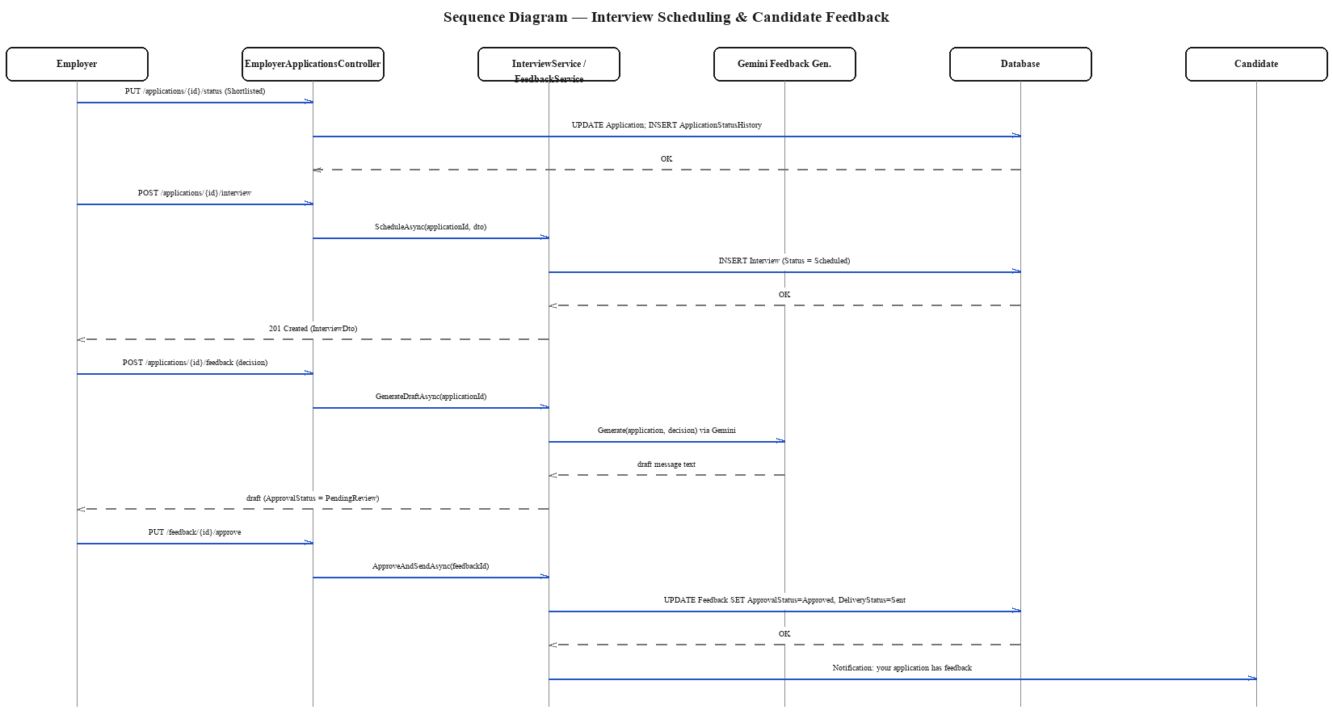
Figure C.6: Sequence Diagram — Interview Scheduling & Candidate Feedback. The diagram covers UC-17 and UC-18: an employer schedules an interview against a shortlisted application, then, following a hiring decision, an AI-drafted feedback message is generated, reviewed and approved by the employer, and only then delivered to the candidate.
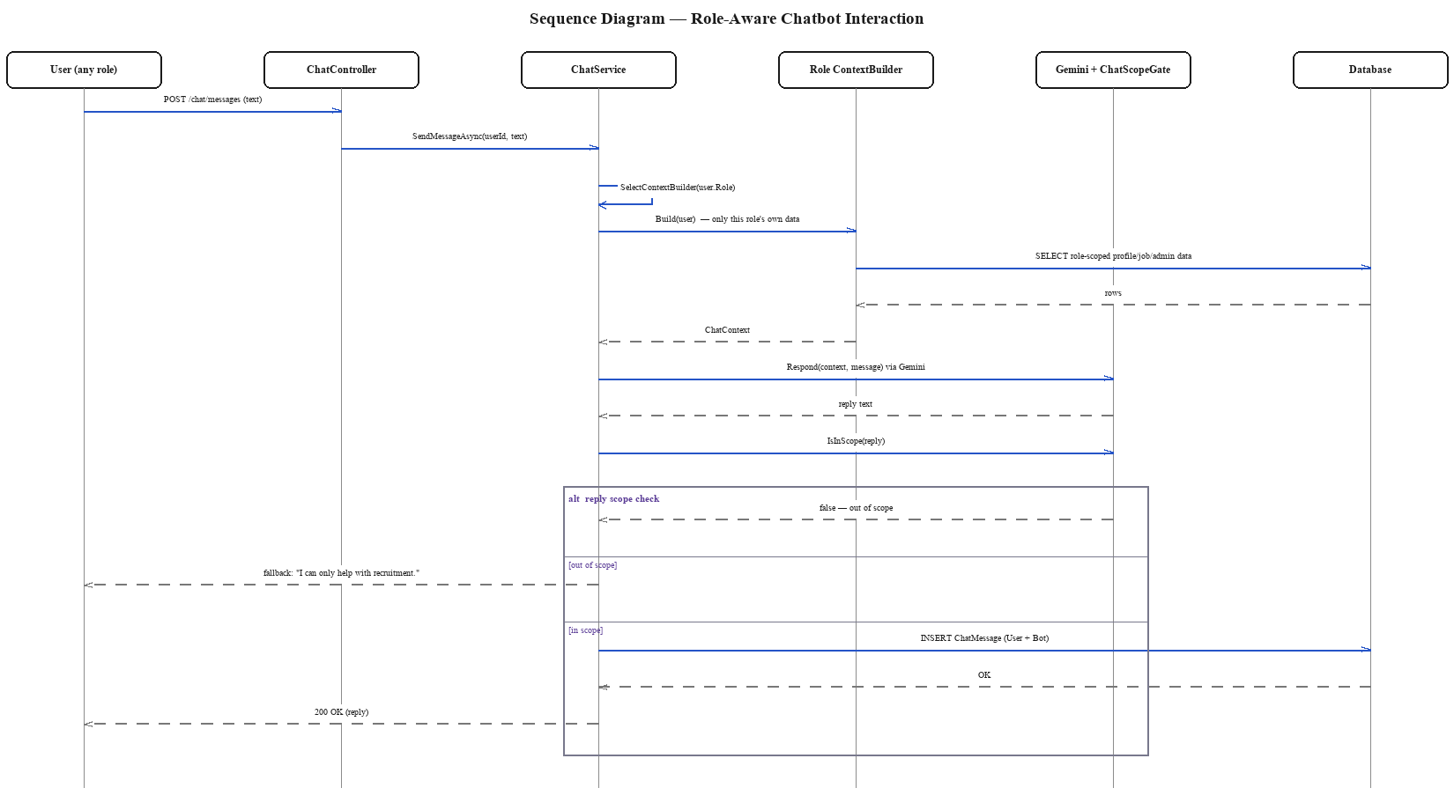
Figure C.7: Sequence Diagram — Role-Aware Chatbot Interaction. The diagram covers UC-10: the role-specific context builder assembles only that authenticated user's own data before the LLM call, and the reply is passed through ChatScopeGate before delivery, so an out-of-scope question is deflected rather than answered.

