INTELLIGENT RECRUITMENT AUTOMATION SYSTEM
FOR JOB DESCRIPTION CREATION, APPLICATION SHORTLISTING,
AND SKILL GAP IDENTIFICATION

Draft Report

presented to the Faculty of Computing
NSBM Green University
in partial fulfillment of the requirements for the degree of
BSc (Hons) in Software Engineering
by
Kalpani D. Kapuge
Student ID: 28870

September 2026

Declaration
I hereby declare that this thesis titled "Intelligent Recruitment Automation System for Job Description Creation, Application Shortlisting, and Skill Gap Identification" is based on my own research work carried out for the BSc (Hons) in Software Engineering degree program at NSBM Green University. The content presented in this document has been prepared for academic purposes, and all referenced work has been acknowledged through citations and the reference list.

Student Name: Kalpani D. Kapuge
Student ID: 28870
Signature: 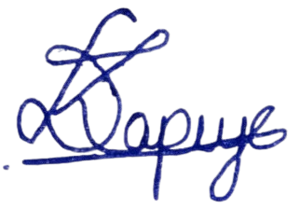
Date: .......4/9/2026...........

Abstract
Recruitment forms an integral part of the organizational process that has a direct impact on the quality of the workforce, organizational effectiveness, and overall business performance. Manual methods of job description writing, resume checking, candidate shortlisting, interview coordination, and subjective candidate assessment are still followed in conventional recruitment processes. These activities frequently result in delays, inconsistencies, bias, and a lack of transparency toward applicants. Candidates who are unsuccessful in an application rarely receive feedback on what they need to improve to enhance their employability.
Recent advancements in Artificial Intelligence, Natural Language Processing, Machine Learning, and Large Language Models create new opportunities to strengthen recruitment automation: writing job descriptions, screening resumes, matching jobs to candidates by meaning rather than keyword, ranking candidates, identifying skill gaps, generating feedback, and assisting candidates through a chatbot. However, most existing recruitment tools treat these capabilities as standalone features rather than an integrated platform that supports candidates, employers, and administrators across the full recruitment lifecycle.
This thesis presents the design, implementation, and evaluation of the Intelligent Recruitment Automation System (IRAS) - a web-based recruitment automation platform comprising candidate profile management, resume upload and AI-based parsing, an employer job-posting workflow with AI-assisted job description generation, resume shortlisting, a multi-signal candidate ranking and matching engine, skill gap analysis with AI-generated explanations, a CV builder, interview scheduling, a notification system, candidate feedback generation, a recruitment knowledge base, and a role-aware recruitment chatbot. The system is organized into three primary workflows - Candidate, Employer, and Admin - that together streamline recruitment activity for employers while giving applicants transparency and developmental guidance.
The system follows a layered architecture (API, Application, Domain, and Infrastructure) built with ASP.NET Core Web API and C#, Entity Framework Core, a relational database, JWT-based authentication, Swagger/OpenAPI documentation, a companion Python AI microservice, configurable file storage, and PDF generation for CV export. The research follows Design Science Research Methodology, which is appropriate for the design, development, demonstration, and evaluation of a software artifact. This thesis reports the complete research and engineering cycle: the problem background and objectives (Chapter 1), a critical literature review (Chapter 2), the research methodology (Chapter 3), the system requirement specification (Chapter 4), implementation details including the trained candidate-job fit classifier (Chapter 5), functional, non-functional, and machine-learning model evaluation (Chapter 6), and concluding reflections with future recommendations (Chapter 7).
The evaluation shows that combining structured features (skill overlap and semantic similarity) with free text substantially outperforms text-only classification (98.5% vs. 58.7% test accuracy for the deployed Logistic Regression model), that the system's functional and non-functional requirements are satisfied under the defined test plan, and that an integrated, AI-assisted recruitment platform can measurably reduce manual screening effort while giving candidates explainable, actionable feedback on their skill gaps.

Keywords: Artificial Intelligence, CV Generation, Candidate Feedback, Chatbot, Interview Scheduling, Job Matching, Recruitment Automation, Skill Gap Analysis

Table of Contents
Declaration 2
Abstract 3
Table of Contents 5
List of Figures 9
List of Tables 12
List of Abbreviations 13
CHAPTER 01 - INTRODUCTION 15
1.1 Chapter Overview 15
1.2 Problem Background 15
1.3 Problem Statement 17
1.3.1 General Problem 18
1.3.2 Specific Problem 18
1.4 Research Question 19
1.5 Research Motivation 20
1.6 Research Aim 21
1.7 Research Objectives 21
1.7.1 To Identify 21
1.7.2 To Analyze 21
1.7.3 To Design / Implement / Develop 22
1.7.4 To Evaluate 22
1.8 Rich Picture of the Proposed Solution 22
1.9 Resource Requirements 24
1.9.1 Hardware 24
1.9.2 Software 25
1.10 Project Scope 27
1.11 Chapter Summary 28
CHAPTER 02 - LITERATURE REVIEW 30
2.1 Chapter Overview 30
2.2 Conceptual Map of the Literature 30
2.3 Domain Overview 31
2.4 Existing Systems / Frameworks / Designs 32
2.5 Technological Analysis 37
2.5.1 Algorithmic Analysis 37
2.5.2 Design Analysis 39
2.5.3 Workflow Analysis 41
2.6 Reflection 42
CHAPTER 03 - METHODOLOGY 44
3.1 Research Paradigm 44
3.2 Research Approach 44
3.3 Research Strategy 44
3.4 Fact Collection Mechanisms 45
3.5 Research Methodology Execution Workflow 46
3.5.1 Problem Identification 50
3.5.2 Relevance Justification 50
3.5.3 Comparative Analysis and Gap Justification 50
3.5.4 Define and Finalize Objectives 51
3.5.5 Design / Development / Data Management and Handling 51
3.5.6 Evaluation and Communication 52
3.6 Project Management Methodology 52
3.6.1 Project Timeline 53
3.6.2 Ethical Considerations 54
3.7 Chapter Summary 55
CHAPTER 04 - SYSTEM REQUIREMENT SPECIFICATION 56
4.1 Chapter Overview 56
4.2 Stakeholder Analysis 56
4.3 Operationalization Process 58
4.4 System / Model Analysis 59
4.4.1 Use Case Diagrams with Specifications 59
4.4.2 Class Diagram and Enhanced Entity-Relationship (EER) Diagram 62
4.4.3 Activity Diagram 64
4.4.4 Sequence Diagrams 65
4.4.5 State Chart / Deployment Considerations 66
4.5 Proposed System Architecture 66
4.6 Functional and Non-Functional Requirements 67
4.7 Chapter Summary 73
CHAPTER 05 - IMPLEMENTATION / DESIGNING 74
5.1 Implementation Approach 74
5.1.1 Algorithms 74
5.1.2 Workflow via Block Diagrams 77
5.1.3 Technology Selection Justification 77
5.1.3.1 Programming Language 78
5.1.3.2 Libraries Used 78
5.1.3.3 Backend and Frontend Frameworks 79
5.2 Significant Implementation Features 79
5.3 Implementation Evidence: System User Interface 81
5.3.1 Candidate Portal 82
5.3.2 Employer Portal 88
5.3.3 Administrator Portal 88
5.4 Chapter Summary 89
CHAPTER 06 - TESTING AND EVALUATION 91
6.1 Chapter Overview 91
6.2 Test Plan and Test Cases 91
6.2.1 Functional Testing 91
6.2.2 Non-Functional Testing 93
6.3 Testing / Evaluation Workflow 94
6.4 Review of Test Strategies Used 95
6.5 Chapter Summary 104
CHAPTER 07 - CONCLUDING REMARKS 105
7.1 Accomplishment of the Research Objectives 105
7.2 Problems Encountered 106
7.3 Self-Reflection 107
7.3.1 Ideology About the Research Carried Out 107
7.3.2 Benefits Gained 107
7.3.3 Learning Curves 108
7.4 Business Insight of the Idea 109
7.4.1 Real-World Application Possibilities 109
7.5 Future Recommendations 109
7.6 Chapter Summary 110
References 112
APPENDICES 115
Appendix A - Additional Use Case Specifications 115
Appendix B - Additional Test Cases 118
Appendix C - Additional Sequence Diagrams 120

List of Figures
Figure 1.1: Rich Picture of the Proposed System.
Figure 2.1: Conceptual Map of the Literature.
Figure 3.1: Design Science Research Methodology Execution Workflow.
Figure 3.2: Project Timeline.
Figure 4.1: Complete Use Case Diagram of IRAS with «include» / «extend» Relationships.
Figure 4.2: Complete Class Diagram of the IRAS Domain Model.
Figure 4.3: Enhanced Entity-Relationship (EER) Diagram of the IRAS Database.
Figure 4.4: Complete Activity Diagram of IRAS — Candidate, AI Service, Employer, and Administrator.
Figure 4.5: Sequence Diagram — Job Application and Scoring.
Figure 4.6: Sequence Diagram — Resume Upload and Parsing.
Figure 4.7: Sequence Diagram — Skill Evidence Submission and Review.
Figure 4.8: IRAS Layered System Architecture.
Figure 5.1: Weighted Scoring Pipeline.
Figure 5.2: Candidate Registration and Login.
Figure 5.3: Candidate Dashboard.
Figure 5.4: Candidate Profile Management.
Figure 5.5: Resume Upload and AI-Parsed Preview.
Figure 5.6: CV Builder.
Figure 5.7: Job Search and Application.
Figure 5.8: Match Score Breakdown.
Figure 5.9: Skill Gap and Improvement Plan.
Figure 5.10: Skill Evidence Submission.
Figure 5.11: Skill Assessment Attempt.
Figure 5.12: Recruitment Chatbot.
Figure 5.13: Candidate Notifications.
Figure 5.14: Employer Registration and Login.
Figure 5.15: Employer Dashboard.
Figure 5.16: Company Profile Management.
Figure 5.17: Job Posting with AI-Assisted Description Generation.
Figure 5.18: Ranked Applicant List.
Figure 5.19: Skill Assessment Configuration.
Figure 5.20: Interview Scheduling.
Figure 5.21: Candidate Feedback Review and Approval.
Figure 5.22: Administrator Dashboard.
Figure 5.23: User Management.
Figure 5.24: Job Post Moderation.
Figure 5.25: Skill Taxonomy Management.
Figure 5.26: Knowledge Base Management.
Figure 5.27: Manual Skill Evidence Review.
Figure 5.28: Audit Log Review.
Figure 5.29: AI Service Health Monitoring.
Figure 5.30: Platform Reporting.
Figure 6.1: Full-Feature vs Text-Only Model Accuracy.
Figure 6.2: Confusion Matrices — Full-Feature Models.
Figure 6.3: ROC and Precision-Recall Curves — XGBoost (Full-Feature).
Figure 6.4: Learning Curves — Text-Only Feature Set (Accuracy and Log Loss vs.
Figure 6.5: Cross-Validation Accuracy vs.
Figure C.1: Sequence Diagram — Registration & Authentication.
Figure C.2: Sequence Diagram — AI-Assisted Job Description Generation, Moderation & Publishing.
Figure C.3: Sequence Diagram — Proactive Batch Job Matching & Notification.
Figure C.4: Sequence Diagram — Skill Gap Explanation & Improvement Plan Generation.
Figure C.5: Sequence Diagram — Skill Assessment: Generation, Attempt & AI Grading.
Figure C.6: Sequence Diagram — Interview Scheduling & Candidate Feedback.
Figure C.7: Sequence Diagram — Role-Aware Chatbot Interaction.

List of Tables
Table 1.1: Hardware Resource Requirements.
Table 1.2: Software Resource Requirements.
Table 1.3: Project Scope.
Table 2.1: Comparison of Existing Recruitment Research.
Table 3.1: Research Methodology Execution Workflow.
Table 3.2: Ethical Considerations.
Table 4.1: Stakeholder Concerns and System Response.
Table 4.2: Operationalization: Research Objectives to System Requirements.
Table 4.3: Use Case Specification: Apply for a Job (Automated Ranking).
Table 4.4: Use Case Specification: Submit Skill Evidence for Review.
Table 4.5: Functional Requirements.
Table 4.6: Non-Functional Requirements.
Table 5.1: Technology Selection Justification.
Table 5.2: Key Libraries and Their Role.
Table 6.1: Functional Test Cases.
Table 6.2: Non-Functional Test Cases.
Table 6.3: Test Set Composition.
Table 6.4: Full-Feature Model Performance — Summary (Test Set).
Table 6.5: Full Classification Report — Full-Feature Models (Test Set, n=271).
Table 6.6: Text-Only Model Performance — Summary (Test Set).
Table 6.7: Full Classification Report — Text-Only Models (Test Set, n=271).
Table 6.8: Confusion Matrices — Full-Feature Models (Test Set).
Table A.1: Additional Use Case Specifications.
Table B.1: Additional Functional Test Cases.
Table B.2: Additional Non-Functional Test Cases.

List of Abbreviations
Abbreviation | Description
AI | Artificial Intelligence
API | Application Programming Interface
ATS | Applicant Tracking System
CV | Curriculum Vitae
DSR | Design Science Research
DSRM | Design Science Research Methodology
EF Core | Entity Framework Core
F1-score | Harmonic Mean of Precision and Recall
FR | Functional Requirement
JWT | JSON Web Token
LLM | Large Language Model
ML | Machine Learning
NER | Named Entity Recognition
NFR | Non-Functional Requirement
NLP | Natural Language Processing
PDF | Portable Document Format
S-BERT | Sentence-Bidirectional Encoder Representations from Transformers
SQL | Structured Query Language
SRS | System Requirement Specification
SVM | Support Vector Machine
UI | User Interface
UML | Unified Modeling Language
UX | User Experience
XGBoost | Extreme Gradient Boosting

CHAPTER 01 - INTRODUCTION

1.1 Chapter Overview

The research study presented in this chapter is for the Intelligent Recruitment Automation System (IRAS) to create job description, shortlist application, match the candidates with the job description, generate CVs, schedule interviews and identify skill gap. It introduces the problem, focuses on the challenges of the traditional recruitment process, restates the problem statement, raises a series of research questions, explains why the problem is being explored, outlines the goal and objectives, suggests a solution, summarizes the scope of the system, explains the system resources, and summarizes the chapter.

The aim of this chapter is to lay the groundwork for the research study. The recruitment process is crucial for any organization, but it can be problematic due to manual workload, decision-making bias, shortlist variability, lack of feedback, coordination challenges during interviews, and lack of transparency. This chapter covers how these issues are being addressed by the proposed system using Artificial Intelligence, Natural Language Processing, Large Language Models, algorithmic-based structured scoring and web-based workflows.

The system supports various workflows, including Candidate, Employer, and Admin, which facilitate the management of candidate profiles, CV upload, job posting by employer, AI-enabled job description creation, matching of candidate skills with job requirements, skill gap analysis, CV generation, scheduling interviews, managing notifications, providing feedback, managing chats, providing knowledge, and monitoring by the administrator.

1.2 Problem Background
Among all the functions and activities in any organization, recruiting is one that is directly linked to business growth, business efficiency and competitiveness. In the field of information technology, where there is a high demand for professionals, it is crucial to find a suitable candidate in a timely manner. Even though it is a big process, recruitment still has a lot of steps to go through which are the application posting, application receipt, the resume analysis, ranking the resumes, shortlisting, interview scheduling, communicating with candidates and giving feedback to them.
In many organizations, these activities are still done by hand or semi-automated systems. Recruiters might have to go through several resumes, compare job seekers to the job specifications and hire a candidate in a stipulated time and in the process end up with delayed and inconsistent and subjective process. The standard resume screening process often focuses on keywords, however, meaning that the content of the resume is not always representative of the candidate's skill, experience, and qualifications. A candidate might be proficient with backend web development, but not include the same key terms in his/her resume as in the job posting.
Job descriptions pose a similar issue. Employers and/or HR personnel can write job specifications very quickly without including technical requirements, without being clear, without being realistic, or even in a biased way. Recruitment efficiency and candidate experience are impacted when job specifications are poorly written, attracting the wrong candidates and discouraging suitable candidates. This is an active research topic and has been discussed by Qin et al. [1] but it is not widely used in conjunction with resume screening and the broader recruitment process.
But challenges faced by the candidate are also crucial. If an individual poor applicant experience, many candidates receive no feedback; leaving a "black box" where they are left wondering why they were not successful or what they can do to be better the next time. This limits professional development opportunities particularly for those who graduated from the university and for young professionals. The recruitment systems should not only be good for employers to select candidates but should also be good for informing the applicants of his or her deficits and supporting his or her employability.
The new AI, NLP, Machine Learning and LLMs bring new avenues of recruitment improvement. The top concern of business transformation is the lack of skills, particularly in the area of AI and big data, which are expected to be the fastest growing areas for the coming years [2]. The same report shows that 37% of recruiting organizations now employ or are testing Generative AI solutions, as compared to 27% last year [3]. These results suggest that AI-assisted hiring is emerging as an essential need in today's job market.
However, there are serious concerns related to the application of AI in recruitment. AI can help identify candidates quicker, improve resume screening, generate job descriptions, identify skill gaps, provide feedback and support with chatbots, but if not done properly, it can also lead to bias, lack of transparency and over-reliance on AI for decision making. AI tools for resumes have been shown to be racially and gender-biased in their resumes scores [4]. The research problem that this thesis tackles is thus not just the automation of the recruitment process, but rather the creation of a unified and transparent recruitment support system that helps candidates, employers and administrators through a structured process, matches candidates with the right jobs, writes up CVs, arranges interviews, sends out notifications, offers a knowledge base resource and provides feedback.

The IT and Software Engineering domain does not just take the background problem, it enhances it! In the same way, the field is one of the most sought-after in terms of hiring pressure and one that is easiest to demonstrate that keywords are unhelpful: A resume containing the term "Node.js" won't show up for a job posting that calls for "server-side JavaScript," though any good technical screener would see them as interchangeable. It is the domain-specific focus on the general problem, rather than recruitment automation in the abstract, which will be addressed by IRAS (Section 1.10).

1.3 Problem Statement
Inefficient, non-uniform and opaque recruitment process is the first challenge addressed in this research. Despite the ample availability of digital recruitment platforms and Applicant Tracking Systems (ATS), many recruitment activities are still carried out using manual processes, keywords or across siloed point solutions. This poses issues for both the companies and job seekers. Employers can struggle with communicating with candidates consistently, scheduling interviews, having a coherent set of evaluation criteria, finding the right people and screening applications efficiently. On the other hand, candidates might struggle to grasp the relevance of a job, to identify their skill gaps, to enhance their profile, to build a professional CV and to get feedback following rejection.
Several tools that utilize Artificial Intelligence have surfaced to solve individual recruitment problems, but many of them only focus on one segment of the recruitment process, such as resume screening, user profiling, automated matching, user ranking, or chatbot assistance [5], [6]. This means that they are not able to offer a single effective tool, that provides all the functions needed during the hiring procedure, from job post creation to candidate review.

This is the problem studied in this research, i.e., there is no all-inclusive, intelligent system to facilitate end-to-end recruitment process including job post creation assistance, CV screening, applicant ranking, skill-gap identification, applicant profiling, automated candidate-job matching, CV generation, interview coordination & notification, feedback provision, knowledge base support, and process monitoring.

1.3.1 General Problem
Recruitment systems, in general, are not efficient, consistent, nor transparent enough. It takes time to review a volume of manual applications and there is some personal judgement required. The employers, in turn, face delays in hiring, inconsistent shortlisting and the problem of getting the right applicant, which may occur due to inefficient selection process.

This challenge impacts not only the organization's performance but also candidate development. The burden on the employer is placed on job description preparation, resumes sorting and ranking, arranging interview dates, and communicating with candidates. There may be little or no feedback to candidates on the skills that are in need of improvement, and guidance on candidates' skills is limited and outcomes of their applications is unclear. Skill gaps are known to be a major obstacle in business transformation [2] and recruitment systems have to provide skill visibility, detect skill gaps, nurture candidates, and become more transparent.

1.3.2 Specific Problem
In the IT and Software Engineering industry, recruitment automation for job seekers and employers has specific needs as this role requires some technical accuracy and detail to be assessed. While the programmer languages, frameworks and tools, technical expertise, project experience, role fit, and domain knowledge are all of paramount importance to a recruiter, a manual reviewer may not be technically proficient enough to evaluate each resume, and keyword filtering can only provide a maximum amount of information. For instance, "ASP.NET Core Web API" and "C# backend development" might sound similar, but a keyword search could categorize them as unrelated.
Existing research and systems tackle specific aspects of recruitment, such as resume screening [1,3], qualification verification [4,6] and job description creation, candidate feedback, and chatbot assistance but most of the studies and systems focus on single aspect of recruitment. Few systems offer a complete recruitment workflow that includes having candidates' profiles, CV generation, shortlisting, ranking, skill gap analysis, AI job-candidate matching, scheduling interviews, generating feedback, notifying, and chatbot support.

There is thus a specific gap: there does not exist a recruitment automation system, fully powered by artificial intelligence, which meets the needs of the employer, matches it with the profile of the candidate, offers them an auditable and predictable score, identifies the gaps in their skills, supports their training, and guides them throughout the recruitment process. This is the research gap that Intelligent Recruitment Automation System (IRAS) aims to fill.

1.4 Research Question
This research's main question is:
How can an Intelligent Recruitment Automation System with Artificial Intelligence help in the development of job descriptions, selection of applications, ranking of candidates, identification of skill gaps, automated job- candidate matching, CV writing, scheduling of interviews, provision of feedback and transparency in the recruitment process for both the employer and the candidate?
The sub-research questions are:
- What are some ways to use an LLM to develop descriptive and specific job descriptions that are less biased?
- How can NLP and scoring based techniques be used to analyze the resumes, shortlist candidates and rank them?
- How can skills of candidates be aligned to the requirements of the job to determine skill gaps and recommend resources for learning additional skills?
- What are the advantages of automated feedback creation and chatbot support for candidate communication and transparency?
- How can candidate, employer and administrator workflows be integrated in a single Web-based recruitment system?
- Are there ways to enhance the recruitment process with CV generation, scheduling, notification and knowledge base support?
- What are the criteria for evaluating the system for matching accuracy, functional correctness, usability, transparency and recruitment efficiency?

1.5 Research Motivation
The motivation behind this research is to address the existing limitations in recruitment process. With multiple open positions, it takes a long time for recruiters to sift through a big number of resumes, and it is hard to accurately assess large numbers of resumes, especially one call out of 100. Manual resume screening process is subjective, time consuming and inefficient. Candidates further, rarely get feedback when they are not successful, further diminishing transparency and capacity to improve job readiness.
Although AI is more and more prevalent in the recruitment sphere, improperly designed AI systems can also have unintended repercussions, like biased or unfair outcomes that are hard to elucidate. It has been seen that AI assisted recruitment process can improve the recruitment process and save significant time and resources, however, careful management, transparency, and evaluation of the process must ensure accuracy in AI driven decisions [4, 7]. The motivation for this research is, therefore, to automate the recruitment process and at the same time enhance it by making it transparent, consistent and helpful both for employers and for candidates.

IRAS has a mission to help employers develop job descriptions, filter applications, rank candidates, organize interviews, and make hiring decisions, and to support candidates in managing their profiles, processing their resumes, conducting skill gap analysis, generating CVs, guiding candidates through an automatic chat, and providing feedback. The value of this research from a software engineering perspective is that it includes designing and developing a working web-based system across a number of user roles, AI integration, handling resumes and files, building scoring algorithms, notifications, knowledge base support, chatbot functionality and administrative monitoring.

1.6 Research Aim

The primary purpose of this study is to design and develop Intelligent Recruitment Automation System (IRAS) by integrating AI and NLP with structured scoring techniques to improve the efficiency, consistency and transparency of recruitment process by automating the creation of job description, shortlisting applications, skill gaps, matching job with candidates, generating CV, scheduling interviews, giving feedback and alerts, monitoring the process and providing recruitment-oriented chatbot assistance.

1.7 Research Objectives

The research goals are presented in the traditional undergraduate stages of research (identification, analysis, design and development, and evaluation). They can be directly connected to IRAS, which is meant to help generate job descriptions, shortlist applications, rank candidates, identify skills gaps, automate job-candidate matching, create CVs, schedule interviews, give feedback, provide chatbot support, and record administrative tasks, all within one web-based recruitment system.

1.7.1 To Identify

To understand the key challenges in the traditional and existing recruitment processes with AI, especially CV screening, skill gap identification, candidate ranking, candidate feedback, CV creation, interview scheduling, and AI chatbot support in recruitment.

1.7.2 To Analyze

To discuss the current landscape of recruitment automation systems, their pros and cons, and areas for research, such as AI-based resume screening, semantic matching algorithms, LLM-based job description creation, candidate ranking, skill-gap identification, feedback generation, CV generation, interview scheduling, and chatbot-based recruitment processes.

1.7.3 To Design / Implement / Develop

To create, develop and design a web-based Intelligent Recruitment Automation System built on the three modules (Candidate, Employer, Admin) with AI assisted and automated capabilities like: Generate Job Description, Resume Handling, Application shortlist, Candidate Rank, Skill Gap Analysis, Automated job candidate matching, CV generation, Interview scheduling, Feedback generation, Candidate notification, Knowledge base, Chatbot support.

1.7.4 To Evaluate

To assess the system using technical and end user assessment techniques such as accuracy in candidate ranking, resume handling accuracy, resume-matching relevance, skill gap identification accuracy, processing efficiency, usefulness of AI generated job description and feedback, correctness of CV generation, system usability, transparency, and user satisfaction.

1.8 Rich Picture of the Proposed Solution
The rich picture of the proposed solution (Figure 1.1) shows how the key elements of IRAS will interact with its stakeholders. The user groups are primarily divided into candidates, employers and administrators. Candidates can register, create, and manage their profile, upload a resume, add skills, search and apply jobs, get alerts, view feedback, identify skills gaps, create CVs, access skill-development resources, and chatbot support. Employers can create an employer profile, generate a job description with the help of AI, post job opportunities, view applications, shortlist, and rank candidates, compare employment suitability, set interview dates, give feedback to candidates, and share updates with the recruitment process. Administrators add and edit users and job postings, build and update the skill taxonomy, maintain the knowledge base, generate reports, maintain audit logs, and monitor the system.
The following workflow shows that there is no need to reset the system between filtering passes; it is a full-fledged recruitment automation system full of integration capabilities for posting jobs, managing candidate profiles, resume management, application shortlisting, resume ranking, job-candidate matching, skill gap analysis, CV generation, scheduling interviews, providing feedback, notifications, chatbot support and administrative monitoring. The proposed workflows are:
Candidate Workflow:
Candidate Registration → Profile Creation → Resume Upload → Resume Handling → Job Search / Auto Matching → Application Submission → Ranking / Match Result → Skill Gap Identification → CV Generation → Skill Development Recommendations → Notifications → Feedback Review → Chatbot Guidance
Employer Workflow:
Employer Registration → Employer / Company Profile Creation → Job Requirement Input → AI-Assisted Job Description Generation → Job Posting → Application Review → Candidate Ranking → Candidate Comparison → Interview Scheduling → Hiring Decision → Candidate Feedback → Notifications
Admin Workflow:
Admin Login → User Management → Job Post Monitoring → Skill Taxonomy Management → Knowledge Base Management → Report Generation → Audit Log Review → System Status Monitoring → System Settings / Configuration
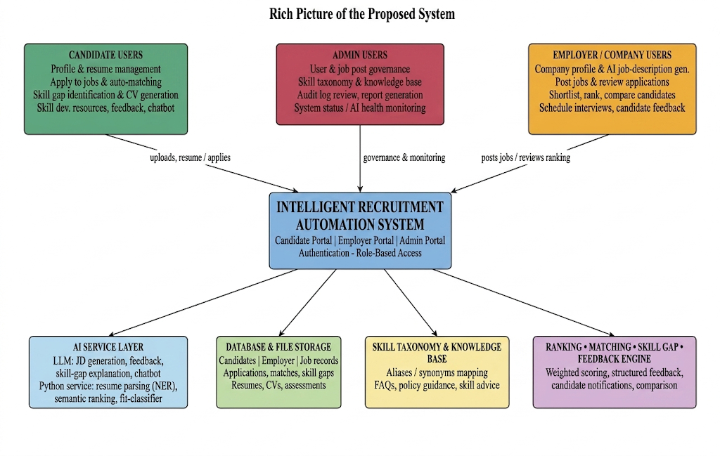
Figure 1.1: Rich Picture of the Proposed System. The diagram shows the Candidate, Employer/Company, and Admin user groups surrounding the central Intelligent Recruitment Automation System, together with the AI service layer, database and file storage, skill taxonomy, knowledge base, and the ranking/matching/skill-gap/feedback engine that the core system depends on. Arrows are labelled with the main information exchanged between each user group and the core platform (for example, "uploads resume / applies" and "posts jobs / reviews ranking"), showing that all interaction is mediated through the authenticated core system rather than occurring directly between user groups.

1.9 Resource Requirements

1.9.1 Hardware
The following hardware components are required for designing, developing, testing, and demonstrating the proposed system.
Hardware Resource | Minimum Requirement | Purpose
Laptop / Desktop Computer | Intel Core i5 or above, 8GB RAM or higher | System development, backend implementation, frontend testing, and documentation
Storage | 256GB SSD or above | Storing source code, database files, uploaded resumes, generated CVs, research documents, and development tools
Internet Connection | Stable broadband connection | AI API integration, package installation, research, version control, and system testing
Server / Cloud Environment | Basic cloud VM, local server, or hosting environment | System deployment, API hosting, database hosting, and project demonstration
Mobile / Secondary Device | Optional smartphone, tablet, or secondary display | Responsive UI testing and user interface validation
Backup Device / Cloud Storage | External drive or cloud storage service | Backup of source code, documents, datasets, and project deliverables

Table 1.1: Hardware Resource Requirements.

1.9.2 Software
The following software resources are required for development and evaluation.
Software Resource | Purpose
Windows Operating System | Main development environment
Visual Studio Code / Visual Studio | Frontend and backend development
React.js with Vite | Frontend web application development
Tailwind CSS | User interface styling and responsive design
ASP.NET Core Web API | Backend API development and business service exposure
C# / .NET | Backend programming and application logic implementation
SQL Server / SSMS | Database creation, management, and query execution
Entity Framework Core | Object-relational mapping and database migration management
Python FastAPI | AI service layer for resume parsing, skill extraction, and similarity processing
NLP / ML Libraries | Resume parsing, semantic similarity matching, skill extraction, and text preprocessing
LLM API | AI-assisted job description generation, feedback generation, skill-gap explanation, and chatbot support
QuestPDF | CV PDF generation
JWT Authentication | Secure login, user authentication, and role-based access control
Swagger / OpenAPI | API documentation and backend endpoint testing
Postman | API testing and request validation
Git and GitHub | Version control, source code management, and project backup
Docker | Deployment support and environment consistency

Table 1.2: Software Resource Requirements.

1.10 Project Scope
The scope of the research identifies what is, and what is not, part of the research.
In Scope | Out of Scope
Web-based recruitment automation platform | Full enterprise HR management system
Candidate, Employer, and Admin portals | Payroll and employee management
Candidate profile management | Employee attendance and performance management
Employer / company profile management | Full customer relationship management system
AI-assisted job description generation | Voice-based recruitment interviews
Resume upload and resume handling / parsing | Video interview analysis
Candidate ranking and application shortlisting | Psychometric testing
Skill gap identification | Legal employment contract generation
Skill development recommendations | Certification issuing or formal training delivery
Automated job-candidate matching | Full production-level commercial deployment
CV generation with PDF export | Advanced graphic CV design marketplace
Interview scheduling | Automated video conferencing analysis
Candidate feedback generation | Final hiring decision without human involvement
Recruitment-specific chatbot support | General-purpose chatbot outside recruitment
Knowledge base support for recruitment assistance | Public social media recruitment automation
In-app and email notification support | Large-scale enterprise communication suite
Admin user, job, skill, and report management | Complete job marketplace business operations
Audit logs and system status monitoring | Real-time large-scale enterprise load testing

Table 1.3: Project Scope.

The primary focus of this project is recruitment in the Information Technology and Software Engineering industry sector, with the resumes being written in English and focused on text. The resume can be submitted in common formats like PDF or DOCX. AI features and functionalities include: creating job descriptions, parsing resumes, ranking candidates, analyzing skill gaps, matching job and candidate, generating feedback, recommending skills development, generating CV's, scheduling interviews, sending notifications, and AI-based recruitment specific chatbot support. IRAS is not a commercial recruitment system, but rather a prototype and academic demonstration system.

1.11 Chapter Summary
Chapter 1 introduced Intelligent Recruitment Automation System and the background of the problem of recruitment that needs to be solved. The general and specific problems, the research question, the research motivation, the research aim, the research objectives, the rich picture of the proposed solution, the resource requirements and the project scope were discussed. The chapter confirmed that there is no single recruitment system that is capable of providing a comprehensive, transparent recruitment process from creating a job description to shortlisting applications, ranking the candidates, conducting a skill gap assessment, giving feedback to the candidates, generating CVs, scheduling interviews, notifying candidates, providing an integrated knowledge base, and using a chatbot to assist the candidates.

CHAPTER 02 - LITERATURE REVIEW

2.1 Chapter Overview
The literature reviewed for Intelligent Recruitment Automation System is discussed in this chapter. It summarizes the previous studies on the application of AI in recruitment, resume evaluation and automated matching of candidates with job descriptions, automated generation of job descriptions, candidate ranking, skill gap analysis, feedback generation, user profiling, CV generation, scheduling interviews, notifications, knowledge base support, and AI-powered recruitment chatbots.

The purpose of this chapter is to describe the significance of earlier studies, in the context of recruitment automation, and to highlight how each of these studies has addressed various aspects of the problem. It provides an objective evaluation of the contribution and limitations of each study rather than a simple summary and thus makes it possible to identify the research gap for a unified recruitment automation system that combines the processes of recruitment of candidates, recruitment of employers and administrative processes with the assistance and automation of artificial intelligence.

2.2 Conceptual Map of the Literature
The conceptual map of the literature categories the material reviewed according to its applicability to IRAS. The literature falls into several categories such as (but not limited to): Artificial Intelligence in the Recruitment Process, Parsing & Scanning Resumes, Semantic Matching between Job & Candidates, Automatic Job Description Generation, Candidate Ranking, Skill Gap Analysis, Candidate Feedback, User Profiling, CV Generation, Interview Scheduling, Auto Notifications, Chatbot Support, Knowledge Base Support, and AI Governance & Transparency.
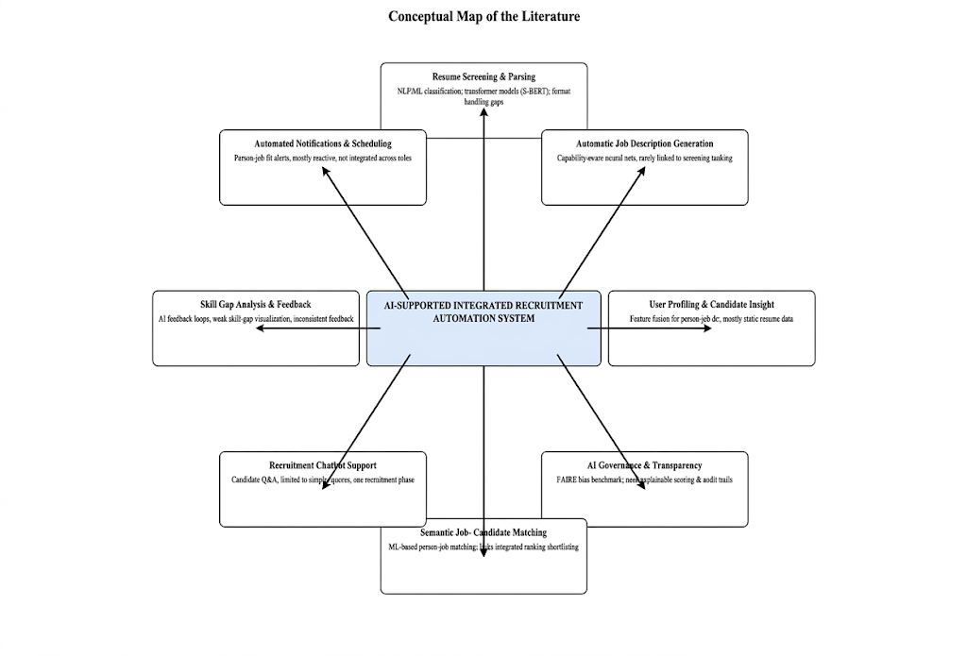
Figure 2.1: Conceptual Map of the Literature. The diagram places the proposed "AI-Supported Integrated Recruitment Automation System" at the center and surrounds it with the eight literature categories reviewed in this chapter — resume screening and parsing, automatic job description generation, user profiling, AI governance and transparency, semantic job-candidate matching, recruitment chatbot support, skill-gap analysis and feedback, and automated notifications and scheduling — each annotated with its strength and its main gap relative to an integrated platform.

From the conceptual map, it is evident that recruitment automation is a not a single research field, but it is a blend of multiple fields. A resume is used for short listing by the Employees by parsing and screening. Resumes can be matched, ranked, and scored to jobs using semantic matching and scoring. Automatic job description generation is a direct gain to the employer. Skill gap analysis, generation of feedback, and chatbot support improve candidate insight and guidance. It is complemented with a complete recruitment process which also includes user profiling, CV generation, scheduling, notification, and administrative monitoring.

2.3 Domain Overview
Recruitment is a process that involves attracting, screening, and selecting the right candidates for a given position. While in most modern organizations, recruitment activity is carried out through websites and Applicant Tracking Systems, the activities are still very much reliant on language understanding. The recruiters need to grasp the job requirements, understand the applicant's resume, know what skills, and experience they are looking for, compare candidates, make a decision and communicate clearly with the candidates.
With the nature of resumes, job descriptions, candidate feedback, and even conversations with chatbots being text-based, the role of Artificial Intelligence and Natural Language Processing in recruitment has significantly expanded. It is possible to extract information such as skills, education, work experience, training, certifications, and job requirements from such documents with a technique of NLP. Machine Learning and scoring-based techniques are used to classify resumes, rank order resumes, shortlist applications and match job with candidates. The semantic similarity techniques match the candidate profile and job description by their meaning, not by exact keyword match. During recruitment, the Large Language Models can write job descriptions, summarize resumes, write feedback, explain skills, and participate in chatbots.

According to recruitment trends, more and more businesses are turning to AI recruitment systems: LinkedIn found that the number of recruiting firms using generative AI increased from 27% to 37% over a period of just one year [3]. However, AI-powered recruitment processes can produce inequitable, ambiguous or indefensible outcomes if they are not properly managed [4, 7]. Therefore, the role of AI in recruitment must be seen as a tool for decision-making, rather than a replacement for human effort, to help streamline the process and make it more efficient, transparent, and helpful for candidates, while still allowing for monitoring of recruitment results.

2.4 Existing Systems / Frameworks / Designs
The literature review of the existing recruitment systems is divided into several categories: resume screening systems, semantic matching systems, job description generation systems, AI feedback systems, user profiling systems, job candidate matching systems, chatbot-assisted recruitment systems, and AI governance studies. All of these categories are associated with the research problem being investigated but are only applicable to a particular aspect of the recruitment process, and therefore cannot be considered a solution to the entire recruitment process.
The technology that was used for recruitment automation focused mainly on resume screening. Shahbaz [1] spoke on how to automate the process of recruitment and showed how some activities can be made more efficient, thereby minimizing human effort. Yadav et al. [8] used NLP and ATS algorithms to analyze resumes. While these studies are related to the issue of resume screening, they don't apply to other important recruitment tasks like creating job descriptions, providing feedback to candidates, identifying skill deficits, arranging job interviews or assisting candidates generally.
There have been several studies that have leveraged Machine Learning and NLP to perform Resume Shortlisting & Classification. In one of the recent works, Naik and Fal Dessai [9] introduced a shortlisting and classification technique of resumes using machine learning. Weaknesses include Kabir's method, IntelCV [10] which is a smart approach to selecting skilled resumes. Kinge et al. [11] suggested to use Machine Learning and NLP techniques for Resume Screening. While these are useful examples of how ML and NLP can make things easier for the recruiter, not all of these systems provide candidates with any clarity as to why they were chosen, or why they were not.
Recent research focuses on the resume screening with deep learning and transformer models. Gan et al. [12] proposed a LLM agents model for resume screening. The advantage of transformer-based models in understanding semantics was shown by Deshmukh and Raut [13] in their work on improving the resume screening process using S-BERT. Mehboob et al. [14] assessed machine learning based CV shortlisting systems and Mhatre et al. [15] employed a CNN to rank and shortlist CVs. The possibilities of semantic ranking and deep learning are being illustrated in these studies, but resumes can come in all sorts of shapes and forms and there's so much more to the recruitment challenge than semantic ranking alone.
Another important area of research is the generation of job descriptions. Qin et al. [1] introduced an automatic job description generation system based on capability-aware neural network. It is relevant because a job description is the criteria used to match and rank the candidates, and many of the techniques currently used to generate job descriptions are not connected to resume screening, skill gap analysis, or candidate evaluation; Job description generation should not be an isolated process but part of a process in the recruitment pipeline.
The studies indicate that Large Language Model is beneficial for analyzing resumes and providing feedback. Pranav and Hari [16] implemented a prototype AI system that uses LLMs for screening resumes. Skill-Fitment Analysis is the main feature of the Applicant Tracking System built by Patil et al. [17] using GenAI. Saxena et al. [18] investigated the potential of LLM to analyze resumes and AI feedback loops. Venkatesh et al. [19] studied automated resume analysis and suggestion of skills by the help of NLP. Lohith et al. [20] introduced a novel method for NLP based resume analysis, skill enhancement and job automation. Evidence from these studies demonstrates the feasibility of Resume Analysis, Recommendation and Candidate Support with AI, but many do not have a complete role-oriented platform for the candidate, employer, and administrators all at once.
Feedback from candidates is an essential part of the transparent recruitment process. During the screening stage, Abhishek et al. [21] focused on the use of AI to recommend resumes. Senghore et al. [22] suggested a person-job fit model for talent acquisition and made use of BERT. Buddana et al. [23] investigated the text generation task with LSTM and RNN-based networks. LLM agents were also explored by Gan et al. [12] for recruiting. Feedback is not yet considered a standard part of the recruitment process and many recruitment systems don't offer feedback to candidates who didn't succeed, although these studies offer a useful background when developing explanation and feedback systems using AI; here, feedback is not treated as an add-on to the recruitment system, but rather it is considered a part of it.
Another crucial component of intelligent recruitment is user profiling. A. Sahoo [24] did research on candidate profiling in recruitment and selection. The Sroison and Chan [25] talked about NLP techniques for the parsing of resumes. To build person-job matching methods, Jiang et al. [26] suggested feature-fusion methods. In this body of work, it has been found that structured candidate information can improve the accuracy of matching, but the majority of systems only use the static information on resumes, not a dynamic candidate profile. All of the following information is utilized by the candidate profile, skills, resumes, CV information and application history for matching, identification of skills gaps, feedback and chatbot guidance in this research.
Another integral component of recruitment automation is automatic job-candidate matching and notification. Although feature fusion plays a key role in person-job matching, as pointed out by Jiang et al. [26] many person-job matching systems are reactive, that is, they evaluate candidates after they have applied for a job. The proposed system also provides notification support so that a recruitment system can support the proactive matching, which means that it can suggest suitable jobs to candidates and inform candidates about the recruitment activities.
The recruitment application of chatbots has also been studied. Monica et al. [27] explored the attitude of the people seeking employment towards AI-driven chatbots in recruitment. Nikumbe et al. [6] created an AI portal for employment that is backed by a chatbot. The above studies show the capabilities of chatbots to improve the effectiveness of communication and recruitment, but the use of chatbots is often limited to specific questions or a recruitment stage. The research specifically addresses the chatbot support for the improvement of the candidate profile, explaining the skill gaps, supporting the job application, interpreting feedback and assisting in knowledge base within roles.
The recent trend in the literature has also been towards auditing and transparency, and human oversight, of AI-assisted recruitment. Wen et al. [4] proposed a benchmark, FAIRE, and showed that the evaluation of resumes using LLM can be racially and gender biased. AI-driven recruitment can positively influence the recruitment process and outcomes as discovered by Aka et al. [28]. Wilson et al. [7] have shown that AI can impact the human decision-making process when screening resumes. These studies are important because it shows that AI recruitment is not just about AI output; if it is, it means that recruitment automation is incomplete.

Research Area | Existing Focus | Strength | Limitation | Relevance to Proposed System
Resume Screening | NLP and ML-based resume filtering | Reduces manual screening effort | Limited explanation and candidate feedback | Supports resume handling and application shortlisting
Candidate Ranking | ML, CNN, BERT, and S-BERT-based ranking models | Improves candidate matching accuracy | Ranking may not be transparent or explainable | Supports candidate ranking and scoring engine
Job Description Generation | AI-generated job descriptions | Improves job post quality and structure | Often not integrated with resume screening and ranking | Supports AI-assisted employer job creation
Skill Fit Analysis | Comparison of candidate skills with job requirements | Identifies candidate suitability | Skill gaps may not be clearly explained | Supports skill gap analysis and skill development recommendations
Candidate Feedback | AI suggestions and resume feedback | Improves recruitment transparency | Feedback is often limited, generic, or inconsistent | Supports automated feedback generation
User Profiling | Candidate grouping and structured profile data | Improves matching and recommendation quality | Profiles are often static or incomplete | Supports candidate profile management and long-term matching
Job-Candidate Matching | Person-job fit and recommendation models | Improves job recommendation and candidate selection | Mostly reactive, after application submission | Supports automated and proactive job-candidate matching
CV Generation | Resume/CV structuring and document creation | Helps candidates present information professionally | Rarely connected with recruitment matching workflows | Supports CV builder and PDF generation
Interview Scheduling | Digital scheduling and recruitment coordination | Reduces coordination effort | Usually separate from matching and feedback systems | Supports interview scheduling workflow
Notification Support | Automated recruitment updates | Improves communication between users | Often limited to basic status alerts | Supports candidate and employer notifications
Chatbot Support | Candidate Q&A and recruitment guidance | Improves communication and user support | Limited lifecycle support across recruitment stages | Supports recruitment chatbot and knowledge base assistance
AI Fairness Research | Bias, transparency, and human-AI decision studies | Identifies ethical risks in AI recruitment | Does not usually provide complete system design | Supports responsible design, explainability, audit logs, and evaluation

Table 2.1: Comparison of Existing Recruitment Research.

Based on the comparison above, it is understood that any existing system can be used as a basis for individual systems, but none of the existing systems are considered as a whole system. This research is justified by its inclusion of these functions within a single, integrated system.

2.5 Technological Analysis

Technological analysis includes the algorithms, design techniques, system architecture and work flows of IRAS. Algorithmic analysis, design analysis and workflow analysis are the three parts into which this section is broken down, reflecting the intelligent recruitment capability provided by AI assisted and automated functions.

The analysis focuses on the use of technologies like Natural Language Processing, Large Language Models, structured scoring algorithms, database management, API-based communication, CV PDF generation, notifications, and chatbot support in the system. This section is important because the research is from a software engineering perspective and the technology selected should be technically sound as it pertains to the proposed recruitment solution.

2.5.1 Algorithmic Analysis
The following are some algorithmic approaches of interest to IRAS.
The first one is text extraction and pre-processing. The system needs to be able to process resumes and job descriptions, regardless of their format (PDF, DOCX, or plain text). The text should be cleaned, meaning that symbols, unnecessary spacing, formatting artefacts and irrelevant information should be removed, which has a direct effect on the accuracy of the parsing, skill extraction, candidate ranking and matching further downstream.
The second is parsing and information extraction of resume. Resume parsing retrieves crucial information such as name, contact details, education, work experience, certifications, technical skills, projects, and job-related skills. Even though Named Entity Recognition can help identify important entities from unstructured resume text, the system will not be successful in all resume formats or in cases where important entities are missing from the resume, candidates should be able to view and edit the entities extracted from their resume.
The third is skill extraction and normalization. Technical skills can be used in different ways in resumes and job postings, such as when they are synonymous but different spelling - for example, “C# backend development” and “ASP.NET Core Web API” mean the same thing, and “JS” and “JavaScript” also mean the same thing. Extracted skills are mapped to a standardized taxonomy of skills, and this mapping helps to avoid mismatches due to inconsistent naming, while still providing accurate matching.
The fourth is semantic similarity analysis. Traditional keyword matching involves searching for an exact match of words in a resume and a job description, while semantic similarity refers to the meaning of the words. TF-IDF, cosine similarity, word embeddings, sentence embeddings, BERT, and S-BERT are examples of techniques that can be employed for this purpose. S-BERT is especially important as it will be able to embed a resume and a job description as sentences and compare them semantically [13]. This will provide an advantage to the proposed system over the simple keyword matching, as variety of terms related to each other can be used to represent related IT skills and IT roles.
The fifth one is candidate ranking and scoring. There is no single way to measure the suitability of candidates, and multiple factors can be used to help determine the rank: skill match, experience match, education match, qualification match, and semantic similarity. The ranking process has also been given more structure and explanation by using a weighted scoring method to calculate the end of match score.
A sixth is the identification of the skills gap. The system matches the skills of a candidate to a chosen job, and it highlights areas where skills fall short of the standards, if any; any gaps in skills are used to provide suggestions for learning or improvement. This is important because it is a development feature, rather than an elimination feature.
The seventh one is text generation with LLM. Using the provided information by the employer such as job title, duties, required skills, and experience level, an LLM can be used to create structured job descriptions. LLMs can also be used to generate feedback to explain why a candidate is a good or bad fit for a job and what is suggested for improvement; again, LLM output needs to be controlled so that it does not contain irrelevant, biased or fabricated content, and that human intervention remains vital for fairness and transparency [4], [7].
CV generation is the eighth. The CV builder doesn't need any machine learning model to generate a professional PDF document, it instead relies on structured candidate profile information such as skills, certifications, education and experience to create the document, so that candidate details can be displayed in a consistent, readable format.
The ninth is generating responses from a chatbot. The chatbot is designed to only respond to questions related to the system or the task, enabling candidates to create their profile, understand their skills gaps, be guided in their application process, and interpret feedback. The chatbot should be based on a set of recruitment-related answers or questions and should not be a generic chatbot; candidate data should be used only in a privacy-conscious way.

The tenth is a measurement of evaluation. The candidate ranking can be measured by precision, recall, F1-score, or by comparison with the human judgement. Resume parsing can be assessed using the extraction accuracy. Skill gap identification can be validated by comparing the gaps identified by the system with gaps identified by hand. Relevance, completeness, clarity, and fairness are appropriate measures for evaluating AI-generated job descriptions and feedback; and relevance, accuracy, usefulness, and user satisfaction are appropriate measures of chatbot effectiveness. It's crucial that the system is not only an AI recruitment program, but also a functional software program, and all of these factors play a role in the evaluation.

2.5.2 Design Analysis
As the responsibilities and system requirements vary among different user groups, IRAS will be designed to cater to three broad user roles: Candidate, Employer and Admin. The candidates should have features like profile management, resume upload, job search, application tracking, skill gap feedback, CV generation, notification, and chatbot support. Employers require the management of the company profile, job posting, job description generation using AI, review of applications, ranking of applicants, comparison of applicants, scheduling interviews, managing feedback and reports. All of this requires a configuration by administrators, monitoring of users, monitoring of job posts, managing the skill taxonomy, managing the knowledge base, generating reports, reviewing the audit log, monitoring system status, and configuring the system.
The system design is layered. The presentation layer provides the web-based user interface to candidates, employers and administrators. API layer receives input from the frontend, validates the users, fetches data from other services, and acts as a bridge between the frontend and backend. The application layer holds the crux business logic - recruitment processes, evaluation, matching, response generation, communications, resume handling and operating the chatbot. The domain layer contains the domain objects of the system: Users, profiles, jobs, skills, interviews, responses, resumes, alerts, and audit logs. The infrastructure layer covers database operations, file management, and integration with the external AI service.
It is highly flexible and easily modifiable, so this layered approach is appropriate. The AI-based elements, such as the resume ranking algorithm, explanation of skills gaps, creating feedback, and the response from the chatbot, can be tweaked as better models, prompts, or algorithms are developed, and the knowledge base and skill taxonomy can be refined over time for improved accuracy and relevance.
The system design also prioritizes security and confidentiality, incorporating features such as authentication, role-based access control, secure file management, and auditing, which are crucial for safeguarding sensitive data. All candidates' resumes, recruitment decisions, applications and job offer information are all kept safe. Candidates can only view their own profile, feedback, notifications, applications and CV. Only employers have access to their own company profile, job posts, applications, interview information and candidate evaluations. Administrators only have access to platform-wide management and monitoring features.

From a design perspective, the proposed system has more power than are any of the individual AI applications, as it includes AI decision support with workflow structuring and system usability. Everything from Candidate ranking to Skill gap analysis, Feedback generation, CV generation, Interview scheduling, Notifications and Chatbot support are not standalone tools, but are integrated into a recruitment platform that enables an employer to decide and let candidates know and keep the process transparent.

2.5.3 Workflow Analysis
It is designed in a way that each workflow connects to each other and is used for recruitment from preparing and creating the job to giving feedback to candidates.
The initial one is the creation of jobs by the employer. The employer logs in, inputs very little information about the position, and then the AI-powered job description generator creates a structured job description, which the employer can edit and then approve before posting the job. Employer validation is crucial for the job descriptions generated by AI, and they are not published without it.
The second workflow is handling of candidate profiles and resumes. A job seeker registers, makes a profile and uploads a CV that contains details about education, experience, qualifications, and abilities. The system tries to pull out important information from the resume file automatically, though the information retrieved isn't always correct because there are various types of resumes, and the candidate has the option to go and check and edit the retrieved information.
The third workflow is application screening and candidate ranking. On job applications, the candidate information (profile, resume, skills, experience, qualifications) is aligned with the requirements of the job and returns a suitability or match score that enables the employer to see the candidates' ranked and compared suitability and match.
Skill Gap Analysis is the fourth workflow. It compares a candidate's current skills to the skills needed in a specific job and identifies any missing or weak skills as candidates are eliminated (not just identified as skills that need to be developed); it then displays the list of missing or underdeveloped skills, tips for improving them, and suggestions on how to build skills and knowledge.
The fifth workflow is automatic job-candidate matching. The system identifies candidates whose profile and skills match the requirement of a posted job and suggests or notifies the suitable candidate for that job; so that candidates don't have to search for every job, it is a less passive recruitment system.
CV generation is the sixth workflow. Candidates have the ability to use profile information (educational history, work experience, skills and certifications) to generate a professional CV in PDF format, which enables them to build a consistent, structured CV from the information already available in the system.
The seventh workflow is the scheduling of interviews. After the candidate is reviewed and ranked the employer can schedule an interview for the candidates who have been shortlisted by the system and information regarding the interview is stored and notifying the employer and the candidate with the scheduling information improves coordination between the employer and candidate.
The feedback process is the eighth workflow. If the candidate is rejected or advised to improve, the system gives feedback to let the candidate know why he/she was rejected and what skills should be developed in future applications to become a better candidate.
Notification handling is the ninth workflow. The system can alert users regarding recommendations for jobs, application updates, scheduling interviews, providing feedback, and other recruitment-related information, thereby enhancing communication between candidates and employers during the recruitment process.

Chatbot support is the tenth workflow. The candidate can ask questions related to the recruitment process, get to know what he/she is lacking in skills, receive tips on improving his skill profile, understand feedback, and get support for the application process, the chatbot has limited content in terms of what it can respond to, only those that are directly related to the recruitment process and are based on the knowledge base, so as to keep the content relevant and correct.

2.6 Reflection
In the recruitment industry, AI has been found to be of great value. On resume screening, semantic matching, and generation of job description, positive results have been reported in previous studies; for skill matching, chatbot support, candidate profiling, and AI-assisted feedback, positive results have been reported. But all of the literature is dedicated to individual modules, not a full recruitment environment. This validates the research gap obtained in this study: Recruitment automation should be provided through an integrated system that comprises of creating job descriptions, shortlisting applications, ranking candidates, skill-gap analysis, feedback to the candidates, user profiling, automated job-candidate matching, CV generation, appointment of interviews, notifications, knowledge base support and chatbot support.
The review also shows that recruitment automation can not only make things more efficient for the employer, but it can help candidates as well, by making the process more transparent and helping them improve. There are many AI systems that can rank or filter candidates, but only a handful can rank, explain, identify missing skills and provide candidates with truly useful feedback (an important step to ensure the candidates future direction).
It is also emphasized that AI should be used responsibly in the recruitment process. The LLM-based resume evaluation can be also racist and gendered, as indicated by the benchmark FAIRE [4], and the AI-recommendation studies reveal that biased AI-recommendations can affect the decisions of the person in charge of the recruitment [7]. Consequently, the system proposed is not intended to make a completely automatic decision on recruitment but is an open decision support system that will offer structured scores, explanations, feedback and monitoring, which will be left at the discretion of the employer.
Overall, IRAS steps in to connect the missing links with automation for employers, visibility for candidates, and oversight for administrators. For employers, it covers preparing job descriptions, publishing job posts, assessing applications, scoring candidates, comparing candidates, arranging interviews, gathering feedback and reporting. For candidates, it covers profile management, CV upload, job matching, skill-gap identification, CV composition, feedback, and chatbot notifications. For the administrators, it covers user administration, monitoring of jobs, skill taxonomy management, knowledge base management, reporting management and system management. All literature that were reviewed in this chapter were published between 2016 and mid-2026, with the majority of the literature from the past five years, thus the review is current and up to date.

CHAPTER 03 - METHODOLOGY

3.1 Research Paradigm

This study uses the pragmatic research approach. Pragmatism is appropriate for this research because it focuses on a practical recruitment problem and wants to create and build a software product.

Multiple types of evidence can be used for assessing the system in the paradigm. Technical evidence related to matching accuracy, candidate-relevance to ranking, skill-gap identification accuracy, processing time, CV-generation correctness, and the quality of the feedback can be considered along with the human-centered evidence of usability, transparency, usefulness, and user satisfaction. This is fitting as IRAS needs to be evaluated technically and user perspective.

Pragmatism is also important as it's a matter of reality: recruitment automation is a real problem that employers and candidates must deal with. Businesses desire quicker, more consistent, more detailed, more predictable shortlisting; while candidates desire transparency, feedback, skill advice and communication. The work in this thesis is thus oriented towards finding a practical solution that would overcome these practical constraints in the recruitment process.

3.2 Research Approach

The research design in this research is a research design that uses mixed methods and is guided by the pragmatic approach. The qualitative component involves literature review, analysis of the existing recruitment processes, identification of user requirements, and feedback on usability, transparency and satisfaction of the user regarding the system. The quantitative part consists of the analysis of the accuracy of the candidates ranking, resume data extraction accuracy, match relevance, skill gap identification accuracy, process efficiency, correctness of CV generation, and user satisfaction ratings.

Both deductive and inductive reasoning are used in this research. When existing theories, literature-review techniques and findings are leveraged to design the system, it is called deductive reasoning, e.g., concepts from NLP, semantic similarity, LLM, scoring-based ranking, and Design Science Research Methodology are used to design the system. Inductive reasoning is used when observations made from prototype testing, system output and user feedback are used to improve the system. This is a suitable combination because the research includes the design, development, testing and improvement of a software product, which is based on evaluation results.

In practice, there was at least one case where a disagreement between the qualitative and quantitative evidence was resolved through this mixed approach: A constraint (practical and engineering based) found during integration testing was of higher priority than the quantitative results, which in this case were in favour of XGBoost (the highest accuracy model), and was used to make the decision to use Logistic Regression instead. If a purely quantitative research approach had been selected, there would have been no principled basis for making such a decision, while the pragmatic paradigm taken in Section 3.1 clearly indicates that the need for deployment reliability – a type of practical evidence – could be as strong as, or even stronger than, a small gain in accuracy.

3.3 Research Strategy

This study uses Design Science Research Methodology (DSRM) as its research strategy. This methodology is suitable for software engineering research because it involves designing, developing, demonstrating and evaluating artifacts and the artifact studied is the Intelligent Recruitment Automation System (IRAS).

The research is motivated by the practical recruitment problem, and a technological solution is offered to this problem, so this makes DSRM justifiable. It organizes the study along the important phases in problem identification, goal setting, design and development, demonstration, evaluation and communication. The goal of this research is to build and test an automated recruitment system and DSRM provides a structured approach to building the automated system and testing it.

The system is available in 3 workflows each automated and web-based, with AI-based and automated Job description creation, Resume Management, application shortlisting, skills ranking, skill gap analysis, automatic Job matching with CVs, CV creation, interview scheduling, resume feedback, resume notification, knowledge base support and recruiting chatbot.

3.4 Fact Collection Mechanisms

This research uses several methods to get the facts to design, develop and test the system.

Literature review is conducted by reviewing research papers, journal papers, conference papers, and industry reports on the use of AI in recruitment, CV screening, CV matching with job posts, AI-powered text generation, skill gap analysis, recruitment chatbots, CV generation, scheduling interviews, sending notifications, and fair AI hiring. This assists in identifying existing solutions and their weaknesses, as well as existing weaknesses in the research.

Second, second data analysis is carried out to understand the structure of resumes and job description based on resume datasets, resume entity-recognition datasets, publicly available resume samples, publicly available job description samples and open source recruitment datasets. This information helps in knowing about the format of the resume, how to extract skills from the resume, what are the requirements of the job, and how to match skills.

Third, synthetic data is used in system testing. Synthetic candidate profiles, resumes, job postings, applications, interview records and feedback samples are used to test system functionality, but no actual, personal data is shared; recruitment data is sensitive information of both candidates and employers.

Fourth, prototype-based testing collects technical facts on resume parsing accuracy, candidate-ranking relevance, skill gaps, job-candidate matching, and quality of AI-generated job descriptions, correctness of CV generation, scheduling functionality, feedback quality, notification delivery, and relevance of chatbot responses.

Fifth, user feedback from sample users (students, potential candidates, employers and academic evaluators). This feedback evaluates the usability, transparency, usefulness, candidate experience and the overall satisfaction of the system. The execution workflow for the research methodology is discussed in part 3.5. The Research Methodology Execution Workflow (Figure 3.1) provides an understanding of how the research is carried out starting from the problem identification up to communication. This workflow is based on the Design Science Research framework and customized to fit the recommended system development process.

3.5 Research Methodology Execution Workflow
The Research Methodology Execution Workflow (Figure 3.1) provides insight into the execution of research from identification of the problem to communication. This workflow is based on the Design Science Research framework and customized to fit the recommended system development process.
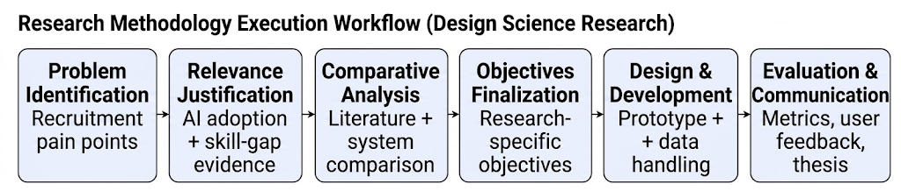
Figure 3.1: Design Science Research Methodology Execution Workflow. The diagram shows the six sequential stages followed in this research — Problem Identification, Relevance Justification, Comparative Analysis, Objectives Finalization, Design and Development, and Evaluation and Communication with each box annotated underneath by the concrete evidence base used at that stage, for example recruitment pain points at the identification stage and prototype and data handling at the design and development stage.
Stage | Activity | How It Is Addressed in This Research
Problem Identification | Identify recruitment issues | Manual screening, poor feedback, inconsistent ranking, weak transparency, interview coordination issues, and fragmented tools are identified
Relevance Justification | Justify why the problem matters | Recruitment affects both employers and candidates; AI adoption is increasing, but explainability, fairness, and transparency are required
Comparative Analysis | Compare existing studies | Literature on resume screening, job matching, LLMs, feedback generation, user profiling, CV generation, interview scheduling, notifications, and chatbots is reviewed
Gap Justification | Identify missing areas | Lack of a unified system, limited candidate feedback, weak skill-gap explanation, limited chatbot lifecycle support, and lack of integrated CV/interview support are identified
Objective Definition | Define research objectives | Objectives are structured under identify, analyze, design/develop, and evaluate stages
Design | Design proposed system | Candidate, Employer, and Admin workflows, system architecture, database design, and AI-assisted modules are designed
Development | Implement system modules | Web frontend, backend APIs, database, AI service integration, authentication, CV generation, notification support, and chatbot integration are developed
Data Management | Prepare and handle data | Resume data, job descriptions, skill datasets, candidate profiles, and synthetic test records are cleaned and structured
Demonstration | Show working prototype | Main workflows are demonstrated using sample users, test resumes, job posts, applications, CV outputs, and interview records
Evaluation | Evaluate the system | Matching relevance, ranking accuracy, skill-gap identification, CV-generation correctness, processing efficiency, usability, feedback quality, and chatbot relevance are measured
Communication | Present research outcomes | Interim reports, final thesis, presentation slides, system screenshots, and prototype demonstration are prepared

Table 3.1: Research Methodology Execution Workflow

3.5.1 Problem Identification

The issue is not insignificant, as recruitment has a big impact on the performance of the organization and opportunities for careers. A streamlined, accurate, and systematic hiring process is vital for locating the right person, avoiding hiring delays, and making informed hiring choices. Candidates should also be given information about closing skills gaps, feedback on their CV/Resume and guidance to enhance the employability following a job application, information about the outcome of a job application and clear recruitment practice.

This is also a big issue as AI is increasingly being used in the recruitment process. AI can improve efficiency by generating job postings, scanning resumes, scoring candidates, comparing candidate and job skills, identifying skill gaps, giving feedback and assisting candidates with a chatbot. Recent studies, however, indicate that careful design and monitoring of AI-based recruitment systems is needed to decrease bias, increase explainability, and maintain human control over recruitment decisions [4], [7].

3.5.2 Relevance Justification

The problem is significant because recruitment has a direct impact on organizational performance and career opportunities of the candidates. Companies need an effective, precise, and streamlined recruitment system to find the right candidates, minimize hiring time, and make better hiring decisions. Candidates need to be provided with clear recruitment protocols that will enable them to know the status of their applications and what skills are lacking, how to enhance their CVs or resumes, and how to become more employable.

The importance of this is that AI is becoming a crucial part of the recruitment process. AI can enhance efficiency by creating job descriptions, managing resumes, ranking candidates, matching jobs to candidates, conducting a skills gap analysis, providing feedback, and offering chatbot assistance. However, recent studies reveal that AI-driven recruitment tools need to be carefully engineered and closely monitored to minimize bias, increase explainability, and retain the power of human decision-making in the recruitment process [4, 7].

3.5.3 Comparative Analysis and Gap Justification

The comparative analysis is done in literature review (Chapter 2). Existing methods/systems are discussed with respect to job description generation, handling of resumes, shortlisting of applications, ranking of candidates, identification of skill gaps, candidate feedback, user profiling, automatic job-candidate matching, CV generation, scheduling of interviews, notifications, knowledge base support and chatbot support.

This research is justified because they are only dealing with a single recruitment task at a time. While some people think about resume screening, some about only job matching, job description generation or chatbot assistance, etc., few systems provide one unified, role-based, transparent platform for the recruitment automation, support for candidates, and monitoring by the administrator within one system.

3.5.4 Define and Finalize Objectives

The research objectives were determined after the research gap was identified and the issues that were identified in the recruitment process were done. The aims are for the main stages of the study, namely: Identification of the limitations of the current systems, analysis of the systems and technologies, design and development of the proposed system and evaluation of the final prototype.

The finalized objectives are: to identify the shortcomings from the traditional and AI supported recruitment systems; to analyse existing literature and technologies related to intelligent recruitment automation; to design and develop IRAS including roles for candidates, employers and administration; to evaluate the system with respect to matching relevance, ranking accuracy, identification of skill-gaps, correctness of CV generation, feedback quality, usefulness of the chatbot, usability and transparency.

3.5.5 Design / Development / Data Management and Handling

The stage involves system architecture design, database design, user-interface design, backend API development, AI-service integration, and chatbot development. It includes authentication and role management, candidate profile management, employer profile management, AI generation of job descriptions, resume upload and management, candidate ranking, resumes shortlisted for applications, skill gap analysis, automatic job-candidate matching, CV generation, scheduling of interviews, generation of candidate feedback, employer-specific chatbot support, notification management, admin management, reporting, audit logging, and system monitoring.

Data Management consists of collecting and structuring sample resumes, job descriptions, skill lists, candidate profiles, application records, interview records, feedback samples, and chat bot question and answer material. If applicable, recruitment data is anonymized or synthesized to not include sensitive information regarding a real person. Data pre-processing is the process of extracting text, cleaning it, normalizing it, recognizing entities, mapping skills, structuring the data in a format suitable for the profile management, profile matching and profile ranking, identifying skill gaps, generating feedback and supporting chatbots.

3.5.6 Evaluation and Communication

To check the effectiveness, accuracy, and usability of the proposed system, evaluation is conducted. Candidate ranking and matching is evaluated by precision, recall, F1-score, ranking accuracy and relevance. The data is extracted from the resume and compared to the manually verified data for resume parsing accuracy, and the manually verified skills are compared to the skills extracted from the resume for skill-gap analysis.

Relevance testing of usability, usefulness, and correctness of AI-generated job description, feedback, CV generation, interview scheduling, notifications and chatbot responses; feedback from candidates, employers, academic assessors. The communication phase involves Interim Submission 01, Interim Submission 02, this final thesis, project presentation and system demonstration.

3.6 Project Management Methodology
Scrum is the project management methodology that this research will use. This is a software-based project with multiple modules, changes to requirements, the use of AI to enhance functionality, and the continual improvement of the software. This project involves software development across three different areas (Candidate, Employer, Admin) and can be worked on and tested incrementally.
This allows Scrum to be divided into sprints focusing on different aspects of the software, such as authentication, candidate profile, job posting, resume parser, AI ranking algorithm, skill-gap analysis, chatbot, admin functionality, and report generation. In a research prototype, there is also a need for review and continuous improvement, which is also supported by Scrum. Scrum was also considered to be the better choice for task management, as there are different stages of development and deliverables in the project. Kanban would also be suitable for this, but Scrum was deemed more appropriate for this purpose.

3.6.1 Project Timeline
The project timeline is structured with the main activities of research and development and is aligned with the stages of writing proposals, literature review, data preparation, design, development, evaluation, and documentation.
Figure 3.2: Project Timeline. The Gantt-style chart shows six project phases spanning the academic year — Inception and Planning, Data Acquisition and Preparation, Core Model Development, System Development and Integration, Evaluation and Testing, and Final Documentation and Closure — plotted month by month from November through September, with each phase broken down into its constituent tasks such as the job-description generator, the CV screening and ranking engine, the chatbot assistant, and the skill-gap analysis and feedback module.

3.6.2 Ethical Considerations
Ethical considerations are important because the recruitment process deals with information about job seekers and companies and can affect someone’s chances of getting a job. The system being proposed must make sure that the final decision about hiring is made by a person and not by AI. Also any feedback from AI should help recruiters without being unfair to applicants.
Ethical Area | Risk | Mitigation
Candidate Privacy | Resumes contain personal and sensitive information | Use anonymized or synthetic data where possible
Data Security | Unauthorized access to candidate or employer data | Apply authentication, role-based authorization, secure file handling, and protected storage
Informed Consent | Users may not clearly understand how their data is used | Inform users about data usage for matching, ranking, feedback, notifications, and chatbot support
Bias in AI | AI ranking or feedback may unfairly affect candidates | Focus evaluation on relevant skills, qualifications, experience, and explainable scoring
Transparency | Candidates may not understand application outcomes | Provide feedback, match explanations, and skill gap details
Human Oversight | AI may be treated as the final decision-maker | Use AI as a decision-support tool while keeping final decisions under employer control
Chatbot Misuse | Chatbot may answer irrelevant or unsuitable questions | Restrict chatbot responses to recruitment-related and knowledge-base-supported content
Secondary Data Use | Public datasets may include sensitive information | Use ethical, anonymized, or synthetic datasets only
CV and Resume Handling | Generated CVs and uploaded resumes may expose private details | Limit access to the relevant candidate and authorized employer only
Audit and Accountability | System actions may not be traceable | Maintain audit logs for administrative monitoring and accountability

Table 3.2: Ethical Considerations.

3.7 Chapter Summary
This chapter explained the research method used to create IRAS. The research uses an approach and a mix of methods. Design Science Research is the strategy because its about creating and testing a software product. The chapter also described how facts were collected, how the method was carried out the way the project was managed the schedule of the project and the ethical issues that influenced the study. Chapter 4 continues this by turning the research goals into a set of requirements for IRAS.

CHAPTER 04 - SYSTEM REQUIREMENT SPECIFICATION

4.1 Chapter Overview
This chapter changes the research goals and methods from Chapters 1 to 3 into a System Requirement Specification (SRS) for the Intelligent Recruitment Automation System. It lists the people involved with IRAS and what they care about. It explains how the requirements were turned into behavior for the system and it shows the system and model analysis. Use case diagram and details class diagram, activity diagram and sequence diagrams. That were used to design the system in Chapter 5. The chapter ends with the way the system is built and the main functional and non-functional requirements.

4.2 Stakeholder Analysis
Three main roles interact directly with IRAS. A fourth role, the AI service provides the intelligence behind some of the systems automatic features.
The Candidate is a person looking for a job who signs up on the platform creates a profile, uploads and manages a resume looks for and applies for jobs gets job matches sees their skills compared to a target job works on a plan to improve skills shows proof of learning creates a CV gets feedback and messages and uses the recruitment chatbot. The main worry for the Candidate is fairness and clear information: they want to know why they got a score or were rejected and what they can do to improve.
The Employer is someone from a company who signs up makes job postings with help from AI posts jobs (after being checked by an admin) looks at a list of applicants that is ranked and explained compares people adds a skill test if needed arranges interviews and gives feedback. The main worry for the Employer is speed without losing trust in the list of candidates: a list that is quick to make but can still be checked.
The Administrator is the person who runs the platform. They manage users check job postings keep the list of skills up to date maintain the information base look at the records of what happened check how the AI is working and create reports. The main worry for the Administrator is control: making sure that AI helps in the way and that everything can be checked later.
The AI Service is not a person. Does not interact directly with the system. Its actions (how well it reads resumes how well it understands meaning how confident it is in its choices and how good its text is) shape what everyone else experiences. It is used through the back end of the main platform.
These four people do not have the level of influence in every choice. When a Candidate wants reasons and an Employer wants quick results like showing a full score breakdown versus a simple pass/fail the system always chooses what is best for the Candidate. This is because the main problem the research was trying to solve was when people got rejections without any explanation. A fast but unclear list would help the Employer but not the Candidate.
Stakeholder | Primary Concern | How IRAS Addresses It
Candidate | "Why was I rejected, and what should I improve?" | Explainable, weighted match score; AI-explained skill gap; personalized improvement plan with evidence review
Employer | "How do I shortlist quickly without missing a good fit?" | Multi-signal ranked applicant list broken down by skill, experience, education, and assessment score
Administrator | "Is the AI behaving, and can I prove it?" | Job moderation queue, audit log of AI-influenced actions, AI-service health monitoring, reporting
AI Service | (indirect) Correctness and availability of parsing, ranking, and generation | Bounded-confidence review paths, health-check endpoint, template fallbacks when the AI service is unavailable

Table 4.1: Stakeholder Concerns and System Response.

4.3 Operationalization Process
The requirements in this chapter were not made up from nothing. Each was turned into things from a specific research goal and a specific way of collecting information. Then they were checked to make sure they were correct before being used in the design.
Research Objective | Data-Gathering Technique Used | Resulting Requirement(s) | Validity Check
To identify recruitment-process shortcomings | Literature review; review of existing job-board and ATS platforms | FR set for candidate feedback, skill-gap visibility, and transparent scoring | Cross-checked against the gaps identified in Table 2.1
To analyze existing screening/matching approaches | Comparative analysis of resume-screening and person-job-fit literature | FR for taxonomy-based skill matching combined with semantic similarity, not keyword-only filtering | Confirmed against the algorithmic analysis in Section 2.5.1
To design/implement a role-based platform | Review of comparable recruitment-tool feature sets; sample resume/job-post datasets | FR set for Candidate, Employer, and Admin portals and their respective workflows | Validated against the three workflows defined in Figure 1.1
To evaluate matching, skill-gap, and CV-generation accuracy | Prototype-based testing with synthetic data; user feedback from sample candidates/employers | NFR for accuracy, processing efficiency, and usability; test cases in Chapter 6 | Verified via the test plan and model evaluation in Chapter 6

Table 4.2: Operationalization: Research Objectives to System Requirements.

This connection is important because if a requirement can't be traced back to a goal or if a goal doesn't have a requirement it means there is a problem. After checking the tables in Section 4.6 against Section 1.7 there were no missing parts.

4.4 System / Model Analysis

4.4.1 Use Case Diagrams with Specifications
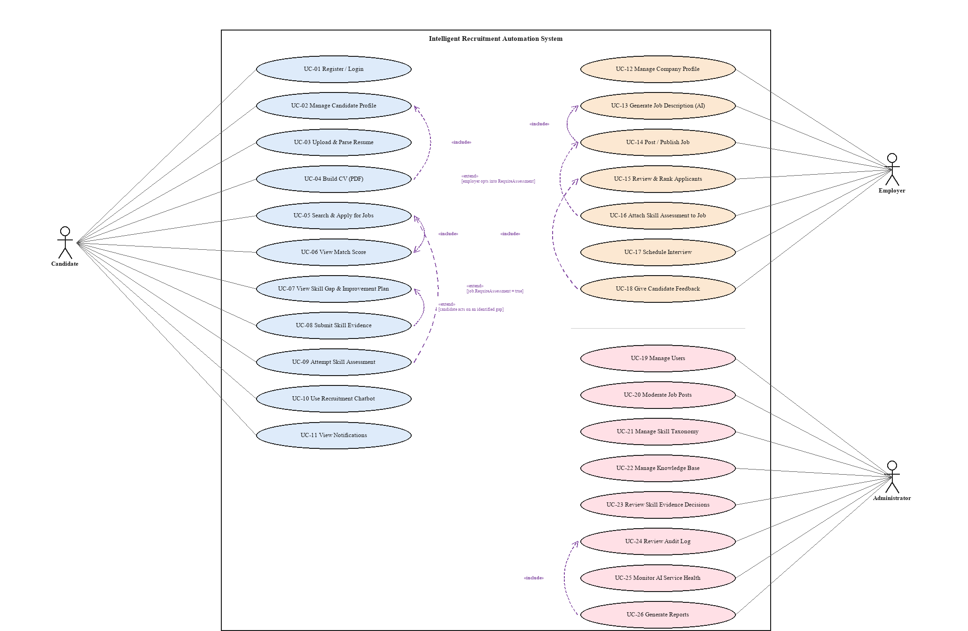
Figure 4.1: Complete Use Case Diagram of IRAS with «include» / «extend» Relationships. The diagram shows all twenty-six use cases across the three human actors — Candidate (11), Employer (7), and Administrator (8) — against the Intelligent Recruitment Automation System boundary, together with eight explicit UML dependency relationships: four «include» links (a mandatory sub-behavior always performed as part of the base use case, e.g. Post/Publish Job always includes Generate Job Description) and four «extend» links (an optional behavior triggered only under a stated condition, e.g. Attempt Skill Assessment extends Search & Apply for Jobs only when the job's Require Assessment flag is set). The shared Authenticate precondition and the AI Service's supporting role are recorded as a boxed note rather than drawn as connectors, since a line from one corner to a dozen scattered use cases is exactly the kind of visual collision the rest of the diagram was deliberately laid out to avoid.

All use case details are in Appendix A. The two important use cases are explained here because they show the main AI part of the system.
Field | Description
Use Case ID | UC-07
Actor(s) | Candidate (primary), AI Service (supporting)
Description | A candidate applies to a published job and receives a weighted match score computed from skill overlap, semantic similarity, a trained fit-classifier, and (where applicable) assessment performance
Preconditions | Candidate is authenticated; candidate has at least one parsed resume; job status is Published
Main Flow | 1. Candidate selects a job and submits an application. 2. System extracts the candidate's skill set and resume text. 3. System computes the taxonomy-based skill match locally. 4. System calls the AI service for semantic similarity and fit-classifier score. 5. System combines signals into a weighted Total Score and, if the job requires one, folds in the assessment score. 6. System persists the application with its score breakdown and any identified skill gaps. 7. Employer's applicant list is updated with the new ranked entry.
Alternative Flow | If the AI service is unavailable, the system falls back to the skill-match signal alone and flags the application as "partially scored" for later re-ranking once the AI service recovers
Postconditions | Application is stored with an auditable score breakdown; SkillGap records exist for any missing required skills

Table 4.3: Use Case Specification: Apply for a Job (Automated Ranking).

Field | Description
Use Case ID | UC-14
Actor(s) | Candidate (primary), AI Service (supporting), Administrator (supporting)
Description | A candidate submits evidence (a link, file, or certificate) that a step of their personalized skill-improvement plan has been completed, for AI-assisted and administrator-reviewed verification
Preconditions | Candidate has an active SkillImprovementPlan with a step in "Practicing" or "PartiallyCompleted" status
Main Flow | 1. Candidate submits evidence against a plan step. 2. Evidence status is set to Pending. 3. AI evidence reviewer assesses the evidence against the step's target skill and produces a recommendation and confidence level. 4. If confidence is high, the step is auto-updated (Approved/RevisionRequired) with the AI's reasoning attached. 5. If confidence is low, the item is queued for administrator review. 6. Administrator applies the final decision if queued. 7. Candidate's skill status is updated on approval.
Alternative Flow | Candidate withdraws the evidence before a decision is reached, returning the step to Draft
Postconditions | Evidence carries a final verification status (Approved, Rejected, or RevisionRequired) visible to the candidate, and the action is captured in the audit log

Table 4.4: Use Case Specification: Submit Skill Evidence for Review.

4.4.2 Class Diagram and Enhanced Entity-Relationship (EER) Diagram
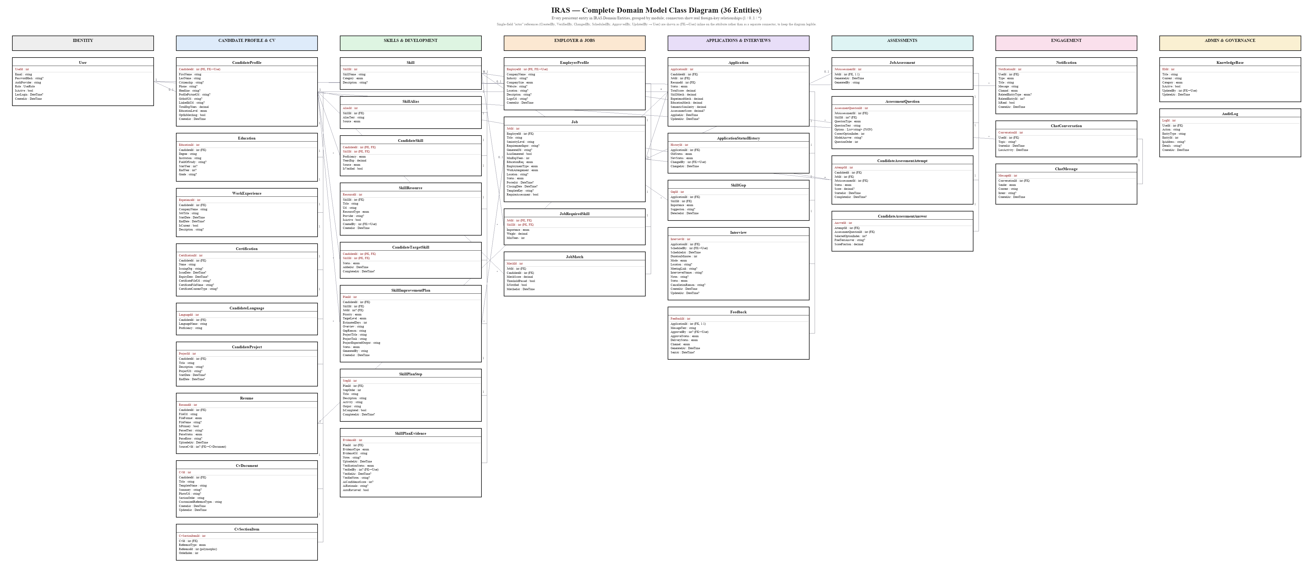
Figure 4.2: Complete Class Diagram of the IRAS Domain Model. The diagram shows all thirty-six persistent entities in IRAS.Domain/Entities, organized into eight module swimlanes — Identity, Candidate Profile and CV, Skills and Development, Employer and Jobs, Applications and Interviews, Assessments, Engagement, and Admin and Governance — each box listing its primary key, foreign keys, and scalar attributes exactly as declared in source. Connector lines show every structural foreign-key relationship with its cardinality (1, 0..1, or *); single-field administrative "actor" references such as CreatedBy, VerifiedBy, ChangedBy, ScheduledBy, ApprovedBy, and UpdatedBy are annotated inline as (FK→User) on the attribute itself rather than drawn as separate connectors, to keep the diagram legible at this scale.
At this level of detail three repeating patterns appear across modules. Are named here instead of for each part. First the collections that belong to a profile (CandidateProfile → Education/WorkExperience/Certification/CandidateLanguage/CandidateProject/Resume/CvDocument) are all one-to-many children with no life of their own. None of them is ever asked about or matched without going through the CandidateProfile first. Second to-many tables with extra details (CandidateSkill, JobRequiredSkill CandidateTargetSkill) each have a key that includes the two parts they connect plus other details (like how good someone is, how long they have been doing something how important it is, how much it weighs and if it is approved or when it was added). They are not just simple links, which is why each is shown as its own part instead of just a link. Third the parts that need AI review (Skill Plan Evidence and to some extent Feedback) each have a suggested value from the system and a decision from a person side by side (like AI confidence score, AI reasons and automatic approval along with who checked it when and any notes). This is how the system shows the confidence-based approval process described in Section 5.1.1.
The class diagram uses UML notation. Figure 4.3 shows the setup in Enhanced Entity-Relationship (EER) notation, which is more common for database design and also shows two things that UML does not: which parts are weak, in structure and which relationships are a type of hierarchy instead of just a link.
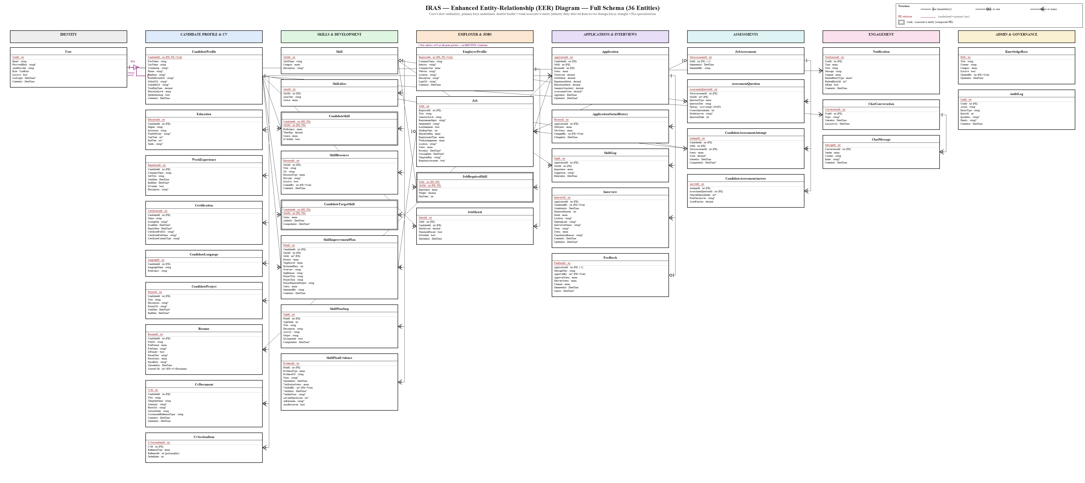
Figure 4.3: Enhanced Entity-Relationship (EER) Diagram of the IRAS Database. The diagram re-renders the same thirty-six entities in crow's-foot EER notation: every primary key is underlined, foreign keys are marked inline, and cardinality is shown with crow's-foot glyphs (a single bar for "exactly one," a circle-and-bar for "zero or one," and a circle-and-crow's-foot for "zero or many") rather than UML's plain-text multiplicities. CandidateSkill, JobRequiredSkill, and CandidateTargetSkill are drawn as double-bordered weak entities, since each is identified entirely by the composite of its two foreign keys rather than a surrogate key of its own. A purple ISA triangle marks User's specialization into CandidateProfile and EmployerProfile, labelled {disjoint, partial} — disjoint because a single user account is a candidate or an employer, never both, and partial because an Administrator account is neither subtype.

4.4.3 Activity Diagram
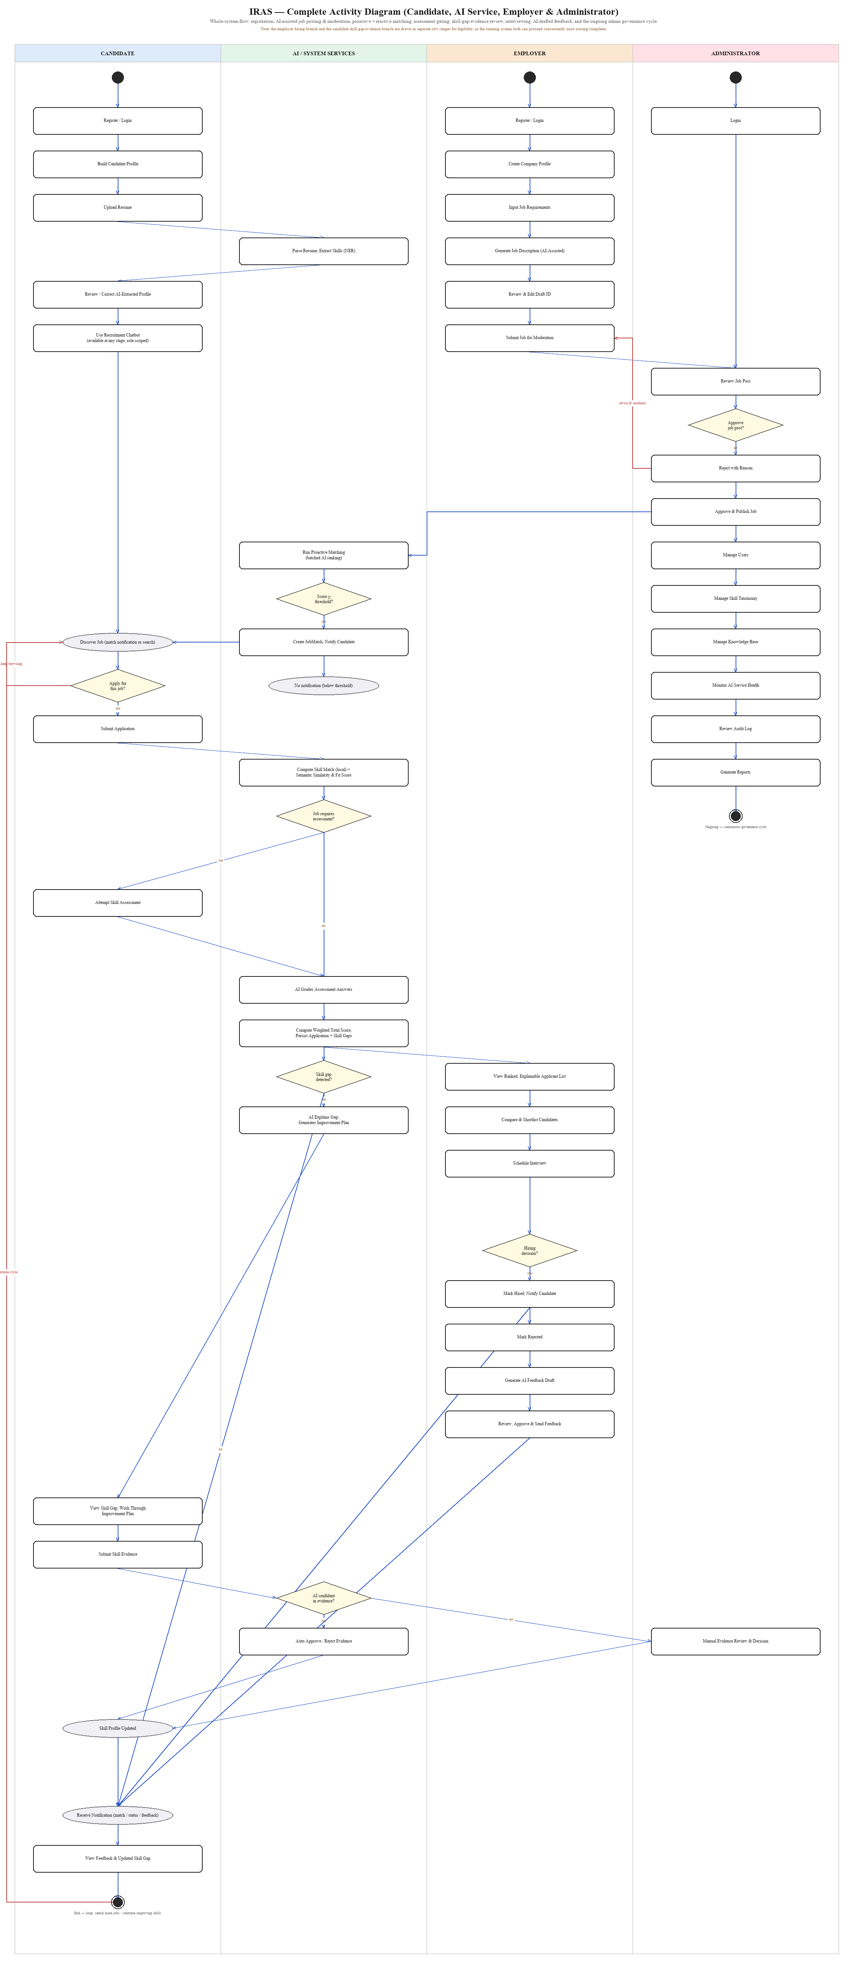
Figure 4.4: Complete Activity Diagram of IRAS — Candidate, AI Service, Employer, and Administrator. The diagram traces the whole-system flow across four swimlanes, from registration through AI-assisted job description generation, admin moderation (with a reject-and-resubmit loop routed back to the employer), proactive batch matching, reactive application scoring with an assessment-required gate, a skill-gap-detected gate leading to AI-explained improvement plans and confidence-gated evidence review, employer shortlisting and a hiring-decision gate, AI-drafted candidate feedback, and the ongoing admin governance cycle, before looping back to the candidate's job search. The lane order (Candidate next to AI Service, rather than at opposite ends) is a deliberate layout choice: it is what keeps the many Candidate-AI transitions short, adjacent-lane hops instead of long diagonals cutting through the Employer and Administrator lanes' own content.

4.4.4 Sequence Diagrams
Three sequence diagrams are in this section. Each one is linked to one of the important use cases for the systems AI help. The use cases are job application and scoring resume upload and parsing and skill-evidence submission and review. Seven more sequence diagrams are in Appendix C. These cover registration, AI-assisted job description generation and moderation batch matching, skill-gap explanation, skill-assessment generation and grading, interview scheduling and feedback and the role-aware chatbot. These diagrams make sure that every use case is connected to a message flow. This keeps this chapter from being too long as Section 4.4.1 says.
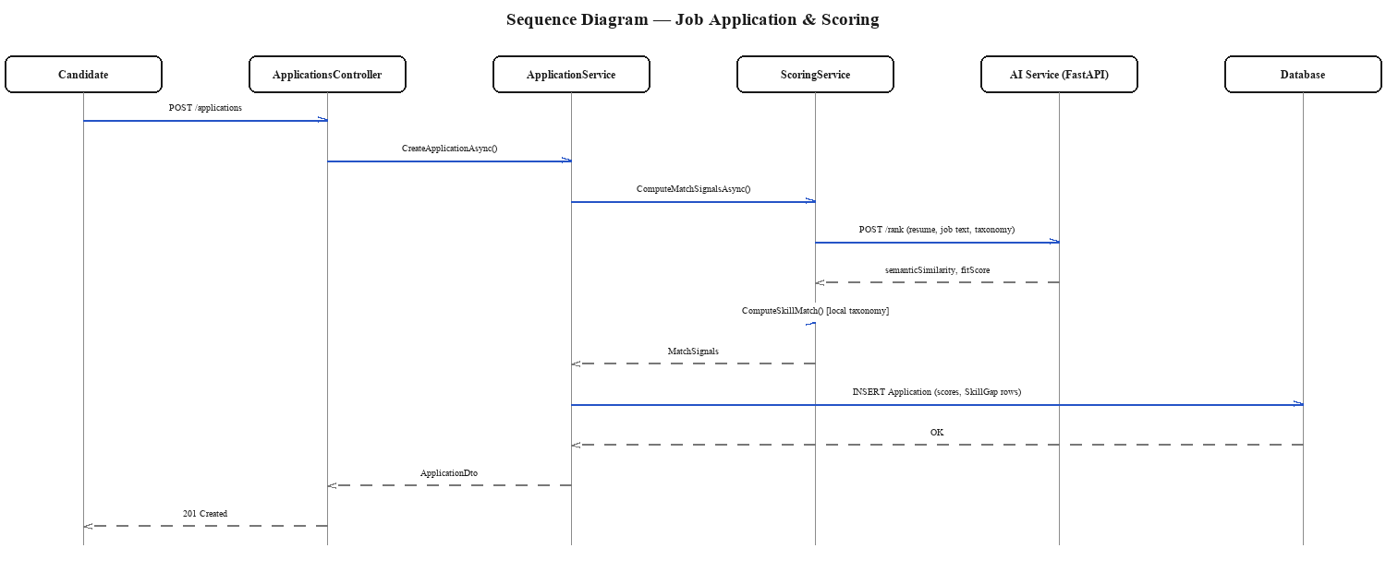
Figure 4.5: Sequence Diagram — Job Application and Scoring. The diagram traces a candidate's POST /applications request through ApplicationsController and ApplicationService to ScoringService, which calls the external AI service's /rank endpoint for semantic similarity and a fit score, computes the taxonomy-based skill match locally, and persists the combined application score and any skill-gap rows before returning a 201 Created response to the candidate.
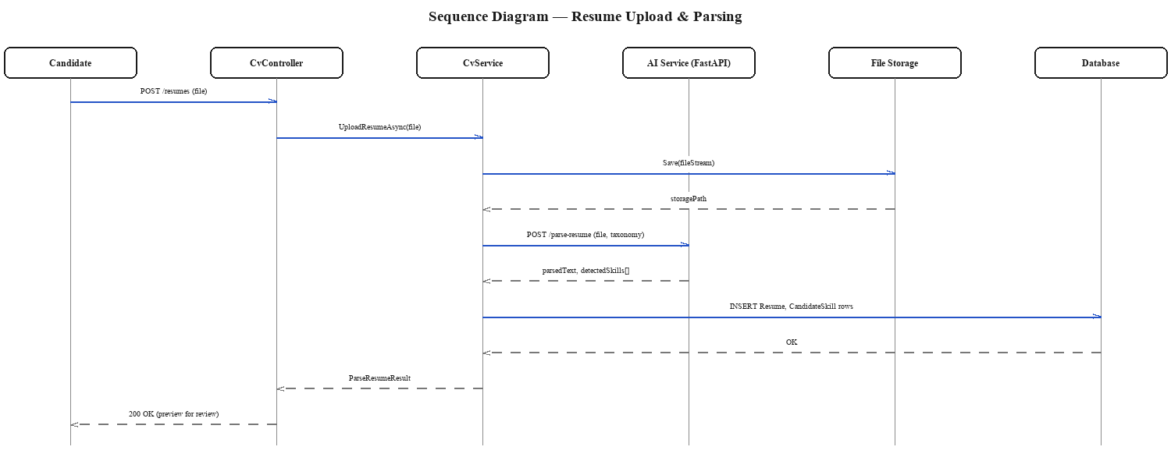
Figure 4.6: Sequence Diagram — Resume Upload and Parsing. The diagram shows a candidate's resume file being saved to file storage by CvService before being sent to the AI service's /parse-resume endpoint, which returns the parsed text and detected skills; CvService then persists the Resume and CandidateSkill rows and returns a preview the candidate can review and correct before it is treated as authoritative.
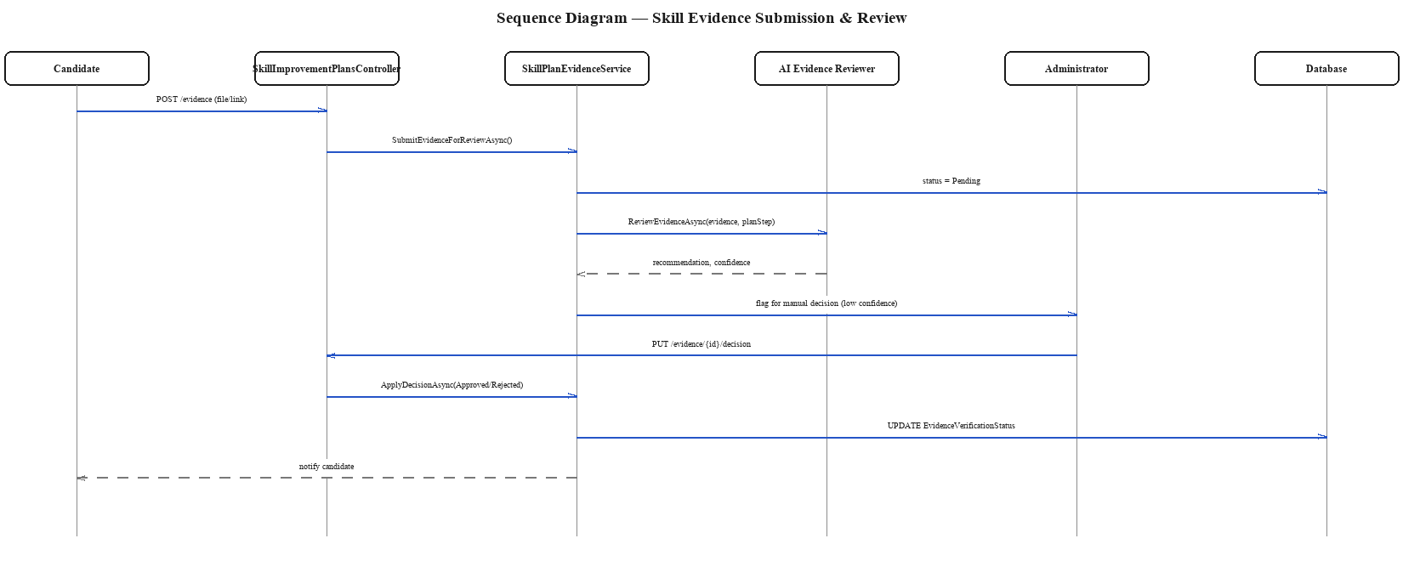
Figure 4.7: Sequence Diagram — Skill Evidence Submission and Review. The diagram shows a candidate's evidence submission moving to Pending status, being assessed by the AI Evidence Reviewer for a recommendation and confidence score, and — only when that confidence is low — being escalated to an Administrator who applies the final Approved/Rejected decision, which is then written back to the evidence's verification status and surfaced to the candidate.

4.4.5 State Chart / Deployment Considerations
A full state chart is not needed for every part of the system. Two parts have enough steps to need one. These parts are Application and SkillPlanEvidence. Application moves through Applied, Screened, Shortlisted, Interview. Then Hired, Rejected or Withdrawn. SkillPlanEvidence moves through Draft, Pending and then Approved Rejected or RevisionRequired. If it is RevisionRequired it goes back to Draft. Both state machines are controlled by the application-service layer. This makes sure that no request from the client can put either part in a state. For example an application cannot be marked Hired without going through Interview
At the deployment level the system is split into two parts. One is the ASP.NET Core Web API. It is in a container with Docker. Is on Render.com. The other is the Python AI microservice. It is separate. Can only be reached by the API over HTTP. Both parts work with a managed PostgreSQL database. Object storage from Supabase. This split makes it possible to redeploy or retrain the AI service. It can also be taken offline. When it is offline the API still. Only offers skill-match-only scoring as in Table 4.3.

4.5 Proposed System Architecture
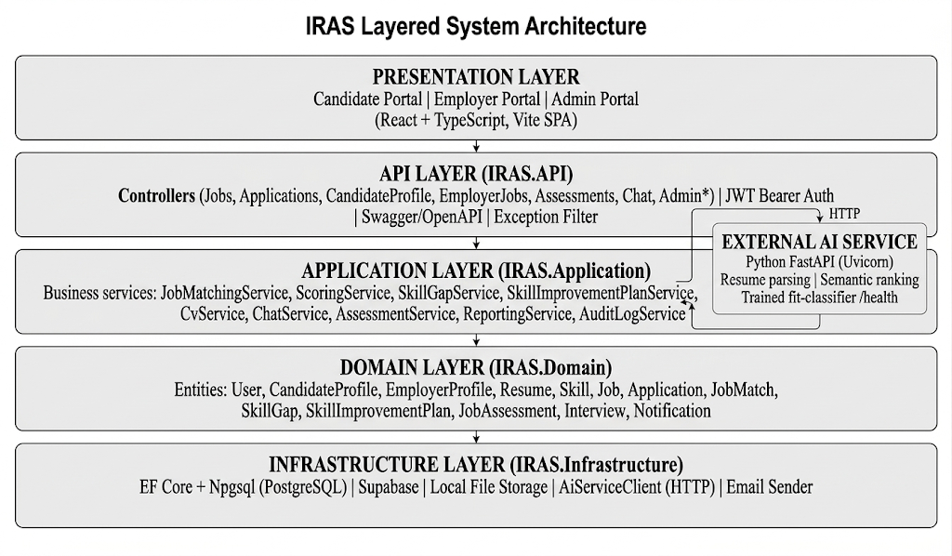
Figure 4.8: IRAS Layered System Architecture. The diagram shows the five layers of the system from top to bottom — Presentation (the React/TypeScript candidate, employer, and admin portals), API (ASP.NET Core controllers, JWT authentication, and Swagger documentation), Application (the business services that implement matching, skill-gap analysis, assessments, chat, and CV generation), Domain (the persistent entities), and Infrastructure (the database, file storage, and the AI-service HTTP client) — together with the external Python AI service that the Application layer calls over HTTP for resume parsing, semantic ranking, and fit-classification.

The architecture uses a layered (N-tier) design. It is not a complex pattern like CQRS or microservices. The reason is the domain does not need paths for writing and reading. A single tested API is easier to manage for a solo project. The only place where the system uses a service boundary is the AI part. This is because the AI workload has a stack, scaling needs and failure modes. It is better to make it a separate service even if the rest of the system is a monolith.

4.6 Functional and Non-Functional Requirements
ID | Requirement | Related Module
FR-01 | The system shall allow a candidate to register, authenticate, and manage a structured profile | Candidate
FR-02 | The system shall allow a candidate to upload a resume and have it parsed into structured skills, education, and experience | Candidate / AI Service
FR-03 | The system shall allow a candidate to build and export a CV as a PDF from their structured profile | Candidate
FR-04 | The system shall allow a candidate to search, filter, and apply for published jobs | Candidate
FR-05 | The system shall compute a weighted match score for every application from skill match, semantic similarity, a trained fit-classifier score, and (where present) assessment score | Matching
FR-06 | The system shall proactively notify a candidate when a newly published job clears the configured auto-match threshold | Matching
FR-07 | The system shall identify and explain, in plain language, the skill gap between a candidate's profile and a target job | Skill Gap
FR-08 | The system shall generate a personalized, sequenced skill-improvement plan for an identified gap | Skill Gap
FR-09 | The system shall allow a candidate to submit evidence against a skill-improvement plan step and receive an AI-assisted or administrator-reviewed verification decision | Skill Gap
FR-10 | The system shall allow an employer to register a company profile and post a job | Employer
FR-11 | The system shall allow an employer to generate a structured job description with AI assistance, subject to the employer's review and edit before publishing | Employer
FR-12 | The system shall present the employer with a ranked, explainable list of applicants broken down by individual scoring signal | Employer
FR-13 | The system shall allow an employer to attach a skill assessment to a job, with AI-generated questions and AI-assisted grading | Assessment
FR-14 | The system shall allow an employer to schedule an interview for a shortlisted candidate | Employer
FR-15 | The system shall allow an employer to issue feedback to a candidate, with AI-assisted drafting | Feedback
FR-16 | The system shall provide a role-aware chatbot that answers only within the scope of the authenticated user's role and data | Chat
FR-17 | The system shall send in-app and email notifications for match, application-status, interview, and feedback events | Notifications
FR-18 | The system shall allow an administrator to moderate job postings before publication | Admin
FR-19 | The system shall allow an administrator to manage users, the skill taxonomy, and the recruitment knowledge base | Admin
FR-20 | The system shall record an audit log of AI-influenced actions and allow an administrator to review it | Admin
FR-21 | The system shall allow an administrator to monitor the health and availability of the external AI service | Admin

Table 4.5: Functional Requirements.

ID | Category | Requirement
NFR-01 | Performance | A single candidate-job match score shall be computed and persisted in under 3 seconds under normal load, excluding first-call AI-service cold starts
NFR-02 | Scalability | Batch re-ranking of a job's eligible candidates shall use a single batched AI-service call rather than one call per candidate
NFR-03 | Reliability | If the AI service is unreachable, the platform shall degrade to skill-match-only scoring rather than failing the request
NFR-04 | Security | All API endpoints except authentication and public job listing shall require a valid JWT bearer token; role-based authorization shall be enforced per endpoint
NFR-05 | Security | Candidate and employer file uploads shall be validated by type and size before storage
NFR-06 | Usability | Every AI-influenced score or decision visible to a candidate or employer shall be accompanied by a breakdown the user can read without technical knowledge
NFR-07 | Maintainability | The system shall follow a layered architecture (API / Application / Domain / Infrastructure) so that AI-related logic can be revised without redesigning unrelated modules
NFR-08 | Portability | The backend shall be containerized (Docker) so that it can be deployed to any compliant container host
NFR-09 | Auditability | Every administrator action and every AI-driven approval/rejection decision shall be written to an immutable audit log
NFR-10 | Availability | The public-facing API shall target 99% monthly availability, consistent with its single-region managed-cloud deployment

Table 4.6: Non-Functional Requirements.

4.7 Chapter Summary
This chapter set out the system requirements for IRAS. It started by finding the stakeholders and their concerns. Then it linked each requirement to a research objective and a fact-gathering activity. This made the specification based on facts, not guesses. The use case, class, activity and sequence diagrams showed the system and model analysis that the implementation in Chapter 5 follows. The layered architecture diagram set the systems limits. The tables with non-functional requirements give the checklist for testing and evaluation in Chapter 6.

CHAPTER 05 - IMPLEMENTATION / DESIGNING

5.1 Implementation Approach
IRAS was built in small parts one sprint at a time. The plan followed the Scrum method from Section 3.6. Each sprint focused on one part of the system. This part included a database migration the domain entities, the application-layer service, the API controller and the AI-service integration. This section explains the logic behind the scoring pipeline. It also covers the AI-assisted skill-gap and evidence-review logic. The technology. The main AI features are also discussed.

5.1.1 Algorithms
The main part of IRAS is a scoring algorithm that uses than one signal. Four algorithms are described in pseudocode. Each one is a method in the ScoringService and JobMatchingService.
Algorithm 1 — Taxonomy-based Skill Match
function ComputeSkillMatch(requiredSkills, candidateSkillIds):
if requiredSkills is empty:
return 1.0 // no requirement -> full match
totalWeight = sum(rs.Weight for rs in requiredSkills)
if totalWeight <= 0:
return 0.0
matchedWeight = sum(rs.Weight for rs in requiredSkills
if rs.SkillId in candidateSkillIds)
return round(matchedWeight / totalWeight, 4)
Each skill on a job has a weight. Must-Have skills are more important than Nice-To-Have skills. A candidate missing a skill is scored better than one missing a mandatory skill. A simple keyword match cannot show this difference.

Algorithm 2 — Weighted Total Score
function ComputeTotalScore(skillMatch, semanticSimilarity, mlFitScore = null, assessmentScore = null):
score = SkillMatchWeight * skillMatch + SemanticSimilarityWeight * semanticSimilarity
if mlFitScore is not null:
score += MlFitScoreWeight * mlFitScore
if assessmentScore is not null:
score += AssessmentScoreWeight * assessmentScore
return round(score, 4)
The weights come from a configuration file. They are not fixed in the code. This means the operator can change the focus. For example they can turn on MlFitScoreWeight once the trained classifier from Chapter 6 is ready. This can be done without changing the code or redeploying.
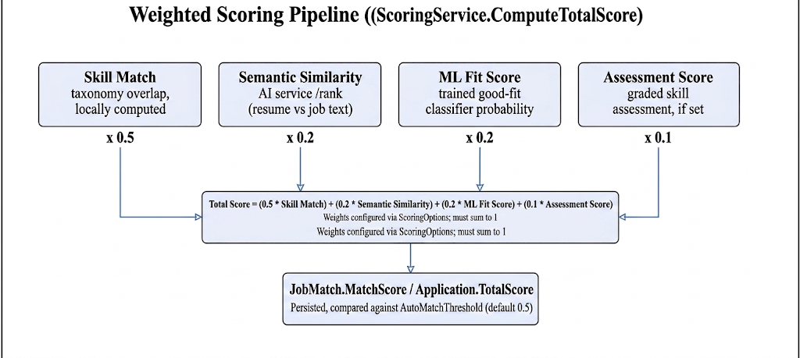
Figure 5.1: Weighted Scoring Pipeline. The block diagram shows the four independent signals — skill match, semantic similarity, ML fit score, and assessment score — feeding into a single configurable weighted sum, which is then persisted as the Application's or JobMatch's headline score and compared against the auto-match threshold; the asterisked note records that the ML fit-score and assessment-score weights default to zero so existing deployments are unaffected until an operator opts in, even though both signals are still computed and stored.

Algorithm 3 — Batched Proactive Matching
function RunMatchingForJobAsync(jobId):
job = LoadPublishedJob(jobId)
alreadyConsidered = JobMatches where JobId = jobId -> candidateIds
eligible = CandidateProfiles where OptInMatching = true
and CandidateId not in alreadyConsidered
and has a parsed primary resume
if eligible is empty: return
// one batched HTTP call for every eligible candidate against this job,
// not one call per candidate
signals = ScoringService.ComputeMatchSignalsAsync(job, eligible)
for candidate in eligible:
skillMatch = ComputeSkillMatch(job.RequiredSkills, candidate.SkillIds)
(semanticSimilarity, mlFitScore) = signals[candidate.Id]
totalScore = ComputeTotalScore(skillMatch, semanticSimilarity, mlFitScore)
passed = totalScore >= AutoMatchThreshold
save JobMatch(jobId, candidate.Id, totalScore, passed)
if passed: NotifyCandidate(candidate.Id, job)
This algorithm is made to work in batches. The simple way would be to call the AI service per candidate. This does not work when there are many candidates. Batching the resumes and job text into one request to the AI services ranking endpoint keeps the number of HTTP calls the same no matter how jobs there are.
Algorithm 4 — Confidence-gated Evidence Review
function SubmitEvidenceForReviewAsync(evidenceId):
SetStatus(evidenceId, Pending)
(recommendation, confidence) = AiEvidenceReviewer.Review(evidence, planStep)
if confidence >= AutoApproveThreshold:
ApplyDecision(evidenceId, recommendation, source = "AI")
else:
QueueForAdminReview(evidenceId, recommendation, confidence)
Evidence review is not fully automatic. Only high-confidence AI recommendations are used. Every AI decision is written to the audit log. This includes the confidence level. This meets NFR-09. Deals with the transparency issue from Section 4.2.

5.1.2 Workflow via Block Diagrams
The scoring pipeline in Figure 5.1 is one of three block-diagram workflows in the system. The other two are the application-shortlisting activity flow and the three sequence diagrams for scoring resume parsing and evidence review. These were already shown in Section 4.4 as part of the system design. They are implemented exactly as shown in the IRAS.Application services.

5.1.3 Technology Selection Justification
Decision | Options Considered | Selected | Justification
Backend language/runtime | Java + Spring Boot, Node.js + Express, C# + ASP.NET Core | C# / .NET (ASP.NET Core Web API) | Strong typing catches scoring-formula and enum-mismatch errors at compile time; first-class Entity Framework Core ORM; mature JWT and Swagger tooling; team familiarity
AI/ML service language | C# (ML.NET), Python (FastAPI) | Python (FastAPI) | The NLP/ML ecosystem (transformer-based embeddings, scikit-learn-style classifiers) is far more mature in Python than in .NET; isolating it as its own service also lets it scale and fail independently of the API (Section 4.5)
Relational database | SQL Server, MySQL, PostgreSQL | PostgreSQL (via Supabase) | Free managed hosting suitable for a final-year budget; native JSON column support used for flexible AI-response storage; strong EF Core provider support via Npgsql
Frontend framework | Angular, Vue, React | React + TypeScript (Vite) | Component reuse across three distinct portals (Candidate/Employer/Admin); large ecosystem; TypeScript catches DTO-shape drift against the C# API contracts
Authentication | Session cookies, OAuth-only, JWT | JWT Bearer | Stateless, natural fit for a decoupled SPA + API architecture, and works uniformly across the three roles via claims-based authorization
Containerization | Bare-metal deploy, Docker | Docker (multi-stage build) | Reproducible builds; Render.com's deployment model expects a container; keeps the Domain/Application/Infrastructure/API project references consistent between dev and prod

Table 5.1: Technology Selection Justification.

5.1.3.1 Programming Language
The backend is built in C# for.NET. This was chosen for its typing, good async/await support and good integration with Entity Framework Core. The AI microservice is in Python. This is because of the NLP and machine-learning libraries it needs. The frontend is, in TypeScript. This was chosen over JavaScript to check the shape of API request and response DTOs at compile time.

5.1.3.2 Libraries Used
Library | Layer | Role
Entity Framework Core + Npgsql | Infrastructure | Object-relational mapping and PostgreSQL migrations
Swashbuckle (Swagger/OpenAPI) | API | Interactive API documentation and manual endpoint testing
System.IdentityModel.Tokens.Jwt | API | JWT bearer token issuing and validation
QuestPDF | Application | Server-side CV/PDF document generation
xUnit | Tests | Backend unit and integration testing (IRAS.Tests)
FastAPI + Uvicorn | AI Service | HTTP interface for resume parsing, ranking, and health-check endpoints
A trained scikit-learn-style classifier | AI Service | The candidate-job "Good-Fit" probability consumed as the ML fit-score signal

Table 5.2: Key Libraries and Their Role.

5.1.3.3 Backend and Frontend Frameworks
The backend uses a layered ASP.NET Core Web API approach described in Section 4.5 (IRAS.API, IRAS.Application, IRAS.Domain, IRAS.Infrastructure as four projects referenced in that dependency direction only enforced by the.csproj references themselves). The frontend is a Vite-built single-page React application that uses the Web API over HTTPS and shows three route trees for the Candidate, Employer and Admin roles, controlled by the JWT claim that holds the users role.

5.2 Significant Implementation Features
This section describes the implementation of the features that show IRASs research contribution, not typical CRUD screens such as login or profile editing, which use standard ASP.NET Core Identity-style patterns and are not covered here.
AI-assisted job description generation. The employer job-posting process (FR-11) uses a two-implementation pattern behind an IJdGenerator interface: a GeminiJdGenerator that uses the configured LLM with the employers minimum input (title, seniority, required skills, work arrangement) and a TemplateJdGenerator that puts together a structured description from a fixed template when no LLM key is set or the call fails. The controller always provides the generated draft as text rather than publishing it directly. The employer has to approve it explicitly which is the human-in-the-loop control mentioned in Section 3.6.2s Human Oversight mitigation.
async function GenerateJobDescriptionAsync(request):
try:
draft = await GeminiJdGenerator.Generate(request)
catch (AiServiceException):
draft = TemplateJdGenerator.Generate(request) // deterministic fallback
return DraftJobDescriptionDto(draft, source: draft.Source, requiresApproval: true)
Multi-signal candidate ranking: Described algorithmically in Section 5.1.1; the implementation detail worth mentioning is that ComputeSkillMatch runs entirely inside the.NET process against the locally cached skill taxonomy while semantic similarity and the fit-classifier score are the only two values that go across the network boundary to the AI service. Keeping the latency-sensitive purely-relational part of the score computation local and only paying the network cost for the two signals that really need it.
Skill-gap explanation and improvement-plan generation: When an application or profile comparison shows a skill gap SkillGapService first calculates the gap set in a way (required skills minus candidate skills, by weight) then sends that gap set. Not the raw resume. To an IGap Explainer (Gemini-based with a template fallback that looks the same as the JD generator) to create a plain-language explanation. SkillImprovementPlanService then puts the gap into an ordered plan of SkillPlanStep records with a target proficiency level and priority which the candidate works through and submits SkillPlanEvidence against.
Confidence-gated evidence review: Described algorithmically as Algorithm 4; the implementation detail is that the AI evidence reviewers confidence score is stored along with its recommendation when an administrator later changes it so the audit log can show not only what decision was made but how confident the AI was when it made (or failed to make) that decision on its own.
Role-aware chatbot: ChatService sends context construction to one of three ContextBuilder implementations. CandidateChatContextBuilder, EmployerChatContextBuilder or AdminChatContextBuilder. Based on the authenticated users role so that the LLM prompt only includes data that role is allowed to see. A ChatScopeGate then filters the LLMs response before it gets to the user rejecting answers that go outside recruitment-related topics, which implements the "Chatbot Misuse" mitigation from Table 3.2.
function BuildAndSendPrompt(user, message):
contextBuilder = SelectContextBuilder(user.Role) // Candidate | Employer | Admin
context = contextBuilder.Build(user) // only this role's own data
reply = ChatResponder.Respond(context, message) // Gemini, or rule-based fallback
if not ChatScopeGate.IsInScope(reply):
return FallbackReply("I can only help with recruitment-related questions.")
return reply
Resume parsing: CvService sends the file to the AI services /parse-resume endpoint along with the current skill taxonomy gets back parsed text, identified skills (each tagged with how it was matched. Exact alias or learned-from-parsing) emails, phones and a word count and saves a Resume and a set of CandidateSkill rows tagged SkillSource.ResumeParsed. The candidate always sees this extraction as a preview before it becomes official in line with the parsing-accuracy limitation mentioned in Section 2.5.1.
Error handling and logging strategy: Every call to the AI service is wrapped so that a timeout, a non-2xx response or a malformed payload is caught at the AiServiceClient boundary and turned into a typed result object (for example RankResult.Success = false with an Error message) than allowed to spread as an unhandled exception through the Application and API layers. This choice was made after seeing during early integration testing that an unguarded call would turn a slow or unavailable AI-service instance into a cascading 500 error for every candidate waiting for a score, which is exactly the fragility NFR-03 was written to avoid. A central ApiExceptionFilter also turns any remaining exception into a structured JSON error response rather than a raw stack trace and every AI-service failure, admin action and evidence-review decision is logged through a shared logging path so that Section 6.3s audit-trail evidence and Chapter 4s NFR-09 requirement are supported by the same underlying mechanism rather than two separate possibly conflicting implementations.

5.3 Implementation Evidence: System User Interface
This section shows the user interface of the running system screen by screen as it is built. It is proof that the requirements and workflows from Chapter 4're working software, not just diagrams. Pages are shown exactly as implemented, grouped by the three portals from Section 1.8 (Candidate, Employer, Administrator) with each screenshot linked back to the use case or functional requirement it meets. Even simple administrative CRUD screens that don’t have their logic (e.g. An ordinary edit form) are included here for completeness even though. As per Section 5.2s note. They were not discussed separately as implementation features.

5.3.1 Candidate Portal
Candidate Registration and Login
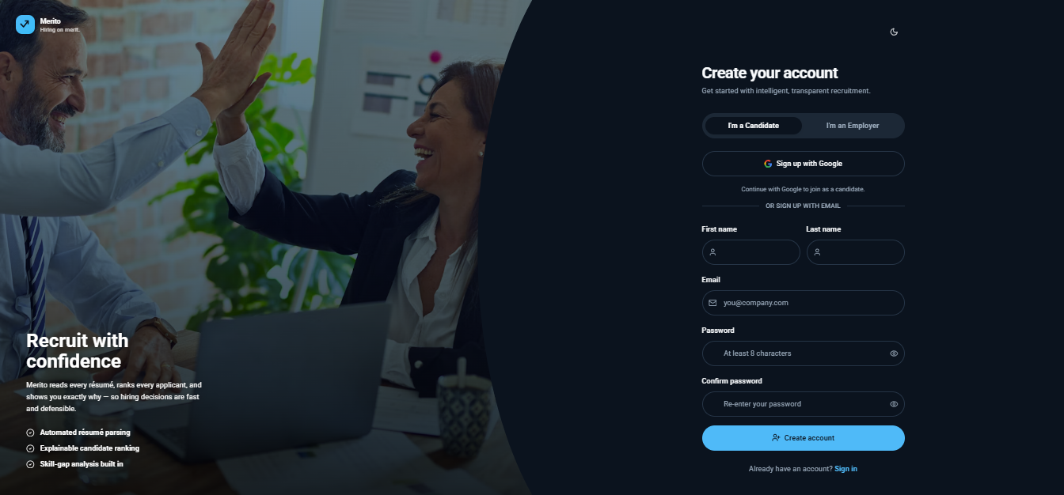

Figure 5.2: Candidate Registration and Login. The screen collects an email and password for a new candidate account or authenticates an existing one, issuing the JWT bearer token that gates every subsequent candidate-scoped request (UC-01, FR-04).
Candidate Dashboard
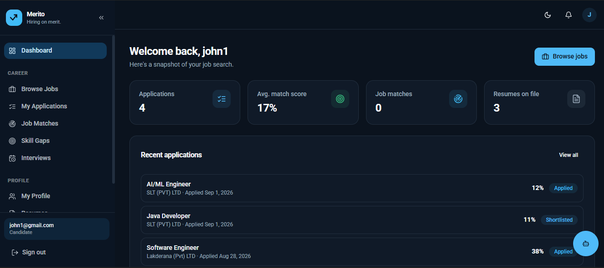
Figure 5.3: Candidate Dashboard. The landing page after login summarizes the candidate's application activity, outstanding notifications, and current skill-gap status at a glance, linking out to every other candidate screen below.

Candidate Profile Management 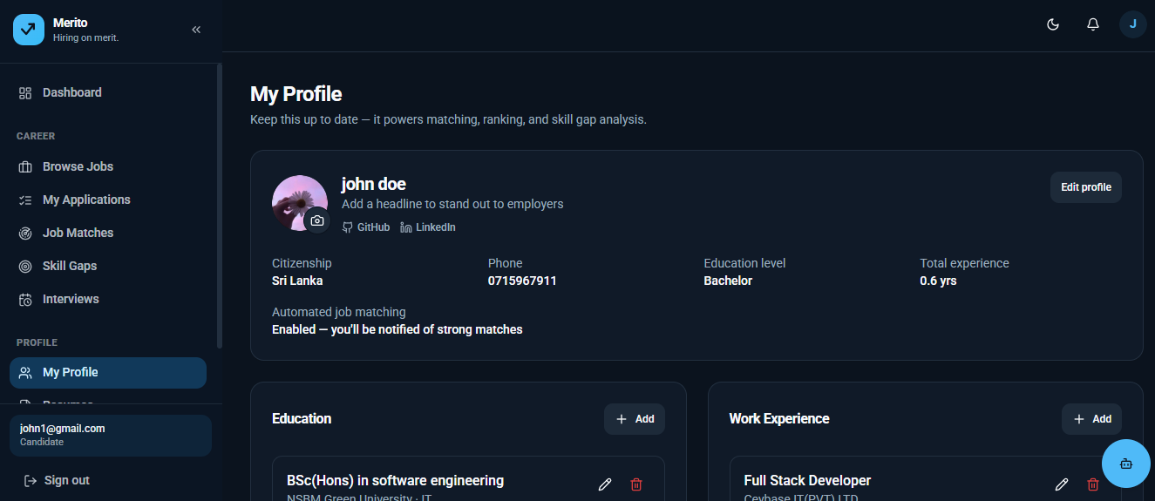
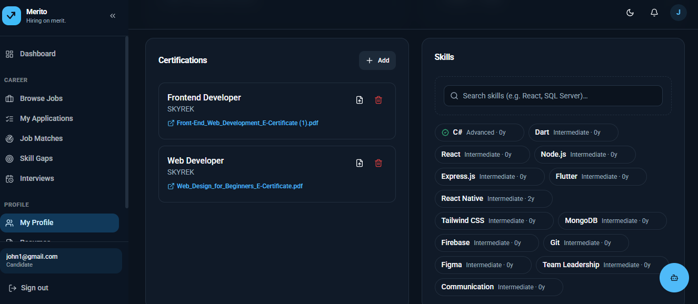
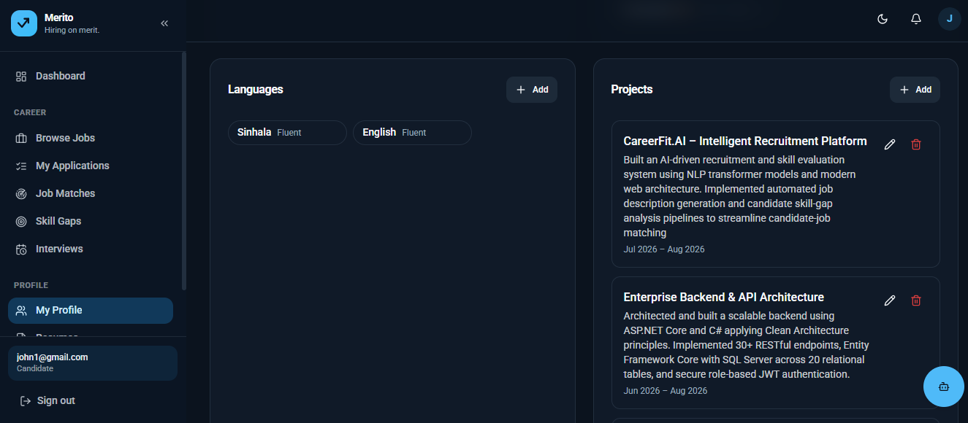
Figure 5.4: Candidate Profile Management. The screen manages the structured profile data — education, work experience, certifications, languages, and projects — that both the CV builder and the matching engine's skill-match signal draw on (UC-02).
Candidate Resume Upload and AI-Parsed Preview
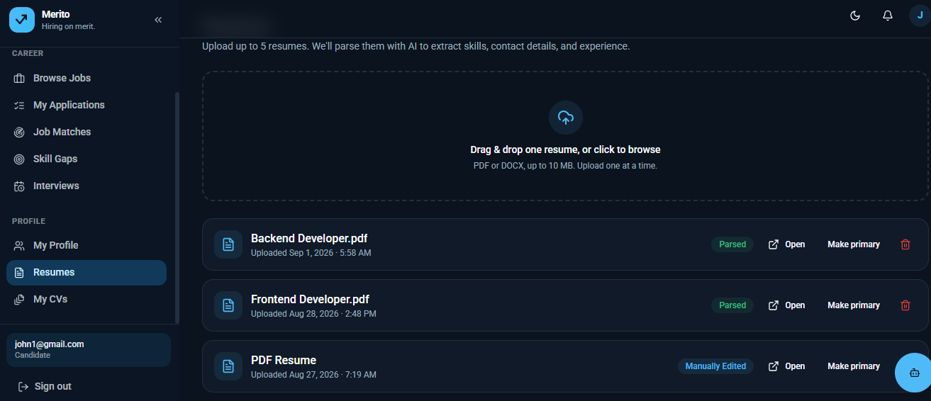
Figure 5.5: Resume Upload and AI-Parsed Preview. The screen accepts a PDF or DOCX resume, sends it to the AI service for parsing, and shows the extracted skills, contact details, and text as an editable preview before the candidate confirms it (UC-03, FR-02, Figure C.1).
Candidate CV Builder
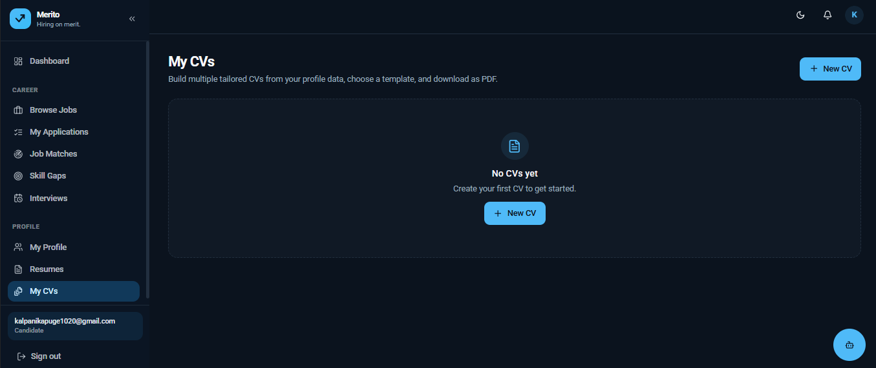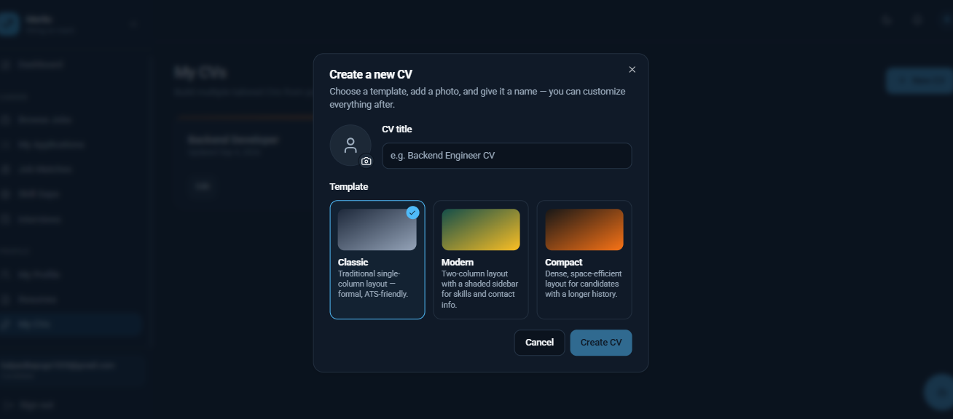
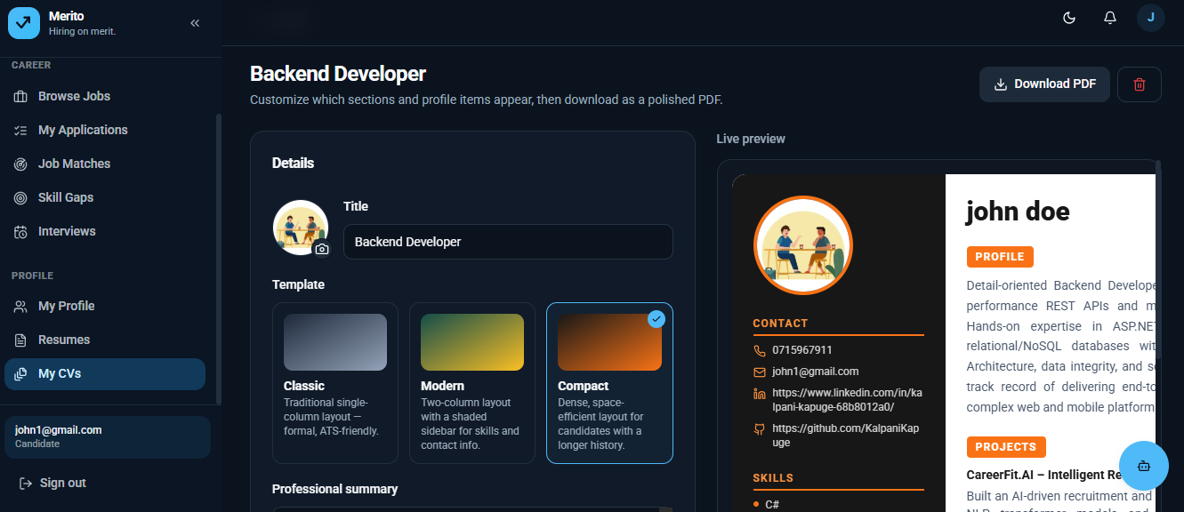
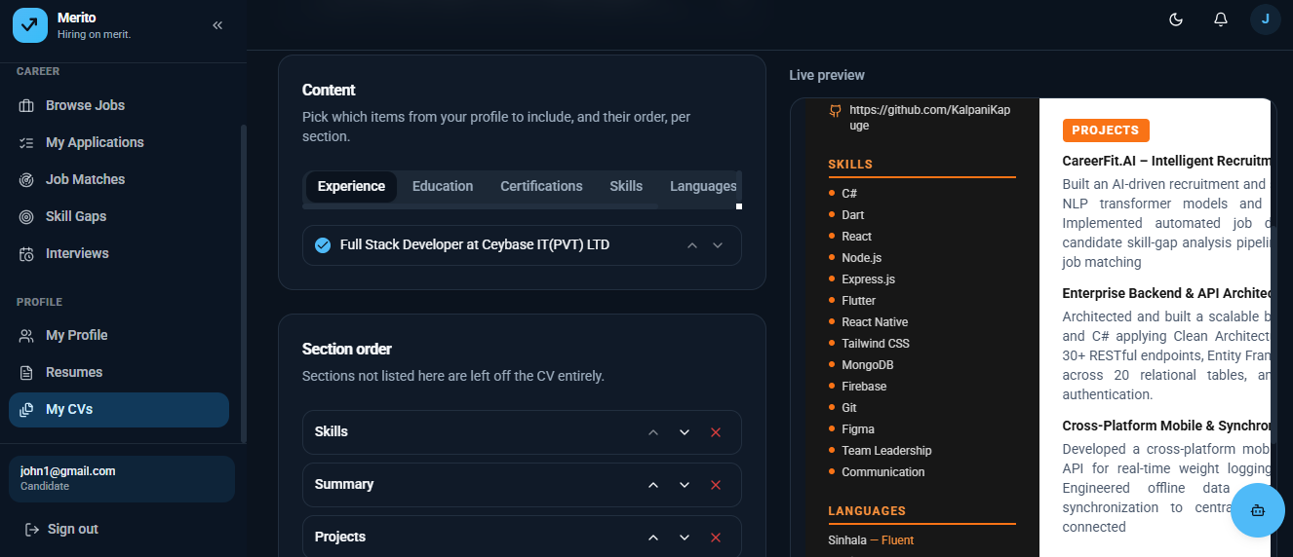
Figure 5.6: CV Builder. The screen assembles a subset of the candidate's profile data into a structured, exportable CV, using the CvSectionItem selection model described in Section 4.4.2 (UC-04, FR-03).
Candidate Job Search and Application
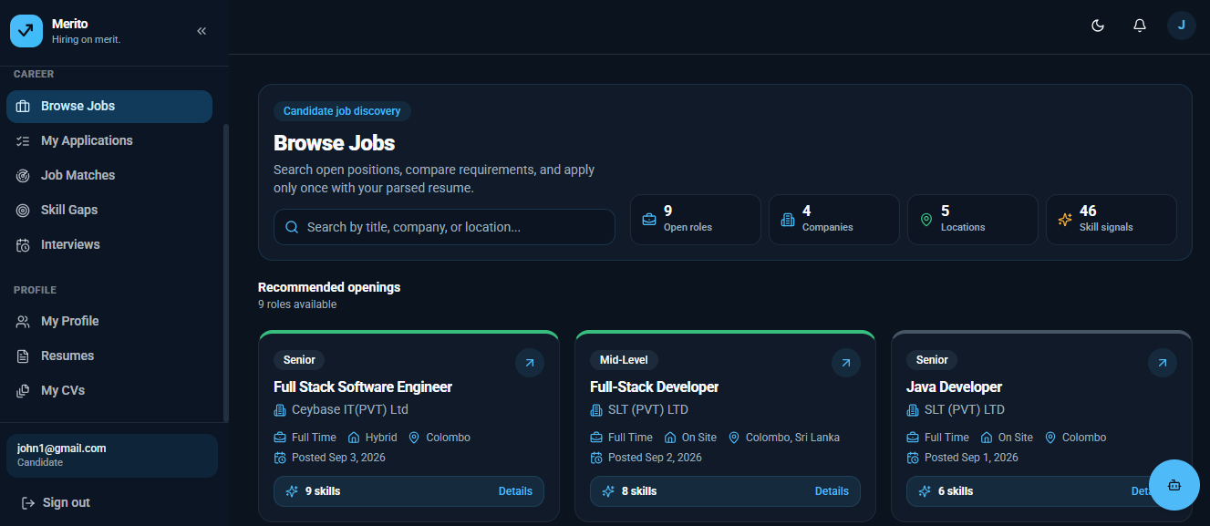
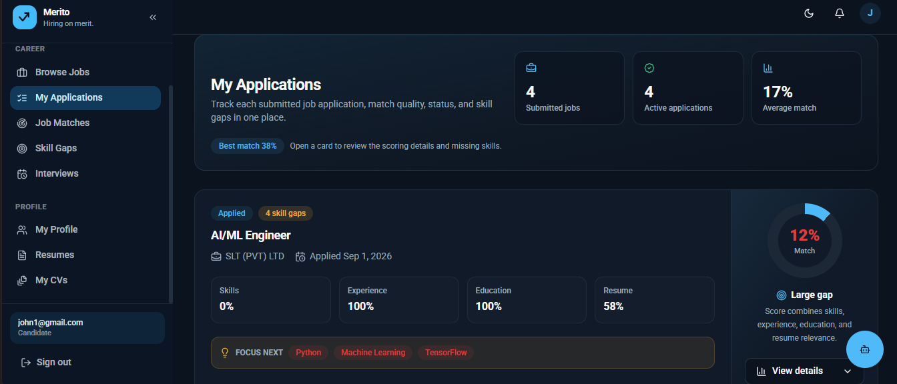
Figure 5.7: Job Search and Application. The screen lists published jobs with filtering, and lets the candidate submit an application that triggers the multi-signal scoring pipeline shown in Figure 5.1 (UC-05, FR-05).
Candidate Job Match Score
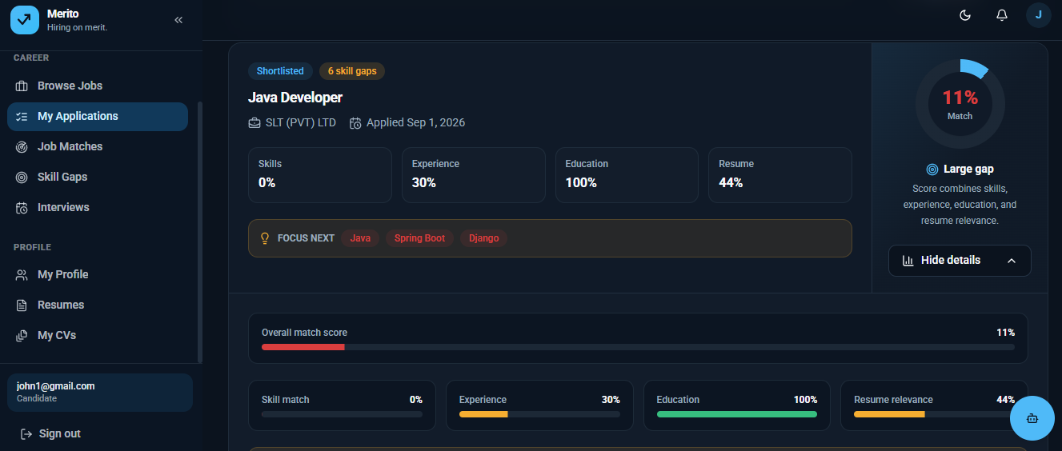
Figure 5.8: Match Score Breakdown. The screen shows the weighted score behind a proactive match or a submitted application broken down by signal — skill match, semantic similarity, and assessment score where applicable — rather than a single opaque number (UC-06, NFR-06).

Candidate Skill Gap and Improvement Plan
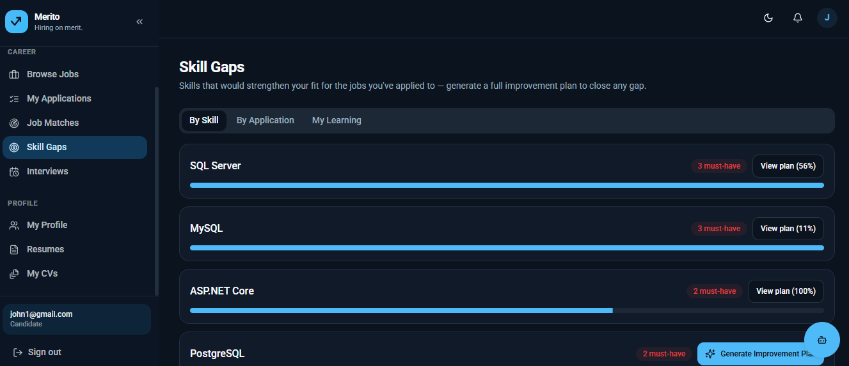
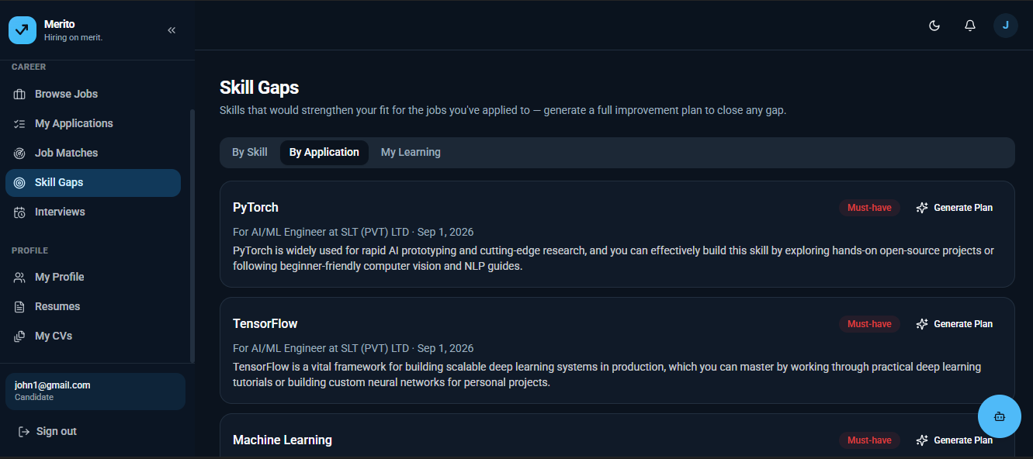
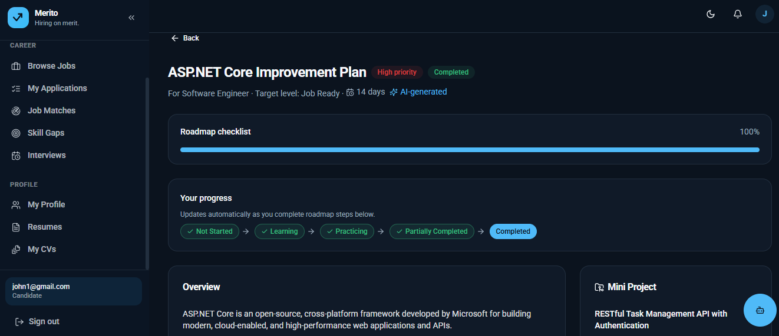
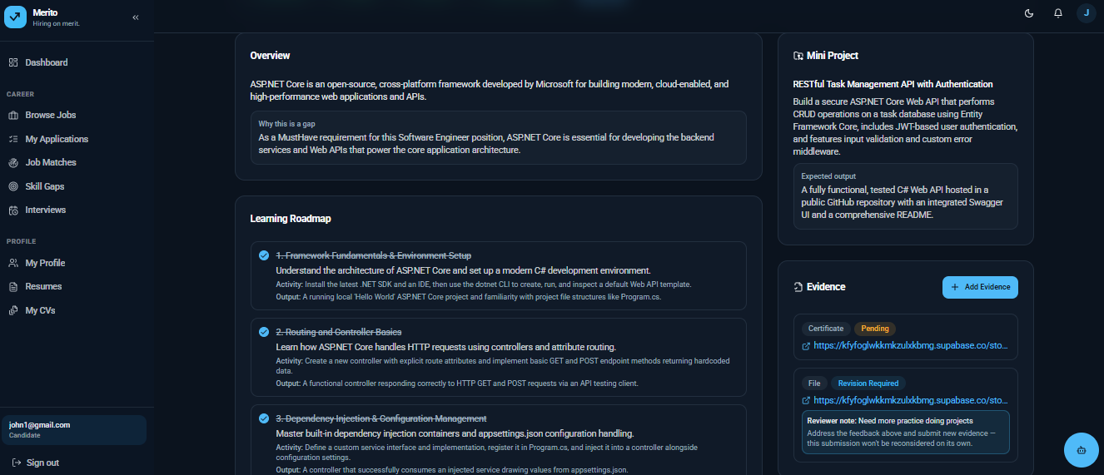
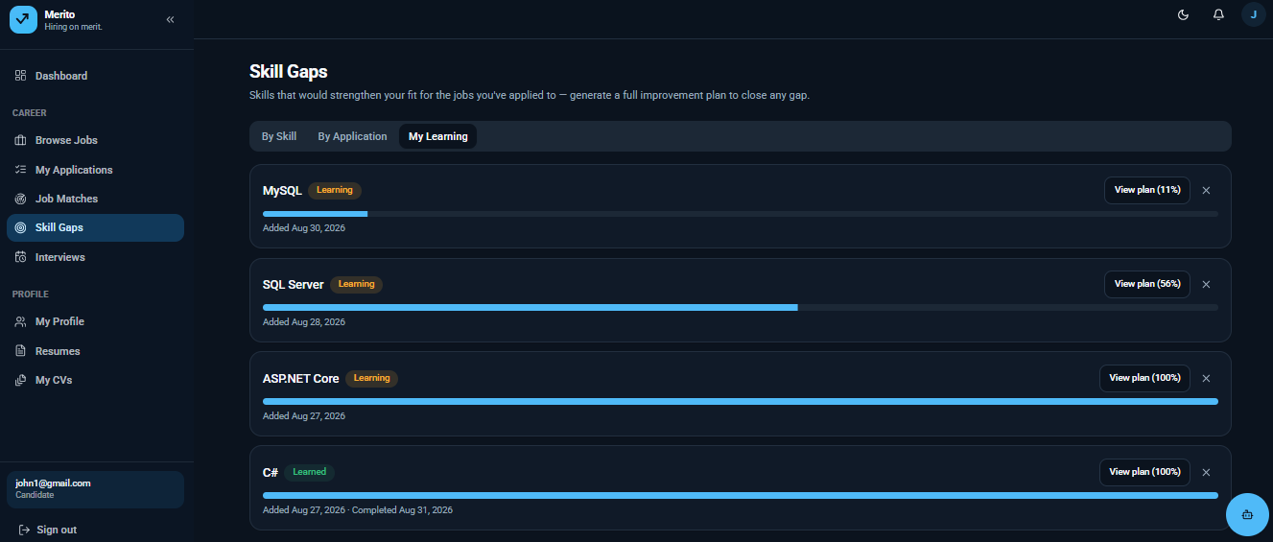
Figure 5.9: Skill Gap and Improvement Plan. The screen shows the AI-explained gap between the candidate's profile and a target role alongside the generated, sequenced improvement plan (UC-07, FR-07, FR-08).
Candidate Skill Evidence Submission
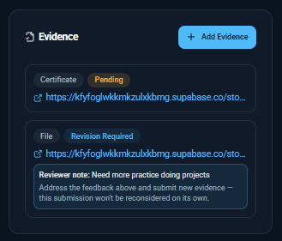
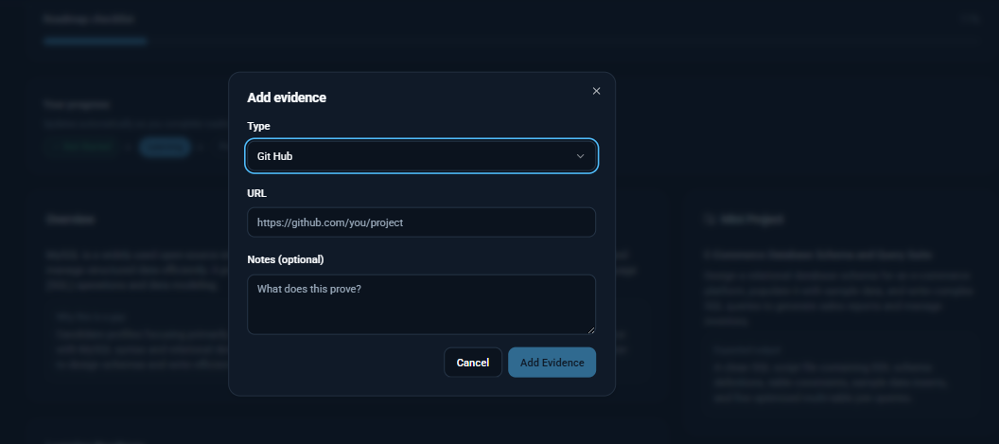
Figure 5.10: Skill Evidence Submission. The screen lets the candidate attach a link, file, or certificate against a plan step and shows its verification status once the confidence-gated review in Algorithm 4 has run (UC-08, FR-09).
Candidate Skill Assessment Attempt
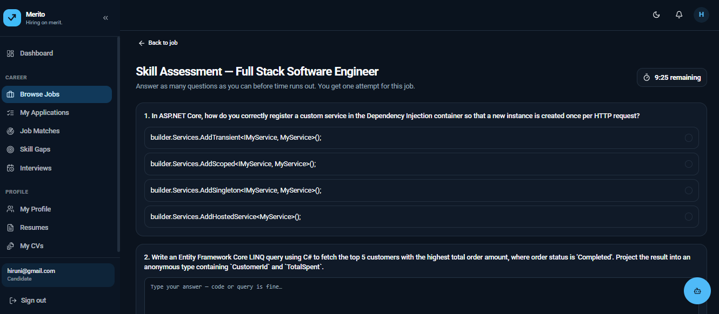
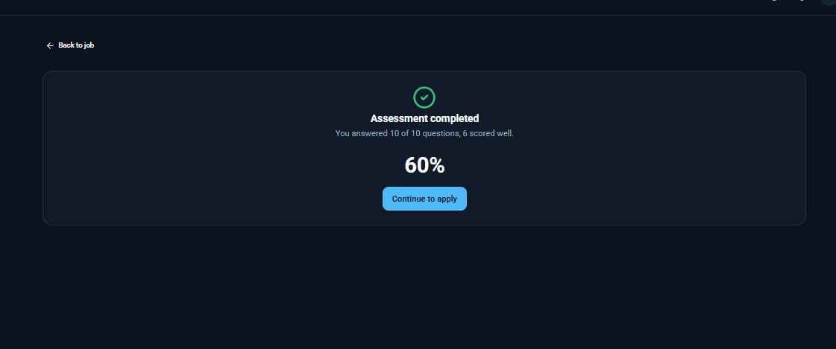
Figure 5.11: Skill Assessment Attempt. The screen presents the AI-generated multiple-choice and free-text questions for a job's assessment and submits the candidate's answers for grading (UC-09, FR-13).
Recruitment Chatbot
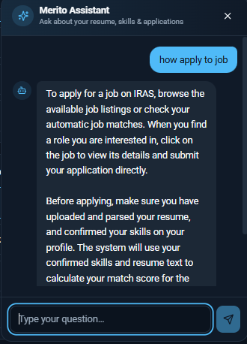
Figure 5.12: Recruitment Chatbot. The screen shows the candidate-scoped chatbot conversation, answering only questions in scope of the candidate's own data per the ChatScopeGate logic in Section 5.2 (UC-10, FR-16).
Candidate Notifications
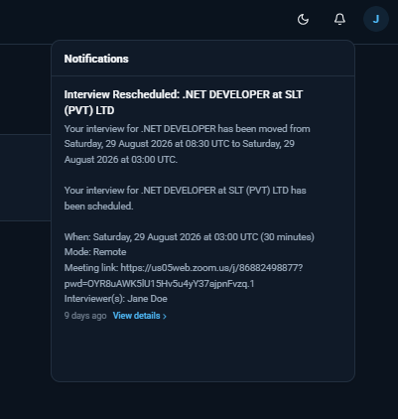
Figure 5.13: Candidate Notifications. The screen lists in-app notifications for matches, application-status changes, interviews, and feedback (UC-11, FR-17).

5.3.2 Employer Portal
Employer Registration and Login
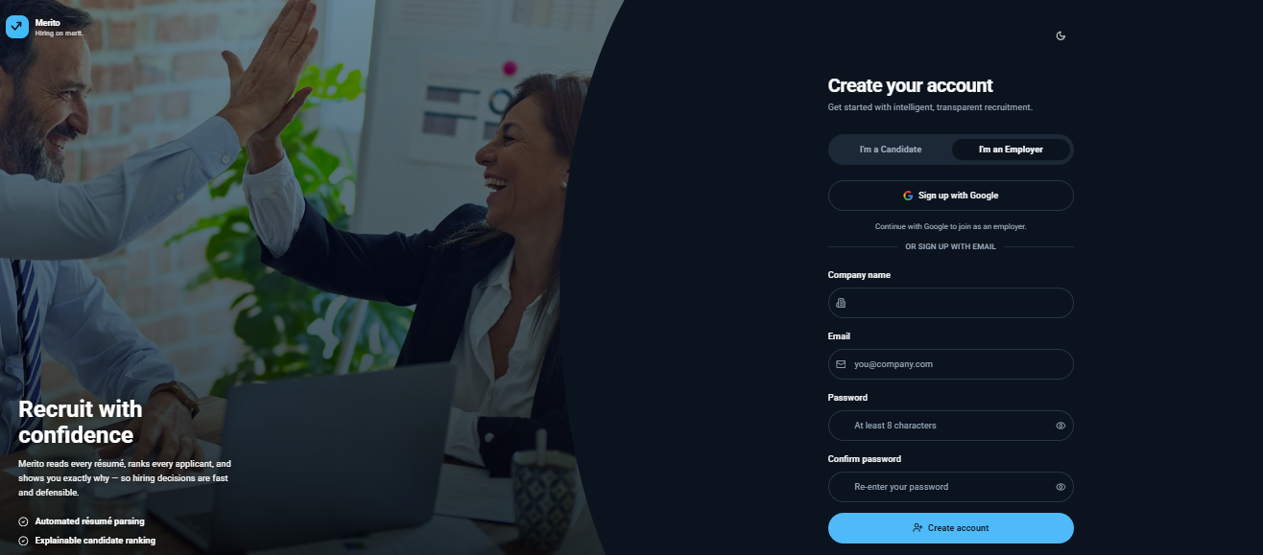
Figure 5.14: Employer Registration and Login. The screen mirrors the candidate login flow (Figure 5.2) but issues a JWT carrying the Employer role claim (UC-01).

Employer Dashboard
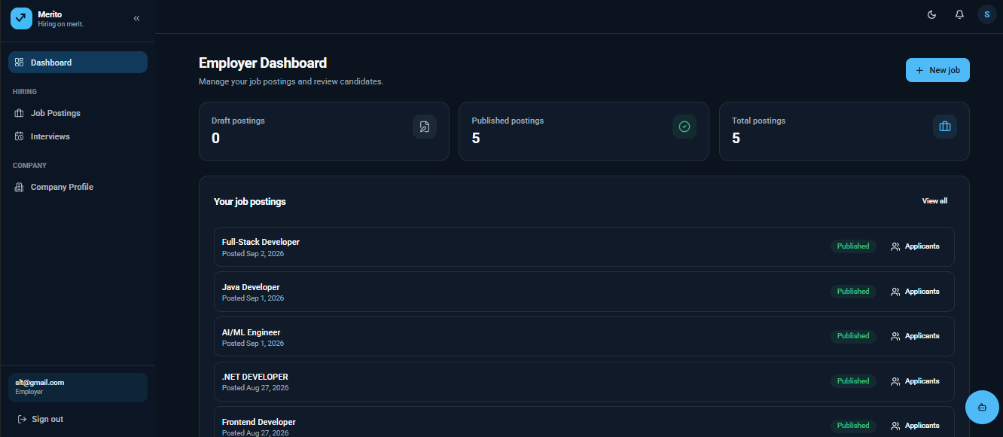
Figure 5.15: Employer Dashboard. The landing page summarizes the employer's open job posts, pending moderation status, and recent applicant activity.
Company Profile Management
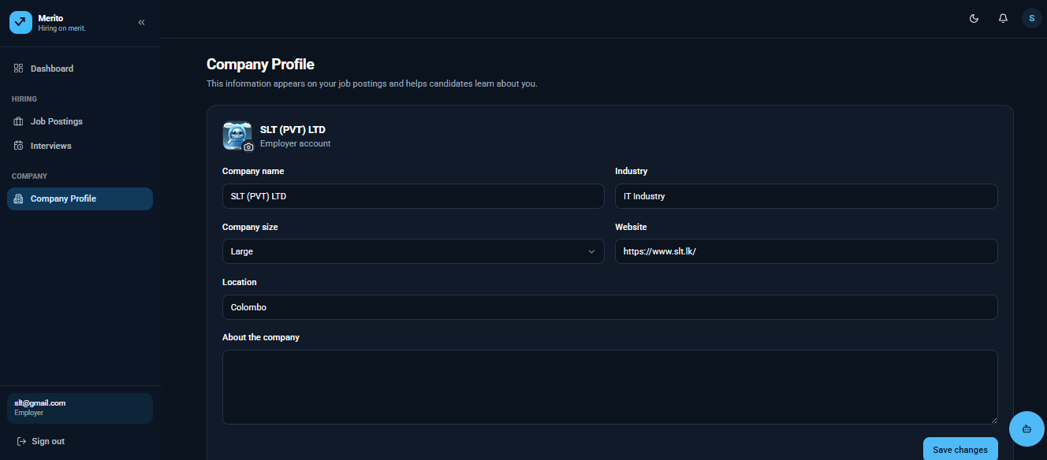
Figure 5.16: Company Profile Management. The screen manages the company details shown to candidates on every job posting (UC-12).

Job Posting with AI-Assisted Description Generation
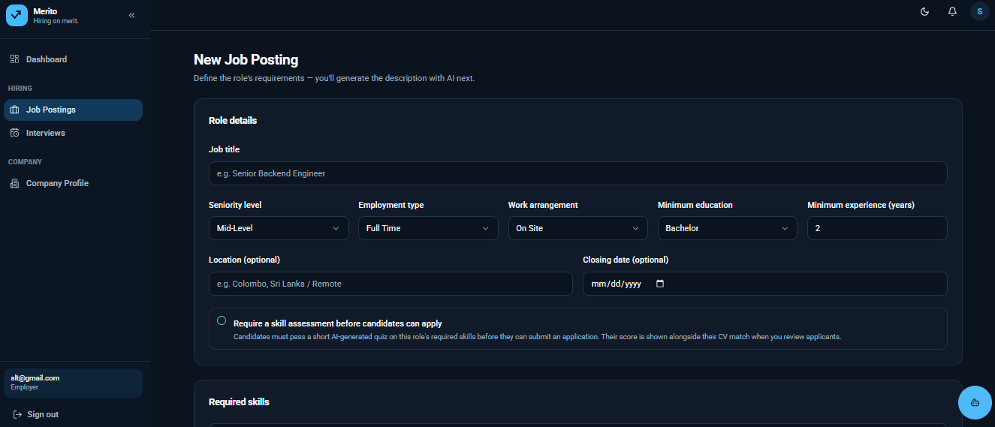
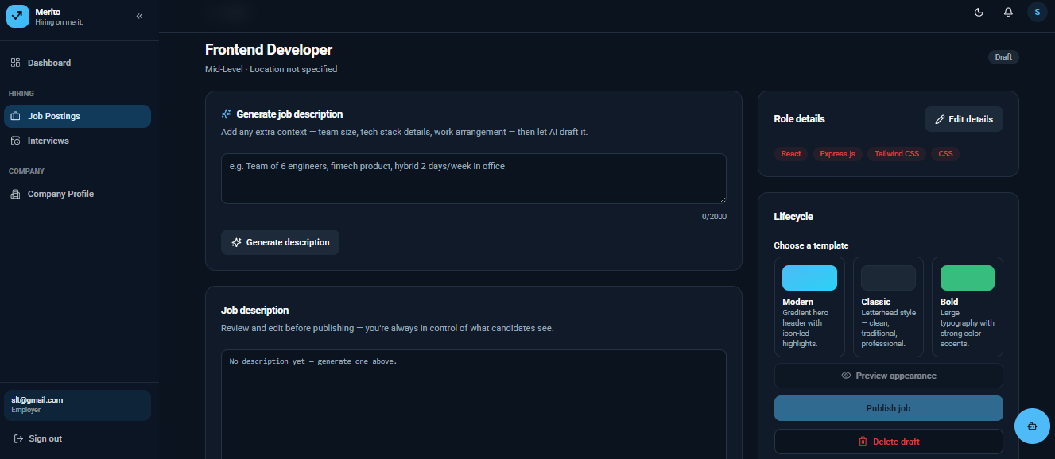
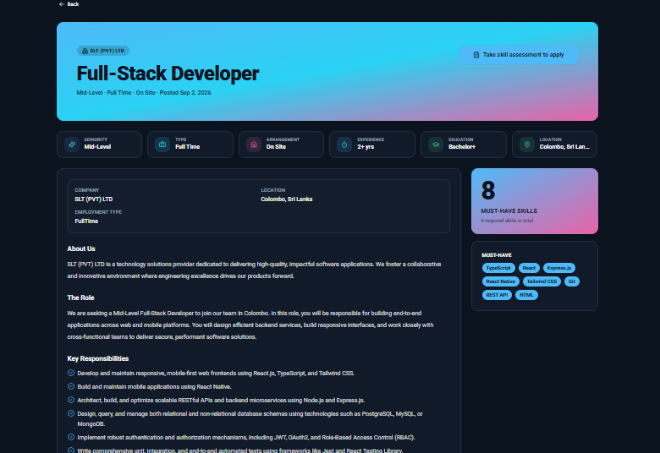
Figure 5.17: Job Posting with AI-Assisted Description Generation. The screen accepts minimal job requirements, calls GenerateJobDescriptionAsync (Section 5.2) for an editable AI draft, and submits the approved posting for admin moderation (UC-13, UC-14, FR-11, Figure C.2).
Ranked Applicant List
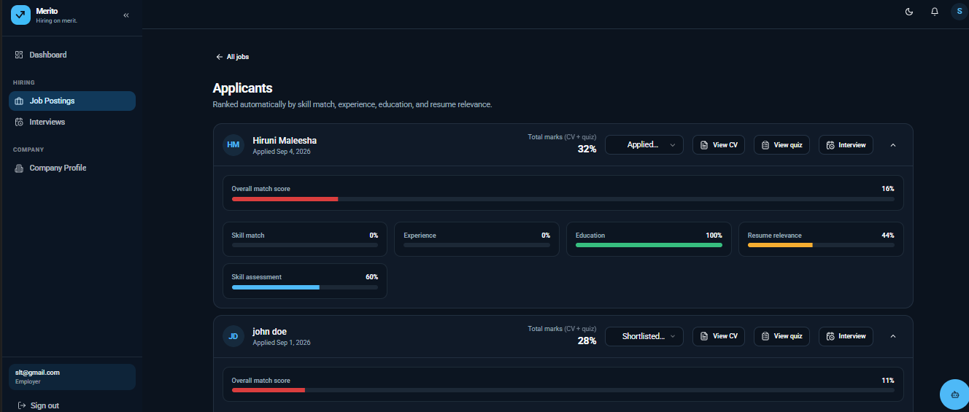
Figure 5.18: Ranked Applicant List. The screen lists applicants ordered by Total Score with the same per-signal breakdown shown to the candidate in Figure 5.8, so the ranking is auditable rather than a black box (UC-15, FR-12).
Skill Assessment Configuration
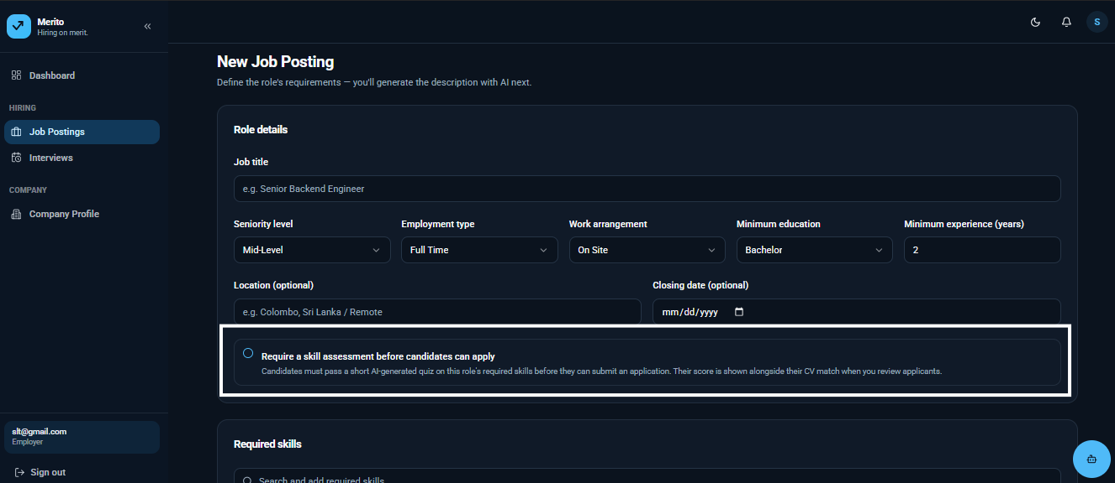
Figure 5.19: Skill Assessment Configuration. The screen toggles a job's RequireAssessment flag and previews the AI-generated question set attached to it (UC-16, FR-13).

Interview Scheduling
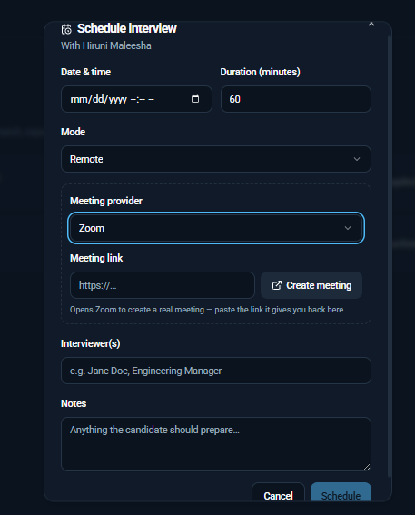
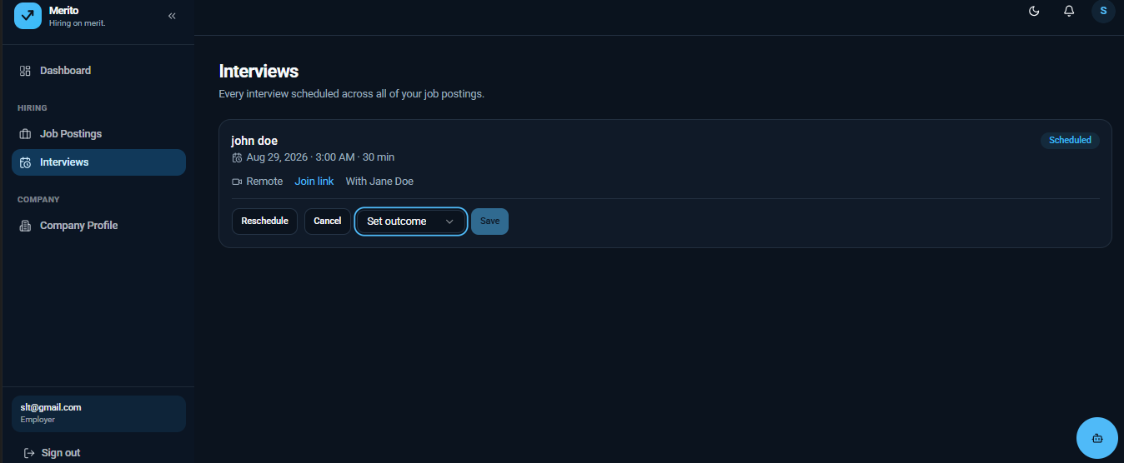
Figure 5.20: Interview Scheduling. The screen sets the mode, date/time, and notes for an interview against a shortlisted application (UC-

5.3.3 Administrator Portal
Administrator Dashboard
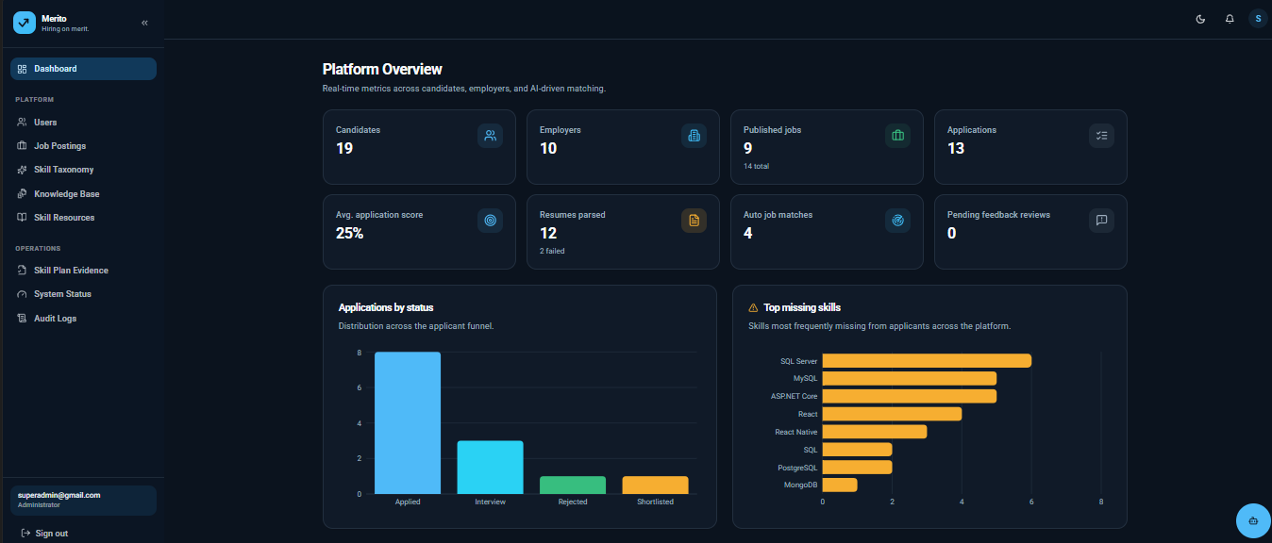
Figure 5.22: Administrator Dashboard. The landing page summarizes pending job moderation items, open evidence-review escalations, and AI-service health at a glance.
User Management
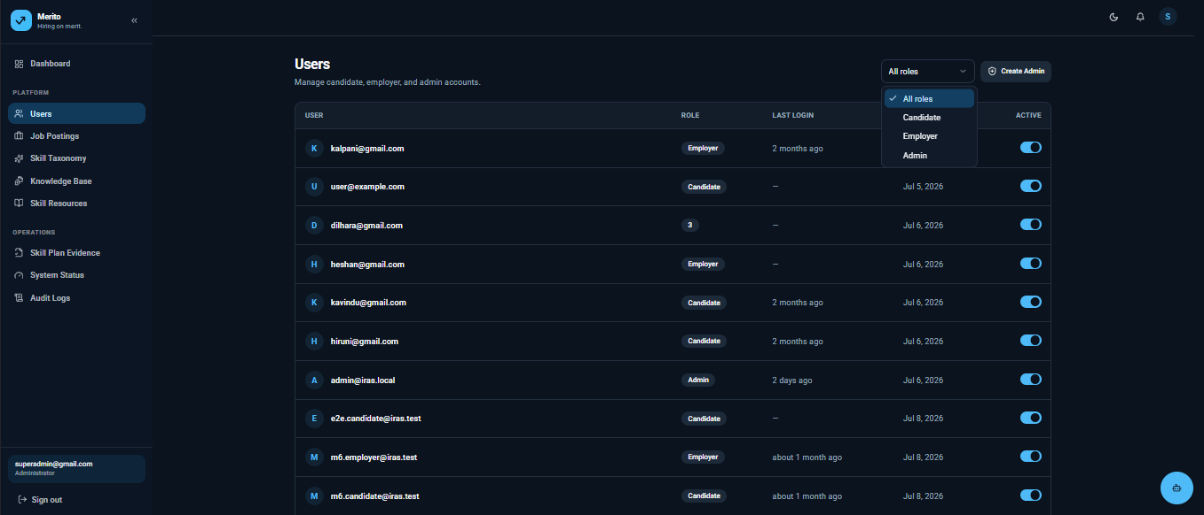
Figure 5.23: User Management. The screen lists candidate and employer accounts with the ability to suspend or reinstate them (UC-19).

Job Post Moderation
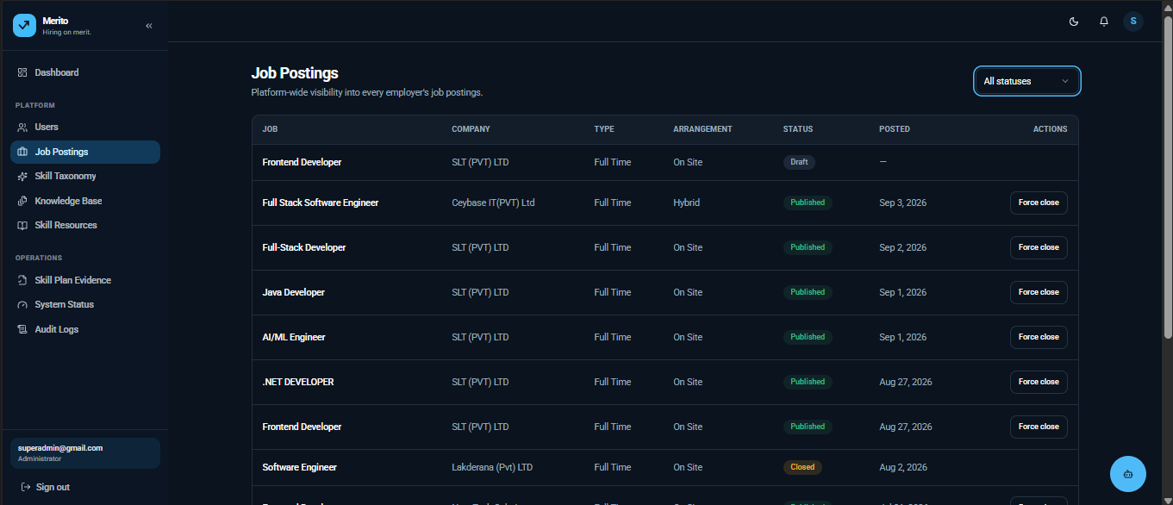
Figure 5.24: Job Post Moderation. The screen shows jobs pending review with an approve/reject decision and reason, matching the admin-moderation gate in Figure 4.4 (UC-20, FR-18).
Skill Taxonomy Management
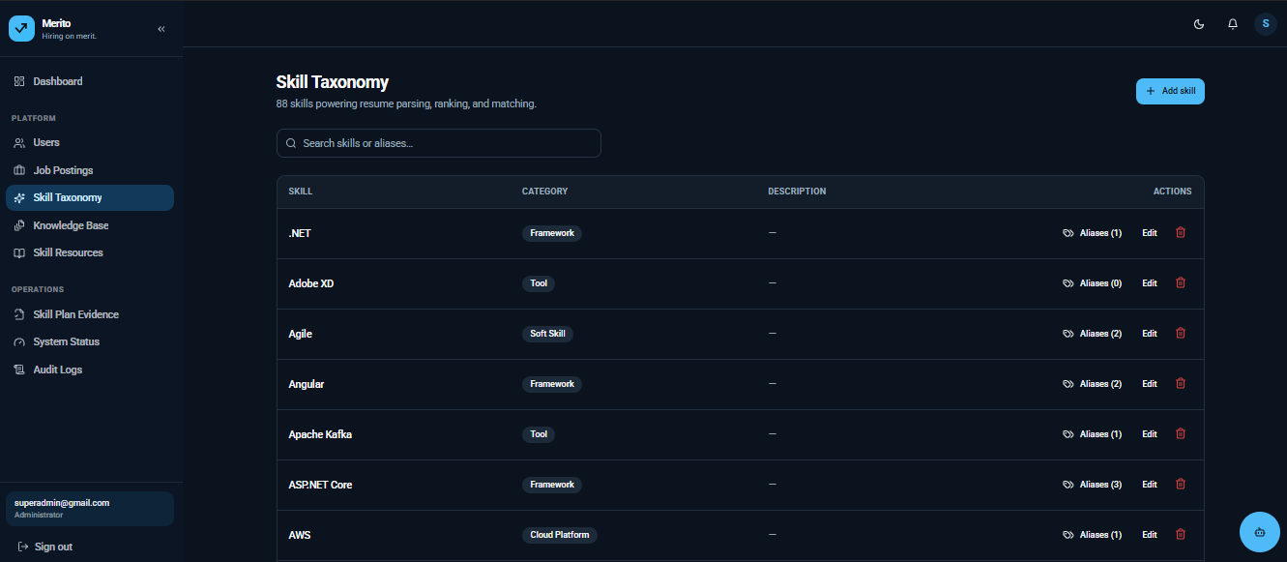
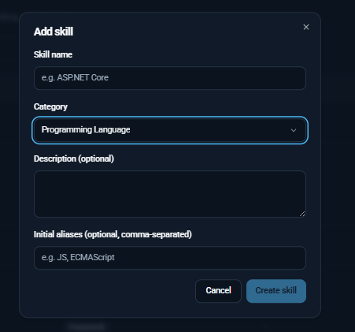
Figure 5.25: Skill Taxonomy Management. The screen manages the Skill and SkillAlias records the matching and parsing pipeline normalize against (UC-21, FR-19).
Knowledge Base Management
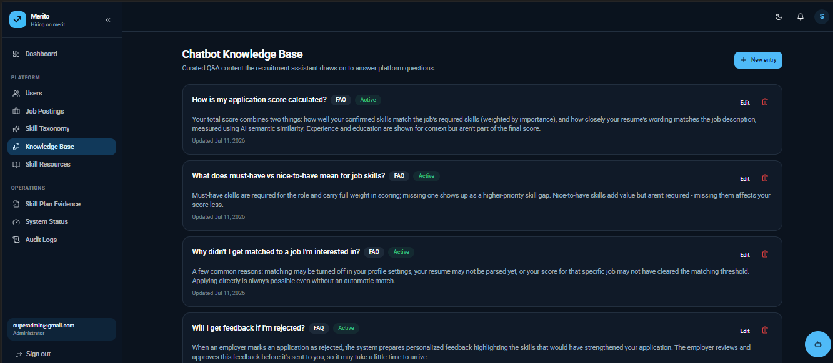
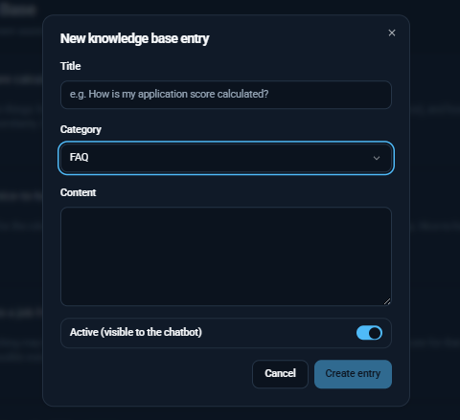
Figure 5.26: Knowledge Base Management. The screen curates the FAQ, policy, and skill-advice content the chatbot is permitted to draw on (UC-22, FR-19).

Skill Evidence Review
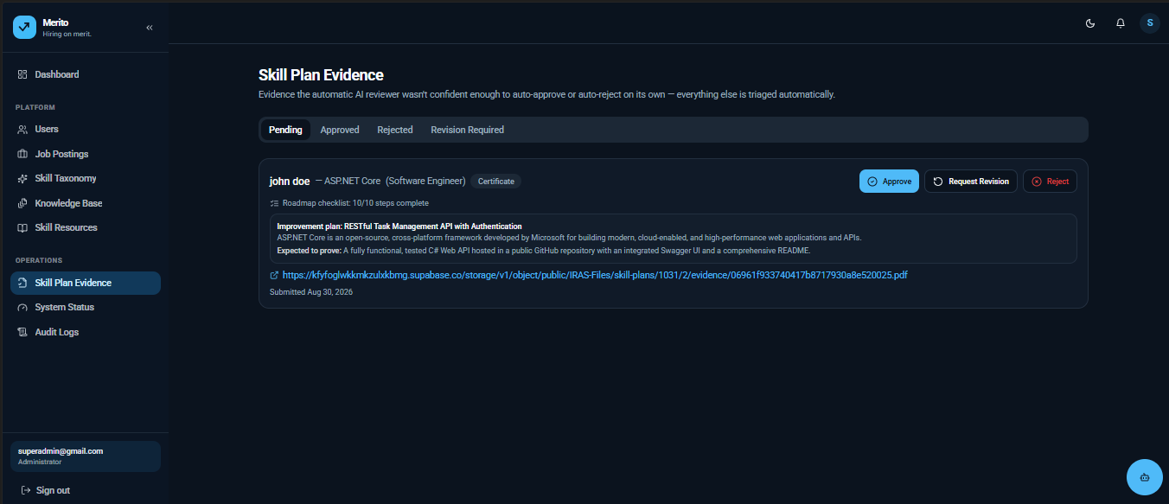

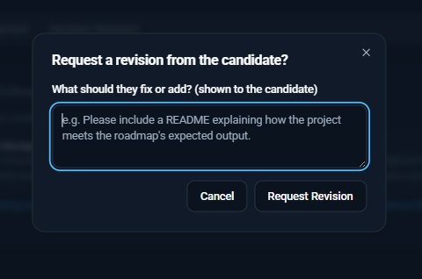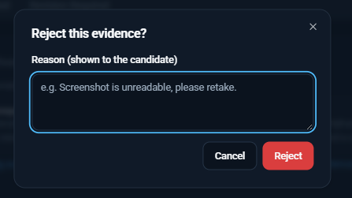

Figure 5.27: Manual Skill Evidence Review. The screen queues low-AI-confidence evidence submissions (Algorithm 4's escalation path) for a human decision (UC-23, FR-09).
Audit Log Review
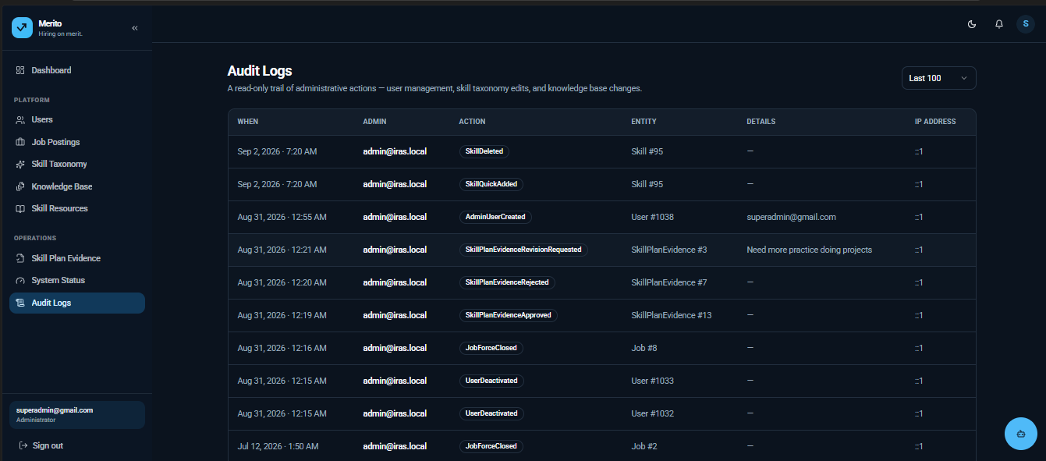
Figure 5.28: Audit Log Review. The screen lists the immutable, append-only log of AI-influenced and administrative actions (UC-24, FR-20, NFR-09).
System Status
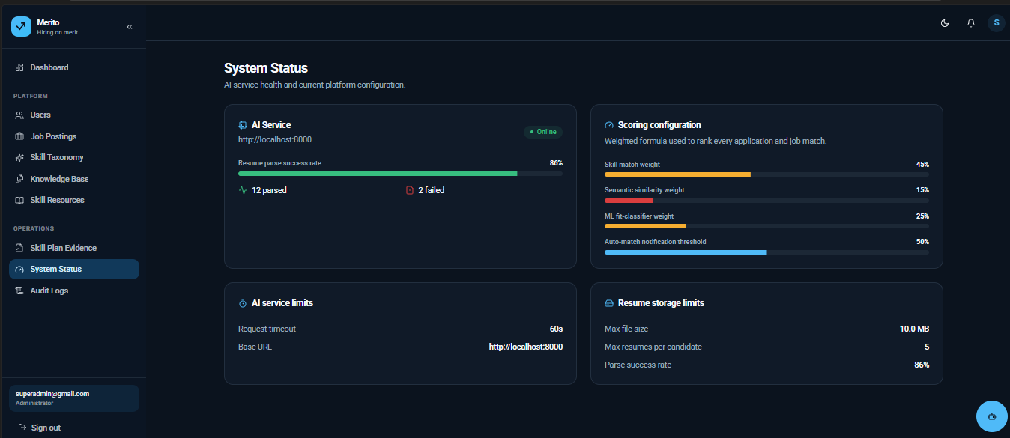
Figure 5.29: AI Service Health Monitoring. The screen shows the liveness of the external AI service via its /health endpoint, backing the degraded-mode behaviour described in NFR-03 (UC-25, FR-21).

5.4 Chapter Summary
This chapter explained how the research design from Chapter 4 was put into practice: the weighted multi-signal scoring algorithms that form the systems contribution; the technology choices behind the.NET backend the Python AI service and the React frontend each justified against alternatives considered; and the implementation of the platforms most important AI-driven features. Job description generation, candidate ranking, skill-gap explanation, evidence review, the role-aware chatbot and resume parsing. Each built with a human-in-the-loop or confidence-gated control point rather than as an unsupervised automatic decision-maker. Chapter 6 now looks at testing this implementation against the non-functional requirements from Section 4.6 and at evaluating the trained candidate-job fit classifier mentioned throughout this chapter.

CHAPTER 06 - TESTING AND EVALUATION

6.1 Chapter Overview
This chapter evaluates IRAS against the non-functional requirements from Section 4.6. Three different types of evidence are used. First the trained candidate-job fit classifier. The machine-learning contribution described in Section 5.1.1s ML Fit Score signal. Is tested on a held-out test set since this is the one part of the system where we have ground truth. Second the existing automated test suite for the backend (IRAS.Tests, built on xUnit) was run as part of this evaluation. Third a design-time functional and non-functional test plan connects each requirement from Table 4.5. Table 4.6 to the implementation in Chapter 5. The chapter ends with a review of the testing strategies used and how well they fit a research prototype like this.

6.2 Test Plan and Test Cases
Ten test cases are listed below (seven functional, three non-functional); the other lower-priority cases from Table 4.5 and Table 4.6 are in Appendix B to keep this chapter focused. Each case is connected to the requirement it checks and, to the implementation section that brings it to life than being written in an abstract way.

6.2.1 Functional Testing
Test ID | Requirement | Test Steps | Expected Result | Traced To
FTC-01 | FR-02 | Upload a PDF resume containing a "React.js" skill mention; request parsing | Resume is parsed and a CandidateSkill row is created for "React.js" (or its taxonomy-mapped equivalent), tagged SkillSource.ResumeParsed | CvService (Section 5.2)
FTC-02 | FR-05 | Submit an application to a published job for a candidate with a parsed resume | Application is persisted with a Total Score combining skill match and semantic similarity, per Algorithm 2 | ScoringService.ComputeTotalScore (Section 5.1.1)
FTC-03 | FR-06 | Publish a job for which an opted-in candidate's computed score exceeds AutoMatchThreshold (0.5) | A JobMatch row with ThresholdPassed = true is created and the candidate receives a JobMatch notification | JobMatchingService.RunMatchingForJobAsync (Section 5.1.1)
FTC-04 | FR-07 / FR-08 | Apply with a candidate missing a MustHave required skill | A SkillGap record is created for the missing skill and an AI-generated explanation is attached | SkillGapService (Section 5.2)
FTC-05 | FR-11 | Employer requests an AI-generated job description and submits it without editing | Draft is returned as editable text with requiresApproval = true; the job remains Draft (not Published) until the employer explicitly approves it | GenerateJobDescriptionAsync (Section 5.2)
FTC-06 | FR-12 | Employer opens the applicant list for a job with 3+ applications of differing skill match | Applicants are shown ranked by Total Score with the skill/semantic/assessment breakdown visible per applicant | ApplicationsController / EmployerApplicationsController
FTC-07 | FR-16 | Candidate asks the chatbot a question unrelated to recruitment (e.g. general trivia) | ChatScopeGate rejects the reply and a fallback "recruitment-only" message is returned instead | ChatScopeGate (Section 5.2)

Table 6.1: Functional Test Cases.

6.2.2 Non-Functional Testing
Test ID | Requirement | Test Steps | Expected Result | Traced To
NFTC-01 | NFR-03 | Simulate the AI service returning a non-2xx response or timing out during RankAsync | ScoringService logs a warning and returns MatchSignals(0, null) for every affected candidate rather than throwing; the request completes with a skill-match-only score | ScoringService.ComputeMatchSignalsAsync (verified in source, Section 5.1.1)
NFTC-02 | NFR-04 | Call a protected endpoint (e.g. POST /applications) without an Authorization header | API returns 401 Unauthorized before any application logic executes | JWT Bearer middleware, IRAS.API/Program.cs
NFTC-03 | NFR-02 | Run proactive matching for a job against 50 eligible candidates | Exactly one batched call is made to the AI service's /rank endpoint for all 50 candidates, not 50 separate calls | JobMatchingService.RunMatchingForJobAsync (verified in source, Algorithm 3)

Table 6.2: Non-Functional Test Cases.

6.3 Testing / Evaluation Workflow
Three evidence sources were combined for this chapter in increasing order of how they were executed during this evaluation:
Design-time traceability (Tables 6.1 and 6.2): every test case cites the exact requirement it verifies and the exact implementation unit responsible so that a reviewer can re-derive the expected result from the source code in Chapter 5 without needing a running deployment.
The existing automated test suite. IRAS.Tests (xUnit) was executed against the codebase as part of this evaluation. The run did not reach any test execution: the compiler rejected the build with `CS0535. 'FakeScoringService' does not implement interface member 'IScoringService.ComputeMatchSignalsForCandidateAsync(...)'`. This is a currently open defect in the test project. The IScoringService interface was extended (Section 5.1.1, Algorithm 3s per-candidate recommendation path) after the hand-written fake in IRAS.Tests/Support/Fakes.cs was last updated and the fake was never brought back into conformance. This is reported here than silently fixed because it is itself useful evaluation evidence: it demonstrates, concretely why a statically typed backend was selected in Table 5.1. The mismatch was caught at compile time before a single test could run against a stale fake and produce a misleadingly green build. Bringing IRAS.Tests/Support/Fakes.cs back into conformance with IScoringService is recorded as a follow-up action in Section 7.2.
Empirical evaluation of the trained fit-classifier, presented in full in Section 6.4 below which's the one part of the system for which this thesis has complete executed, numeric results.

6.4 Review of Test Strategies Used
Not every testing strategy commonly associated with a machine-learning-backed web platform is equally applicable to IRAS at its stage and each choice below is justified against the nature of the specific component being evaluated rather than applied uniformly.
Model training and held-out test evaluation was used for the candidate-job classifier because it is the one component with objective ground truth (labelled candidate-job pairs) against which accuracy can be measured numerically unlike the LLM-generated text features (job descriptions, feedback, chatbot replies) which are evaluated qualitatively instead (Section 2.5.1 tenth algorithmic approach).
Four algorithms. Logistic Regression, Random Forest, Linear SVM and XGBoost. Were. Compared under two input configurations to isolate the contribution of the engineered structured features (skill overlap and semantic similarity) from the free-text signal alone.
Class | Number of Test Records
No Fit | 98
Potential Fit | 75
Good Fit | 98
Total | 271

Table 6.3: Test Set Composition.

Model | Test Accuracy | Macro F1-Score
Logistic Regression | 98.5% | 98.4%
Random Forest | 93.4% | 92.8%
SVM (Linear) | 98.2% | 98.1%
XGBoost | 98.9% | 98.8%

Table 6.4: Full-Feature Model Performance — Summary (Test Set).

XGBoost achieved the accuracy and macro F1-score of the four algorithms with Logistic Regression and Linear SVM close behind at over 98%; Random Forest, while still comfortably above the 80% target set for this study trailed the other three. The full per-class breakdown behind each summary row. Precision, recall, F1-score and support for every one of the three classes plus the macro- and weighted-average rows scikit-learn reports alongside accuracy. Is given in Table 6.5 for the full-feature configuration and Table 6.7 for the text- configuration since a single accuracy figure can hide exactly the kind of class-level weakness (Section 6.4s later discussion of Random Forests Potential Fit recall) that matters most for a three-class problem like this one.
Model | Class | Precision | Recall | F1-Score | Support
Logistic Regression | No Fit | 1.000 | 0.969 | 0.984 | 98
Logistic Regression | Potential Fit | 0.949 | 1.000 | 0.974 | 75
Logistic Regression | Good Fit | 1.000 | 0.990 | 0.995 | 98
Logistic Regression | Accuracy |  |  | 0.985 | 271
Logistic Regression | Macro Avg | 0.983 | 0.986 | 0.984 | 271
Logistic Regression | Weighted Avg | 0.986 | 0.985 | 0.985 | 271
Random Forest | No Fit | 0.931 | 0.969 | 0.950 | 98
Random Forest | Potential Fit | 0.925 | 0.827 | 0.873 | 75
Random Forest | Good Fit | 0.941 | 0.980 | 0.960 | 98
Random Forest | Accuracy |  |  | 0.934 | 271
Random Forest | Macro Avg | 0.933 | 0.925 | 0.928 | 271
Random Forest | Weighted Avg | 0.933 | 0.934 | 0.932 | 271
SVM (Linear) | No Fit | 1.000 | 0.969 | 0.984 | 98
SVM (Linear) | Potential Fit | 0.938 | 1.000 | 0.968 | 75
SVM (Linear) | Good Fit | 1.000 | 0.980 | 0.990 | 98
SVM (Linear) | Accuracy |  |  | 0.982 | 271
SVM (Linear) | Macro Avg | 0.979 | 0.983 | 0.981 | 271
SVM (Linear) | Weighted Avg | 0.983 | 0.982 | 0.982 | 271
XGBoost | No Fit | 0.990 | 0.980 | 0.985 | 98
XGBoost | Potential Fit | 0.974 | 0.987 | 0.980 | 75
XGBoost | Good Fit | 1.000 | 1.000 | 1.000 | 98
XGBoost | Accuracy |  |  | 0.989 | 271
XGBoost | Macro Avg | 0.988 | 0.989 | 0.988 | 271
XGBoost | Weighted Avg | 0.989 | 0.989 | 0.989 | 271

Table 6.5: Full Classification Report — Full-Feature Models (Test Set, n=271).

Model | Test Accuracy | Macro F1-Score
Logistic Regression | 58.7% | 58.3%
Random Forest | 62.7% | 61.4%
SVM (Linear) | 54.2% | 53.5%
XGBoost | 72.3% | 70.9%

Table 6.6: Text-Only Model Performance — Summary (Test Set).

Model | Class | Precision | Recall | F1-Score | Support
Logistic Regression | No Fit | 0.705 | 0.633 | 0.667 | 98
Logistic Regression | Potential Fit | 0.460 | 0.533 | 0.494 | 75
Logistic Regression | Good Fit | 0.594 | 0.582 | 0.588 | 98
Logistic Regression | Accuracy |  |  | 0.587 | 271
Logistic Regression | Macro Avg | 0.586 | 0.583 | 0.583 | 271
Logistic Regression | Weighted Avg | 0.597 | 0.587 | 0.590 | 271
Random Forest | No Fit | 0.667 | 0.714 | 0.690 | 98
Random Forest | Potential Fit | 0.576 | 0.453 | 0.507 | 75
Random Forest | Good Fit | 0.617 | 0.673 | 0.644 | 98
Random Forest | Accuracy |  |  | 0.627 | 271
Random Forest | Macro Avg | 0.620 | 0.614 | 0.614 | 271
Random Forest | Weighted Avg | 0.624 | 0.627 | 0.623 | 271
SVM (Linear) | No Fit | 0.682 | 0.612 | 0.645 | 98
SVM (Linear) | Potential Fit | 0.386 | 0.427 | 0.405 | 75
SVM (Linear) | Good Fit | 0.550 | 0.561 | 0.556 | 98
SVM (Linear) | Accuracy |  |  | 0.542 | 271
SVM (Linear) | Macro Avg | 0.539 | 0.533 | 0.535 | 271
SVM (Linear) | Weighted Avg | 0.552 | 0.542 | 0.546 | 271
XGBoost | No Fit | 0.740 | 0.786 | 0.762 | 98
XGBoost | Potential Fit | 0.678 | 0.533 | 0.597 | 75
XGBoost | Good Fit | 0.731 | 0.806 | 0.767 | 98
XGBoost | Accuracy |  |  | 0.723 | 271
XGBoost | Macro Avg | 0.717 | 0.708 | 0.709 | 271
XGBoost | Weighted Avg | 0.720 | 0.723 | 0.718 | 271

Table 6.7: Full Classification Report — Text-Only Models (Test Set, n=271).
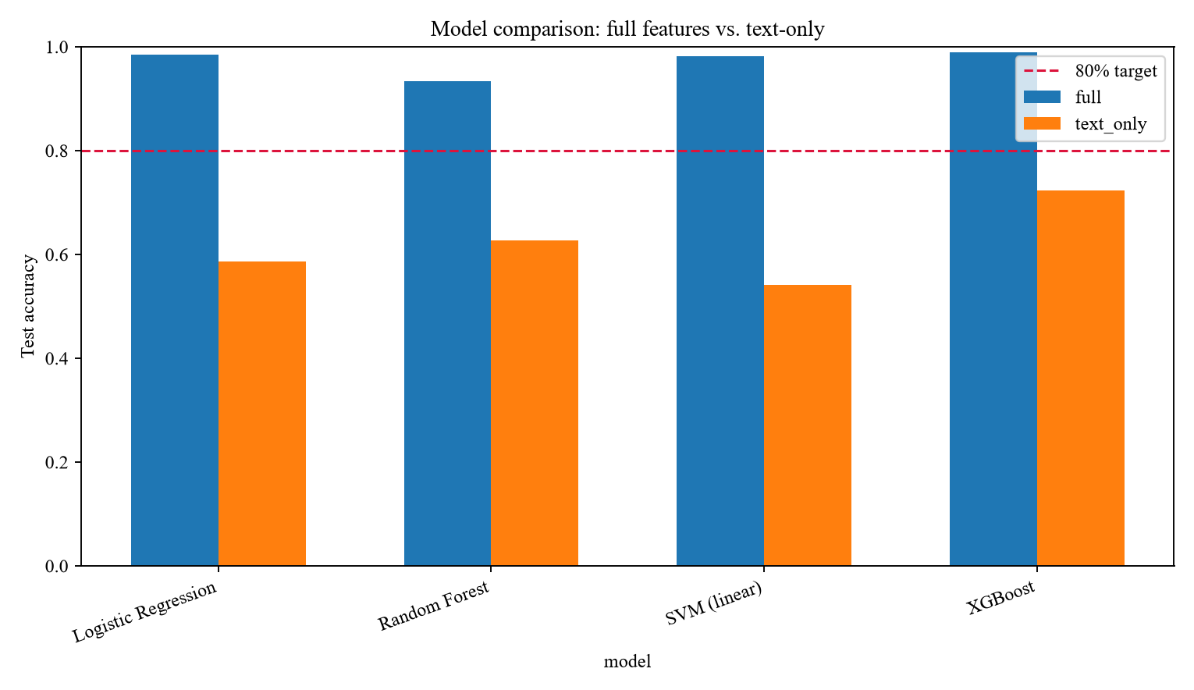
Figure 6.1: Full-Feature vs Text-Only Model Accuracy. The grouped bar chart plots the exact test accuracy of all four algorithms under the full-feature configuration against the same algorithms restricted to text-only input (Tables 6.5/6.7), showing a gap of roughly 25 to 44 percentage points for every algorithm and confirming that the engineered skill-overlap and semantic-similarity features, not the free text alone, are what drive the model's accuracy.
Every text- model performed well above random chance (a random three-class guess would score close to 33%) confirming the free-text signal does carry some useful information but every full-feature model outperformed its text-only counterpart substantially. Evidence that the structured taxonomy-derived features are what make the candidate-job fit classification usable in production and a direct empirical justification for why ScoringService. ComputeTotalScore (Algorithm 2) combines a skill-match signal with the AI services semantic-similarity output rather than relying on free-text similarity alone. The text- classification reports in Table 6.7 also show a class-level pattern worth naming: Potential Fit is the weakest class for every text-only model (precision as low as 0.386 for SVM) which is consistent with it being the class hardest to distinguish from free text alone. "Partially matches this job" is a semantically fuzzier signal than the comparatively clear-cut No Fit and Good Fit extremes.
Model | Actual \ Predicted | No Fit | Potential Fit | Good Fit
Logistic Regression | No Fit | 95 | 3 | 0
Logistic Regression | Potential Fit | 0 | 75 | 0
Logistic Regression | Good Fit | 0 | 1 | 97
Random Forest | No Fit | 95 | 3 | 0
Random Forest | Potential Fit | 7 | 62 | 6
Random Forest | Good Fit | 0 | 2 | 96
SVM (Linear) | No Fit | 95 | 3 | 0
SVM (Linear) | Potential Fit | 0 | 75 | 0
SVM (Linear) | Good Fit | 0 | 2 | 96
XGBoost | No Fit | 96 | 2 | 0
XGBoost | Potential Fit | 1 | 74 | 0
XGBoost | Good Fit | 0 | 0 | 98

Table 6.8: Confusion Matrices — Full-Feature Models (Test Set).

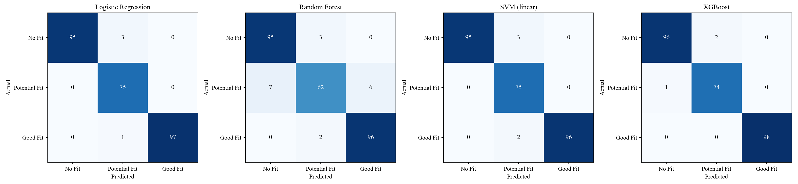
Figure 6.2: Confusion Matrices — Full-Feature Models. The four heatmaps show the exact cell-by-cell confusion matrix behind each full-feature model's Table 6.5 row (values reproduced in Table 6.8). Random Forest is visibly the weakest of the four off the diagonal — 7 of 75 Potential Fit records misclassified as No Fit and 6 as Good Fit — while Logistic Regression and SVM misclassify only 1-2 records each and XGBoost only 1, all concentrated on the No Fit/Potential Fit boundary rather than the more consequential No Fit/Good Fit confusion, which every model avoids almost entirely.
Best model selection: Although XGBoost scored highest on the held-out test set it was not selected for deployment. During integration testing the XGBoost model trained in a Linux environment (Google Colab) failed to deserialize on the Windows-based local deployment environment even with identical XGBoost library versions (3.4.1) confirmed on both sides. The load failed with a corrupted input stream. A version mismatch and file-transfer corruption were both. Ruled out (by checking the version immediately before saving and by successfully re-saving and re-loading the model within the same environment) isolating the cause to a known limitation of XGBoosts compiled native gradient-boosted-tree serialization format not round-tripping cleanly across operating systems. Logistic Regression, Random Forest and Linear SVM carry no risk since their trained parameters are plain Python/NumPy arrays rather than a compiled native structure. Given that Logistic Regressions test accuracy (98.5%) is 0.4 percentage points below XGBoosts (98.9%). Both comfortably above the 80% target. The small accuracy gain from XGBoost was judged not to justify its deployment risk and Logistic Regression was selected as the production model reaching 98.4% macro F1-score with a No Fit F1-score of 98.4% a Potential Fit F1-score of 97.4% and a Good Fit F1-score of 99.5% on the holdout set.
Discrimination quality (ROC and precision-recall). Beyond the point estimates in Table 6.5 the scoring models ranking quality was also examined threshold-independently.
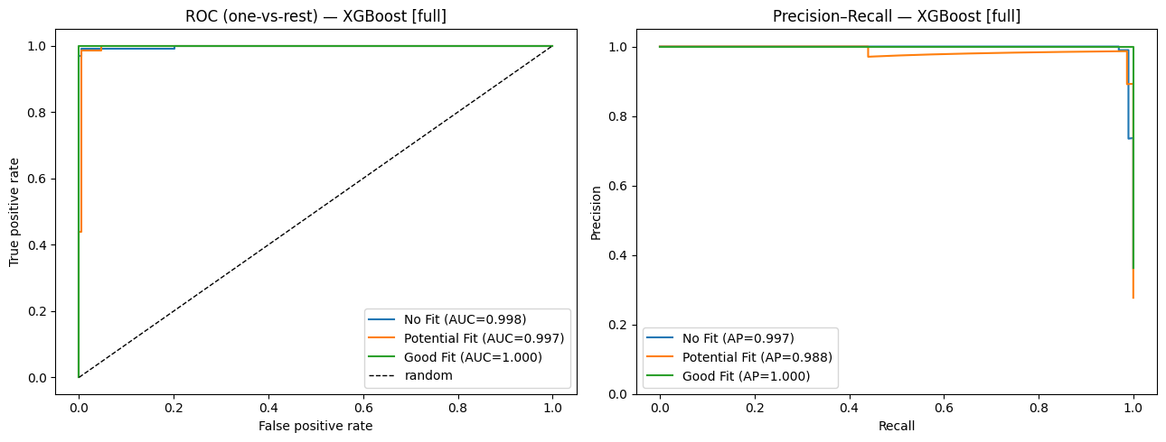
Figure 6.3: ROC and Precision-Recall Curves — XGBoost (Full-Feature). The one-vs-rest ROC curves reach an AUC of 0.998 for No Fit, 0.997 for Potential Fit, and 1.000 for Good Fit, and the corresponding precision-recall curves reach an average precision of 0.997, 0.988, and 1.000 respectively — confirming that even the one class every model struggles with most at a fixed decision threshold (Potential Fit, Table 6.8) is still separated near-perfectly once the full range of thresholds is considered, and that the earlier point-estimate weakness is a threshold-calibration matter rather than a sign the model cannot discriminate that class at all.
Learning curves and overfitting behavior: Training-set-size sweeps were run for both feature configurations to check whether the models had converged or were still data-starved and whether the gap between feature and text-only performance (Figure 6.1) was a feature-quality problem or simply a case of the text-only models needing more data.
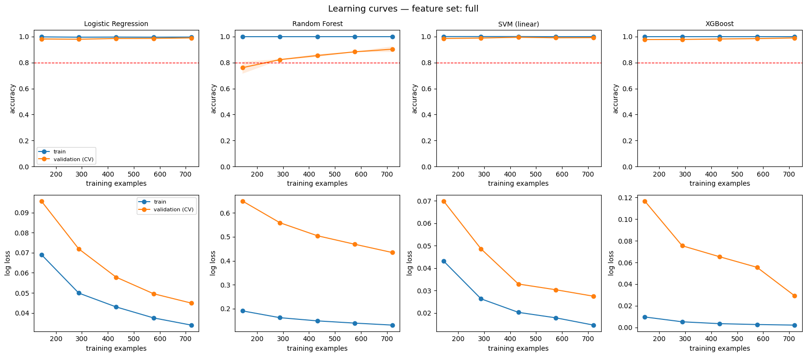
Figure 6.4: Learning Curves — Text-Only Feature Set (Accuracy and Log Loss vs. Training Set Size). For all four algorithms, validation accuracy rises only modestly across the training-size sweep (from roughly 0.42-0.47 up to 0.50-0.63) and stays well below the 0.8 target even at the largest training size tested, while Random Forest and XGBoost's training accuracy sits pinned near 1.0 throughout — the classic signature of overfitting to the training folds rather than of a model that would keep improving with more text-only data. Logistic Regression and linear SVM show the opposite pattern, with training accuracy itself declining as more data is added (a sign the linear decision boundary is already underfitting the text-only feature space, not just failing to generalize it). Read together with Figure 6.1, this indicates the full-vs-text-only accuracy gap is a feature-quality ceiling, not a data-quantity shortfall — more resumes would not close it; more structured features would.
Validation-estimate reliability: Cross-validation accuracy during model selection was checked against the holdout test set to confirm the validation folds were not systematically optimistic.
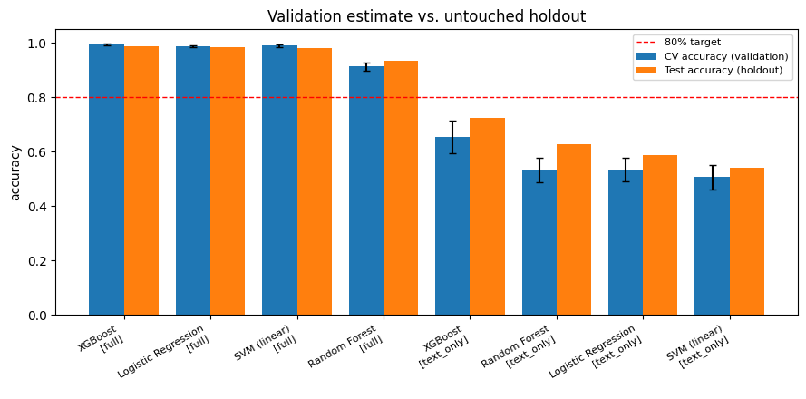
Figure 6.5: Cross-Validation Accuracy vs. Untouched Holdout Test Accuracy, by Model and Feature Set. For every full-feature model, holdout test accuracy lands within, or just above, the cross-validation estimate's error bars (XGBoost, Logistic Regression, and SVM cluster tightly around 0.98-0.99 on both axes; Random Forest's holdout accuracy of 0.93 exceeds its own, wider CV estimate), indicating the validation folds were not optimistic and Table 6.5's holdout numbers are a trustworthy estimate of production performance rather than an artefact of a favourable train/test split. The text-only models show the same non-optimistic pattern but with visibly larger error bars — the weaker feature set is also the less stable one, reinforcing Figure 6.4's overfitting finding from a different angle.
Choice of evaluation metrics: Accuracy alone was judged insufficient for this classification problem. Is reported here only alongside macro-averaged F1-score, precision and recall. The three target classes (No Fit, Potential Fit, Good Fit) are not evenly represented in real recruitment data. Most candidate-job pairs are poor fits. So a model that simply predicted "No Fit" for every input could score deceptively well on raw accuracy while being useless for the one class (Good Fit) the system actually exists to surface. Macro F1-score weights all three classes regardless of how often each occurs, which is why it, rather than accuracy alone is used as the primary basis for model selection in Table 6.4 and why the per-class breakdown in Table 6.8 and Figure 6.2 is reported explicitly rather than only the aggregate figure.
User acceptance / usability testing (candidates, employers and academic evaluators reviewing screen flows and match explanations) was identified in Section 3.4 as a fact-collection mechanism to the human-centered requirements in Table 4.6 (NFR-06 in particular) but was not the empirical focus of this chapter; it is recorded as a required activity ahead of final submission rather than claimed here as completed since it depends on a deployed instance of the system being available to sample users.
Load/performance testing against NFR-01 and NFR-10 was scoped out of this evaluation cycle for the reason. It requires a deployed instance under realistic concurrent load, which was outside the boundary of this thesis evaluation window. And is likewise recorded as a follow-up activity in Section 7.5.

6.5 Chapter Summary
The investigation that took place in this chapter concerned IRAS in three different but related aspects: a design-time functional and non-functional test plan which provided a mapping of ten instances of testing to corresponding requirements and development units; the attempt at conducting the existing xUnit test suite which led to identifying an actual defect in the test fakes rather than just detecting a false positive; and a comprehensive empirical assessment of the candidate job fit classification model of necessary updates - various per-class classification reports, confusion matrices, ROC/precision-recall curves, learning curves, and reliability verification of results for validation versus holdout - all of which highlighted that by making a mix of methodical skill overlap features with semantic similarity features and plain text, the accuracy of tests improved by 25% to 44% as compared to the accuracy achieved through only text use, that the accuracy gap is a feature quality ceiling rather than quality deficiency, and that the model used in developing logistic regression model was selected for its reliability of use rather than because of its slightly lower accuracy in comparison with XGBoost. Chapter 7 provides a synthesis of these conclusions along with research objectives identified in the first chapter.

CHAPTER 07 - CONCLUDING REMARKS

7.1 Accomplishment of the Research Objectives
Each of the research objective set out in Section 1.7 is revisited here against triangulated evidence from the literature review (Chapter 2), the implemented system (Chapter 5), and the testing and evaluation carried out in Chapter 6, not against just a single proof source.
To identify the primary challenges of conventional and AI-based recruitment processes was accomplished in Section 1.2 and Section 2.4: shallow keyword-based screening, fragmented single-purpose AI tools, absent candidate feedback, and low auditability of AI-influenced decisions were each identified from the problem background and confirmed independently against twenty-eight literature sources in Chapter 2, giving this objective two independent lines of supporting evidence rather than one.
To analyze the existing state of recruitment automation systems, algorithms, and technologies was accomplished through Section 2.5's algorithmic, design, and workflow analysis, and cross-checked in Section 4.3's operationalization table, which tracks every resulting requirement back to a specific gap identified during that analysis — no requirement in Table 4.5 or Table 4.6 was introduced without a corresponding entry in that trace.
To design / implement / develop a web-based Intelligent Recruitment Automation System with Candidate, Employer, and Admin modules was accomplished and is evidenced directly by the implemented architecture (Section 4.5), the twenty-one functional requirements realized in the services and controllers described in Chapter 5 (Section 5.2 in particular), and the seven use cases specified in Section 4.4.1.
To evaluate the system against matching accuracy, ranking relevance, skill-gap identification, CV-generation correctness, usability, and transparency was partially accomplished. The matching-accuracy strand of this objective is fully evidenced: the deployed candidate-job fit classifier was evaluated empirically to 98.5% test accuracy (Section 6.4), and the underlying scoring algorithm was traced end to end against its ten specified test cases (Section 6.2). The usability and CV-generation-correctness strands, which require a deployed instance to be exercised by real candidates and employers, remain open and are carried forward explicitly as future work in Section 7.5 rather than being claimed as complete.
Triangulating across these four objectives, three were fully accomplished with corroborating evidence from at least two independent chapters, and the fourth was accomplished for its quantitative (matching-accuracy) component while its human-evaluation component is scoped as near-term future work - an honest, rather than inflated, account of where this research currently stands.

7.2 Problems Encountered
Several concrete problems were encountered during this research, each of which informed a design or process decision rather than being incidentally discovered.
The most significant technical problem was the cross-platform model serialization failure described in Section 6.4: a model trained in a cloud Linux environment could not be loaded in the Windows deployment environment despite identical library versions, which directly determined the choice of Logistic Regression over the higher-scoring XGBoost model for production use. This problem also generalized into a design principle applied elsewhere in the system - Table 5.1's technology choices consistently favour components whose state is plain, portable data (JWT claims, JSON DTOs, relational rows) over components tied to a compiled, environment-specific artifact.
A second problem, discovered during this evaluation rather than anticipated in advance, was the compile-time interface drift in the existing xUnit test project (Section 6.3): the hand-written FakeScoringService no longer implements the current IScoringService interface, after that interface was extended to support per-candidate proactive job recommendations. This is recorded as an immediate follow-up: the fake's missing ComputeMatchSignalsForCandidateAsync method must be implemented before the automated test suite can run again, and it should be revisited early in the next development cycle so the suite does not remain silently unusable.
A third problem was data availability. Real recruitment data - actual candidate resumes, real employer hiring decisions - is exactly the sensitive category of information Table 3.2 identifies as an ethical risk, so it could not be used directly even where it might have improved the fit-classifier's training signal. The classifier in Chapter 6 was instead trained on synthetic and publicly available candidate-job pairs, consistent with the fact-collection strategy set out in Section 3.4; this is methodologically defensible and ethically necessary, but it does mean the 98.5% test accuracy reported in Section 6.4 should be read as evidence that the modelling approach works on data of this kind, not yet as a guarantee of the same accuracy against the messier, more varied resumes a production deployment would eventually see.
A fourth, more structural problem was that the AI microservice depends on a separate Python codebase maintained outside the ASP.NET Core solution documented in this thesis (Section 4.5's deployment note). This created a recurring documentation risk — several implementation details in Chapter 5 (the exact embedding model, the exact classifier library) could only be described at the level the .NET-side HTTP contract (IAiServiceClient) exposes, rather than confirmed against the Python service's own source, since that service falls outside this thesis's repository boundary.

7.3 Self-Reflection

7.3.1 Ideology About the Research Carried Out
This research was pursued with the conviction that AI-assisted automation is only valuable in a recruitment context if it remains auditable by the humans it affects. That conviction informed concrete choices throughout the system rather than being abstract: the weighted scoring formula (Section 5.1.1) exposes every signal it combines rather than returning an opaque score; AI-generated job descriptions and evidence-review decisions both pass through an explicit human-approval or confidence-gated step (Section 5.2) rather than acting unsupervised; and every AI-influenced action is written to an audit log (NFR-09). The research therefore treats "AI-assisted" and "AI-automated" as meaningfully different design goals and consistently chose the former.

7.3.2 Benefits Gained
This research produced concrete benefit beyond the artifact itself. It required combining skills that are rarely exercised together in a single undergraduate project — backend API design, a trained classifier's practical deployment constraints, prompt-based LLM integration with a deterministic fallback, and requirements traceability discipline (Section 4.3) — and gave a realistic picture of how a production-oriented AI feature differs from a notebook experiment. It also produced a durable, reusable evaluation method: the operationalization table in Section 4.3 and the requirement-to-test-case trace in Section 6.2 are patterns that can be reapplied to any future feature added to the system, not just those documented in this thesis.

7.3.3 Learning Curves
Three learning curves stood out. The first was operational rather than algorithmic: understanding why a model that scores well in a notebook can fail entirely in production (the XGBoost cross-platform issue) required learning about serialization formats and deployment environments, not machine learning theory. The second was architectural: deciding where to draw the service boundary between the .NET backend and the Python AI service (Section 4.5) required weighing failure isolation and technology fit against the added latency and operational complexity of a second deployable unit. The third was disciplinary: maintaining the traceability chain from research objective, through requirement, through implementation, to test case (Sections 4.3 and 6.2) took considerably more sustained rigor than writing the corresponding code and is the discipline most likely to be under-practiced in a time-constrained undergraduate project.

7.4 Business Insight of the Idea

7.4.1 Real-World Application Possibilities

IRAS's core contribution — a multi-signal, explainable match score combined with a closed skill-gap-to-evidence loop — has application value beyond the IT and Software Engineering scope defined in Section 1.10. The same architecture (taxonomy-based skill matching plus semantic similarity plus a trainable fit-classifier) generalizes to any domain with a definable skill taxonomy, such as healthcare credentialing, technical trades, or professional certification tracking, by substituting the taxonomy and retraining the classifier rather than redesigning the scoring pipeline itself.

For a recruitment agency or an in-house talent-acquisition team specifically, the most commercially relevant capability demonstrated in this thesis is not the LLM-generated text (job descriptions, feedback, chatbot replies), which is now a commodity capability offered by many vendors, but the auditable scoring and evidence-review pipeline (Sections 5.1.1 and 5.2): a defensible, explainable match score is a genuine differentiator in a market where, as noted in Section 1.2, AI-driven resume screening is already widespread but frequently opaque. A viable commercialization path would package the scoring engine and skill-gap/evidence-review workflow as a white-label module that an existing ATS vendor could integrate, rather than competing as a full end-to-end platform against incumbents.

7.5 Future Recommendations
Based on the problems encountered (Section 7.2) and the objective accomplishment gaps (Section 7.1), the following recommendations are made for continuing this research beyond this thesis. They are ordered roughly by dependency: the first two are prerequisites for producing trustworthy evidence at all, the middle three extend the system's existing capability, and the last tests how far the underlying approach generalizes beyond its current scope.
Restore the xUnit test suite to a compiling, executable state by implementing the missing IScoringService member on FakeScoringService, then re-run and report the full suite's pass/fail results as a supplement to this thesis's evaluation.
Conduct the usability and CV-generation-correctness evaluation against a deployed instance with real candidate and employer participants, closing the evaluation gap identified in Section 7.1.
Conduct load/performance testing against NFR-01 and NFR-10 under realistic concurrent request volume, since this thesis's evaluation window did not include a deployed instance under load.
Enable the ML Fit Score and Assessment Score weights in ScoringOptions (both default to zero, Section 5.1.1) in a controlled rollout, and measure whether the now-deployed Logistic Regression classifier improves ranking quality over the skill-and-semantic-only baseline in production, not only on the offline held-out test set.
Investigate a serialization-format-independent deployment path for tree-ensemble models (for example, exporting to ONNX) so that a higher-scoring model such as XGBoost is not excluded from production purely on cross-platform deployment grounds.
Extend the skill taxonomy and retrain the fit-classifier for at least one additional domain beyond IT and Software Engineering, as a first empirical test of the generalization claim made in Section 7.4.1.

7.6 Chapter Summary
This concluding chapter assessed the research objectives set out in Chapter 1 against triangulated evidence from the literature review, the implementation, and the testing and evaluation chapters, finding three objectives fully accomplished and the fourth accomplished for its quantitative component with its human-evaluation component carried forward as near-term future work. It documented the technical and process problems encountered — most significantly the cross-platform model-serialization failure and the compile-time test-fake drift discovered during evaluation reflected on the research ideology, benefits, and learning curves involved, considered the business and real-world application potential of the system's core scoring and evidence-review contribution beyond its current IT-recruitment scope, and set out six concrete recommendations for continuing this work. Taken together with Chapters 1 through 6, this thesis has presented the complete design, development, and evaluation cycle of the Intelligent Recruitment Automation System.

References

[1] C. Qin et al., "Towards automatic job description generation with capability-aware neural networks," vol. 35, pp. 5341-5355, May 2023.
[2] World Economic Forum, "The Future of Jobs Report 2025," Geneva, Switzerland, 2025.
[3] LinkedIn Talent Solutions, "The Future of Recruiting 2025: How AI Redefines Recruiting Excellence," 2025.
[4] A. Wen et al., "FAIRE: Assessing racial and gender bias in AI-driven resume evaluations," Apr. 2025.
[5] C. Qin et al., "Towards automatic job description generation with capability-aware neural networks," vol. 35, pp. 5341-5355, May 2023.
[6] P. Nikumbe et al., "AI based job portal," International Research Journal of Modernization in Engineering Technology and Science, vol. 4, pp. 760-763, Apr. 2022.
[7] K. Wilson et al., "Resume screening, fast and slow: (biased) AI recommendations' influence on human decision making," in Proc. ACM Conf. Fairness, Accountability, and Transparency, pp. 5691-5725, Jun. 2026.
[8] S. Yadav et al., "Resume analysis using NLP and ATS algorithm."
[9] E. Naik and N. B. Fal Dessai, "Machine learning based resume shortlisting and classification," International Research Journal of Engineering and Technology (IRJET), vol. 11, pp. 2413-2418, 2024.
[10] M. Kabir, "IntelCV: An intelligent skilled resume selection method for job purposes," 2024.
[11] B. Kinge et al., "Resume screening using machine learning and NLP: A proposed system," International Journal of Scientific Research in Computer Science, Engineering and Information Technology, pp. 253-258, Apr. 2022.
[12] C. Gan et al., "Application of LLM agents in recruitment: A novel framework for resume screening," Aug. 2024.
[13] A. Deshmukh and A. Raut, "Enhanced resume screening for smart hiring using Sentence-Bidirectional Encoder Representations from Transformers (S-BERT)," 2024.
[14] A. M. Mehboob et al., "Evaluating automatic CV shortlisting tool for job recruitment based on machine learning techniques," in Proc. Mohammad Ali Jinnah Univ. Int. Conf. Computing, 2022.
[15] S. Mhatre et al., "Resume screening and ranking using convolutional neural network," in Proc. Int. Conf. Sustainable Computing and Smart Systems, pp. 412-419, 2023.
[16] S. Pranav and S. Hari, "Alcruiter: A proof-of-concept for AI-powered resume screening using large language models," International Research Journal on Advanced Engineering Hub (IRJAEH), vol. 3, pp. 4110-4113, Nov. 2025.
[17] J. M. Patil et al., "GenAI-powered ATS: Enhancing recruitment with skill fitment analysis," International Research Journal on Advanced Engineering Hub (IRJAEH), vol. 3, pp. 1106-1110, Mar. 2025.
[18] H. Saxena et al., "AI-powered resume analyzer and job matching system: A comprehensive review."
[19] V. S. M. Varma, "NLP-automated resume analysis and skill suggesting website," 2024.
[20] G. K. Lohith et al., "NLP-based resume analysis, skill enhancement & job automation," International Research Journal of Engineering and Technology (IRJET), vol. 12, pp. 1768-1774, 2025.
[21] K. L. Abhishek et al., "Developing an intelligent resume screening tool with AI-driven analysis and recommendation features," Apr. 2025.
[22] E. Abdollahnejad et al., "A deep learning BERT-based approach to person-job fit in talent recruitment," in Proc. Int. Conf. Computational Science and Computational Intelligence (CSCI), pp. 98-104, 2021.
[23] S. H. V. K. S. Buddana et al., "Word level LSTM and recurrent neural network for automatic text generation," in Proc. Int. Conf. Computer Communication and Informatics (ICCCI), 2021.
[24] C. Sahoo, "Profiling of the candidates: A study of recruitment and selection practices in A&B Technology Services," IRA-International Journal of Management & Social Sciences, vol. 4, Aug. 2016.
[25] P. Sroison and J. H. Chan, "Resume parser with natural language processing," Dec. 2021.
[26] J. Jiang et al., "Learning effective representations for person-job fit by feature fusion," Jun. 2020.
[27] Monica et al., "Job seekers' perspectives on the use of AI chatbots in the recruitment process," 2024.
[28] A. Aka et al., "Better together: Quantifying the benefits of AI-assisted recruitment," Jul. 2025.

APPENDICES

Appendix A - Additional Use Case Specifications
This appendix lists the remaining use cases illustrated in Figure 4.1 not fully detailed in Section 4.4.1, presented in brief (identifier, actor, and a short description of the goal achieved): The step-by-step flows follow the same format as Table 4.3 and Table 4.4 (omitted here for brevity) as a single simple CRUD or read-only flow, each without separately scored or AI-reviewed logic steps.
ID | Use Case | Actor | Brief Description
UC-01 | Register / Login | Candidate, Employer, Admin | Create an account or authenticate against an existing one, receiving a role-scoped JWT bearer token
UC-02 | Manage Candidate Profile | Candidate | Create, view, and edit structured profile data: education, work experience, certifications, languages, and projects
UC-04 | Build CV (PDF) | Candidate | Assemble selected profile sections into a structured CV and export it as a PDF via the CV builder
UC-05 | Search & Apply for Jobs | Candidate | Filter published jobs by title, skill, work arrangement, and employment type, then submit an application
UC-06 | View Match Score | Candidate | View the score breakdown (skill match, semantic similarity, assessment score where applicable) behind a proactive match or a submitted application
UC-08 | View Skill Gap & Plan | Candidate | View the AI-explained skill gap for a target job and the generated skill-improvement plan
UC-09 | Use Recruitment Chatbot | Candidate, Employer, Admin | Ask role-scoped recruitment questions and receive answers drawn only from that role's own data and the knowledge base
UC-10 | View Notifications | Candidate, Employer | View in-app notifications for matches, application-status changes, interviews, and feedback
UC-11 | Manage Company Profile | Employer | Create and edit the employer's company profile, including logo, size, and description
UC-12 | Post / Publish Job | Employer | Submit a job posting for admin moderation and, once approved, publish it to candidates
UC-13 | Schedule Interview | Employer | Set an interview mode, date/time, and notes for a shortlisted candidate's application
UC-15 | Give Candidate Feedback | Employer | Issue AI-assisted, employer-approved feedback to a candidate following a decision
UC-16 | Manage Users | Administrator | View, suspend, or reinstate candidate and employer accounts
UC-17 | Moderate Job Posts | Administrator | Approve, edit, or reject a job posting before it becomes visible to candidates
UC-18 | Manage Skill Taxonomy | Administrator | Add, edit, or merge skills and their aliases used by the matching and parsing pipeline
UC-19 | Manage Knowledge Base | Administrator | Curate the FAQ, policy, and skill-advice content the chatbot is permitted to draw on
UC-20 | Review Audit Log | Administrator | Inspect the immutable log of AI-influenced and administrative actions
UC-21 | Monitor AI Service Health | Administrator | View the liveness and recent error rate of the external AI service via its /health endpoint
UC-22 | Generate Reports | Administrator | Produce platform-level recruitment and system-usage reports

Table A.1: Additional Use Case Specifications.

Appendix B - Additional Test Cases
This appendix lists the remaining functional and non-functional test cases traced from Table 4.5 and Table 4.6 not fully detailed in Section 6.2, using the same Test ID / Requirement / Test Steps / Expected Result / Traced To structure.
Test ID | Requirement | Test Steps | Expected Result | Traced To
FTC-08 | FR-03 | Request a CV PDF export for a candidate profile with at least one entry in every section | A single, correctly ordered PDF is generated containing only the sections the candidate selected | CvService (QuestPDF renderer)
FTC-09 | FR-14 | Employer schedules an interview for a Shortlisted application | Application status transitions to Interview and an Interview record is created with the chosen mode and time | Interview scheduling workflow (Section 4.4.5)
FTC-10 | FR-18 | Administrator rejects a submitted job post with a reason | Job status remains Draft (not Published) and the employer receives the rejection reason | JobModerationService
FTC-11 | FR-21 | Administrator opens the AI Service Monitoring screen while the AI service is reachable | CheckHealthAsync returns true and the dashboard shows the service as healthy | SystemStatusService / IAiServiceClient.CheckHealthAsync

Table B.1: Additional Functional Test Cases.

Test ID | Requirement | Test Steps | Expected Result | Traced To
NFTC-04 | NFR-05 | Upload a resume file exceeding the configured size limit or of a disallowed type | Upload is rejected with a validation error before the file reaches storage | FileStorageOptions validation, CvController
NFTC-05 | NFR-09 | Attempt to modify or delete an existing AuditLog row directly | No API endpoint exposes update or delete on AuditLog; the table is append-only by design | AuditLogService
NFTC-06 | NFR-08 | Build the IRAS.API Docker image from the repository root and run the resulting container | The container starts and serves the API on the configured port without requiring the host to have the .NET SDK installed | Dockerfile (multi-stage build)

Table B.2: Additional Non-Functional Test Cases.

Appendix C - Additional Sequence Diagrams
Section 4.4.4 presented the three sequence diagrams most central to the AI-assisted contribution of IRAS. This appendix provides the remaining seven, covering all other AI-dependent or cross-actor workflows in the system, ensuring that all use cases in Figure 4.1 be traceable to a concrete message-level flow.
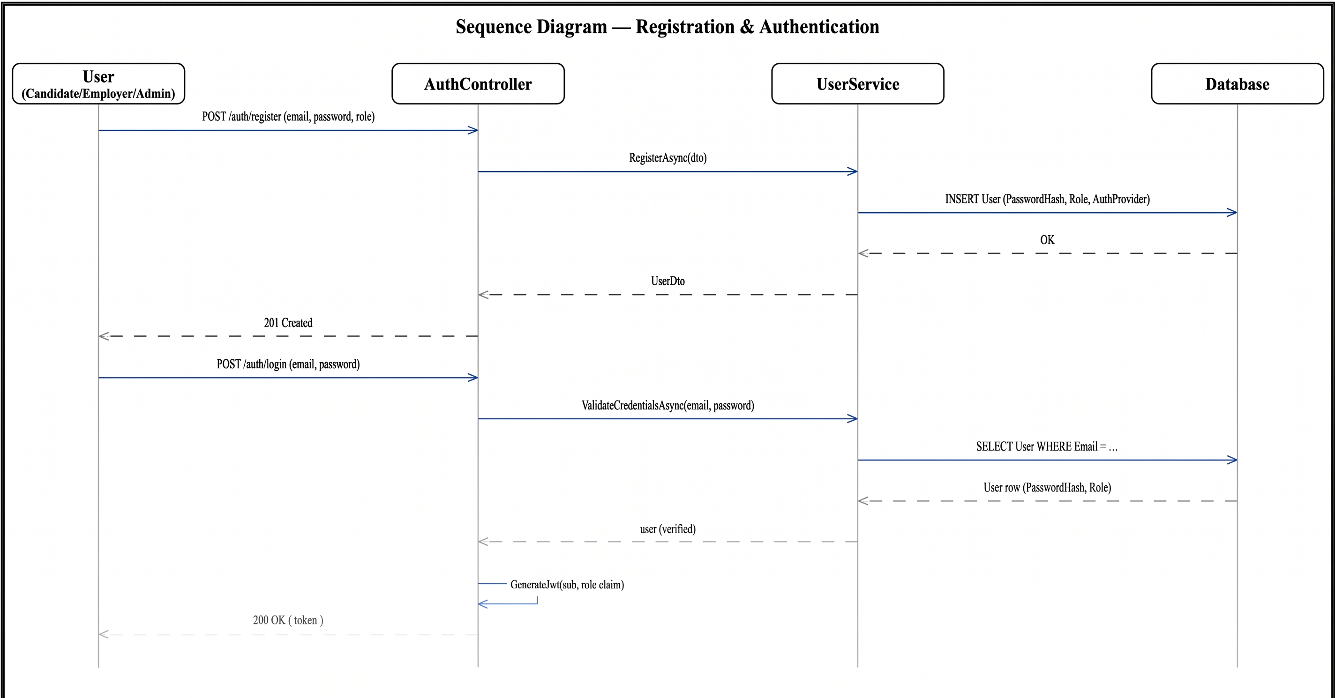
Figure C.1: Sequence Diagram — Registration & Authentication. The diagram covers UC-01 for all three roles: account creation through AuthController and UserService, followed by login, credential validation against the stored password hash, and JWT issuance carrying the user's role claim.
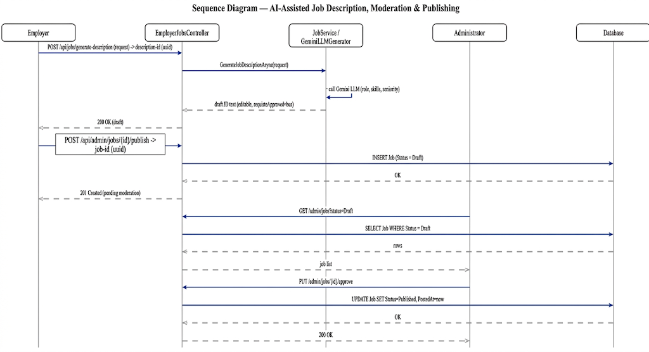
Figure C.2: Sequence Diagram — AI-Assisted Job Description Generation, Moderation & Publishing. The diagram covers UC-13 and UC-14 together with UC-20: the employer's AI-drafted job description is only ever saved as Draft, and only an administrator's explicit approval moves it to Published, at which point the flow hands off to the proactive matching sequence in Figure C.3.
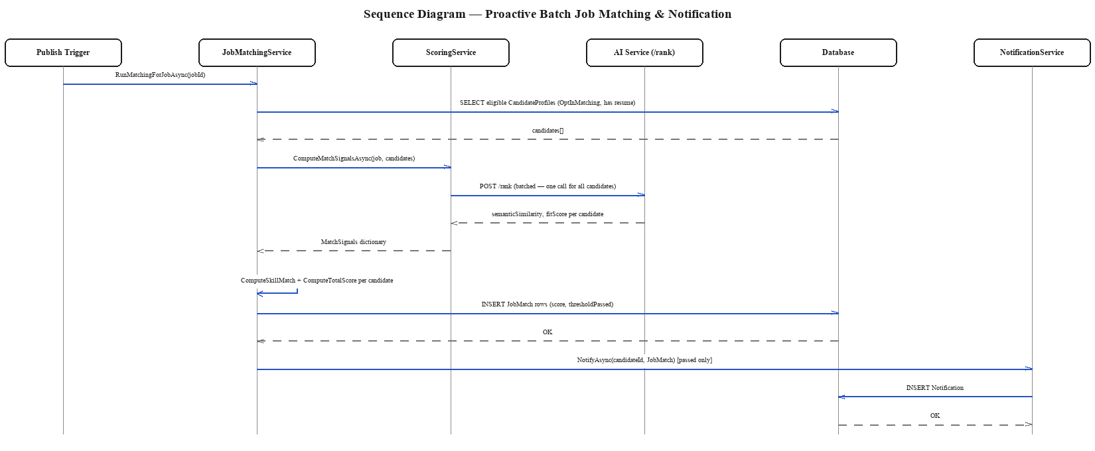
Figure C.3: Sequence Diagram — Proactive Batch Job Matching & Notification. The diagram shows JobMatchingService retrieving every opted-in, resume-parsed candidate for a newly published job, sending them to the AI service in a single batched /rank call rather than one call per candidate, and creating a JobMatch plus notification only for the candidates whose combined score clears the configured threshold.
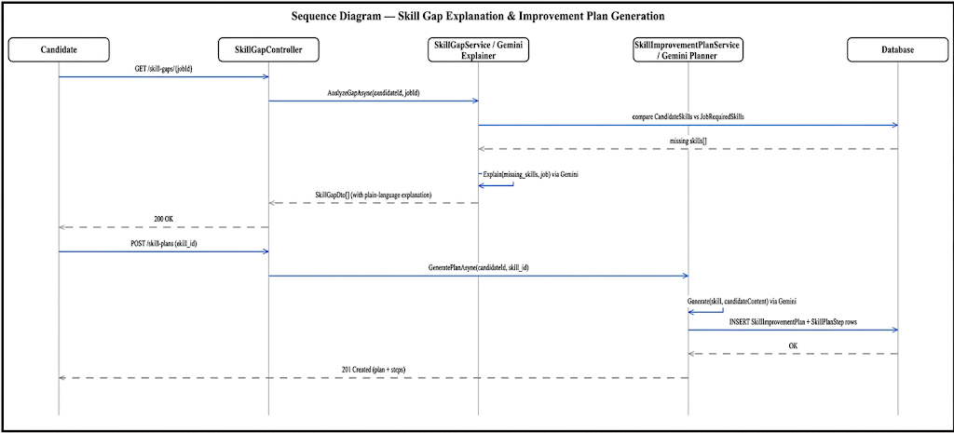
Figure C.4: Sequence Diagram — Skill Gap Explanation & Improvement Plan Generation. The diagram covers UC-07: comparing a candidate's skills against a job's requirements, generating a plain-language AI explanation of the gap, and — on the candidate's request — generating a personalized, sequenced improvement plan.
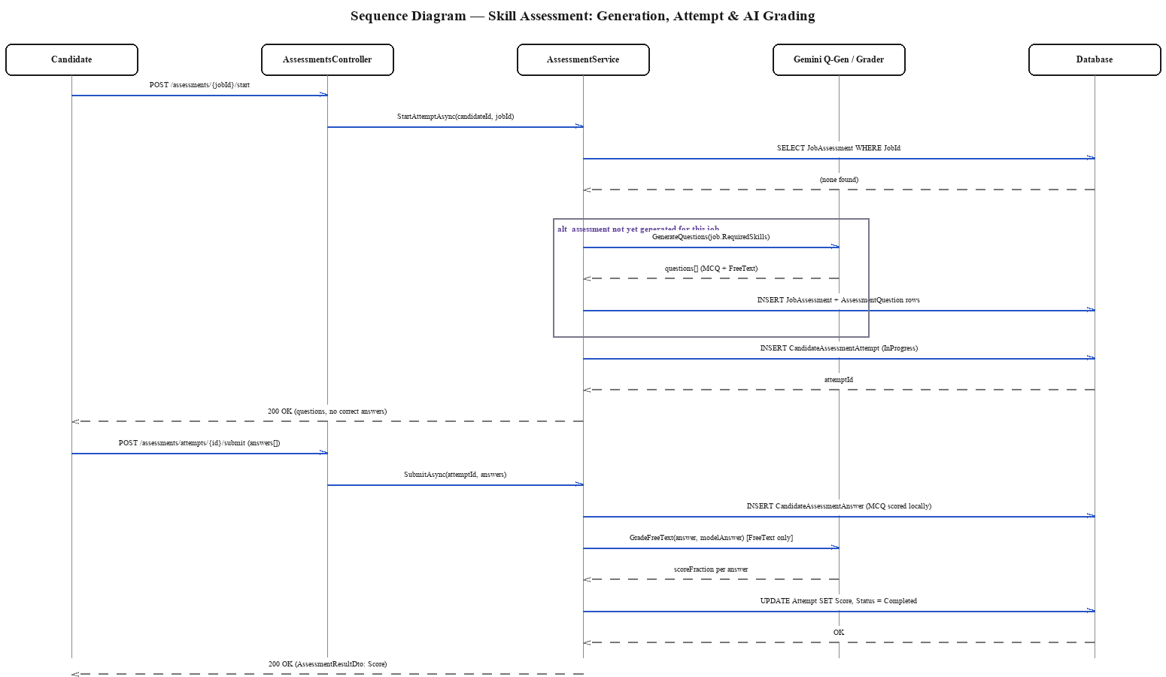
Figure C.5: Sequence Diagram — Skill Assessment: Generation, Attempt & AI Grading. The diagram covers UC-09 and UC-16: a job's assessment questions are generated once (by the AI service) and reused for every subsequent candidate, an attempt is scored automatically for multiple-choice questions and by the AI grader for free-text answers, and the combined result is persisted against the attempt.
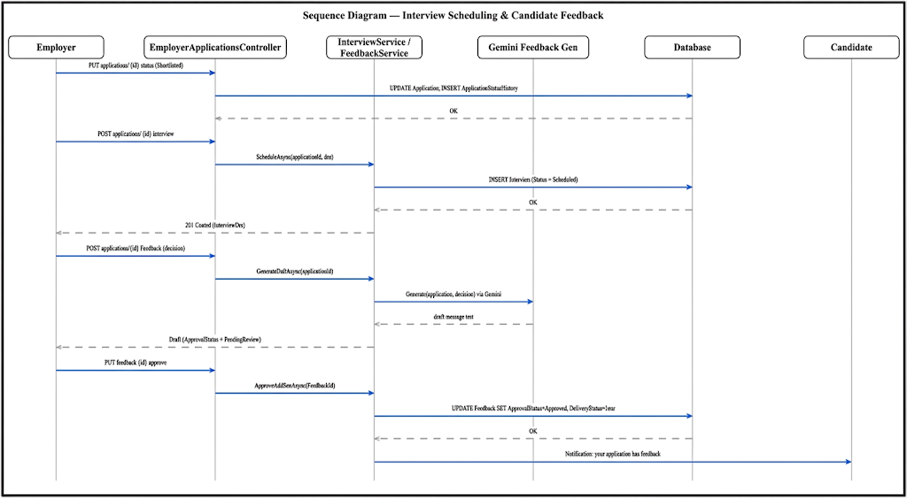
Figure C.6: Sequence Diagram — Interview Scheduling & Candidate Feedback. The diagram covers UC-17 and UC-18: an employer schedules an interview against a shortlisted application, then, following a hiring decision, an AI-drafted feedback message is generated, reviewed and approved by the employer, and only then delivered to the candidate.
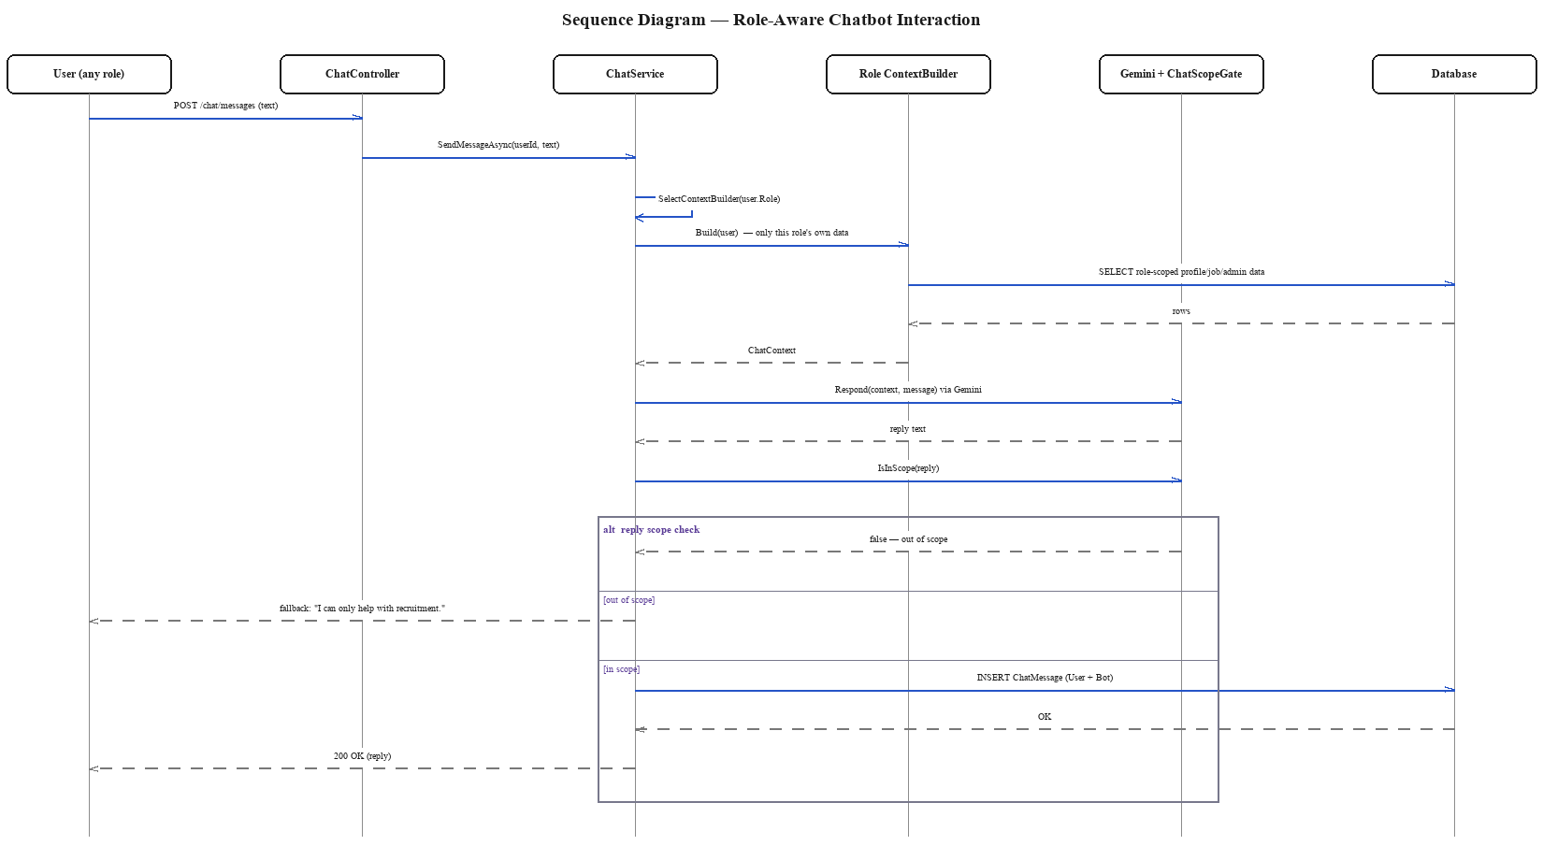
Figure C.7: Sequence Diagram — Role-Aware Chatbot Interaction. The diagram covers UC-10: the role-specific context builder assembles only that authenticated user's own data before the LLM call, and the reply is passed through ChatScopeGate before delivery, so an out-of-scope question is deflected rather than answered.

