Power BI Project made by Kalpesh Parikh: Airbnb data of USA geography

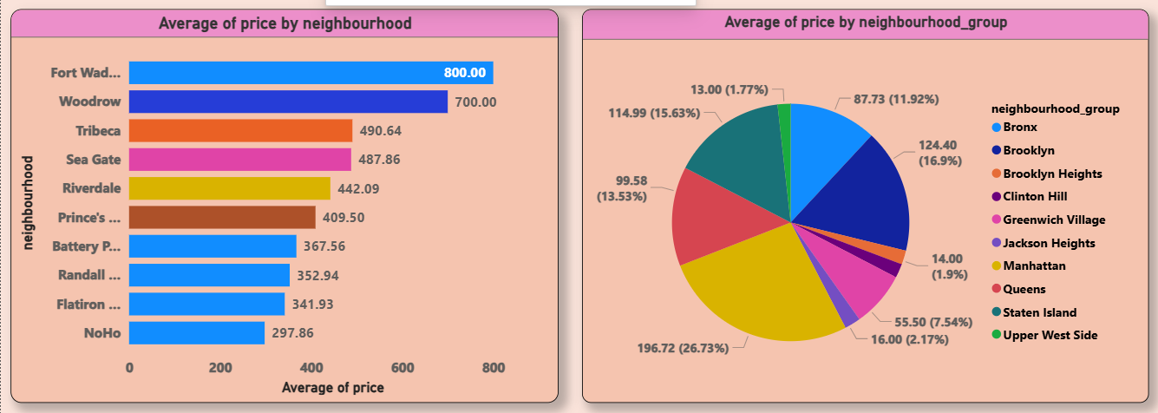

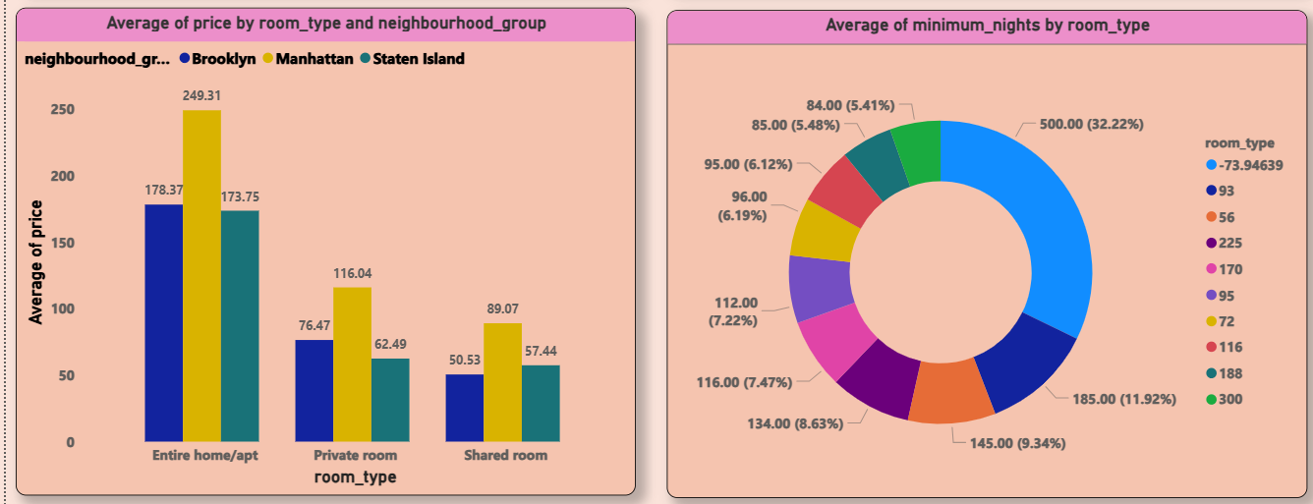

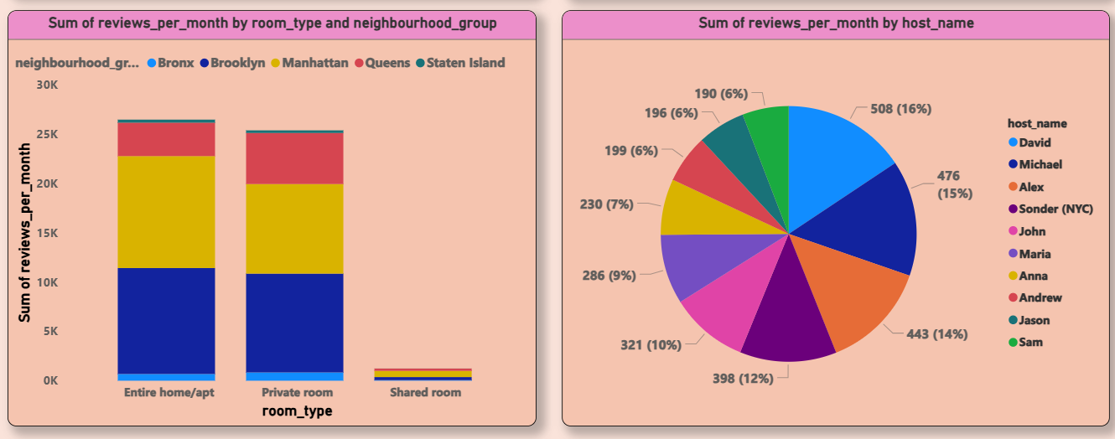

We have given Airbnb data of various geography of USA and need perform various types of analysis.

1. Average of price by neighbourhood: In this information we have presented average price of room for all neighbourhood and taken into consider for top 10 neighbourhood. Fortwed shows the highest room price and NoHo the lowest for top 10
2. Average of price by neighbourhood group: In this data we have shown the average room rate of all top neighbourhood group. Here Manhattan group shows the highest price among all which is due to high pubic footfall in this area
3. Average of price by room type and neighbourhood group: We have further analysed the room rate of top three neighbourhood group for their different types of room and found that entire home apartment has the highest demand in all three-neighbourhood group while shared room has the lowest
4. Average of minimum nights by room type: This analysis shows the room type wise minimum nights occupied
5. Sum of review per month by room type and neighbourhood group: This analysis shows the data of total review per month for different types of room in neighbourhood group. Manhattan has the highest review per month for all types of room followed by Brooklyn.
6. Sum of review per month by host name: This analysis shows the top 10 host who reviewed their stay at Airbnb. The highest review given by David which is 16% of overall review.