Tableau Project made by Kalpesh Parikh

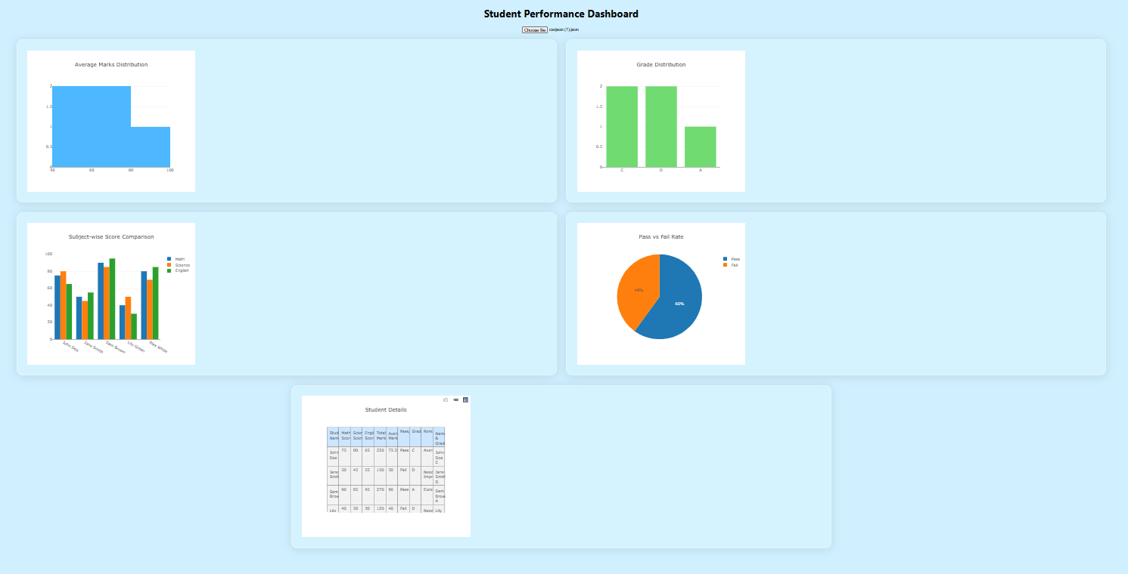

Made a Dashboard for Student data which shows different types of analysis thru graph.

1. Average distribution of marks which tells how the average marks are distributed in various range so you know the maximum marks are in which range
2. Grade distribution which shows how the various grades are distributed among all students. Here you can know which grades has maximum and minimum students
3. Subject wise score of the students which can shows that which students has scored high and in which subject
4. Pass vs Fail; this is an overall pass vs fail ratio shown
5. Student details which give all information about student in a tabular format