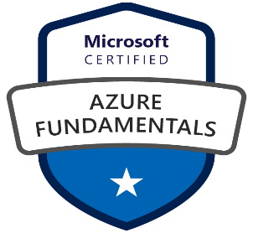

AFFAN KHAN

Azure Administrator

Mobile: +91- 9561743799

E-Mail: 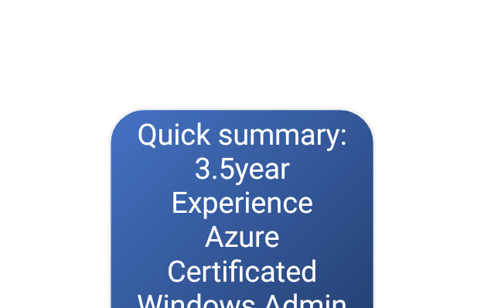affankhan5222@gmail.com

Career Objective:

Looking a role as Azure Engineer in any reputation organization.

Professional Summary:

* Certified Azure Fundamental (AZ-900)
* Total more then 3.5 Years IT experience, including 2.5 years working experience as an Azure Administrator.
* Good knowledge of Azure Administration IaaS and various PaaS Services
* Understanding design documents and worked various project, Hub-Spoke module, ARM templet and Hybrid Infrastructures
* Migrated various workloads and endpoints on Azure.
* Excellent team player with various skill like good communication, presentation, analytical, reasoning, troubleshooting, and problem solving
* Ability to manage work-pressures, prioritize them and address them in a timely and efficient manner
* Willing for work in fast-paced, 24x7, deadline-oriented environment.

Technical Summary:

* Hands on various Azure IAAS services
* Good knowledge on Azure PAAS.
* Creating and configuring Azure Virtual Machines, Azure storage, Azure virtual network
* Deployed availability sets, availability zone and load balancers for Azure Virtual Machine
* Updating and configuring Azure VM like installing required software, configuring windows roles, setting up environments
* Worked on golden image by capturing a VM to create a multiple replicated VMs.
* Good understanding on creating Virtual Network and its various blade options
* Defining the subnet classifications as per requirements
* Configuring Custom DNS on Virtual Network and DNS services
* Basic understanding on site-to-site connectivity VPN and Express route.
* Good understanding on Network Security groups (NSG)
* Understanding of Service endpoints and Private endpoints
* Worked on peering and UDR for Hub-spoke network module.
* Creating the Storage accounts, and worked on Blob and File share service.
* Disk management, snapshot and recreation of disk from snapshot.
* Deployed and maintain the Windows and Linux Virtual Machines in Azure as per end user requirement.
* Troubleshooting the network connectivity issues for Azure VM’s
* Increase the Disk space capacity and adding the new disks to the VM’s as per requirements.
* Change of sizes for the VM’s as per requirements
* Decommissioning the VM’s in Azure to clean up all the components related to specific VM’s
* Protecting the environment with Azure Backup and restore drill.
* Created Azure alert for various Azure services like Azure monitor, Azure log, Azure service health
* Understanding on Intra ID and RBAC (IAM) for subscription.
* Worked on 3-tier environment infrastructure and management layer.
* Patch management
* Azure landing zone setup base on LLD & HLD shared by architect.
* Vm migration - Migrate machine from on-prem to azure IAAS using azure migrate .

Tool:

Putty, RDP, Mobaxtrem, WinSCP, Azure AD Connect, Azure Storage Explorer, PowerShell,

Professional Experience:

Working in Seva network pvt ltd, Aurangabad as Cloud Administrator from mar 2021 to till now.

Education:

BSC IT (information Technology) North Maharashtra University Jalgaon (NMU).

Declaration:

I hear by declare that all the above information is true and correct to best of my knowledge

AFFAN KHAN