**OOPM Mini Project**

SE A

Computer Engineering

**Team members:** **Sap ID:**

Jay Gala (60004170050)

Jashan Banga (60004170049)

Kalpesh Patil (60004170056)

**Topic name:**  **Course to excellence**

The project focusses on providing a great learning experience to users by conducting tests for them.The tests are based on certain programming languages like C,Python,Java,Html.The tests are setup by the admin or in real life it could be a teacher.The users can even learn from the various resources provided under the courses section.These courses are also added by the admin and the admin can keep updating these resources to help the user to get a better understanding of the course.Users can even view their previous results and keep track of their progress.The project starts with a login page for the user where an existing user can login and a new user can register,if you are an admin then you can click on the admin option to get directed to the admin login page.The student is directed to the home page after logging in.The student home pages has 6 options.The student can give a test,learn through courses,view his/her progress,view the about description,change his account details or logout.The admin can change the questions in any one of the 4 tests.For changing the question the admin can first view all the questions for a particular test in a table and if he wants to edit a question then he can enter the question id and make changes. He can change the resources for the separate courses .For doing this he presses the courses options and is shown all the resources for different courses in a tabular format which he can edit by just entering the id from the table and then by making necessary changes to the links.He can also change his/her account details,view the about description and logo

LOGIN PAGE

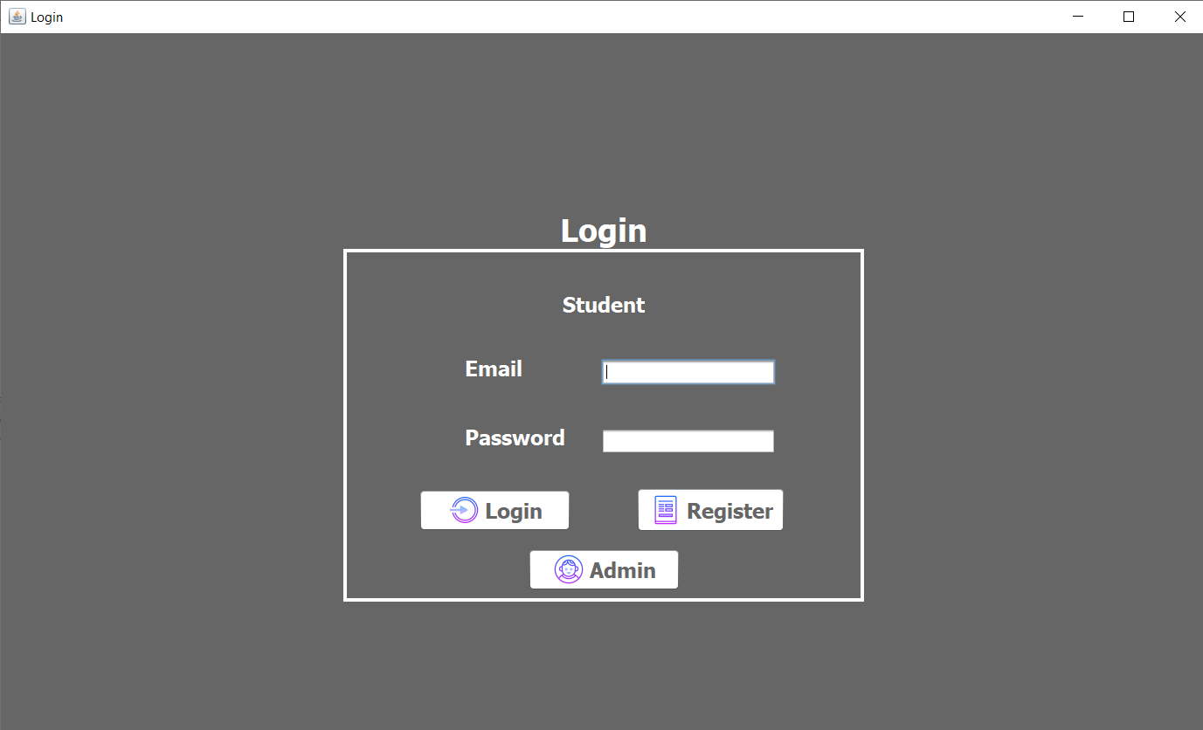

HOME PAGE FOR USER

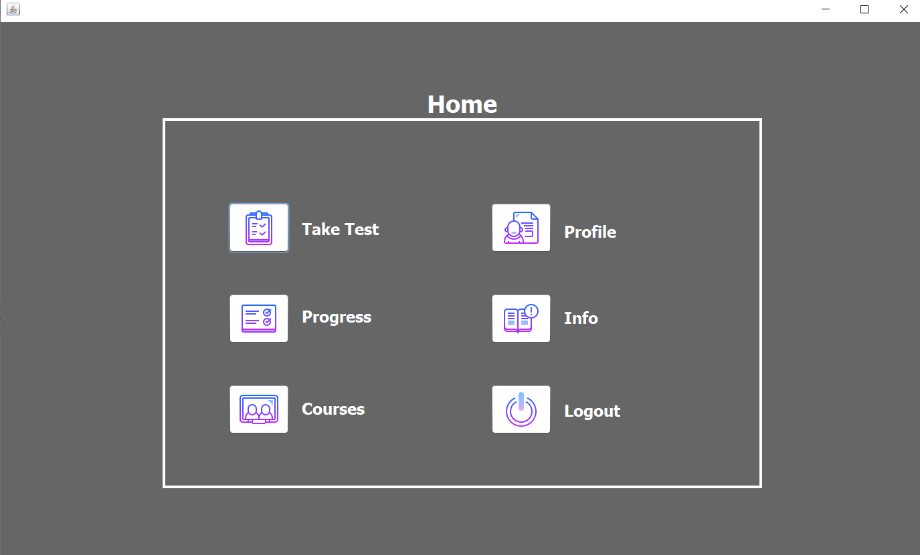

TEST SELECTION PAGE FOR ADMIN & USER

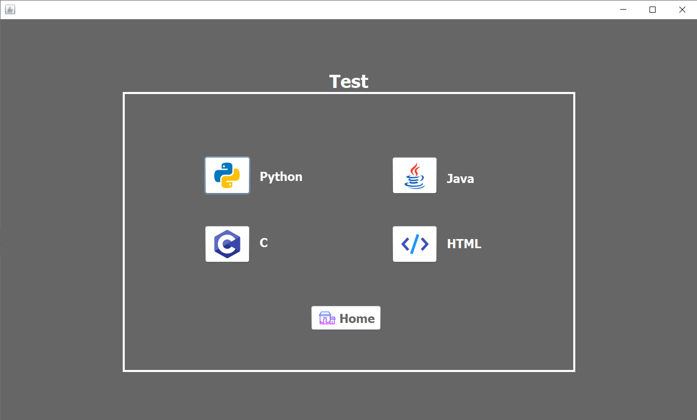

TEST FOR THE USER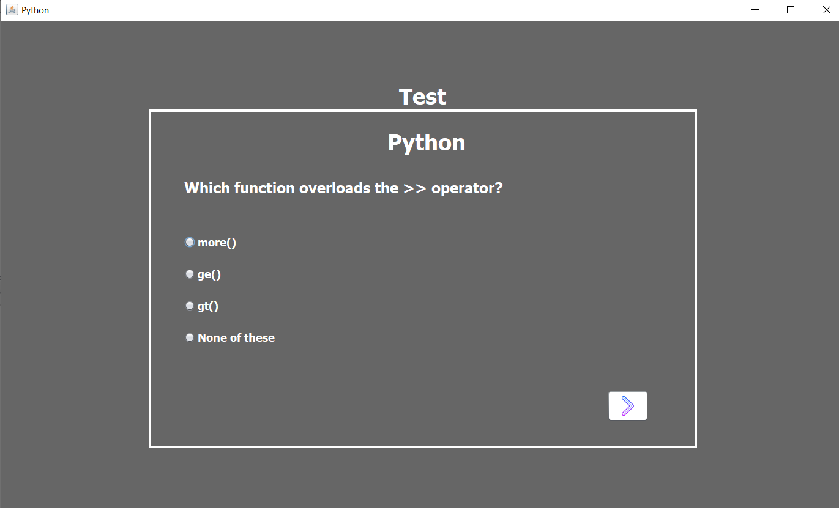

FINAL TEST RESULT PAGE

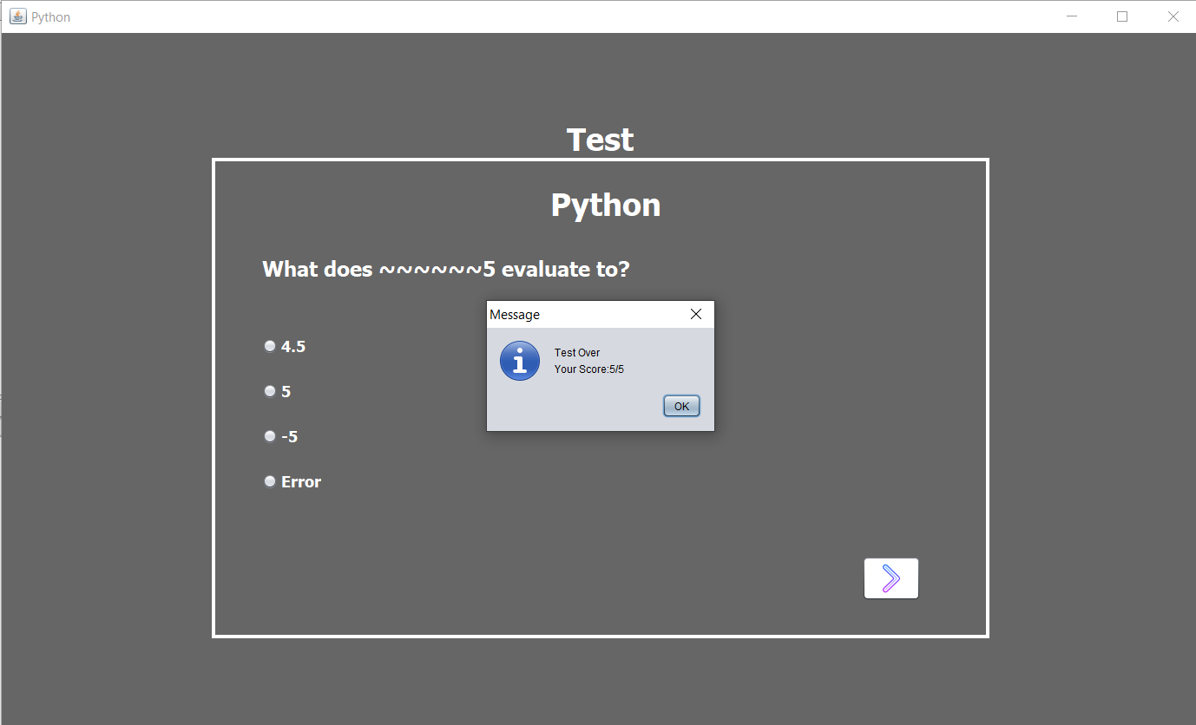

PROFILE PAGE FOR ADMIN & USER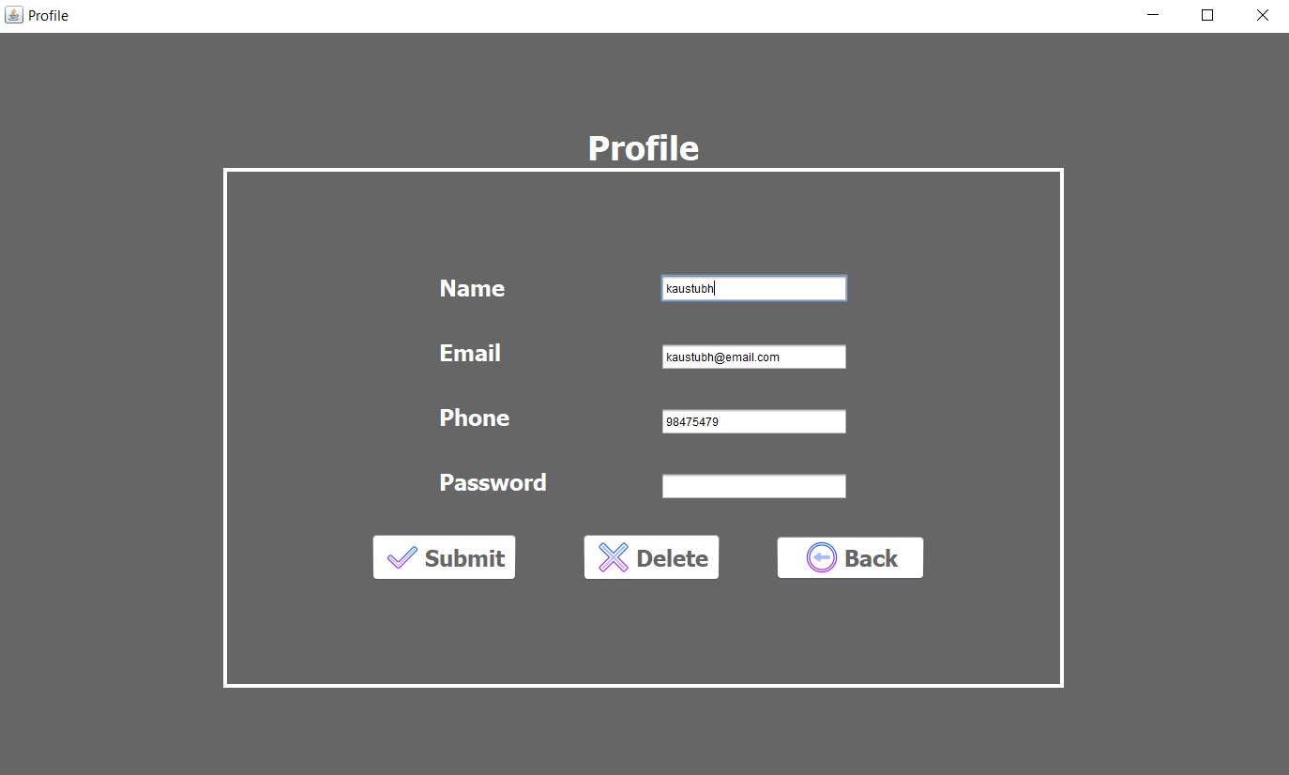

PROGRESS PAGE FOR USER

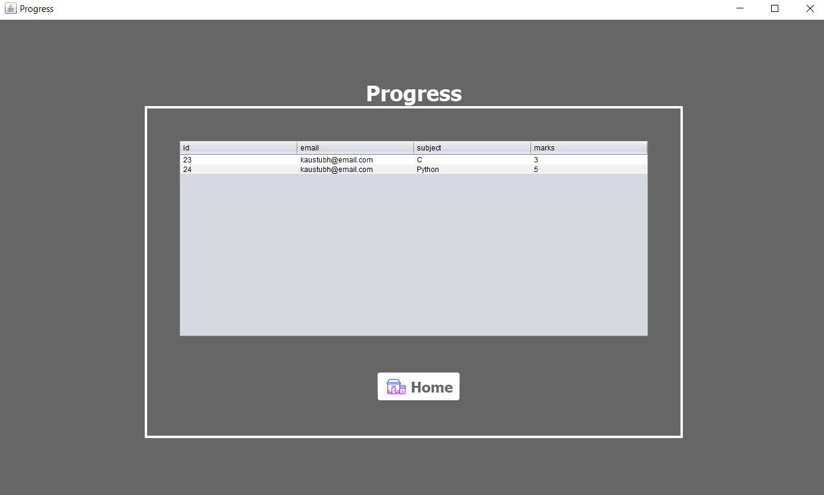

ABOUT THE SITE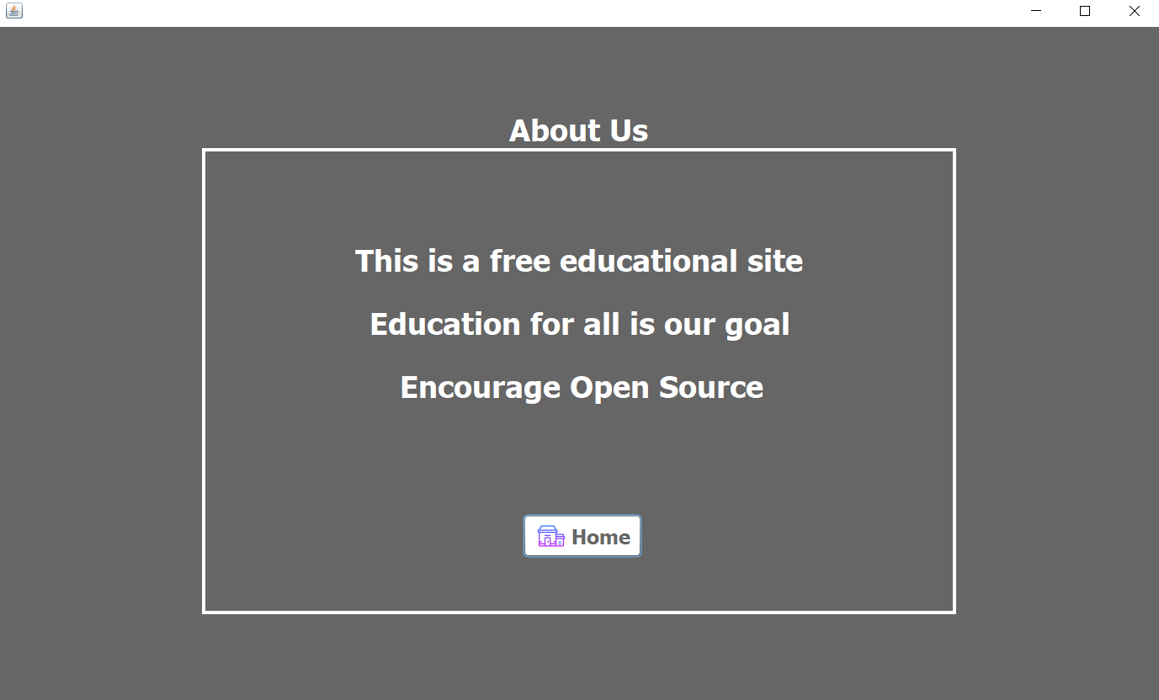

STUDENT REGISTRATION PAGE

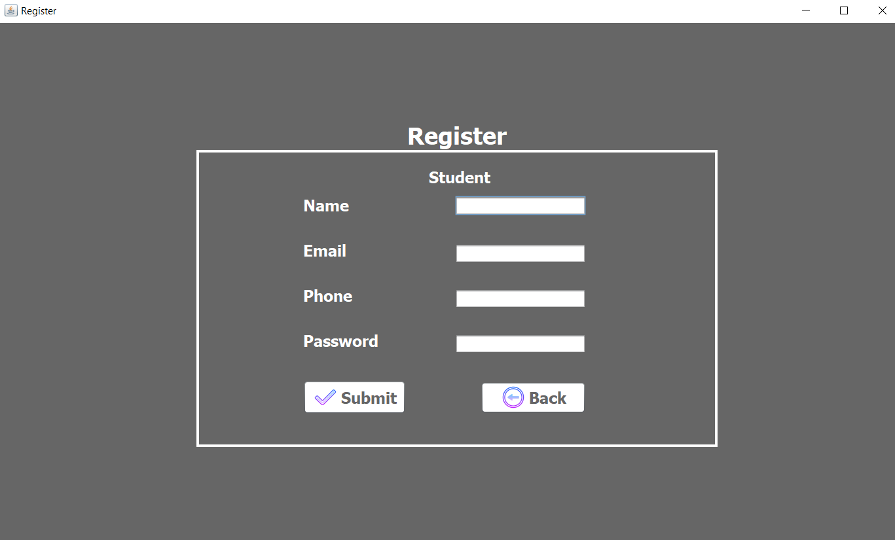

TEST COURSE EDIT PAGE FOR ADMIN

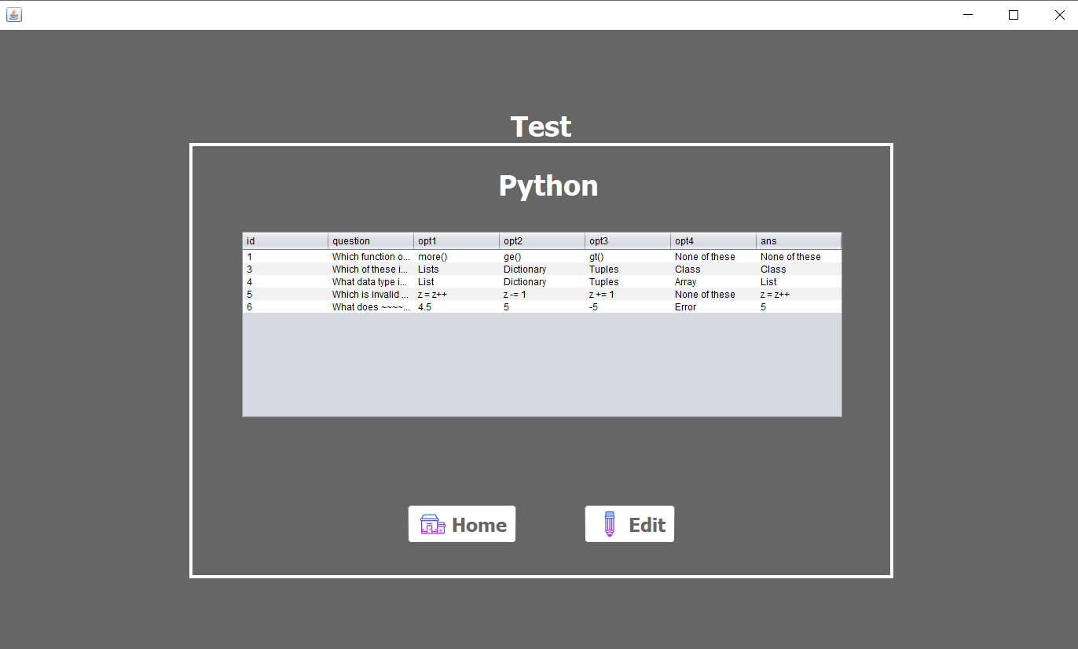

TEST QUESTIONS EDITING PAGE

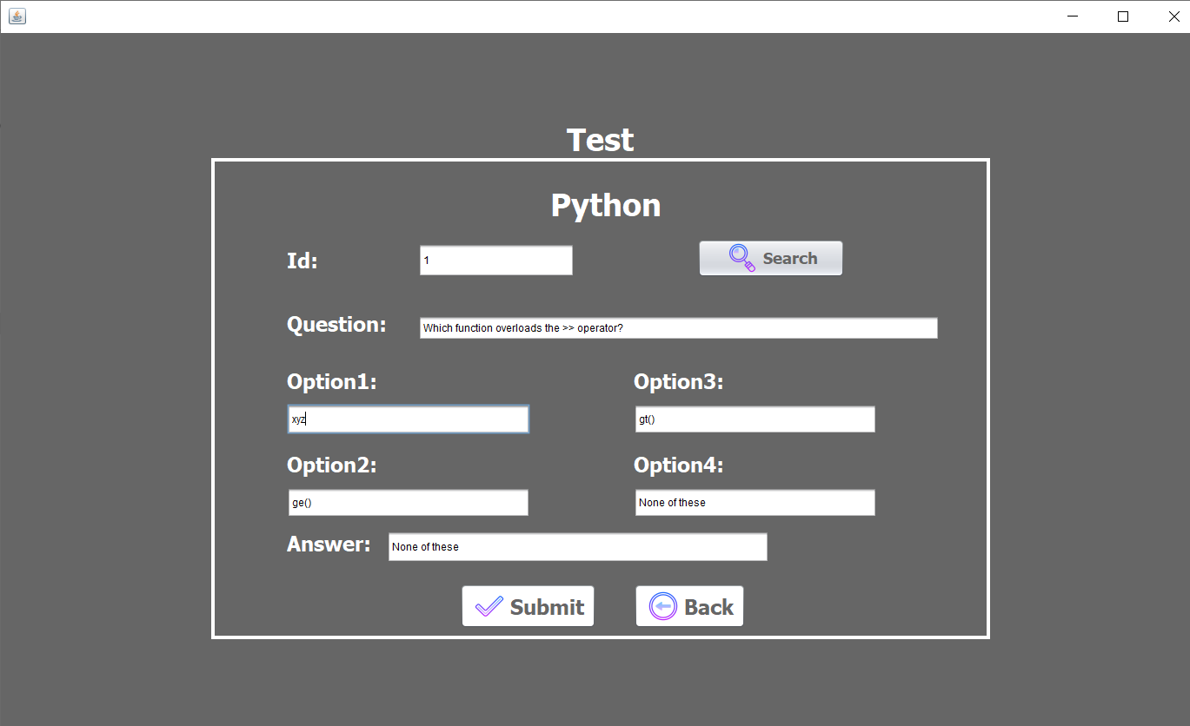

RESOURCE FOR COURSES PAGE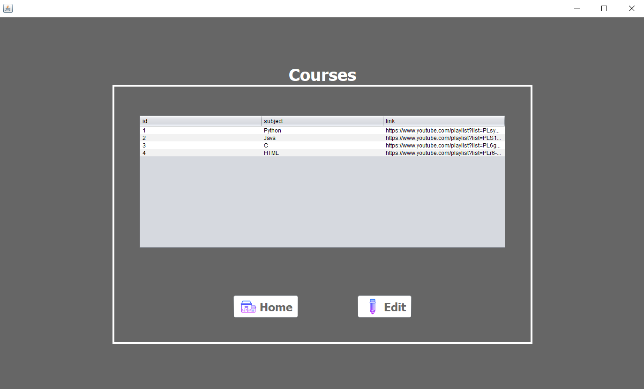

COURSE LINK EDITING PAGE

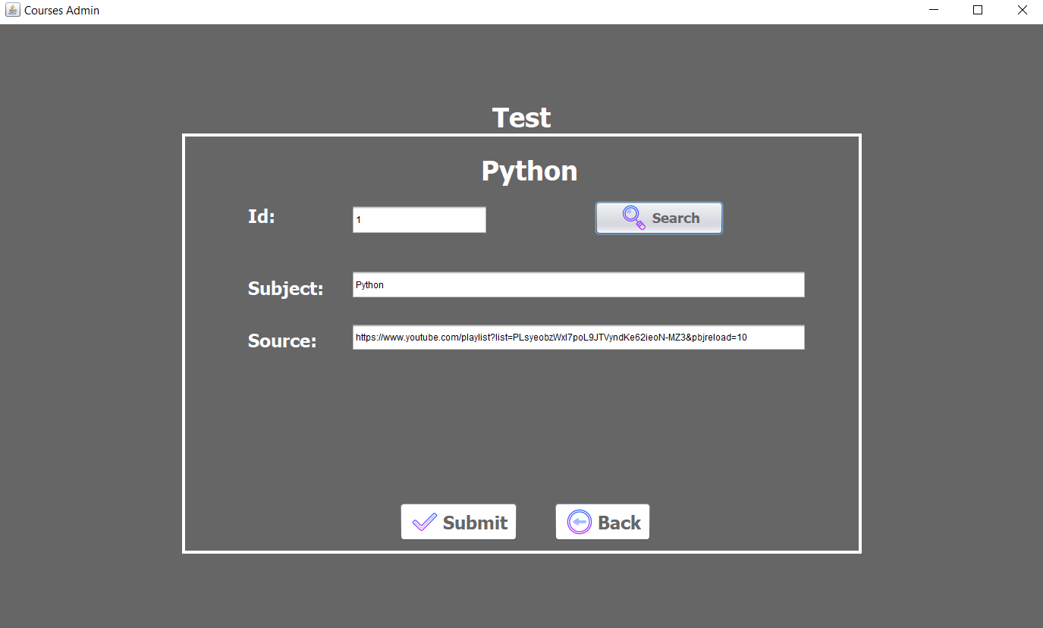

LIST OF REGISTERED STUDENTS PAGE