/*********ASSIGNMNET NO B3*************************

NAME=Kalpesh S Sonawane

ROLL N0=55

BATCH=c

****************************************************

HISTOGRAM

> suvs <- c(4,4,6,6,16)

> hist(suvs)

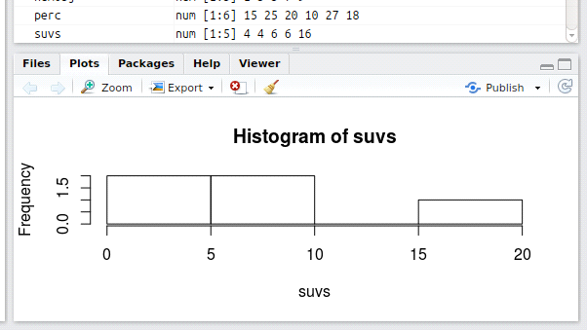

PIE CHARTS

> cars <- c(1, 3, 6, 4, 9)

> pie(cars)

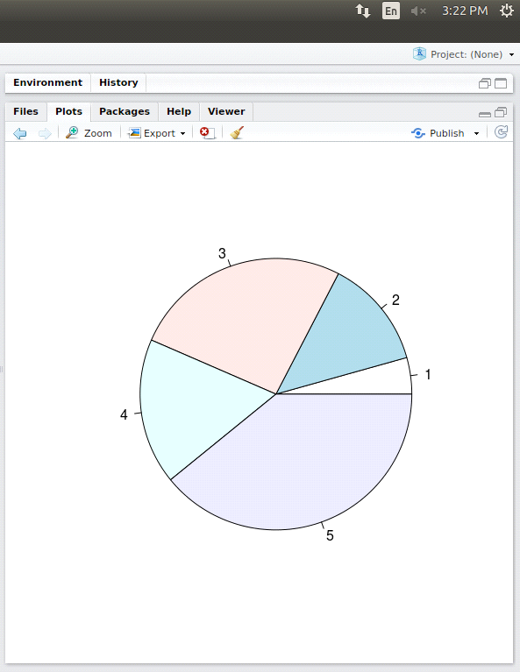

INDEX PLOT

> num<-c(1,4,9,4,6)

> plot(num)

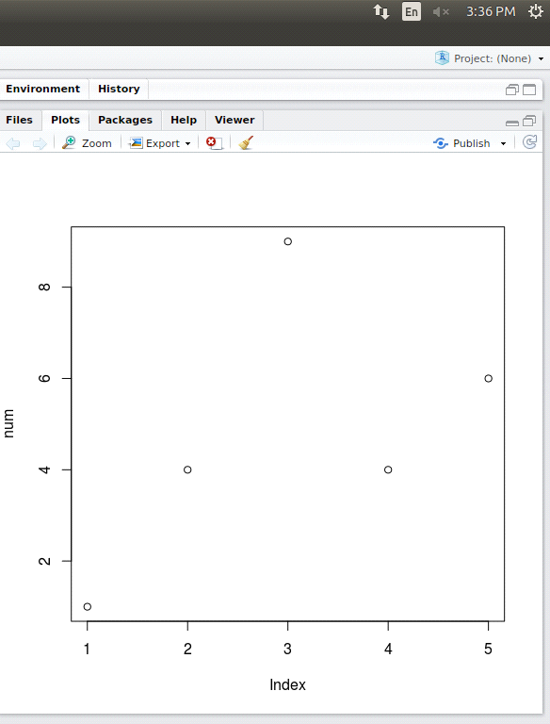

TIME SERIES PLOT

> mydat<-c(10,20,30,40,50,60,70,80,90)

> myts<-ts(mydat,start=c(2010),end=c(2019),frequency=1)

> plot(myts)

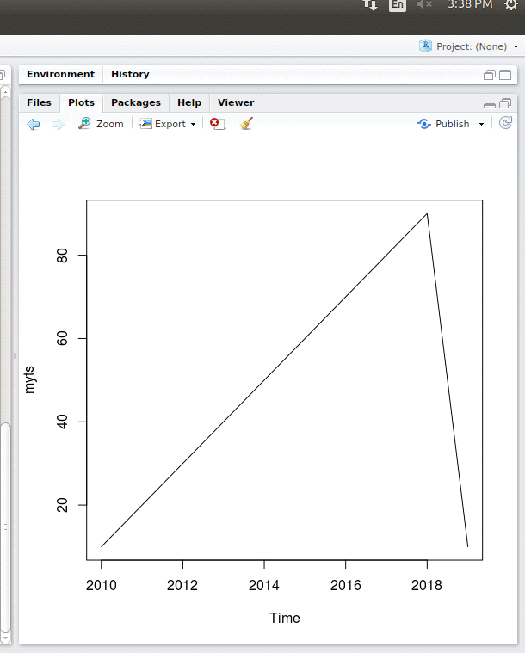

STRIP CHART

> perc<-c(14,34,87,5,9,89)

> values<-c(6,8,4,9,2,5)

> stripchart(perc)

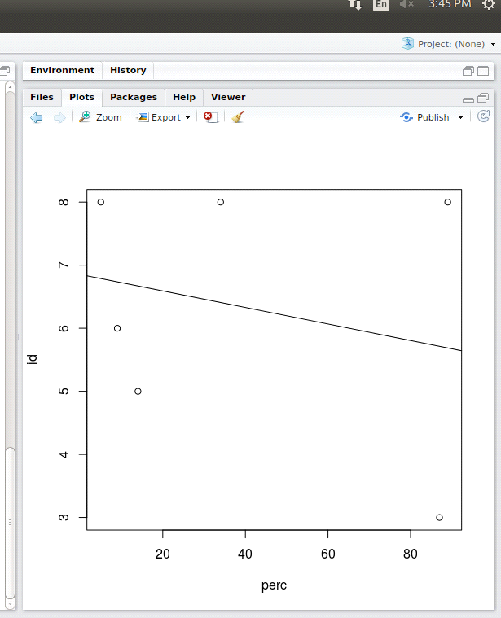

2 VARIABLE

SIMPLE PLOT

> plot(4,7)

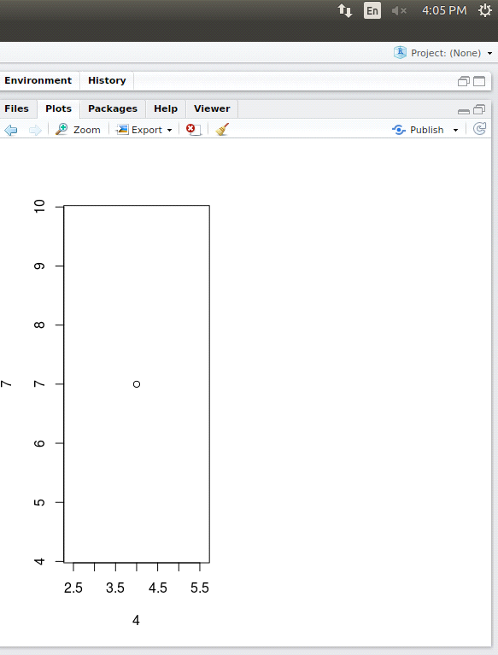

FACTOR PLOT

> plot(factor(3),7)

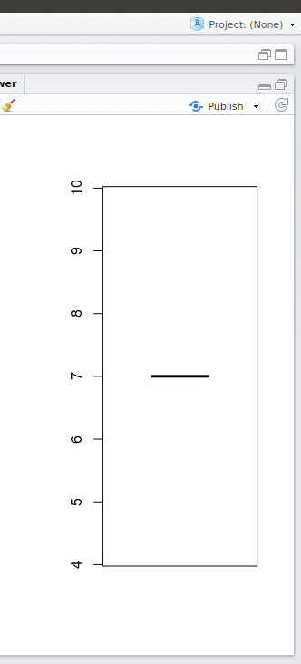

BAR PLOT

perc<-c(14,34,87,5,9,89)

> id<-c(5,8,3,8,6,8)

> plot(perc,id)

> abline(lm(id~perc))

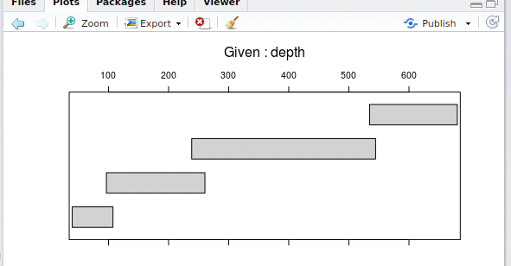

> test_data <-

+ data.frame(

+ var0 = 100 + c(0, cumsum(runif(49, -20, 20))),

+ var1 = 150 + c(0, cumsum(runif(49, -10, 10))),

+ date = seq(as.Date("2002-01-01"), by="1 month", length.out=100)

+ )

> plot(test_data)

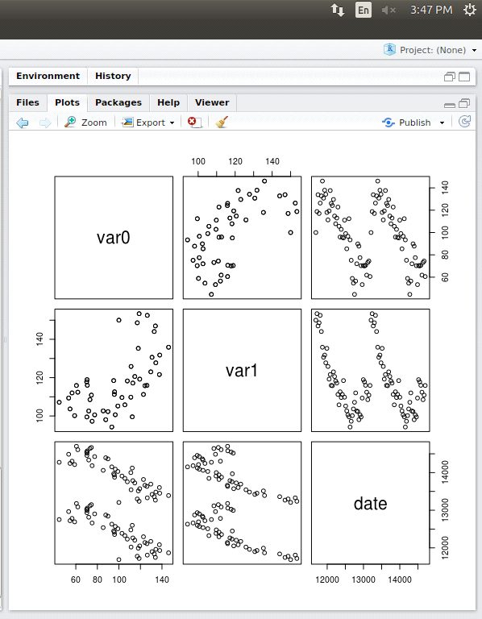

PARIS FUNCTION

> pairs(iris[1:4], main = "Anderson's Iris Data -- 3 species",

+ pch = 21, bg = c("red", "green3", "blue")[unclass(iris$Species)

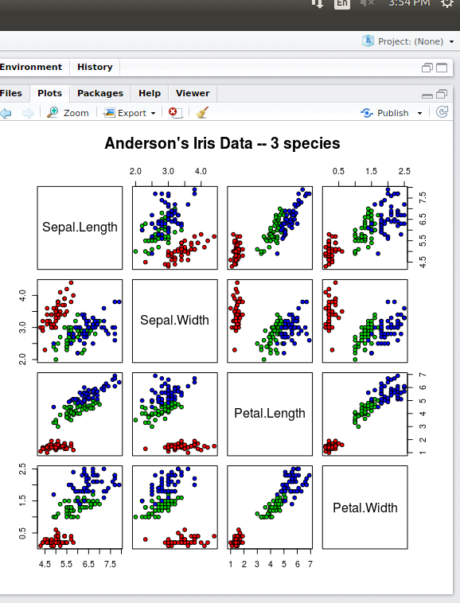

COPLOT

> coplot(lat ~ long | depth, data = quakes)

> given.depth <- co.intervals(quakes$depth, number = 4, overlap = .1)

> coplot(lat ~ long | depth, data = quakes, given.v = given.depth, rows = 1)

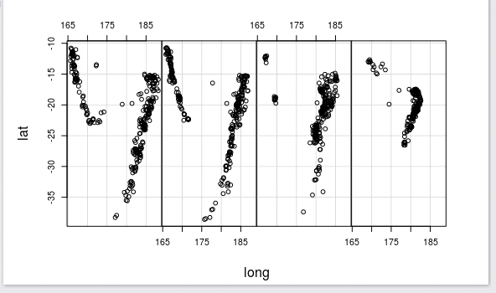

PERSP FUNCTION

> x <- seq(-10, 10, length = 30)

> f <- function(x, y) {r <- sqrt(x ^ 2 + y ^ 2); 10 * sin(r) / r}

> y <- x

> z <- outer(x, y, f)

> persp(x, y, z)

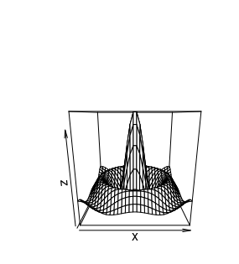

SCATTER PLOT

> attach(mtcars)

> plot(wt, mpg, main="Scatterplot Example",

+ xlab="Car Weight ", ylab="Miles Per Gallon ", pch=19)

