/\*\*\*\*\*\*\*\*\*\*\*\*\*\*\*\*\*\*\*\*\*\*\*\*\*\*\*\*\*\*\*\*\*\*\*\*\*\*\*\*\*\*\*\*\*\*\*\*\*\*\*\*\*

ASSIGNMENT NO: B4

TITLE: Perform the following data visualization operations using Tableau on Adult and Iris datasets

1) 1D (Linear) Data visualization

2) 2D (Planar) Data Visualization

3) 3D (Volumetric) Data Visualization

4) Temporal Data Visualization

5) Multidimensional Data Visualization

6) Tree/ Hierarchical Data visualization

7) Network Data visualization

NAME: Shalini Singh

ROLL NO: 58 BATCH:C

\*\*\*\*\*\*\*\*\*\*\*\*\*\*\*\*\*\*\*\*\*\*\*\*\*\*\*\*\*\*\*\*\*\*\*\*\*\*\*\*\*\*\*\*\*\*\*\*\*\*/

1D(linear) Data Visualization

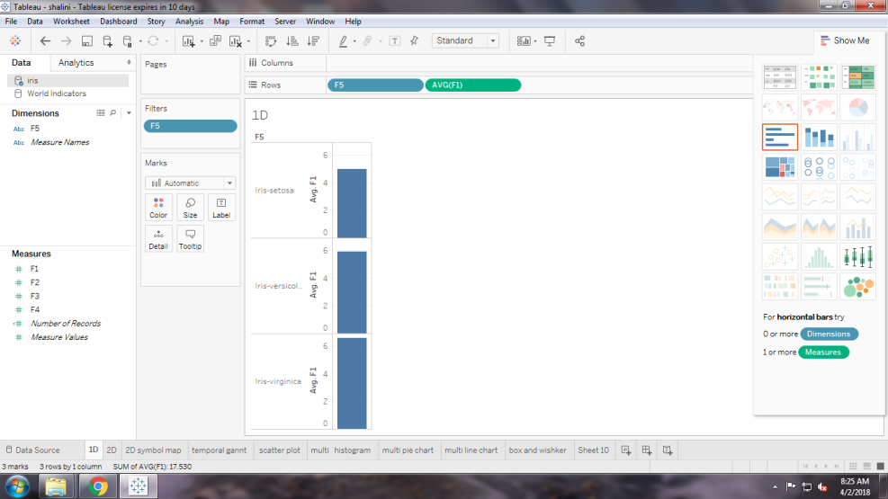

2D(planer) Data Visualization

1.Bar Plot

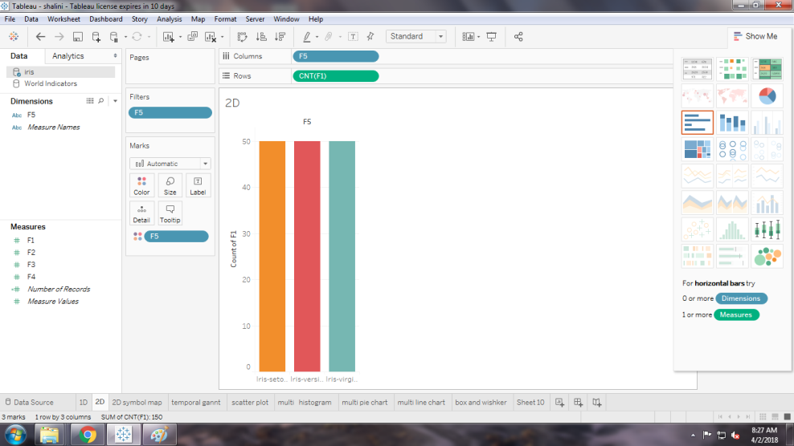

2.Filled Map

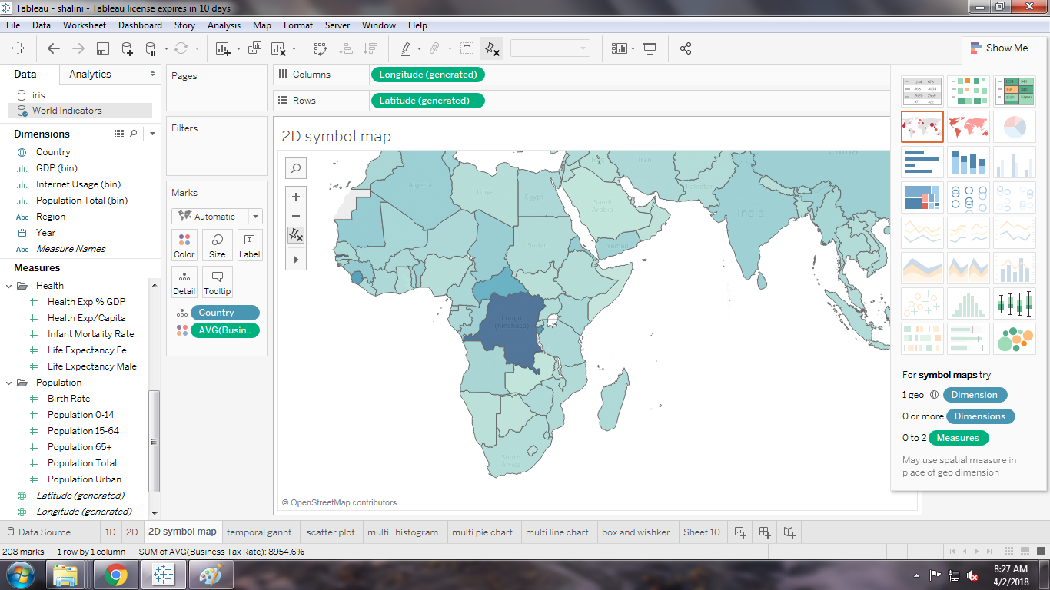

3. Symbol Map

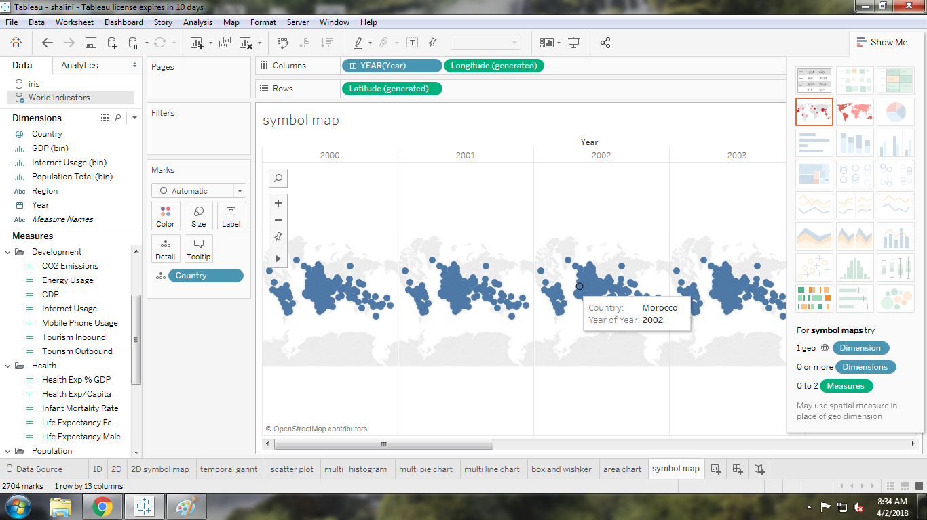

Multi Dimensional Data Visualtization

1. Histogram

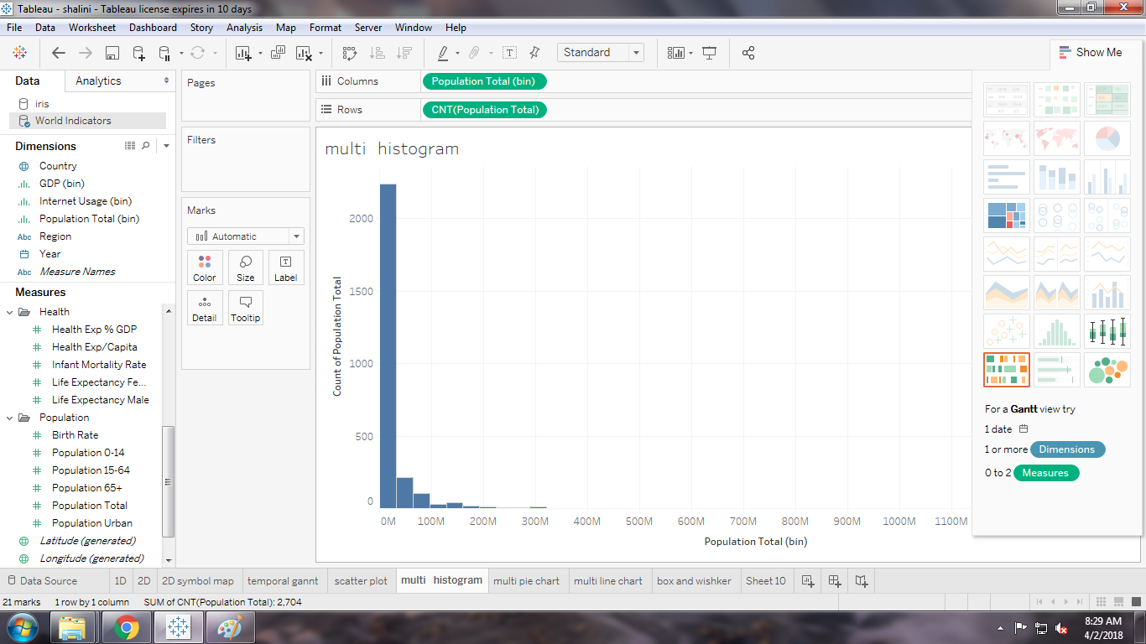

1. Line Chart

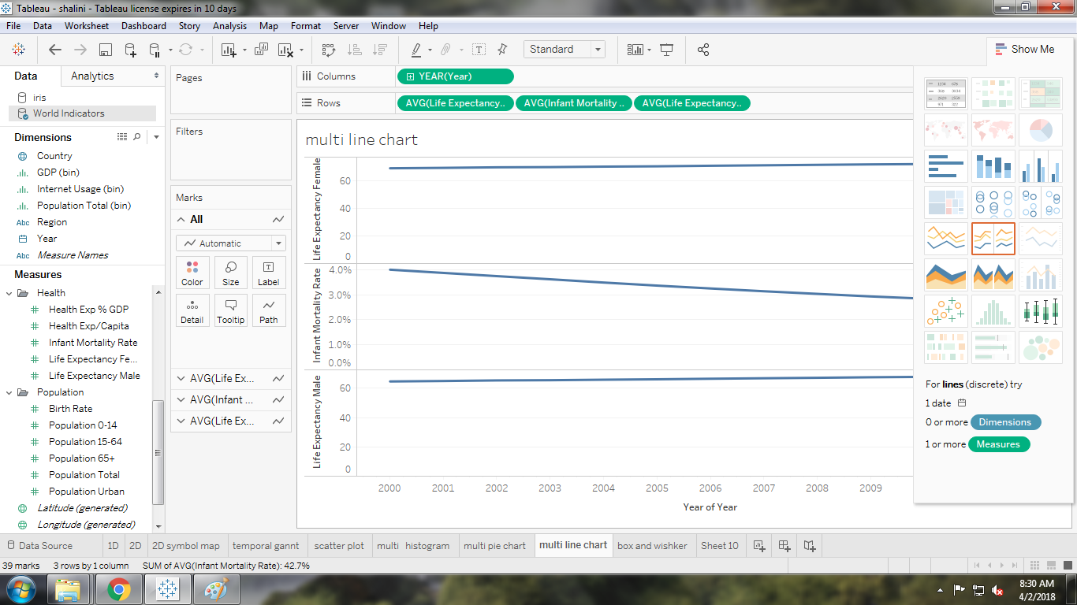

1. Pie Chart

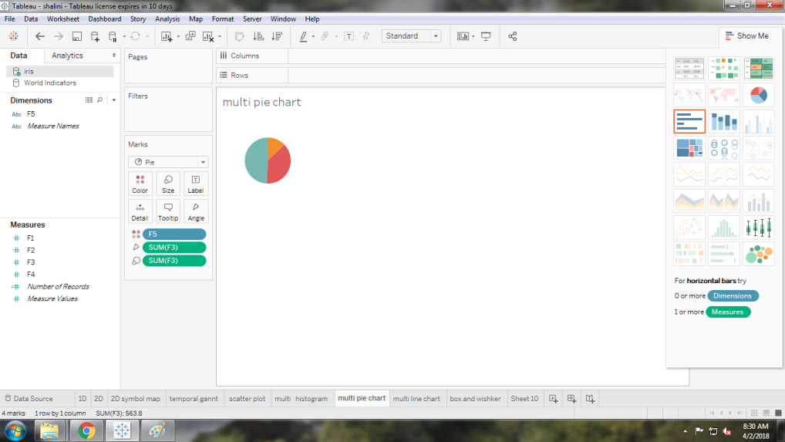

1. Box And Wishker

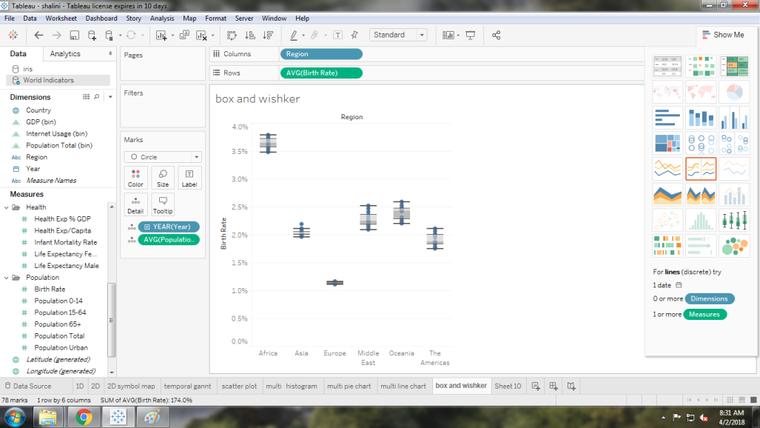

Temporal Data Visualization

1. Gannt Chart

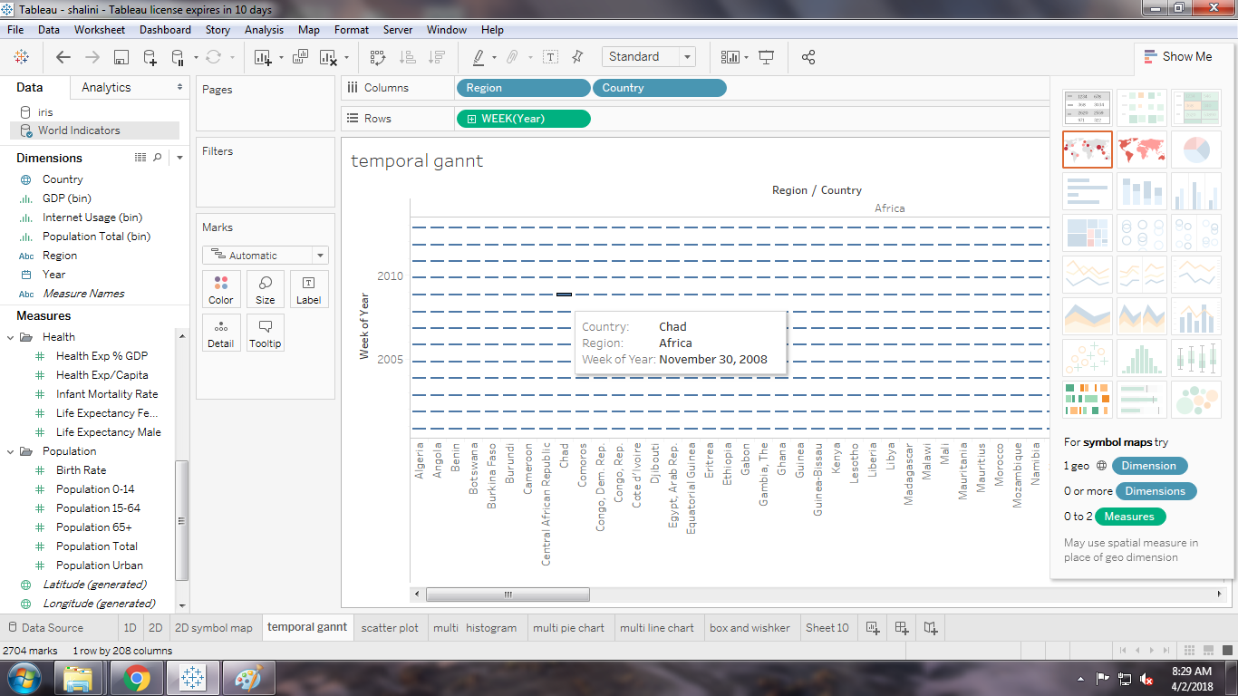

1. Scatter Plot

