Optimizely-To-Sitecore-Accelerator-Toolkit
The Optimizely to Sitecore Accelerator Toolkit is an enterprise-grade utility designed to accelerate the migration of Data Templates, Media, and Content from Optimizely PaaS CMS 12 (.NET 8) to Sitecore (XM/XP/XM Cloud).
This toolkit operates in a decoupled ETL (Extract, Transform, Load) architecture, utilizing Optimizely Scheduled Jobs for extraction and Sitecore PowerShell Extensions (SPE) for code generation and data ingestion.
1. Installation Guide
The toolkit consists of two halves: the Optimizely Extraction Engine and the Sitecore Import Scripts.
A. Installing the Optimizely NuGet Package
The Optimizely export jobs are packaged as a .nupkg file - OptimizelyToSitecore.Accelerator.Toolkit.1.0.0.nupkg
- Place the provided .nupkg file in your local NuGet feed directory (e.g., C:\LocalNuGet).
- Open your Optimizely web project directory in Visual Studio.
- Add a new Package Source to your project and provide the local NuGet feed directory path.
- Search and find the “OptimizelyToSitecore.Accelerator.Toolkit” package in the NuGet Package Manager and install it.
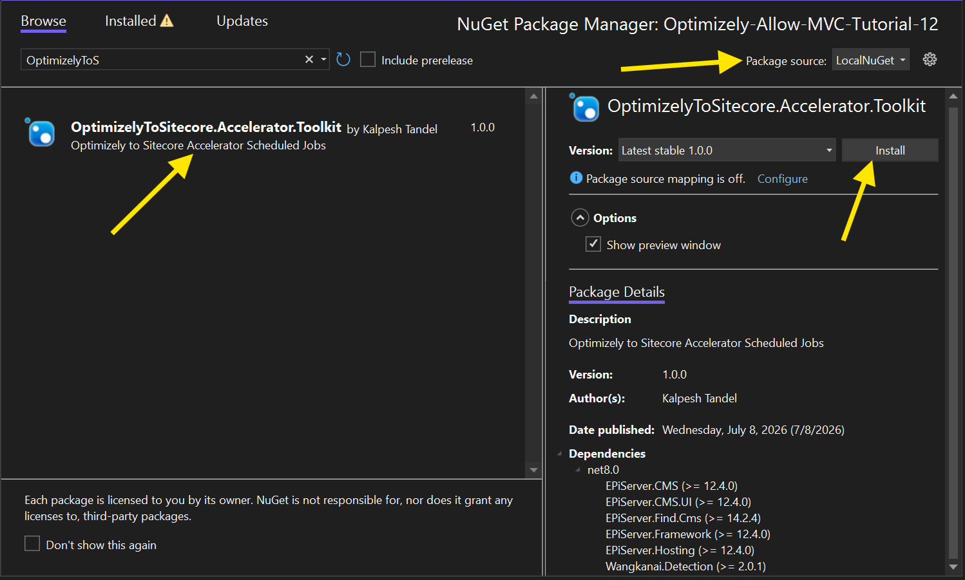
- Build the solution. The export tools are now available in the Optimizely CMS Admin UI under Scheduled Jobs.
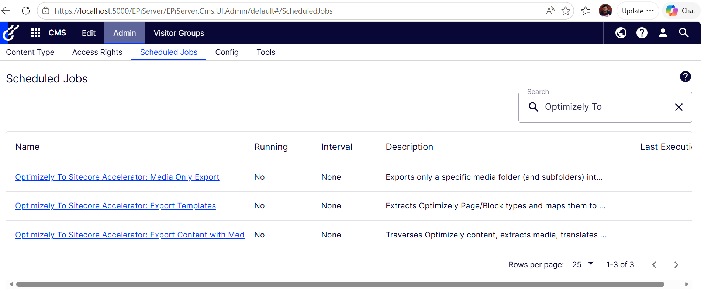

B. Installing the Sitecore PowerShell Toolkit
The Sitecore ingestion tools are packaged as a standard Sitecore installation ZIP.
- Log into your Sitecore Desktop (or Launchpad).
- Navigate to Development Tools > Installation Wizard.
- Upload and install the “Optimizely-To-Sitecore-Accelerator-Toolkit-1.0.zip” sitecore package.
- The import tools are now available in the PowerShell Toolbox (Start Menu > PowerShell Toolbox > Optimizely To Sitecore Accelerator Toolkit).
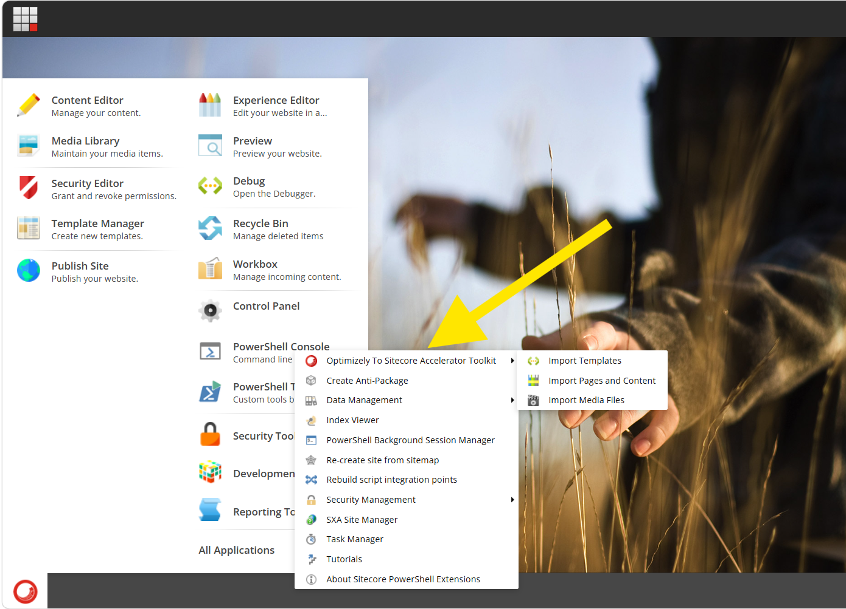

2. Configuration Settings
Optimizely Configuration Keys (appsettings.json)
If your implementation utilizes appsettings.json to manage the C# export destinations,
Add the following Export Settings block to your Optimizely project's appsettings.json file
"ExportSettings": {
"ExportDirectory": "App_Data/Export",
"ContentExport": {
"ContentRootId": "5",
"IncludeSubItems": true,
"IncludeMediaFiles": false,
"TypesToExport": []
},
"MediaExport": {
"MediaFolderRootId": 0,
"IncludeSubFolders": true
}
}
Configuration Keys Explained:
- ExportDirectory: The local physical path on the Optimizely server (e.g., App_Data/Export) where the C# scheduled jobs will securely save the generated JSON files and ZIP bundles for you to download.
- ContentExport .ContentRootId: The Optimizely Page/Folder ID (integer) where the content export should begin.
- ContentExport .IncludeSubItems: A boolean (true / false). When true, the export job will recursively traverse down the tree to export all descendants of the ContentExport .ContentRootId.
- ContentExport .IncludeMediaFiles: A boolean (true / false). When true, the bundle will automatically extract physical media blobs and generate the map.json file inside the ZIP.
- ContentExport .TypesToExport: An optional array of specific Content Type names (e.g., ["ArticlePage"]). If provided, the tool will only export templates and content matching these types. Remove or leave empty to export everything.
- MediaExport.MediaFolderRootId: The Optimizely assets Folder ID (integer) where the media export should begin. Leave as 0 to export the entire Global Media Library
- MediaExport.IncludeSubFolders: A boolean (true / false). When true, the export job will recursively traverse down the tree to export all descendants of the MediaExport.MediaFolderRootId.

3. How to Use the Toolkit
Follow this sequence to execute a complete migration.
Phase 1: Schema Migration (Templates)
- Extract: In the Optimizely CMS Admin UI, go to Scheduled Jobs and run a job – “Optimizely To Sitecore Accelerator: Export Templates”.
Download the resulting Optimizely-templates.json file.
- Move: Save the JSON file locally on your machine.
- Generate: Open the Sitecore PowerShell Toolbox and run the “Import Templates” script. Select your destination Template folder in the dialog, click Next, and upload the JSON file.
Phase 2: Media Migration
- Extract: In the Optimizely CMS Admin UI, run a job – “Optimizely To Sitecore Accelerator: Media Only Export”. Download the resulting ZIP file.
- Move: Save the ZIP file locally on your machine.
- Generate: Open the Sitecore PowerShell Toolbox and run the “Import Media Files” script. Select your target Media Library root, click Next, and upload the ZIP bundle. This will unpack the ZIP, create the media items, upload the blobs, generate thumbnails, and apply the original Optimizely GUIDs.
Phase 3: Content Migration
- Extract: In the Optimizely CMS Admin UI, run a job – “Optimizely To Sitecore Accelerator: Export Content with Media Bundle to Sitecore”. Download the resulting ZIP file.
- Move: Save the ZIP bundle locally on your machine.
- Generate: Open the Sitecore PowerShell Toolbox and run the “Import Pages and Content” script. Select your target Content and Media roots, click Next, and upload the ZIP.
- This job will read the JSON, instantiate the generated templates, insert the data, automatically route Local Blocks into /Data/ folders, and correctly map legacy Optimizely GUIDs to Sitecore Droptree/Droplink fields.

