Meet Dholakia 22BCP004

**Lab – 1**   
 **20CP207P- Operating Systems Lab Title:** Introduction of basic Linux commands.

**Task:** Perform the basic Linux commands and understand how it works **Commands:**   
**1.whoami** : Print the user name associated with the current effective user ID. Same as id -un.

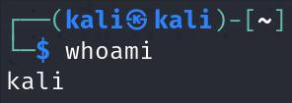

**2.pwd** : Print the full filename of the current working directory.

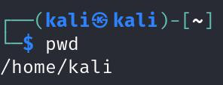

**3.ls** : List information about the FILEs (the current directory by default). Sort entries alphabetically if none of -cf ‐tuvSUX nor --sort is specified.

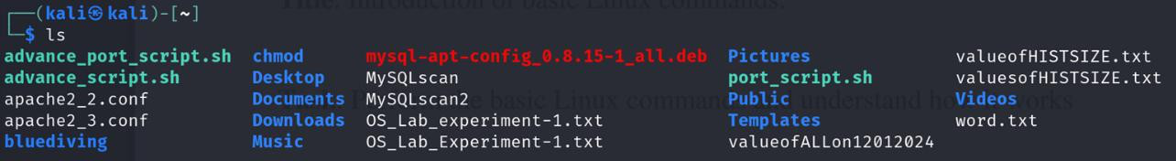

**4.history** : Many programs read input from the user a line at a time. The GNU History library is able to keep track of those lines, associate arbitrary data with each line, and utilize information from previous lines in composing new ones.

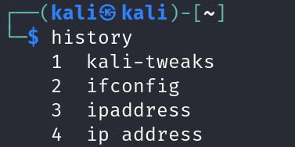

**5.clear** : clear clears your terminal's screen and its scrollback buffer, if any. clear retrieves the terminal type from the environment variable TERM, then consults the terminfo terminal capability database entry for that type to determine how to perform these actions.

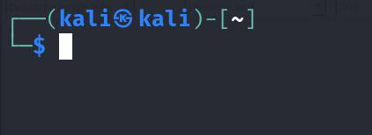

1

Meet Dholakia 22BCP004

**6.echo** : Echo the STRING(s) to standard output.

-n do not output the trailing newline

-e enable interpretation of backslash escapes

-E disable interpretation of backslash escapes (default)

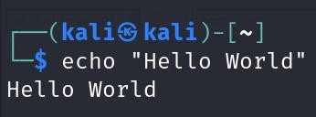

**7.touch** : Update the access and modification times of each FILE to the current time.

•A FILE argument that does not exist is created empty, unless -c or -h is supplied.

•A FILE argument string of - is handled specially and causes touch to change the times of

the file associated with standard output.

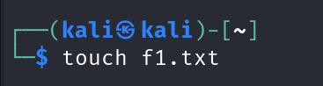

**8.rm** : This manual page documents the GNU version of rm. rm removes each specified file. By

default, it does not remove directories.

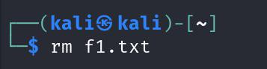

**9.mkdir** : Create the DIRECTORY(ies), if they do not already exist. Mandatory arguments to

long options are mandatory for short options too.

-m, --mode=MODE

•set file mode (as in chmod), not a=rwx -

umask -p, --parents

•no error if existing, make parent directories as needed, with their file

modes unaffected by any -m option.

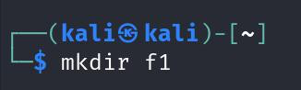

**10.rmdir** : Remove the DIRECTORY(ies), if they are empty.

--ignore-fail-on-non-empty

•ignore each failure that is solely because a directory is non-

empty -p, --parents

•remove DIRECTORY and its ancestors; e.g., 'rmdir -p a/b/c' is similar to

'rmdir a/b/c a/b a'

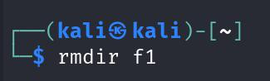

2

Meet Dholakia 22BCP004

**11.mv** : Rename SOURCE to DEST, or move SOURCE(s) to DIRECTORY. Mandatory arguments to long options are mandatory for short options too.

--backup[=CONTROL]  
 • make a backup of each existing destination file -b like --backup but does not accept an argument

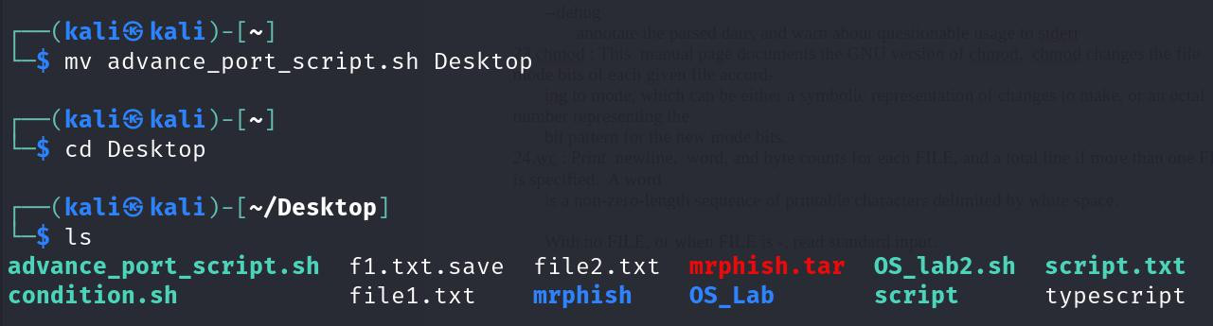

**12.cd** : Changes directory

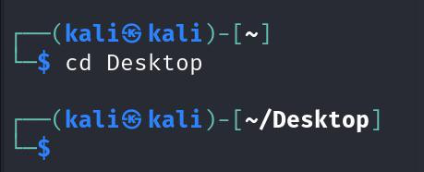

**13.cmp** : Compare two files byte by byte. The optional SKIP1 and SKIP2 specify the number of bytes to skip at the beginning of each file (zero by default). Mandatory arguments to long options are mandatory for short options too.

-b, --print-bytes  
 • print differing bytes  
-i, --ignore-initial=SKIP   
 skip first SKIP bytes of both inputs•

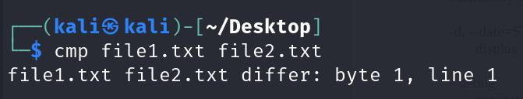

**14.cat** : Concatenate FILE(s) to standard output. With no FILE, or when FILE is -, read standard input.

-A, --show-all  
 • equivalent to -vET  
-b, --number-nonblank  
 • number nonempty output lines, overrides -n

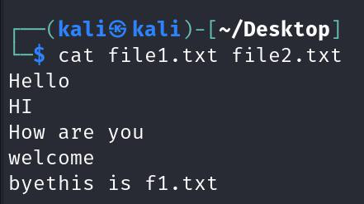

3

Meet Dholakia 22BCP004

**15.cal** : The cal utility displays a simple calendar in traditional format and ncal offers an alternative layout, more options and the date of Easter. The new format is a little cramped but it makes a year fit on a 25x80 terminal. If arguments are not specified, the current month is displayed.

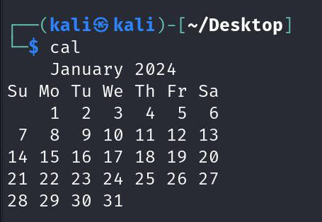

**16.passwd** : The passwd command changes passwords for user accounts. A normal user may only change the password for their own account, while the superuser may change the password for any account. passwd also changes the account or associated password validity period.

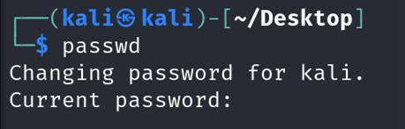

**17.grep** : grep searches for PATTERNS in each FILE. PATTERNS is one or more patterns separated by newline characters, and grep prints each line that matches a pattern. Typically PATTERNS should be quoted when grep is used in a shell command.

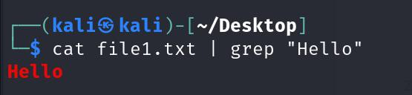

**18.free** : free displays the total amount of free and used physical and swap memory in the system, as well as the buffers and caches used by the kernel. The information is gathered by parsing /proc/meminfo. The displayed columns are: total Total usable memory (MemTotal and SwapTotal in /proc/meminfo). This includes the physical and swap memory minus a few reserved bits and kernel binary code.

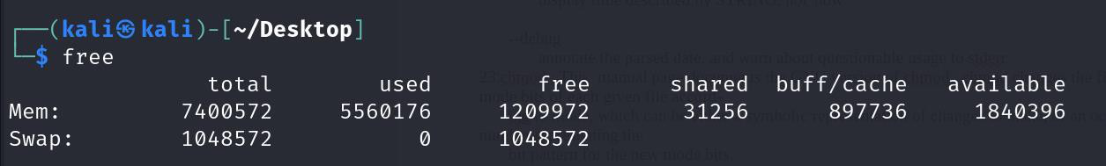

**19.uname** : Print certain system information. With no OPTION, same as -s.-a, --all

• print all information, in the following order, except omit -p and -i if unknown: -s, --kernel-name  
 • print the kernel name

4

Meet Dholakia 22BCP004

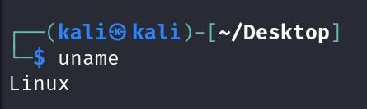

**20.groups** : Print group memberships for each USERNAME or, if no USERNAME is specified, for the current process (which may differ if the groups database has changed).

|  |  |  |  |
| --- | --- | --- | --- |
| |  |  | | --- | --- | | --help | • |   --version  • | display this help and exit  output version information and exit |



**21.comm** : Compare sorted files FILE1 and FILE2 line by line. When FILE1 or FILE2 (not both) is-, read standard input. With no options, produce three-column output. Column one contains lines unique to FILE1, column two contains lines unique to FILE2, and column three contains lines common to both files.

-1 suppress column 1 (lines unique to FILE1)  
-2 suppress column 2 (lines unique to FILE2)  
-3 suppress column 3 (lines that appear in both files)

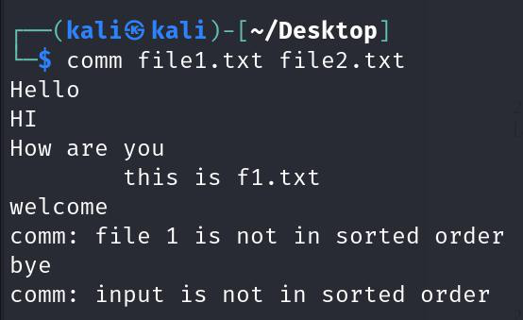

**22.Date** : Display date and time in the given FORMAT. With -s, or with   
[MMDDhhmm[[CC]YY][.ss]], set the date and time. Mandatory arguments to long options are mandatory for short options too.

-d, --date=STRING  
 • display time described by STRING, not 'now'  
--debug   
 annotate the parsed date, and warn about questionable usage to stderr•

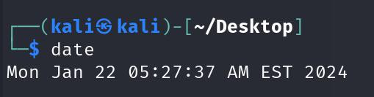

5

Meet Dholakia 22BCP004

**23.chmod** : This manual page documents the GNU version of chmod. chmod changes the file mode bits of each given file according to mode, which can be either a symbolic representation of changes to make, or an octal number representing the bit pattern for the new mode bits.

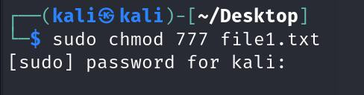

**24.wc** : Print newline, word, and byte counts for each FILE, and a total line if more than one FILE is specified. A word is a non-zero-length sequence of printable characters delimited by white space. With no FILE, or when FILE is -, read standard input.

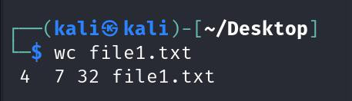

6

|  |  |  |  |  |
| --- | --- | --- | --- | --- |
| Meet Dholakia | | | | 22BCP004 |
| **1** | | | **Lab – 2** |
| **1** | | **20CP207P - Operating Systems Lab** | |
| **2** | **Title:** Introduction of Shell Scrip. | | |
| **3** | **Task:** Perform the basic Shell Scrip | | |

**1) Write a bash script to print from user input.**

**Script :**   
#! /bin/bash   
echo "What is your name? "   
read name   
echo "Hello" $name"!!"   
**Output:**

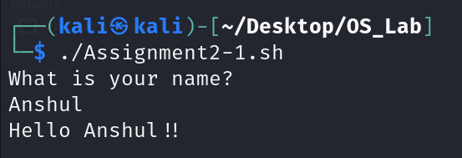

**2) Write a bash script to find whether a number is even or odd.**

**Script :**   
#! /bin/bash   
echo "Enter the number: "   
read num   
num1=0   
if [ `expr $num % 2` == $num1 ];   
then   
 echo "The number is even"   
else   
 echo "Number is odd"   
fi

1

Meet Dholakia 22BCP004

**Output:**

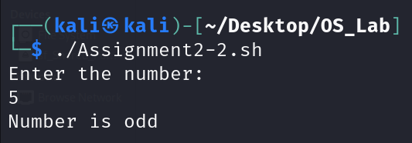

**3) Write a bash script to print the table of a given number.**

**Script :**   
#!/bin/bash   
echo "Enter the number: "   
read num   
i=1   
while [ $i -le 10 ]   
do   
 echo "$num x $i = $((num*$i))"   
 let i=$((i+1))   
done   
**Output:**

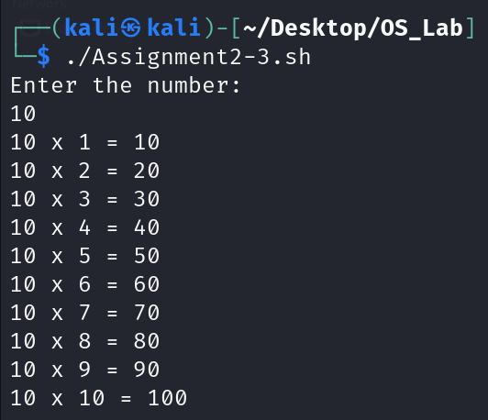

2

Meet Dholakia 22BCP004

**4) Write a bash script to check whether a given no. is prime or not.**

**Script :**   
#!/bin/bash   
echo "Enter the number: "   
read num   
i=2   
j=0   
num2=$((num-1))   
for (( i=2;i<$num;i++ ))   
do   
 if [ $((num%i)) -eq 0 ]   
 then   
 echo "$num is not Prime"   
 exit   
 fi   
done   
echo "$num is Prime"   
**Output:**

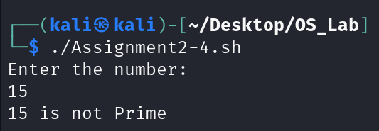

**5) Write a bash script to find the simple interest.**

**Script :**   
#!/bin/bash   
echo "Enter the amount: "   
read amt   
interest=$(( ((amt*7)/100) + amt))   
echo "Interset is $interest"

3

Meet Dholakia 22BCP004

**Output:**

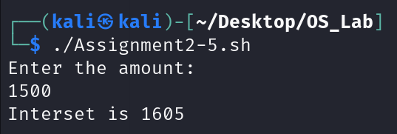

4

**OS Lab**

|  |  |  |  |
| --- | --- | --- | --- |
| Roll No: | 22BCP004 | Batch: | G1 |
| Date: | 02/02/24 | | |
| Practical: | 3 | | |
| Title: | Introduction to shell script. | | |
| Task: | Perform the basic Shell Scrip  1) Write a bash script to calculate the sum of n inputs.  2) Write a bash script to find the largest out of three numbers. 3) Write a menu driven bash script for the following operations.  a. Display calendar of current month  b. Display today’s date information  c. Display the username of the users currently logged in d. Display the username at given coordinates  e. Display the terminal number  4) Write a bash script to get first n Fibonacci numbers.  5) Write a bash script to check whether the given year is a leap year. 6) Write a bash script to print a number triangle.  7) Write a bash script to change the input to uppercase. | | |

**Ques:1 Write a bash script to calculate the sum of n inputs. Code of Shell:**

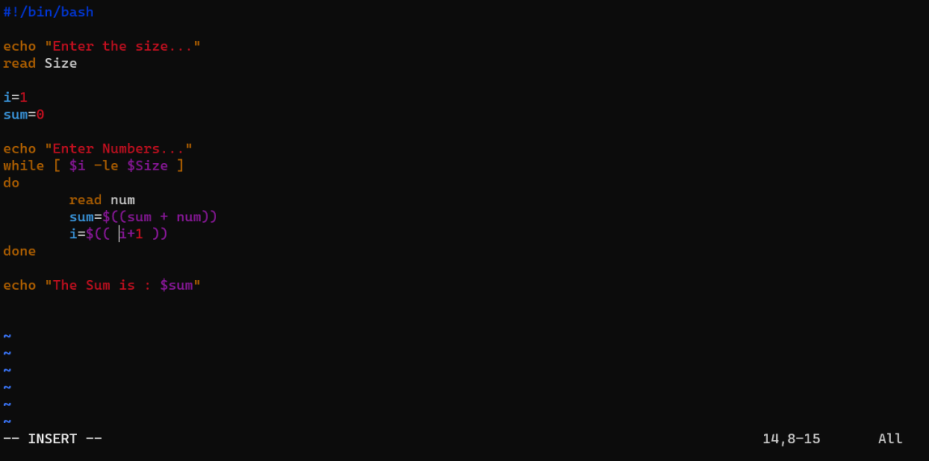

**Output:**

**OS Lab**

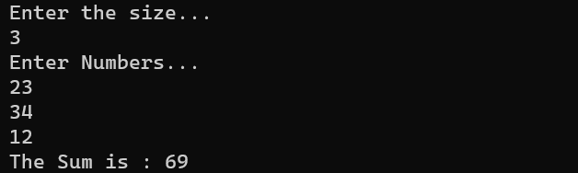

**Ques: 2 Write a bash script to find the largest out of three numbers. Code:**

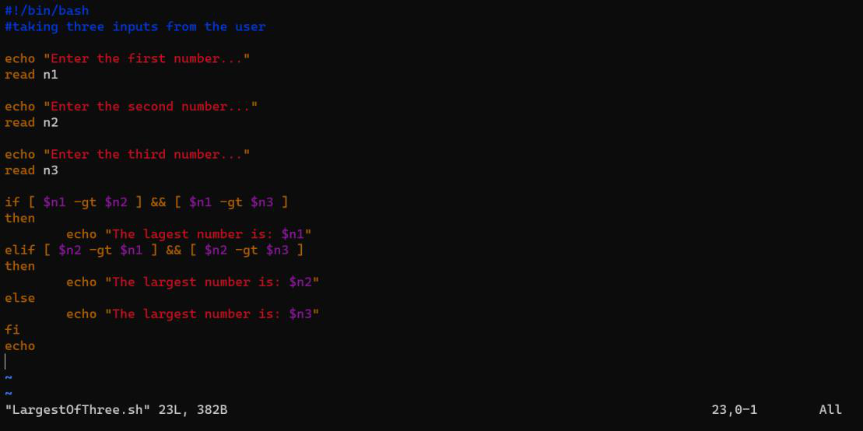

**Output:**

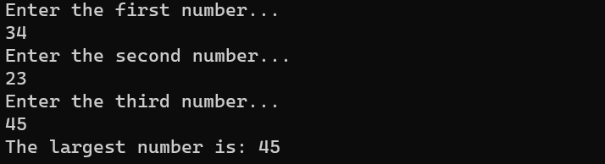

**Ques: 3 Write a menu driven bash script for the following operations.**

**a. Display calendar of current month**   
**b. Display today’s date information**   
**c. Display the username of the users currently logged in**

**OS Lab d. Display the username at given coordinates e. Display the terminal number**

**Code:**

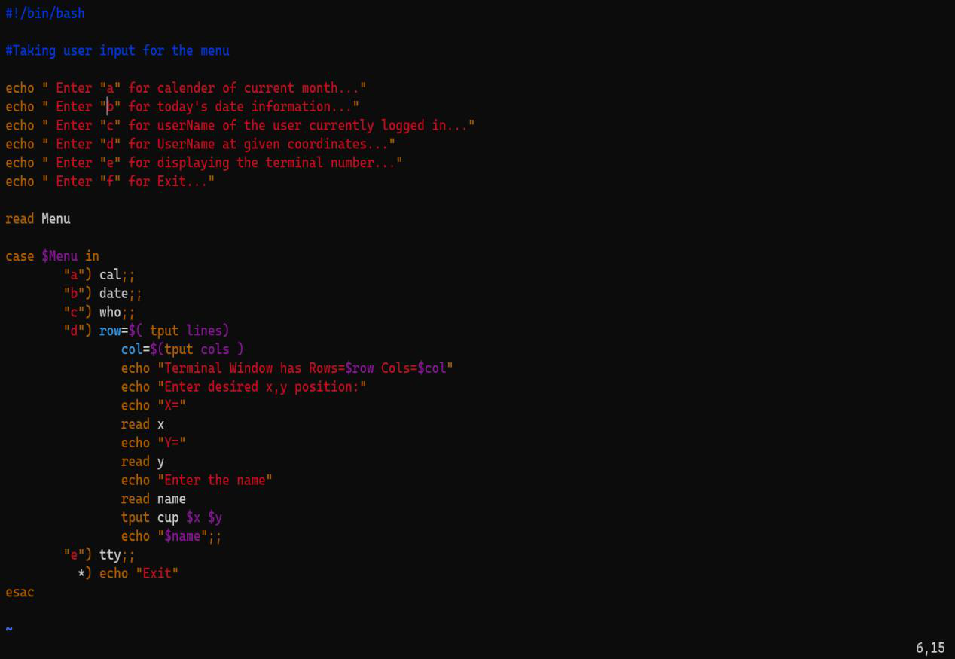

**Output:**

**OS Lab**

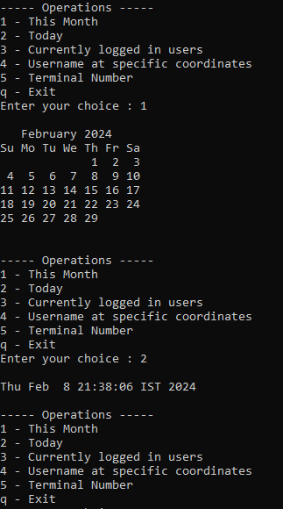

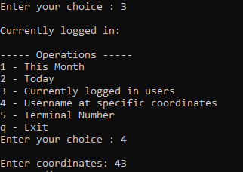

**OS Lab**

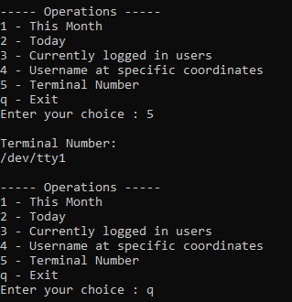

**Ques: 4 Write a bash script to get first n Fibonacci numbers Code:**

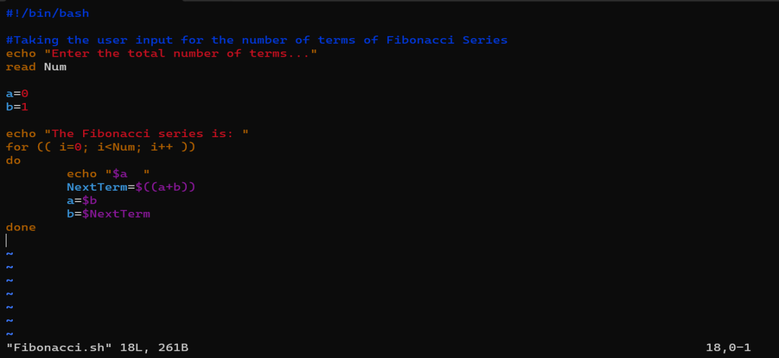

**Output:**

**OS Lab**

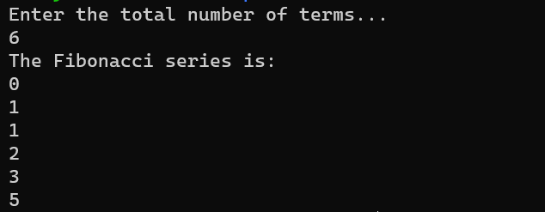

**Ques: 5 Write a bash script to check whether the given year is a leap year. Code:**

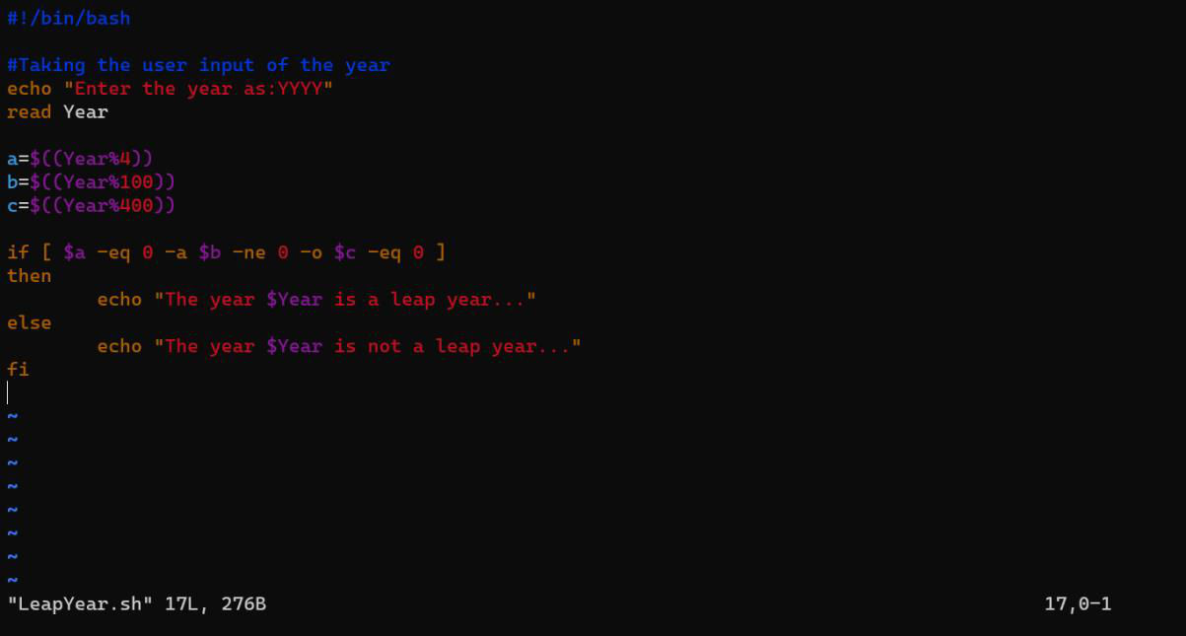

**Output:**

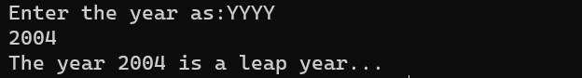

**Ques: 6 Write a bash script to print a number triangle. Code:**

**OS Lab**

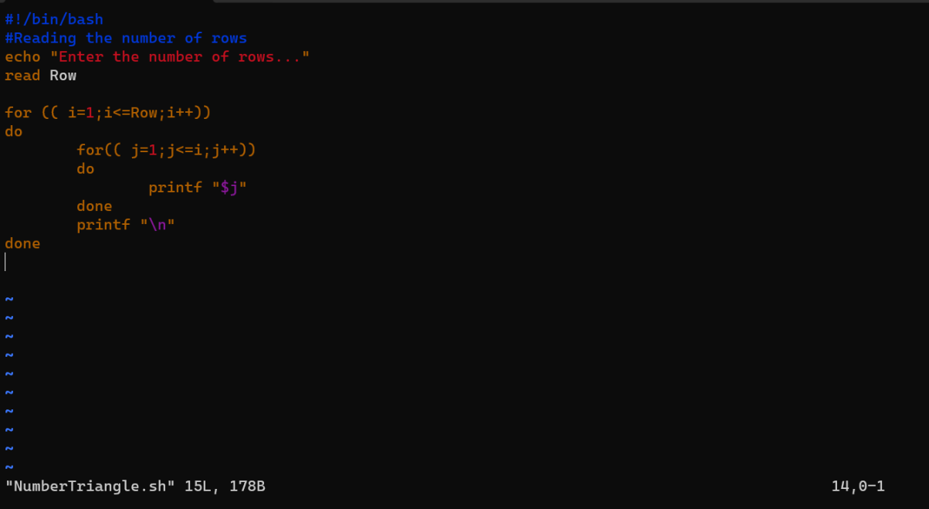

**Output**:

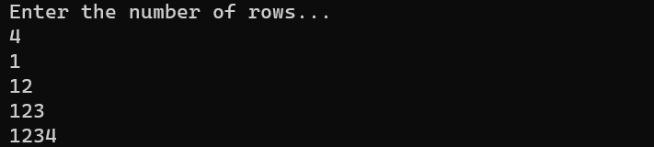

**Ques: 7 Write a bash script to change the input to uppercase. Code:**

**OS Lab**

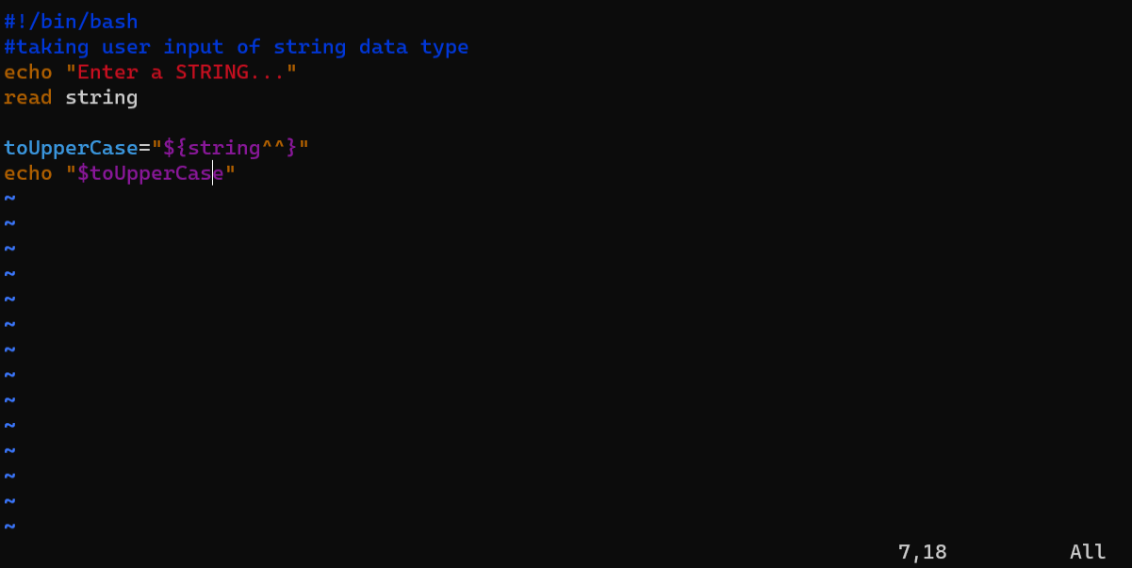

**Output:**

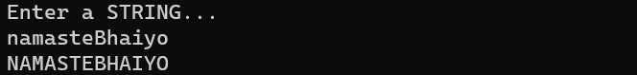

**OPERATING SYSTEM**

**Lab Assignment - 04**

**Name:** Meet Dholakia

**Roll no.:** 22BCP004

**Q1. Write a bash script to print the reverse of a given number. Ans.=>**

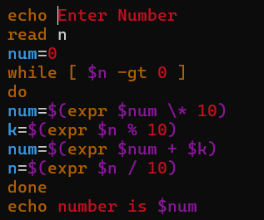

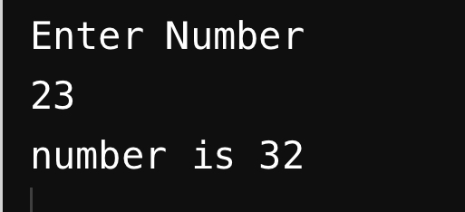

**Q2. Write a bash script to add 2 float numbers. Ans.=>**

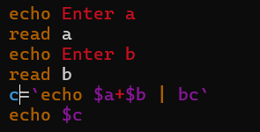

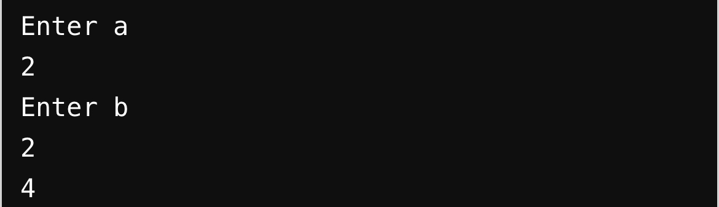

**Q3. Write a bash script for a menu driven calculator for + -* / Ans.=>**

|  |  |
| --- | --- |
| |  | | --- | |  | |

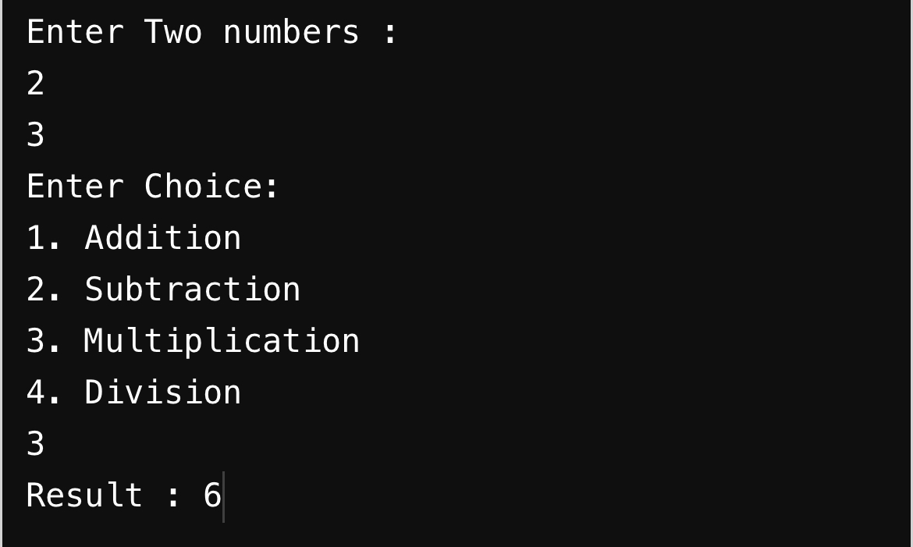

**Q4. Write a bash script to add the digits of a number. Ans.=>**

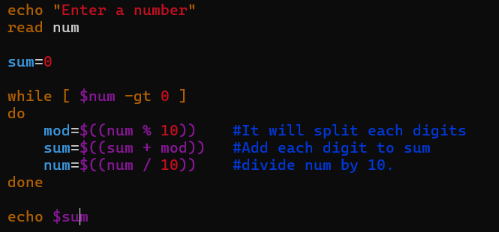

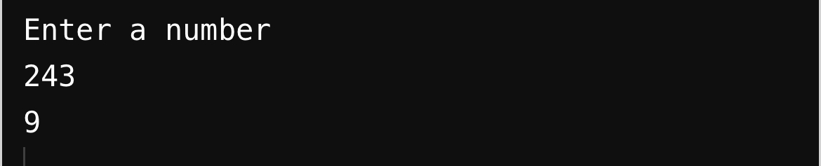

**Q5. Write a bash script to print the factorial of a number. Ans.=>**

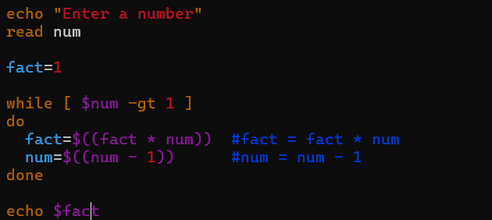

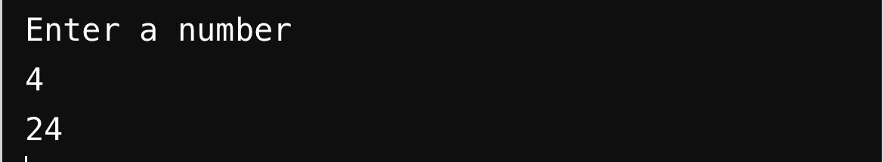

**Q6. Write a shell script to find the largest of three numbers and also find the sum and the mean.**

**Ans.=>**

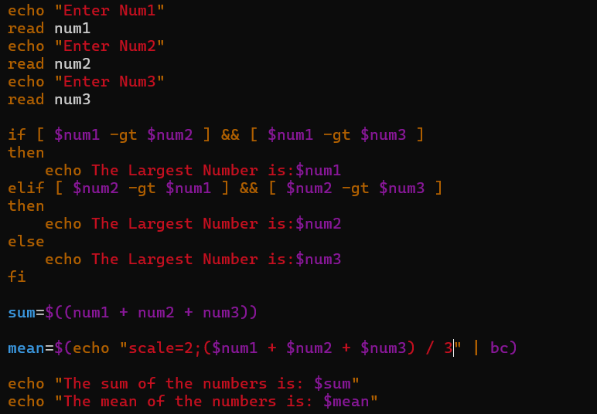

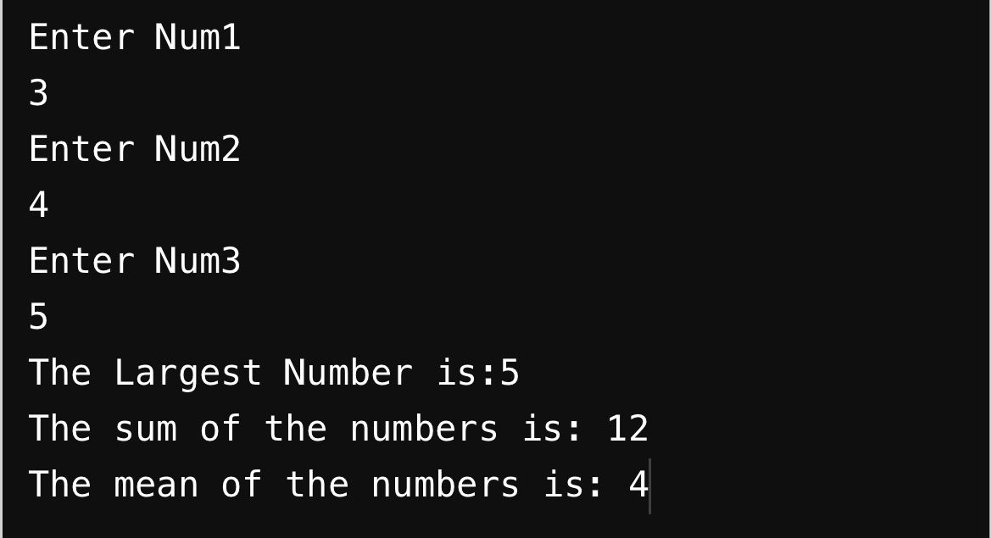

**Q7. Write a shell script to check whether the number of command line arguments passed are less than or equal to 5.**

**Ans.=>**

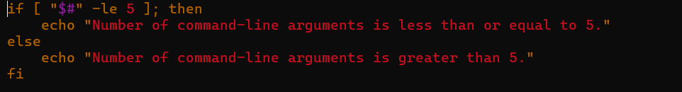

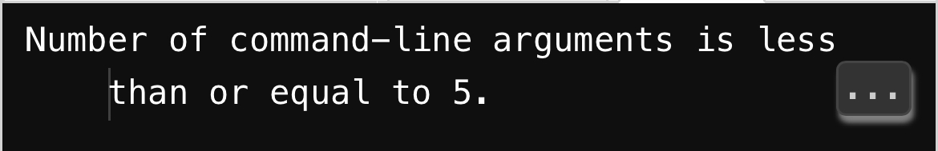

**Q8. Write a bash script to print the maximum from command line arguments.**

**Ans.=>**

