two   
*by* Rohit Agrawal

**Submission date:** 18-Mar-2024 04:38PM (UTC+0530)   
**Submission ID:** 2323598021   
**File name:** Probability11.docx  
(801.12K)   
**Word count:** 2211   
**Character count:** 14291

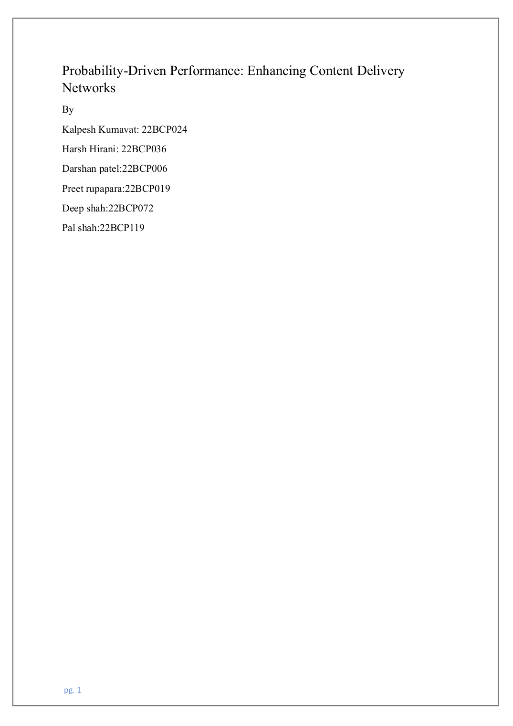

|  |  |
| --- | --- |
| |  | | --- | | 1 | |

|  |
| --- |
|  |

|  |
| --- |
|  |

|  |
| --- |
|  |

|  |
| --- |
|  |

|  |
| --- |
|  |

|  |
| --- |
|  |

|  |
| --- |
|  |

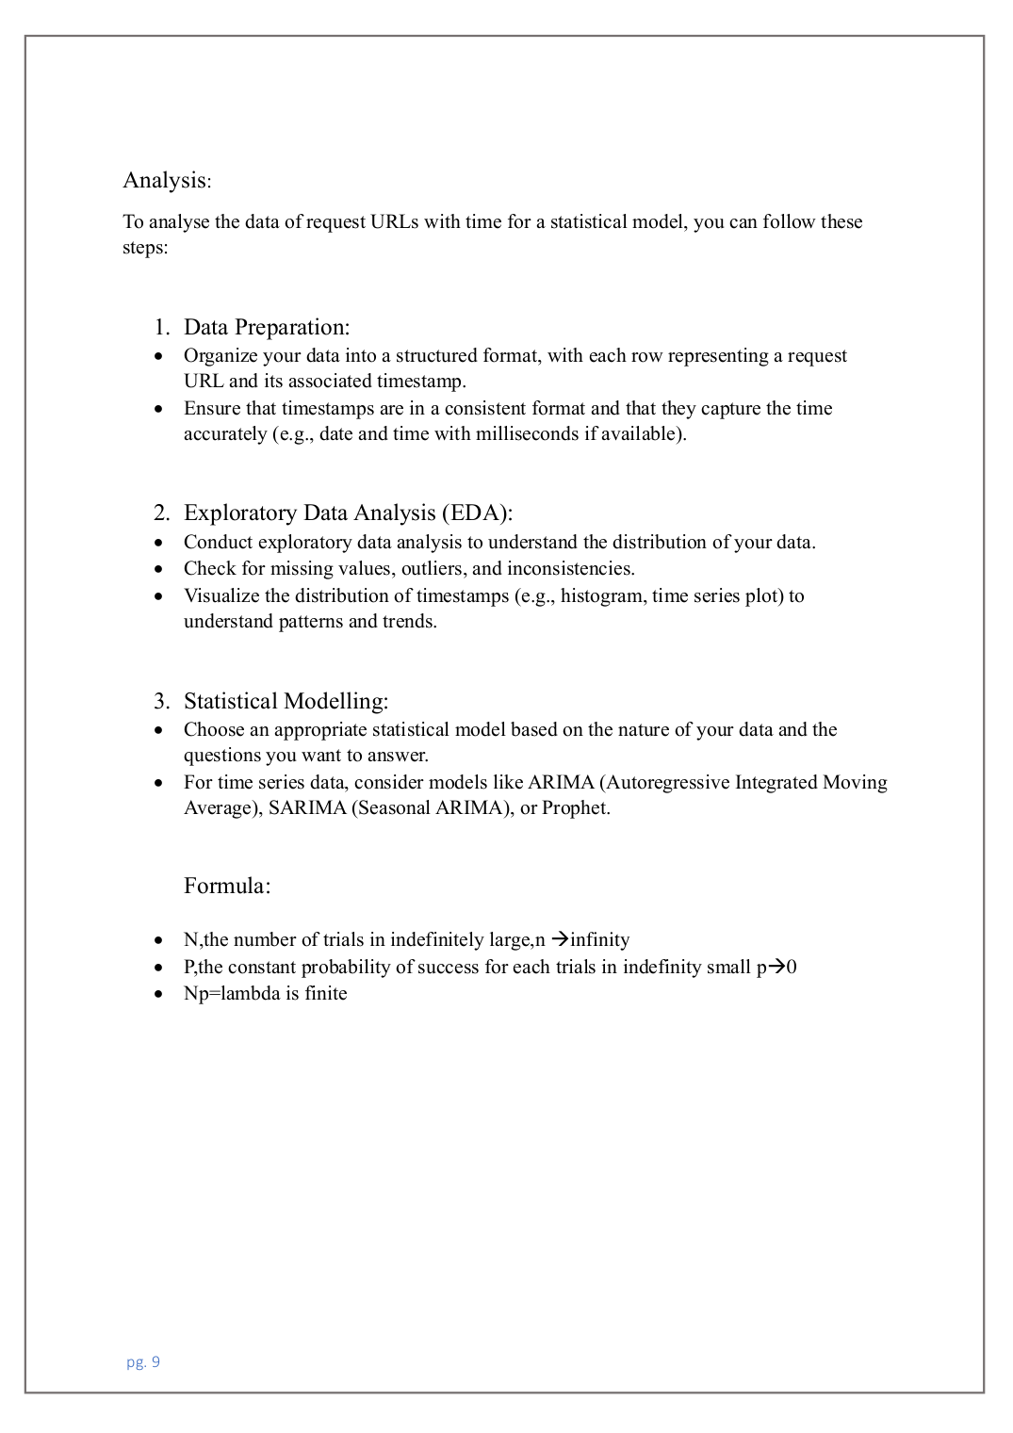

|  |  |
| --- | --- |
| |  | | --- | | 2 |   2  3 |

|  |
| --- |
|  |

|  |
| --- |
|  |

|  |
| --- |
|  |

|  |
| --- |
|  |

two

|  |  |  |  |
| --- | --- | --- | --- |
| ORIGINALITY REPORT | 2%  INTERNET SOURCES | 1%  PUBLICATIONS | 2%  STUDENT PAPERS |
| 3% SIMILARITY INDEX |

PRIMARY SOURCES

|  |  |  |  |  |  |  |
| --- | --- | --- | --- | --- | --- | --- |
| |  | | --- | | 1 | | www.oocities.org  Internet Source | | | | 1% |
| |  | | --- | | 2 | | fastercapital.com  Internet Source | | | | 1% |
| |  | | --- | | 3 | | Submitted to Yew Chung International School of Beijing  Student Paper | | | | 1% |
| Exclude quotes | | On | Exclude matches | < 15 words |  |

Exclude bibliography On