PRASAR
PR Volunteer User Guide
BAPS Africa · Dignitary outreach workflow
This guide explains how PR Volunteers (Karyakars) use PRASAR for dignitary outreach: who you can see, how to invite guests, track responses, log calls, and check in attendees.
App URL: https://prasar.vercel.app
Your role in the app: PR Volunteer (sidebar shows *Limited Access*).

1. What PRASAR does for you
PRASAR is the BAPS Africa digital tool for public-relations seva. As a volunteer you typically:
1. Work with your assigned dignitaries (guests).
2. Use published events created by administrators.
3. Send invitations (PDF, email, or WhatsApp when enabled).
4. Track outreach and RSVP in the Invitation Tracker.
5. Log phone calls and other contact in Communications.
6. Scan QR codes at the mandir when attendance is open for an event.
You do not manage other volunteers, approve guests, or change system-wide settings—admins handle that.

2. Signing in
1. Open the PRASAR link in your browser (Chrome or Edge recommended).
2. Under Select role, choose PR Volunteer.
3. Enter the email and password from your credentials sheet (use email, not only your name, if you were given one).
4. Optionally tick Remember email for next time.
5. Click Enter PRASAR.
If login fails, confirm role is PR Volunteer, check caps lock, and contact an administrator to reset your password.
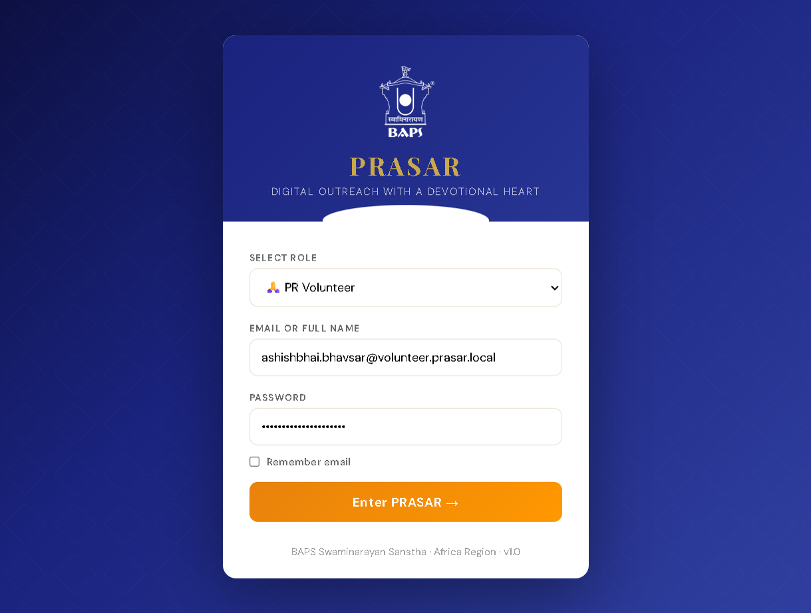
PRASAR login screen — select PR Volunteer

3. Your sidebar and access
After login you see the dark blue sidebar. Available pages depend on what your administrator enabled in Master Edits. A typical volunteer menu includes:
Section | Pages
Main | Dashboard, About PRASAR, Dignitaries, Events, Invitations, Invitation Tracker
Engagement | Communications, QR Attendance, Hospitality
Analytics | Reports, Donations
Your name and PR Volunteer • Limited Access appear at the bottom. Use the exit control there to sign out.
Important: You only see dignitaries assigned to you (primary, secondary, or tertiary volunteer on their record). Counts on the dashboard and Dignitaries badge reflect *your* list, not the whole region.

4. Dashboard
The dashboard is your home screen after login.
• Quick actions: Log Interaction and Send Invitation jump to common tasks.
• Stat cards: Your dignitary count, regional volunteer count, active events, invitations sent, etc. (figures sync from the server when you log in).
• Charts: Use All events (or a specific event) to filter attendance and category charts when data exists.
Use the top search box to find dignitaries or events quickly.
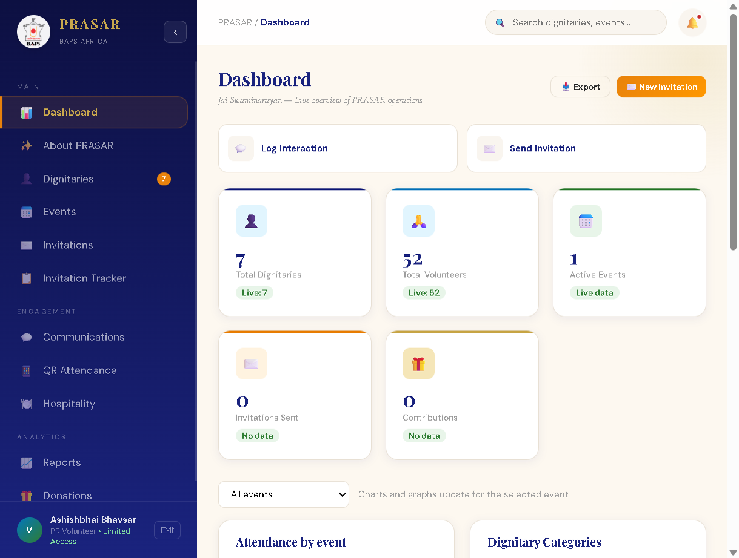
Volunteer dashboard overview

5. Dignitaries — your guest list
Open Dignitaries from the sidebar.

What you see
• A numbered list (1, 2, 3…) sorted A–Z by name.
• Columns: name, designation, organization, phone, sector, sub sector, VIP.
• Filters: sector, active/inactive, volunteer filter, and search (name, org, town, etc.).

What you can do
• View (eye) — full profile: dietary, protocol notes, contact details.
• Edit — update details for guests you manage (changes may require admin approval if your center uses approvals).
• WhatsApp (green) — open chat when a mobile number is stored.
• Add Dignitary / Import Excel — if your admin allows; new guests may sit in Pending until an administrator approves them.
You cannot delete dignitaries unless your deployment grants admin tools; volunteers normally add/edit only.
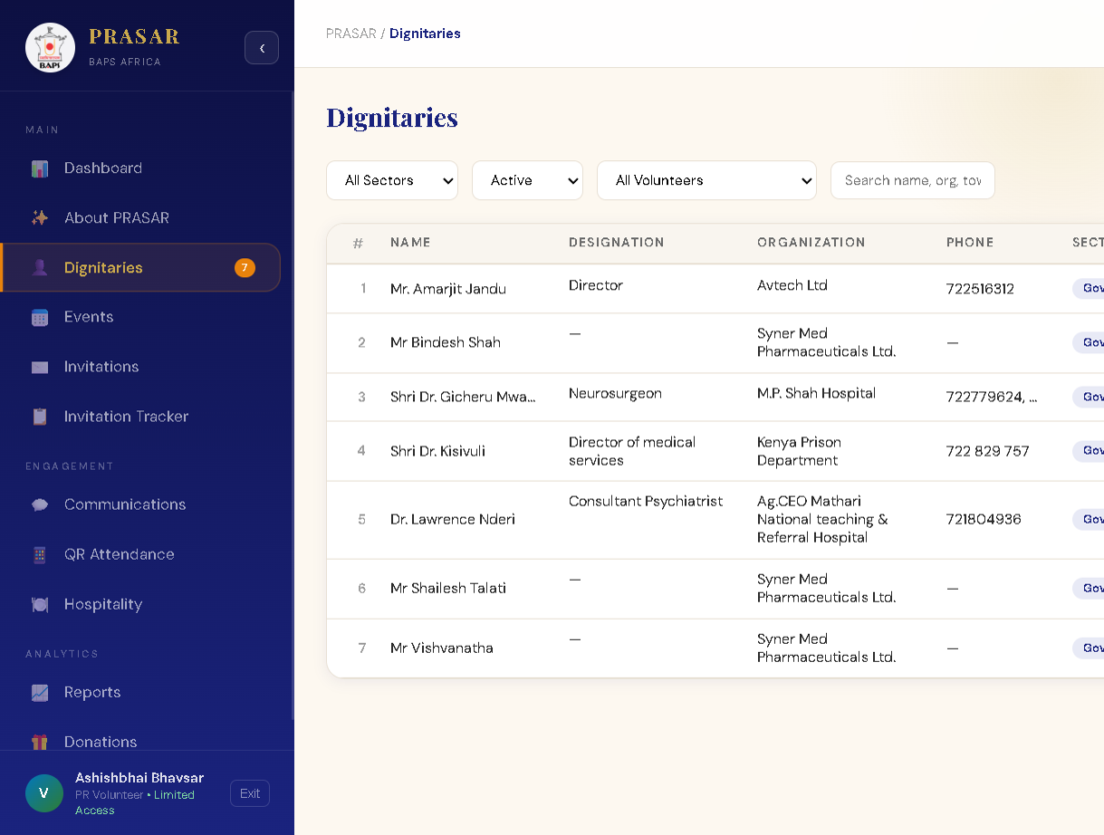
Dignitaries list with numbered rows

6. Events — programs you invite guests to
Open Events. Tabs: Upcoming and Past Events.
• You only see published events (not admin drafts).
• Each card shows dates, venue, and per-day schedule (Day 1, Day 2, …).
• Standard message to send to guests is the default wording for invitations; admins set this. It may show as several paragraphs.
• Send Invites opens the Invitations page for that event.
• Attendance closed / open — only when an admin enables attendance can you use QR check-in for that event.
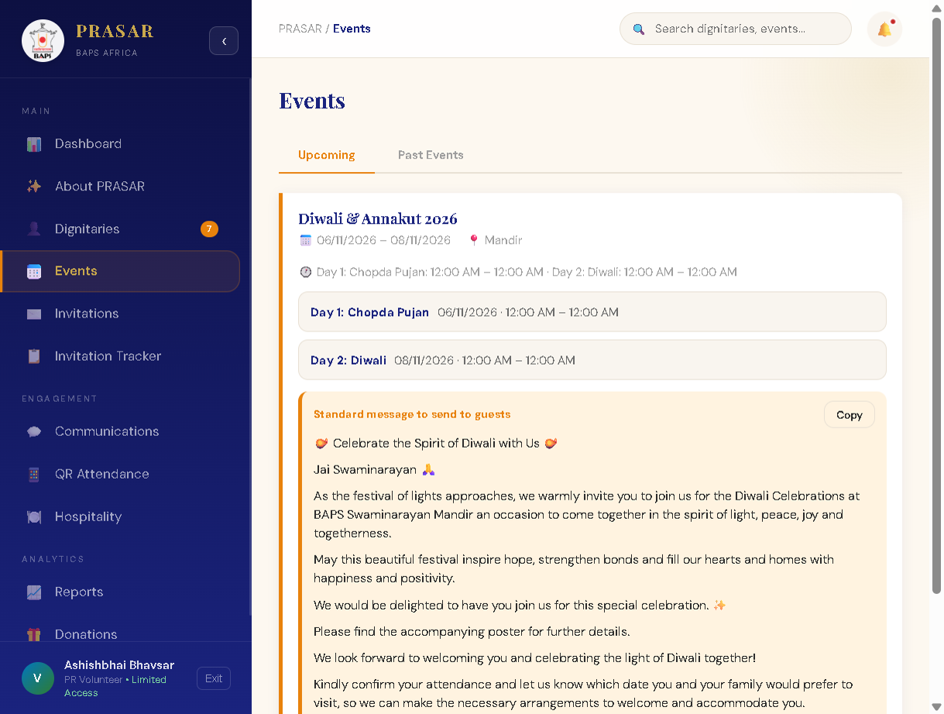
Events page with standard guest message

7. Invitations — generate and send
Open Invitations (or Send Invites from an event).

Steps
1. Select event — e.g. *Diwali & Annakut 2026*.
2. Select dignitary — only your active, approved guests appear.
3. Custom message — leave blank to use the event standard message, or edit for this guest.
4. Design canvas — shows the invitation layout. Admins design the layout per event; you load it by selecting the event. You do not change the master template unless you are an admin.
5. Actions:
• Generate PDF — download/print formal invitation.
• WhatsApp — send when WhatsApp is configured on the server.
• Email — sends via Postmark when configured; otherwise admin may use outbox mode on staging.
Use Bulk Generate when sending many PDFs at once (admin-heavy flows may vary).
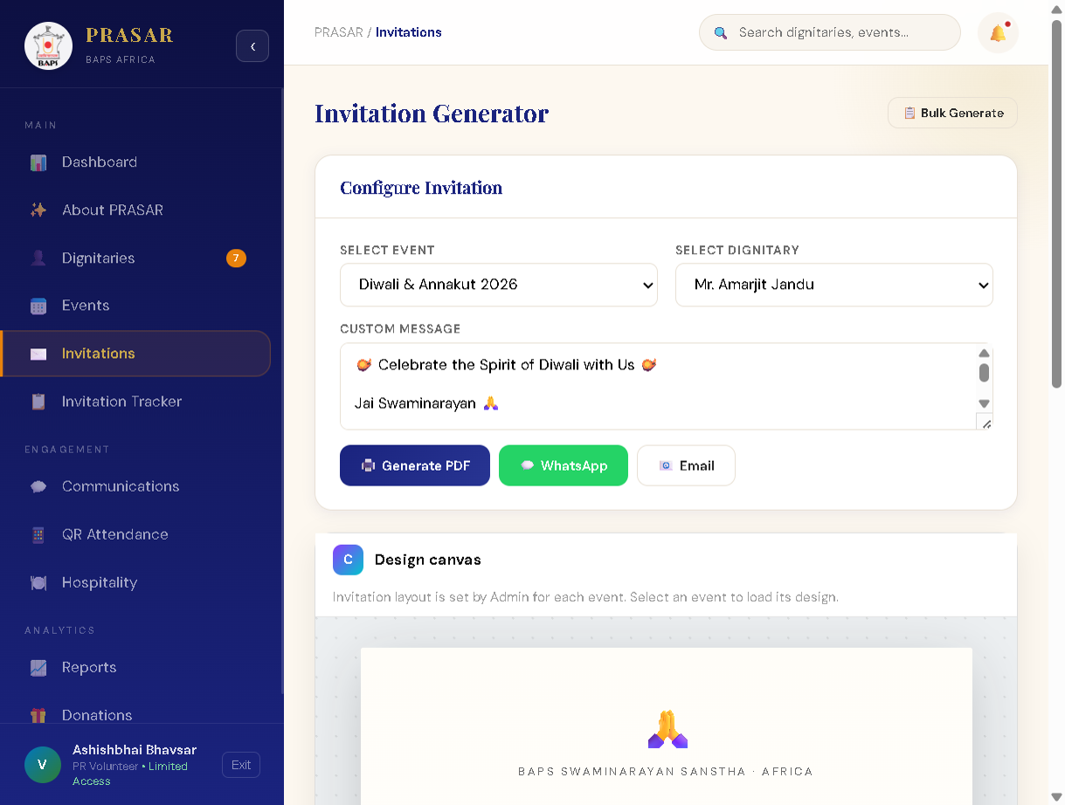
Invitation generator and preview

8. Invitation Tracker — follow-up grid
Open Invitation Tracker after invitations exist.
For each dignitary / event you can record:
• Reached out via (phone, WhatsApp, email, in person, etc.).
• Notes from conversations.
• Ladies / Gents counts (per event day when applicable).
• RSVP yes/no per day.
• Attendance when the admin has enabled attendance for the event.
Filter by event or search. If the table is empty, create an invitation first from the Invitations page (Send Invitation on the dashboard also works).
Tip shown in the app: mark *Reached Out Via* once, then set RSVP for each day; add ladies/gents counts as needed.
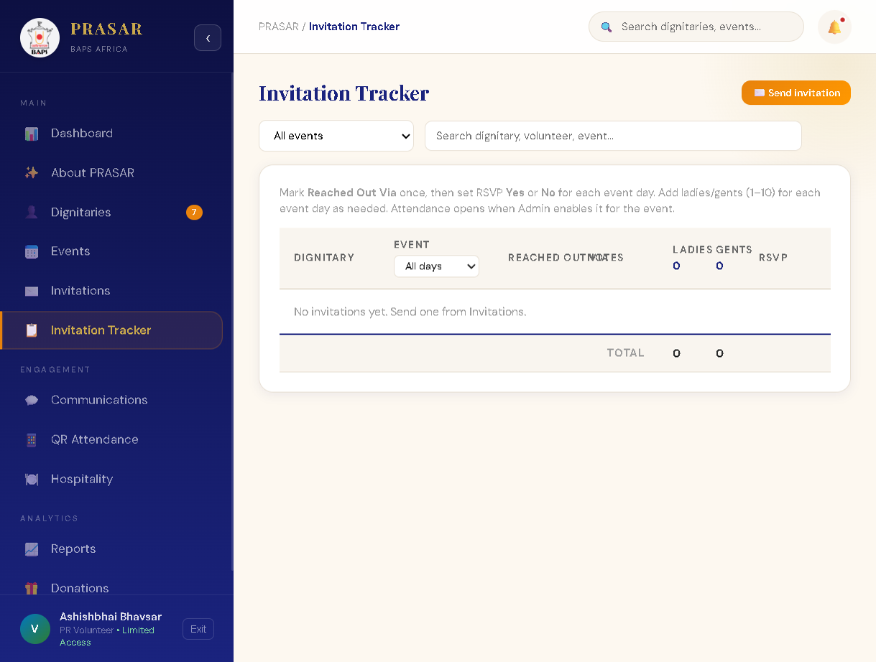
Invitation Tracker grid

9. Communications — log every touchpoint
Open Communications → Communication Timeline.
1. Click + Log Interaction.
2. Choose dignitary, type (phone, WhatsApp, email, in-person, PDF sent, gift), date/time, and notes.
3. Save — the row appears with Logged by your name.
Filter by type, volunteer, or date. This creates a shared history so admins and other sevaks see outreach continuity (subject to visibility rules).
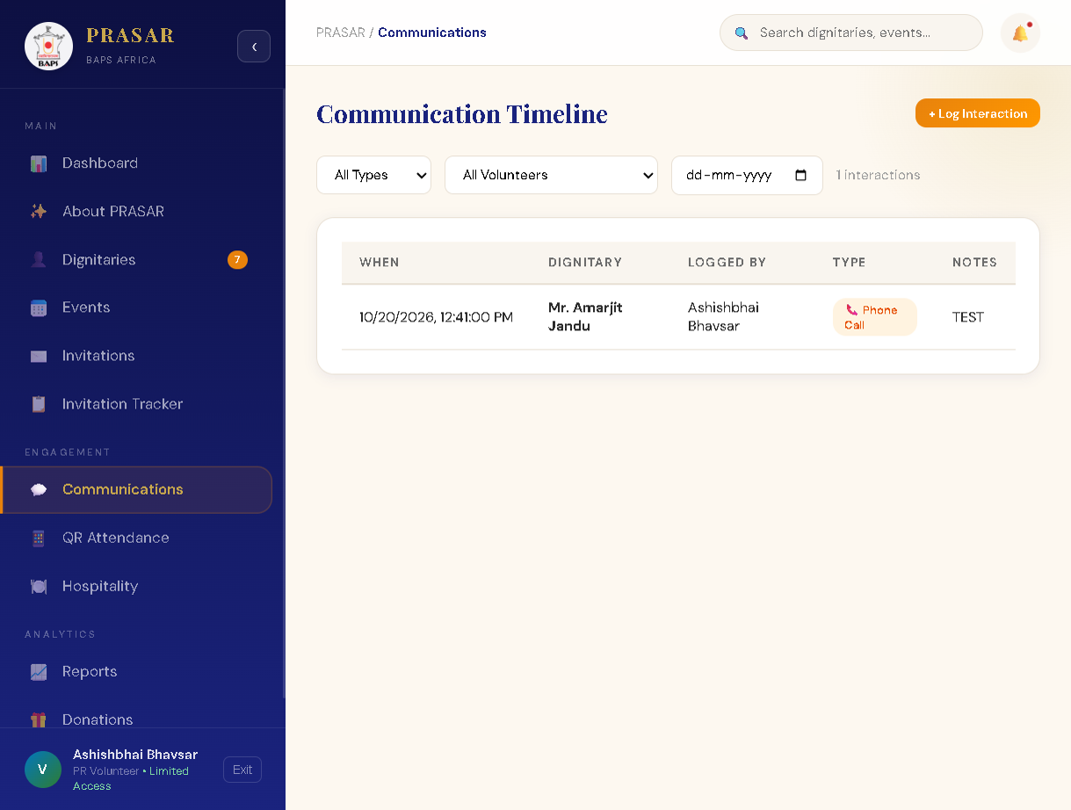
Communication timeline with logged phone call

10. QR Attendance — at the venue
Open QR Attendance when guests arrive.
1. Select event and day (must match a published event with attendance enabled by admin).
2. Use Scan QR / Simulate — point the camera at the QR on the guest’s invitation PDF.
3. Live arrivals lists who checked in and when.
4. Guest list at the bottom is view-only for ladies/gents/status summary.
If attendance is closed on the event card, contact an administrator to enable it before the program.
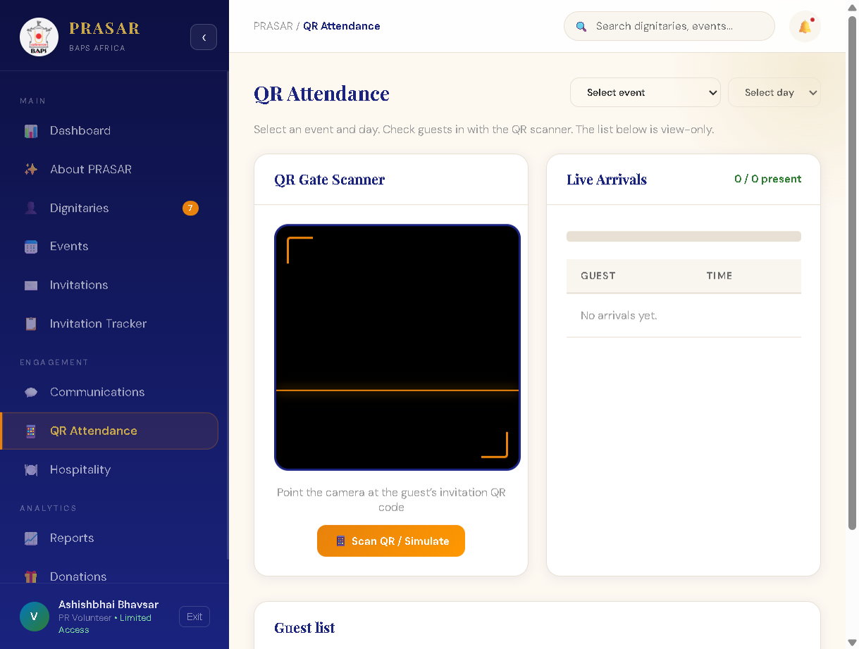
QR Attendance scanner screen

11. Other pages (brief)
Page | Volunteer use
About PRASAR | Mission and values — read-only.
Hospitality | Dietary and protocol planning for assigned guests.
Reports | Charts and exports for your activity where enabled.
Donations | Record donations linked to dignitaries when your team uses this module.
Pages such as Approvals, Master Edits, Settings, and User Management are admin-only and do not appear on your menu.

12. Recommended weekly workflow
Monday–Wednesday Review Dignitaries → update phones/emails
↓
Send Invitations (PDF / WhatsApp / Email)
↓
Update Invitation Tracker (reached out, RSVP)
↓
Log Communications for every call/message
↓
Event day QR Attendance check-in
↓
After event Finalize tracker & notes for handover to admin

13. Tips and troubleshooting
Situation | What to do
Empty dignitary list | Confirm admin assigned you on guest records (primary/secondary/tertiary volunteer name must match your full name).
Cannot see an event | Event must be Published; drafts are admin-only.
No invitation template | Select the event first; admin must save a layout for that event.
WhatsApp/email button fails | Server may not have Postmark/WhatsApp keys—use Generate PDF and send manually.
QR scan not working | Allow camera permission; pick correct event/day; ask admin to enable attendance.
Guest not in dropdown | Guest must be Active, Approved, and assigned to you.

14. Getting help
• Password / access: Regional PR administrator (admin `@prasar.admin` accounts).
• Technical issues: Contact your regional PR tech coordinator.
*PRASAR · BAPS Swaminarayan Sanstha · Africa Region · PR Volunteer Guide*

