**1.SDLC**

**Software development life cycle (SDLC) is a structured process that is used to design, develop, and test good-quality software.** SDLC, or software development life cycle, is a methodology that defines the entire procedure of software development step-by-step. The **goal of the SDLC life cycle model** is to deliver high-quality, maintainable software that meets the user's requirements. SDLC in software engineering models outlines the plan for each stage so that each stage of the software development model can perform its task efficiently to deliver the software at a low cost within a given time frame that meets users requirements. In this article we will see Software Development Life Cycle (SDLC) in detail.

**What is the Software Development Life Cycle (SDLC)?**

**SDLC is a process followed for software building within a software organization.**SDLC consists of a precise plan that describes how to develop, maintain, replace, and enhance specific software. The life cycle defines a method for improving the quality of software and the all-around development process.

## Stages of the Software Development Life Cycle

SDLC specifies the task(s) to be performed at various stages by a software engineer or developer. It ensures that the end product is able to meet the customer's expectations and fits within the overall budget. Hence, it's vital for a software developer to have prior knowledge of this software development process. SDLC is a collection of these six stages,

### **Stage 1: Planning and Requirement Analysis**

### **Stage 2: Defining Requirements**

### **Stage 3: Designing the Product Architecture**

### **Stage 4: Building or Developing the Product**

### **Stage 5: Testing the Product**

### **Stage 6: Deployment in the Market and Maintenance**

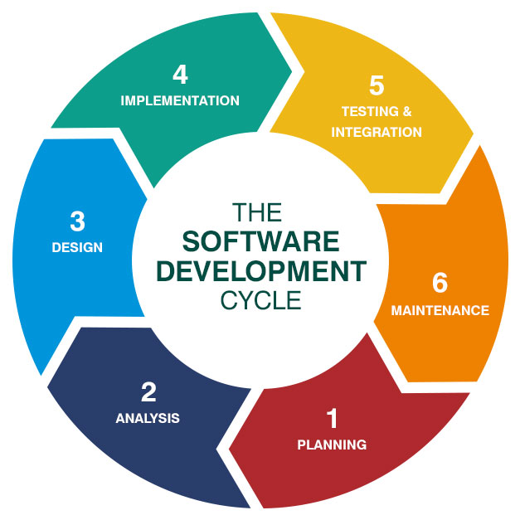

**2.AGILE METHODOLOGY**

# What is Agile Methodology?

**Last Updated :**24 Apr, 2025

The **Agile methodology** is a proper way of managing the project with breaking them into smaller phases which is iteration. It basically focus on flexibility of the project which we can change and improve the team work regularly as per requirements.

## What is the Agile Methodology?

**Agile Methodology** is a **way to manage projects by breaking them into smaller parts**. It focuses on working together and making constant improvements. Teams plan, work on the project, and then review how things are going in a repeating cycle.

* They prioritize flexibility, collaboration, and customer satisfaction.
* Major companies like Facebook, Google, and Amazon use Agile because of its adaptability and customer-focused approach.

## ****Agile Methodology Definition****

[Agile methodology](https://en.wikipedia.org/wiki/Agile_software_development) is a pivotal project management approach predominantly applied in software development. It embodies a dynamic process where demands and solutions evolve through the synergistic collaboration of self-organizing, cross-functional teams, and their engaged customers.

The Agile methodology is rooted in a set of principles (see next chapter) valuing adaptability and flexibility. Agile stands as a transformative force, enhancing responsiveness to ever-changing business needs.

It empowers teams to deliver tangible progress in incremental, workable increments, fostering a climate of continuous improvement.

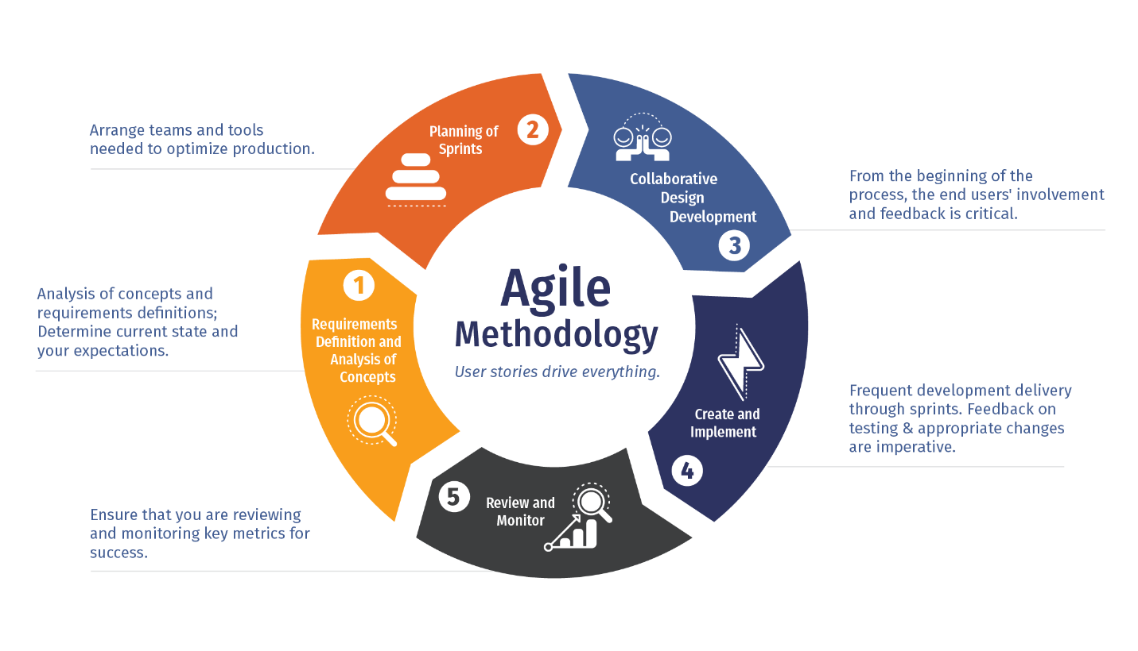

**3.DevOps**

**Ai overview**

DevOps is a software development approach that emphasizes collaboration and communication between development (Dev) and operations (Ops) teams. It's a cultural philosophy, set of practices, and tools that automate and integrate the processes between software development and IT teams, enabling faster and more reliable software delivery. In essence, DevOps aims to break down the silos between development and operations, fostering a continuous cycle of development, testing, deployment, and monitoring.

Here's a more detailed explanation:

Key Concepts:

* **Collaboration and Communication:**

DevOps promotes a culture where development and operations teams work together throughout the entire software development lifecycle, from planning to deployment and beyond.

* **Automation:**

DevOps heavily relies on automating repetitive tasks, such as testing, deployment, and infrastructure management, to speed up the process and reduce manual errors.

* **Continuous Integration and Continuous Delivery (CI/CD):**

CI/CD pipelines automate the process of building, testing, and deploying code changes, enabling frequent and reliable releases.

* **Cultural Philosophy:**

DevOps is not just about tools and processes; it's also a mindset shift that emphasizes collaboration, shared responsibility, and a focus on continuous improvement.

Benefits of DevOps:

* **Faster Release Cycles:**

By automating and streamlining processes, DevOps enables faster and more frequent software releases.

* **Improved Quality:**

Continuous testing and monitoring throughout the development lifecycle help identify and fix issues early, leading to higher quality software.

* **Increased Efficiency:**

Automation and collaboration reduce manual effort and streamline workflows, increasing overall efficiency.

* **Reduced Costs:**

Faster release cycles, improved quality, and increased efficiency can lead to cost savings.

* **Better Customer Satisfaction:**

Faster delivery of new features and improvements, along with higher quality, can lead to greater customer satisfaction.

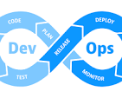

In simple terms, DevOps is about getting software from development to users faster, more reliably, and with better quality.

## How DevOps Works?

Here is a basic understanding of DevOps working flow:

* Code is developed collaboratively by Dev and Ops teams.
* Changes are integrated continuously using automated builds and tests (CI).
* Applications are deployed automatically through Continuous Delivery (CD).
* Infrastructure is managed as code for consistency and repeatability (IaC).
* Systems are monitored continuously to gather feedback and improve future releases.

