Task Status Tracker

**Purpose**

This utility is developed to track the status of the Scheduled Tasks of the server.

**Project made of**

1. Console Application

**Requirements**

.Net Framework 4.0

**Note**

Two different projects for XP and windows 7 PC.

**Folder Structure of Project**

*- denotes mandatory files and folders which should be present in the project to successfully run the project.

Windows 7 and above

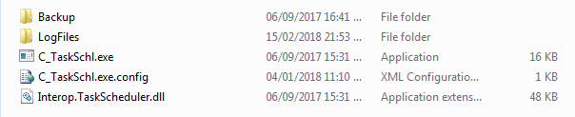

1. **Backup** - To keep backup of the previous setup when new changes are to be updated.
2. **LogFiles** - contains log of the project whenever the project runs.
3. **C_TaskSchl.exe** * – The project exe file.
4. **C_TaskSchl.exe.config** * – The project configuration file.
5. **Interop.TaskScheduler.dll** * – dll used to access Tasks data.

Windows XP

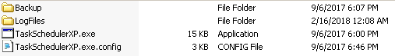

1. **Backup** - To keep backup of the previous setup when new changes are to be updated.
2. **LogFiles** - contains log of the project whenever the project runs.
3. **TaskSchedulerXP.exe** * – The project exe file.
4. **TaskSchedulerXP .exe.config** * – The project configuration file.

**Deployment**

The **console application** should be **scheduled** on **task scheduler** to run daily for every **30 minutes**.

**TaskSchedulerXP.exe** – for servers having Windows XP.

**C_TaskSchl.exe** – for servers having Windows 7 and above.

**Configuration File**

Windows 7 and above

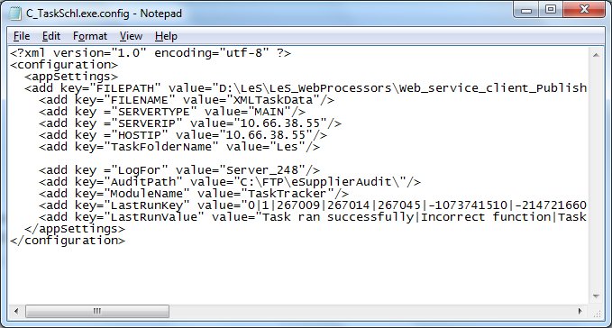

|  |  |
| --- | --- |
| **Key** | **Value** |
| FILEPATH | “SendFiles” folder path of the Server Status Indicator Web service. |
| FILENAME | Name of the file to be created at this path. |
| SERVERTYPE | Should be “MAIN” for parent PC and “VIRTUAL” for Virtual PC. |
| SERVERIP | The accessible IP address of the server where this exe is deployed. |
| HOSTIP | The accessible IP address of the parent server on which this exe is deployed. If the server is “MAIN” server both the IP address will be same. If the server is “VIRTUAL” then IP address of its parent server is specified. |
| TaskFolderName | Name of the Folder of the tasks of the task scheduler of which tasks status are to be tracked. |
| LogFor | Name to be displayed as “Server Name” in the Audit log tab of “Les Monitor”. |
| AuditPath | Path where the audit log file will get created. |
| ModuleName | Name to be displayed as “Module” in the Audit log tab of “Les Monitor”. |
| LastRunKey | Key of the status of the task to be checked. |
| LastRunValue | Value of the status of the task to be checked. |

Windows XP

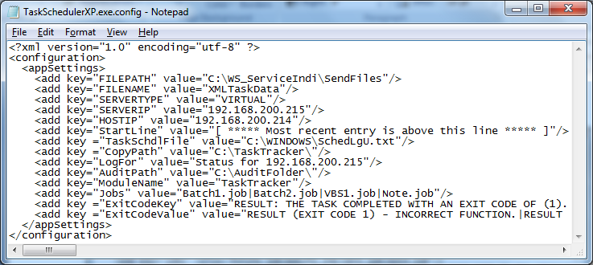

|  |  |
| --- | --- |
| **Key** | **Value** |
| FILEPATH | “SendFiles” folder path of the Server Status Indicator Web service. |
| FILENAME | Name of the file to be created at this path. |
| SERVERTYPE | Should be “MAIN” for parent PC and “VIRTUAL” for Virtual PC. |
| SERVERIP | The accessible IP address of the server where this exe is deployed. |
| HOSTIP | The accessible IP address of the parent server on which this exe is deployed. If the server is “MAIN” server both the IP address will be same. If the server is “VIRTUAL” then IP address of its parent server is specified. |
| StartLine | Start line to search in “SchedLgu.txt” found on this path. |
| TaskSchdlFile | Path where “SchedLgu.txt” file can be found. |
| CopyPath | Path to copy this file. |
| LogFor | Name to be displayed as “Server Name” in the Audit log tab of “Les Monitor”. |
| AuditPath | Path where the audit log file will get created. |
| ModuleName | Name to be displayed as “Module” in the Audit log tab of “Les Monitor”. |
| LastRunKey | Key of the status of the task to be checked. |
| LastRunValue | Value of the status of the task to be checked. |

**Functionality-**

The exe will create an XML file on this location. The XML file will have data-

If the task status is one of these or

If the task ran successfully but has not run again for last 45 minutes or

If the task is already running and has been running for more than 30 minutes.