Remix/Solidity

The normal, very basic program for solidity is when we have a normal getter and setter function which directly just read values and write values into the blockchain. The very easy way of making a normal getter is by just setting the variable public, that allows any person to access those variables.
Eg:
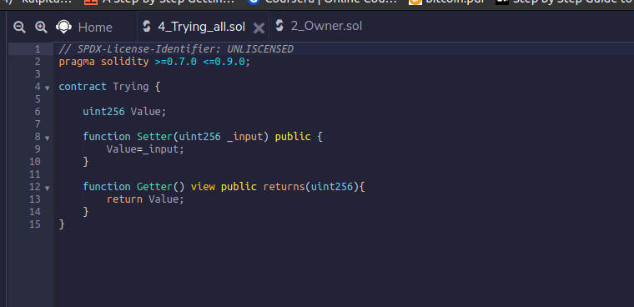
So,
The next set of operation to be done is using events and modifiers to give and change ownership.

Difference between external and Public visibility type
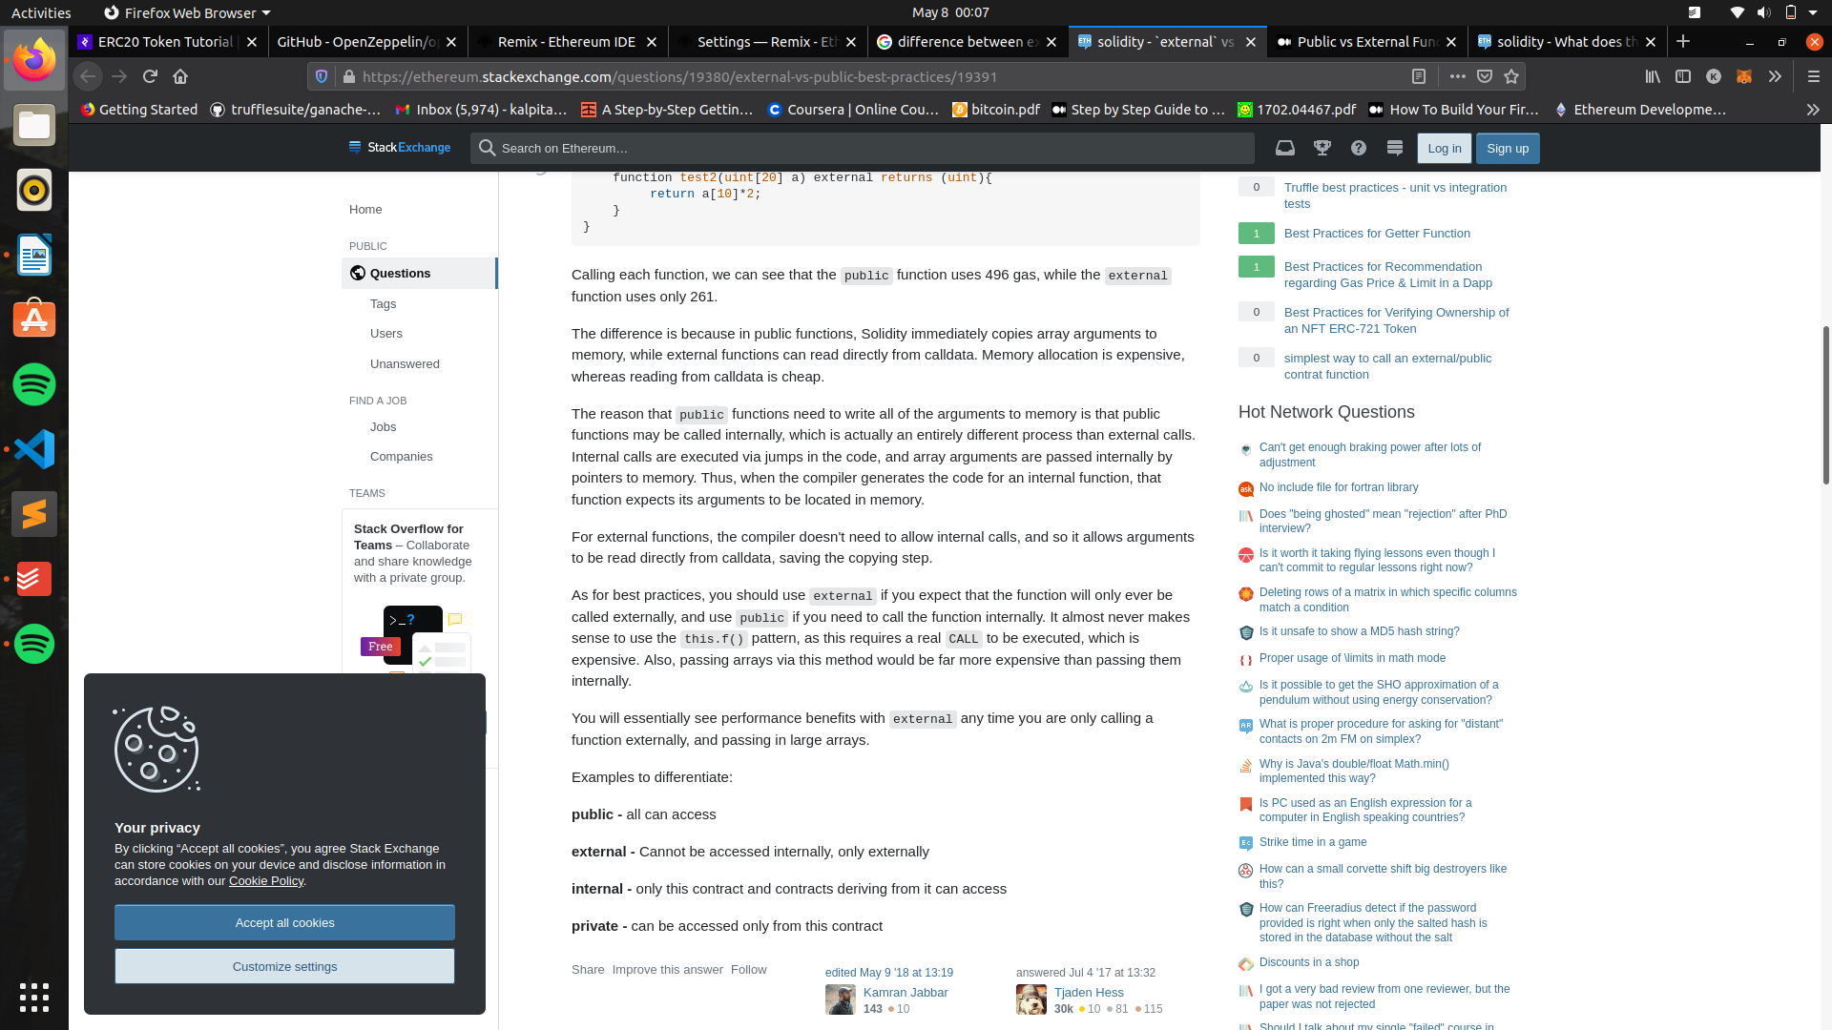
The code used for change in owners using modifiers and events

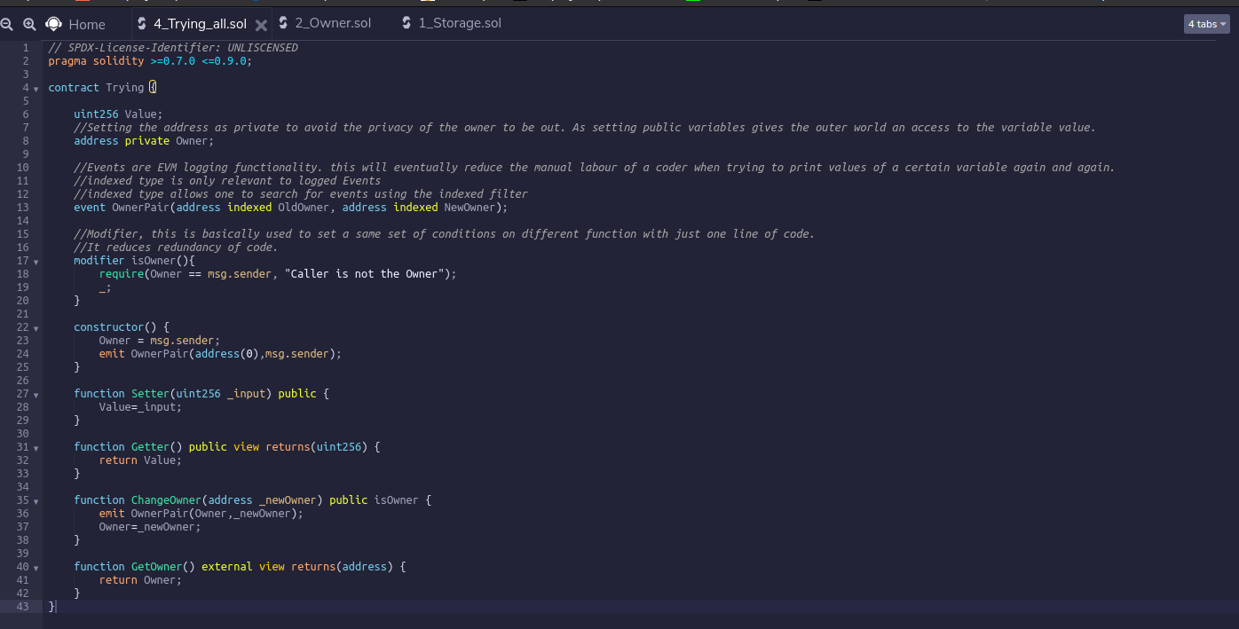
Crypto Zombies

Crypto zombies

Ethereum has the hash function keccak256 built in, which is a version of SHA3. A hash function basically maps an input into a random 256-bit hexadecimal number. A slight change in the input will cause a large change in the hash.
It's useful for many purposes in Ethereum, but for right now we're just going to use it for pseudo-random number generation.
Also important, keccak256 expects a single parameter of type bytes. This means that we have to "pack" any parameters before calling keccak256:
//6e91ec6b618bb462a4a6ee5aa2cb0e9cf30f7a052bb467b0ba58b8748c00d2e5
keccak256(abi.encodePacked("aaaab"));
//b1f078126895a1424524de5321b339ab00408010b7cf0e6ed451514981e58aa9
keccak256(abi.encodePacked("aaaac"));

Typecasting
Sometimes you need to convert between data types. Take the following example:
uint8 a = 5;
uint b = 6;
// throws an error because a * b returns a uint, not uint8:
uint8 c = a * b;
// we have to typecast b as a uint8 to make it work:
uint8 c = a * uint8(b);
In the above, a * b returns a uint, but we were trying to store it as a uint8, which could cause potential problems. By casting it as a uint8, it works and the compiler won't throw an error.
Events are a way for your contract to communicate that something happened on the blockchain to your app front-end, which can be 'listening' for certain events and take action when they happen.

You're going to need the zombie's id. array.push() returns a uint of the new length of the array - and since the first item in an array has index 0, array.push() - 1 will be the index of the zombie we just added. Store the result of zombies.push() - 1 in a uint called id, so you can use this in the NewZombie event in the next line.

Frontend code

// Here's how we would access our contract:
var abi = /* abi generated by the compiler */
var ZombieFactoryContract = web3.eth.contract(abi)
var contractAddress = /* our contract address on Ethereum after deploying */
var ZombieFactory = ZombieFactoryContract.at(contractAddress)
// `ZombieFactory` has access to our contract's public functions and events

// some sort of event listener to take the text input:
$("#ourButton").click(function(e) {
var name = $("#nameInput").val()
// Call our contract's `createRandomZombie` function:
ZombieFactory.createRandomZombie(name)
})

// Listen for the `NewZombie` event, and update the UI
var event = ZombieFactory.NewZombie(function(error, result) {
if (error) return
generateZombie(result.zombieId, result.name, result.dna)
})

// take the Zombie dna, and update our image
function generateZombie(id, name, dna) {
let dnaStr = String(dna)
// pad DNA with leading zeroes if it's less than 16 characters
while (dnaStr.length < 16)
dnaStr = "0" + dnaStr

let zombieDetails = {
// first 2 digits make up the head. We have 7 possible heads, so % 7
// to get a number 0 - 6, then add 1 to make it 1 - 7. Then we have 7
// image files named "head1.png" through "head7.png" we load based on
// this number:
headChoice: dnaStr.substring(0, 2) % 7 + 1,
// 2nd 2 digits make up the eyes, 11 variations:
eyeChoice: dnaStr.substring(2, 4) % 11 + 1,
// 6 variations of shirts:
shirtChoice: dnaStr.substring(4, 6) % 6 + 1,
// last 6 digits control color. Updated using CSS filter: hue-rotate
// which has 360 degrees:
skinColorChoice: parseInt(dnaStr.substring(6, 8) / 100 * 360),
eyeColorChoice: parseInt(dnaStr.substring(8, 10) / 100 * 360),
clothesColorChoice: parseInt(dnaStr.substring(10, 12) / 100 * 360),
zombieName: name,
zombieDescription: "A Level 1 CryptoZombie",
}
return zombieDetails
}

Mapping Functions

zombieToOwner[id] = msg.sender;
ownerZombieCount[msg.sender]++;

Inheritance and talking to smart contracts:

When we want to inherit some features from a smart contract that we own, we just import the contract to our current contract. However when we want to talk to a contract that we do not own we have to create an interface from our contract to the other contract.

NFT

All I need is the openzeppelin contract and I can have npm install for the nft coding part.

It’s better to just use the current versions of solidity and try out the things that I can try out and not be hindered because of versions and compatibility issues.

Enums restrict a variable to have one of only a few predefined values. The values in this enumerated list are called enums.
With the use of enums it is possible to reduce the number of bugs in your code.
For example, if we consider an application for a fresh juice shop, it would be possible to restrict the glass size to small, medium, and large. This would make sure that it would not allow anyone to order any size other than small, medium, or large.

Example
Try the following code to understand how the enum works in Solidity.
pragma solidity ^0.5.0;

contract test {
enum FreshJuiceSize{ SMALL, MEDIUM, LARGE }
FreshJuiceSize choice;
FreshJuiceSize constant defaultChoice = FreshJuiceSize.MEDIUM;

function setLarge() public {
choice = FreshJuiceSize.LARGE;
}
function getChoice() public view returns (FreshJuiceSize) {
return choice;
}
function getDefaultChoice() public pure returns (uint) {
return uint(defaultChoice);
}
}
Run the above program using steps provided in Solidity First Application chapter.
First Click setLarge Button to set the value as LARGE then click getChoice to get the selected choice.

Output
uint8: 2
Click getDefaultChoice Button to get the default choice.

Output
uint256: 1

Gas — the fuel Ethereum DApps run on
In Solidity, your users have to pay every time they execute a function on your DApp using a currency called gas. Users buy gas with Ether (the currency on Ethereum), so your users have to spend ETH in order to execute functions on your DApp.
How much gas is required to execute a function depends on how complex that function's logic is. Each individual operation has a gas cost based roughly on how much computing resources will be required to perform that operation (e.g. writing to storage is much more expensive than adding two integers). The total gas cost of your function is the sum of the gas costs of all its individual operations.
Because running functions costs real money for your users, code optimization is much more important in Ethereum than in other programming languages. If your code is sloppy, your users are going to have to pay a premium to execute your functions — and this could add up to millions of dollars in unnecessary fees across thousands of users.

Why is gas necessary?
Ethereum is like a big, slow, but extremely secure computer. When you execute a function, every single node on the network needs to run that same function to verify its output — thousands of nodes verifying every function execution is what makes Ethereum decentralized, and its data immutable and censorship-resistant.
The creators of Ethereum wanted to make sure someone couldn't clog up the network with an infinite loop, or hog all the network resources with really intensive computations. So they made it so transactions aren't free, and users have to pay for computation time as well as storage.
Note: This isn't necessarily true for other blockchain, like the ones the CryptoZombies authors are building at Loom Network. It probably won't ever make sense to run a game like World of Warcraft directly on the Ethereum mainnet — the gas costs would be prohibitively expensive. But it could run on a blockchain with a different consensus algorithm. We'll talk more about what types of DApps you would want to deploy on Loom vs the Ethereum mainnet in a future lesson.

Struct packing to save gas
In Lesson 1, we mentioned that there are other types of uints: uint8, uint16, uint32, etc.
Normally there's no benefit to using these sub-types because Solidity reserves 256 bits of storage regardless of the uint size. For example, using uint8 instead of uint (uint256) won't save you any gas.
But there's an exception to this: inside structs.
If you have multiple uints inside a struct, using a smaller-sized uint when possible will allow Solidity to pack these variables together to take up less storage. For example:
struct NormalStruct {
uint a;
uint b;
uint c;
}

struct MiniMe {
uint32 a;
uint32 b;
uint c;
}

// `mini` will cost less gas than `normal` because of struct packing
NormalStruct normal = NormalStruct(10, 20, 30);
MiniMe mini = MiniMe(10, 20, 30);
For this reason, inside a struct you'll want to use the smallest integer sub-types you can get away with.
You'll also want to cluster identical data types together (i.e. put them next to each other in the struct) so that Solidity can minimize the required storage space. For example, a struct with fields uint c; uint32 a; uint32 b; will cost less gas than a struct with fields uint32 a; uint c; uint32 b; because the uint32 fields are clustered together.

Function modifiers with arguments
Previously we looked at the simple example of onlyOwner. But function modifiers can also take arguments. For example:
// A mapping to store a user's age:
mapping (uint => uint) public age;

// Modifier that requires this user to be older than a certain age:
modifier olderThan(uint _age, uint _userId) {
require(age[_userId] >= _age);
_;
}

// Must be older than 16 to drive a car (in the US, at least).
// We can call the `olderThan` modifier with arguments like so:
function driveCar(uint _userId) public olderThan(16, _userId) {
// Some function logic
}
You can see here that the olderThan modifier takes arguments just like a function does. And that the driveCar function passes its arguments to the modifier.

Note: calldata is somehow similar to memory, but it's only available to external functions.

After you send Ether to a contract, it gets stored in the contract's Ethereum account, and it will be trapped there — unless you add a function to withdraw the Ether from the contract.
You can write a function to withdraw Ether from the contract as follows:
contract GetPaid is Ownable {
function withdraw() external onlyOwner {
address payable _owner = address(uint160(owner()));
_owner.transfer(address(this).balance);
}
}
Note that we're using owner() and onlyOwner from the Ownable contract, assuming that was imported.
And most important for _owner variable that it's have to be a address payable type for doing a sending and transferring ether instruction.
But our owner() isn't a type address payable so we have to explicitly cast to address payable. Casting any integer type like uint160 to address produces an address payable.
You can transfer Ether to an address using the transfer function, and address(this).balance will return the total balance stored on the contract. So if 100 users had paid 1 Ether to our contract, address(this).balance would equal 100 Ether.
You can use transfer to send funds to any Ethereum address. For example, you could have a function that transfers Ether back to the msg.sender if they overpaid for an item:
uint itemFee = 0.001 ether;
msg.sender.transfer(msg.value - itemFee);
Or in a contract with a buyer and a seller, you could save the seller's address in storage, then when someone purchases his item, transfer him the fee paid by the buyer: seller.transfer(msg.value).
These are some examples of what makes Ethereum programming really cool — you can have decentralized marketplaces like this that aren't controlled by anyone.

What is Web3.js?
Remember, the Ethereum network is made up of nodes, with each containing a copy of the blockchain. When you want to call a function on a smart contract, you need to query one of these nodes and tell it:
- The address of the smart contract
- The function you want to call, and
- The variables you want to pass to that function.
Ethereum nodes only speak a language called JSON-RPC, which isn't very human-readable. A query to tell the node you want to call a function on a contract looks something like this:
// Yeah... Good luck writing all your function calls this way!
// Scroll right ==>
{"jsonrpc":"2.0","method":"eth_sendTransaction","params":[{"from":"0xb60e8dd61c5d32be8058bb8eb970870f07233155","to":"0xd46e8dd67c5d32be8058bb8eb970870f07244567","gas":"0x76c0","gasPrice":"0x9184e72a000","value":"0x9184e72a","data":"0xd46e8dd67c5d32be8d46e8dd67c5d32be8058bb8eb970870f072445675058bb8eb970870f072445675"}],"id":1}
Luckily, Web3.js hides these nasty queries below the surface, so you only need to interact with a convenient and easily readable JavaScript interface.
Instead of needing to construct the above query, calling a function in your code will look something like this:
CryptoZombies.methods.createRandomZombie("Vitalik Nakamoto 🤔")
.send({ from: "0xb60e8dd61c5d32be8058bb8eb970870f07233155", gas: "3000000" })
We'll explain the syntax in detail over the next few chapters, but first let's get your project set up with Web3.js.

Getting started
Depending on your project's workflow, you can add Web3.js to your project using most package tools:
// Using NPM
npm install web3

// Using Yarn
yarn add web3

// Using Bower
bower install web3

// ...etc.
Or you can simply download the minified .js file from github and include it in your project:
<script language="javascript" type="text/javascript" src="web3.min.js"></script>
Since we don't want to make too many assumptions about your development environment and what package manager you use, for this tutorial we're going to simply include Web3 in our project using a script tag as above.
Frontend:

<!DOCTYPE html>
<html lang="en">
<head>
<meta charset="UTF-8">
<title>CryptoZombies front-end</title>
<script language="javascript" type="text/javascript" src="https://cdnjs.cloudflare.com/ajax/libs/jquery/3.3.1/jquery.min.js"></script>
<script language="javascript" type="text/javascript" src="web3.min.js"></script>
<script language="javascript" type="text/javascript" src="cryptozombies_abi.js"></script>
</head>
<body>
<div id="txStatus"></div>
<div id="zombies"></div>

<script>
var cryptoZombies;
var userAccount;

function startApp() {
var cryptoZombiesAddress = "YOUR_CONTRACT_ADDRESS";
cryptoZombies = new web3js.eth.Contract(cryptoZombiesABI, cryptoZombiesAddress);

var accountInterval = setInterval(function() {
// Check if account has changed
if (web3.eth.accounts[0] !== userAccount) {
userAccount = web3.eth.accounts[0];
// Call a function to update the UI with the new account
getZombiesByOwner(userAccount)
.then(displayZombies);
}
}, 100);

// Start here
}

function displayZombies(ids) {
$("#zombies").empty();
for (id of ids) {
// Look up zombie details from our contract. Returns a `zombie` object
getZombieDetails(id)
.then(function(zombie) {
// Using ES6's "template literals" to inject variables into the HTML.
// Append each one to our #zombies div
$("#zombies").append(`<div class="zombie">
<ul>
<li>Name: ${zombie.name}</li>
<li>DNA: ${zombie.dna}</li>
<li>Level: ${zombie.level}</li>
<li>Wins: ${zombie.winCount}</li>
<li>Losses: ${zombie.lossCount}</li>
<li>Ready Time: ${zombie.readyTime}</li>
</ul>
</div>`);
});
}
}

function createRandomZombie(name) {
// This is going to take a while, so update the UI to let the user know
// the transaction has been sent
$("#txStatus").text("Creating new zombie on the blockchain. This may take a while...");
// Send the tx to our contract:
return cryptoZombies.methods.createRandomZombie(name)
.send({ from: userAccount })
.on("receipt", function(receipt) {
$("#txStatus").text("Successfully created " + name + "!");
// Transaction was accepted into the blockchain, let's redraw the UI
getZombiesByOwner(userAccount).then(displayZombies);
})
.on("error", function(error) {
// Do something to alert the user their transaction has failed
$("#txStatus").text(error);
});
}

function feedOnKitty(zombieId, kittyId) {
$("#txStatus").text("Eating a kitty. This may take a while...");
return cryptoZombies.methods.feedOnKitty(zombieId, kittyId)
.send({ from: userAccount })
.on("receipt", function(receipt) {
$("#txStatus").text("Ate a kitty and spawned a new Zombie!");
getZombiesByOwner(userAccount).then(displayZombies);
})
.on("error", function(error) {
$("#txStatus").text(error);
});
}

function levelUp(zombieId) {
$("#txStatus").text("Leveling up your zombie...");
return cryptoZombies.methods.levelUp(zombieId)
.send({ from: userAccount, value: web3.utils.toWei("0.001", "ether") })
.on("receipt", function(receipt) {
$("#txStatus").text("Power overwhelming! Zombie successfully leveled up");
})
.on("error", function(error) {
$("#txStatus").text(error);
});
}

function getZombieDetails(id) {
return cryptoZombies.methods.zombies(id).call()
}

function zombieToOwner(id) {
return cryptoZombies.methods.zombieToOwner(id).call()
}

function getZombiesByOwner(owner) {
return cryptoZombies.methods.getZombiesByOwner(owner).call()
}

window.addEventListener('load', function() {

// Checking if Web3 has been injected by the browser (Mist/MetaMask)
if (typeof web3 !== 'undefined') {
// Use Mist/MetaMask's provider
web3js = new Web3(web3.currentProvider);
} else {
// Handle the case where the user doesn't have Metamask installed
// Probably show them a message prompting them to install Metamask
}

// Now you can start your app & access web3 freely:
startApp()

})
</script>
</body>
</html>

Listening for New Zombies
If you recall from zombiefactory.sol, we had an event called NewZombie that we fired every time a new zombie was created:
event NewZombie(uint zombieId, string name, uint dna);
In Web3.js, you can subscribe to an event so your web3 provider triggers some logic in your code every time it fires:
cryptoZombies.events.NewZombie()
.on("data", function(event) {
let zombie = event.returnValues;
// We can access this event's 3 return values on the `event.returnValues` object:
console.log("A new zombie was born!", zombie.zombieId, zombie.name, zombie.dna);
}).on("error", console.error);
Note that this would trigger an alert every time ANY zombie was created in our DApp — not just for the current user. What if we only wanted alerts for the current user?

Using indexed
In order to filter events and only listen for changes related to the current user, our Solidity contract would have to use the indexed keyword, like we did in the Transfer event of our ERC721 implementation:
event Transfer(address indexed _from, address indexed _to, uint256 _tokenId);
In this case, because _from and _to are indexed, that means we can filter for them in our event listener in our front end:
// Use `filter` to only fire this code when `_to` equals `userAccount`
cryptoZombies.events.Transfer({ filter: { _to: userAccount } })
.on("data", function(event) {
let data = event.returnValues;
// The current user just received a zombie!
// Do something here to update the UI to show it
}).on("error", console.error);
As you can see, using events and indexed fields can be quite a useful practice for listening to changes to your contract and reflecting them in your app's front-end.

Querying past events
We can even query past events using getPastEvents, and use the filters fromBlock and toBlock to give Solidity a time range for the event logs ("block" in this case referring to the Ethereum block number):
cryptoZombies.getPastEvents("NewZombie", { fromBlock: 0, toBlock: "latest" })
.then(function(events) {
// `events` is an array of `event` objects that we can iterate, like we did above
// This code will get us a list of every zombie that was ever created
});
Because you can use this method to query the event logs since the beginning of time, this presents an interesting use case: Using events as a cheaper form of storage.
If you recall, saving data to the blockchain is one of the most expensive operations in Solidity. But using events is much much cheaper in terms of gas.
The tradeoff here is that events are not readable from inside the smart contract itself. But it's an important use-case to keep in mind if you have some data you want to be historically recorded on the blockchain so you can read it from your app's front-end.
For example, we could use this as a historical record of zombie battles — we could create an event for every time one zombie attacks another and who won. The smart contract doesn't need this data to calculate any future outcomes, but it's useful data for users to be able to browse from the app's front-end.
To do
So we've left this implementation bare-bones. Here's a checklist of ideas for things we would want to implement in order to make our front-end a full implementation for our zombie game, if you want to run with this and build it on your own:
- Implementing functions for attack, changeName, changeDna, and the ERC721 functions transfer, ownerOf, balanceOf, etc. The implementation of these functions would be identical to all the other send transactions we covered.
- Implementing an "admin page" where you can execute setKittyContractAddress, setLevelUpFee, and withdraw. Again, there's no special logic on the front-end here — these implementations would be identical to the functions we've already covered. You would just have to make sure you called them from the same Ethereum address that deployed the contract, since they have the onlyOwner modifier.
- There are a few different views in the app we would want to implement:
a. An individual zombie page, where you can view info about a specific zombie with a permalink to it. This page would render the zombie's appearance, show its name, its owner (with a link to the user's profile page), its win/loss count, its battle history, etc.
b. A user page, where you could view a user's zombie army with a permalink. You would be able to click on an individual zombie to view its page, and also click on a zombie to attack it if you're logged into MetaMask and have an army.
c. A homepage, which is a variation of the user page that shows the current user's zombie army. (This is the page we started implementing in index.html).
- Some method in the UI that allows the user to feed on CryptoKitties. We could have a button by each zombie on the homepage that says "Feed Me", then a text box that prompted the user to enter a kitty's ID (or a URL to that kitty, e.g. https://www.cryptokitties.co/kitty/578397). This would then trigger our function feedOnKitty.
- Some method in the UI for the user to attack another user's zombie.
One way to implement this would be when the user was browsing another user's page, there could be a button that said "Attack This Zombie". When the user clicked it, it would pop up a modal that contains the current user's zombie army and prompt them "Which zombie would you like to attack with?"
The user's homepage could also have a button by each of their zombies that said "Attack a Zombie". When they clicked it, it could pop up a modal with a search field where they could type in a zombie's ID to search for it. Or an option that said "Attack Random Zombie", which would search a random number for them.
We would also want to grey out the user's zombies whose cooldown period had not yet passed, so the UI could indicate to the user that they can't yet attack with that zombie, and how long they will have to wait.
- The user's homepage would also have options by each zombie to change name, change DNA, and level up (for a fee). Options would be greyed out if the user wasn't yet high enough level.
- For new users, we should display a welcome message with a prompt to create the first zombie in their army, which calls createRandomZombie().
- We'd probably want to add an Attack event to our smart contract with the user's address as an indexed property, as discussed in the last chapter. This would allow us to build real-time notifications — we could show the user a popup alert when one of their zombies was attacked, so they could view the user/zombie who attacked them and retaliate.
- We would probably also want to implement some sort of front-end caching layer so we aren't always slamming Infura with requests for the same data. (Our current implementation of displayZombies calls getZombieDetails for every single zombie every time we refresh the interface — but realistically we only need to call this for the new zombie that's been added to our army).
- A real-time chat room so you could trash talk other players as you crush their zombie army? Yes plz.
That's just a start — I'm sure we could come up with even more features — and already it's a massive list.
Since there's a lot of front-end code that would go into creating a full interface like this (HTML, CSS, JavaScript and a framework like React or Vue.js), building out this entire front-end would probably be an entire course with 10 lessons in itself. So we'll leave the awesome implementation to you.
Test:

2. Act
We've reached the part where we're going to be calling the function that creates a new zombie for Alice- createRandomZombie.
But there's a slight problem- how can we make it so the method "knows" who calls it? Another way to put it would be- how can we make sure Alice (and not Bob) is going to be the owner of this new zombie?🧐
Well... the problem is solved with the contract abstraction. One of the features of Truffle is that it wraps the original Solidity implementation and lets us specify the address that makes the function call by passing that address as an argument.
The following calls createRandomZombie and makes sure msg.sender is set to Alice's address:
const result = await contractInstance.createRandomZombie(zombieNames[0], {from: alice});
Now I have a quick question for you: do you know what gets stored in result?
Well, let me explain.

Logs and Events
Once we specified the contract we wanted to test using artifacts.require, Truffle automatically provides the logs generated by our smart contract. What this means is that we can now retrieve the name of Alice's newly created zombie using something like this: result.logs[0].args.name. In a similar fashion, we can get the id and the _dna.
Besides these bits of information, result is going to be giving us several other useful details about the transaction:
- result.tx: the transaction hash
- result.receipt: an object containing the transaction receipt. If result.receipt.status is equal to true it means that the transaction was successful. Otherwise, it means that the transaction failed.
Note: Note that logs can also be used as a much cheaper option to store data. The downside is that they can't be accessed from within the smart contract itself.

3. Assert
In this chapter we will be using the built-in assertion module which comes with a set of assertion functions such as equal() and deepEqual(). Simply put, these functions check the condition and throw an error if the result is not as expected. Since we will be comparing simple values, we are going to be running assert.equal().
However, if they could keep calling this function to create unlimited zombies in their army, the game wouldn't be very fun. Thus, in Chapter 4 of Lesson 2 we've added a require statement to the createZombieFunction() that makes sure each user can't own more than one zombie:
require(ownerZombieCount[msg.sender] == 0)
Let's test this feature and see if it works.

Hooks
In just a few minutes🤞, we'll have more than one test and the way this works is that each test should start with a clean sheet. Thus, for every single test we'll have to create a new instance of our smart contract like so:
const contractInstance = await CryptoZombies.new();
Wouldn't be nice if you could write this just once and have Truffle run it automatically for every test?
Well... one of Mocha's (and Truffle's) features is the ability to have some snippets of code called hooks run before or after a test. To run something before a test gets executed, the code should be put inside a function named beforeEach().
So, instead of writing contract.new() several times, you just do it once like this:
beforeEach(async () => {
// let's put here the code that creates a new contract instance
});
Then, Truffle will take care of everything. That's pretty sweet, isn't it?

Put it to the test
- Below the line of code that initializes alice and bob, let's declare a variable named contractInstance. Don't assign it to anything.
Note: We want contractInstance to be limited in scope to the block in which it's defined. Use let instead of var.
- Next, copy/paste the snippet from above for defining the beforeEach() function.
- Let's fill in the body of our new function. Go ahead and move the line of code that creates a new contract instance inside of the beforeEach() function. Now that we've defined contractInstance somewhere else, you can remove the const qualifier.
- We're going to want a new empty it function for our test. Set the name of the test (that is the first parameter we're passing to the it function) equal to "should not allow two zombies".
We'll continue fleshing out this function in the next chapter!

🧟‍♂️Here be... zombies of every kind!!!🧟‍♂️
If you really, really want to achieve mastery, go ahead and read on. Otherwise... just click next and off you go to the next chapter.
You still around?😁
Awesome! After all, why would you want to deny yourself a whole lot of awesomeness?
Now, let's circle back to how contract.new works. Basically, every time we call this function, Truffle makes it so that a new contract gets deployed.
On one side, this is helpful because it lets us start each test with a clean sheet.
On the other side, if everybody would create countless contracts the blockchain will become bloated. We want you to hang around, but not your old test contracts!
We would want to prevent this from happening, right?
Happily, the solution is pretty straightforward... our contract should selfdestruct once it's no longer needed.
The way this works is as follows:
- first, we would want to add a new function to the CryptoZombies smart contract like so:
function kill() public onlyOwner {
selfdestruct(owner());
}
Note: If you want to learn more about selfdestruct(), you can read the Solidity docs here. The most important thing to bear in mind is that selfdestruct is the only way for code at a certain address to be removed from the blockchain. This makes it a pretty important feature!
- next, somewhat similar to the beforeEach() function explained above, we'll make a function called afterEach():
afterEach(async () => {
await contractInstance.kill();
});
- Lastly, Truffle will make sure this function is called after a test gets executed.
And voila, the smart contract removed itself!

The context function
To group tests, Truffle provides a function called context. Let me quickly show you how use it in order to better structure our code:
context("with the single-step transfer scenario", async () => {
it("should transfer a zombie", async () => {
// TODO: Test the single-step transfer scenario.
})
})

context("with the two-step transfer scenario", async () => {
it("should approve and then transfer a zombie when the approved address calls transferFrom", async () => {
// TODO: Test the two-step scenario. The approved address calls transferFrom
})
it("should approve and then transfer a zombie when the owner calls transferFrom", async () => {
// TODO: Test the two-step scenario. The owner calls transferFrom
})
})
If we add this to our CryptoZombies.js file and then run truffle test the output would look similar to this:
Contract: CryptoZombies
✓ should be able to create a new zombie (100ms)
✓ should not allow two zombies (251ms)
with the single-step transfer scenario
✓ should transfer a zombie
with the two-step transfer scenario
✓ should approve and then transfer a zombie when the owner calls transferFrom
✓ should approve and then transfer a zombie when the approved address calls transferFrom

5 passing (2s)
Well?
Hmm...
Take a look again - there's an issue with the above output. It looks like all tests have passed which is obviously false since we didn't even write them yet!!
Fortunately, there's an easy solution- if we just place an x in front of the context() functions as follows: xcontext(), Truffle will skip those tests.
Note: x can be placed in front of an it() function as well. Don't forget to remove all the x's when the tests for those functions have been written!
Now, let's run truffle test. The output should look something like this:
Contract: CryptoZombies
✓ should be able to create a new zombie (199ms)
✓ should not allow two zombies (175ms)
with the single-step transfer scenario
- should transfer a zombie
with the two-step transfer scenario
- should approve and then transfer a zombie when the owner calls transferFrom
- should approve and then transfer a zombie when the approved address calls transferFrom

2 passing (827ms)
3 pending
Where "-" represents a test that's been skipped with that "x" marker.
Pretty neat, huh? Now you can run your tests as you go along, and mark out empty functions where you know you will need to write tests in the near future.

Time Travelling
Fortunately, we don't have to wait that much. In fact, there's no need to wait at all. That's because Ganache provides a way to move forward in time through two helper functions:
- evm_increaseTime: increases the time for the next block.
- evm_mine: mines a new block.
You don't even need a Tardis or a DeLorean for this kind of time travel.
Let me explain how these functions work:
- Every time a new block gets mined, the miner adds a timestamp to it. Let's say the transactions that created our zombies got mined in block 5.
- Next, we call evm_increaseTime but, since the blockchain is immutable, there is no way of modifying an existing block. So, when the contract checks the time, it will not be increased.
- If we run evm_mine, block number 6 gets mined (and timestamped) which means that, when we put the zombies to fight, the smart contract will "see" that a day has passed.
Putting it together, we can fix our test by traveling through time as follows:
await web3.currentProvider.sendAsync({
jsonrpc: "2.0",
method: "evm_increaseTime",
params: [86400], // there are 86400 seconds in a day
id: new Date().getTime()
}, () => { });

web3.currentProvider.send({
jsonrpc: '2.0',
method: 'evm_mine',
params: [],
id: new Date().getTime()
});
Yeah, that’s a nice piece of code, but we wouldn’t want to add this logic to our CryptoZombies.js file.
We’ve gone ahead and moved everything to a new file named helpers/time.js. To increase the time, you'll simply have to call: time.increaseTime(86400);
Yeah, still not good enough. After all, do we really expect you to know how many seconds are there in a day right of the top of your head?
Of course not. This is why we’ve added another helper function named days that takes the number of days we want to increase time with as an argument. You would call this function like so: await time.increase(time.duration.days(1))
Note: Obviously, time traveling is not available on the main net or on any of the available test chains that are secured by miners. It would make a real mess of things if anyone could just choose to change how time operates in the real world! For testing smart contracts, time travel can be an essential part of the coder's repertoire.

Chai Assertion Library
Chai is very powerful and, for the scope of this lesson, we're just going to scratch the surface. Once you've finished this lesson, feel free check out their guides to further your knowledge.
That said, let's take a look at the three kinds of assertion styles bundled into Chai:
- expect: lets you chain natural language assertions as follows:
let lessonTitle = "Testing Smart Contracts with Truffle";
expect(lessonTitle).to.be.a("string");
- should: allows for similar assertions as expect interface, but the chain starts with a should property:
let lessonTitle = "Testing Smart Contracts with Truffle";
lessonTitle.should.be.a("string");
- assert: provides a notation similar to that packaged with node.js and includes several additional tests and it's browser compatible:
let lessonTitle = "Testing Smart Contracts with Truffle";
assert.typeOf(lessonTitle, "string");
In this chapter, we are going to show you how to improve your assertions with expect.
Note: We're assuming the chai package is already installed on your computer. If that's not the case, you can easily install it like so: npm -g install chai
In order to use expect style, the first thing we should do is to import it into our project as follows:
var expect = require('chai').expect;

expect().to.equal()
Now that we've imported the expect into our project, checking if two strings are equal would look like below:
let zombieName = 'My Awesome Zombie';
expect(zombieName).to.equal('My Awesome Zombie');
Enough talking. Let's put Chai's powers to some good use!

truffle-hdwallet-provider
In this lesson, we will be using Infura to deploy our code to Ethereum. This way, we can run the application without needing to set up our own Ethereum node or wallet. However, to keep things secure, Infura does not manage the private keys, which means it can't sign transactions on our behalf. Since deploying a smart contract requires Truffle to sign transactions, we are going to need a tool called truffle-hdwallet-provider. Its only purpose is to handle the transaction signing.
Note: Maybe you are asking why we chose not to install truffle-hdwallet-provider in the previous chapter using something like:
npm install truffle truffle-hdwallet-provider
Well... the truffle init command expects to find an empty directory. If there's any file there, it will error out. Thus, we need to do everything in the correct order and install truffle-hdwallet-provider after we run truffle init.

Ethereum Test Networks
Several public Ethereum test networks let you test your contracts for free before you deploy them to the main net (remember once you deploy a contract to the main net it can't be altered). These test networks use a different consensus algorithm to the main net (usually PoA), and Ether is free to encourage thorough testing.
In this lesson, we will be using Rinkeby, a public test network created by The Ethereum Foundation.

The truffle.js configuration file
Now, let's take a look at the default Truffle configuration file:
$ cat truffle.js
/*
* NB: since truffle-hdwallet-provider 0.0.5 you must wrap HDWallet providers in a
* function when declaring them. Failure to do so will cause commands to hang. ex:
*
* mainnet: {
* provider: function() {
* return new HDWalletProvider(mnemonic, 'https://mainnet.infura.io/<infura-key>')
* },
* network_id: '1',
* gas: 4500000,
* gasPrice: 10000000000,
* },
*/
It is just an empty shell. Thus, we'll be required to update this file to allow us to deploy contracts to Rinkeby and the Ethereum mainnet.

Truffle's HD Wallet Provider
Remember the second chapter?
We asked you to install an additional package called truffle-hdwallet-provider that helps Truffle sign transactions.
Now, we want to edit our configuration file to use HDWalletProvider. To get this to work we'll add a line at the top of the file:
var HDWalletProvider = require("truffle-hdwallet-provider");
Next, we'll create a new variable to store our mnemonic:
var mnemonic = "onions carrots beans ...";
Note that we don't recommend storing secrets like a mnemonic or a private key in a configuration file.
...but why?
Config files are often pushed to GitHub, where anyone can see them, leaving you wide open to attack 😱! To avoid revealing your mnemonic (or your private key!), you should read it from a file and add that file to .gitignore. We'll show you how to do this later.
To keep things simple in this case, we've copied the mnemonic and stored in a variable.

Set up Truffle for Rinkeby and Ethereum main net
Next, to make sure Truffle "knows" the networks we want to deploy to, we will have to create two separate objects- one for Rinkeby and the other one for the Ethereum main net:
networks: {
// Configuration for mainnet
mainnet: {
provider: function () {
// Setting the provider with the Infura Rinkeby address and Token
return new HDWalletProvider(mnemonic, "https://mainnet.infura.io/v3/YOUR_TOKEN")
},
network_id: "1"
},
// Configuration for rinkeby network
rinkeby: {
// Special function to setup the provider
provider: function () {
// Setting the provider with the Infura Rinkeby address and Token
return new HDWalletProvider(mnemonic, "https://rinkeby.infura.io/v3/YOUR_TOKEN")
},
// Network id is 4 for Rinkeby
network_id: 4
}
Note: the provider value is wrapped in a function, which ensures that it won't get initialized until it's needed.

Wrapping it up
Now, let's put these piece together and have a look at how our config file should look:
// Initialize HDWalletProvider
const HDWalletProvider = require("truffle-hdwallet-provider");

// Set your own mnemonic here
const mnemonic = "YOUR_MNEMONIC";

// Module exports to make this configuration available to Truffle itself
module.exports = {
// Object with configuration for each network
networks: {
// Configuration for mainnet
mainnet: {
provider: function () {
// Setting the provider with the Infura Rinkeby address and Token
return new HDWalletProvider(mnemonic, "https://mainnet.infura.io/v3/YOUR_TOKEN")
},
network_id: "1"
},
// Configuration for rinkeby network
rinkeby: {
// Special function to setup the provider
provider: function () {
// Setting the provider with the Infura Rinkeby address and Token
return new HDWalletProvider(mnemonic, "https://rinkeby.infura.io/v3/YOUR_TOKEN")
},
// Network id is 4 for Rinkeby
network_id: 4
}
}
};

Migrations
It sounds like a migration involves a lot of stuff moving around, but in practice, a migration is nothing more than a JavaScript file that tells Truffle how to modify the state of our smart contracts.
Obviously, the first migration will just deploy the smart contract. Some other migrations deploy a new version of the code to add features or fix bugs.
In a nutshell, migrations provide a convenient way to keep track of the changes you make to your code.
If you want to deploy more than one contract, a separate migration file must be created for each contract. Migrations are always executed in order- 1,2,3, etc.
In this lesson, we will deploy only to Rinkeby. Deployment to the main net would require real money to pay for the gas and, once deployed, we won't be able to modify the code. Hence, it's best to deploy to Rinkeby first, and thoroughly test the code.

Get some Ether
Before doing the deployment, make sure there is enough Ether in your account. The easiest way to get Ether for testing purposes is through a service known as a faucet. We recommend the Authenticated Faucet running on Rinkeby. Follow the instructions, and within a few minutes, your address will be credited with some Ether.

Put it to the test
- Now that everything is set up, it's time to deploy to Rinkeby. To do so, run truffle migrate --network rinkeby in the terminal to the right. Note how migrations are being executed in order😉.
Note: truffle deploy is just an alias for truffle migrate. However, since our command-line interpreter is pretty basic, it won't consider the answer correct unless you're using migrate.
Deployment to the main net is not complicated at all. Once the smart contract is tested, you'll only have to run: truffle migrate --network mainnet. Don't forget that you'll have to pay for gas! We trust you'll be able to do it.
If everything goes well, you're going to see a response that's similar to the one to the right.

First, we should create our own Loom private key. The easiest way to do it is by downloading and installing Loom according to this tutorial.
Next, creating a private key is as as simple as this:
$./loom genkey -a public_key -k private_key
local address: 0x42F401139048AB106c9e25DCae0Cf4b1Df985c39
local address base64: QvQBE5BIqxBsniXcrgz0sd+YXDk=
$cat private_key
/i0Qi8e/E+kVEIJLRPV5HJgn0sQBVi88EQw/Mq4ePFD1JGV1Nm14dA446BsPe3ajte3t/tpj7HaHDL84+Ce4Dg==
Note: Never reveal your private keys! We are only doing this for simplicity's sake.

Updating truffle.js
The first thing we are required to do is to initialize loom-truffle-provider. The syntax is similar to the one we've already used for HDWalletProvider:
const LoomTruffleProvider = require('loom-truffle-provider');
Next, just as we did in chapter 5, we'll have to let Truffle know how to deploy on Loom testnet. To do so, let's add a new object to truffle.js
loom_testnet: {
provider: function() {
const privateKey = 'YOUR_PRIVATE_KEY'
const chainId = 'extdev-plasma-us1';
const writeUrl = 'http://extdev-plasma-us1.dappchains.com:80/rpc';
const readUrl = 'http://extdev-plasma-us1.dappchains.com:80/query';
return new LoomTruffleProvider(chainId, writeUrl, readUrl, privateKey);
},
network_id: '9545242630824'
}

Chapter 10: Deploy to Basechain
Congratulations! You've successfully deployed to Loom Testnet. But can you guess what's coming next?🤔
Yup, you're right! This chapter will walk you through the process of deploying to Basechain (that is our Mainnet).
Here's a brief rundown of what you'll do in this chapter:
- Create a new private key.
- Creating a new private key is pretty straightforward. But since we're talking about deploying to the main net, it's time to get more serious about security. Thus, we'll show you how to securely pass the private key to Truffle.
- Tell Truffle how to deploy to Basechain by adding a new object to the truffle.js configuration file.
- Whitelist your deployment keys so you can deploy to Basechain.
- Lastly, we wrap everything up by actually deploying the smart contract.

Create a new private key
You already know how to create a private key. However, we must change the name of the file in which we're going to save it:
./loom genkey -a mainnet_public_key -k mainnet_private_key
local address: 0x07419790A773Cc6a2840f1c092240922B61eC778
local address base64: B0GXkKdzzGooQPHAkiQJIrYex3g=

Securely pass the private key to Truffle
The next thing we want to do is to prevent the private key file from being pushed to GitHub. To do so, let's create a new file called .gitignore:
touch .gitignore
Now let's "tell" GitHub that we want it to ignore the file in which we saved the private key by entering the following command:
echo mainnet_private_key >> .gitignore
Now that we made sure our secrets aren't going to be pushed to GitHub, we must edit the truffle.js configuration file and make it so that Truffle reads the private key from this file.
Let's start by importing a couple of things:
const { readFileSync } = require('fs')
const path = require('path')
const { join } = require('path')
Next, we would want to define a function that reads the private key from a file and initializes a new LoomTruffleProvider:
function getLoomProviderWithPrivateKey (privateKeyPath, chainId, writeUrl, readUrl) {
const privateKey = readFileSync(privateKeyPath, 'utf-8');
return new LoomTruffleProvider(chainId, writeUrl, readUrl, privateKey);
}
Pretty straightforward, isn't it?

Tell Truffle how to deploy to Basechain
Now, we must let Truffle know how to deploy to Basechain. To do so, let's add a new object to truffle.js
basechain: {
provider: function() {
const chainId = 'default';
const writeUrl = 'http://basechain.dappchains.com/rpc';
const readUrl = 'http://basechain.dappchains.com/query';
return new LoomTruffleProvider(chainId, writeUrl, readUrl, privateKey);
const privateKeyPath = path.join(__dirname, 'mainnet_private_key');
const loomTruffleProvider = getLoomProviderWithPrivateKey(privateKeyPath, chainId, writeUrl, readUrl);
return loomTruffleProvider;
},
network_id: '*'
}
At this point, your truffle.js file should look something like the following:
// Initialize HDWalletProvider
const HDWalletProvider = require("truffle-hdwallet-provider");

const { readFileSync } = require('fs')
const path = require('path')
const { join } = require('path')

// Set your own mnemonic here
const mnemonic = "YOUR_MNEMONIC";

function getLoomProviderWithPrivateKey (privateKeyPath, chainId, writeUrl, readUrl) {
const privateKey = readFileSync(privateKeyPath, 'utf-8');
return new LoomTruffleProvider(chainId, writeUrl, readUrl, privateKey);
}

// Module exports to make this configuration available to Truffle itself
module.exports = {
// Object with configuration for each network
networks: {
// Configuration for mainnet
mainnet: {
provider: function () {
// Setting the provider with the Infura Rinkeby address and Token
return new HDWalletProvider(mnemonic, "https://mainnet.infura.io/v3/YOUR_TOKEN")
},
network_id: "1"
},
// Configuration for rinkeby network
rinkeby: {
// Special function to setup the provider
provider: function () {
// Setting the provider with the Infura Rinkeby address and Token
return new HDWalletProvider(mnemonic, "https://rinkeby.infura.io/v3/YOUR_TOKEN")
},
// Network id is 4 for Rinkeby
network_id: 4
},

basechain: {
provider: function() {
const chainId = 'default';
const writeUrl = 'http://basechain.dappchains.com/rpc';
const readUrl = 'http://basechain.dappchains.com/query';
return new LoomTruffleProvider(chainId, writeUrl, readUrl, privateKey);
const privateKeyPath = path.join(__dirname, 'mainnet_private_key');
const loomTruffleProvider = getLoomProviderWithPrivateKey(privateKeyPath, chainId, writeUrl, readUrl);
return loomTruffleProvider;
},
network_id: '*'
}
}
};

Whitelist your deployment keys
Before deploying to Basechain, you need to whitelist your keys by following the instructions from our Deploy to Mainnet guide. Don't worry about it right now, but keep in mind that you have to do this after you finish this tutorial.
We've gone ahead and performed all these steps and now we are ready to deploy to Basechain!

Building an Oracle
Now, let's suppose you're building a DeFi dapp, and want to give your users the ability to withdraw ETH worth a certain amount of USD. To fulfill this request, your smart contract (for simplicity's sake we'll call it the "caller contract" from here onwards) must know how much one Ether is worth.
And here's the thing: a JavaScript application can easily fetch this kind of information, making requests to the Binance public API (or any other service that publicly provides a price feed). But, a smart contract can't directly access data from the outside world. Instead, it relies on an oracle to pull the data.
Phew! At first glance, this sounds like a complicated thing to do 🤯. But, by taking it one step at a time, we'll set you on a smooth sail.
Now I know that a picture is sometimes worth a thousand words, so here's a simple diagram that explains how this works:
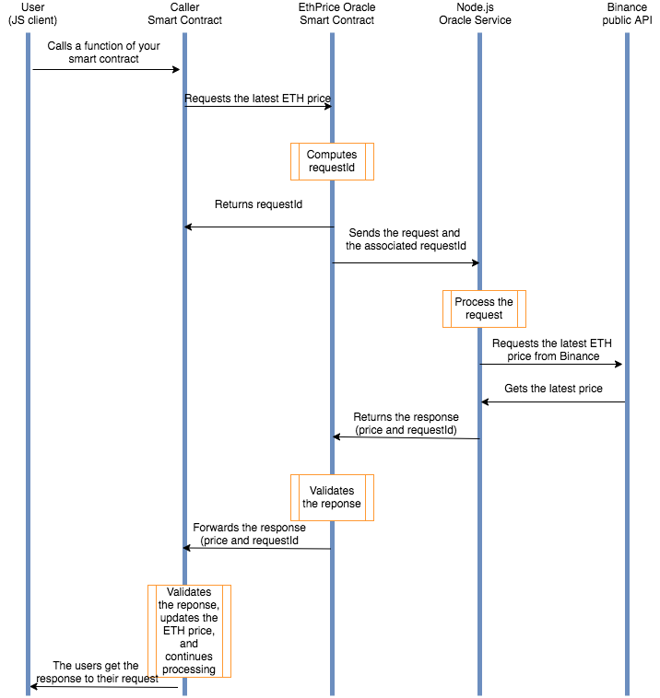
Let this sink in before you read on.
For now, let's initialize your new project.

Put It to the Test
Fire up a terminal window and move into your projects directory. Then, create a directory called EthPriceOracle and cd into it.
- In the box to the right, initialize your new project by running the npm init -y command.
- Next, let's install the following dependencies: truffle, openzeppelin-solidity, loom-js, loom-truffle-provider, bn.js, and axios.
Note: You can install multiple packages by running something like the following:
npm i <package-a> <package-b> <package-c>
Why do you need all these packages you ask? Read on and things will become clearer.
You'll be using Truffle to compile and deploy your smart contracts to Loom Testnet so we've gone ahead and created two bare-bones Truffle projects:
  - The oracle will live in the oracle directory:
mkdir oracle && cd oracle && npx truffle init && cd ..
✔ Preparing to download box
✔ Downloading
✔ cleaning up temporary files
✔ Setting up box
  - The caller contract will live in the caller directory:
mkdir caller && cd caller && npx truffle init && cd ..
✔ Preparing to download box
✔ Downloading
✔ cleaning up temporary files
✔ Setting up box
We trust you to do the same and, if everything goes well, your directory structure should look something like the following:
tree -L 2 -I node_modules
.
├── caller
│ ├── contracts
│ ├── migrations
│ ├── test
│ └── truffle-config.js
├── oracle
│ ├── contracts
│ ├── migrations
│ ├── test
│ └── truffle-config.js
└── package.json
Note: Learning how to use Truffle is beyond the scope of this lesson. If you're inclined to learn more, check out our very own Deploying DApps with Truffle lesson.

